Supplementary figure 1 (A)
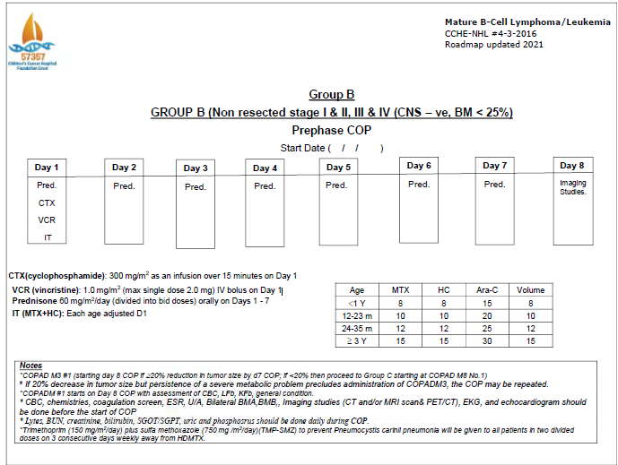

Supplementary figure 1(B)
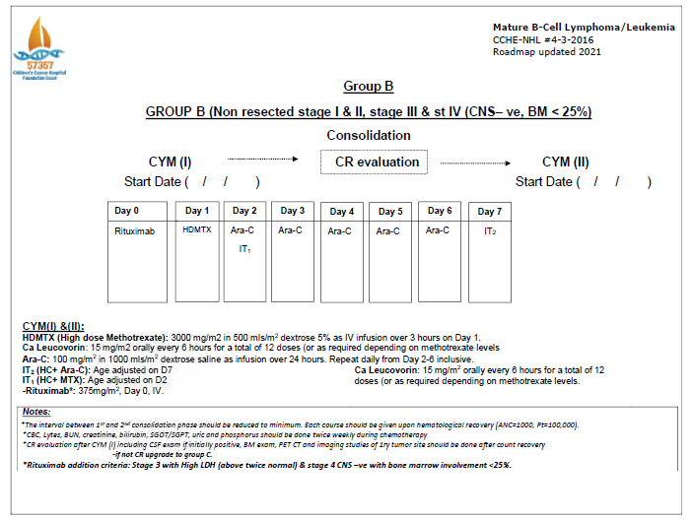

Supplementary figure1 (C )
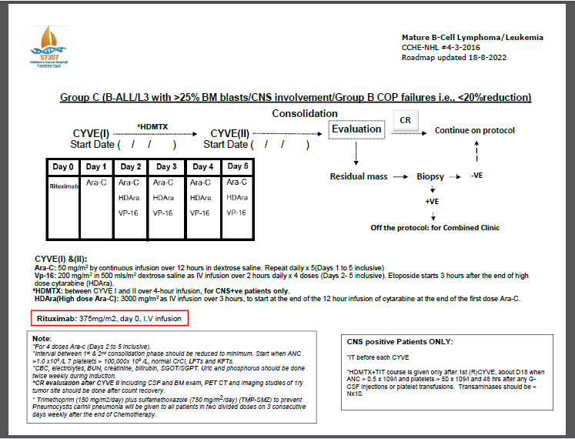

The impact of pathologically confirmed residual disease, on event-free survival(EFS) was evaluated using Kaplan-Meier analysis. Comparison of patients with residual disease (RD;n=73) and those without residual disease (n=27) showed no significant difference in EFS (p = 0.73),
as shown in Figure 4.

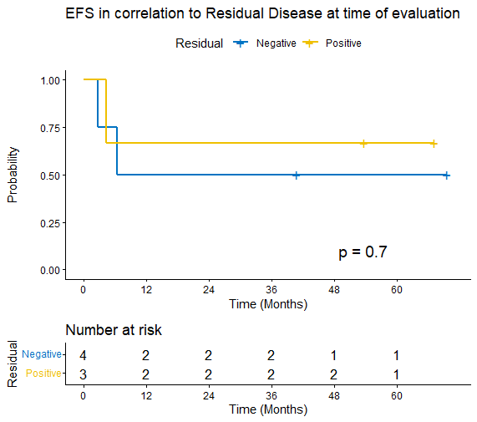

Figure (2) supplementary: Impact of pathologically confirmed residual disease on EFS. : RD + (n=73) VS RD – (n=27) ; no significant difference observed (P =0.731).

Event free survival by response category.Kaplan-Meier curves comparing event-free survival EFS CR (n=28) , CRb (biopsy-proven CR; n=24) , and CRu (Unconfirmed CR; n=30). Showed no significant difference (p = 0.28). 3 years EFS 90 % in Cru , in comparison to 89.3 % for CR group, with non-significant P value.P=0.28. EFS rates were 90 % (Cru) , 100 % (CRb), and 89.3 % (CR) .Eighteen patients were not evaluable for response and were excluded from this analysis. as shown in figure (5).
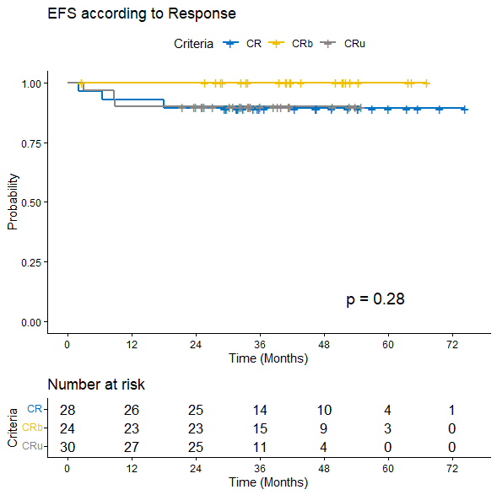

Figure 3 supplementay: There is no significant difference in EFS , between CR group and (CR b , CR u ) groups.

