Supplementary Material to ‘Cytogenetics-based Clinical Trajectories in Patients with MRD Negativity Post Autologous Transplant for Multiple Myeloma’.
Table of Content | Page Number
Supplementary Figure 1. PFS according to MAF translocations | 2
Supplementary Figure 2. OS according to individual HRCAs present versus absent | 3
Supplementary Table 1. Most frequent HRCA combinations among patients with ≥ 2 abnormalities | 4

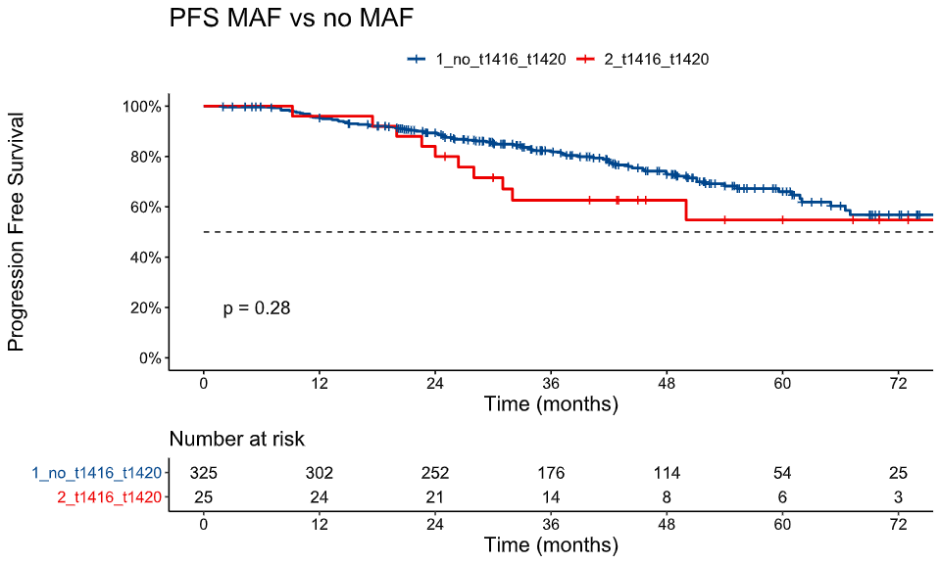
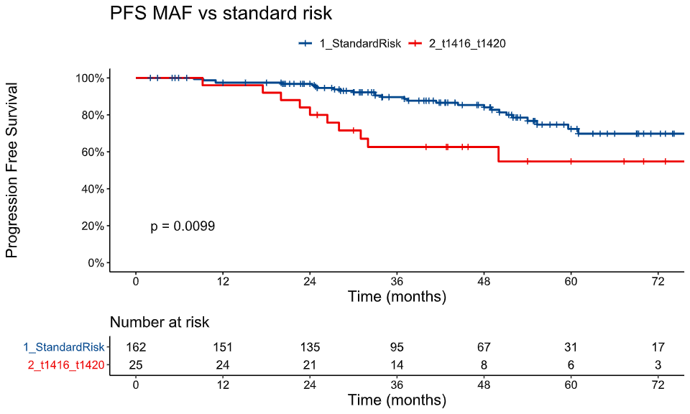
4-year PFS
73%
58%
A
4-year PFS
58%
84%
B
HR 2.51 (95% CI:1.21–5.2)
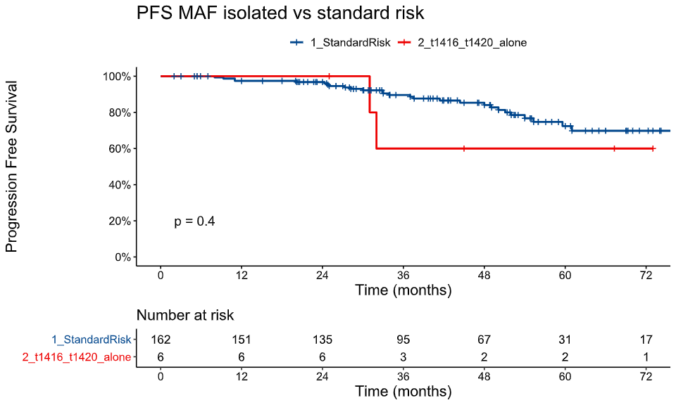
4-year PFS
60%
84%
C

Supplementary Figure 1. PFS according to MAF translocations among MRD-negative patients after ASCT.
Kaplan–Meier curves depict PFS stratified by the presence of MAF translocations and by comparisons with the standard-risk group.
(A) PFS in patients with MAF translocations vs those without MAF translocations.
(B) PFS in patients with MAF translocations vs standard-risk disease.
(C) PFS in patients with isolated MAF translocations vs standard-risk disease.
Vertical dashed lines indicate 4-year PFS estimates. HRs, 95% CIs, and log-rank p values are shown within each panel; comparisons that did not reach statistical significance do not display HRs. Numbers at risk are displayed below each plot.
PFS, progression-free survival; MRD, measurable residual disease; ASCT, autologous stem cell transplantation; HR, hazard ratio; CI, confidence interval; HRCA, high-risk cytogenetic abnormality.

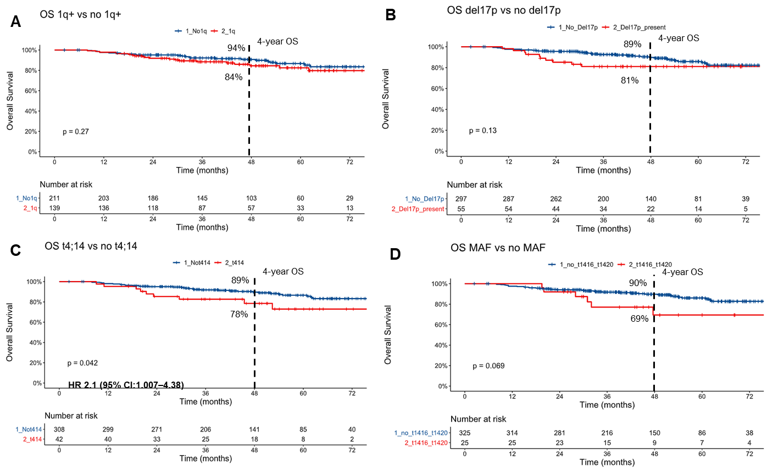

Supplementary Figure 2. OS according to individual HRCAs present versus absent among MRD-negative patients after ASCT.
Kaplan–Meier curves depict OS stratified by the presence or absence of individual HRCAs.
(A) OS in patients with 1q21+ vs those without 1q21+.
(B) OS in patients with del(17p) vs those without del(17p).
(C) OS in patients with t(4;14) vs those without t(4;14).
(D) OS in patients with MAF translocations vs those without MAF translocations.
Vertical dashed lines indicate 4-year OS estimates. HRs, 95% CIs, and log-rank p values are shown within each panel; comparisons that did not reach statistical significance do not display HRs. Numbers at risk are displayed below each plot.
OS, overall survival; MRD, measurable residual disease; ASCT, autologous stem cell transplantation; HR, hazard ratio; CI, confidence interval; HRCA, high-risk cytogenetic abnormality

Supplemental Table 1. Most frequent HRCA combinations among patients with ≥ 2 abnormalities (n = 71)
Double-hit and triple-hit combinations | n (%)
1q21 + t(4;14) | 20 (28.2)
del(17p) + 1q21 | 11 (15.5)
1q21 + t(14;16) | 9 (12.7)
del(17p) + 1q21 + t(4;14) | 7 (9.9)
1q21 + del(1p) | 6 (8.5)
del(17p) + del(1p) | 4 (5.6)
1q21 + t(14;20) | 4 (5.6)
del(17p) + t(4;14) | 3 (4.2)
del(17p) + 1q21 + t(14;16) | 3 (4.2)
del(17p) + t(14;16) | 2 (2.8)
del(17p) + 1q21 + del(1p) | 1 (1.4)
del(17p) + t(4;14) + t(14;16) | 1 (1.4)
* Percentages are based on n = 71 double/triple-hit cases.

