Vapour-Phase-Metalation Nanosurgery by ALD: A Tool for Single Molecular Replacement on Enterobactin for Drug Discovery and Nanomaterial Design
Mabel A. Moreno^{1,2*}, Angelica Zacarias³, Andrea Porzel⁴, Melissa Alegría-Arcos⁵, Luis Velasquez¹, Fernando D. Gonzalez-Nilo⁶, Anjana Devi^{7,8}, Eberhard K.U. Gross⁹, Holger B. Deising^{10**}.

¹Instituto de Investigación Interdisciplinar en Ciencias Biomédicas SEK (I³CBSEK), Facultad Ciencias de la Salud, Universidad SEK, Chile, Fernando Manterola 0789, Providencia, Santiago.
²Fachbereich Ingenieur- Und Naturwissenschaften, Hochschule Merseburg − University of Applied Sciences, Eberhard-Leibnitz-Str. 2, Merseburg, Germany
³Max Planck Institute of Microstructure Physics, Weinberg 2, D 06120 Halle, Germany.
⁴Leibniz Institute of Plant Biochemistry, Weinberg 3, D 06120, Halle, Germany
⁵Núcleo de Investigación en Data Science, Facultad de Ingeniería y Negocios, Universidad de las Américas, Santiago 7500000, Chile
⁶Andres Bello University, Facultad de Biologia, Center for Bioinformatics and Integrative Biology. Av Republica 239, Santiago, Chile.
⁷Leibniz Institute for Solid State and Materials Research (IFW), Helmholtzstr. 20, D-01069, Dresden
⁸Faculty of Chemistry and Food Chemistry Dresden University of Technology (TUD)
⁹Fritz Haber Research Center for Molecular Dynamics and Institute of Chemistry, The Hebrew University of Jerusalem, Jerusalem 91904, ISRAEL
¹⁰Martin-Luther-Universität, Halle-Wittenberg, Naturwissenschaftliche Fakultät III, Betty-Heimann-Str. 3

Corresponding authors: (*) mabel.moreno@zonavirtual.uisek.cl, (**) holger.deising@landw.uni-halle.de

Figure S1. UV-Visible spectra of experimental and calculated H₆EB structures 1-5.

Table S1. Excitation energies (nm), molecular orbital contributions and assignments of Enterobactin.

Structure |  | Enterobactin |  |  |  | Excitation  Energy (nm) | Contribution | Experimental
Structure |  | Arm-1 | Arm-2 | Arm-3
Structure-2 | H |  |  |  |  | 195.81 | 163→175 | 225.9
Structure-2 | L |  |  |  |  | 195.81 | 163→175 | 225.9
 | H |  |  |  |  | 230.62 | 174→177 | 249.2
 | L |  |  |  |  | 230.62 | 174→177 | 249.2
 | H |  |  |  |  | 273.03 | 167→175 | 315.2
 | L |  |  |  |  | 273.03 | 167→175 | 315.2
Structure-3 | H |  |  |  |  | 217.07 | 161→179 | 225.9
Structure-3 | L |  |  |  |  | 217.07 | 161→179 | 225.9
 | H |  |  |  |  | 253.45 | 167→175 | 249.2
 | L |  |  |  |  | 253.45 | 167→175 | 249.2
 | H |  |  |  |  | 267.31 | 173→175 | 315.2
 | L |  |  |  |  | 267.31 | 173→175 | 315.2
Structure-4 | H |  |  |  |  | 184.76 | 172→178 | 225.9
Structure-4 | L |  |  |  |  | 184.76 | 172→178 | 225.9
 | H |  |  |  |  | 214.80 | 169→175 | 249.2
 | L |  |  |  |  | 214.80 | 169→175 | 249.2
 | H |  |  |  |  | 267.31 | 173→ 175 | 315.2
 | L |  |  |  |  | 267.31 | 173→ 175 | 315.2
Structure-5 | H |  |  |  |  | 173.99 | 174→183 | 225.9
Structure-5 | L |  |  |  |  | 173.99 | 174→183 | 225.9
 | H |  |  |  |  | 202.86 | 168→175 | 249.2
 | L |  |  |  |  | 202.86 | 168→175 | 249.2
 | H |  |  |  |  | 237.73 | 174→177 | 315.2
 | L |  |  |  |  | 237.73 | 174→177 | 315.2

S2. Detailed H₆EBZnOH fragments calculated using monoisotopic mass based on MALDI-TOF MS spectra, * reported in [37] and correspond to [H₆EB+H⁺]⁺ and [H₆EB+Na⁺]⁺ monoisotopic mass.

.

S3. Detailed FeH₃EBZnOH fragments calculated using monoisotopic mass based on MALDI-TOF MS spectra.

Table S2. Experimental and Calculated ¹³C and ¹H chemical shifts (ppm) of Model 1, 2 and the average of Model 1+2 of H₆EBZnOH.

 | Calculated  H₆EB-ZnOH  (Model 1) |  |  |  | Calculated  H₆EB-ZnOH  (Model 2) |  |  |  | Calculated  H₆EB-ZnOH  (Model 1+2) |  | Exp.  H₆EBZnOH  (solvent: CD3OD)
 | ¹H |  | ¹³C |  | ¹H |  | ¹³C |  | ¹H | ¹³C | δ¹H m (J [Hz]) | δ ¹³C
10” | 9.29 | 9.02 | 132.52 | 133.19 | 8.05 | 7.69 | 123.7 | 122.75 | 8.35 | 127.97 | 7.34 br d (8.3) | 122.3
10’ | 9.29 | 9.02 | 136.37 | 133.19 | 8.1 | 7.69 | 128.01
10 | 8.49 | 9.02 | 130.69 | 133.19 | 6.91 | 7.69 | 116.54
8” | 8.21 | 8.36 | 131.72 | 129.82 | 6.55 | 5.95 | 118.8 | 110.37 | 7.16 | 120.10 | 6.87 br d (7.6) | 116.8
8’ | 8.27 | 8.36 | 131.62 | 129.82 | 6.47 | 5.95 | 121.91
8 | 8.61 | 8.36 | 126.13 | 129.82 | 4.83 | 5.95 | 90.41
9” | 8.07 | 8.02 | 129.36 | 125.55 | 6.87 | 6.50 | 118.48 | 117.98 | 7.26 | 121.77 | 6.35 dd (8.3/7.6) | 113.7
9’ | 8.13 | 8.02 | 129.25 | 125.55 | 6.47 | 6.50 | 116.02
9 | 7.88 | 8.02 | 118.04 | 125.55 | 6.15 | 6.50 | 119.45
2 | 5.76 | 5.79 | 45.01 | 44.42 | 3.70 | 4.23 | 38.4 | 36.67 | 5.01 | 40.54 | 5.22 m | 53.9
2’’ | 6 | 5.79 | 41.42 | 44.42 | 4.80 | 4.23 | 36.4
2’’ | 5.62 | 5.79 | 46.83 | 44.42 | 4.20 | 4.23 | 35.2
3A | 6.94 | 6.19 | 58.27 | 57.66 | 5.23 | 4.69 | 42.29 | 49.18 | 5.44 | 53.42 | 5.38 m | 66.6
3A | 6.27 | 6.19 | 56.25 | 57.66 | 4.97 | 4.69 | 52.88
3A | 5.35 | 6.19 | 58.45 | 57.66 | 3.87 | 4.69 | 52.36
3B | 4.28 | 4.89 | 58.27 | 57.66 | 3.16 | 4.04 | 42.29 | 49.18 | 4.46 | 53.42 | 3.98 br d (11.0) | 66.6
3B | 4.11 | 4.89 | 56.25 | 57.66 | 3.65 | 4.04 | 52.88
3B | 6.27 | 4.89 | 58.45 | 57.66 | 5.30 | 4.04 | 52.36
4/4’/4’’ |  |  | 187.69/172.59/173.26 | 177.85 |  |  | 166.93/165.62/  135.61 | 156.03 |  | 166.95 |  | 170.9
5/5’/5’’ |  |  | 121.12/129.52/121.30 | 123.98 |  |  | 113.42/112.19/  101.52 | 109.04 |  | 116.51 |  | 117.9
6/6’/6’’ |  |  | 161.60/146.19/145.85 | 151.21 |  |  | 143.06/141.11/  128.62 | 137.60 |  | 144.41 |  | -----
7/7’/7’’ |  |  | 147.21/144.97/150.85 | 149.34 |  |  | 135.96/133.05  /127.16 | 132.06 |  | 140.7 |  | 147.5
1/1’/1’’ |  |  | 177.08/180.15/176.54 | 177.92 |  |  | 189,1/174,92/  178,1 | 180.7 |  | 179.32

Figure S4. Experimental 2D ¹³C-¹H NMR Spectra of H₆EB(ZnOH)₂.

Figure S5. 2D ¹³C-¹H NMR Spectra of simulated H₆EB(ZnOH)₂ (model 1).

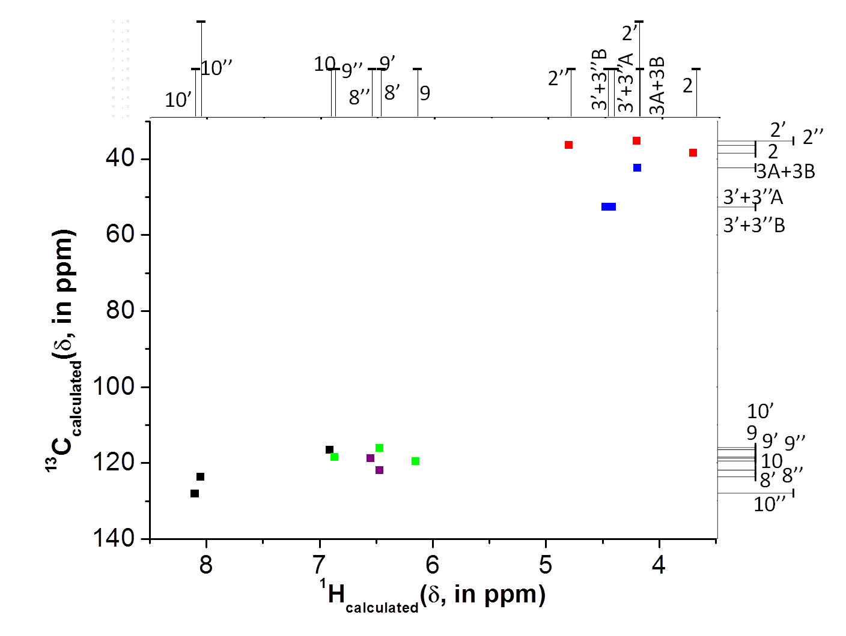

Figure S6. 2D ¹³C-¹H NMR Spectra of simulated H₆EB(ZnOH)₂ (model 2).

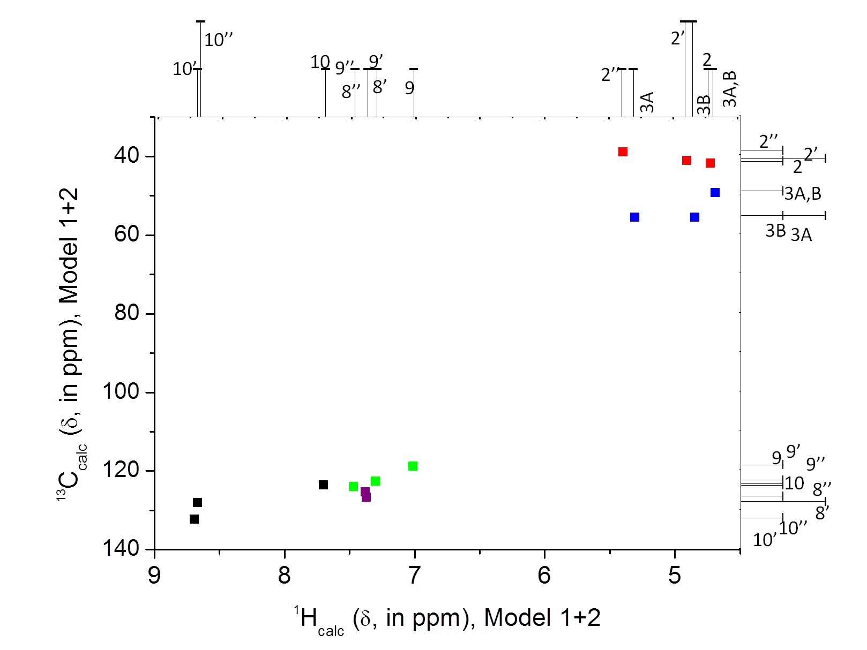

Figure S7. Average 2D ¹³C-¹H NMR Spectra of simulated H₆EB(ZnOH)₂ for model 1+2.

Figure S8. ¹³C,¹H Model 1 linear correlation. a) ¹H_{Experimental} and ¹H_{calc} linear correlation (¹H_{Experimental}=0.7386 ¹H_{calc} + 0.6531), and (b) ¹³C_{experimental} and ¹³C_{calc} linear correlation ( ¹³C_{Experimental}=0.8384 ¹³C_{calc} + 15.236).

Figure S9. ¹³C,¹H Model 2 linear correlation. a) ¹H_{Experimental} and ¹H_{calc} linear correlation (¹H_{Experimental}=0.7822 ¹H_{calc} + 1.5418), and (b) ¹³C_{experimental} and ¹³C_{calc} linear correlation ( ¹³C_{Experimental}=0.9132 ¹³C_{calc} + 18.717).

Figure S10. ¹³C,¹H Model 1+2 linear correlation. a) ¹H_{Experimental} and ¹H_{calc} linear correlation (¹H_{Experimental}=0.7783 ¹H_{calc} + 0.9681), and (b) ¹³C_{experimental} and ¹³C_{calc} linear correlation ( ¹³C_{Experimental}=0.8757 ¹³C_{calc} + 16.743).

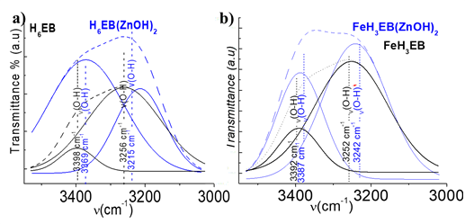

Figure S11. a) H₆EB (black) and H₆EB-ZnOH (blue) FTIR Spectra on the range 3500-3000 cm⁻¹. Two typical O-H symmetric stretch bands from the catechol, with frequency values of 3256 and 3398 cm⁻¹ for H₆EB, and for H₆EB(ZnOH)₂ 3215 and 3369 cm⁻¹. b) Similar effect is found for FeH₃EB and FeH₃EB(ZnOH), frequency shifts from 3252 and 3392 cm⁻¹ for the bare FeH₃EB to 3242 to 3387 cm⁻¹ for FeH₃EB(ZnOH). The deconvolution of such bands was realized by means of Gaussian functions using Origin 7.5 program.

Figure S12. FTIR Spectra of H₆EB PBE average³¹ (black), ZnOH linked at CO from amide (blue), and ZnOH linked at CO from catechol (green), in the range of 400-4000 cm⁻¹.

Table S3. Calculated Infrared spectra of FeEnterobactin models compared with experimental result within the range of 1000-2000 cm⁻¹; finger print (*), main peak (**).

Band Assignment | H6EB  PBE  Average | H6EB  Exp | Band Assignment | Model 3 | Experimental  FeEnterobactin
C-OH, C-H | 1031.77 | 1072.31 | C3H, C2H | 1003.49  1025.06  C2-H  C3H  C-H
C-OH, C-H | 1031.77 | 1072.31 | Car-H, O(C=O), C2H,C3H | 1003.49  1025.06  C2-H  C3H  C-H
C-OH, C2-H, C3-H | 1124.99 | 1134.17 | O(C=O), C2H, C3H,  NH | 1065.25  *C3H, C2H, O(C=O), NH | 1060.89**
C-OH | 1174.80 | 1176.59 | O(C=O), C2H, C3H,  NH | 1117.88  1120.90  1127.99  C-H, C=C | 1110.99**
C2-H, C3-H, N-H, C-OH
C-OH, Car-H
Car-H | 1235.19 | 1236.78 | C-H  C=C | 1157.60  1182.97  O-H, C=C, C-H, C3H, C2H. | 1169.00**
δar-H, C-OH
C2-H in the plane deformation | 1256.43 | 1264.99 | C3H, C2H | 1251.88  C-H,O-H  1262.19  1282.83  1286.12  C-H,O-H  1286.12  1296.49  1317.22  salicyate | 1233.96**
C=C
N-H, OH, Car-H, | 1336.54 | 1343.36 | C2H+NH+C3H | 1331.48  1351.83  salicyate  1376.09  1388.09  1405.19  1409.28  1417.38  1428.04  C2H+NH+C3H, C(O)-O | 1357.67**
C=C, N-H, OH, Car-H,
N-H, C2-H, C=C
N-H, C2-H, C3-H | 1407.78 | 1390.18 | C2H+NH+C3H | 1433.38  1447.09  1450.27  1469.05  1475.53  Salicylate +OH +C=C
C2-H
C2-H, C=C
C=C, C-N N-C2

Table S4. Calculated Infrared spectra of FeEnterobactin models compared with experimental result within the range of 1000-2000 cm⁻¹; finger print (*), main peak (**), first part.
Band Assignment | H6EB-PBE  Average | H₆EB  Exp | Band Assignment | Model 3 | Experimental  FeEnterobactin
C-OH, C-H | 1031.77 | 1072.309 | C₃H, C2H | 1003.49  1025.06
C-OH, C-H | 1031.77 | 1072.309 | C_{ar}-H, O(C=O), C2H,C3H | 1003.49  1025.06
C-OH, C₂-H, C₃-H | 1124.99 | 1134.169 | O(C=O), C2H, C3H,  NH | 1065.25  *C3H, C2H, O(C=O), NH | 1060.89**
C-OH | 1174.80 | 1176.59 | O(C=O), C₂H, C₃H,  NH, C=c | 1117.88  1120.90  1127.99 | 1110.99**
C₂-H, C₃-H, N-H, C-OH
C-OH, C_{ar}-H
C_{ar}-H | 1235.19 | 1236.78 | O-H, C=C, C-H, C3H, C2H. | 1157.60  1182.97 | 1169.00**
δ_{ar}-H, C-OH
C₂-H in the plane deformation | 1256.43 | 1264.99 | C3H, C2H | 1251.88/C-H,O-H  1262.19  1282.83  1286.12/C-H,O-H  1286.12  1296.49  1317.22/salicyate | 1233.96**
C=C
N-H, OH, C_{ar}-H, | 1336.54 | 1343.36 | C2H+NH+C3H | 1331.48  1351.83/salicyate  1376.09  1388.09  1405.19  1409.28  1417.38  1428.04 | 1357.67**
C=C, N-H, OH, C_{ar}-H,
N-H, C₂-H, C=C
N-H, C₂-H, C₃-H | 1407.78 | 1390.18 | C2H+NH+C3H | 1433.38  1447.09  1450.27  1469.05  1475.53/Salicylate +OH +C=C
C₂-H
C₂-H, C=C
C=C, C-N N-C₂

Table S5. Calculated Infrared spectra of FeEnterobactin models compared with experimental result within the range of 1000-2000 cm⁻¹; *Average, second part.

Band Assignment | H6EB-PBE | Band Assignment |  | Model 3 |  | H6EB-PBE | Experimental  FeEnterobactin
C=C, N-C2 | 1461.42 | C2H+ C3H+NH |  | 1450.4  1453.1  1466.6  Catecholate-like | 1516.5  C22H  1524.24  salicylate | 1499.07  1502.59  1511.70  1516.47  1520.25  1524.12  1531.99  1539.70  1564.56  1566.88 | 1455.22
C=C
1551.67
1569.20
salicylate
C₃-H | 1538.35 | C3H |  | 1514.02  1532.64  1534.30  C3H
C₃-H
C₃-H
C=C
C=C
C=C
C=C | 1588.92 | O(C=O), C=C |  | 1555.31  1574.53  1604.32  Catecholate-like | 1619.25  1632.13  1645.33  Salicylate  C=C | 1603.80  1609.52  1627.30  1711.01 | 1544.41  1640.41
C=C
C=C
N-(C=O)- (amide) | 1644.31 | C=C, N-(C=O) |  | 1607.3  1620.7  1622.7  Catecholate-like | 1672.30  1677.07  1683.9  Salicylate  C=C
N-(C=O)- (amide)
N-(C=O)- (amide) | 1644.31 | N-(C=O)-,C=C |  | 1631.9  1670.5  1675.8  1681.2  1685.5  Catecholate-like
N-(C=O)- (amide) | 1750.26 |  |  | 1736.4  1740.4  1733.7  1740.4  amide | 1710.31  1730.35  1754.88  1765.18  1777.77  1789.40 | 1714.79  1721.58 | 1700.03  1746.33  1832.48
N-(C=O)- (amide)
N-(C=O)- (amide)
C-(C=O)- (ester) | 1817.34 | 1836.71* | C-(C=O)- (ester), C2H, N-H | 1800.4  1815.9  1825.2  Ester | 1818.73 | 1736.40  1744.64  1748.49  1780.50 | 1859.80  1874.23  1915.22
C-(C=O)- (ester) | 1835.11
C-(C=O)- (ester) | 1857.68

Figure S13. Ribbon diagram of the complete FepA modeled with MODELLER software. A) Side view of FepA. The extracellular space is located at the top of Figure, and the periplasmic space is at the bottom. b) FepA as viewed from the periplasm; α-helices are shown in purple, the β-strands are shown in yellow and the loops are shown in cyan and white.

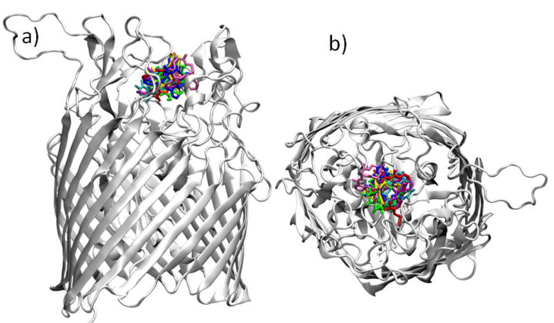

Figure S14. Ligand-protein Molecular docking showing the best conformation reported for each ligand obtained with the Glide software; a) Side view of FepA with the ligands in the central position, and b) Preferential ligand distribution in FepA as viewed from the periplasm. Ligands are shown together, but the docking calculation was donefor an individual ligand.

Table S6. Amino acid residues localised in the first ligand coordination sphere (at 3Ǻ). (L: loop, I: Inner structure, yellow region in the concentrical part of FepA, see Figure S14).

System | L₇ | L₁₁ | L₁₀ | L₄ | L₃ | L₂ | I
[FeEB]³⁻ | K₄₈₃  S₄₉₀ | N₆₈₈  T₆₉₂  I₇₀₁ |  |  | N₂₆₆  T₂₆₄ | Y₂₁₇  T₂₂₀ | Q₆₅
H₆EB | K₄₈₃  Y₄₈₁  A₄₉₁  S₄₈₂ | N₆₈₈  T₆₉₂ | Y₆₃₈ | E₃₁₉ | D₂₆₃  T₂₆₄ | Y₂₁₇ | Q₆₅  R₆₆
[Fe(EB)ZnOH]³⁻ | K₄₈₃  S₄₉₀  A₄₉₁ | T₆₉₂ | Y₆₃₈ | E₃₁₉ | T₂₆₄ |  | R₁₀₂  W₁₀₁  Q₆₅
Model 1 | K₄₈₃  Y₄₈₁  S₄₈₂  A₄₉₁  L₄₇₀ |  | Y₆₃₈ | G₃₂₀  E₃₁₉  L₃₂₁ | T₂₆₄ |  | Q₆₅  R₆₆  R₉₂  W₁₀₁  E₁₀₄
Model 2 | K₄₈₃  Y₄₈₁  S₄₈₂  A₄₉₁  L₄₈₀ |  | Y₆₃₈ | G₃₂₀  E₃₁₉  L₃₂₁ | T₂₆₄ |  | Q₆₅  R₁₀₂  W₁₀₁  G₁₀₀  E₁₀₄
Model 3 | K₄₈₃  Y₄₈₁  S₄₈₂  A₄₉₁ |  | Y₆₃₈ | G₃₂₀  E₃₁₉ | T₂₆₄ |  | Q₆₅  R₁₀₂  W₁₀₁  G₁₀₀

