SUPPLEMENTARY FILE ( FULL BLOTS: HIGHLIGHTED AREA)
Targeting Androgen Receptor as a Novel Radiosensitizing Therapy to Improve Long-Term Survival and Anti-tumor Immunity in Glioblastoma via TGF-β/Smad3 Axis Reprogramming
*^{1,8}Chi Zhang, M.D., Ph.D.; ¹Jyoti B. Kaushal, Ph.D.; ¹Nan Zhao, M.B.B.S.; ¹Rubayat Khan, Ph.D.; ²Kan Liu, Ph.D.; ²Chi Zhang, Ph.D.; ¹Fei Wang, M.B.B.S.; ³Jie Chen, M.D., Ph.D.; ⁴Bingjie Guan, B.S.; ¹Shuo Wang, Ph.D.; ⁵Tom K. Hei, Ph.D.; ⁶Tony J. C. Wang, M.D.; ⁷Yuguo Lei, Ph.D.; ⁹Michele R. Aizenberg, M.D.; ¹Chi Lin, M.D., Ph.D.

¹Department of Radiation Oncology, Fred & Pamela Buffett Cancer Center, University of Nebraska Medical Center, Omaha, NE
²School of Biological Sciences, University of Nebraska - Lincoln, Lincoln, NE
³Department of Pathology, University of Nebraska Medical Center, Omaha, NE
⁴Department of Radiation Oncology, United Hospital of Fujian, Fuzhou, Fujian, P.R. China
⁵Center for Radiological Research, College of Physicians and Surgeons; Columbia University, New York, New York
⁶Department of Radiation Oncology, Columbia University Irving Medical Center, New York, New York; Herbert Irving Comprehensive Cancer Center, New York, NY
⁷Department of Biomedical Engineering, Huck Life Science Institute, Pennsylvania State University, University Park, PA
⁸Department of Radiation Oncology, Mayo Clinic Arizona, Phoenix, AZ

⁹Department of Neurosurgery, Fred & Pamela Buffett Cancer Center, University of Nebraska Medical Center, Omaha, NE

Figure 4F
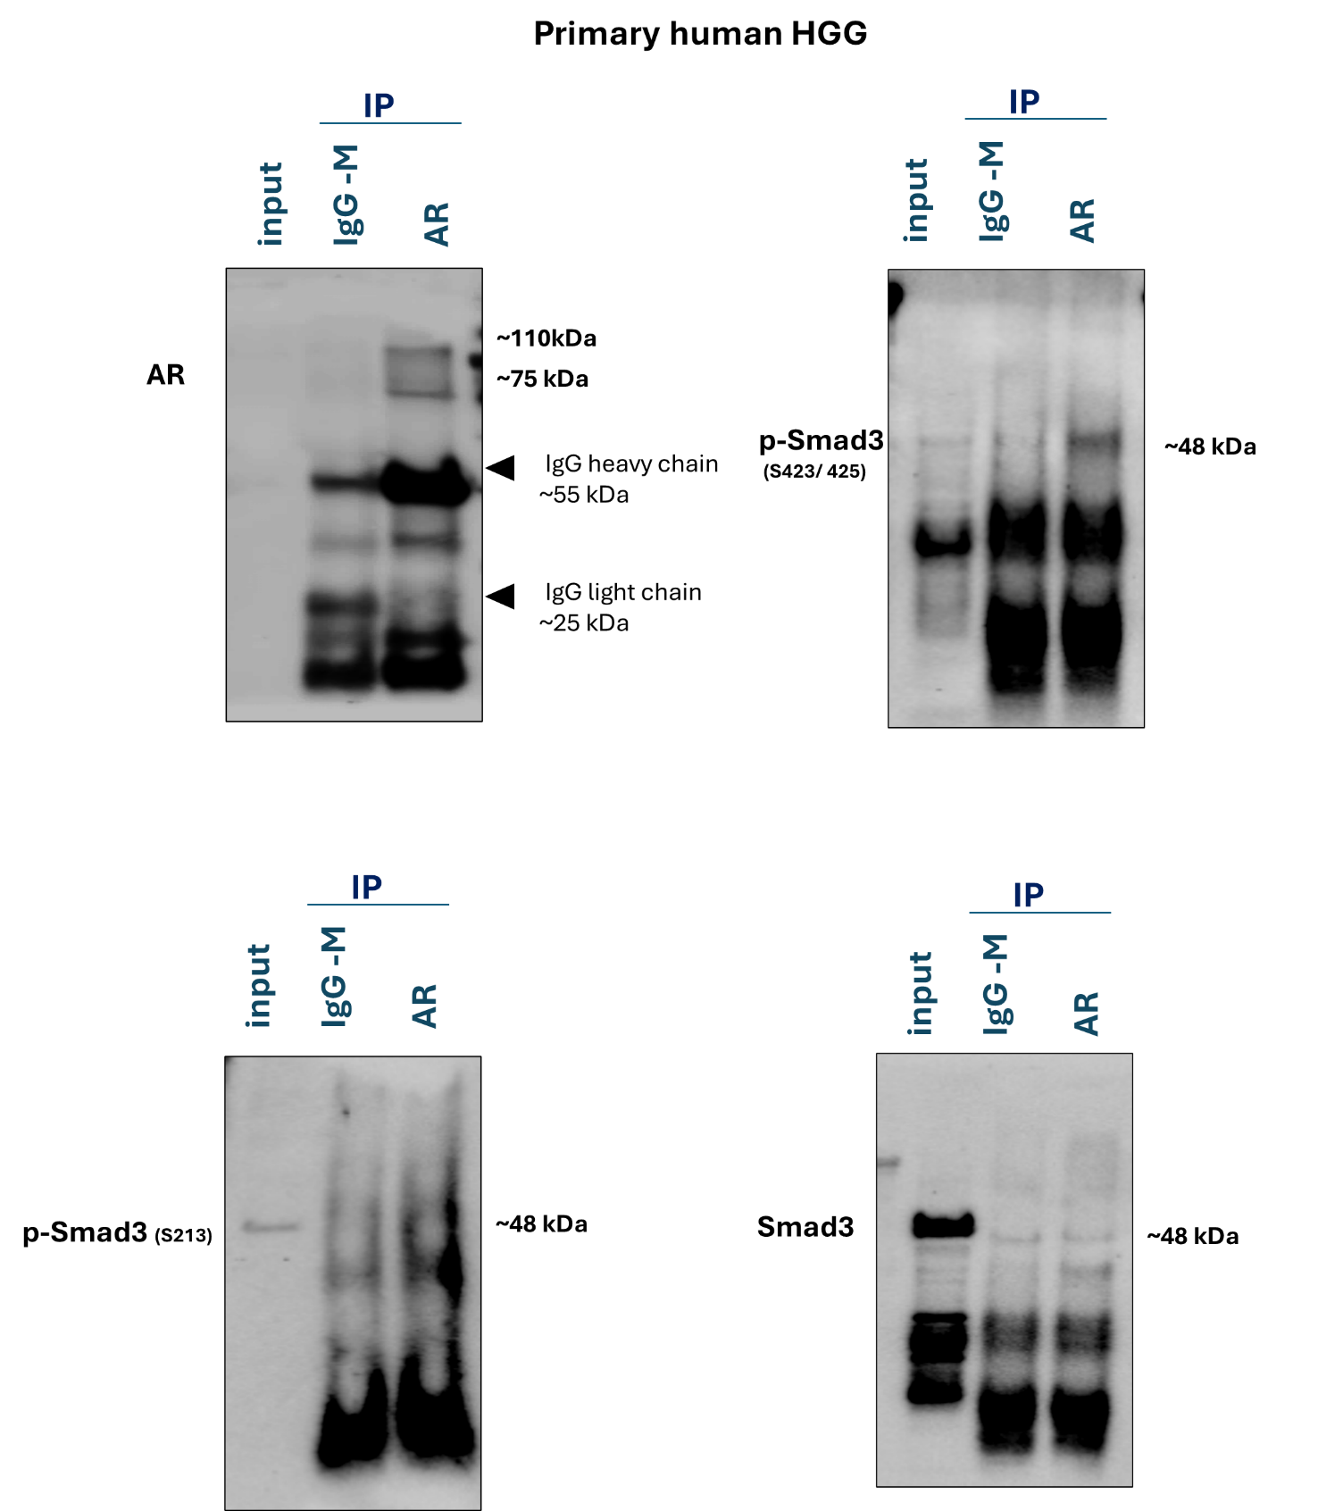

Figure 4 G

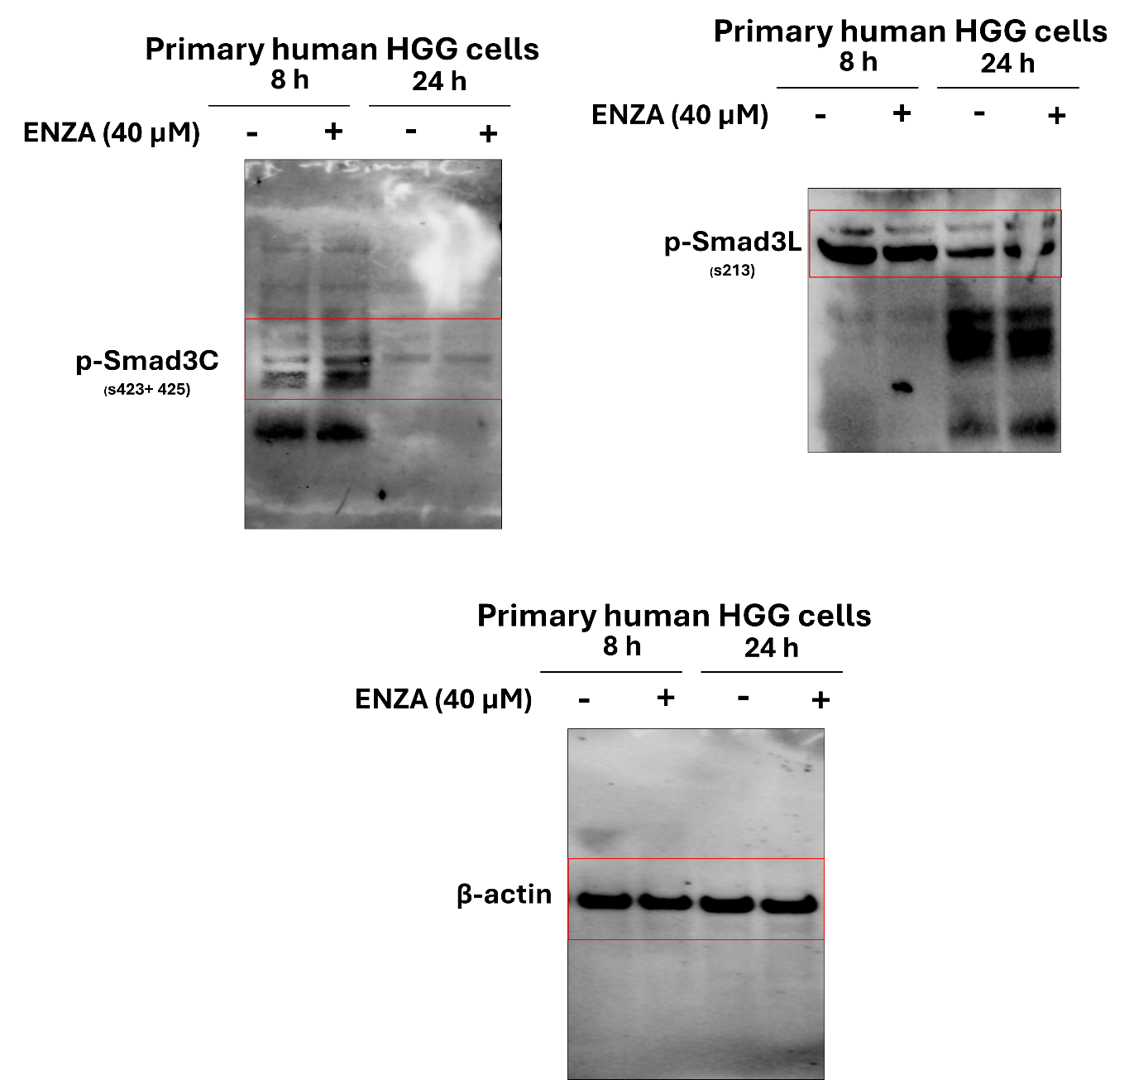

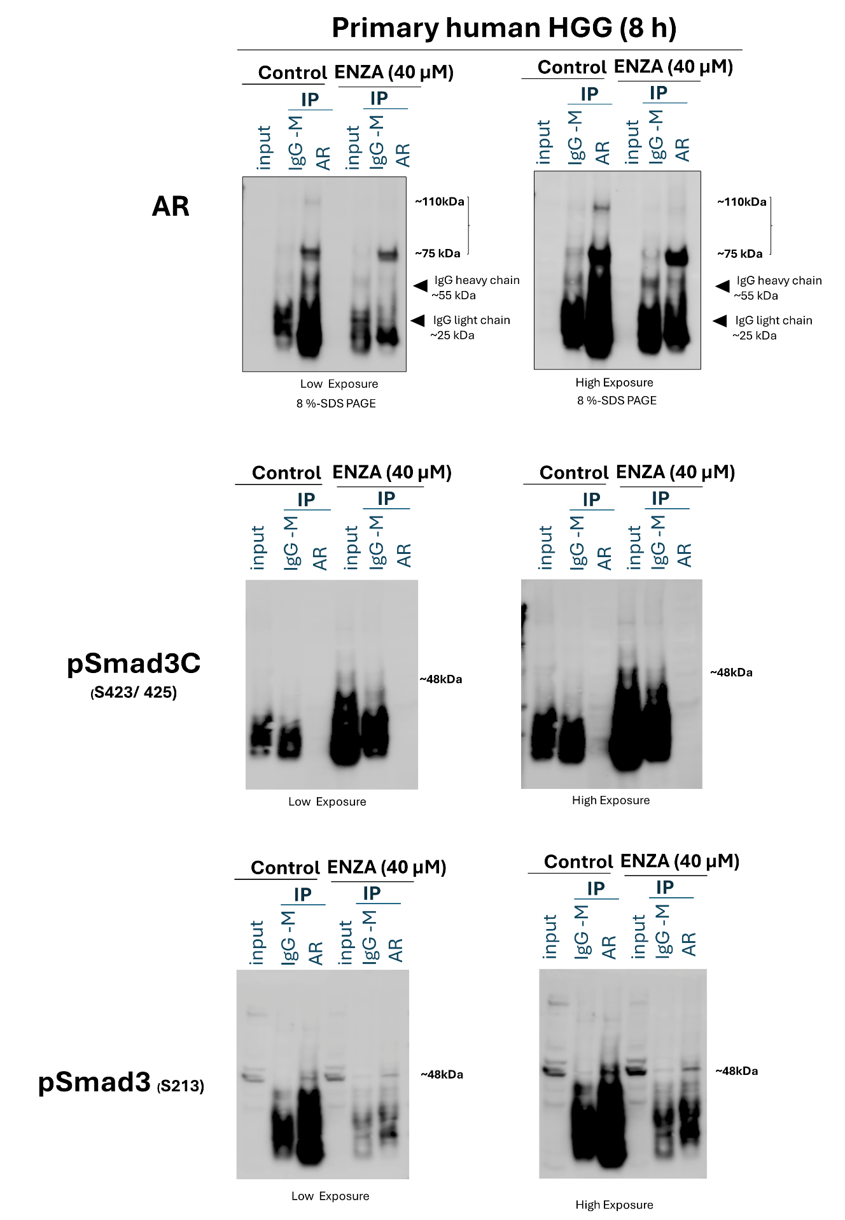

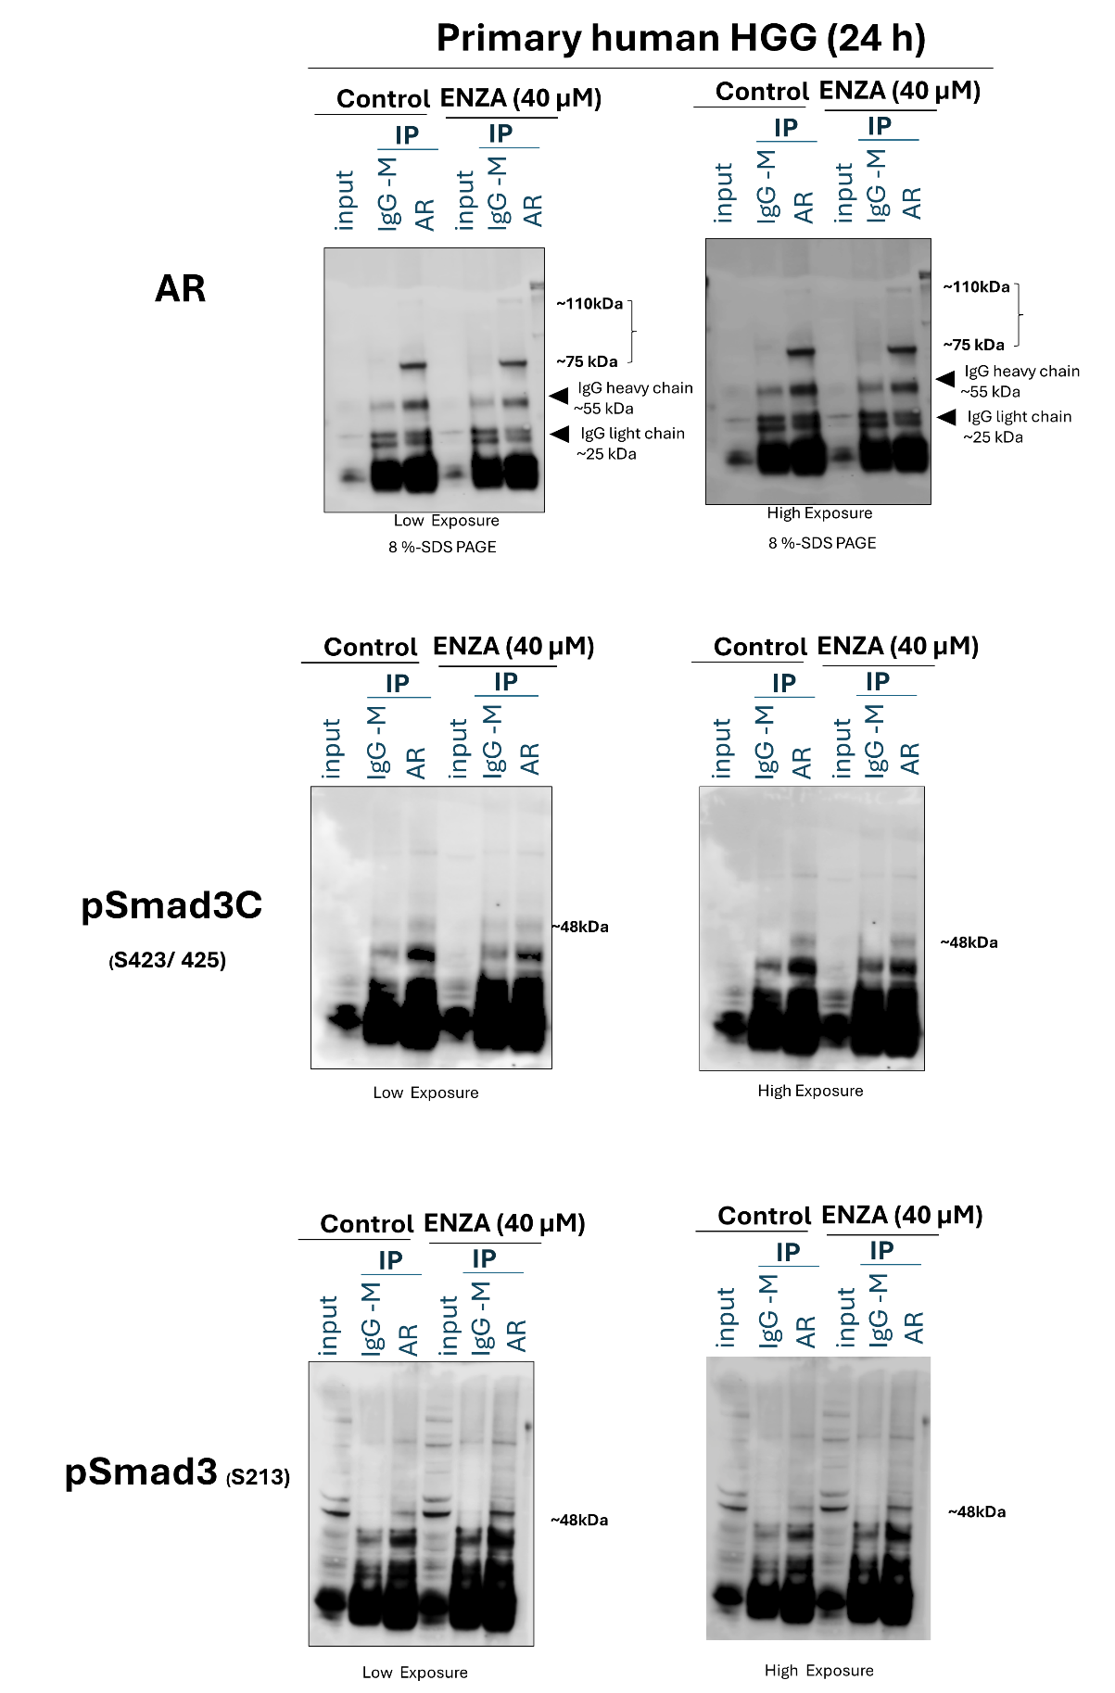

Figure 5 D
