Supplementary figures
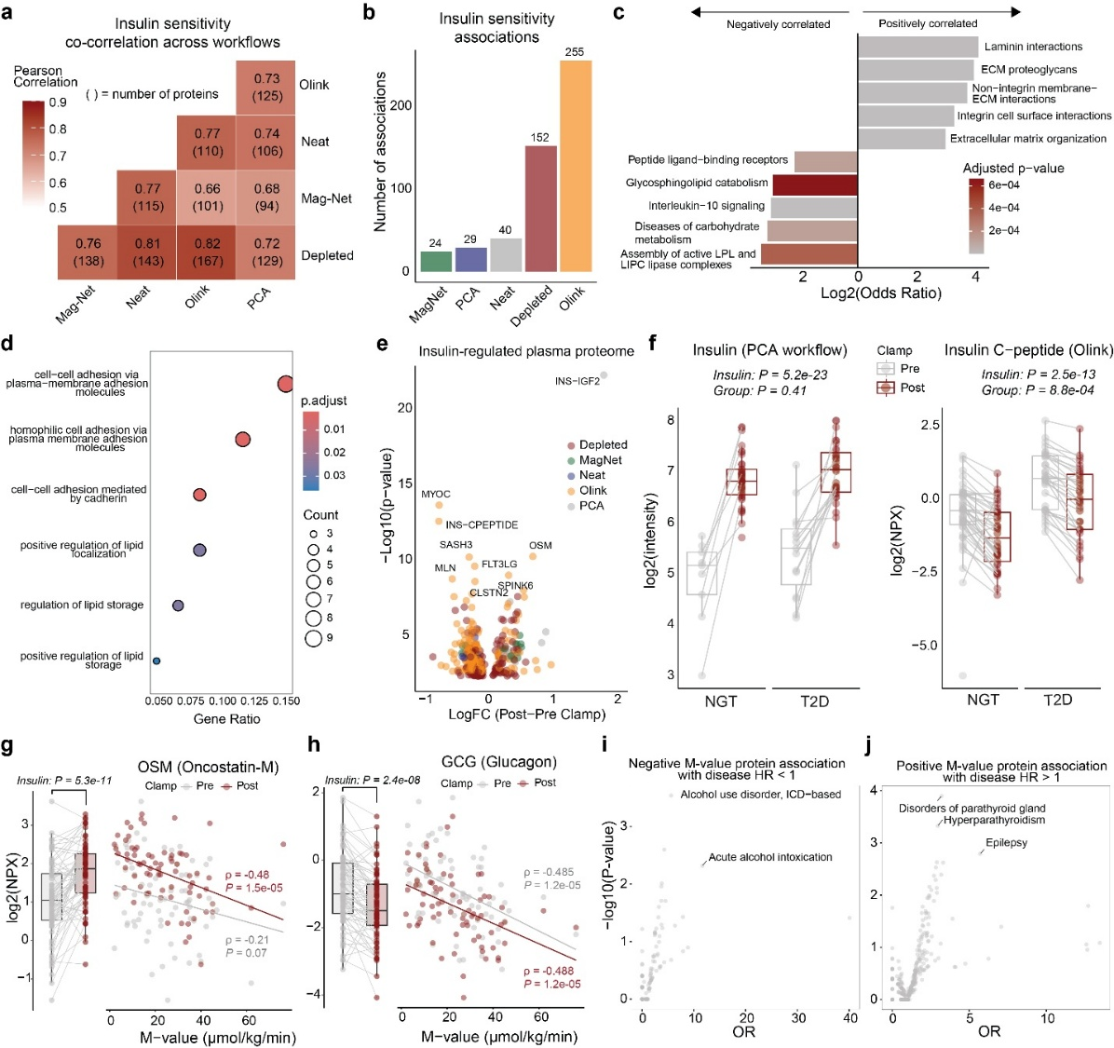
Supplementary Fig 1. Systemic plasma protein signatures of insulin resistance a) Pearson correlation of insulin-sensitivity associated proteins across proteomics workflows. The number of proteins that went into individual correlations is displayed in parentheses. b) Number of protein-insulin sensitivity associations across workflows c) Top 5 Reactome pathways enriched for positively or negatively correlated proteins with insulin sensitivity. All plasma proteins identified were used as background. d) Gene Ontology Biological Processes overrepresentation analysis of the insulin-sensitivity associated proteins adjusted for covariates. All identified plasma proteins were used as background. e) The insulin-regulated plasma proteome. A linear model (adjusted for BMI, Disease, Sex, and Age) was used. Only Benjamini-Hochberg corrected P < 0.05 are displayed. Proteins are colored based on the workflow, identifying the most significant P-value. f) Insulin and insulin C-peptide abundance in plasma were identified exclusively with the PCA and Olink workflows, respectively. g) Oncostatin-M (OSM) abundance and insulin sensitivity correlation at pre- and post- hyperinsulinemic–euglycemic clamp. h) Glucagon (GCG) abundance and insulin sensitivity correlation at pre- and post- hyperinsulinemic–euglycemic clamp. i) Enrichment analysis showing that proteins negatively associated with insulin sensitivity in our study were also less likely to be associated with decreased risk of future disease in the UK Biobank. j) Enrichment analysis showing that proteins positively associated with insulin sensitivity in our study were also less likely to be associated with increased risk of future disease in the UK Biobank.

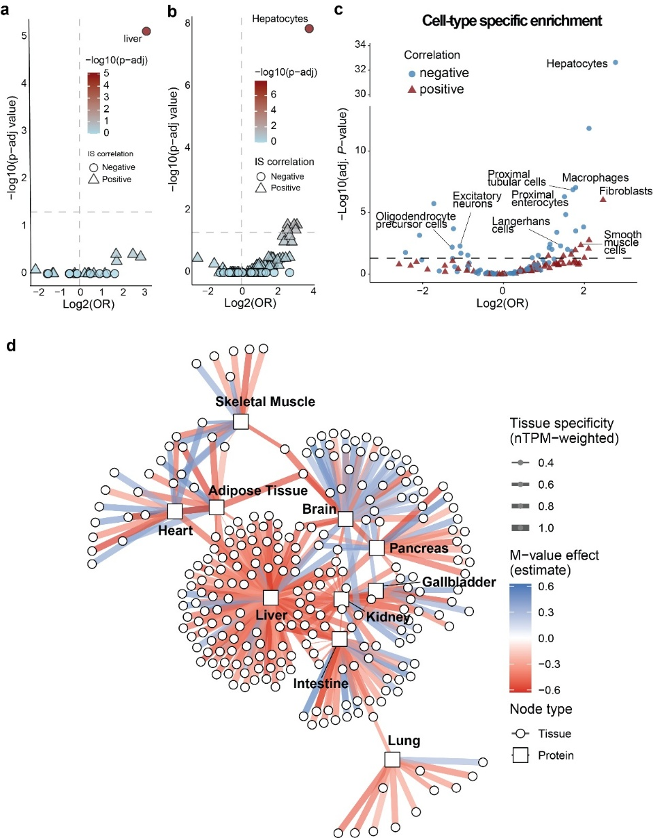
Supplementary Fig 2. Plasma protein multi-tissue origin defines human insulin resistance a) Tissue of origin analysis for the insulin sensitivity-associated plasma proteome adjusted for body fat percentage, age, and sex. Negative and positive significantly correlated proteins with insulin sensitivity were used as input to predict the tissue of origin. b) Cell-type resolved contribution to insulin-sensitivity associated proteins when adjusting for body fat percentage, age, and sex. A Fisher's exact test was used to test for enriched or depleted cell types among negatively and positively insulin sensitivity-associated proteins. All proteins identified in the plasma proteome were used as background. c) Cell-type resolved contribution to the insulin-sensitivity associated proteins. A Fisher's exact test was used to test for enriched or depleted cell types among negatively and positively insulin sensitivity-associated proteins. All proteins identified in the plasma proteome were used as background. d) Tissue–protein network showing the relationships between insulin sensitivity–associated proteins and their tissues of origin. Edge width reflects relative tissue specificity (nTPM-weighted), and edge color indicates the direction and magnitude of the insulin-sensitivity effect.
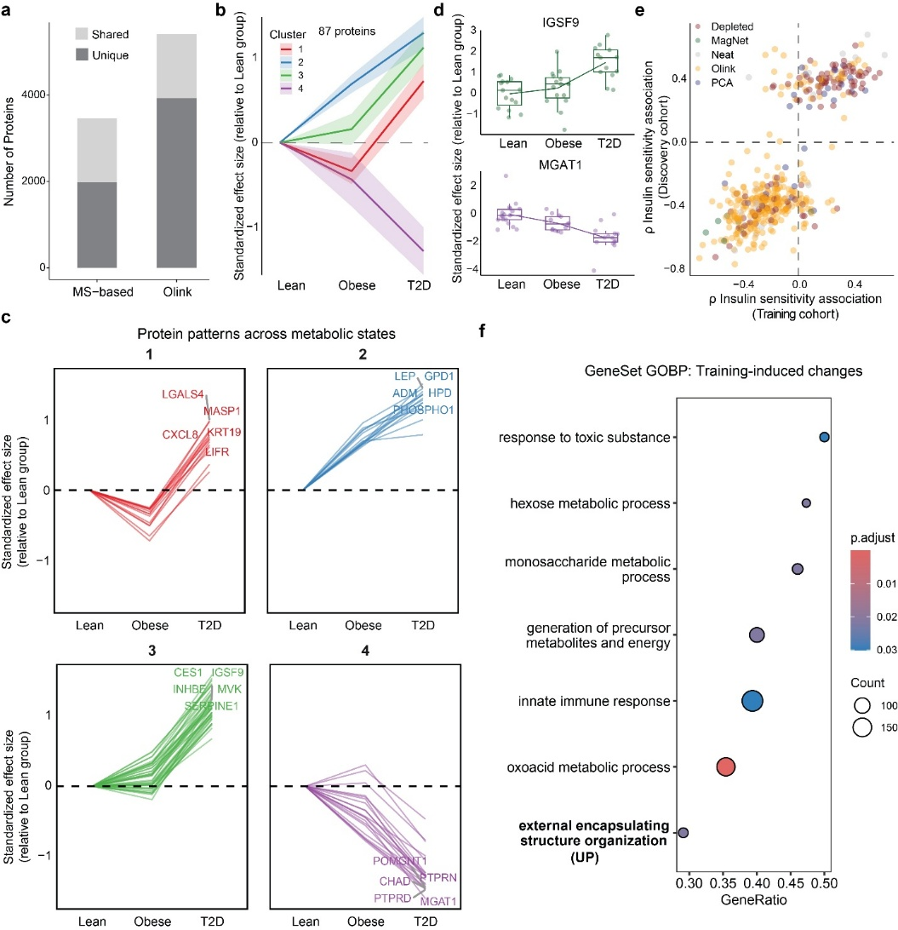

Supplementary Fig 3. Exercise Training Partially Reverses Plasma Proteomic Signatures of Insulin Resistance a) Unique and shared protein identifications by mass spectrometry (MS) or Olink-based proteomics. b) Four clusters of individual protein trajectories across individuals with normal weight, obesity, and T2D. Median +/- standard deviation levels from the normal weight group are displayed.c) Protein disease progression trajectories. A total of 87 significantly differentially regulated proteins were clustered using k-means clustering. Median +/- standard deviation levels from the lean group are displayed. d) IGSF9 and MGAT1 protein abundance across lean, obese and T2D groups. e) Plasma proteome correlation with insulin sensitivity (partial Spearman correlation, adjusted for sex) between the discovery and training intervention cohort. f) GeneSet enrichment analysis (Gene Ontology Biological Processes) of training-regulated protein. For this analysis, significantly changing proteins were defined as P < 0.01.

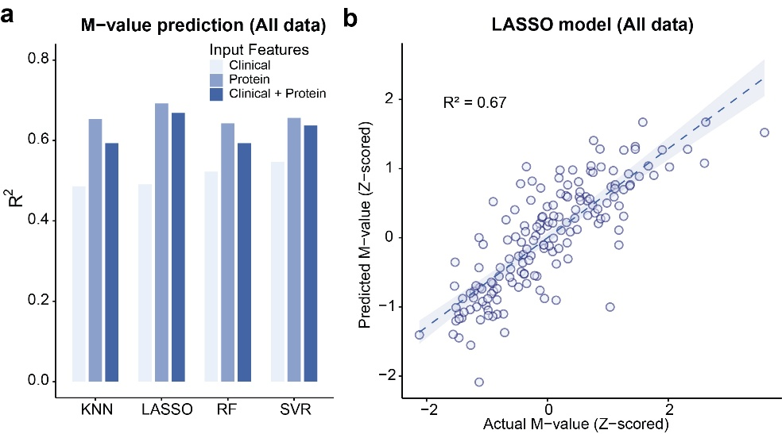
Supplementary Fig 4. Population-level prediction of insulin sensitivity and associated disease risk a) Performance of insulin sensitivity (M-value) prediction using four machine learning models: k-nearest neighbors (kNN), LASSO regression, random forest (RF), and support vector regression (SVR). Models were trained on all data with 5-fold cross-validation and forward feature selection (up to 20 protein features), using either protein features, clinical features, or a combination of both. Average performance (R²) across folds is displayed. b) Predicted vs actual M-value (z-scored) prediction for the LASSO model using both protein and clinical features.

