Decoding Anti-obesity Mechanisms of Adzuki Bean Saponin and Soyasaponin Ba: An Integrated Multi-Omics Approach and Experimental Validation

Jinhai Luo ^{a, b, 1}, Jincan Luo ^{c, 1}, Yingzi WU ^{a, b, 1}, Baoning Liu ^{d}, Nannan Wang ^{d}, Bincheng Han ª, Baojun Xu ^{a, *}

ª Food Science and Technology Program, Department of Life Sciences, Beijing Normal-Hong Kong Baptist University, Zhuhai, Guangdong 519087, China.
^{b} School of Chinese Medicine, Hong Kong Baptist University, Hong Kong, China.
^{c} School of Engineering, Guangzhou College of Technology and Business, Guangzhou 510850, China.
^{d} Guangzhou National Laboratory, International Bio-Island, Guangzhou 510005, China.
¹ Three authors have equal contribution to this paper.

*Corresponding Author at
Prof. Baojun Xu, Food Science and Technology Program, Beijing Normal-Hong Kong Baptist University.
Postal address: 2000, Jintong Road, Tangjiawan, Zhuhai, Guangdong 519087, China
Email: baojunxu@uic.edu.cn: Phone: +86-756-3620636.

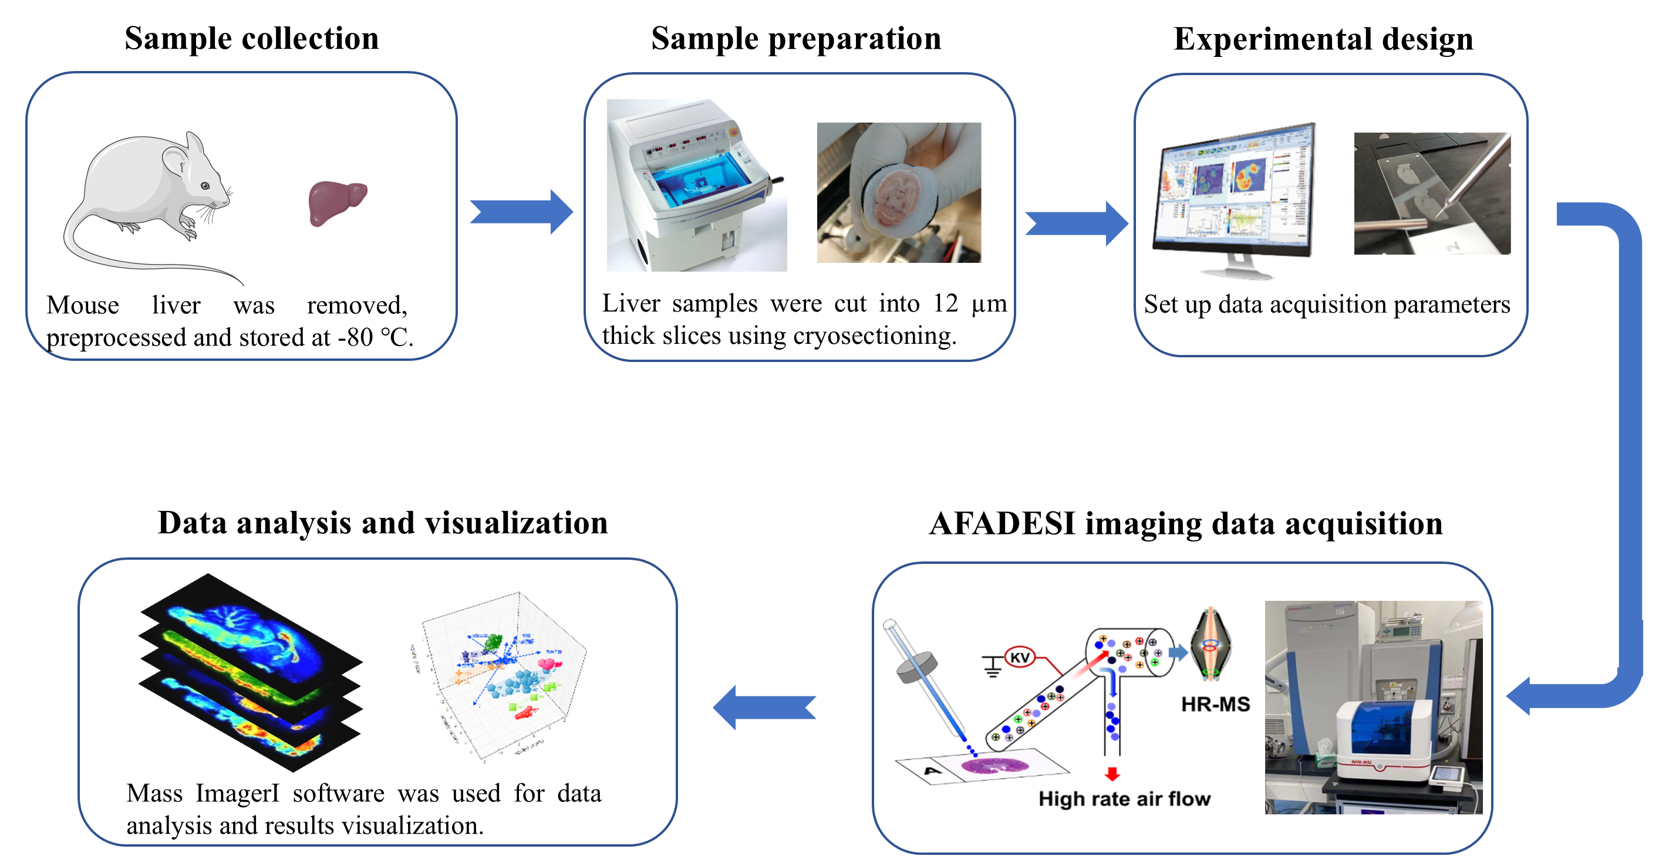
Supplementary figure 1. Flow chart of mass spectrometry imaging analysis in Spatial metabolomics.

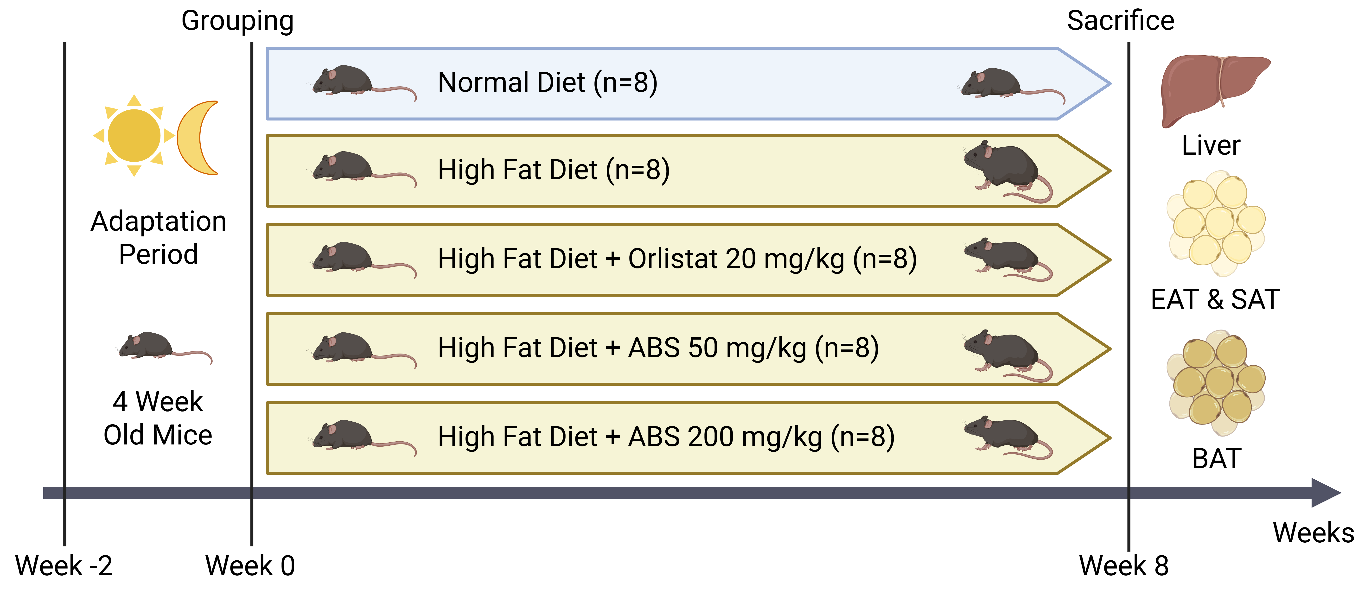
Supplementary figure 2. The experiment design of the animal study.

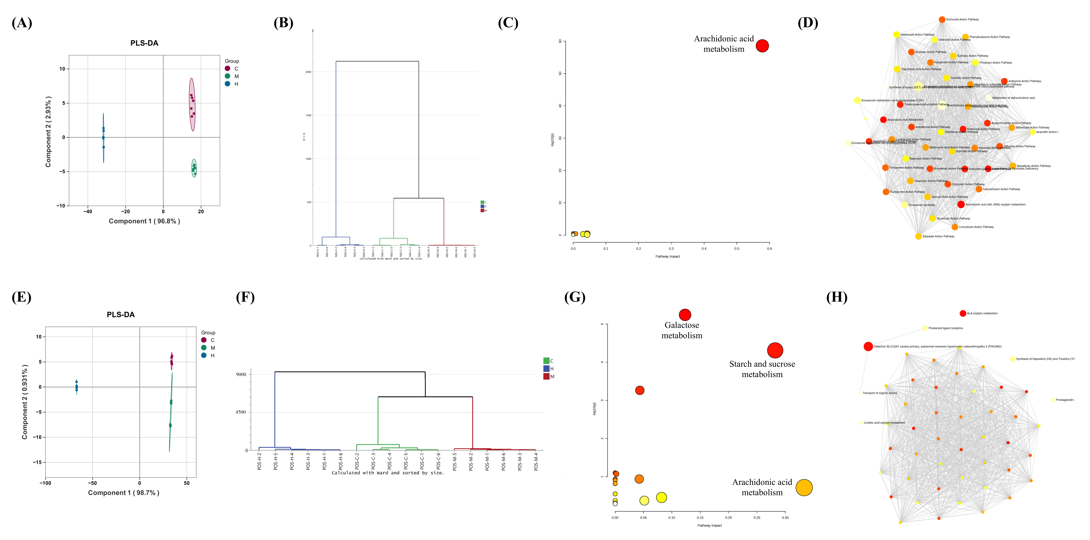
Supplementary figure 3. Data analysis of mass spectrometry imaging of mouse livers in negative (A-D) and positive (E-H) mode. (A) PLS-DA plot of the differential metabolites in negative mode. (B) Hierarchical Clustering analysis of negative mode. (C) Pathway analysis view of all differential metabolites in negative mode. (D) Network view of enrichment analysis of all differential metabolites in negative mode. (E) PLS-DA plot of the differential metabolites in positive mode. (F) Hierarchical Clustering analysis of positive mode. (G) Pathway analysis view of all differential metabolites in positive mode. (H) Network view of enrichment analysis of all differential metabolites in positive mode.

Supplementary figure 4. Ion images of differential metabolites in liver. (A) Ion images and boxplots of representative differential metabolites in arachidonic acid oxylipin metabolism in mouse livers in negative mode. (B) Ion images and boxplots of representative differential metabolites in arachidonic acid oxylipin metabolism in mouse livers in positive mode. In boxplots, * indicates a p-value less than 0.05, ** indicates a p-value less than 0.01, and *** indicates a p-value less than 0.001, and so on.

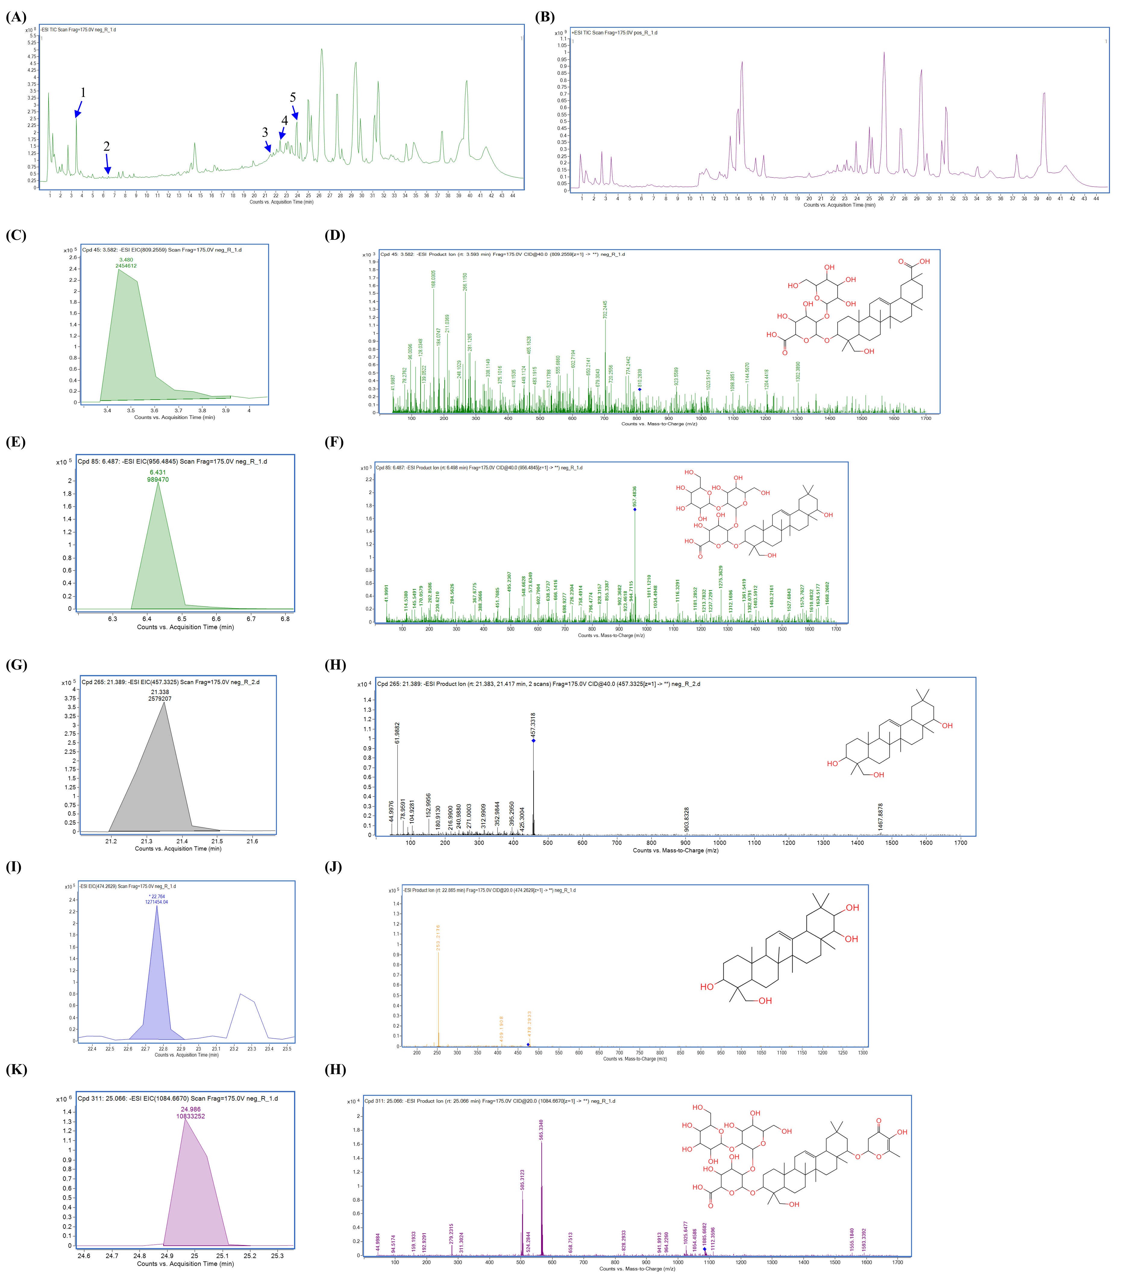
Supplementary figure 5. The serum analysis by the UHPLC-QTOF-MS/MS. (A) Total ion current chromatogram in negative mode. (B) Total ion current chromatogram in positive mode. (C) Extracted ion chromatogram of Azukisaponin III. (D) MS/MS spectrum and chemical structure of Azukisaponin III. (E) Extracted ion chromatogram of Soyasaponin Ba. (F) MS/MS spectrum and chemical structure of Soyasaponin Ba.
(G) Extracted ion chromatogram of Soyasapogenol B. (H) MS/MS spectrum and chemical structure of Soyasapogenol B. (I) Extracted ion chromatogram of Soyasapogenol A. (J) MS/MS spectrum and chemical structure of Soyasapogenol A. (K) Extracted ion chromatogram of AZ IV. (H) MS/MS spectrum and chemical structure of AZ IV.

Supplementary table 1. Sources of materials and reagents.
Material/reagent name | Supplier | Address
Hematoxylin-Eosin (HE) Stain Kit | Beijing Solarbio Science & Technology Co., Ltd. | Beijing, China
Bovine Serum Albumin V | Beijing Solarbio Science & Technology Co., Ltd. | Beijing, China
DAB Horseradish Peroxidase Color Development Kit | Beyond Biotech Inc. | Shanghai, China
Citrate Antigen Retrieval Solution | Shanghai Yuanye Bio-Technology Co., Ltd. | Shanghai, China
EDTA Antigen Retrieval Solution | Shanghai Yuanye Bio-Technology Co., Ltd. | Shanghai, China
High-glucose Dulbecco’s Modified Eagle Medium | Procell Life Science & Technology Co., Ltd. | Wuhan, China
Penicillin–streptomycin Solution | Procell Life Science & Technology Co., Ltd. | Wuhan, China
3T3-L1 Cell | Procell Life Science & Technology Co., Ltd. | Wuhan, China
Adipogenesis Assay | Sigma-Aldrich | St. Louis, MO, U.S.A.
Phosphate-buffered Solution | Beijing Solarbio Science & Technology Co., Ltd. | Beijing, China
Dimethyl Sulfoxide | Beijing Solarbio Science & Technology Co., Ltd. | Beijing, China
Oil Red O staining storage solution | Beijing Solarbio Science & Technology Co., Ltd. | Beijing, China
Fetal bovine serum | Shanghai XP Biomed Ltd. | Shanghai, China
Cell Counting Kit-8 (CCK-8) Reagent Kit | Beyond Biotech Inc. | Shanghai, China
Blocking Reagent | Beyond Biotech Inc. | Shanghai, China
SignalUpTM 1st and QuickBlockTM 2nd antibody dilution reagent for Immunofluorescence Assay | Beyond Biotech Inc. | Shanghai, China
Hochest 33342 | Beyond Biotech Inc. | Shanghai, China
Carboxy-H₂DCFDA | Beyond Biotech Inc. | Shanghai, China
RIPA lysis buffer | Wuhan Servicebio Technology Co., Ltd. | Wuhan, China
Phenylmethanesulfonyl Fluoride | Wuhan Servicebio Technology Co., Ltd. | Wuhan, China
10X TBST solution | Wuhan Servicebio Technology Co., Ltd. | Wuhan, China
Epigallocatechin gallate (EGCG) | Shanghai Yuanye Bio-Technology Co., Ltd. | Shanghai, China
AB-8 resin column | Shanghai Yuanye Bio-Technology Co., Ltd. | Shanghai, China
BCA Protein Quantification Kit | Yeasen Biotechnology Co., Ltd. | Shanghai, China
Primary antibodies (Wnt10b, β-catenin, C/EBPα, PPARγ) | Affinity Biosciences | Cincinnati, OH, U.S.A.
2nd Antibody, Immunofluorescent Sntibody, Fluorescein (FITC)-conjugated Affinipure Goat Anti-Rabbit IgG(H+L) | Proteintech | Wuhan, China
4% Paraformaldehyde | Biosharp | Beijing, China

Supplementary table 2. Information of the databases included in the research.
GSE ID | Platform | Paticipant | Tissue
GSE162653 | GPL11154 | 10 non-obese and 10 obese adults | White adipose tissue
GSE88837 | GPL570 | 15 lean and 15 obese adolescents | Visceral adipose tissue
GSE164760 | GPL13667 | 6 healthy people and 74 NASH people | Liver tissue

