Tables
Supplement table 1. Data points included in ML analysis.
Cognitive test | Author, sample injury severity | Score | BL, months | Last FU, months | BL vs. last FU, months | Reported PROGRESS-Plus characteristics of study samples | Cognitive Domain
 |  |  |  |  |  |  | Learn / Mem | Lang | Percep Motor | Comp Attent | Exec Func | Info Proc Speed/ RT | Soc Cog
AMIPB | Powell et al. (1996), mild | Raw | 0 | 3 | 3 | P, O, G, S, Age SD, + | Y |  |  |  | Y
ANAM CDS | Sours et al. (2015), mild | Raw | 0.3 | 1.2 | 0.9 | P, G, E, Age SD |  |  | Y
ANAM CPT | Bleiberg et al. (2004), mild | Raw | 0 | 0.4 | 0.4 | P, O, G, Age SD |  |  | Y | Y | Y | Y
ANAM CS | Sours et al. (2015), mild | Raw | 0.3 | 1.2 | 0.9 | P, G, E, Age SD |  |  | Y
ANAM MSP | Bleiberg et al. (2004), mild | Raw | 0 | 0.4 | 0.4 | P, O, G, Age SD |  |  | Y | Y | Y | Y
ANAM MTH | Sours et al. (2015), mild | Raw | 0.3 | 1.2 | 0.9 | P, G, E, Age SD |  |  |  |  | Y
ANAM MTH | Bleiberg et al. (2004), mild | Raw | 0 | 0.4 | 0.4 | P, O, G, Age SD |  |  |  |  | Y
ANAM MTS | Sours et al. (2015), mild | Raw | 0.3 | 1.2 | 0.9 | P, G, E, Age SD |  |  | Y
ANAM PRT | Sours et al. (2015), mild | Raw | 0.3 | 1.2 | 0.9 | P, G, E, Age SD |  |  | Y
ANAM SPD | Bleiberg et al. (2004), mild | Raw | 0 | 0.4 | 0.4 | P, O, G, Age SD |  |  | Y | Y | Y | Y
ANAM SRT | Bleiberg et al. (2004), mild | Raw | 0 | 0.4 | 0.4 | P, O, G, Age SD |  |  |  |  |  | Y
ANAM SRT | Sours et al. (2015), mild | Raw | 0.3 | 1.2 | 0.9 | P, G, E, Age SD |  |  |  |  |  | Y
ANAM SRT2 | Sours et al. (2015), mild | Raw | 0.3 | 1.2 | 0.9 | P, G, E, Age SD |  |  |  |  |  | Y
ANAM STN | Bleiberg et al. (2004), mild | Raw | 0 | 0.4 | 0.4 | P, O, G, Age SD |  |  | Y | Y | Y | Y
ANAM WT | Sours et al. (2015), mild | Raw | 0.3 | 1.2 | 0.9 | P, G, E, Age SD |  |  | Y
BVRT | Kwok et al. (2008), mild | Raw | 0 | 3 | 3 | P, G, E, Age SD | Y | Y |  | Y | Y
CANTAB PA | Stenberg et al. (2020), mild | Raw | 0.6 | 3.2 | 2.6 | P, G, E, Age SD, + |  |  | Y
CANTAB RT | Stenberg et al. (2020), mild | Raw | 0.6 | 3.2 | 2.6 | P, G, E, Age SD, + |  |  | Y
CANTAB RVP | Stenberg et al. (2020), mild | Raw | 0.6 | 3.2 | 2.6 | P, G, E, Age SD, + |  |  | Y
CANTAB SC | Stenberg et al. (2020), mild | Raw | 0.6 | 3.2 | 2.6 | P, G, E, Age SD, + |  |  | Y
CANTAB SWM | Stenberg et al. (2020), mild | Raw | 0.6 | 3.2 | 2.6 | P, G, E, Age SD, + |  |  | Y
CASI | Chen et al. (2013), mild | Raw | 0 | 2.8 | 2.8 | P, G, Age SD |  |  | Y | Y | Y | Y
CFFT | Lee et al. (2005), mod | Raw | 1 | 1.9 | 0.9 | P, G, E, Age SD |  |  | Y |  | Y
CNS-VS | Barker-Collo et al. (2019), mild | Raw | 0.2 | 48.7 | 48.5 | P, R, G, Age SD, + |  |  | Y | Y | Y | Y
CNS-VS CA | Barker-Collo et al. (2019), mild | Raw | 0.2 | 48.7 | 48.5 | P, R, G, Age SD, + | Y | Y |  |  | Y |  | Y
CNS-VS CM | Barker-Collo et al. (2019), mild | Raw | 0.2 | 48.7 | 48.5 | P, R, G, Age SD, + | Y | Y |  |  | Y |  | Y
CNS-VS EF | Barker-Collo et al. (2019), mild | Raw | 0.2 | 48.7 | 48.5 | P, R, G, Age SD, + |  |  | Y | Y | Y | Y
CNS-VS NI | Barker-Collo et al. (2019), mild | Raw | 0.2 | 48.7 | 48.5 | P, R, G, Age SD, + |  |  | Y | Y | Y | Y
CNS-VS ProS | Barker-Collo et al. (2019), mild | Raw | 0.2 | 48.7 | 48.5 | P, R, G, Age SD, + | Y | Y |  |  | Y |  | Y
CNS-VS PsyS | Barker-Collo et al. (2019), mild | Raw | 0.2 | 48.7 | 48.5 | P, R, G, Age SD, + |  |  | Y | Y | Y | Y
CNS-VS RT | Barker-Collo et al. (2019), mild | Raw | 0.2 | 48.7 | 48.5 | P, R, G, Age SD, + | Y | Y |  |  | Y |  | Y
CNS-VS VerM | Barker-Collo et al. (2019), mild | Raw | 0.2 | 48.7 | 48.5 | P, R, G, Age SD, + | Y | Y |  |  | Y |  | Y
CNS-VS VisM | Barker-Collo et al. (2019), mild | Raw | 0.2 | 48.7 | 48.5 | P, R, G, Age SD, + | Y | Y |  |  | Y |  | Y
COWAT | Kersel et al. (2001), sev | Raw | 6.7 | 12.9 | 6.2 | P, G, Age SD, + | Y | Y |  | Y | Y
COWAT | Schmitter-Edgecombe et al. (2015), mod-sev | Raw | 1.4 | 10.2 | 8.8 | P, G, E, Age SD | Y | Y |  | Y | Y
COWAT | Robertson et al. (2015), mod-sev | Raw | 1.5 | 9.3 | 7.8 | P, G, E, Age SD | Y | Y |  | Y | Y
COWAT | Farbota et al. (2012), mod-sev | Raw | 2.1 | 50.2 | 48.1 | P, G, E, Age SD | Y | Y |  | Y | Y
COWAT FAS | Snow et al. (1998), sev | Raw | 4.5 | 32.8 | 28.3 | P, O, G, E, Age SD | Y |  |  | Y
CRT MRT | Lee et al. (2005), mod | Raw | 1 | 1.9 | 0.9 | P, G, E, Age SD | Y |  |  | Y | Y
CRT RRT | Lee et al. (2005), mod | Raw | 1 | 1.9 | 0.9 | P, G, E, Age SD | Y |  |  | Y | Y
CRT TRT | Lee et al. (2005), mod | Raw | 1 | 1.9 | 0.9 | P, G, E, Age SD | Y |  |  | Y | Y
CTT | Lee et al. (2005), mod | Raw | 1 | 1.9 | 0.9 | P, G, E, Age SD | Y |  |  | Y | Y
CTT P | Lee et al. (2005), mod | Raw | 1 | 1.9 | 0.9 | P, G, E, Age SD | Y |  |  | Y | Y
CVLT A1 | Vanderplog et al. (2014), mod-sev | Raw | 1.1 | 12.2 | 11.1 | P, R, G, E, + | Y |  | Y
CVLT A5 | Vanderplog et al. (2014), mod-sev | Raw | 1.1 | 12.2 | 11.1 | P, R, G, E, + | Y |  | Y
CVLT B | Vanderplog et al. (2014), mod-sev | Raw | 1.1 | 12.2 | 11.1 | P, R, G, E, + | Y |  | Y
CVLT E | Vanderplog et al. (2014), mod-sev | Raw | 1.1 | 12.2 | 11.1 | P, R, G, E, Age SD, + |  | Y
CVLT HFalsePos | Vanderplog et al. (2014), mod-sev | Raw | 1.1 | 12.2 | 11.1 | P, R, G, E, Age SD, + |  | Y
CVLT LDCR | Vanderplog et al. (2014), mod-sev | Raw | 1.1 | 12.2 | 11.1 | P, R, G, E, + | Y |  | Y
CVLT LDFR | Vanderplog et al. (2014), mod-sev | Raw | 1.1 | 12.2 | 11.1 | P, R, G, E, + | Y |  | Y
CVLT LS | Vanderplog et al. (2014), mod-sev | Raw | 1.1 | 12.2 | 11.1 | P, R, G, E, Age SD, + |  | Y
CVLT SDCR | Vanderplog et al. (2014), mod-sev | Raw | 1.1 | 12.2 | 11.1 | P, R, G, E, + | Y |  | Y
CVLT SDFR | Vanderplog et al. (2014), mod-sev | Raw | 1.1 | 12.2 | 11.1 | P, R, G, E, Age SD, + |  | Y
DSPAN | Farbota et al. (2012), mod-sev | Raw | 2.1 | 50.2 | 48.1 | P, G, E, Age SD |  |  | Y | Y |  | Y
DSST | Lee et al. (2005), mod | Raw | 1 | 1.9 | 0.9 | P, G, E, Age SD | Y |  |  | Y | Y
DVT | Kwok et al. (2008), mild | Raw | 0 | 3 | 3 | P, G, E, Age SD | Y | Y |  | Y | Y
FIM-Cog | Sandhaug et al. (2015), mod-sev* | Raw | 3 | 24.4 | 21.3 | P, G, E, S, Age SD, + | Y | Y |  |  | Y
FIM-Cog | Lu et al. (2018), mod-sev | Raw | 3 | 60.9 | 57.8 | P, G, Age SD, + | Y | Y |  |  | Y
FIM-Cog | Malec et al. (2019), mod-sev | Raw | 0.9 | 121.8 | 120.9 | P, R, O, G, E, S, Age SD | Y | Y |  |  | Y
FIM-Cog C | Wang et al. (2013), mod-sev | Raw | 71.3 | 77.4 | 6.1 | P, G, Age SD, + |  | Y
FIM-Cog SC | Wang et al. (2013), mod-sev | Raw | 71.3 | 77.4 | 6.1 | P, G, Age SD, + |  | Y
FTT D | Dikmen et al. (2017), mild* | Raw | 1 | 12.2 | 11.2 | P, G, E, Age SD |  |  | Y |  |  | Y
FTT D | Dikmen et al. (2017), mild* | Raw | 1 | 12.2 | 11.2 | P, G, E, Age SD |  |  | Y |  |  | Y
FTT D | Dikmen et al. (2017), mild* | Raw | 1 | 12.2 | 11.2 | P, G, E, Age SD |  |  | Y |  |  | Y
FTT D | Farbota et al. (2012), mod-sev | Raw | 2.1 | 50.2 | 48.1 | P, G, E, Age SD |  |  | Y |  |  | Y
FTT ND | Dikmen et al. (2017), mild* | Raw | 1 | 12.2 | 11.2 | P, G, E, Age SD |  |  | Y |  |  | Y
FTT ND | Dikmen et al. (2017), mild* | Raw | 1 | 12.2 | 11.2 | P, G, E, Age SD |  |  | Y |  |  | Y
FTT ND | Dikmen et al. (2017), mild* | Raw | 1 | 12.2 | 11.2 | P, G, E, Age SD |  |  | Y |  |  | Y
FTT ND | Farbota et al. (2012), mod-sev | Raw | 2.1 | 50.2 | 48.1 | P, G, E, Age SD |  |  | Y |  |  | Y
GPT A | Zaninotto et al. (2017), mod-sev | Raw | 6.1 | 12.2 | 6.1 | P, G, E, Age SD, + |  | Y
GPT B | Zaninotto et al. (2017), mod-sev | Raw | 6.1 | 12.2 | 6.1 | P, G, E, Age SD, + | Y
HRNB SRT | Dikmen et al. (2017), mild* | Raw | 1 | 12.2 | 11.2 | P, G, E, Age SD |  |  |  | Y | Y
HRNB SRT | Dikmen et al. (2017), mild* | Raw | 1 | 12.2 | 11.2 | P, G, E, Age SD |  |  |  | Y | Y
HRNB SRT | Dikmen et al. (2017), mild* | Raw | 1 | 12.2 | 11.2 | P, G, E, Age SD |  |  |  | Y | Y
HT | Hicks et al. (2022), mod-sev | Raw | 129.2 | 290.9 | 161.7 | P, G, E, Age SD |  |  | Y | Y |  | Y
HVLT D | Field et al. (2003), mild | Raw | 0 | 0.2 | 0.2 | P, O, Age SD, + |  |  | Y | Y |  | Y
HVLT T | Field et al. (2003), mild | Raw | 0 | 0.2 | 0.2 | P, O, Age SD, + |  |  | Y | Y |  | Y
ImPACT CE | Wylie et al. (2015), mild | Raw | 0.1 | 0.3 | 0.2 | P, G, E, + | Y |  | Y | Y | Y | Y
ImPACT IC | Wylie et al. (2015), mild | Raw | 0.1 | 0.3 | 0.2 | P, G, E, + | Y |  |  | Y |  | Y
ImPACT PS | Covassin et al. (2008), mild* | Raw | 0 | 0.2 | 0.1 | P, O, G, Age SD, + | Y |  | Y | Y |  | Y
ImPACT PS | Covassin et al. (2008), mild* | Raw | 0 | 0.2 | 0.1 | P, O, G, Age SD, + | Y |  | Y | Y |  | Y
ImPACT RT | Wylie et al. (2015), mild | Raw | 0.1 | 0.2 | 0.2 | P, G, E, + |  |  |  |  | Y | Y
ImPACT RT | Covassin et al. (2008), mild* | Raw | 0 | 0.2 | 0.1 | P, O, G, Age SD, + |  |  |  |  | Y | Y
ImPACT RT | Covassin et al. (2008), mild* | Raw | 0 | 0.2 | 0.1 | P, O, G, Age SD, + |  |  |  |  | Y | Y
ImPACT VerbM | Wylie et al. (2015), mild | Raw | 0.1 | 0.3 | 0.2 | P, G, E, + | Y |  |  |  | Y | Y
ImPACT VerbM | Covassin et al. (2008), mild* | Raw | 0 | 0.2 | 0.1 | P, O, G, Age SD, + | Y |  |  |  | Y | Y
ImPACT VerbM | Covassin et al. (2008), mild* | Raw | 0 | 0.2 | 0.1 | P, O, G, Age SD, + | Y |  |  |  | Y | Y
ImPACT VisM | Wylie et al. (2015), mild | Raw | 0.1 | 0.3 | 0.2 | P, G, E, + | Y |  | Y |  | Y | Y
ImPACT VisM | Covassin et al. (2008), mild* | Raw | 0 | 0.2 | 0.1 | P, O, G, Age SD, + | Y |  | Y |  | Y | Y
ImPACT VisM | Covassin et al. (2008), mild* | Raw | 0 | 0.2 | 0.1 | P, O, G, Age SD, + | Y |  | Y |  | Y | Y
ImPACT VisMS | Wylie et al. (2015), mild | Raw | 0.1 | 0.3 | 0.2 | P, G, E, + | Y |  | Y |  |  | Y
MAT | Lee et al. (2005), mod | Raw | 1 | 1.9 | 0.9 | P, G, E, Age SD | Y |  | Y |  | Y
MImPACT P | Kontos et al. (2015), mild* | Raw | 0.1 | 0.5 | 0.3 | P, O, G, Age SD, + |  |  |  |  |  | Y
MImPACT P | Kontos et al. (2015), mild* | Raw | 0.1 | 0.5 | 0.3 | P, O, G, Age SD, + |  |  |  |  |  | Y
MImPACT RT | Kontos et al. (2015), mild* | Raw | 0.1 | 0.5 | 0.3 | P, O, G, Age SD, + |  |  |  |  |  | Y
MImPACT RT | Kontos et al. (2015), mild* | Raw | 0.1 | 0.5 | 0.3 | P, O, G, Age SD, + |  |  |  |  |  | Y
MImPACT VisM | Kontos et al. (2015), mild* | Raw | 0.1 | 0.5 | 0.3 | P, O, G, Age SD, + | Y |  | Y |  | Y | Y
MImPACT VisM | Kontos et al. (2015), mild* | Raw | 0.1 | 0.5 | 0.3 | P, O, G, Age SD, + | Y |  | Y |  | Y | Y
MImPACT VM | Kontos et al. (2015), mild* | Raw | 0.1 | 0.5 | 0.3 | P, O, G, Age SD, + |  |  |  |  |  | Y
MImPACT VM | Kontos et al. (2015), mild* | Raw | 0.1 | 0.5 | 0.3 | P, O, G, Age SD, + |  |  |  |  |  | Y
MMSE | Lee et al. (2005), mod | Raw | 1 | 1.9 | 0.9 | P, G, E, Age SD | Y |  | Y |  | Y
MMSE | Chen et al. (2013), mild | Raw | 0 | 2.8 | 2.8 | P, G, Age SD | Y |  | Y |  | Y
PASAT Task 3 | Macciocchi et al. (2001), mild* | Raw | 0 | 0.3 | 0.3 | P, O, E, Age SD, + | Y |  |  | Y |  | Y
PASAT Task 3 | Macciocchi et al. (2001), mild* | Raw | 0 | 0.3 | 0.3 | P, O, E, Age SD, + | Y |  |  | Y |  | Y
PASAT Task 4 | Macciocchi et al. (2001), mild* | Raw | 0 | 0.3 | 0.3 | P, O, E, Age SD, + | Y |  |  | Y |  | Y
PASAT Task 4 | Macciocchi et al. (2001), mild* | Raw | 0 | 0.3 | 0.3 | P, O, E, Age SD, + | Y |  |  | Y |  | Y
RAVLT | Hicks et al. (2022), mod-sev | Raw | 129.2 | 290.9 | 161.7 | P, G, E, Age SD |  |  | Y | Y |  | Y
RAVLT | Stenberg et al. (2020) , mild | Raw | 0.6 | 3.2 | 2.6 | P, G, E, Age SD, + |  |  | Y
RAVLT DR | Kersel et al. (2001), sev | Raw | 6.7 | 12.9 | 6.2 | P, G, Age SD, + | Y
RAVLT DR | Stenberg et al. (2020) , mild | Raw | 0.6 | 3.2 | 2.6 | P, G, E, Age SD, + | Y
RAVLT DR | Schmitter-Edgecombe et al. (2015), mod-sev | Raw | 1.4 | 10.2 | 8.8 | P, G, E, Age SD | Y
RAVLT DR | Robertson et al. (2015), mod-sev | Raw | 1.5 | 9.3 | 7.8 | P, G, E, Age SD | Y
RAVLT DR (Chinese) | Kwok et al. (2008), mild | Raw | 0 | 3 | 3 | P, G, E, Age SD | Y
RAVLT IR | Kersel et al. (2001), sev | Raw | 6.7 | 12.9 | 6.2 | P, G, Age SD, + | Y
RAVLT IR (Chinese) | Kwok et al. (2008), mild | Raw | 0 | 3 | 3 | P, G, E, Age SD | Y
RAVLT L | Schmitter-Edgecombe et al. (2015), mod-sev | Raw | 1.4 | 10.2 | 8.8 | P, G, E, Age SD | Y
RAVLT L | Robertson et al. (2015), mod-sev | Raw | 1.5 | 9.3 | 7.8 | P, G, E, Age SD | Y
RAVLT Rec | Kersel et al. (2001), sev | Raw | 6.7 | 12.9 | 6.2 | P, G, Age SD, + | Y
RAVLT Rec (Chinese) | Kwok et al. (2008), mild | Raw | 0 | 3 | 3 | P, G, E, , | Y
RAVLT Ret | Kersel et al. (2001), sev | Raw | 6.7 | 12.9 | 6.2 | P, G, Age SD, + |  |  |  |  | Y
RAVLT TL | Kersel et al. (2001), sev | Raw | 6.7 | 12.9 | 6.2 | P, G, Age SD, + | Y
RAVLT TR | Snow et al. (1998), sev | Raw | 4.5 | 32.8 | 28.3 | P, O, G, E, Age SD | Y
RAVLT TR (Chinese) | Kwok et al. (2008), mild | Raw | 0 | 3 | 3 | P, G, E, , | Y
RFFT | Kwok et al. (2008), mild | Raw | 0 | 3 | 3 | P, G, E, Age SD | Y |  |  | Y | Y
ROCF C | Zaninotto et al. (2017), mod-sev | Raw | 6.1 | 12.2 | 6.1 | P, G, E, Age SD, + | Y
ROCF R | Zaninotto et al. (2017), mod-sev | Raw | 6.1 | 12.2 | 6.1 | P, G, E, Age SD, + | Y
ROCF SC | Zaninotto et al. (2017), mod-sev | Raw | 6.1 | 12.2 | 6.1 | P, G, E, Age SD, + | Y
ROCF SR | Zaninotto et al. (2017), mod-sev | Raw | 6.1 | 12.2 | 6.1 | P, G, E, Age SD, + | Y
SAC | McCrea et al. (2005), mild | Raw | 0 | 0.2 | 0.2 | P, O, E, Age SD, + | Y
SDMT O | Kwok et al. (2008), mild | Raw | 0 | 3 | 3 | P, G, E, , |  |  |  | Y |  | Y
SDMT O | Schmitter-Edgecombe et al. (2015), mod-sev | Raw | 1.4 | 10.2 | 8.8 | P, G, E, Age SD |  |  |  | Y |  | Y
SDMT O | Robertson et al. (2015), mod-sev | Raw | 1.5 | 9.3 | 7.8 | P, G, E, Age SD |  |  |  | Y |  | Y
SDMT W | Kwok et al. (2008), mild | Raw | 0 | 3 | 3 | P, G, E, , |  |  |  | Y |  | Y
SDMT W | Schmitter-Edgecombe et al. (2015), mod-sev | Raw | 1.4 | 10.2 | 8.8 | P, G, E, Age SD |  |  |  | Y |  | Y
SDMT W | Robertson et al. (2015), mod-sev | Raw | 1.5 | 9.3 | 7.8 | P, G, E, Age SD |  |  |  | Y |  | Y
SMST | Lee et al. (2005), mod | Raw | 1 | 1.9 | 0.9 | P, G, E, Age SD | Y |  | Y |  | Y
SOMCT | Powell et al. (1996), mild | Raw | 0 | 3 | 3 | P, O, G, S, Age SD, + | Y |  |  |  | Y
SRT SRCL | Dikmen et al. (2017), mild* | Raw | 1 | 12.2 | 11.2 | P, G, E, Age SD | Y
SRT SRCL | Dikmen et al. (2017), mild* | Raw | 1 | 12.2 | 11.2 | P, G, E, Age SD | Y
SRT SRCL | Dikmen et al. (2017), mild* | Raw | 1 | 12.2 | 11.2 | P, G, E, Age SD | Y
TAPI DSp4 E | Pare et al. (2009), mild | Raw | 0.1 | 3.1 | 3 | P, G, E, Age SD | Y |  |  |  | Y
TAPI DSp5 E | Pare et al. (2009), mild | Raw | 0.1 | 3.1 | 3 | P, G, E, Age SD | Y |  |  |  | Y
TAPI E1 | Pare et al. (2009), mild | Raw | 0.1 | 3.1 | 3 | P, G, E, Age SD | Y |  |  |  | Y
TAPI E2 | Pare et al. (2009), mild | Raw | 0.1 | 3.1 | 3 | P, G, E, Age SD | Y |  |  |  | Y
TAPI E3 | Pare et al. (2009), mild | Raw | 0.1 | 3.1 | 3 | P, G, E, Age SD | Y |  |  |  | Y
TAPI RT1 | Pare et al. (2009), mild | Raw | 0.1 | 3.1 | 3 | P, G, E, Age SD | Y |  |  |  | Y
TAPI RT2 | Pare et al. (2009), mild | Raw | 0.1 | 3.1 | 3 | P, G, E, Age SD | Y |  |  |  | Y
TAPI RT3 | Pare et al. (2009), mild | Raw | 0.1 | 3.1 | 3 | P, G, E, Age SD | Y |  |  |  | Y
TMT A | Macciocchi et al. (2001), mild* | Raw | 0 | 0.3 | 0.3 | P, O, E, Age SD, + |  |  | Y | Y | Y | Y
TMT A | Macciocchi et al. (2001), mild* | Raw | 0 | 0.3 | 0.3 | P, O, E, Age SD, + |  |  | Y | Y | Y | Y
TMT A | Stenberg et al. (2020) , mild | Raw | 0.6 | 3.2 | 2.6 | P, G, E, Age SD, + |  |  | Y | Y | Y | Y
TMT A | Prigatano et al. (1984), sev | Raw | 16.1 | 28.9 | 12.8 | P, O, G, E, Age SD |  |  | Y | Y | Y | Y
TMT A | Dikmen et al. (2017), mild* | Raw | 1 | 12.2 | 11.2 | P, G, E, Age SD |  |  | Y | Y | Y | Y
TMT A | Dikmen et al. (2017), mild* | Raw | 1 | 12.2 | 11.2 | P, G, E, Age SD |  |  | Y | Y | Y | Y
TMT A | Dikmen et al. (2017), mild* | Raw | 1 | 12.2 | 11.2 | P, G, E, Age SD |  |  | Y | Y | Y | Y
TMT A | Schmitter-Edgecombe et al. (2015), mod-sev | Raw | 1.4 | 10.2 | 8.8 | P, G, E, Age SD |  |  | Y | Y | Y | Y
TMT A | Robertson et al. (2015), mod-sev | Raw | 1.5 | 9.3 | 7.8 | P, G, E, Age SD |  |  | Y | Y | Y | Y
TMT A | Farbota et al. (2012), mod-sev | Raw | 2.1 | 50.2 | 48.1 | P, G, E, Age SD |  |  | Y | Y | Y | Y
TMT B | Powell et al. (1996), mild | Raw | 0 | 3 | 3 | P, O, G, S, Age SD, + |  |  | Y | Y | Y | Y
TMT B | Macciocchi et al. (2001), mild* | Raw | 1 | 12.2 | 11.2 | P, O, E, Age SD, + |  |  | Y | Y | Y | Y
TMT B | Macciocchi et al. (2001), mild* | Raw | 1 | 12.2 | 11.2 | P, O, E, Age SD, + |  |  | Y | Y | Y | Y
TMT B | Stenberg et al. (2020) , mild | Raw | 0.6 | 3.2 | 2.6 | P, G, E, Age SD, + |  |  | Y | Y | Y | Y
TMT B | Prigatano et al. (1984), sev | Raw | 16.1 | 28.9 | 12.8 | P, O, G, E, Age SD |  |  | Y | Y | Y | Y
TMT B | Snow et al. (1998), sev | Raw | 4.5 | 32.8 | 28.3 | P, O, G, E, Age SD |  |  | Y | Y | Y | Y
TMT B | Dikmen et al. (2017), mild* | Raw | 1 | 12.2 | 11.2 | P, G, E, Age SD |  |  | Y | Y | Y | Y
TMT B | Dikmen et al. (2017), mild* | Raw | 1 | 12.2 | 11.2 | P, G, E, Age SD |  |  | Y | Y | Y | Y
TMT B | Dikmen et al. (2017), mild* | Raw | 1 | 12.2 | 11.2 | P, G, E, Age SD |  |  | Y | Y | Y | Y
TMT B | Hicks et al. (2022), mod-sev | Raw | 129.2 | 290.9 | 161.7 | P, G, E, Age SD |  |  | Y | Y | Y | Y
TMT B | Schmitter-Edgecombe et al. (2015), mod-sev | Raw | 1.4 | 10.2 | 8.8 | P, G, E, Age SD |  |  | Y | Y | Y | Y
TMT B | Robertson et al. (2015), mod-sev | Raw | 1.5 | 9.3 | 7.8 | P, G, E, Age SD |  |  | Y | Y | Y | Y
TMT B | Farbota et al. (2012), mod-sev | Raw | 2.1 | 50.2 | 48.1 | P, G, E, Age SD |  |  | Y | Y | Y | Y
VFT | Kwok et al. (2008), mild | Raw | 0 | 3 | 3 | P, G, E, Age SD | Y |  |  | Y | Y
WAIS BD | Kersel et al. (2001), sev | Raw | 6.7 | 12.9 | 6.2 | P, G, Age SD, + |  |  | Y |  |  | Y
WAIS DSp | Kersel et al. (2001), sev | Raw | 6.7 | 12.9 | 6.2 | P, G, Age SD, + | Y
WAIS DSp | Kwok et al. (2008), mild | Raw | 0 | 3 | 3 | P, G, E, , | Y
WAIS DSp | Hicks et al. (2022), mod-sev | Raw | 129.2 | 290.9 | 161.7 | P, G, E, Age SD | Y
WAIS DSp B | Zaninotto et al. (2017), mod-sev | Raw | 6.1 | 12.2 | 6.1 | P, G, E, Age SD, + | Y
WAIS DSp B | Powell et al. (1996), mild | Raw | 0 | 3 | 3 | P, O, G, S, Age SD, + | Y
WAIS DSp F | Zaninotto et al. (2017), mod-sev | Raw | 6.1 | 12.2 | 6.1 | P, G, E, Age SD, + | Y
WAIS DSp F | Powell et al. (1996), mild | Raw | 0 | 3 | 3 | P, O, G, S, Age SD, + | Y
WAIS DSym | Macciocchi et al. (2001), mild* | Raw | 0 | 0.3 | 0.3 | P, O, E, Age SD, + | Y |  | Y |  | Y
WAIS DSym | Macciocchi et al. (2001), mild* | Raw | 0 | 0.3 | 0.3 | P, O, E, Age SD, + | Y |  | Y |  | Y
WAIS DSym | Kersel et al. (2001), sev | Raw | 6.7 | 12.9 | 6.2 | P, G, Age SD, + |  |  |  | Y
WAIS DSym | Hicks et al. (2022), mod-sev | Raw | 129.2 | 290.9 | 161.7 | P, G, E, Age SD |  |  |  | Y
WAIS DSym | Dikmen et al. (2017), mild* | Raw | 1 | 12.2 | 11.2 | P, G, E, Age SD |  |  |  | Y
WAIS DSym | Dikmen et al. (2017), mild* | Raw | 1 | 12.2 | 11.2 | P, G, E, Age SD |  |  |  | Y
WAIS DSym | Dikmen et al. (2017), mild* | Raw | 1 | 12.2 | 11.2 | P, G, E, Age SD |  |  |  | Y
WAIS IQ | Zaninotto et al. (2017), mod-sev | Raw | 6.1 | 12.2 | 6.1 | P, G, E, Age SD, + |  | Y | Y | Y | Y | Y
WAIS IQ | Kersel et al. (2001), sev | Raw | 6.7 | 12.9 | 6.2 | P, G, Age SD, + |  | Y | Y | Y | Y | Y
WAIS PIQ | Dikmen et al. (2017), mild* | Raw | 1 | 12.2 | 11.2 | P, G, E, Age SD |  |  | Y | Y | Y
WAIS PIQ | Dikmen et al. (2017), mild* | Raw | 1 | 12.2 | 11.2 | P, G, E, Age SD |  |  | Y | Y | Y
WAIS PIQ | Dikmen et al. (2017), mild* | Raw | 1 | 12.2 | 11.2 | P, G, E, Age SD |  |  | Y | Y | Y
WAIS Sim | Kersel et al. (2001), sev | Raw | 6.7 | 12.9 | 6.2 | P, G, Age SD, + |  |  | Y |  |  | Y
WAIS VIQ | Dikmen et al. (2017), mild* | Raw | 1 | 12.2 | 11.2 | P, G, E, Age SD |  | Y |  | Y | Y
WAIS VIQ | Dikmen et al. (2017), mild* | Raw | 1 | 12.2 | 11.2 | P, G, E, Age SD |  | Y |  | Y | Y
WAIS VIQ | Dikmen et al. (2017), mild* | Raw | 1 | 12.2 | 11.2 | P, G, E, Age SD |  | Y |  | Y | Y
WAIS-III LNS | Schmitter-Edgecombe et al. (2015), mod-sev | Raw | 1.4 | 10.2 | 8.8 | P, G, E, Age SD |  |  |  | Y
WAIS-III LNS | Robertson et al. (2015), mod-sev | Raw | 1.5 | 9.3 | 7.8 | P, G, E, Age SD |  |  | Y | Y
WIS PIQ | Mandleberg et al. (1976), sev* | Raw | 3 | 30.4 | 27.4 | P, G, Age SD | Y |  |  |  | Y
WIS PIQ | Mandleberg et al. (1976), sev* | Raw | 3 | 30.4 | 27.4 | P, G, Age SD | Y |  |  |  | Y
WIS PIQ | Mandleberg et al. (1976), sev* | Raw | 3 | 30.4 | 27.4 | P, G, Age SD | Y |  |  |  | Y
WIS PIQ | Mandleberg et al. (1976), sev* | Raw | 3 | 30.4 | 27.4 | P, G, Age SD | Y |  |  |  | Y
WIS PIQ | Mandleberg et al. (1976), sev* | Raw | 3 | 30.4 | 27.4 | P, G, Age SD | Y |  |  |  | Y
WIS PIQ | Mandleberg et al. (1976), sev* | Raw | 3 | 30.4 | 27.4 | P, G, Age SD | Y |  |  |  | Y
WIS PIQ | Mandleberg et al. (1976), sev* | Raw | 3 | 30.4 | 27.4 | P, G, Age SD | Y |  |  |  | Y
WIS PIQ | Mandleberg et al. (1976), sev* | Raw | 3 | 30.4 | 27.4 | P, G, Age SD | Y |  |  |  | Y
WIS VIQ | Mandleberg et al. (1976), sev* | Raw | 3 | 30.4 | 27.4 | P, G, Age SD |  |  |  |  | Y
WIS VIQ | Mandleberg et al. (1976), sev* | Raw | 3 | 30.4 | 27.4 | P, G, Age SD |  |  |  |  | Y
WIS VIQ | Mandleberg et al. (1976), sev* | Raw | 3 | 30.4 | 27.4 | P, G, Age SD |  |  |  |  | Y
WIS VIQ | Mandleberg et al. (1976), sev* | Raw | 3 | 30.4 | 27.4 | P, G, Age SD |  |  |  |  | Y
WIS VIQ | Mandleberg et al. (1976), sev* | Raw | 3 | 30.4 | 27.4 | P, G, Age SD |  |  |  |  | Y
WIS VIQ | Mandleberg et al. (1976), sev* | Raw | 3 | 30.4 | 27.4 | P, G, Age SD |  |  |  |  | Y
WIS VIQ | Mandleberg et al. (1976), sev* | Raw | 3 | 30.4 | 27.4 | P, G, Age SD |  |  |  |  | Y
WIS VIQ | Mandleberg et al. (1976), sev* | Raw | 3 | 30.4 | 27.4 | P, G, Age SD |  |  |  |  | Y
WMS LM | Prigatano et al. (1984), sev | Raw | 16.1 | 28.9 | 12.8 | P, O, G, E, Age SD | Y |  |  |  | Y
WMS MQ | Prigatano et al. (1984), sev | Raw | 16.1 | 28.9 | 12.8 | P, O, G, E, Age SD | Y |  |  |  | Y
WMS VR | Prigatano et al. (1984), sev | Raw | 16.1 | 28.9 | 12.8 | P, O, G, E, Age SD | Y |  | Y |  | Y
WRAT-III R | Farbota et al. (2012), mod-sev | Raw | 2.1 | 50.2 | 48.1 | P, G, E, Age SD | Y |  |  |  | Y | Y

Supplement table 2. Data library and encoding procedure.
Study and cohort identifiers
Variable name | Type | Description
first_author_year | string | first author and year of study publication
injury_severity | string | author-described injury severity (mild, moderate, moderate-severe, severe)
sample_size | integer | number of participants in the cohort at this time point
Primary predictors
Place of residence (P)
country_of_study | string | country(ies) of recruitment
english_language_dominance | binary | whether country of recruitment is predominantly English speaking
Race, ethnicity, culture, language (R)
race_categories | string | reported race categories
ethnicity_categories | string | reported ethnicity categories
Occupation and work (O)
employment_status_categories | string | employed, unemployed, etc.
work_type_category | string | full time, part time
industry category | string | Healthcare, trades, education, policing
Gender and sex (G)
gender_sex_ratio | float | proportion of men/males (0-1)
Religion and spirituality (R)
religious_affiliation_categories | string | as reported
spirituality_description | string | meaning, purpose
religious_practice_relevance | string | impact on research/care
Education (E)
mean_education_years | float | mean years of education at injury or assessment
sd_education_years | float | standard deviation of mean years of education
Socioeconomic status (S)
income_measure | string | as reported (bracket, proxy)
wealth_assets_description | string | assets, ownership
financial_strain_definition | string | assessment of stain, as reported
insurance_coverage_type | string | public, private, mixed
Social capital (S)
marital_status_categories | string | as reported
number_household_members | integer | number of people in household
Age (Plus)
mean_age_years | float | mean age at injury or assessment
sd_age_years | float | standard deviation of mean age
Outcome
cognitive_test | string | Name of cognitive test
baseline_test_score | float | Cognitive test score at baseline assessment
last_fu_test score | float | Cognitive test score at last follow-up assessment
cognitive_domain_learning_mem | binary | whether cognitive test addresses learning and memory domain of cognition
cognitive_domain_language | binary | whether cognitive test addresses language domain of cognition
cognitive_domain_percep_motor | binary | whether cognitive test addresses perceptual-motor domain of cognition
cognitive_domain_complex_attn | binary | whether cognitive test addresses complex attention domain of cognition
cognitive_domain_exec_func | binary | whether cognitive test addresses executive function domain of cognition
cognitive_domain_process_speed | binary | whether cognitive test addresses information processing speed domain of cognition
cognitive_domain_soc_cog | binary | whether cognitive test addresses social cognition domain of cognition
Time related variables
time_interval | float | time from baseline to last follow-up assessment, days
baseline_time | float | time points of last baseline assessment, days since injury
last_followup_time | float | time points of last follow-up assessment, days since injury
Country-level structural indicators
gender_inequality_index | float | UNDP GII (0–1; higher = more inequality)
human_development_index | float | HDI value (0-1)

Supplement Table 3. Data transformation and processing procedure, by study.
Study author, year | Variable name | Original data format | Transformation method | Transformed format (unit) / SD handling | Justification
Barker-Collo, 2019 | Baseline time | Reposted “within 2 weeks” | Standardized to 7 days; SD estimated via uniform distribution formula | Days (mean=7)/ SD=4.04 estimated from range | Ensures uniformity for timing analysis; accounts for variation in “within 2 weeks”
Chen, 2013 | Baseline time | Assessed within 24 hours post-injury | Standardized as 1 day with zero SD | Days (mean=1)/ SD=0 exact time | Precise timing reduces uncertainty
Farbota, 2012 | Baseline time | Given as mean from range in days | Kept as mean from range in days | Mean as from study/SD calculated from range using formula SD=range/3.464 | Converted reported range into SD for analysis
Bleiberg, 2004 | Baseline time | Given as range in hours | Converted hours to days; calculated mean and SD from range | Days/ calculated SD with time unit conversion | Standardized unit essential for data analysis
Powel, 1996 | Follow-up time | Reported as within 3 months | Used 30.44 days/month average; ±15-days window to estimate mean and SD | Days (mean=91.3)/ SD=8.66 (from±15-days window) | Accounts for calendar month variability and range around follow up
Lu, 2018 | Follow-up time | Follow up within 5 years post injury | Treated as 1826 days; SD assumed uniform ± 6-month window | Days/ SD =105 days | Captures uncertainty in exact follow up timing
Dikmen, 2017 | Baseline and follow up | Baseline=1 month post injury; follow up = 1 year post injury | Used exact days; baseline = 30.4 days±4.04 days; follow up =365.35 days | Days /reported SD used | Precision timing from study
Malec, 2019 | Baseline and follow up time | Rehab LOS baseline; follow-up at 10 years | Transformed LOS and follow up to mean and SD in days | Transformed from reported data | Standardized long-term follow up timing
Zaninotto, 2017 | Baseline time | Scheduled at 6 months post injury | Treated as 182.6 days; ±30 day window assumed for SD | Days/ SD=17.3 | Captures timing uncertainty around 6 months
Lee, 2005 | Follow-up time | Follow up 4 weeks after baseline | Converted 4 weeks to days; adjusted to days ± SD days post injury | Days/ SD | Allows standardization of follow up
Snow, 1998 | Baseline time | Reported as 3-6 months range | Converted range to mean (135 days); SD calculated via range formula | Days / SD =26 days | Enables continuous variable used in models
Vanderploeg, 2014 | Follow up time | 1 year follow-up fixed at 365 days | No transformation needed; follow up anchored to injury date | Days /not applicable | Anchored timing reduced uncertainty
Wang, 2013 | Baseline and follow-up time | Baseline in years; follow-up 6 months after | Converted years to days; follow up days added; SD assumed same as baseline | Days / SD carried over | Maintained consistency
Sandhaug, 2015 | Follow-up time | Follow-up interval converted to days | Follow up added to baseline days; SD carried from baseline | Days /SD carried over | Maintains variance estimates
Wylie, 2015 | Follow-up time | Baseline and follow-up added | Added intervals; combined SD using root sum of squared formula | Days /combined SD estimated | Allows account for variances
Kontos, 2015 | Baseline and follow-up time | Ranges given for baseline and follow-up | Converted to mean and SD using midpoint and SD formulas | Days/ calculated SD | Transforms categorical variables to continuous
Covassin, 2008 and  Macciocchi, 2001 | SD | Missing SD values | Assigned SD=0 where missing | Days or unit relevant for variables/SD=0 | Conservative approach to missing data
Sandhaug, 2015 | Age at follow-up | Attrition-adjusted age SD | Adjusted SD for attrition in participant follow-up | Years / calculated SD=15.3 | Reflects changing sample size
Mandleberg, 1976 | Time conversion | Baseline in months, follow up in months | Conversed months to days using average days/month | Days/ SD carried from baseline assessment | Standardized time units
Powell, 1996 and Field, 2003 | Age SD | Age SD estimated from range | Used formula SD=range/3.464 | Years /estimated SD | Enables age SD estimation when missing
Sandhaug, 2015 and Macciocchi, 2001 | Education | Converted categorical for education in years | Assigned numeric scores (“some college”=14 years), estimated SD | Years/estimated SD (1.5 or calculated where possible) | Enables analysis using continuous numeric value
Kwok, 2008 | Cognitive test scores | Scores in milliseconds | Converted to seconds for uniformity | Seconds/not applicable | Harmonizes test score units
Powell, 1996 and Mandleberg, 1976 | Education and education SD | Missing data | Estimated using Global Data Lab averages by country and year of publication and lowest typical SD value for high and low/middle income countries | Mean years = 10.2 and 9.6, respectively/SD = 2.5 for high income country (UK) | Allow modelling without missing data in case where imputation would not be accurate due to historical evolution of education levels
Chen, 2013 and Wang, 2013 | Education and education SD | Missing data | Estimated using Global Data Lab averages by country and year of publication and lowest typical SD value for high and low/middle income countries | Mean years = 7.1 /SD = 4 for low/middle income country (China) | Allow modelling without missing data in case where imputation would not be accurate due to historical evolution of education levels
Lu, 2018 | Education and education SD | Missing data | Estimated using Global Data Lab averages by country and year of publication and lowest typical SD value for high and low/middle income countries | Mean years = 13 /SD = 2.5 for high income country (Norway) | Allow modelling without missing data in case where imputation would not be accurate due to historical evolution of education levels
Barker-Collo, 2019 and Kersel, 2001 | Education and education SD | Missing data | Estimated using Global Data Lab averages by country and year of publication and lowest typical SD value for high and low/middle income countries | Mean years = 13.04 and 13.1, respectively /SD = 2.5 for high income country (New Zealand) | Allow modelling without missing data in case where imputation would not be accurate due to historical evolution of education levels
Field, 2003; Beliberg, 2004; McCrea, 2005; Covassin, 2008; Kontos, 2015; | Education and education SD | Missing data | Estimated using Global Data Lab averages by country and year of publication and lowest typical SD value for high and low/middle income countries | Mean years = 12.86, 12.83, 12.83, 12.99, 13.25, respectively /SD = 2.5 for high income country (USA) | Allow modelling without missing data in case where imputation would not be accurate due to historical evolution of education levels
Gender inequality index (GII) | Country-level covariate for sensitivity analysis | UN data by year | Used year of publication or earliest available year | Numeric index/not applicable | Enables country-structural adjustment, continuous variable accounts for historical evolution
Human Development Index (HDI) | Country-level covariate for sensitivity analysis | UN data by year | Used year of publication or earliest available year | Numeric index/not applicable | Enables country-structural adjustment, continuous variable accounts for historical evolution

Supplement Table 5. Performance of ML models for predicting rate of change in mild and moderate-severe TBI for two domains of cognition.
Executive function
ML model | MAE |  |  | RMSE |  |  | MAE 5 CV |  | RMSE 5 CV
ML model | Mild | Mod-sev |  | Mild | Mod-sev |  | Mild | Mod-sev | Mild | Mod-sev
Random Forest | 7.06 | 7.30 |  | 11.18 | 15.78 |  | 8.29 +/- 2.85 | 7.79 +/- 2.61 | 14.03 +/- 3.93 | 17.17 +/- 4.08
Gradient boosting | 5.32 | 8.15 |  | 8.53 | 17.83 |  | 8.94 +/- 2.40 | 7.77 +/- 2.48 | 15.02 +/- 2.15 | 17.03 +/- 3.74
XGBoost | 6.69 | 7.31 |  | 11.09 | 16.24 |  | 8.57 +/- 2.41 | 7.95 +/- 2.81 | 14.48 +/- 2.31 | 17.28 +/- 4.13
Learning and Memory
ML model | MAE |  |  | RMSE |  |  | MAE 5 CV |  | RMSE 5 CV
ML model | Mild | Mod-sev |  | Mild | Mod-sev |  | Mild | Mod-sev | Mild | Mod-sev
Random Forest | 14.38 | 5.79 |  | 23.83 | 10.93 |  | 10.92 +/- 0.89 | 7.50 +/- 2.74 | 17.69 +/- 3.88 | 17.20 +/- 5.12
Gradient boosting | 14.61 | 4.65 |  | 24.86 | 10.64 |  | 10.62 +/- 1.29 | 6.93 +/- 3.17 | 17.27 +/- 5.14 | 16.86 +/- 5.37
XGBoost | 14.41 | 6.27 |  | 25.99 | 14.16 |  | 10.82 +/- 2.08 | 7.50 +/- 3.07 | 17.62 +/- 5.96 | 17.53 +/- 5.01
ML model | MAE |  |  | RMSE |  |  | MAE 5 CV |  | RMSE 5 CV
ML model | Mild |  | Mod-sev | Mild |  | Mod-sev | Mild | Mod-sev | Mild | Mod-sev
Random Forest | 6.39 |  | 3.79 | 10.20 |  | 12.69 | 7.17 ± 1.42 | 4.22 ± 2.50 | 14.36 ± 3.17 | 11.78 ± 5.06
Gradient boosting | 6.55 |  | 4.61 | 11.05 |  | 13.41 | 7.27 ± 1.75 | 4.21 ± 2.55 | 14.20 ± 3.72 | 11.94 ± 5.39
XGBoost | 6.06 |  | 4.48 | 10.59 |  | 13.85 | 7.07 ± 1.58 | 4.50 ± 2.56 | 14.11 ± 3.84 | 12.21 ± 5.37
Abbreviations: 5CV = 5-fold cross-validation; MAE = mean absolute error; ML= machine learning; mod-sev = moderate–severe RMSE = root mean squared error; XGBoost = extreme gradient boosting

Figures
- a) d) g)
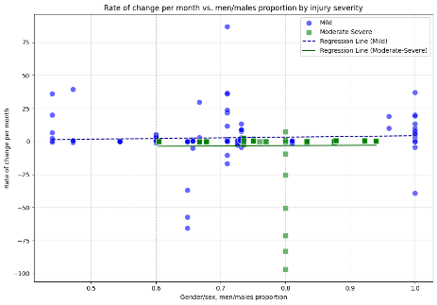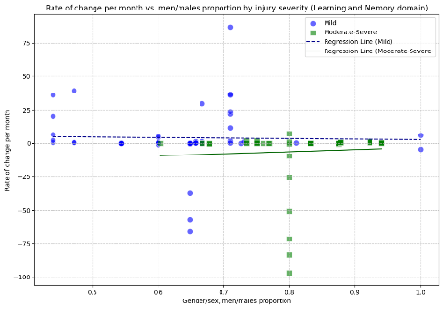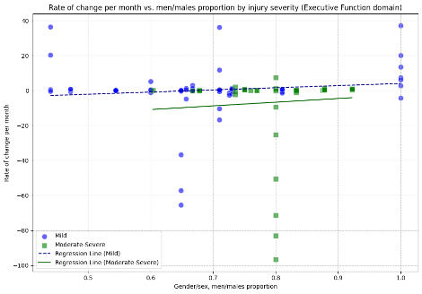
b) e) h)
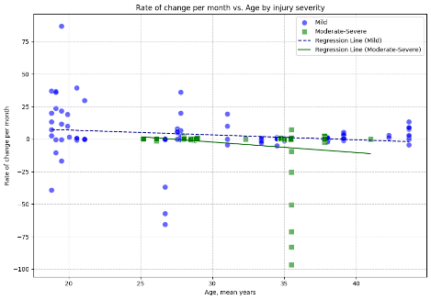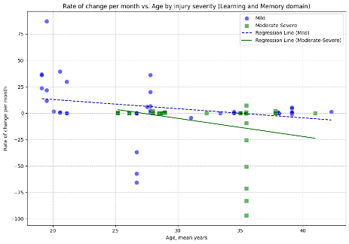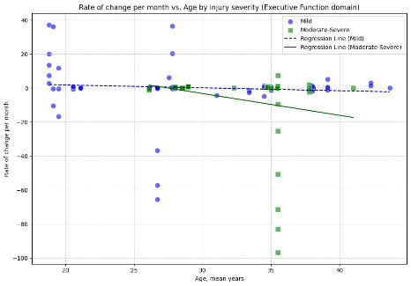
c) f) i)
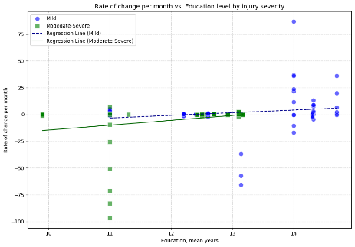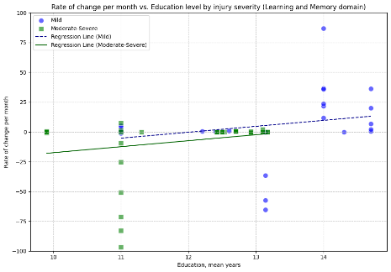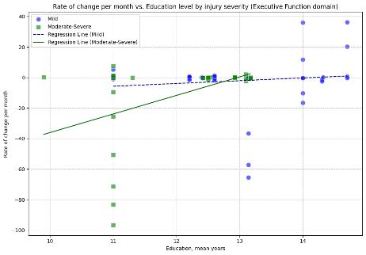
Supplement figure 1. Standardised rate of change for mild and moderate-severe TBI for each of the PROGRESS Plus parameters with available data: gender/sex, age, and education, overall (a, b, c, respectively) and by domains of cognition with sufficient data: learning and memory (d, e, f) and executive function (g, h, i).

- a) Mild TBI
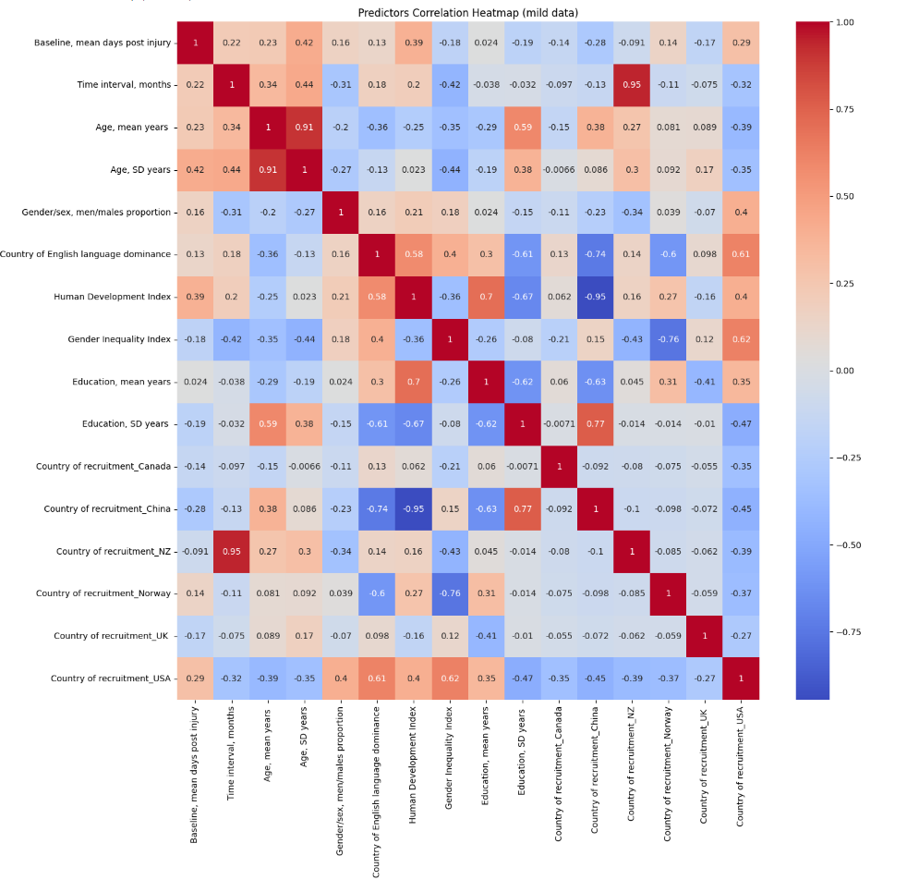
- Moderate-severe TBI
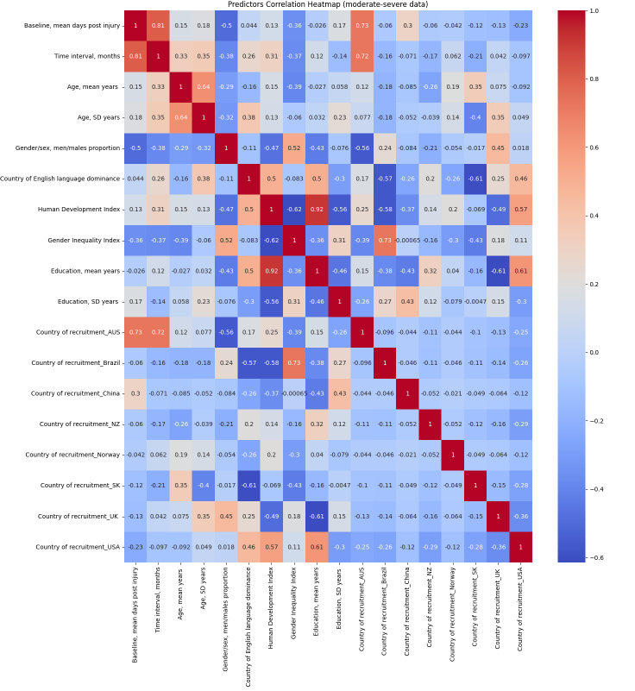
Supplement figure 2. Predictor correlation heatmaps for a) mild and b) moderate severe TBI cohorts showing correlation coefficients for associations between variables. Red signifies a positive correlation, while blue represents a negative correlation. The intensity of the color reflects the magnitude of the correlation coefficient, with more vibrant shades indicating stronger correlations. Specifically, shades tending towards red represent coefficients approaching 1, while those leaning towards blue represent coefficients approaching -1.
- a) Mild TBI
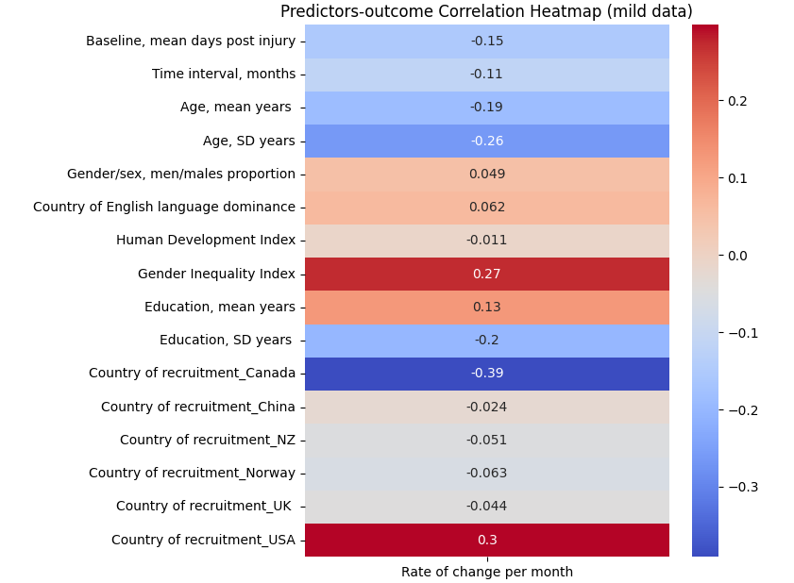
- Moderate-severe TBI

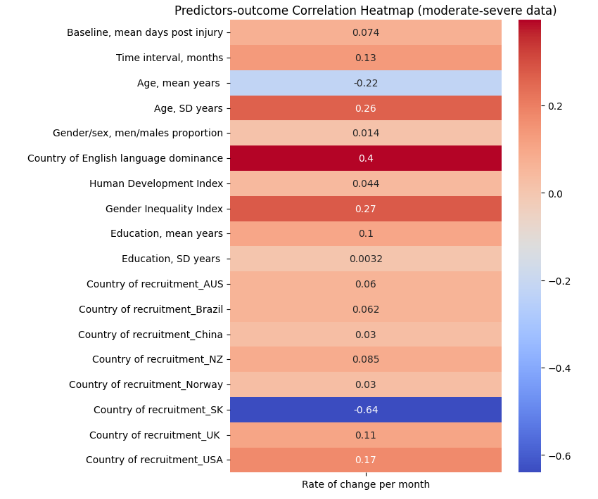
Supplement figure 3. Heatmaps of the correlation coefficient matrix, for a) mild and b) moderate-severe TBI for each of the predictors’ association with the outcome (bivariate association). Red signifies a positive correlation while blue represents a negative correlation. The intensity of the color reflects the magnitude of the correlation coefficient, with more vibrant shades indicating stronger correlations; shades tending towards red represent coefficients approaching 1, while those leaning towards blue represent coefficients approaching -1.

- a) Mild TBI
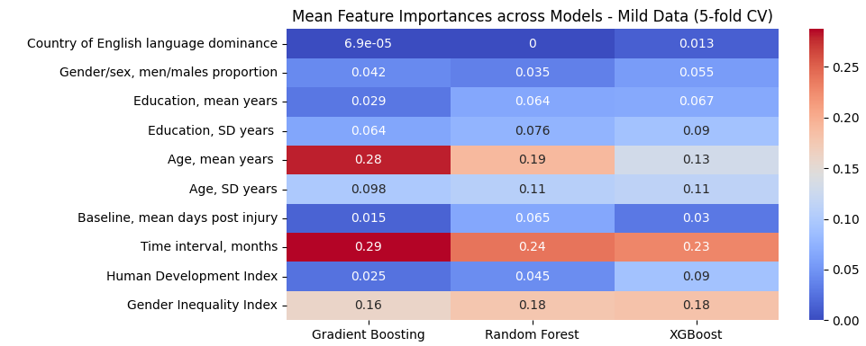
- Moderate-severe TBI
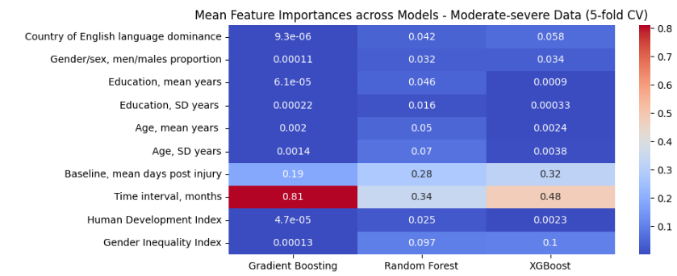
Supplement figure 4. Feature importance across models for a) mild and b) moderate-severe TBI cohorts with 5-fold cross validation modelling.

- a) Mild TBI
Gradient Boosting Random Forest XGBoost
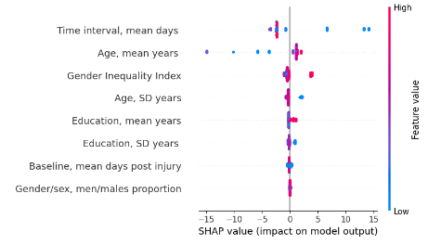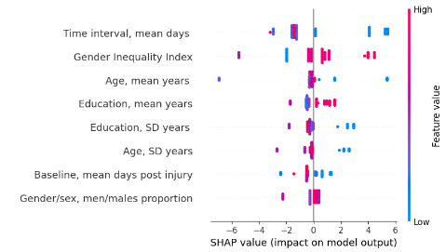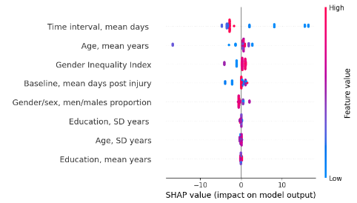

- Moderate-severe TBI
Gradient Boosting Random Forest XGBoost
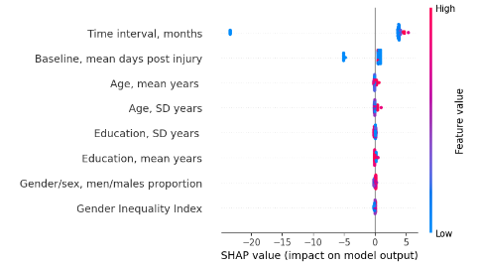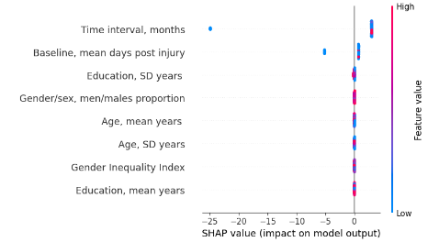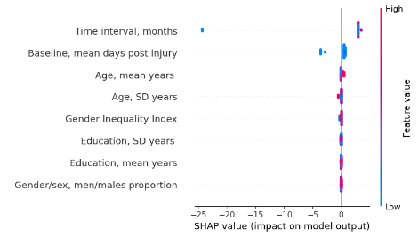
Supplement figure 5. SHAP analysis for ranking of variable impact on model output in 5-fold cross validation modelling for a) mild and b) moderate-severe TBI cohorts. Each point represents a SHAP value for each input variable, indicating the magnitude and direction of a feature’s contribution to the predicted outcome, summarizing model-specific predictive patterns for each TBI severity group. Features are ordered according to their relative contribution to model predictions.

- a) Mild TBI
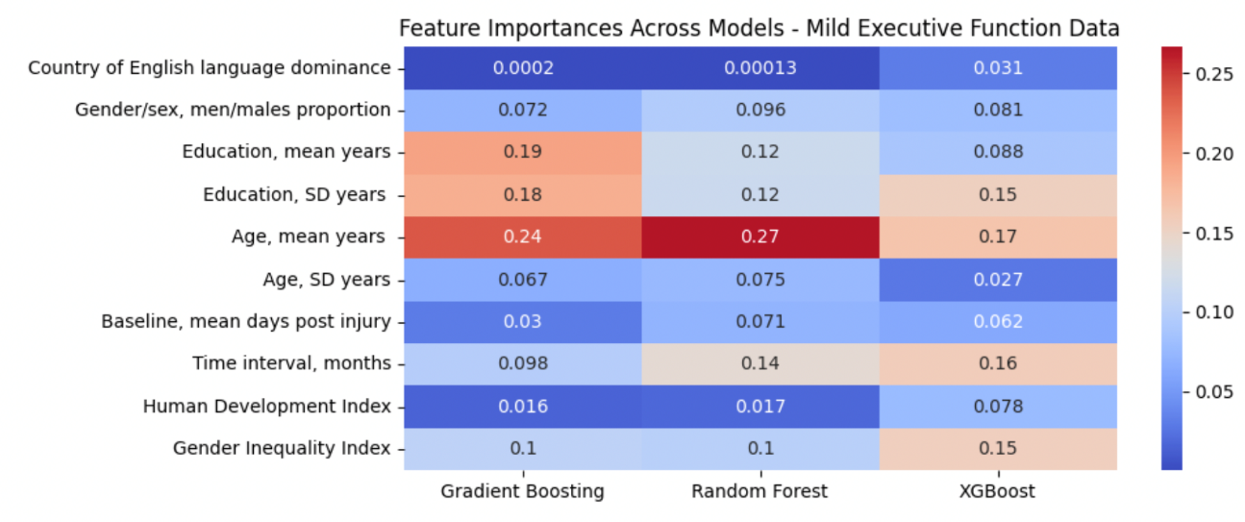
- Moderate-severe TBI
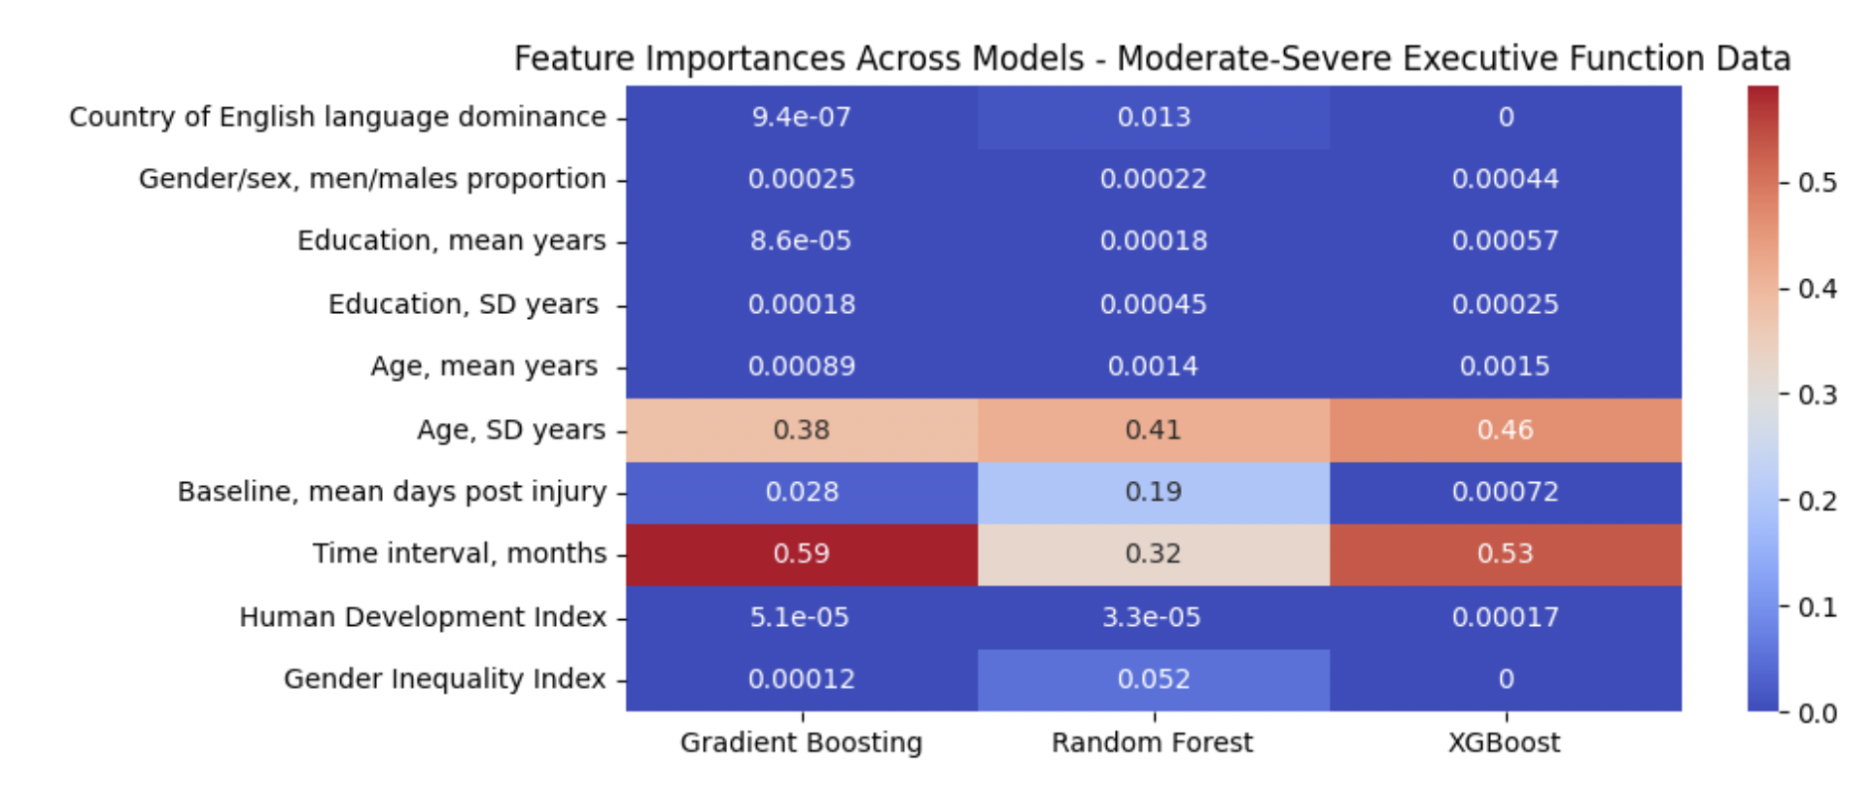
Supplement figure 6. Ranking of feature contributions for prediction of the rate of change in executive function outcome in (a) mild and (b) moderate-to-severe traumatic brain injury (TBI) cohorts.

- a) Mild TBI
Gradient Boosting Random Forest XGBoost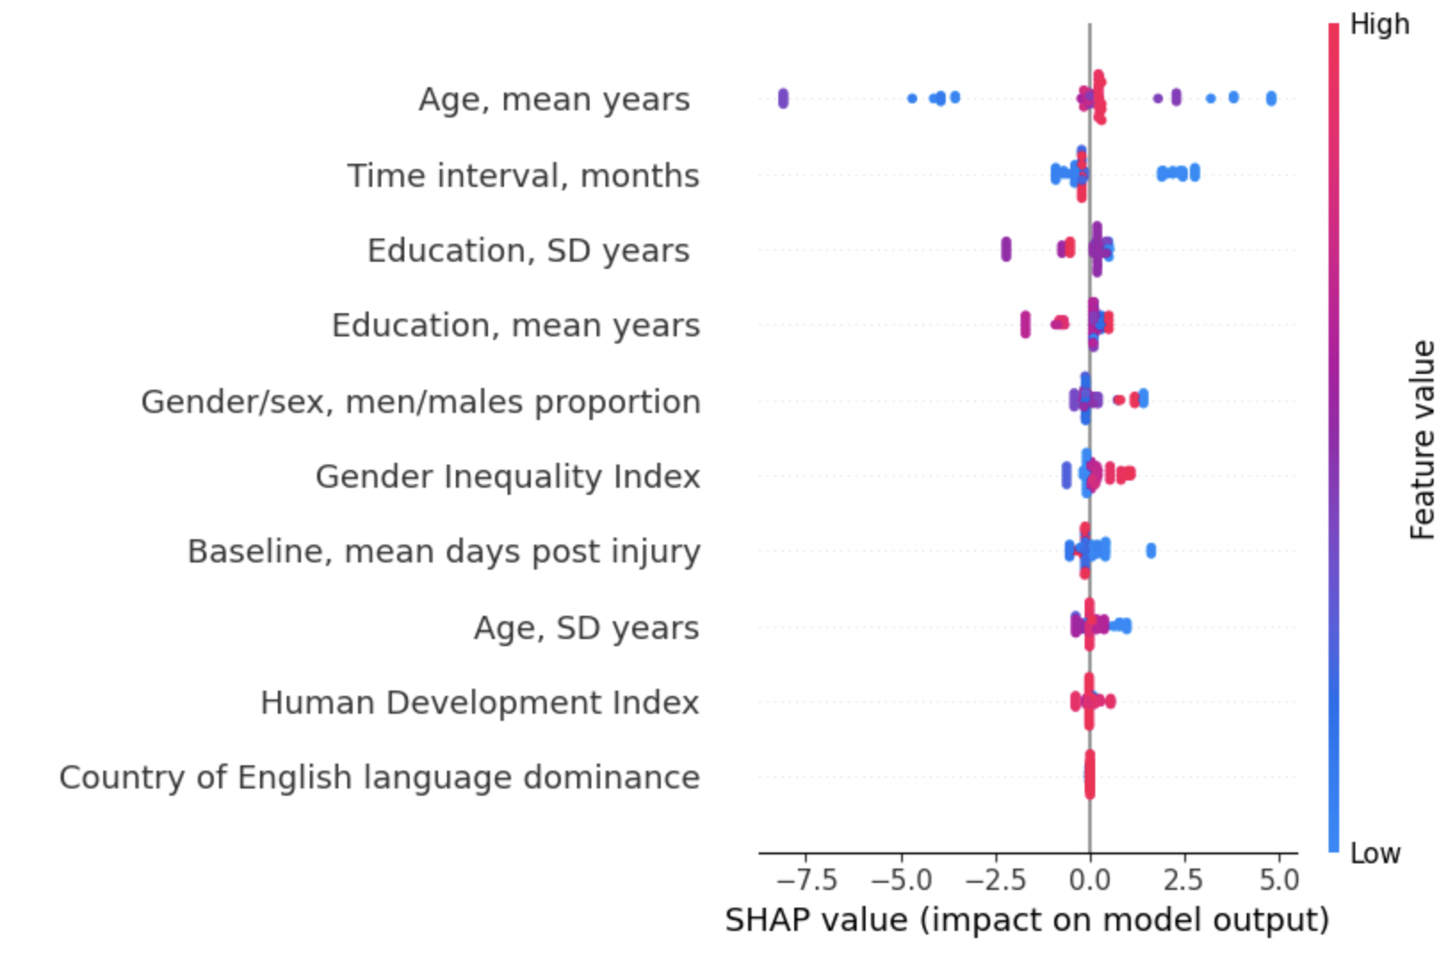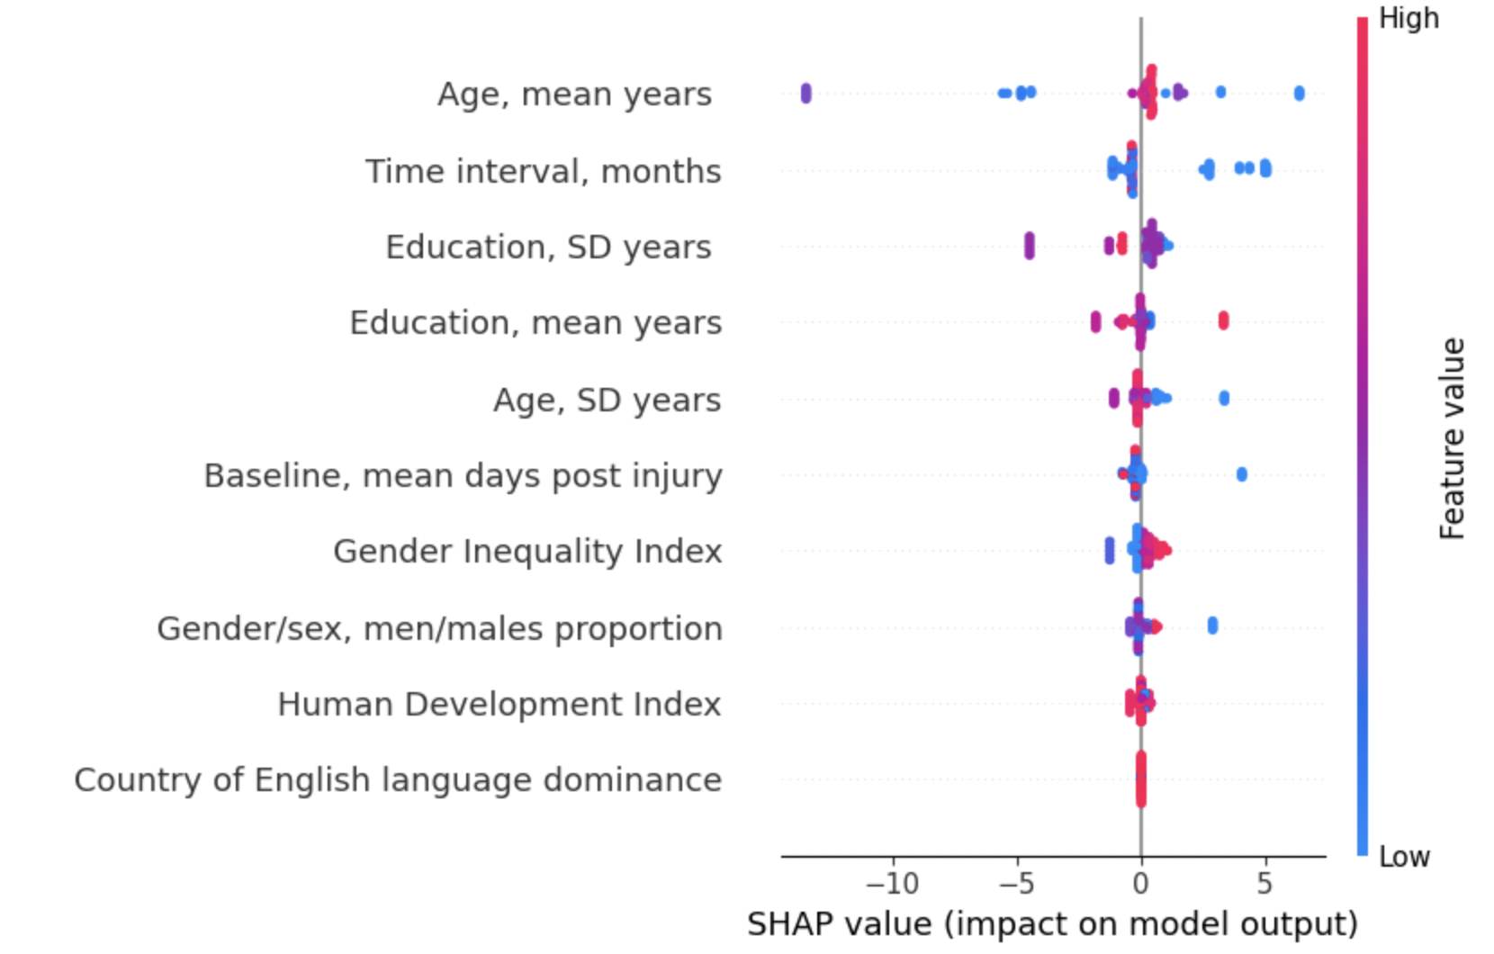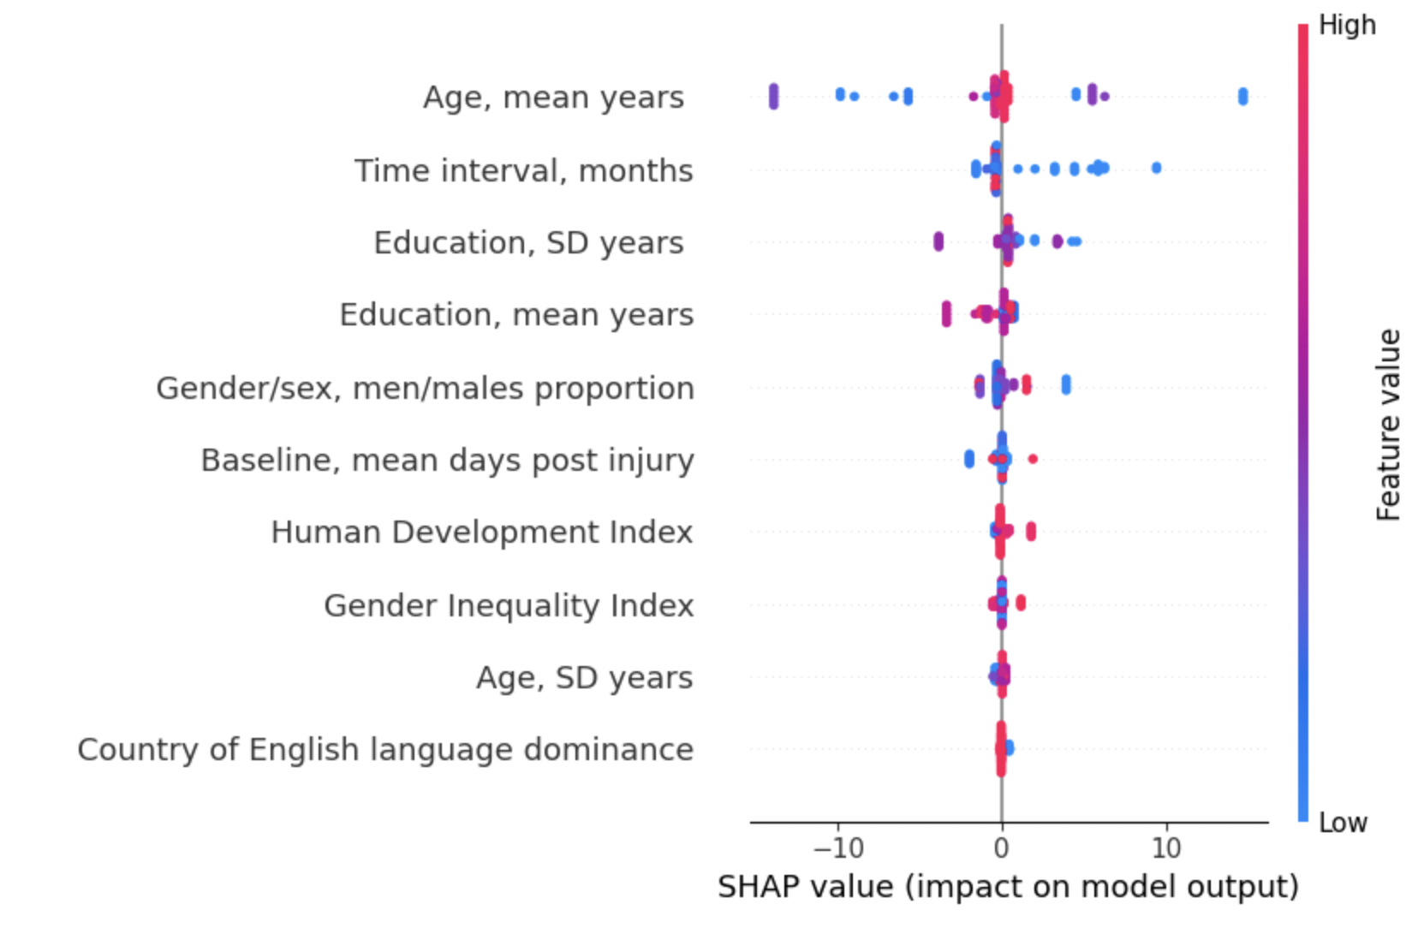
- Moderate-severe TBI
Gradient Boosting Random Forest XGBoost
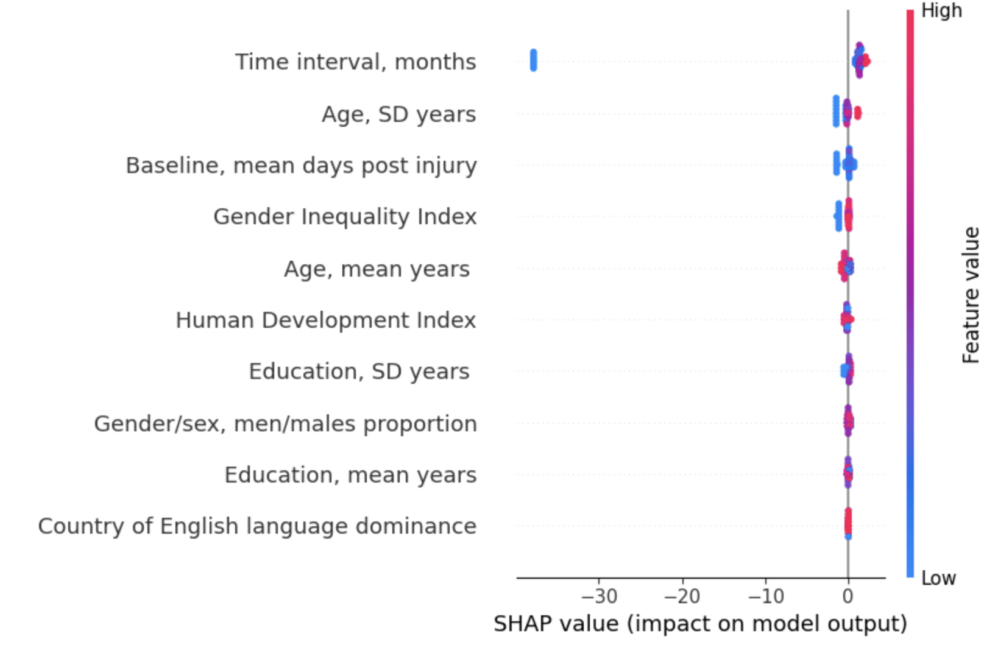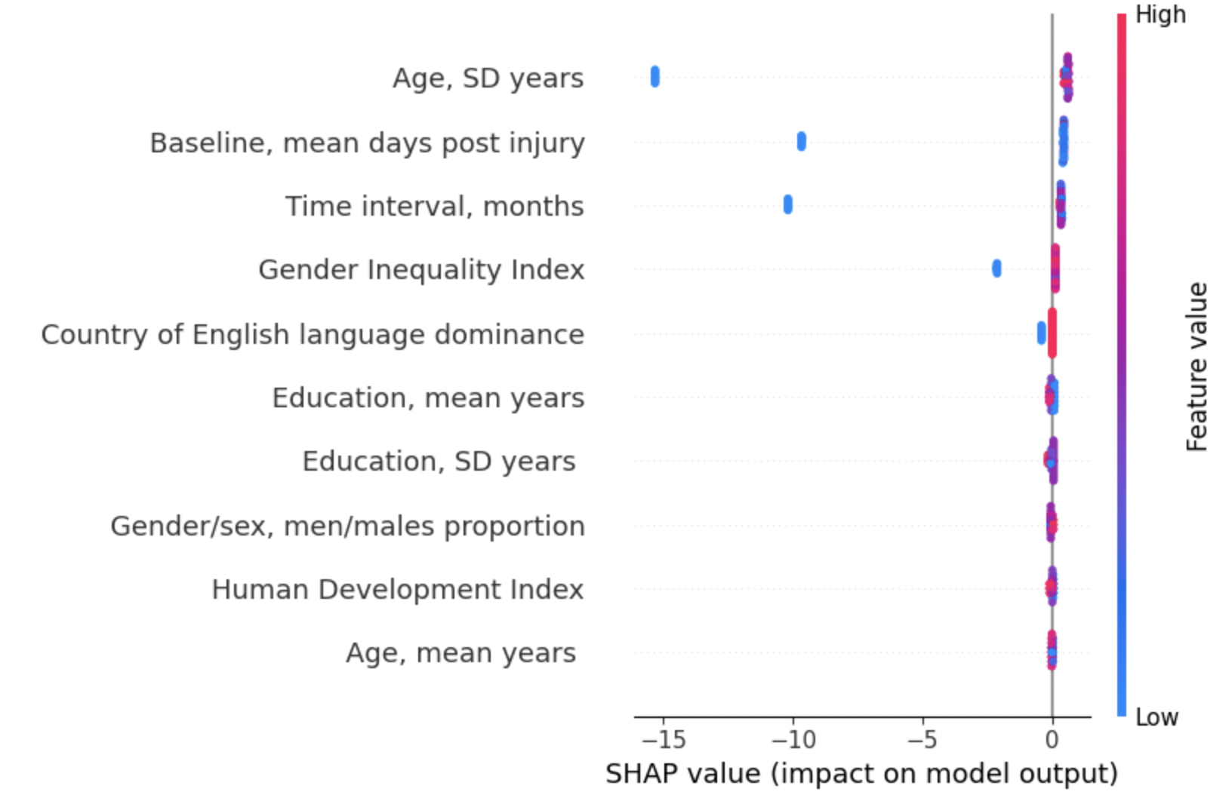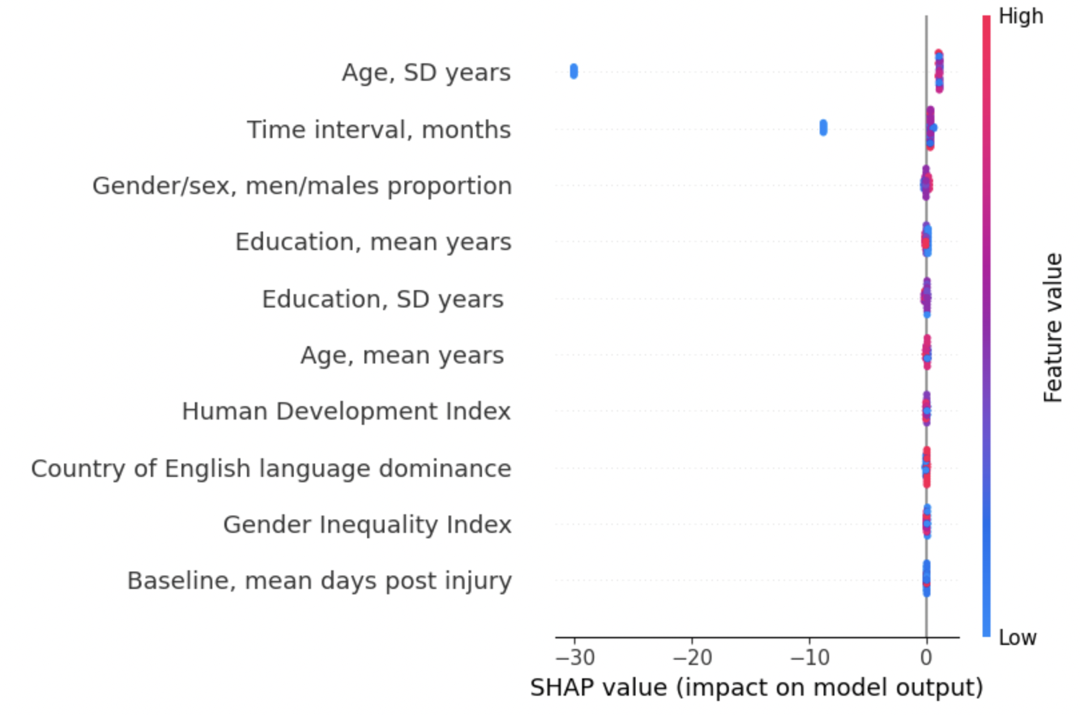
Supplement figure 7. SHAP summary plots illustrating the influence of input variables on executive function model predictions across models for (a) mild and (b) moderate-severe TBI cohorts, respectively. Each point represents a SHAP value for each input variable, indicating the magnitude and direction of a feature’s contribution to the predicted outcome, summarizing model-specific predictive patterns for each TBI severity group. Features are ordered according to their relative contribution to model predictions.

- a) Mild TBI
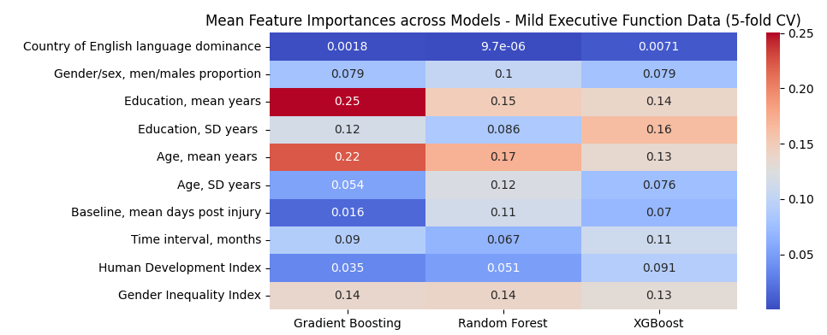
- Moderate-severe TBI
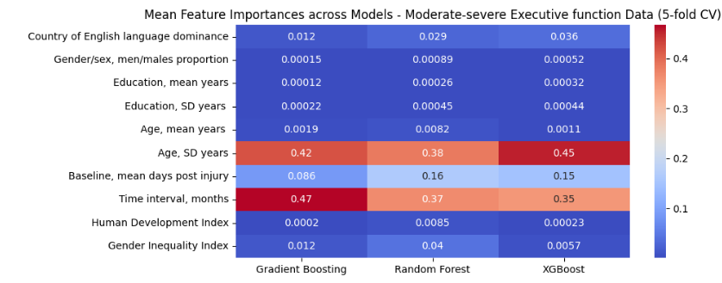
Supplement figure 8. Feature importance across models for a) mild and b) moderate-severe TBI executive function domain cohorts with 5-fold cross validation modelling.

- a) Mild TBI
Gradient Boosting Random Forest XGBoost
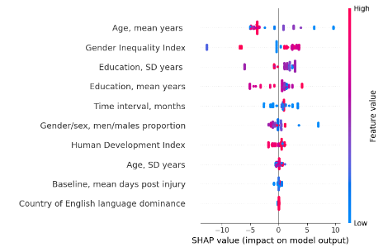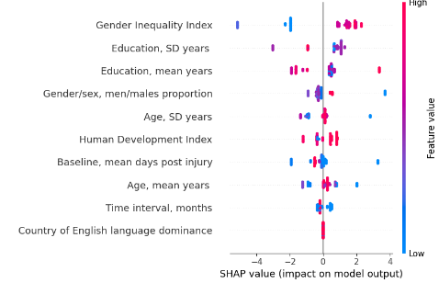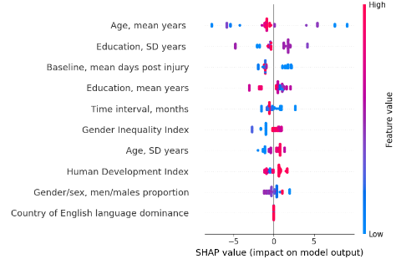
- Moderate-severe TBI
Gradient Boosting Random Forest XGBoost
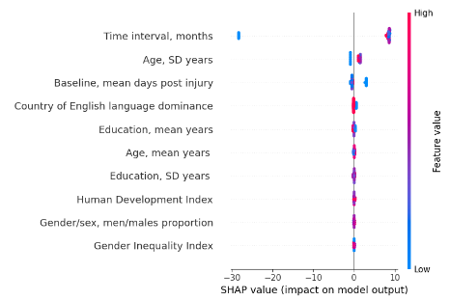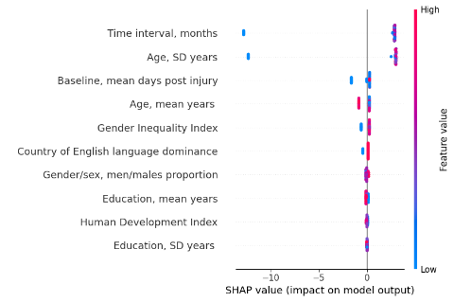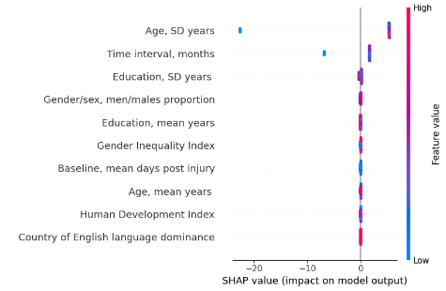
Supplement figure 9. SHAP analysis for ranking of variable impact on model output in 5-fold cross validation modelling for a) mild and b) moderate-severe TBI executive function domain cohorts. Each point represents a SHAP value for each input variable, indicating the magnitude and direction of a feature’s contribution to the predicted outcome, summarizing model-specific predictive patterns for each TBI severity group. Features are ordered according to their relative contribution to model predictions.

- a) Mild TBI
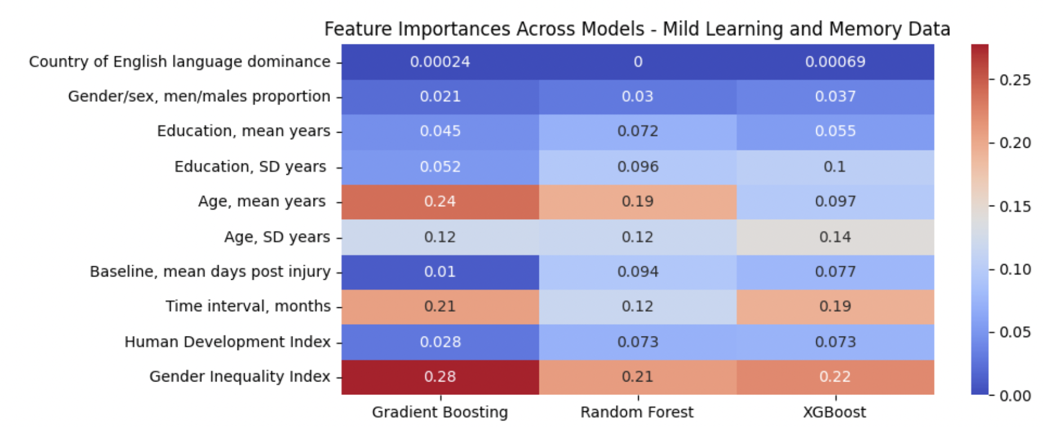
- Moderate-severe TBI
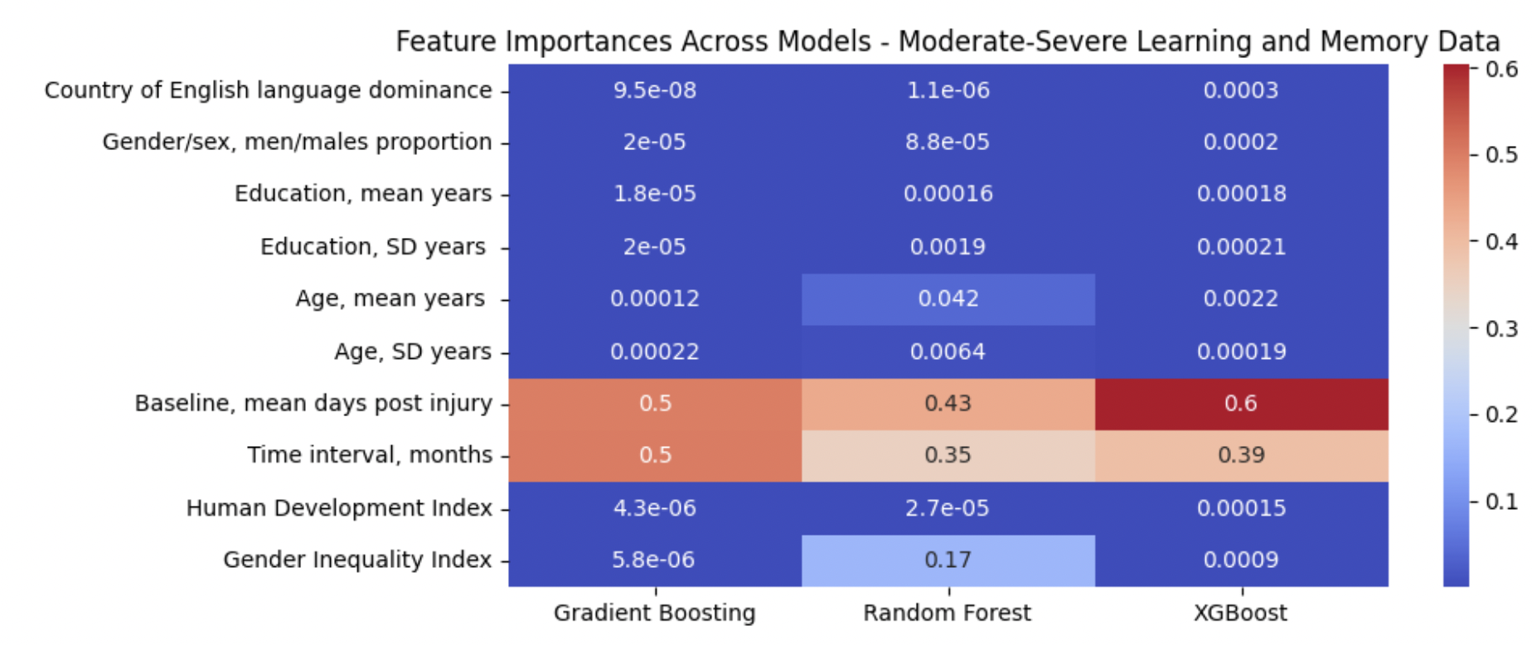
Supplement figure 10. Ranking of feature contributions for prediction of the rate of change in learning and memory function outcome in (a) mild and (b) moderate-to-severe traumatic brain injury (TBI) cohorts.
- a) Mild TBI
Gradient Boosting Random Forest XGBoost
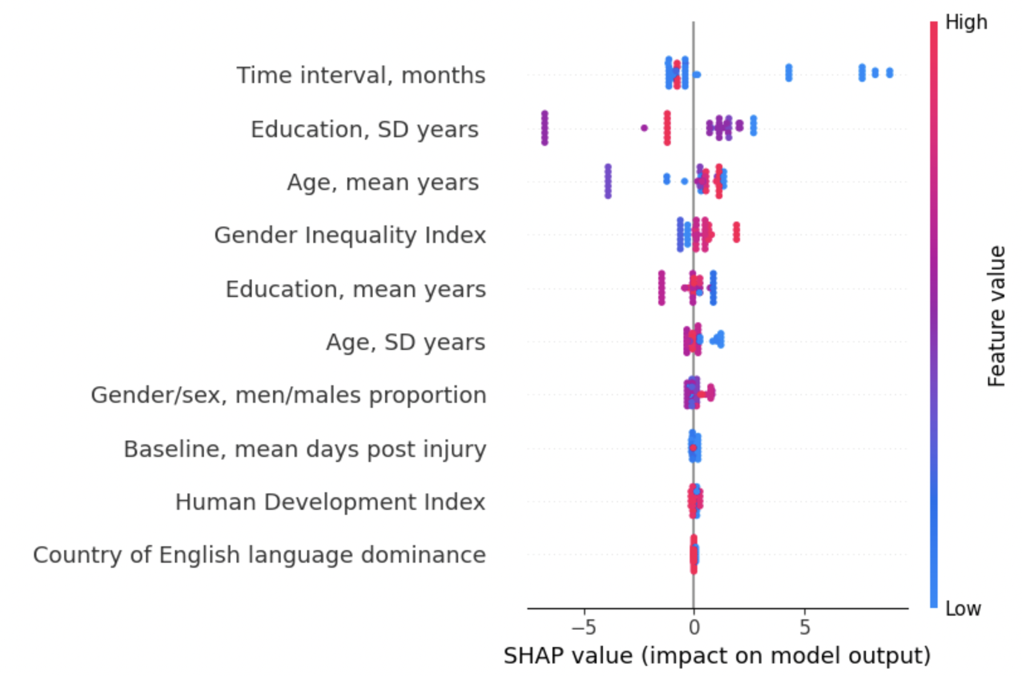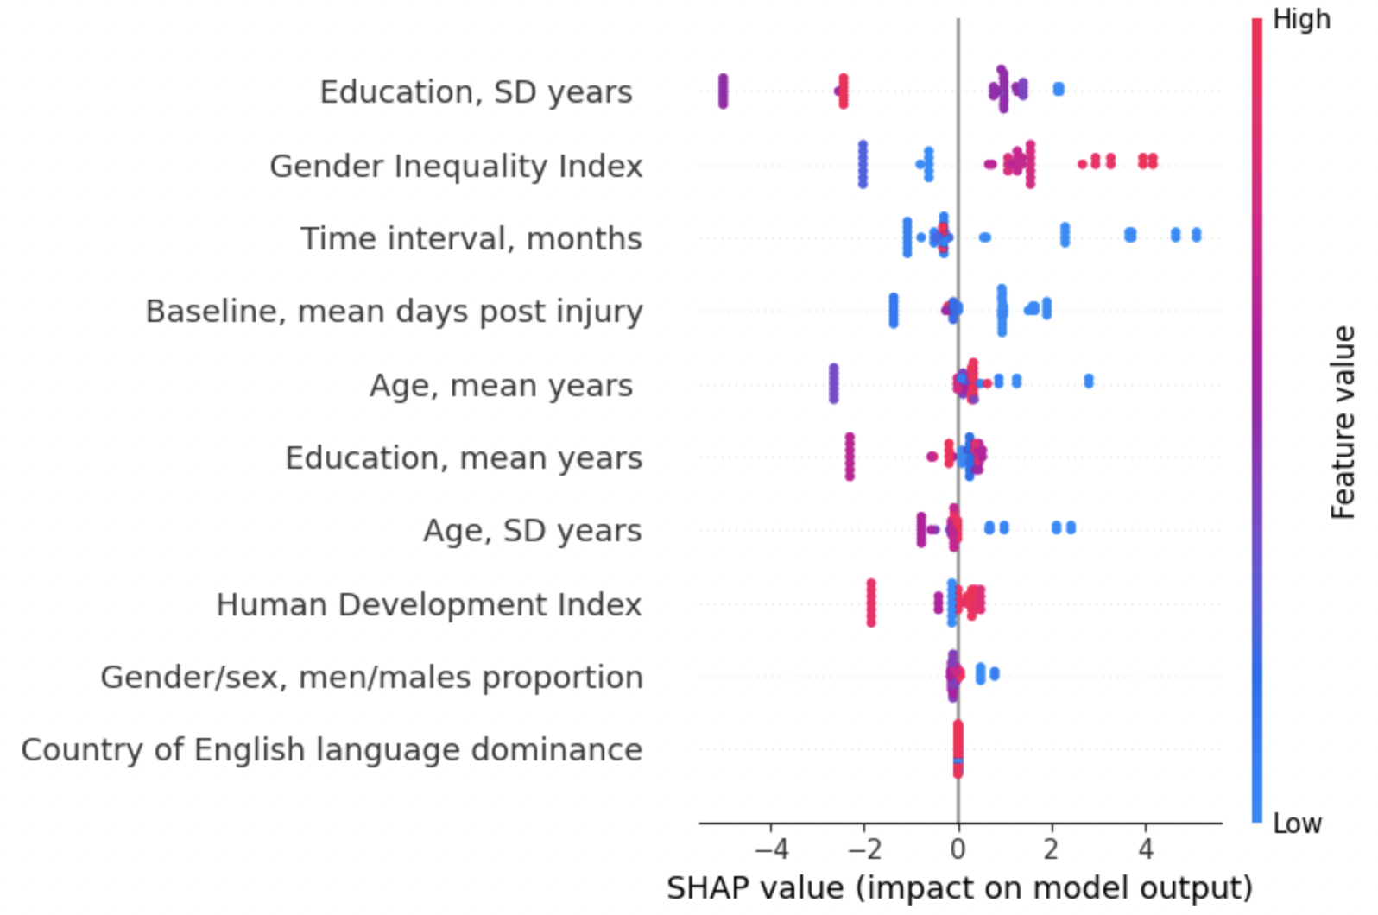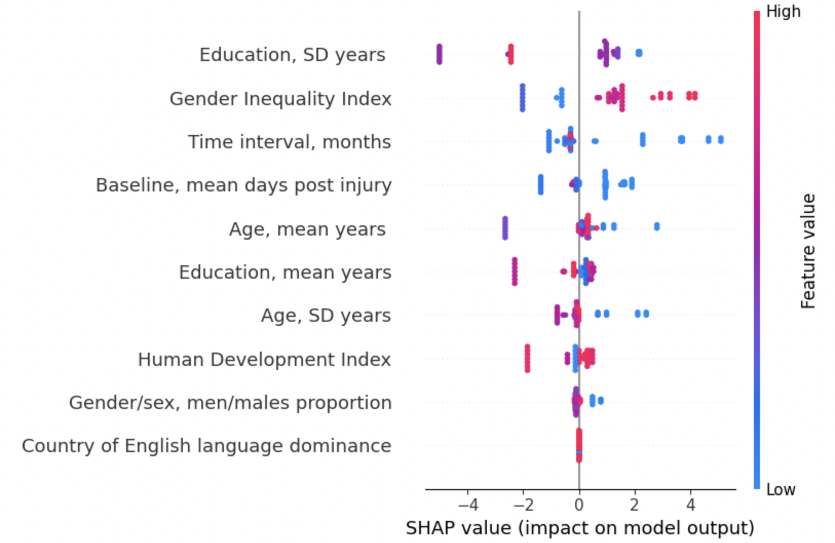
- Moderate-severe TBI
Gradient Boosting Random Forest XGBoost
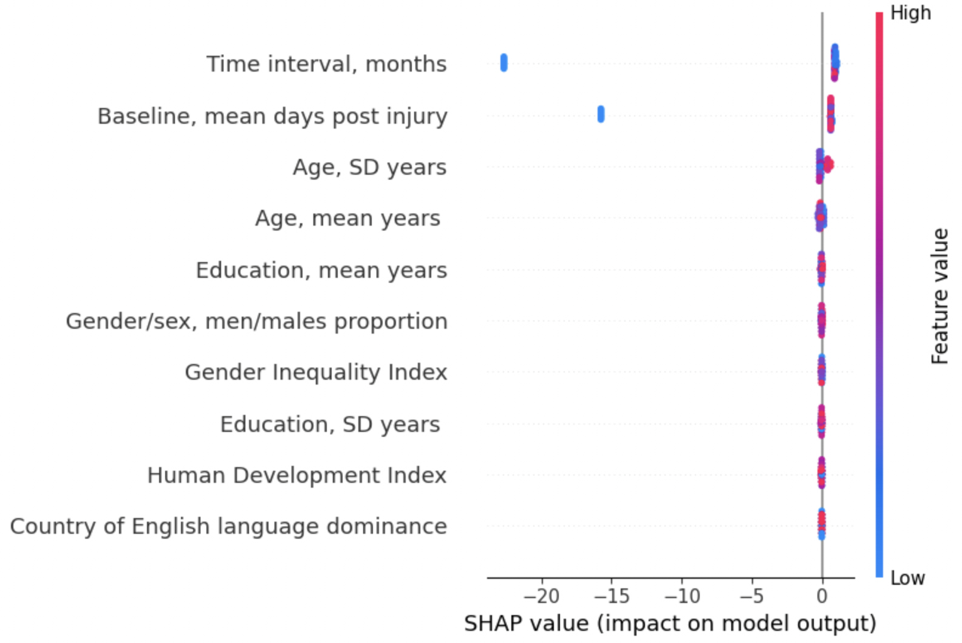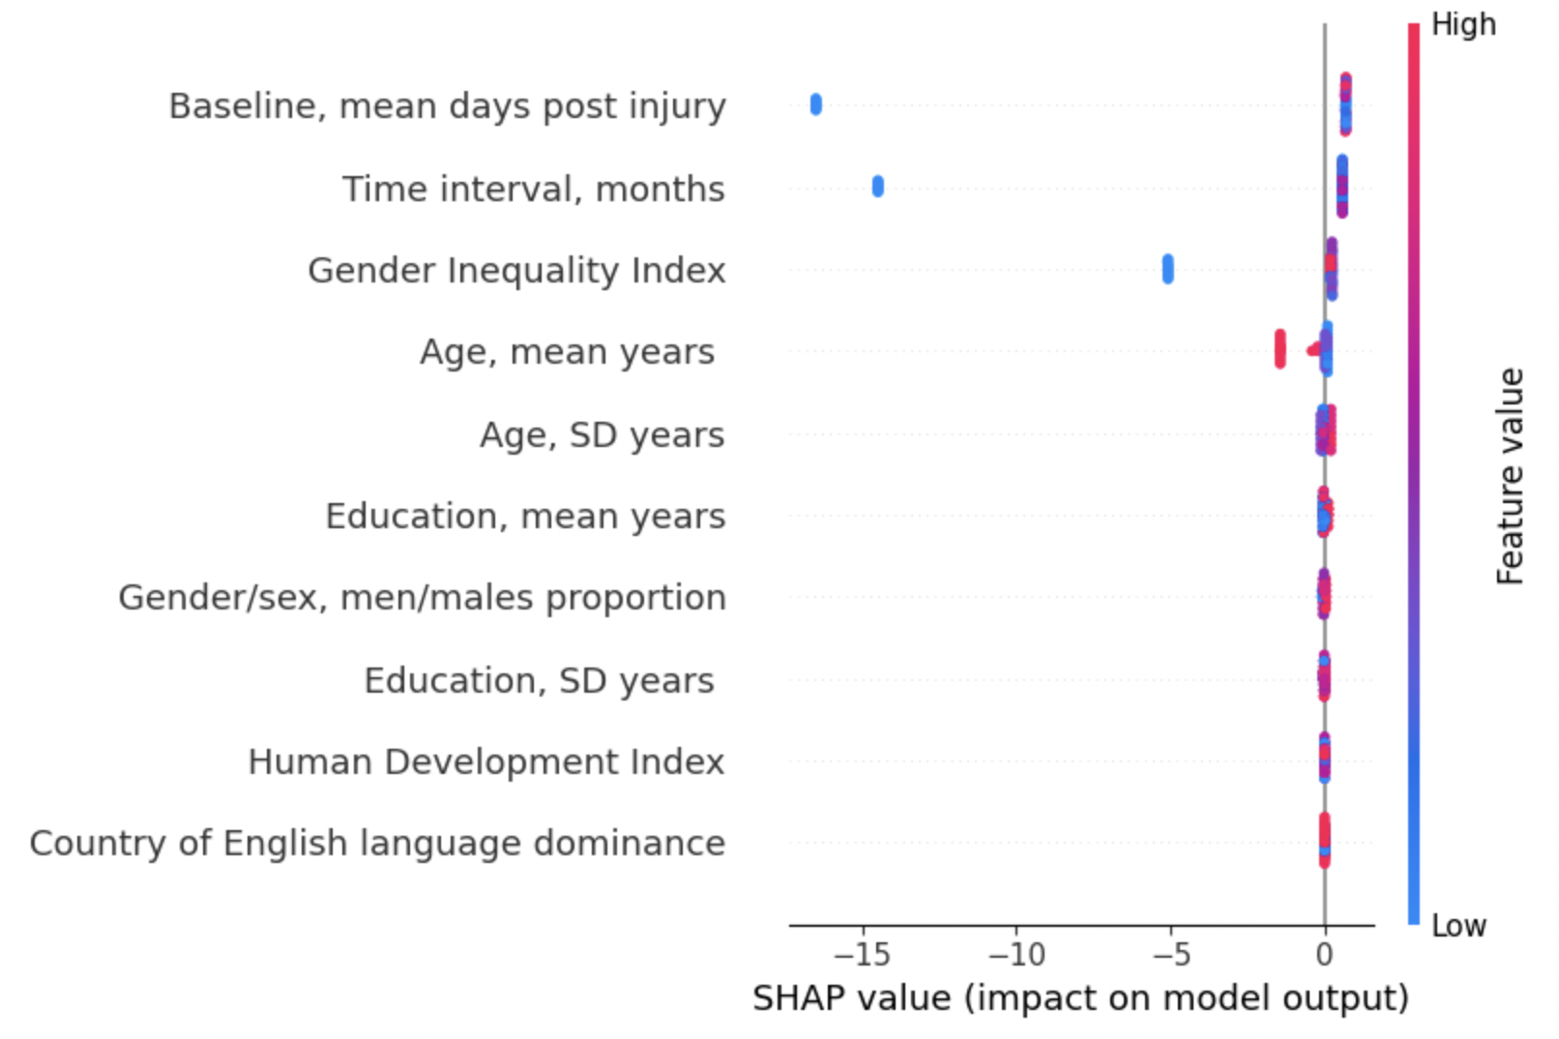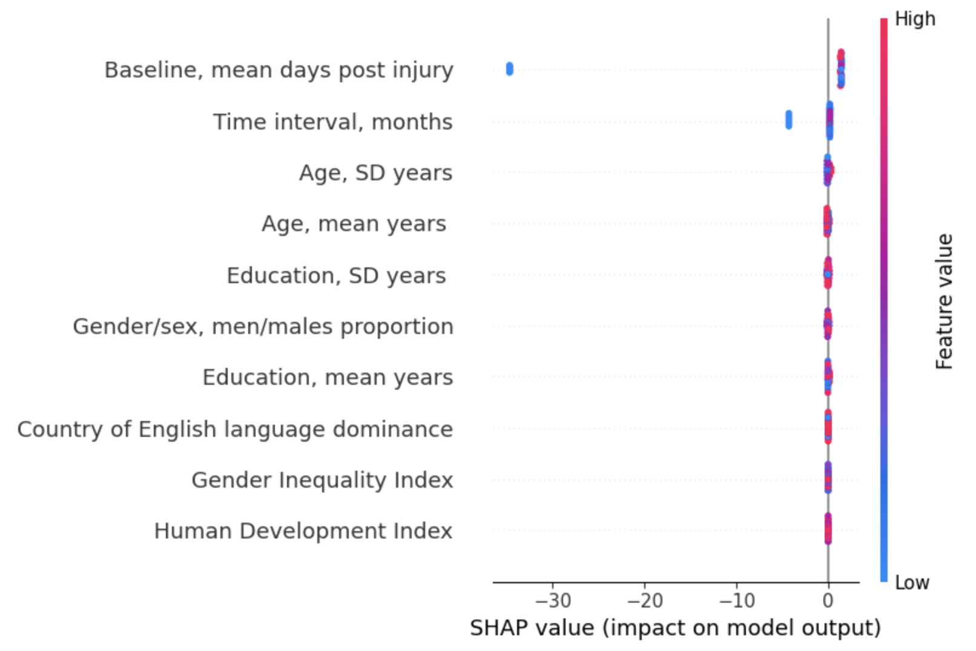
Supplement figure 11. SHAP summary plots illustrating the influence of input variables on learning and memory domain model predictions across models for (a) mild and (b) moderate-severe TBI cohorts, respectively. Each point represents a SHAP value for each input variable, indicating the magnitude and direction of a feature’s contribution to the predicted outcome, summarizing model-specific predictive patterns for each TBI severity group. Features are ordered according to their relative contribution to model predictions.

- a) Mild TBI
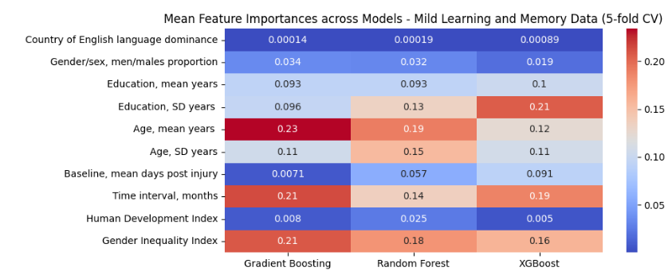
- Moderate-severe TBI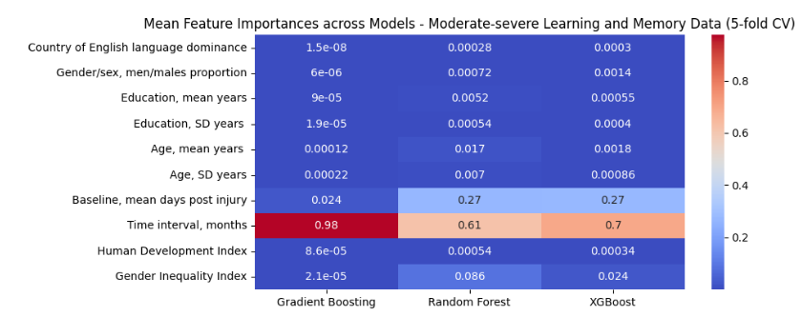
Supplement figure 12. Feature importance across models for a) mild and b) moderate-severe TBI learning and memory domain cohorts with 5-fold cross validation modelling.

- a) Mild TBI
Gradient Boosting Random Forest XGBoost
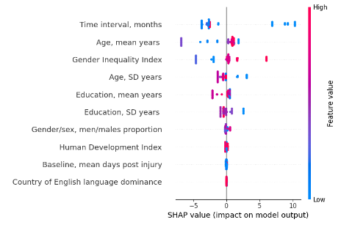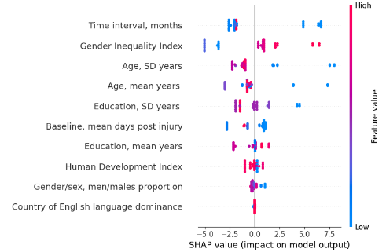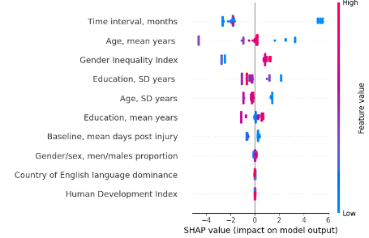
- Moderate-severe TBI
Gradient Boosting Random Forest XGBoost
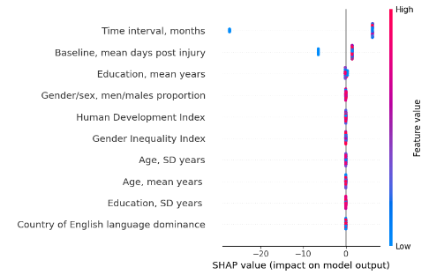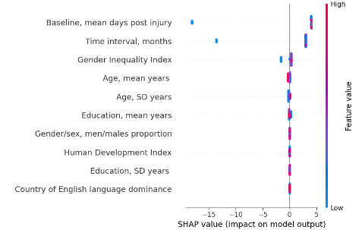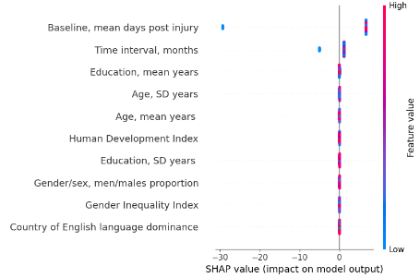
Supplement figure 13. SHAP analysis for ranking of variable impact on model output in 5-fold cross validation modelling for a) mild and b) moderate-severe TBI learning and memory domain cohorts. Each point represents a SHAP value for each input variable, indicating the magnitude and direction of a feature’s contribution to the predicted outcome, summarizing model-specific predictive patterns for each TBI severity group. Features are ordered according to their relative contribution to model predictions.

- a) Mild TBI
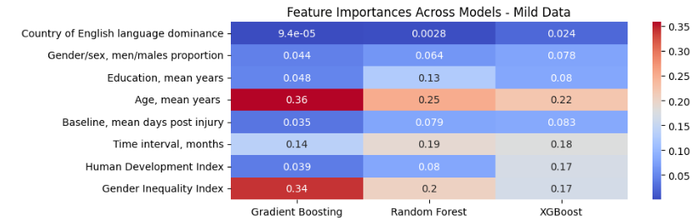
- Moderate-severe TBI
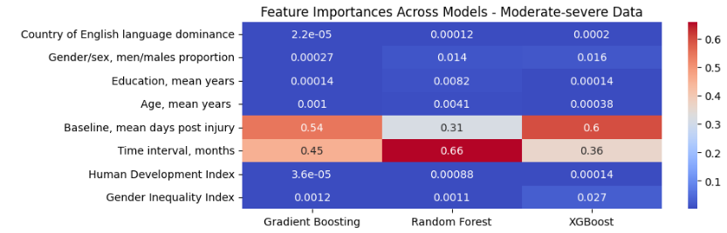
Supplement figure 14. Ranking of feature contributions for prediction of the rate of change outcomes in (a) mild and (b) moderate-to-severe traumatic brain injury (TBI) cohorts, without age and education standard deviations included as predictors in models.

- a) Mild TBI
Gradient Boosting Random Forest XGBoost
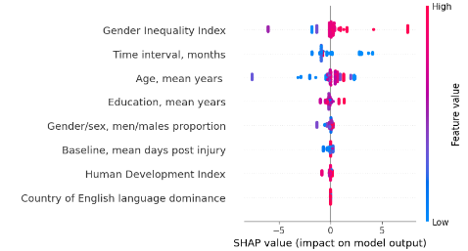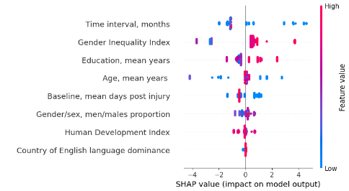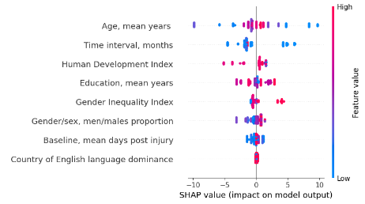
- Moderate-severe TBI
Gradient Boosting Random Forest XGBoost
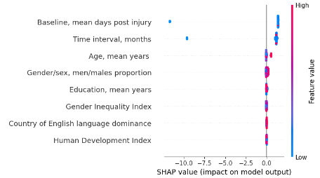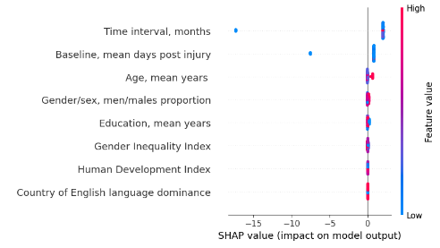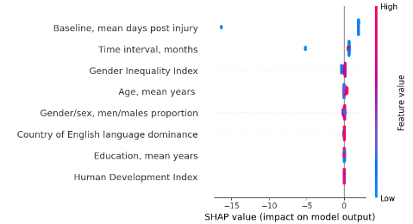
Supplement Figure 15. SHAP summary plots illustrating the influence of input variables on model predictions across models for (a) mild and (b) moderate-severe TBI cohorts, respectively, without age and education standard deviations as predictors. Each point represents a SHAP value for each input variable, indicating the magnitude and direction of a feature’s contribution to the predicted outcome, summarizing model-specific predictive patterns for each TBI severity group. Features are ordered according to their relative contribution to model predictions.

