Supplementary materials
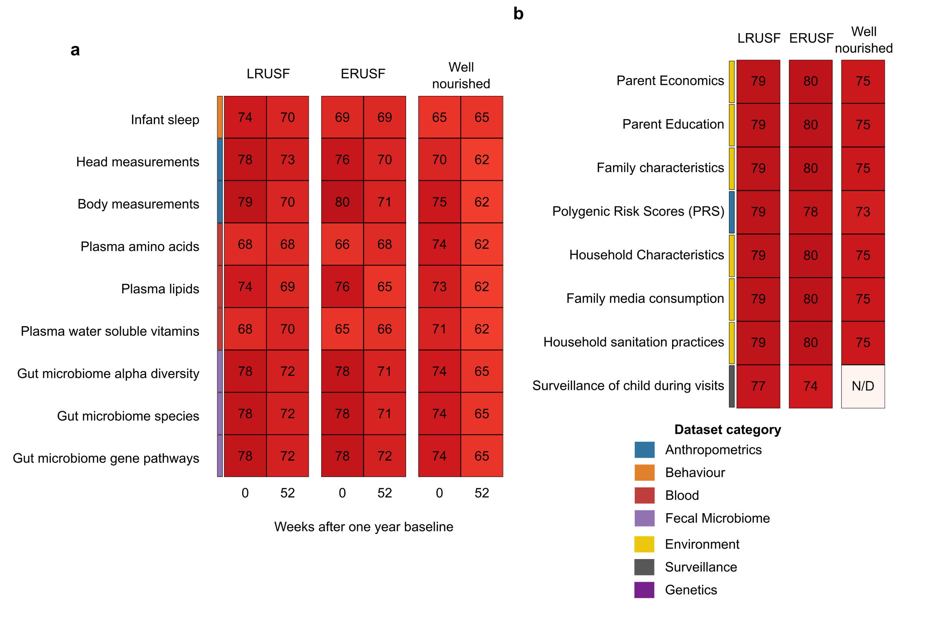
Figure S1: Datasets recorded in the M4EFaD study. a and b are datasets for which multiple timepoints were and were not recorded, respectively. Numbers represent the total number of samples available in that dataset. Darker red colour represents a larger number of samples.
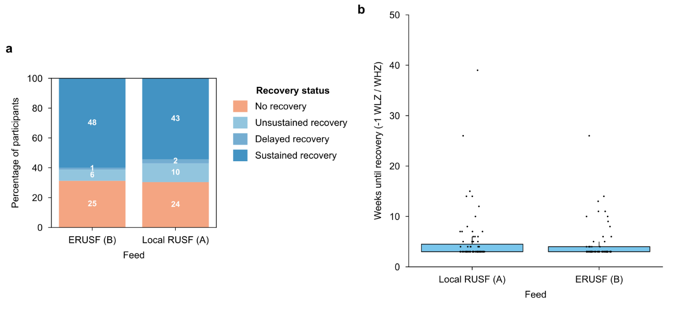
Figure S2: Recovery according to the WHO criteria during rapid catch-up growth in children with MAM. a) Stacked barplot to show that there were no differences in rapid catch-up or sustained recovery following use of RUSF or ERUSF. ~69% of participants achieved recovery following rapid catch-up growth (age 15 months) and had sustained recovery at age 24 months. b) boxplot to show that there were no differences in weeks until recovery according to the WHO criteria. Box plots show the median, the 25th-75th percentiles (IQR), and whiskers extending to 1.5 x IQR.

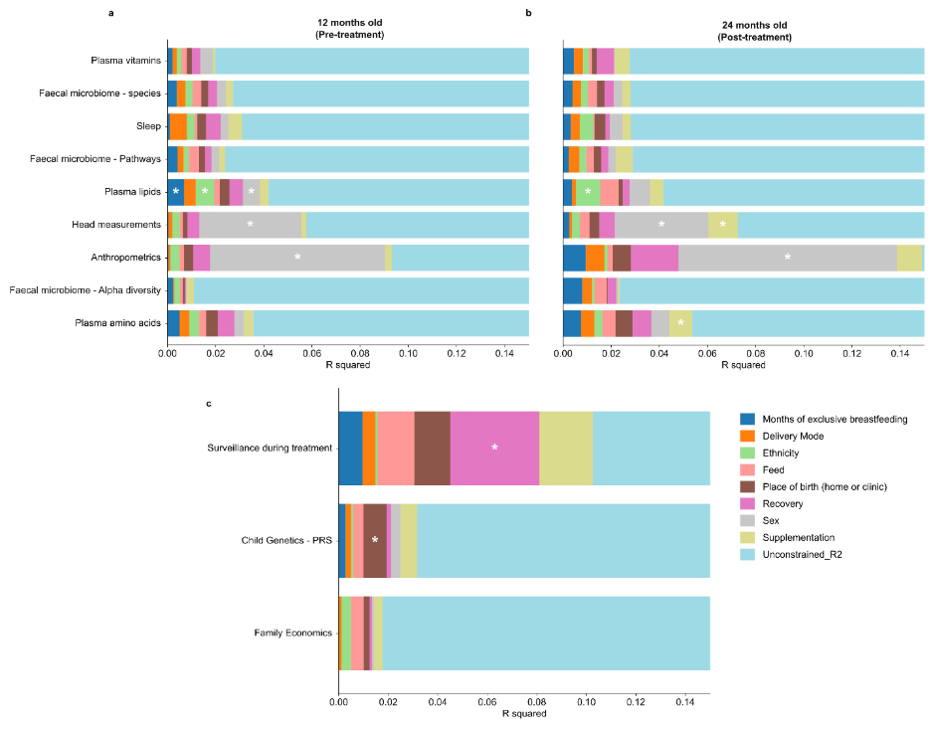
Figure S3. Stacked barplots showing variance explained (R²) from RDA across all datasets in Year 1 (a), Year 2 (b), and pooled no-timepoint data (c). Each RDA model was constrained by one-hot encoded metadata variables, and the contribution of each predictor is shown as a horizontal stacked bar coloured by predictor identity, with significant predictors marked by an asterisk (p < 0.05). Bars are truncated at R² = 0.15 to highlight the interpretable range of explained variance with all above 0.15 being unconstrained variance.

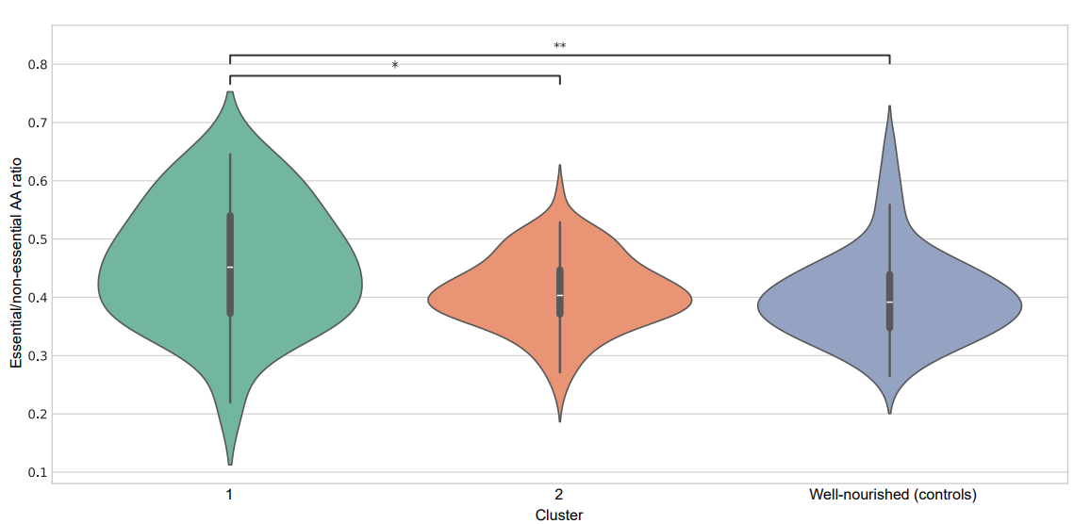
Figure S4: Ratio of essential/conditionally essential to non-essential amino acids in each cluster. Cluster one had a significantly higher ratio (essential/non-essential) than cluster two (p < 0.05) and the well-nourished cohort (p < 0.01).
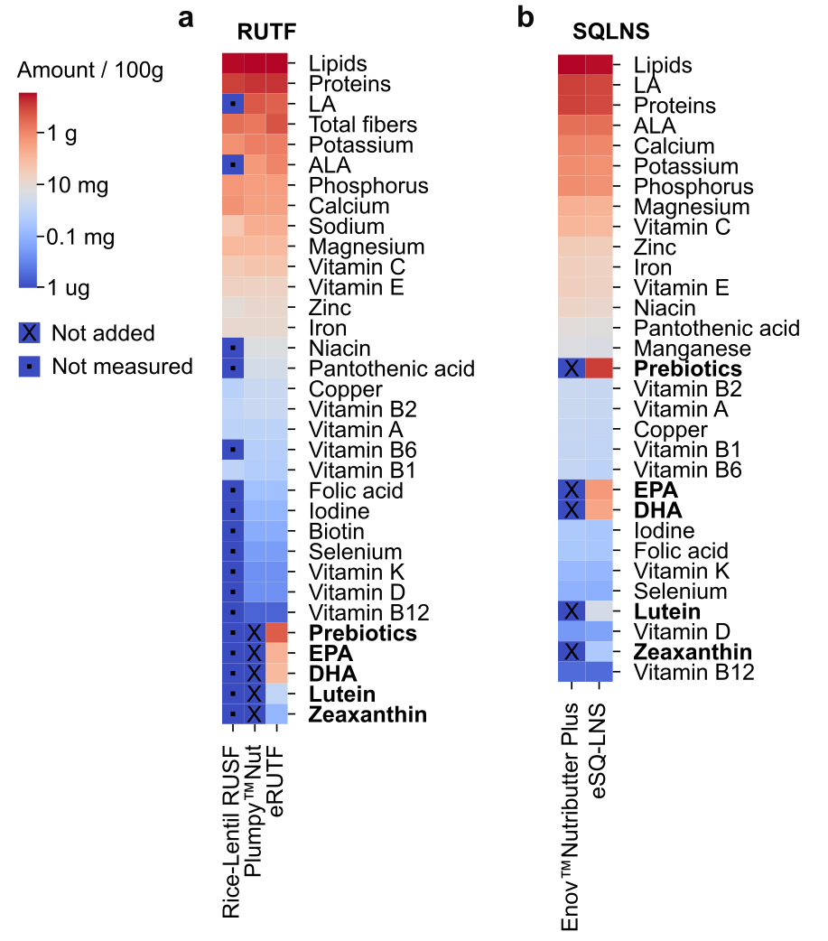
Figure S5: Comparison of nutritional composition of (a) eRUSF and (b) e-SQ-LNS. Additional details can be found in Table S2. In the RUSF, the prebiotics are considered as a proportion of the total fiber content.

