Supplementary Material

Environmental covariates

ERA5-Land hourly data for 2023 and 2024 were downloaded from Copernicus Climate Data Store [1] for temperature, precipitation, wind, potential evaporation and soil moisture, which were processed to calculate annual, cold, dry, warm and wet quarter potential evaporation and soil moisture, 19 bioclimatic variables, annual number of dry days, annual daily maximum precipitation rate, June and July 2023 and 2024 mean daily precipitation rate, June and July 2023 and 2024 minimum, maximum and mean daily temperature, and June and July mean wind speed.
The corresponding future environmental covariates were also downloaded from Copernicus Climate Data Store from the “Downscaled bioclimatic indicators for selected regions from 1950 to 2100 derived from climate projections” dataset [2]. This provides environmental data derived from CMIP5 climate projections bias-adjusted against ERA5 reanalysis data. Projections were made using an ensemble of the HadGEM2-ES, bcc-csm1-1-m, GFDL-ESM2M, IPSL-CM5A-LR and NorESM1-M models for two future climate scenarios, Representative Concentration Pathway (RCP) 4.5 and RCP 8.5.
Additionally, elevation was downloaded from WorldClim 2.1, derived from SRTM elevation data [3], and the 2023 land cover map was downloaded from UKCEH [4], which was further processed to represent three categories: urban, suburban and rural (all remaining land cover classes which were not urban or suburban). Spatial resolutions for all covariates are described below.
The following table displays the initial environmental covariates considered for the models prior to analysis of collinearity and correlation between present and future data. Present day bioclimatic variables were manually calculated from the Copernicus ERA-5-Land hourly data. All Copernicus ERA-5-Land hourly data had a horizontal resolution of 0.1° x 0.1°, CMIP5 projections had a resolution of 1 km x 1 km, WorldClim elevation data had a resolution of 30 seconds, building count had a resolution of 500 m x 500 m, and land cover had a resolution of 10 m x 10 m. All were projected into the coordinate reference system WGS 84 and kept at their original resolution. Some Copernicus ERA-5 Land hourly rasters did not extend over locations of surveillance points (near the coast), and therefore for these points, values were extracted from the nearest available pixel.

SM Table 1 Initial covariates considered for the models prior to correlation analysis
Abbreviation | Description | Present day source | Future projection source
BIO01 | Annual Mean Temperature | Copernicus ERA-5-Land hourly | Copernicus CMIP5 ERA5-bias adjusted
BIO02 | Mean Diurnal Range (Mean of monthly (max temp - min temp)) | Copernicus ERA-5-Land hourly | Copernicus CMIP5 ERA5-bias adjusted
BIO03 | Isothermality (BIO2/BIO7) (×100) | Copernicus ERA-5-Land hourly | Copernicus CMIP5 ERA5-bias adjusted
BIO04 | Temperature Seasonality (standard deviation ×100) | Copernicus ERA-5-Land hourly | Copernicus CMIP5 ERA5-bias adjusted
BIO05 | Max Temperature of Warmest Month | Copernicus ERA-5-Land hourly | Copernicus CMIP5 ERA5-bias adjusted
BIO06 | Min Temperature of Coldest Month | Copernicus ERA-5-Land hourly | Copernicus CMIP5 ERA5-bias adjusted
BIO07 | Temperature Annual Range (BIO5-BIO6) | Copernicus ERA-5-Land hourly | Copernicus CMIP5 ERA5-bias adjusted
BIO08 | Mean Temperature of Wettest Quarter | Copernicus ERA-5-Land hourly | Copernicus CMIP5 ERA5-bias adjusted
BIO09 | Mean Temperature of Driest Quarter | Copernicus ERA-5-Land hourly | Copernicus CMIP5 ERA5-bias adjusted
BIO10 | Mean Temperature of Warmest Quarter | Copernicus ERA-5-Land hourly | Copernicus CMIP5 ERA5-bias adjusted
BIO11 | Mean Temperature of Coldest Quarter | Copernicus ERA-5-Land hourly | Copernicus CMIP5 ERA5-bias adjusted
BIO12 | Annual Precipitation | Copernicus ERA-5-Land hourly | Copernicus CMIP5 ERA5-bias adjusted
BIO13 | Precipitation of Wettest Month | Copernicus ERA-5-Land hourly | Copernicus CMIP5 ERA5-bias adjusted
BIO14 | Precipitation of Driest Month | Copernicus ERA-5-Land hourly | Copernicus CMIP5 ERA5-bias adjusted
BIO15 | Precipitation Seasonality (Coefficient of Variation) | Copernicus ERA-5-Land hourly | Copernicus CMIP5 ERA5-bias adjusted
BIO16 | Precipitation of Wettest Quarter | Copernicus ERA-5-Land hourly | Copernicus CMIP5 ERA5-bias adjusted
BIO17 | Precipitation of Driest Quarter | Copernicus ERA-5-Land hourly | Copernicus CMIP5 ERA5-bias adjusted
BIO18 | Precipitation of Warmest Quarter | Copernicus ERA-5-Land hourly | Copernicus CMIP5 ERA5-bias adjusted
BIO19 | Precipitation of Coldest Quarter | Copernicus ERA-5-Land hourly | Copernicus CMIP5 ERA5-bias adjusted
SOIL_ANN | Annual mean volumetric soil moisture | Copernicus ERA-5-Land hourly | Copernicus CMIP5 ERA5-bias adjusted
SOIL_COLD | Mean volumetric soil moisture of Coldest Quarter | Copernicus ERA-5-Land hourly | Copernicus CMIP5 ERA5-bias adjusted
SOIL_DRY | Mean volumetric soil moisture of Driest Quarter | Copernicus ERA-5-Land hourly | Copernicus CMIP5 ERA5-bias adjusted
SOIL_WARM | Mean volumetric soil moisture of Warmest Quarter | Copernicus ERA-5-Land hourly | Copernicus CMIP5 ERA5-bias adjusted
SOIL_WET | Mean volumetric soil moisture of Wettest Quarter | Copernicus ERA-5-Land hourly | Copernicus CMIP5 ERA5-bias adjusted
PEV_ANN | Annual mean potential evaporation | Copernicus ERA-5-Land hourly | Copernicus CMIP5 ERA5-bias adjusted
PEV_COLD | Mean potential evaporation of Coldest Quarter | Copernicus ERA-5-Land hourly | Copernicus CMIP5 ERA5-bias adjusted
PEV_DRY | Mean potential evaporation of Driest Quarter | Copernicus ERA-5-Land hourly | Copernicus CMIP5 ERA5-bias adjusted
PEV_WARM | Mean potential evaporation of Warmest Quarter | Copernicus ERA-5-Land hourly | Copernicus CMIP5 ERA5-bias adjusted
PEV_WET | Mean potential evaporation of Wettest Quarter | Copernicus ERA-5-Land hourly | Copernicus CMIP5 ERA5-bias adjusted
PREC_ANN | Annual maximum daily precipitation rate | Copernicus ERA-5-Land hourly | Copernicus CMIP5 ERA5-bias adjusted
PREC_1m | Mean monthly precipitation rate 1 month prior to surveillance (June) | Copernicus ERA-5-Land hourly | Copernicus CMIP5 ERA5-bias adjusted
PREC | Mean monthly precipitation rate in month of surveillance (July) | Copernicus ERA-5-Land hourly | Copernicus CMIP5 ERA5-bias adjusted
MAX_TEMP_1m | Maximum monthly temperature 1 month prior to surveillance (June) | Copernicus ERA-5-Land hourly | Copernicus CMIP5 ERA5-bias adjusted
MAX_TEMP | Maximum monthly temperature in month of surveillance (July) | Copernicus ERA-5-Land hourly | Copernicus CMIP5 ERA5-bias adjusted
AV_TEMP_1m | Mean monthly temperature 1 month prior to surveillance (June) | Copernicus ERA-5-Land hourly | Copernicus CMIP5 ERA5-bias adjusted
AV_TEMP | Mean monthly temperature in month of surveillance (July) | Copernicus ERA-5-Land hourly | Copernicus CMIP5 ERA5-bias adjusted
MIN_TEMP_1m | Minimum monthly temperature 1 month prior to surveillance (June) | Copernicus ERA-5-Land hourly | Copernicus CMIP5 ERA5-bias adjusted
MIN_TEMP | Minimum monthly temperature in month of surveillance (July) | Copernicus ERA-5-Land hourly | Copernicus CMIP5 ERA5-bias adjusted
WND_1m | Mean monthly wind speed in month prior to surveillance (June) | Copernicus ERA-5-Land hourly | Copernicus CMIP5 ERA5-bias adjusted
WND | Mean monthly wind speed in month of surveillance (July) | Copernicus ERA-5-Land hourly | Copernicus CMIP5 ERA5-bias adjusted
DEM | Elevation | WorldClim 2.1, derived from SRTM elevation data | WorldClim 2.1, derived from SRTM elevation data
BUILD_500m | Number of buildings within 500m radius | OpenStreetMap [5] | OpenStreetMap
RU | Landcover (rural, suburban, urban classification) | UKCEH Land cover 2023 | UKCEH Land cover 2023
SPG_70 | Spatial cluster at 70km | Computed | Computed

Covariate pre-processing
To reduce collinearity in the covariates, covariate pairs were tested using a correlation matrix based on Pearson’s coefficients, where a collinearity was identified if $r$ > 0.7. To determine which of the covariates is retained in the model, negative binomial generalised linear models (GLMs) were then fitted with response variables of either Cx. p. pipiens, Cx. p. molestus or Cx. torrentium abundance and each environmental covariate as the sole predictor in turn. The percentage of “deviance explained” ($DE$) was then calculated using the following formula,
$$DE=100*\frac{D_{null}-D_{res}}{D_{res}}$$
where $D_{null}$ is the null deviance and $D_{res}$ is the residual deviance. This was then scaled between 0 and 1 using the min-max scaling method. Additionally, an ecological weight score was assigned, where covariates had a neutral score of 3/5, apart from July monthly covariates of precipitation and mean, minimum and maximum temperatures, which were assigned a score of 5/5, because temporally close weather conditions to the trapping date summarised over 30 days have previously been identified as preferred covariates in Culex species modelling [6]. The percentage of “deviance explained” and the ecological scores were then combined with a weight of 70% “deviance explained” and 30% ecological score, to calculate the final importance score for each of the three response variables (Cx. p. pipiens, Cx. p. molestus or Cx. torrentium abundance).
Pairs of collinear covariates were then ranked in order of most correlated to least, and sequentially the covariate with the lowest importance score was removed each pair until no highly correlated pairs remained, and a list of potential environmental covariate candidates remained to be used in the model. This resulted in 11 covariates remaining for Cx. torrentium and 13 for Cx. p. pipiens and Cx. p. molestus.

References

- Copernicus Climate Change Service (C3S). ERA5-Land hourly data from 1950 to present [dataset]. Copernicus Climate Change Service Climate Data Store (CDS); 2019. doi:10.24381/cds.e2161bac. Accessed December 1, 2024
- Copernicus Climate Change Service (C3S). Downscaled bioclimatic indicators for selected regions from 1950 to 2100 derived from climate projections [dataset]. Copernicus Climate Change Service Climate Data Store (CDS); 2021. doi:10.24381/cds.0ab27596. Accessed December 1, 2024.
- Fick SE, Hijmans RJ. WorldClim 2: new 1 km spatial resolution climate surfaces for global land areas. Int J Climatol. 2017;37(12):4302–4315.
- Morton RD, Marston CG, O’Neil AW, Rowland CS. Land Cover Map 2023 (10 m classified pixels, GB) [dataset]. NERC EDS Environmental Information Data Centre; 2024. doi:10.5285/7727ce7d-531e-4d77-b756-5cc59ff016bd. Accessed December 1, 2024.
- Humanitarian OpenStreetMap Team (HOT). GBR buildings polygons [dataset]. 2024. Available from: https://data.humdata.org/dataset/hotosm_gbr_buildings. Accessed September 1, 2025.
- Ludwig A, Rousseu F, Kotchi SO, Allostry J, Fournier RA. Mapping the abundance of endemic mosquito-borne diseases vectors in southern Quebec. BMC Public Health. 2023 May 22;23(1):924.

Presence and absence model development

To understand the entire distribution of the three Culex species in England and Wales, “probability of presence” models were also developed to explore the drivers of habitat suitability and likely areas where these mosquitoes may be found. The methodology for these models followed a similar outline to that in the main manuscript, however, prior to building the model, duplicate sites where surveillance recorded no mosquitoes in one year, and one or more mosquitoes in another year, were reduced to only keep the year positive for mosquitoes. Count data were then transformed into presence and absence data, represented as 0 if absent and 1 if present.

Models for confirmed Cx. p. pipiens, Cx. p. molestus or Cx. torrentium collected during this study at location $i$ were fitted by using generalized linear mixed model (GLMM) with a binomial distribution and a logit link function, implemented in the glmmTMB package.

The mean of the AUC values across the three iterations were then calculated to determine which 200 models of each mosquito performed the best and were to be used for further analysis, as per the abundance models.

Presence and absence model results

When evaluated using a five-fold cross validation approach, including the model formulae with random effects now added, the Culex p. pipiens presence models had a mean AUC 0.72 ± 0.06, the Cx. p. molestus models had a mean AUC of 0.84 ± 0.10, and the Cx. torrentium models had a mean AUC of 0.65 ± 0.09.
From the models included in the ensemble for each species, the percentage of significant covariates is presented in SM Table 2.

SM Table 2 Percentage of models with each significant covariate identified and their association with presence. Abbreviations can be found in Supplementary Material 1. A weak (+/-) association is where 50-70% of the models experienced a positive/negative association, a moderate (++/--) association is 70-90% and a strong (+++/---) association is >90%. [see also explanation of percentage from the main manuscript]
Model | Covariates | Percentage of models significant | Association with presence
Culex p. pipiens | Maximum temperature (MAX_TEMP)  Soil moisture warmest quarter (SOIL_WARM)  Elevation (DEM)  Wind speed (WND)  Precipitation coldest month (BIO14)  Mean diurnal range (BIO02)  Temperature seasonality (BIO04)  Precipitation rate (PREC)  Mean temperature driest quarter (BIO09) | 99%  92%  65%  58%  18%  17%  10%  7%  3% | +++  ---  ---  ---  +++  ---  ---  +++  +++
Culex p. molestus | Precipitation rate one month prior (PREC_1m)  Precipitation seasonality (BIO15) | 89%  44% | ---  ---
Culex torrentium | Wind speed one month prior (WND_1m)  Temperature annual range (BIO07) | 87%  20% | ---  +++

Culex p. pipiens showed high probability of presence across most of England, especially in the southeast regions. Areas with higher elevation, such as Wales and North Pennines showed a lower probability of presence. Culex p. molestus and Cx. torrentium displayed a much lower probability of presence in comparison to Cx. p. pipiens. The model predicted that Culex p. molestus would have a higher probability of presence in the southeast of England, especially around Greater London, Kent and Norfolk. Whereas, the Cx. torrentium model predicted increased probability of presence in Wales and the south of England (SM Figure 1).

SM Figure 1 Probability of presence of Cx. p. pipiens (TOP), Cx. p. molestus (MIDDLE), Cx. torrentium (BOTTOM) and their associated uncertainties.

Maps with observations
The following maps (SM Figures 2-7) display the predicted abundance or probability of presence of the ensemble with field data overlaid.
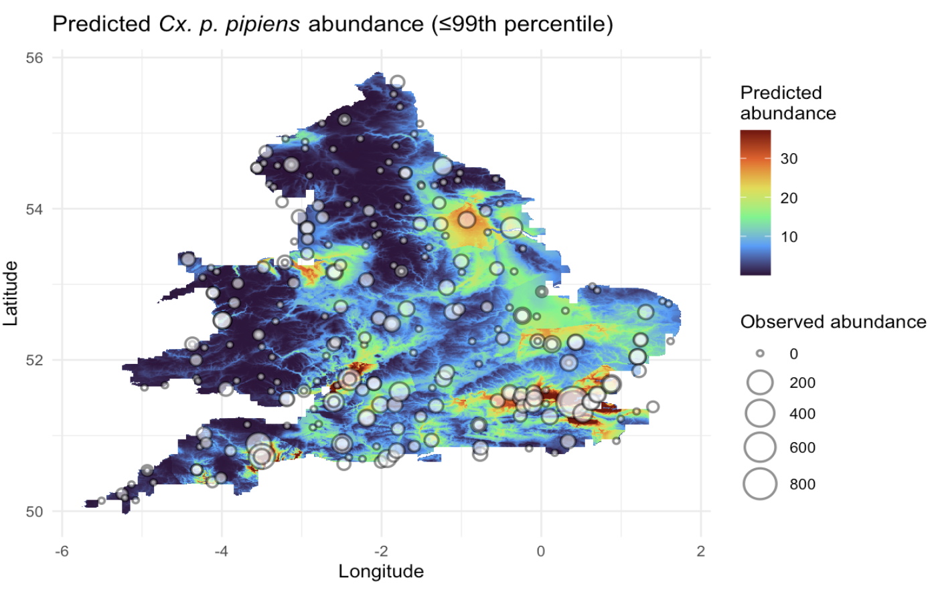
SM Figure 2 Predicted present day Culex p. pipiens abundance with observed abundances from field data
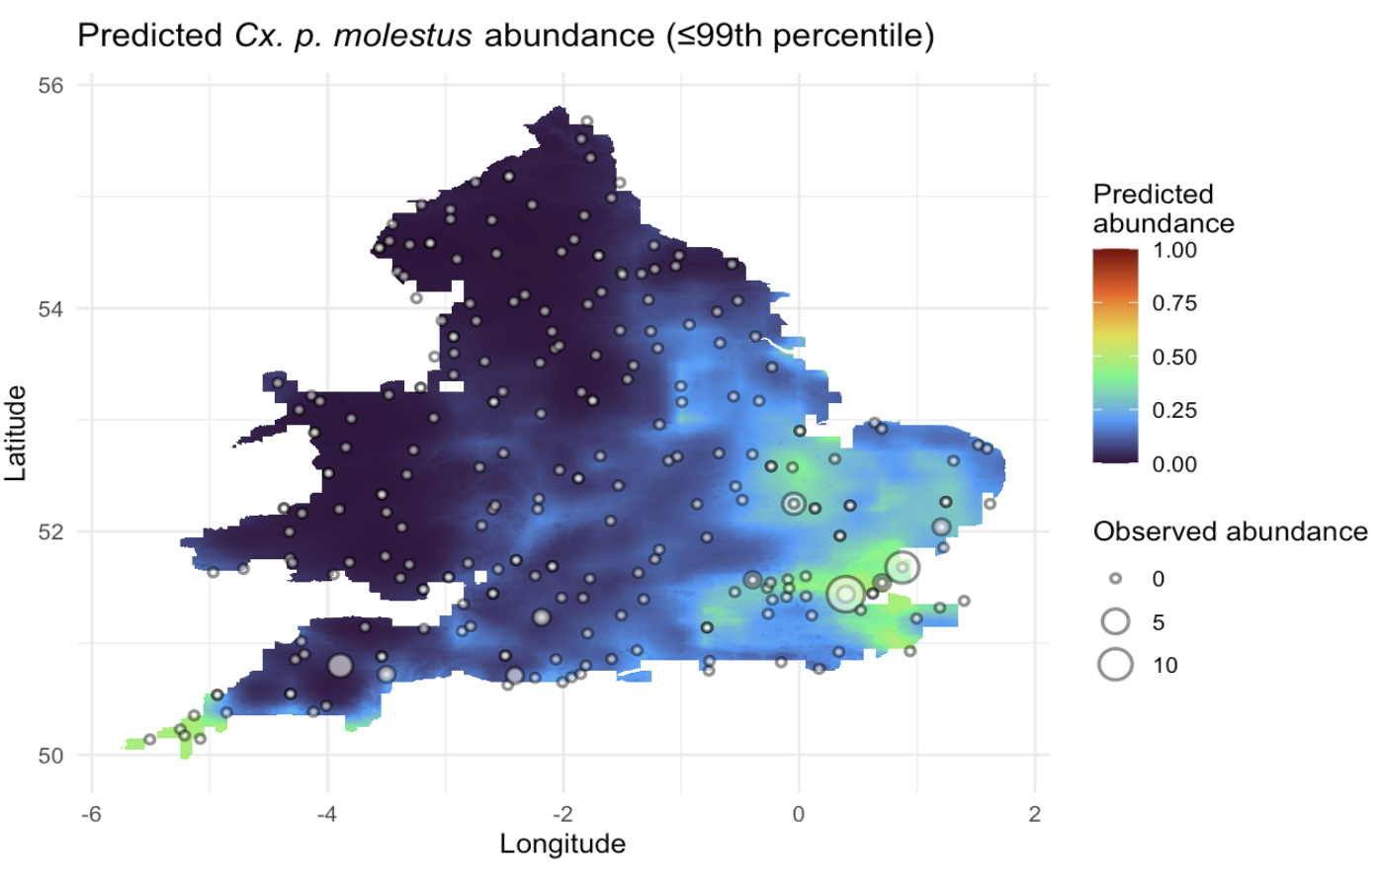
SM Figure 3 Predicted present day Culex p. molestus abundance with observed abundances from field data
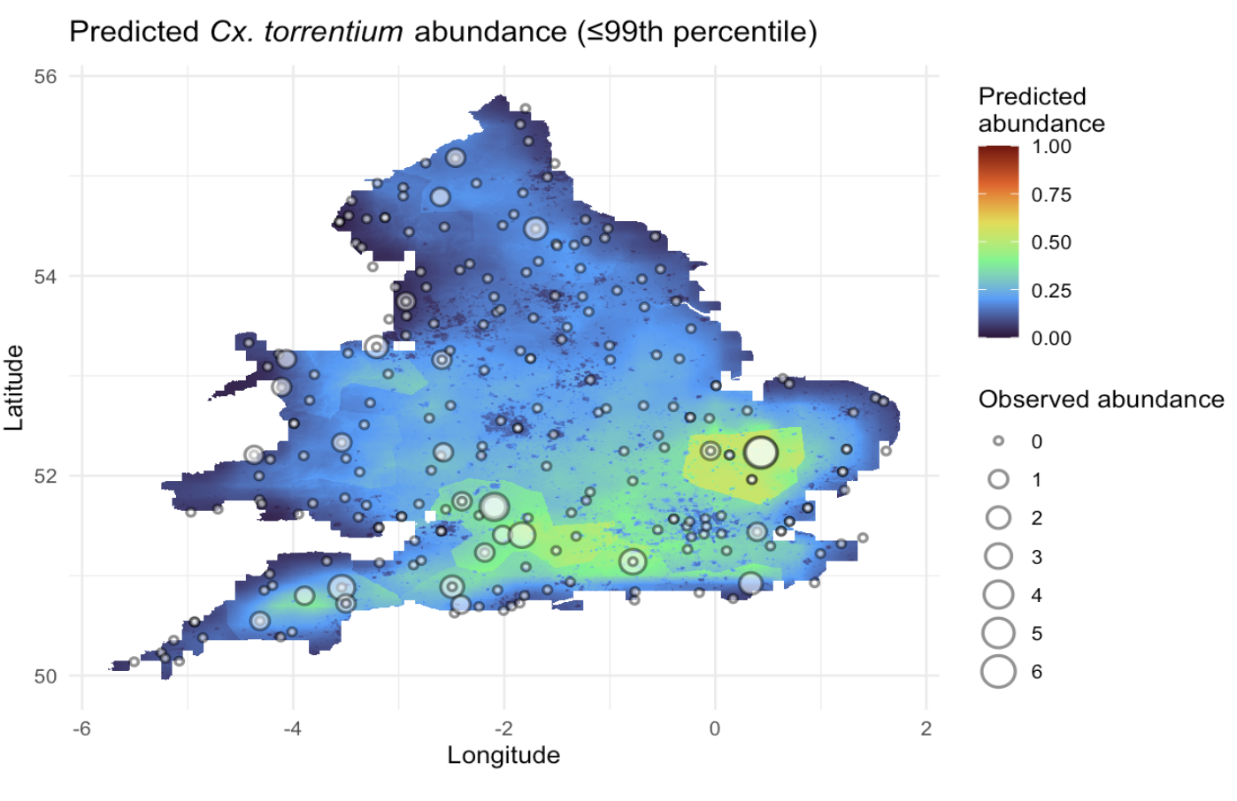
SM Figure 4 Predicted present day Culex torrentium abundance with observed abundances from field data
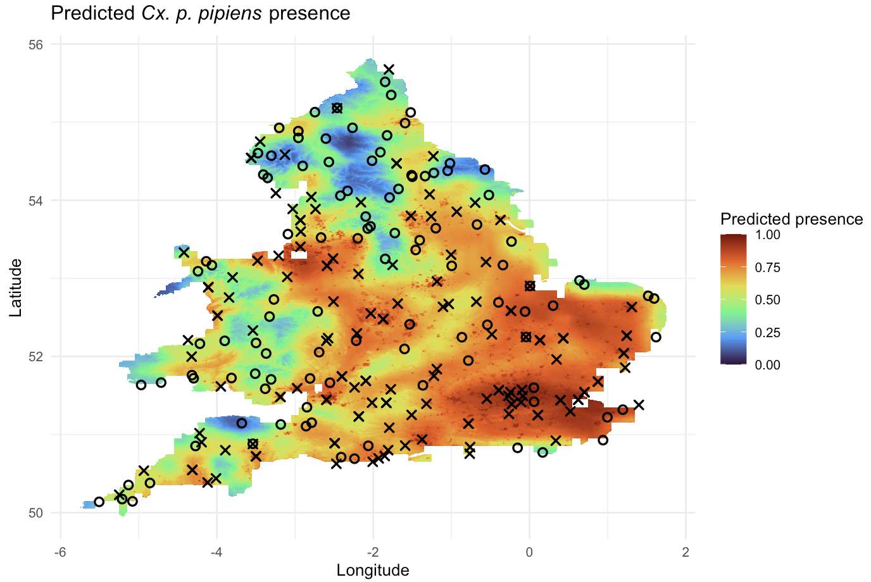
SM Figure 5 Predicted present day Culex p. pipiens probability of presence with observed catches from field data. X = present, O = absent
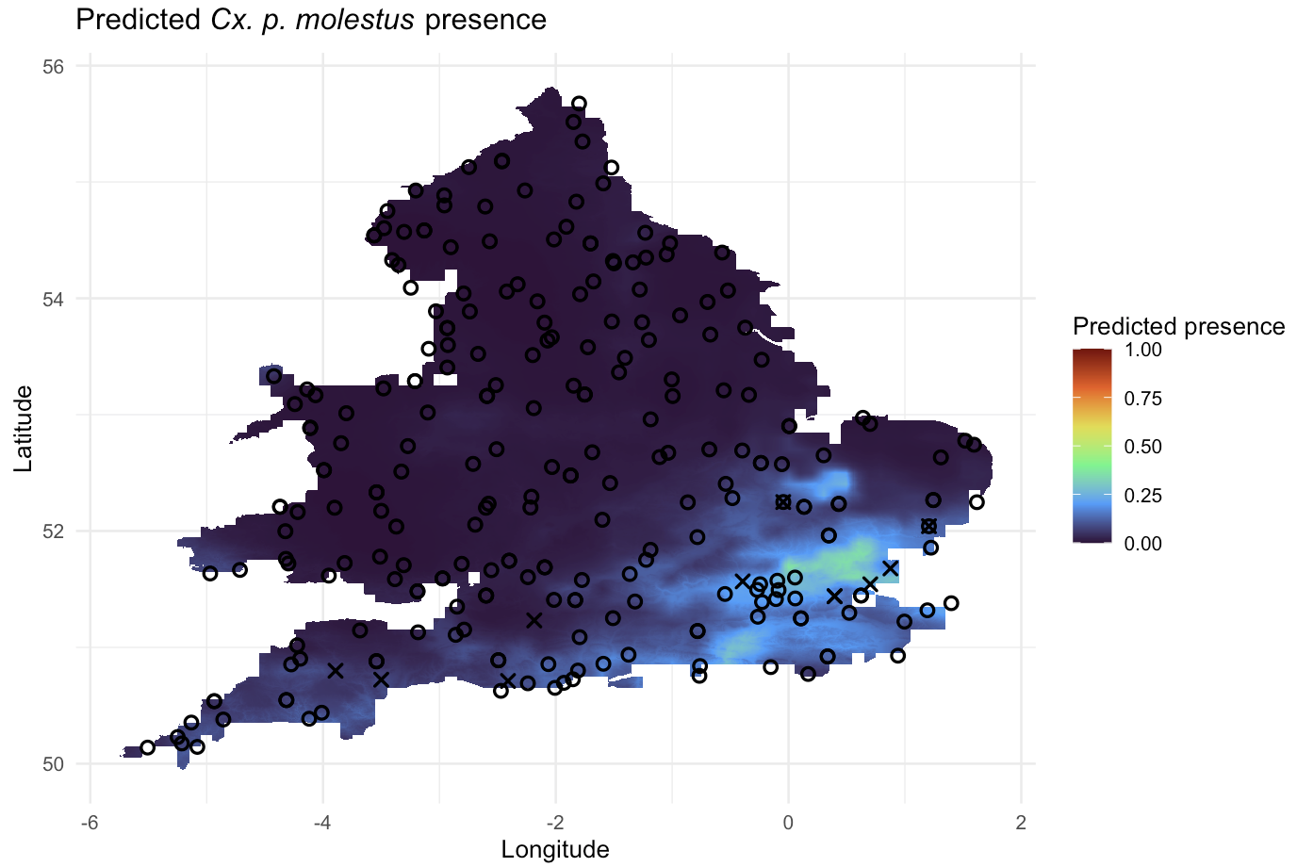
SM Figure 6 Predicted present day Culex p. molestus probability of presence with observed catches from field data. X = present, O = absent
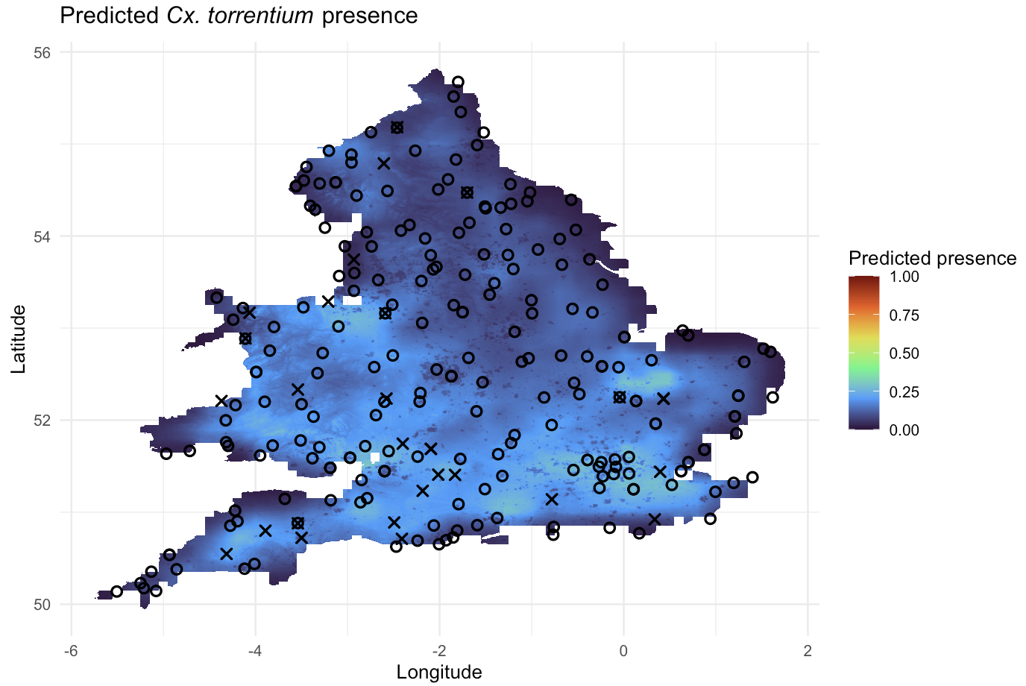
SM Figure 7 Predicted present day Culex torrentium probability of presence with observed catches from field data. X = present, O = absent

Maps with masked areas
The following maps display areas in grey which have been capped at the value of the 99th percentile in the main publication to prevent spurious results.
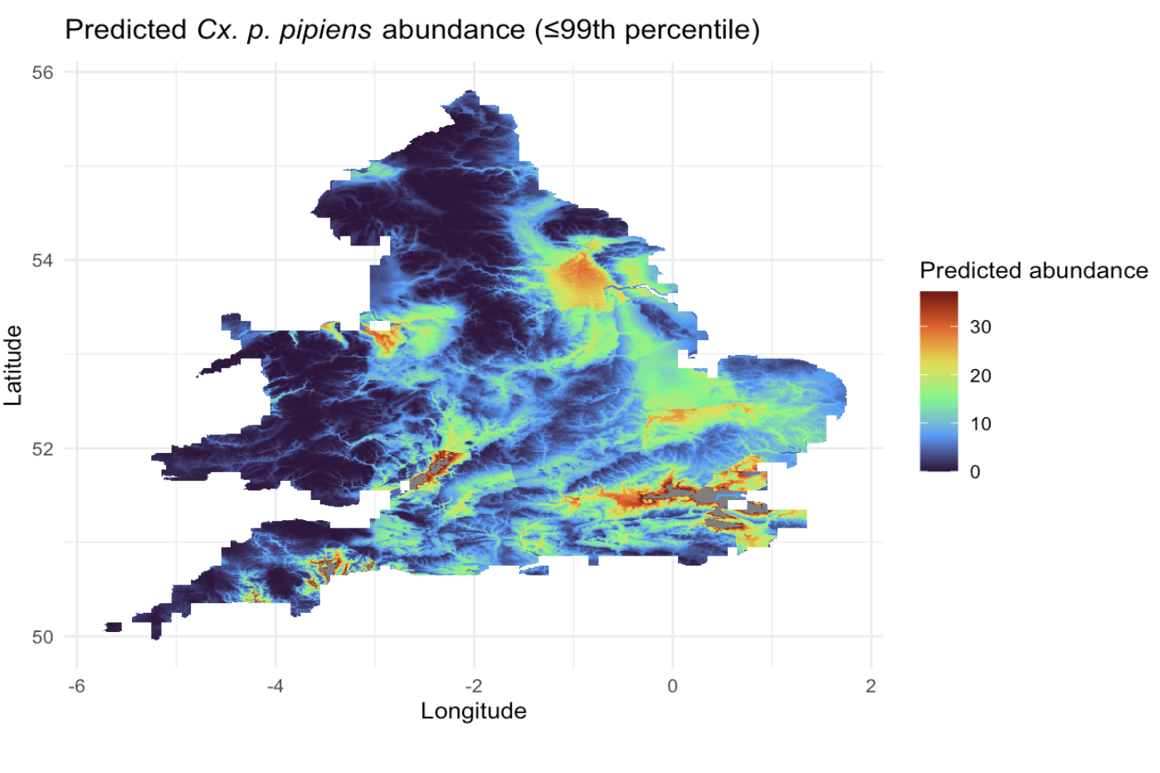
SM Figure 8 Predicted present day Culex p. pipiens abundance with masked out areas where results were above the 99th percentile. These included along the river Thames, river Exe and the Severn estuary.

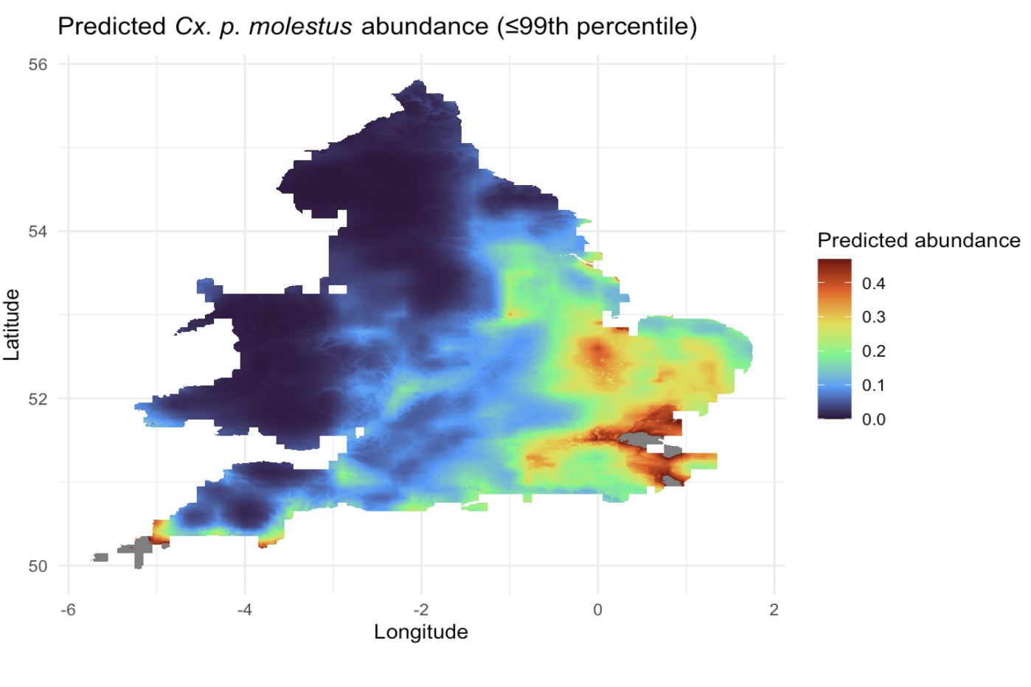
SM Figure 9 Predicted present day Culex p. molestus abundance with masked out areas where results were above the 99th percentile. These included along the river Thames, and small areas in Kent and Cornwall.

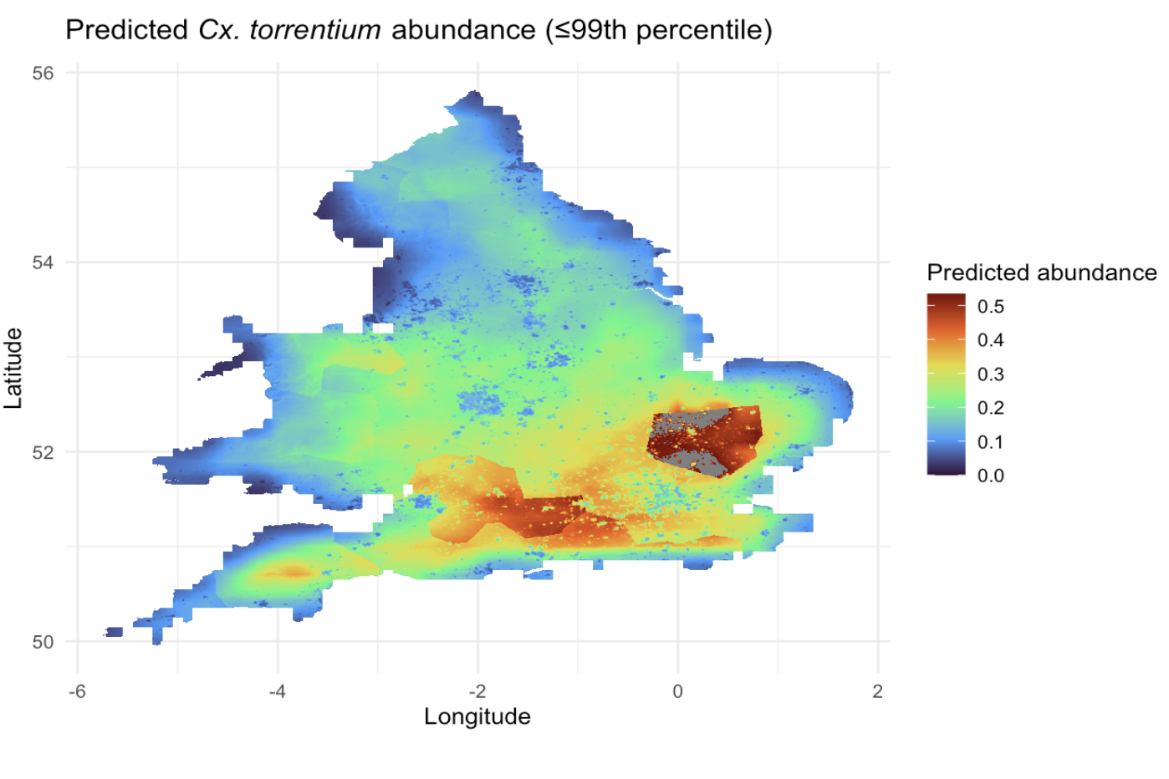
SM Figure 10 Predicted present day Culex torrentium abundance with masked out areas where results were above the 99th percentile. These included in the Cambridgeshire and Hertfordshire areas.

