Isolation and Optimization of Proteolytic Bacteria for Protease Production Using Response Surface Methodology
Plabon Islam Turzo^{1*}, Israt Jahan², Aicha Akouz³, Sharmin Zaman Emon⁴, Fatema-Tuj-Zohra^{5*}
^{1*}Department of Civil and Environmental Engineering, University of Nevada, Reno, 1664 N. Virginia Street, Reno, NV 89557, USA
²Department of Biochemistry and Molecular Biophysics, Texas A&M University, 300 Olsen Blvd. College Station, TX 77843-2128, USA
³Environmental, ecological and agro-industrial engineering laboratory, Faculty of Sciences and Technologies, Sultan Moulay Slimane University, BP 523, 23000, Beni Mellal, Morocco
⁴Food and Nutrition Research Laboratory, Centre for Advanced Research in Science, University of Dhaka, Dhaka-1000, Bangladesh
^{5*}Department of Leather Products Engineering, University of Dhaka, 44-50 Sher-E-Bangla Road, Hazaribagh, Dhaka-1209, Bangladesh
(Email: plabonislam4@gmail.com, isratjsurovi@gmail.com, a.akouz@usms.ma, sharmin_micro@du.ac.bd, fatema.ilet@du.ac.bd)
* Corresponding author: Fatema-Tuj-Zohra, Department of Leather Products Engineering, University of Dhaka, 44-50, Hazaribagh, Dhaka-1209, Bangladesh, E-mail: fatema.ilet@du.ac.bd; https://orcid.org/0000-0002-2298-9978
Plabon Islam Turzo, Department of Civil and Environmental Engineering, University of Nevada, Reno, 1664 N. Virginia Street, Reno, NV 89557, USA, E-mail: plabonislam4@gmail.com ; https://orcid.org/my-orcid?orcid=0000-0001-8903-7608
Summary:
S1. Extraction process of genomic DNA 3
S2. Production of crude protease 3
S3. Determination of protease activity 4
S4. Identification using API strip 4

Figure S1. PCR amplification cycle showing denaturation, annealing, and extension steps applied for 16S rRNA gene amplification of isolate PS15. 6
Figure S2. Disc diffusion assay showing inhibition zones around antibiotic discs. PS15 was sensitive to cefixime, azithromycin, levofloxacin, tetracycline, and gentamicin, while resistant to bacitracin. 6
Figure S3. The results of the API 50CHB/E strip for the S7 isolate. (a) and (c) the result of the API 20E strip, (b) and (d) the result of the API 50CH strip 7
Figure S4. Identification results of S7 isolate in APIWEBT™ 7
Figure S5. MALDI-TOF mass spectrometry (VITEK MS) results showing protein profile matching with S7 8
Figure S6. DNA quantification of isolate PS15 using Nanodrop spectrophotometer. The A260/A280 absorbance ratio indicated acceptable purity for downstream PCR and sequencing. 8
Figure S7. Agarose gel electrophoresis of PCR-amplified 16S rRNA gene showing a distinct ~1.5 kb band for isolate PS15 9
Figure S8. BLAST alignment of 16S rRNA sequence of isolate S7 (PS15) with closest hits to Lysobacter enzymogenes. Sequence similarity below 98% suggests potential novelty. 9
Figure S9. (a) Predicted vs experimental plot, (b) plot of residuals vs predicted, (c) Box-Cox plot for power transforms 10

Table S1. Composition of the master mix (MM) solution 11
Table S2. Composition of the PCR reaction 11
Table S3. Colony tozone diameter ratio in SMA media of different isolates 13
Table S4. Colony characteristics of S7 bacteria. 13
Table S5. Antibiotic susceptibility test of L. enzymogenes PS15 13
Table S6. Experimental design matrix for optimization of protease according to CCRD 14
Table S7. Predicted and experimental results of the confirmation run at the optimal point, with a prediction interval of 95%. 15

S1. Extraction process of genomic DNA
For DNA isolation up to 2×10⁹ bacterial cells were harvested in a 1.5 mL microcentrifuge tube by centrifugation for 5 min at 7000 rpm. Then the supernatant was discarded. Following the initial step, the pellets were suspended in 180 μL of ATL buffer, followed by the addition of 20μL of Proteinase K. Achieving a homogeneous mixture involved thorough vortexing or pipetting.
Subsequently, the sample underwent incubation at 56 ºC, occasionally vortexing or utilizing a shaking water bath until complete cell lysis occurred (1-3 h). Next, 200 μL of AL buffer solution was introduced and mixed by vortexing, followed by a 10 min incubation at 70 ºC at room temperature.
Following this, 200μL of 50 % ethanol was added and mixed by vortexing. The resulting lysate was then transferred to a spin column inserted in a collection tube and centrifuged for 1 min at 6000 x g. The collection tube containing the flow-through solution was discarded, and the spin column was relocated to a new 2 mL collection tube.
Subsequently, 500 μL of Wash Buffer I (ethanol added) was introduced and centrifuged for 1 min at 8000 x g. The flow-through column was then discarded, and the purification column was returned to the collection tube. 500μL of wash buffer II (ethanol added) was added to the spin column, followed by centrifugation for 3 min at maximum speed (12000 x g). The collection tube containing the flow-through solution was discarded, and the spin column was transferred to a sterile 1.5 mL microcentrifuge tube.
Next, 70 μL of Elution Buffer was added to the center of the Spin Column membrane to elute genomic DNA. After a 5-minute incubation at room temperature, centrifugation for 1 min at 6000 x g followed. Finally, the DNA was stored at -20 ºC.

S2. Production of crude protease
The pure isolate was inoculated into sterile nutrient broth media (peptone 1%, yeast extract 0.5%, NaCl 0.5%) at a pH of 7.0 and 37 °C temperature at 150 rpm for 24 h incubation to produce bacterial seed. Then, 1% (v/v) of the culture was transferred to broth medium and incubated in an orbital shaker at 37 °C for 48 h. Cultures were centrifuged at 10,000 rpm using benchtop centrifuges machine(Model: PRO-RESEARCH.K241R, UK) for 15 min at 4 °C to separate the enzyme and the bacterial pellets. The supernatant, containing crude protease, was analyzed using Aldrich’s Non-specific Protease Activity Assay (Cupp-Enyard, 2008). Although OFAT indicated growth at 30-37 °C, production and assays were performed at 37 °C for consistency with the casein assay and also protease activity detected in the supernatant after removal of cells confirmed extracellular localization.

S3. Determination of protease activity
Protease activity was measured using a modified version of Sigma Aldrich’s nonspecific Protease Activity Assay with casein as the substrate. A 1.0 gL⁻¹ casein solution in 50 mM phosphate buffer (pH 7.5) was heated to 80 °C for 10 min, with pH adjusted afterwards.
For the assay, 5 mL of casein solution was dispensed into two Falcon tubes: one containing 1 mL of crude enzyme and the other serving as the blank. The tubes were incubated at 37 °C for 10 min. Then, 5 mL of 10 gL⁻¹ chilled trichloroacetic acid (TCA) solution was added to both tubes to halt the reaction, and 1 mL of enzyme was added to the blank. The samples were incubated for 10 min and then centrifuged at 8000 rpm for 20 min.
From each tube, 2 mL of supernatant was mixed with 5 mL of 0.25 M sodium carbonate and 1 mL diluted Folin’s phenol reagent (1:4), incubated at 37 °C for 20 min, and centrifuged again at 8000 rpm for 5 min. Absorbance was measured at 660 nm using UV-Vis spectrometry, and the concentration of released tyrosine was determined from a standard curve.
To get the activity of the enzyme in U/ml, perform the following calculation:
$$Activity\left(\frac{U}{mL}\right)=\frac{µmole of tyrosine equivalents released x Total volume of assay }{Volume used in colorimeter x Time of assay x Volume of enzyme}$$
One unit of enzyme activity was defined as the amount of enzyme that liberates 1 μg of tyrosine per mL per minute under the specified assay conditions. In this context, tyrosine equivalents (μg) were calculated using the standard curve derived from the absorbance readings of the sample and its blank.

S4. Preliminary identification using API strip
The API system is commonly used for classification and rapid identification of bacteria based on biochemical profiling. Each test strip contains multiple wells containing dehydrated substrates that, upon inoculation, assess specific enzymatic activities. These reactions reflect the metabolic capabilities of the organism, such as carbohydrate fermentation or the degradation of proteins and amino acids. API 50CH and 20E tests were used to identify the bacterium. Suspensions matched with McFarland Standard 2 were inoculated into the first 12 wells of the API 20E strip and all wells of the API 50CH strip. The remaining 8 wells of the API 20E strip were not rehydrated, as the corresponding tests are duplicated on the API 50CH strip. Then they were incubated for 24 h at 30 °C (for 50CH strip) and 37 °C (20E strip). Reagents (TDA, JAMES, Barritt’s A/B) were added to the 20E post-incubation strip for final identification.

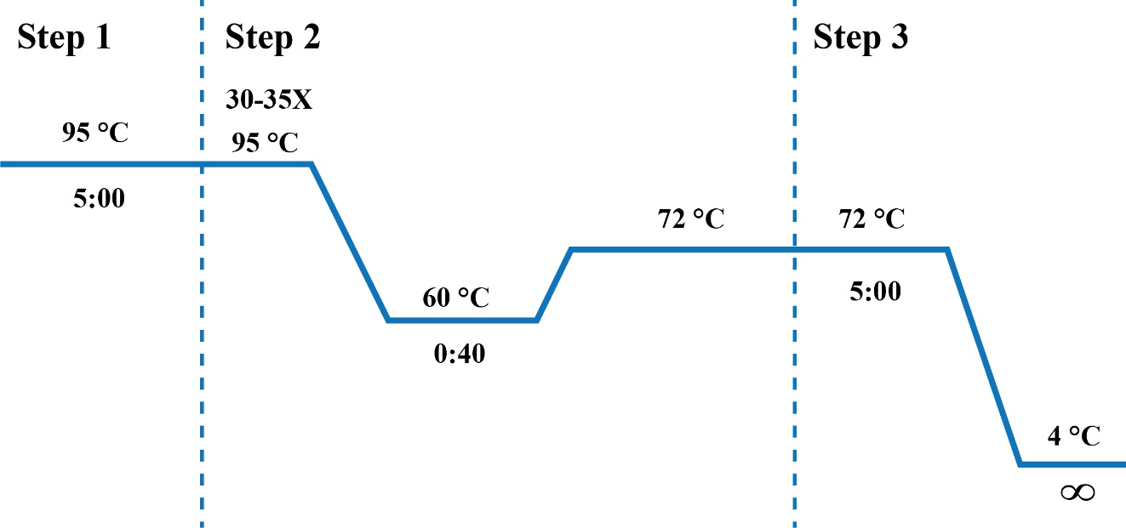
Figure S1. PCR amplification cycle showing denaturation, annealing, and extension steps applied for 16S rRNA gene amplification of isolate PS15.
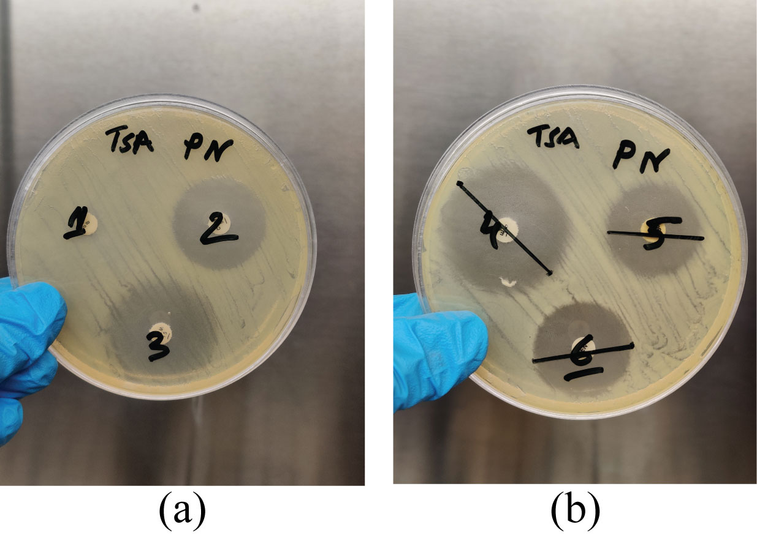
Figure S2. Disc diffusion assay showing inhibition zones around antibiotic discs. PS15 was sensitive to cefixime, azithromycin, levofloxacin, tetracycline, and gentamicin, while resistant to bacitracin.

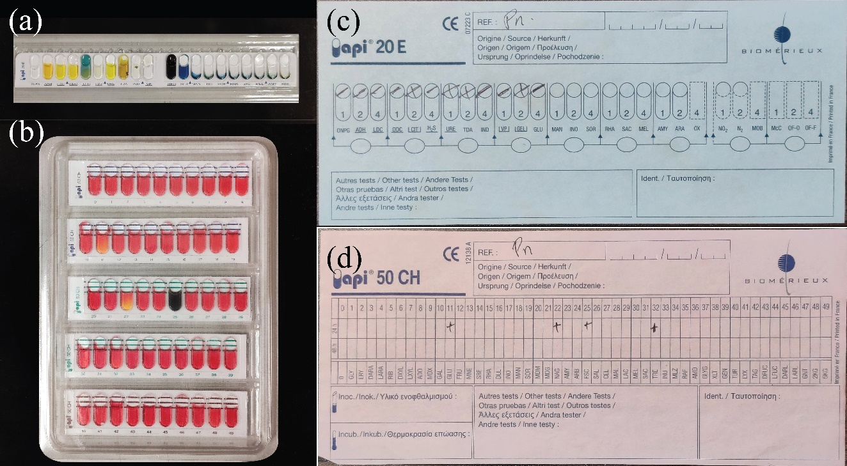
Figure S3. The results of the API 50CHB/E strip for the S7 isolate. (a) and (c) the result of the API 20E strip, (b) and (d) the result of the API 50CH strip

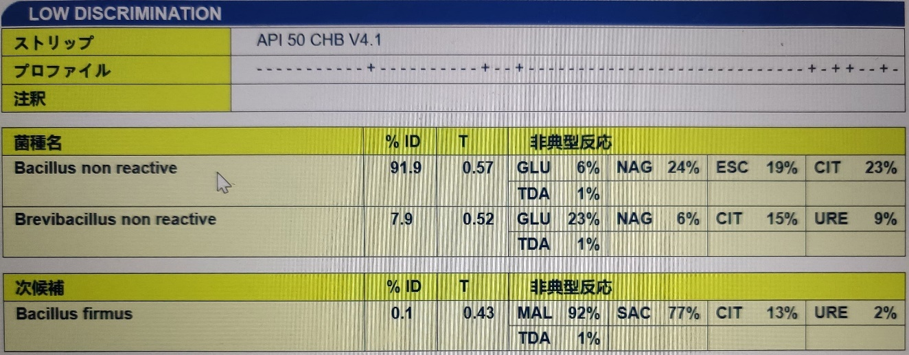
Figure S4. Identification results of S7 isolate in APIWEBT™

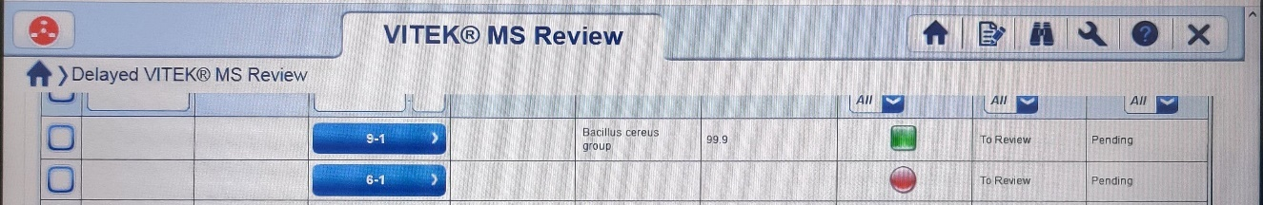
Figure S5. MALDI-TOF mass spectrometry (VITEK MS) results showing protein profile matching with S7

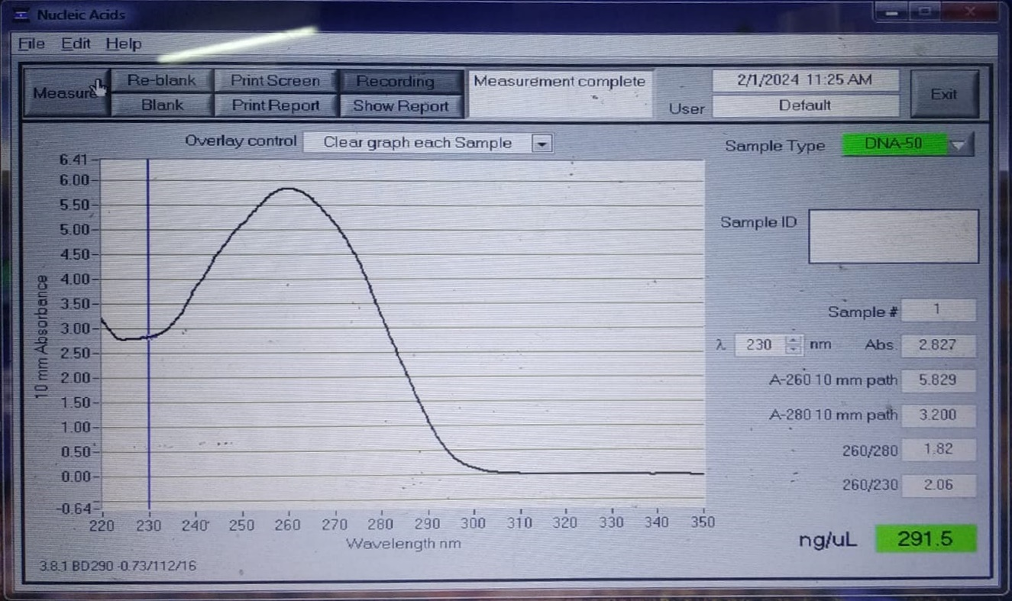
Figure S6. DNA quantification of isolate PS15 using Nanodrop spectrophotometer. The A260/A280 absorbance ratio indicated acceptable purity for downstream PCR and sequencing.
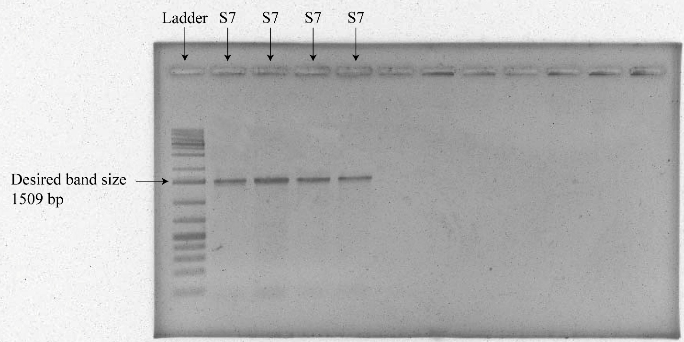
Figure S7. Agarose gel electrophoresis of PCR-amplified 16S rRNA gene showing a distinct ~1.5 kb band for isolate PS15

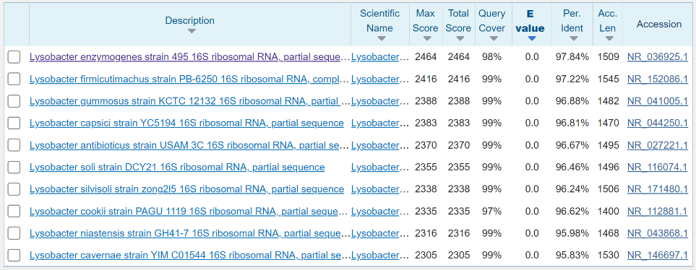
Figure S8. BLAST alignment of 16S rRNA sequence of isolate S7 (PS15) with closest hits to Lysobacter enzymogenes. Sequence similarity below 98% suggests potential novelty.

Figure S9. (a) Predicted vs experimental plot, (b) plot of residuals vs predicted, (c) Box-Cox plot for power transforms

Table S1. Composition of the master mix (MM) solution
Components | Volume
PCR buffer (10x) | 1.5 μl
dNTPs (1mM) | 1.5 μl
MgCl2 (50mM) | 0.5 μl
Forward primer(10mM) | 0.5 μl
Reverse primer (10mM) | 0.5 μl
Taq polymerase (1x) | 0.15 μl

Table S2. Composition of the PCR reaction
Components | Volume
Master Mix solution | 4.65 μl
Sample | 1.5 μl
Nuclease Free Water | 8.85 μl
Total volume | 15 μl

Table S3. Cases selected for maximum protease production
Case | A: pH | B: Time (h) | C: Temperature (°C) | D: Inoculum volume (%) | Y: Enzyme Activity (U/mL)
1 | I-3 | I-3 | I-3 | I-3 | Max-5
2 | I-3 | Max-5 | I-3 | I-3 | Max-5
3 | I-3 | Max-5 | Max-5 | I-3 | Max-5
4 | I-3 | Max-5 | Max-5 | Max-5 | Max-5
5 | I-3 | Min-5 | I-3 | I-3 | Max-5
6 | I-3 | Min-5 | Min-5 | I-3 | Max-5
7 | I-3 | Min-5 | Min-5 | Min-5 | Max-5
8 | I-3 | Max-3 | I-3 | I-3 | Max-5
9 | I-3 | Max-3 | Max-3 | I-3 | Max-5
10 | I-3 | Max-3 | Max-3 | Max-3 | Max-5
11 | I-3 | Min-3 | I-3 | I-3 | Max-5
12 | I-3 | Min-3 | Min-3 | I-3 | Max-5
13 | I-3 | Min-3 | Min-3 | Min-3 | Max-5
Note: I = In range; Min = Minimized; Max = Maximized; 3 = Medium importance level; 5 = Highest importance level. If a factor was indicated by “I” (In range), the corresponding ranges were pH (6.5-7.5), time (24-48 hours), temperature (37-43°C), and inoculum volume (1-2.5%).
Case 1 involved keeping all parameters within their defined ranges, with an importance level set at 3. Cases 2 through 4 focused on maximizing one parameter at a time, assigning each a higher importance level of 5, while cases 5 through 7 did the opposite. The same procedure was repeated for cases 8 through 13, but with the importance level adjusted to 3. The objective is to minimize both time and temperature while maximizing enzyme activity to enhance the potential for commercial application.

Table S4. Colony tozone diameter ratio in SMA media of different isolates
Isolate ID | S1 | S2 | S3 | S4 | S5 | S6 | S7 | S8 | S9
Colony: Zone diameter(mm) | 17:21 | 5:25 | 7:11 | 8:25 | 6:28 | 7:25 | 4:24 | 7:27 | 5:23

Table S5. Colony characteristics of S7 bacteria.
Test Name | Observed results
Gram staining | Gram-negative
Shape of bacteria | Bacillus (rod-shape)
Motility | Swarming positive
Endospore staining | Negative
Biofilm formation | Positive
Cultural characteristics | Yellowish
The shape of the colony | Rounded, reef edge
Edge | Lobate
Elevation | Raised
Size | Medium
Pigment | Not pigmented
Optical | Translucent

Table S6. Antibiotic susceptibility test of L. enzymogenes PS15
ID | Antibiotic | Zone of Inhibition  (mm) | Susceptance (S)/ resistance (R)
1 | Bacitracin (10 μg) | 6 | R
2 | Cefixime (5 μg) | 28 | S
3 | Azithromycin (15 μg) | 31 | S
4 | Levofloxacin (5 μg) | 35 | S
5 | Tetracycline (30 μg) | 25 | S
6 | Gentamicin (10 μg) | 27 | S
Table S7. Experimental design matrix for optimization of protease according to CCRD
Run | Factor 1 | Factor 2 | Factor 3 | Factor 4 | Response
Run | A: pH | B: Time  (h) | C: Temperature  (°C) | D: Seed volume  (%) | Actual Enzyme Activity  (U/mL) | Predicted Enzyme Activity  (U/mL)
1 | -2 | 0 | 0 | 0 | 12.3366 | 11.93
2 | 0 | 0 | 0 | 2 | 5.918 | 10.04
3 | 1 | 1 | -1 | 1 | 25.6419 | 21.23
4 | -1 | -1 | -1 | -1 | 3.3221 | 4.33
5 | 0 | 2 | 0 | 0 | 17.8366 | 23.16
6 | 1 | -1 | -1 | 1 | 0.793023 | -0.5248
7 | 0 | 0 | -2 | 0 | 3.41512 | 11.73
8 | 1 | -1 | 1 | 1 | 2.58372 | 5.46
9 | 1 | 1 | 1 | -1 | 5.48779 | 10.12
10 | -1 | -1 | 1 | -1 | 1.56047 | 6.63
11 | -1 | 1 | -1 | 1 | 21.0983 | 18.36
12 | -1 | 1 | -1 | -1 | 25.9703 | 23.76
13 | 0 | 0 | 0 | 0 | 32.6978 | 34.21
14 | 1 | -1 | 1 | -1 | 1.4093 | 3.71
15 | 0 | 0 | 0 | 0 | 33.9791 | 34.21
16 | 1 | 1 | -1 | -1 | 29.2349 | 24.96
17 | 0 | 0 | 0 | 0 | 33.2877 | 34.21
18 | 2 | 0 | 0 | 0 | 11.6971 | 11.88
19 | -1 | -1 | 1 | 1 | 2.87151 | 6.71
20 | 0 | 0 | 0 | 0 | 36.2349 | 34.21
21 | -1 | 1 | 1 | 1 | 15.9209 | 15.08
22 | 0 | -2 | 0 | 0 | 0.72907 | -4.82
23 | 0 | 0 | 2 | 0 | 15.3657 | 6.82
24 | 0 | 0 | 0 | 0 | 36.6321 | 34.21
25 | 0 | 0 | 0 | -2 | 18.0285 | 13.68
26 | 0 | 0 | 0 | 0 | 32.4321 | 34.21
27 | -1 | 1 | 1 | -1 | 11.9762 | 12.86
28 | -1 | -1 | -1 | 1 | 0.761047 | -3.21
29 | 1 | -1 | -1 | -1 | 3.8366 | 5.34
30 | 1 | 1 | 1 | 1 | 15.4616 | 14.01

Table S8. Predicted and experimental results of the confirmation run at the optimal point, with a prediction interval of 95%.
Analysis | Predicted Mean | Predicted Median | Std Dev | n | SE Pred | 95% PI low | Data Mean | 95% PI high
Activity | 36.6252 | 36.6252 | 1.94264 | 3 | 1.4734 | 33.4847 | 35.0933 | 39.7657

