Post-2000 Nonlinear Escalation of Humid Heat Stress Over South Asia
Prolay Saha^{1*}
ORCID id: 0000-0002-9404-9029
Correspondence: end.havoc@gmail.com
Rahul Mahanta^{1,2}
ORCID id: 0000-0002-0947-4291s
Toru Terao³

Author details
¹Department of Physics, Cotton University, Guwahati, Assam, India
² Centre for Clouds and Climate Change Research, Cotton University, Guwahati, Assam, India
³Faculty of Education, Kagawa University, Takamatsu, Kagawa, Japan

- Methods in Details:
  - Computation of the Humidex Index
The humidex (H) is defined
$$H=T+0.5555\left(e-10\right) (1)$$

Where $e$(hPa) is the water-vapour pressure estimated from the dewpoint temperature as
$$e=6.11×exp\left[5417.7530×\left(\frac{1}{273.16}-\frac{1}{273.15+T_{d}}\right)\right] (2)$$

Both ($T$) and ($T_{d}$) are expressed in °C. The humidex thus combines thermal and moisture effects to represent apparent temperature and perceived heat stress. The Canadian Centre for Occupational Health and Safety (CCOHS) (for Occupational Health and Safety,2024) classifies humidex values exceeding 45 °C as “dangerous” for human health; however, this threshold may not be universally applicable to South Asia due to differences in climate, topography, and population acclimatization. Consequently, region-specific percentile-based thresholds are derived here to identify heatwave conditions.
  - Definition of Humidex based Heatwave Metrics
The SAM region exhibits highly heterogeneous topography, ranging from low-lying plains to mountainous areas (Fig. S3). This study focuses on two east–west asymmetric portions of the SAM region, representing these contrasting terrains, making it essential to account for their differing thermal characteristics. In recent decades, the region has emerged as a hotspot of humid heat stress. If heatwave metrics were computed over the entire domain using simple box averages, the distinct thermal features of plains and hills would be mixed, potentially leading to misleading results. For instance, the 90th percentile of daily maximum humidex differs substantially between the two terrains, with ~44 °C in the plains and ~28 °C in the hilly regions.
To preserve these contrasts, the dataset was masked using SRTM topography (Tozer et al., 2019): grid points with elevations below 700 m were classified as plains, while those above were classified as hilly regions. This threshold ensures a comparable number of grid points in each region and effectively isolates major highlands, such as the Meghalaya Plateau.

To identify heatwave conditions from humidex, two percentile thresholds were employed:
Case I: daily maximum humidex exceeds the 90th percentile of the 1961–1990 climatology for that calendar day;
Case II: daily maximum humidex exceeds the 95th percentile of the same climatological baseline.
Unlike most studies that focus on a single season, the present analysis uses year-round data (January–December) from 1940 to 2023 to identify heatwave events across all seasons. To define heatwave thresholds, daily maximum humidex values from the 1961–1990 reference period were used to calculate percentile-based thresholds (90th and 95th percentiles) for each day of the year at every grid point. This approach ensures that the threshold accounts for the seasonal background climate throughout the year.
For each grid point, a day is considered a humidex exceedance day when the daily maximum humidex value is higher than its corresponding climatological percentile threshold for that calendar day. When such exceedances occur for three or more consecutive days, the period is identified as a heatspell.
From these heatspells, four key metrics are analyzed:
- Total Heatspell Days (THD) – the total number of days that are part of any heatspell.
- Heatwave Events (HWE)– the number of separate heatspells.
- Intensity – the average of the three highest daily humidex values within each heatspell.
- Longest Heatspell (LHS) – the duration (in days) of the longest continuous heatspell within a year.
To assess sub-daily heat exposure, the Hour of Exposure (HoE) metric is computed from hourly humidex data for the extended boreal summer (May–September). Restricting the analysis to this period prevents mixing summer and winter conditions, which differ substantially in background humidity and temperature.
For each grid point and hour, a percentile threshold (90th or 95th) is computed using the same 1961–1990 baseline. An hour is classified as a heat-exceedance hour if the humidex value exceeds this climatological threshold. The HoE for a given day is then the total number of hours (out of 24) when the hourly humidex surpasses its threshold.
This metric captures short-term fluctuations in thermal discomfort that are not visible in daily averages and provides a more detailed measure of cumulative heat stress exposure at sub-daily timescales.
  - Contributions of Temperature and Humidity to Humidex Variability
To understand the physical drivers of humid heat extremes, we decomposed humidex anomalies into contributions from air temperature ($T$) and dewpoint temperature ($T_{d}$), following a linearized approach. For each grid point, the observed humidex anomaly ($ΔH$) relative to the 1979–2022 climatology was approximated by Taylor expansion series as:
$$ΔH≈ΔH_{T}+ΔH_{T_{d}} \left(3\right)$$
where $ΔH_{T}$and $ΔH_{T_{d}}$are the contributions from temperature and humidity, respectively. These contributions are computed as:
$$ΔH_{T}=\frac{∂H}{∂T}ΔT=ΔT \left(4\right)$$
$$ΔH_{T_{d}}=\frac{∂H}{∂T_{d}}ΔT_{d}=0.5555⋅\frac{e⋅5417.7530}{\left(273.15+T_{d})^{2}\right.}⋅ΔT_{d} \left(5\right)$$
Here, $e$ is the vapour pressure derived from the dewpoint (Eq. 2). The total predicted humidex anomaly, $ΔH_{\text{pred}}=ΔH_{T}+ΔH_{T_{d}}$, is used to quantify the fractional contribution of temperature (R_{T}) and humidity (via dewpoint, R_{d}) to the total humidex anomaly:
$$R_{T}=\frac{ΔH_{T}}{ΔH_{T}+ΔH_{T_{d}} } (6)$$

$$R_{T_{d}}= 1 - R_{T} (7)$$

Supplementary figures:

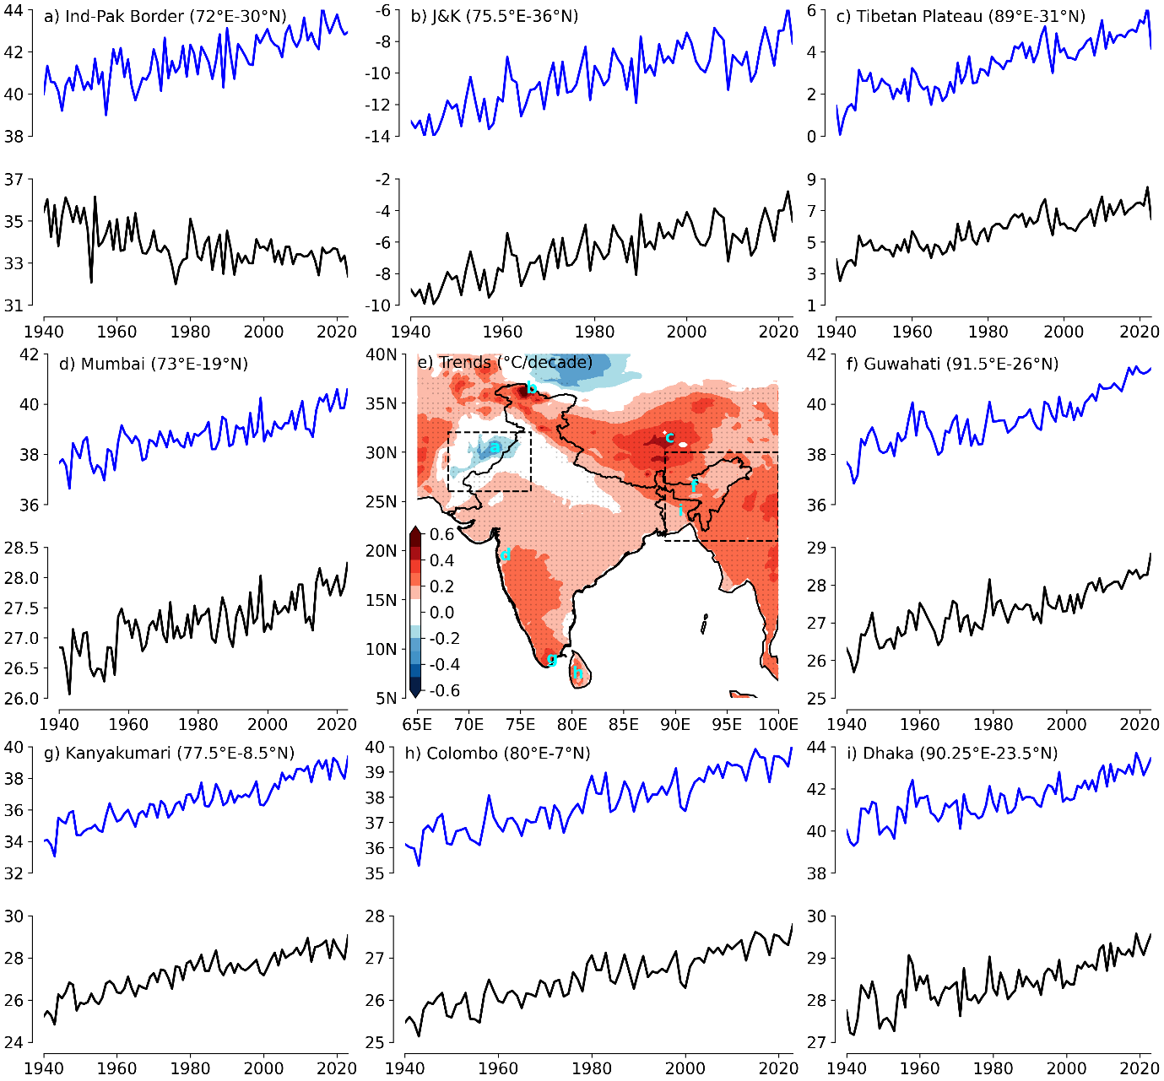

Fig. S1: Trends and variability of near surface temperature and humidex: Time series of 2-meter air temperature (black) and humidex (blue) averaged over the MJJAS (May–September, 1940-2023 from ERA5) season at eight selected locations across the South Asian Summer Monsoon domain: a) India-Pakistan Border (72°E-30°N), b) Jammu and Kashmir (75.5°E-36°N), c) Tibetan Plateau (89°E-31°N), d) Mumbai (73°E-19°N), f) Guwahati (91.5°E-26°N), g) Kanyakumari (77.5°E-8.5°N), h) Colombo (80°E-7°N), and i) Dhaka (90.25°E-23.5°N). Panel e) shows the spatial distribution of trends (Sen’s slope) in 2-meter temperature anomalies for the MJJAS season (1940-2023, ERA5). Stippling indicates statistically significant trends at the 99% confidence level (p < 0.01) based on the Mann–Kendall test. The unit of the color bar is °C per decade. The selected boxes represent regions with contrasting characteristics in near surface temperature anomalies over Northwest India (68°E to 76°E, 26°N to 32°N) and Northeast India (89°E to 100°E, 21°N to 30°N), which are further analysed to explore heatwave events in greater detail.

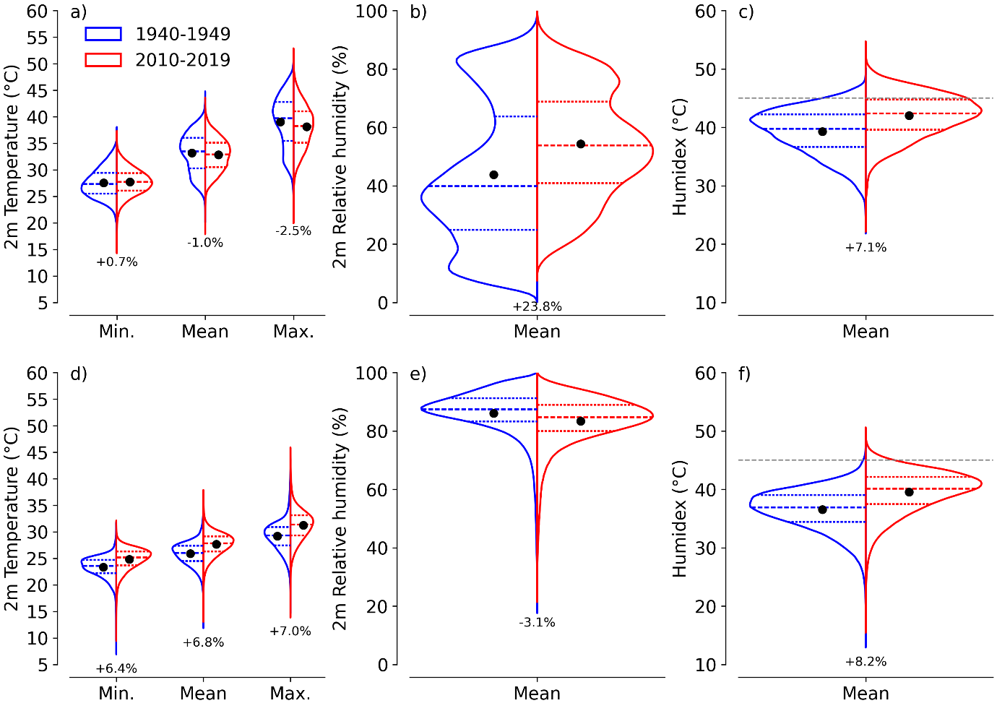

Fig. S2: Violin plot for past and present decades: Probability density distributions of 2-meter air temperature (daily minimum, mean, and maximum), daily mean 2-meter relative humidity, and humidex during the MJJAS (May–September) season for the past decade (1940-1949, blue) and the present decade (2010-2019, red), based on ERA5 reanalysis data. Panels a–c corresponds to Northwest India, and panels d–f corresponds to Northeast India.

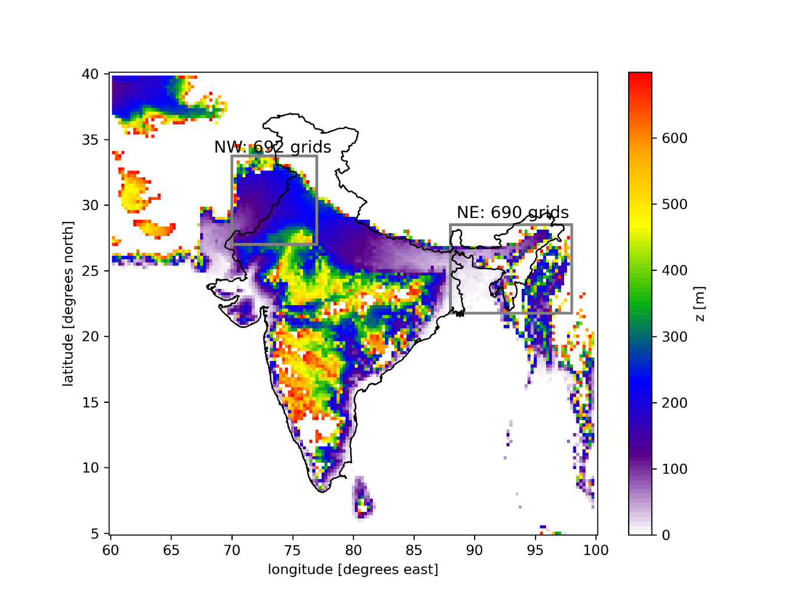

Fig. S3: Topography: Topography over the South Asian monsoon region is shown, masked over land areas below 700 m elevation. The two key study regions of interest, selected to have comparable grid points and elevation, are also highlighted with grey boxes.

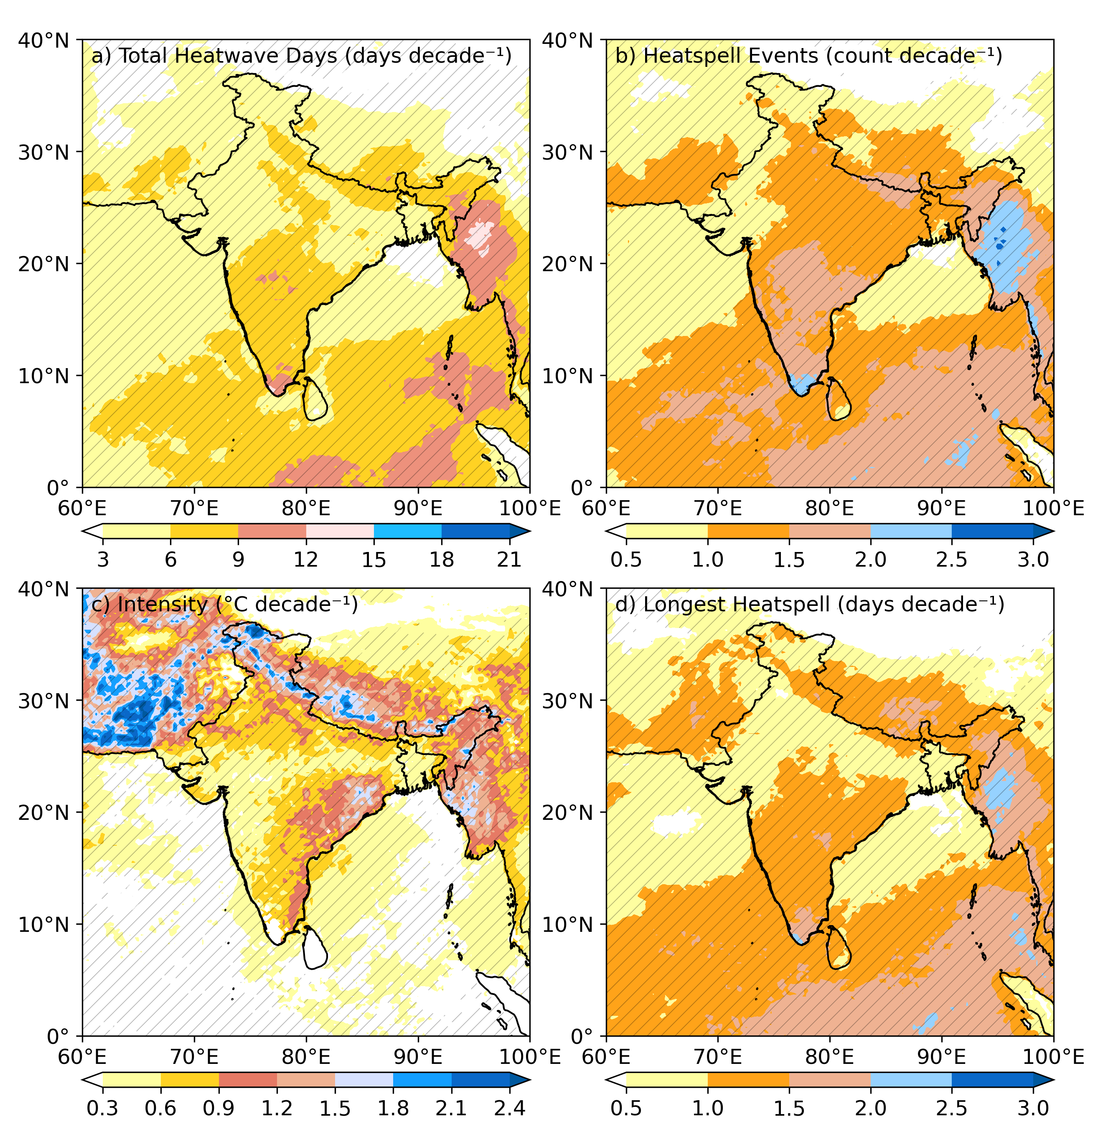
Fig. S4: Trends of Heatwave metrics based on 95th percentile threshold using daily maximum surface humidex: Trends of heatwave metrics from daily maximum surface humidex over the South Asian Summer Monsoon region based on the 95th percentile criteria (1940–2023): a) Total Heatwave Days (days decade⁻¹), b) Heatspell Events (count decade⁻¹), c) Intensity (°C decade⁻¹), d) Longest Heatspell (days decade⁻¹).

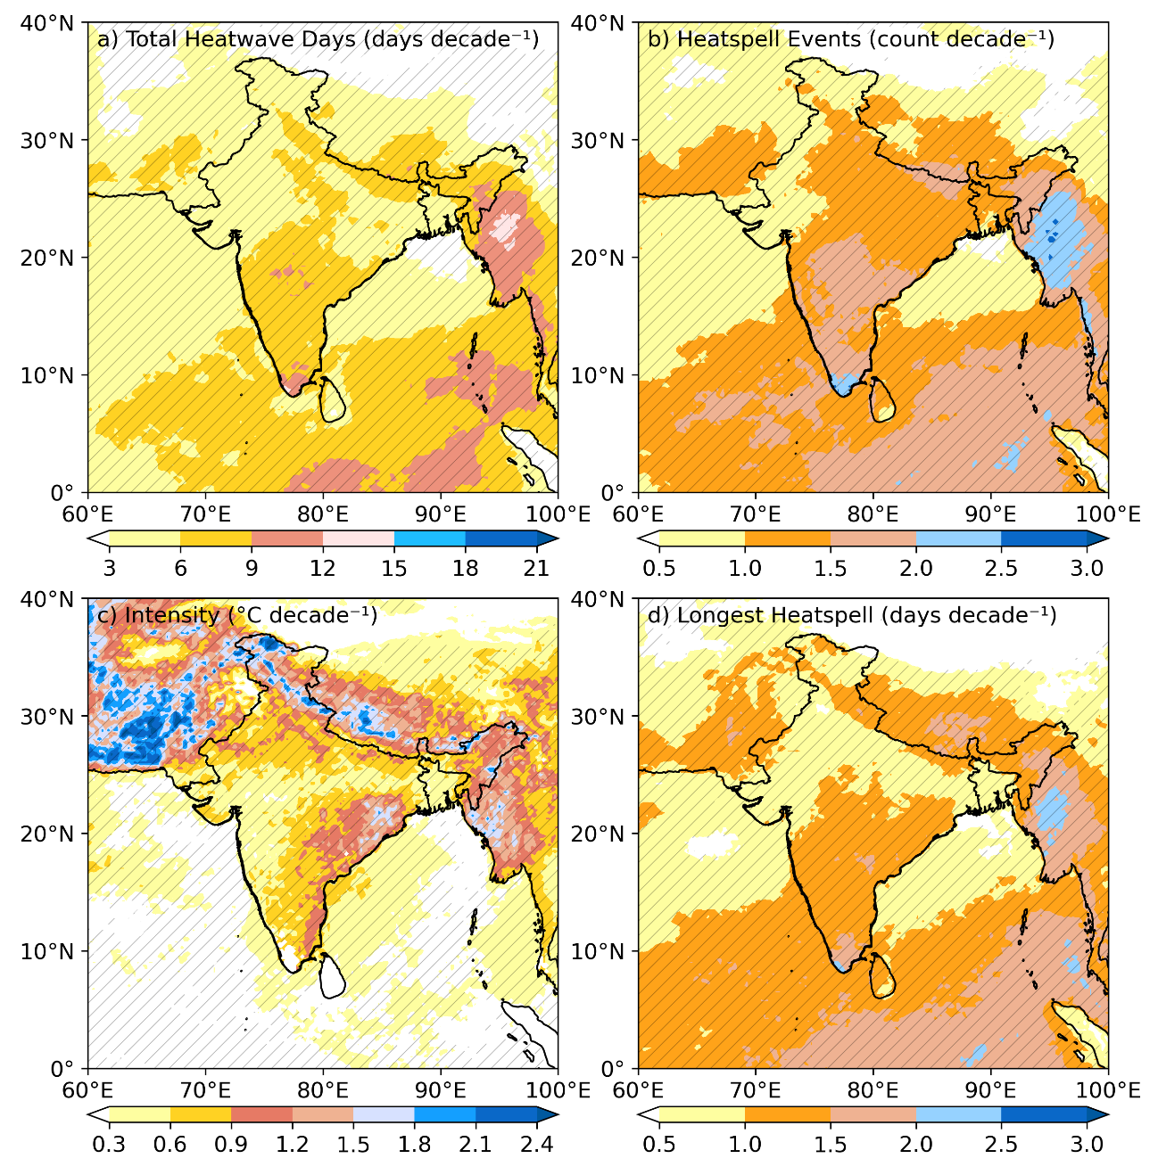

Fig. S5: Trends of Heatwave metrics based on 90th percentile threshold using daily maximum 2m air temperature: Trends of heatwave metrics from daily maximum surface temperature over the South Asian Summer Monsoon region based on the 90th percentile criteria (1940–2023): a) Total Heatwave Days (days decade⁻¹), b) Heatspell Events (count decade⁻¹), c) Intensity (°C decade⁻¹), d) Longest Heatspell (days decade⁻¹).

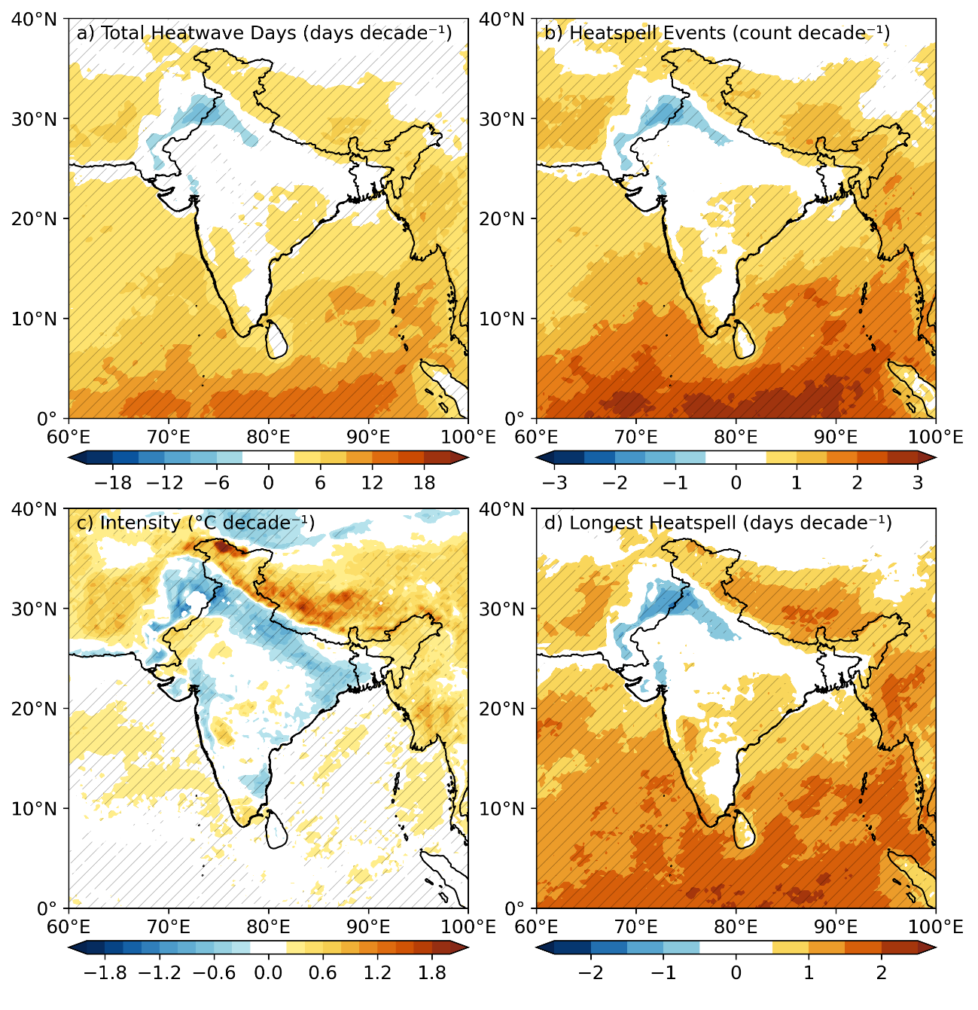

Fig. S6: Trends of Heatwave metrics based on 95th percentile threshold using daily maximum 2m air temperature: Trends of heatwave metrics from daily maximum surface temperature over the South Asian Summer Monsoon region based on the 95th percentile criteria (1940–2023): a) Total Heatwave Days (days decade⁻¹), b) Heatspell Events (count decade⁻¹), c) Intensity (°C decade⁻¹), d) Longest Heatspell (days decade⁻¹).

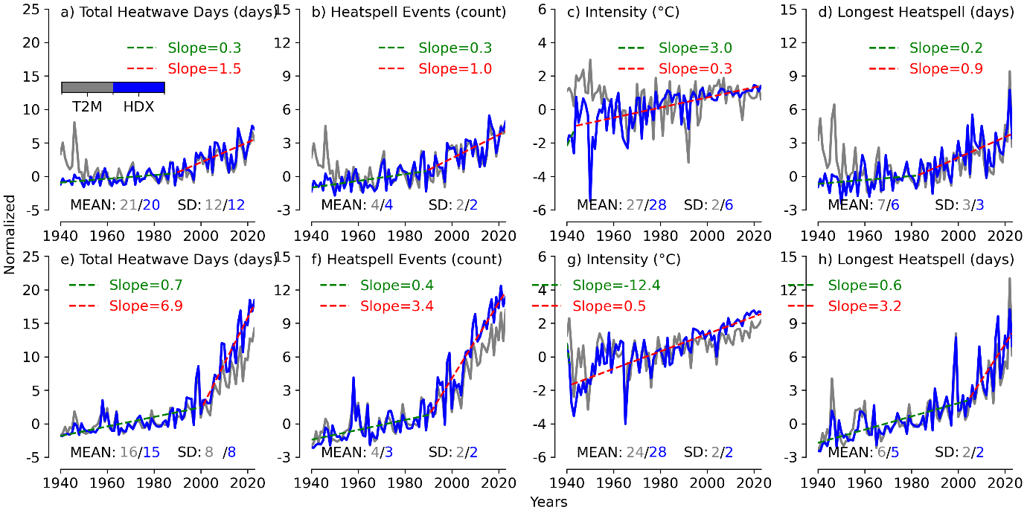

Fig. S7: Area averaged Heatwave metrics based on 90th percentile threshold over Northwest India and Northeast India-Bangladesh (hills): Time series of heatwave metrics (90th-percentile threshold) from 1940–2023 over Northwest India (70–77°E, 33.75–27°N; upper panels, a–d) and Northeast India–Bangladesh (88–98°E, 28.5–21.75°N; lower panels, e–h). Grey curves represent surface air temperature, blue curves represent surface humidex, and trend lines (green and red) are estimated using piecewise linear least squares fits>700m.

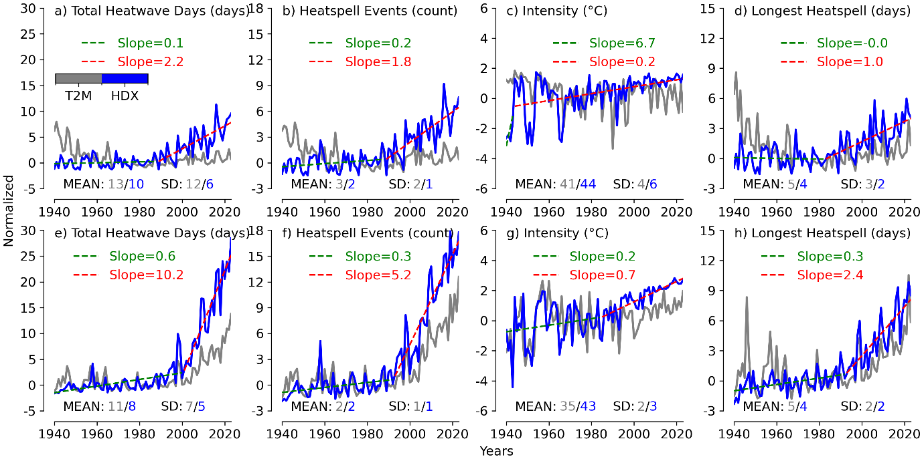

Fig. S8: Area averaged Heatwave metrics based on 95th percentile threshold over Northwest India and Northeast India-Bangladesh: Time series of heatwave metrics (95th-percentile threshold) from 1940–2023 over Northwest India (70–77°E, 33.75–27°N; upper panels, a–d) and Northeast India–Bangladesh (88–98°E, 28.5–21.75°N; lower panels, e–h). Grey curves represent surface air temperature, blue curves represent surface humidex, and trend lines (green and red) are estimated using piecewise linear least squares fits.

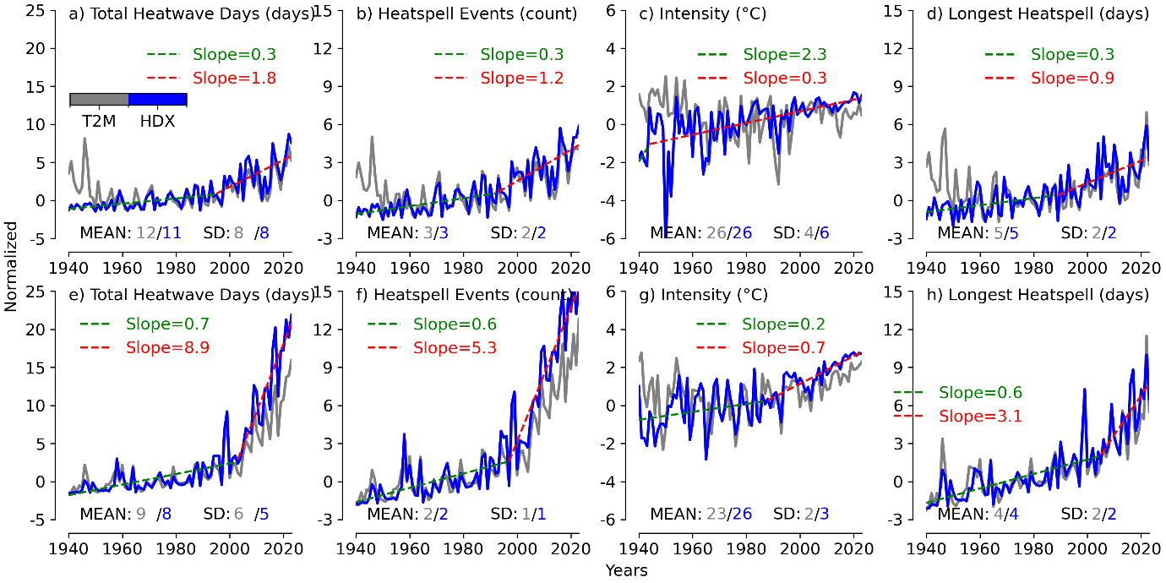

Fig. S9: Area averaged Heatwave metrics based on 95th percentile threshold over Northwest India and Northeast India-Bangladesh: Time series of heatwave metrics (95th-percentile threshold) from 1940–2023 over Northwest India (70–77°E, 33.75–27°N; upper panels, a–d) and Northeast India–Bangladesh (88–98°E, 28.5–21.75°N; lower panels, e–h). Grey curves represent surface air temperature, blue curves represent surface humidex, and trend lines (green and red) are estimated using piecewise linear least squares fits > 700m.

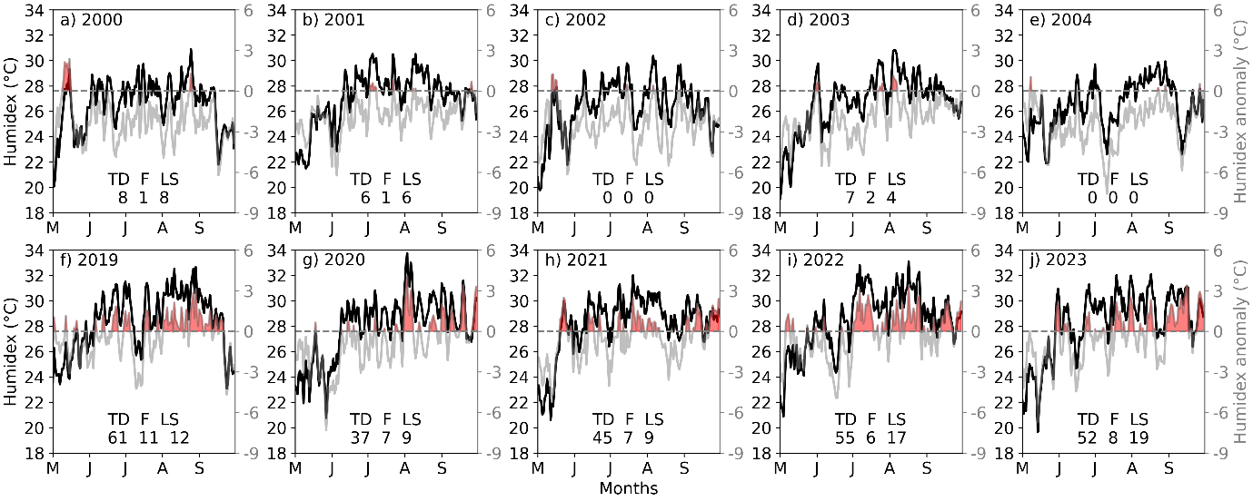

Fig. S10: Area averaged timeseries of daily maximum Humidex and its anomaly (based on 90th percentile) for MJJAS season over Northeast India-Bangladesh (hilly area): Time series of daily maximum Humidex (black curve, left y-axis) and Humidex anomaly (grey curve, right y-axis) for May–September in representative years: a) 2000, b) 2001, c) 2002, d) 2003, e) 2004, f) 2019, g) 2020, h) 2021, i) 2022, and j) 2023. The anomaly at each grid point is computed relative to the daily climatological 90th percentile (1961–1990), and then averaged over Northeast India–Bangladesh (88–98°E, 28.5–21.75°N). Heatwave days (red shading) are defined as periods with anomaly > 0 persisting for at least three consecutive days. Here, TD denotes total heatwave days, F denotes the frequency of heatwave spells, and LS denotes the length of the longest spell. The dataset is masked with DEM to get plane area grids with elevation less than 700m.The dataset is masked using the Shuttle Radar Topography Mission (SRTM) DEM to retain only hilly-area grids with elevation ≥ 700 m.

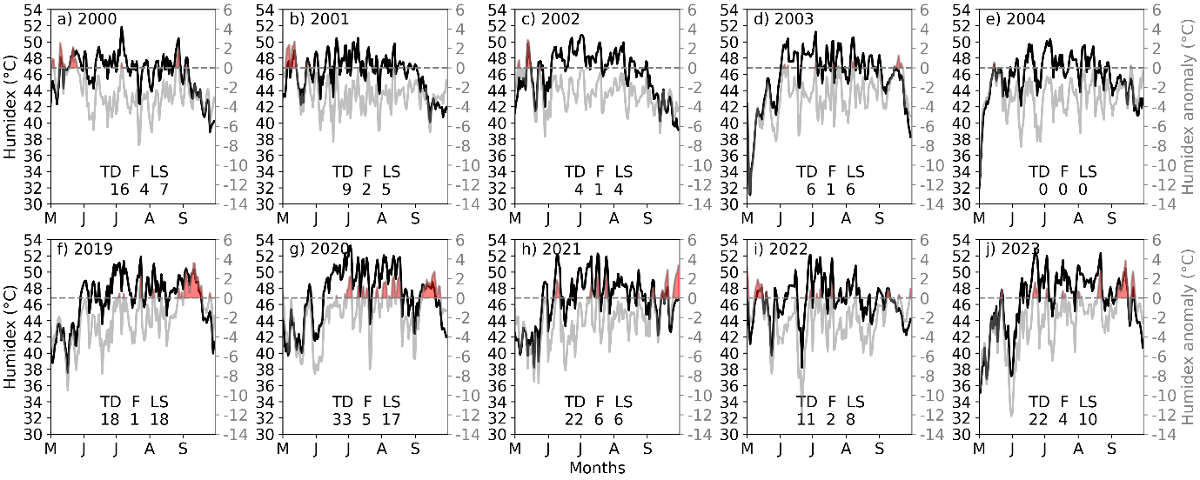

Fig. S11: Area averaged timeseries of daily maximum Humidex and its anomaly (based on 95th percentile) for MJJAS season over Northwest India (plain area): Time series of daily maximum Humidex (black curve, left y-axis) and Humidex anomaly (grey curve, right y-axis) for May–September in representative years: a) 2000, b) 2001, c) 2002, d) 2003, e) 2004, f) 2019, g) 2020, h) 2021, i) 2022, and j) 2023. The anomaly at each grid point is computed relative to the daily climatological 95th percentile (1961–1990), and then averaged over Northwest India (70–77°E, 33.75–27°N). Heatwave days (red shading) are defined as periods with anomaly > 0 persisting for at least three consecutive days. Here, TD denotes total heatwave days, F denotes the frequency of heatwave spells, and LS denotes the length of the longest spell. The dataset is masked using the Shuttle Radar Topography Mission (SRTM) DEM to retain only plain-area grids with elevation < 700 m.

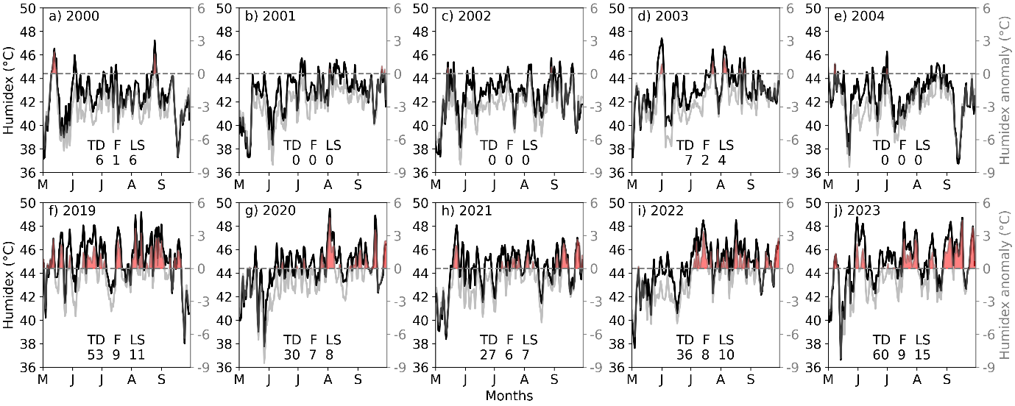
Fig. S12: Area averaged timeseries of daily maximum Humidex and its anomaly (based on 95th percentile) for MJJAS season over Northeast India-Bangladesh (plain area): Time series of daily maximum Humidex (black curve, left y-axis) and Humidex anomaly (grey curve, right y-axis) for May–September in representative years: a) 2000, b) 2001, c) 2002, d) 2003, e) 2004, f) 2019, g) 2020, h) 2021, i) 2022, and j) 2023. The anomaly at each grid point is computed relative to the daily climatological 90th percentile (1961–1990), and then averaged over Northeast India–Bangladesh (88–98°E, 28.5–21.75°N). Heatwave days (red shading) are defined as periods with anomaly > 0 persisting for at least three consecutive days. Here, TD denotes total heatwave days, F denotes the frequency of heatwave spells, and LS denotes the length of the longest spell. The dataset is masked using the Shuttle Radar Topography Mission (SRTM) DEM to retain only plain-area grids with elevation < 700 m.

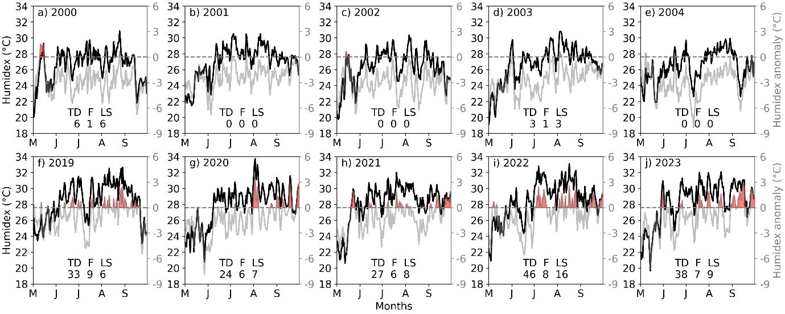

Fig. S13: Area averaged timeseries of daily maximum Humidex and its anomaly (based on 95th percentile) for MJJAS season over Northeast India-Bangladesh (hilly area):Time series of daily maximum Humidex (black curve, left y-axis) and Humidex anomaly (grey curve, right y-axis) for May–September in representative years: a) 2000, b) 2001, c) 2002, d) 2003, e) 2004, f) 2019, g) 2020, h) 2021, i) 2022, and j) 2023. The anomaly at each grid point is computed relative to the daily climatological 95th percentile (1961–1990), and then averaged over Northeast India–Bangladesh (88–98°E, 28.5–21.75°N). Heatwave days (red shading) are defined as periods with anomaly > 0 persisting for at least three consecutive days. Here, TD denotes total heatwave days, F denotes the frequency of heatwave spells, and LS denotes the length of the longest spell. The dataset is masked with DEM to get plane area grids with elevation less than 700m.The dataset is masked using the Shuttle Radar Topography Mission (SRTM) DEM to retain only hilly-area grids with elevation ≥ 700 m.

References:

for Occupational Health, C.C. and Safety (2024) ‘Humidex Rating and Work’.
Tozer, B. et al. (2019) ‘Global Bathymetry and Topography at 15 Arc Sec: SRTM15+’, Earth and Space Science, 6(10), pp. 1847–1864. Available at: https://doi.org/https://doi.org/10.1029/2019EA000658.

