Supplementary:

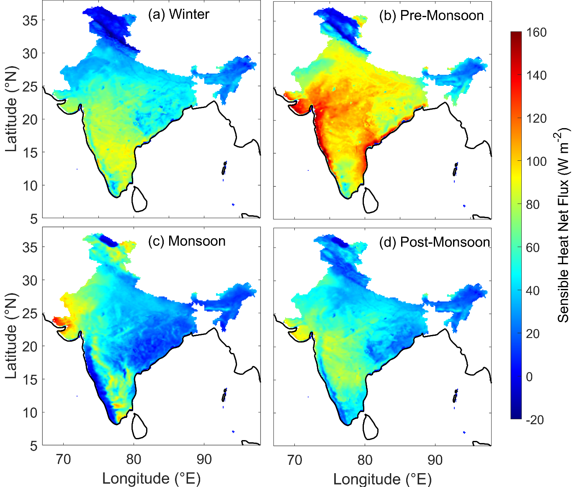
Fig. S1. Seasonal mean sensible heat net flux (W m⁻²) over the Indian region from IMDAA during 2018.

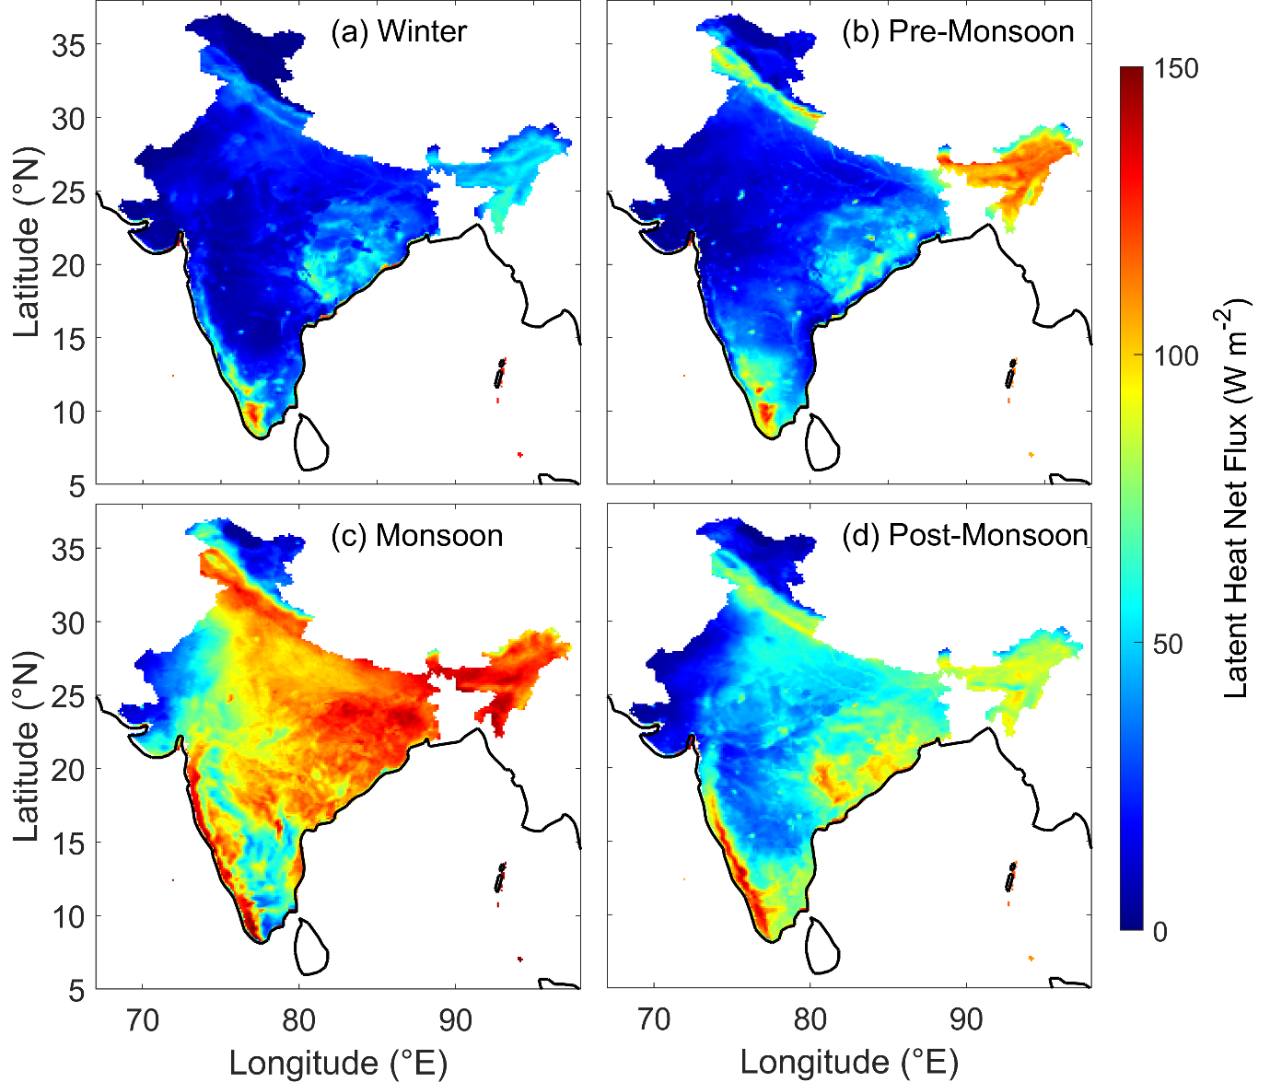

Fig. S2. Same as Fig. S1 but for latent heat flux (W m⁻²)

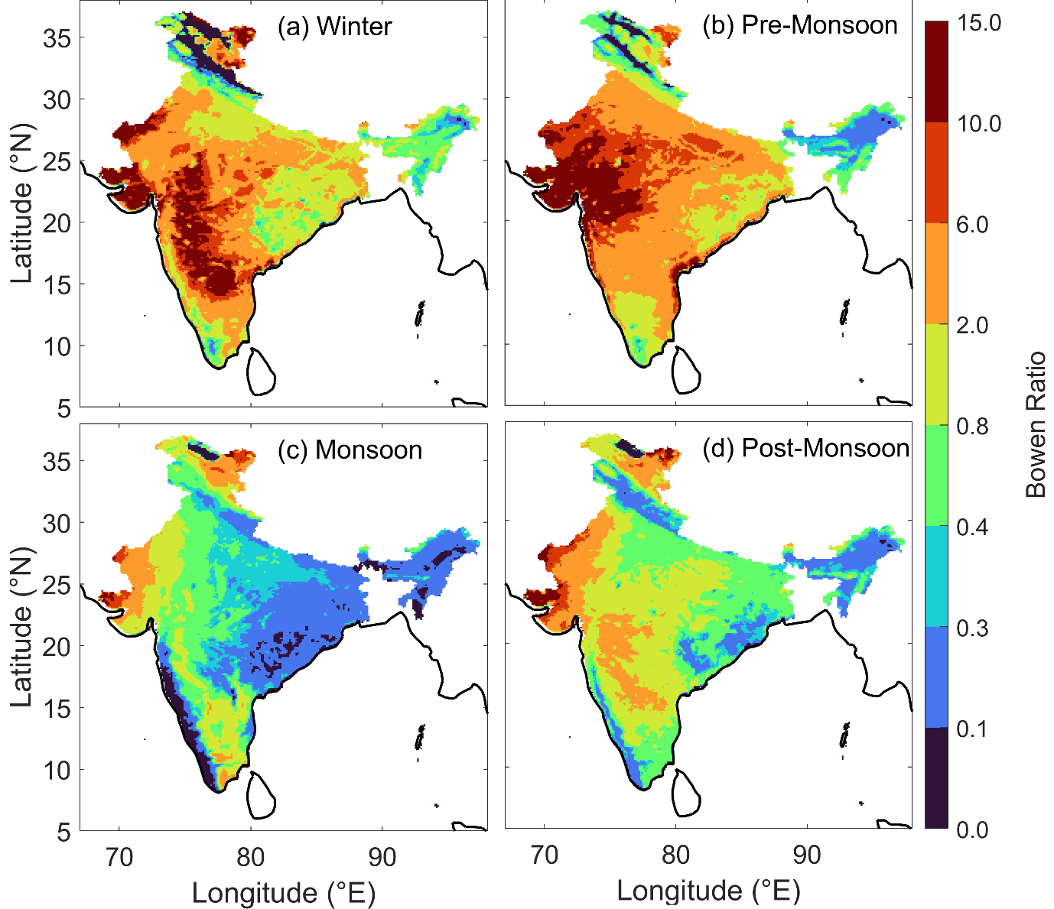
Fig. S3. Same as Fig. S1 but for Bowen ratio.

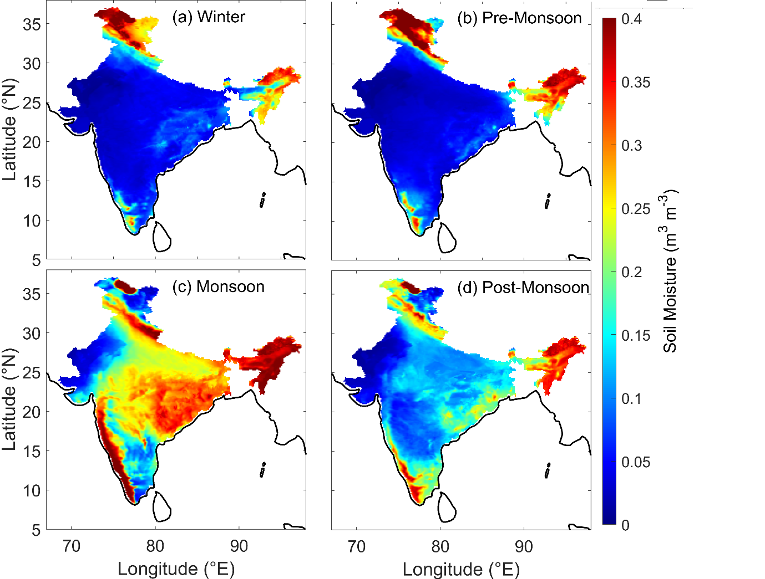
Fig. S4. Same as Fig. S1 but for soil moisture (m³ m⁻³)

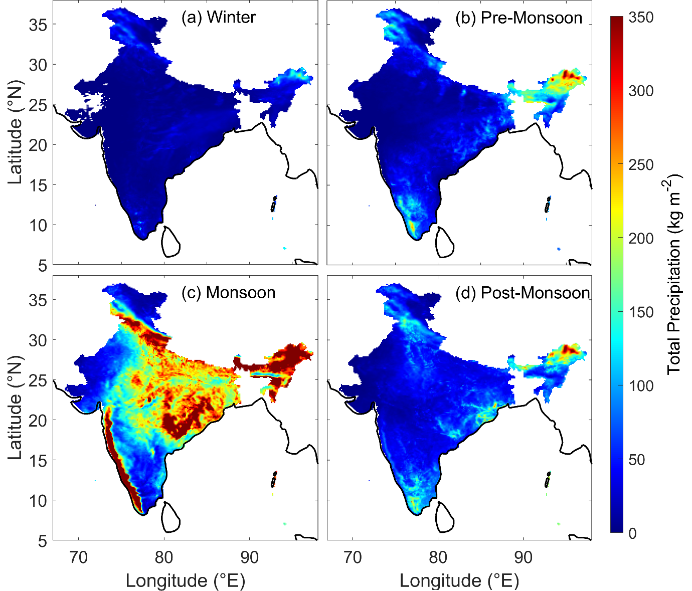
Fig. S5. Same as Fig. S1 but for total precipitation (kg m⁻²)

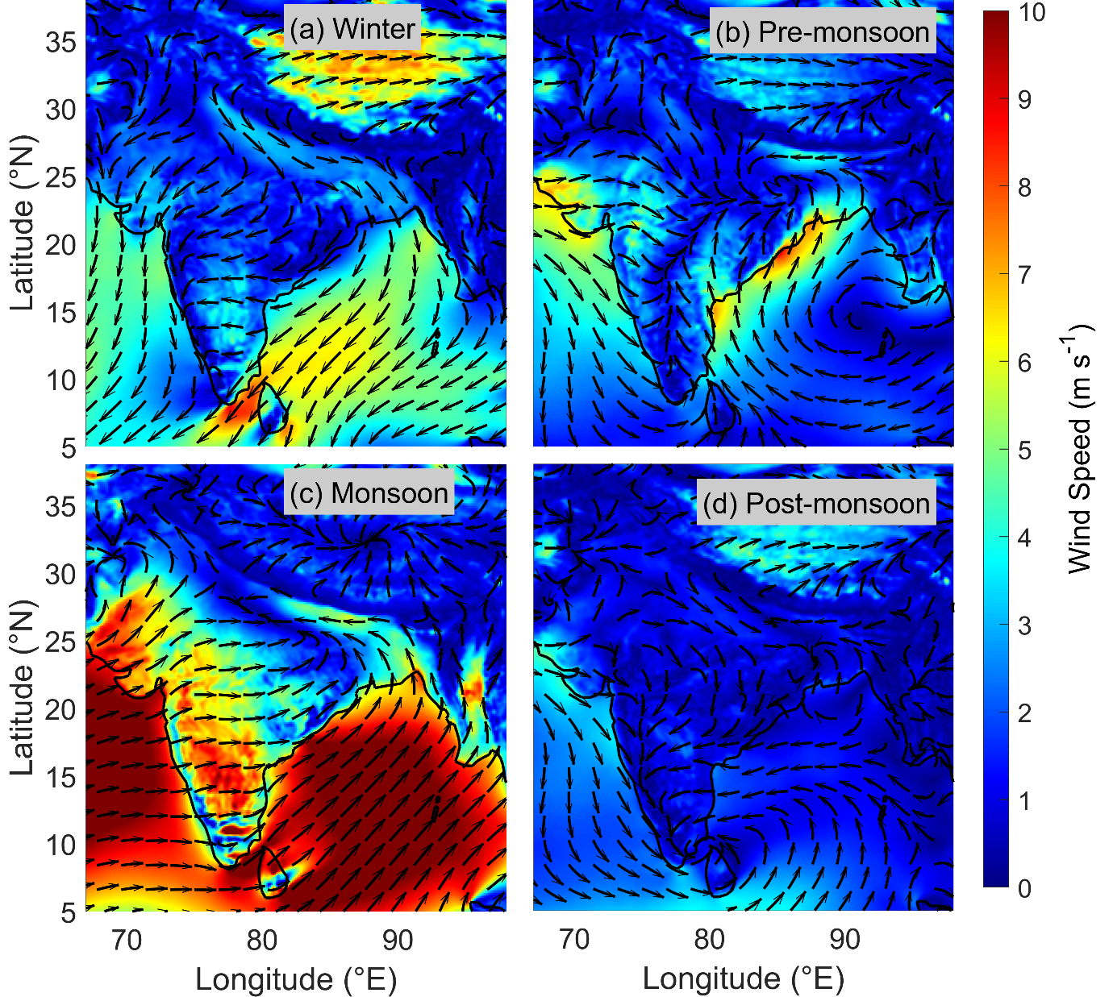
Fig. S6. Same as Fig. S1 but for mean wind speed (m s⁻¹)

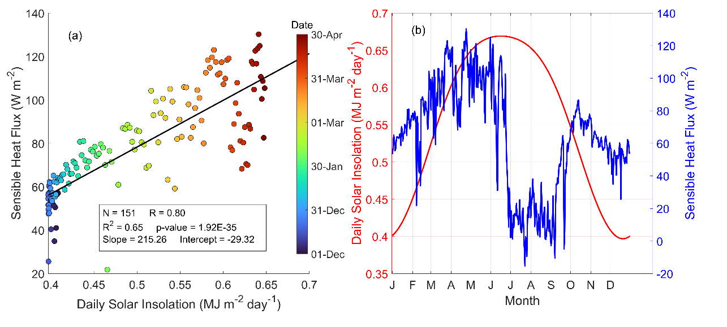
Fig. S7. (a) Scatter plot between the daily solar insolation (MJ m⁻² day⁻¹) and sensible heat flux (Wm⁻²) over Central India (Latitude: 23.07°N and Longitude: 80.09°N) for the period from December to April. The colour of each point indicates the day of the year, ranging from 1st December to 30th April. The black line denotes the linear regression fit. (b) Time series of daily mean solar insolation (left y-axis, red line) and sensible heat flux (right y-axis, blue line). The x-axis tick labels represent the beginning of each month, indicated by the first letter of the month.

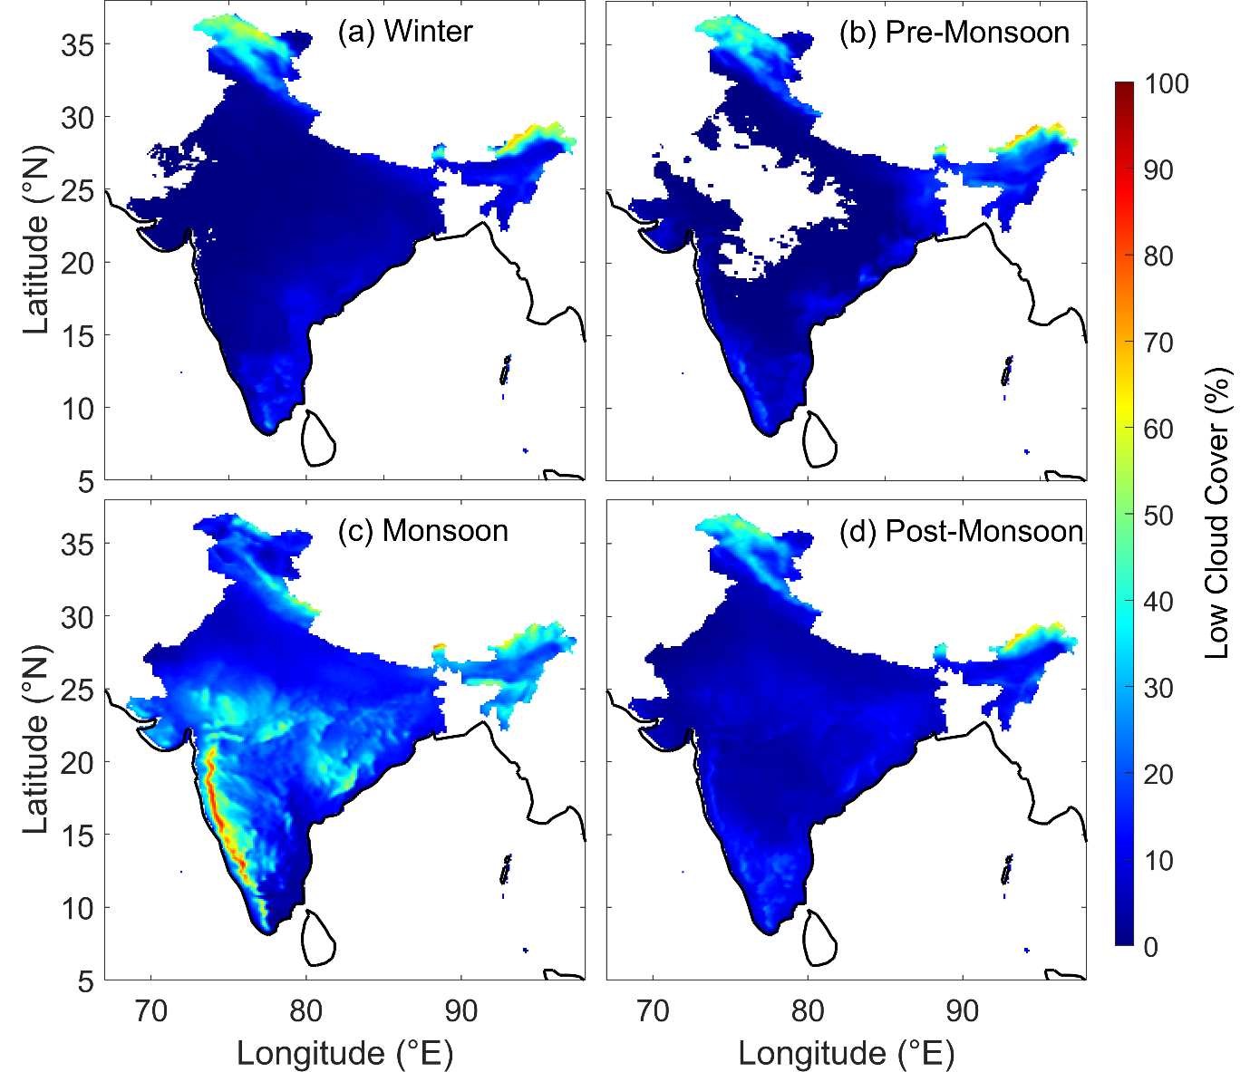
Fig. S8. Same as Fig. S1 but for low cloud cover (%)

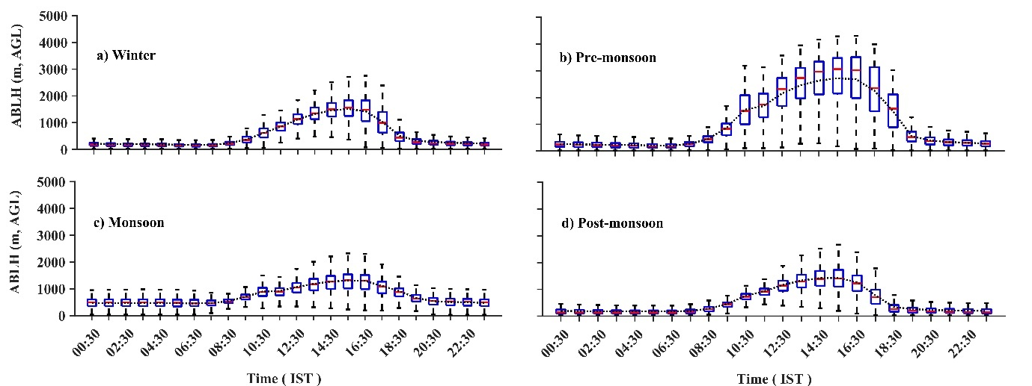
Fig. S9. Diurnal variation of the Z_{i} from IMDAA during 2018. The dotted line represents the mean Z_{i}.

