Table S1: Results of linear mixed-effect models (LMM) showing the effect of watering treatment on alpha diversity indices of bacterial and fungal community. The model includes genotype as a random effect. The fixed effects include the intercept and the treatment ("Waterlogged").
Formula (For Bacteria) | lme (Shannon Index ~ Treatment, random = ~ 1|Genotype)
Fixed effects | Coefficient | Standard Error | Degree of freedom | t-value | p-value
Intercept | 6.171789 | 0.05331936 | 29 | 115.75137 | 0
TreatmentWaterlogged | -0.038354 | 0.07540497 | 29 | - 0.50865 | 0.6148

Formula (For Bacteria) | lme (Observed Richness ~ Treatment, random = ~ 1|Genotype)
Fixed effects | Coefficient | Standard Error | Degree of freedom | t-value | p-value
Intercept | 816.55 | 51.90078 | 29 | 15.732906 | 0
TreatmentWaterlogged | -70.80 | 73.39878 | 29 | - 0.964594 | 0.3427

Formula (For Fungi) | lme (Shannon Index~ Treatment, random = ~ 1|Genotype)
Fixed effects | Coefficient | Standard Error | Degree of freedom | t-value | p-value
Intercept | 3.950288 | 0.06034623 | 29 | 65.46040 | 0
TreatmentWaterlogged | 0.061527 | 0.08505728 | 29 | - 0.72336 | 0.4753

Formula (For Fungi) | lme (Observed Richness~ Treatment, random = ~ 1|Genotype)
Fixed effects | Coefficient | Standard Error | Degree of freedom | t-value | p-value
Intercept | 354.70 | 10.71772 | 29 | 33.09474 | 0
TreatmentWaterlogged | -15.05 | 15.15714 | 29 | -0.99293 | 0.329

Table S2: PERMANOVA analysis to show the effect of barley genotypes, watering treatment, and their interactions on the bacterial and fungal community structure.
Variable | Degree of freedom | R² (%) | F | Pr (>F)
For Bacteria
Genotype | 9 | 0.17243 | 1.0510 | 0.365
Water treatment | 1 | 0.27833 | 15.2683 | 0.001
Genotype: Treatment | 9 | 0.18466 | 1.1256 | 0.222
For Fungi
Genotype | 9 | 1.0316 | 1.0821 | 0.164
Water treatment | 1 | 0.097 | 4.4115 | 0.001
Genotype: Treatment | 9 | 0.20835 | 0.9949 | 0.498

Table S3: Results of Redundancy Analysis (RDA) assessing the effectiveness of spatial predictors, particularly the distance between treatment fields, in explaining variation in mycobiome structure. The spatial variables were selected through forward selection procedures, retaining only the most significant predictors.

Formula | Microbiome structure ~ Distance between treatment fields
Metric | Total | Constrained |  | Unconstrained
For Bacteria
Inertia | 4.56834 |  | 1.62477 |  | 2.94357
Proportion | 1.00000 |  | 0.35566 |  | 0.64434
Rank |  |  | 4 |  | 39
For Fungi
For Fungi
Inertia | 4.6855 |  | 0.72663 |  | 3.9588
Proportion | 1.00000 |  | 0.15508 |  | 0.84492
Rank |  |  | 4 |  | 37

Table S4: PERMANOVA analysis to show the effect of soil and plant parameters on the bacterial and fungal community structure.
Variable | Degree of freedom | R² (%) | F | Pr (>F)
For Bacteria
Plant yield | 1 | 0.0268 | 1.0472 | 0.300
Total Kernal Weight | 1 | 0.0257 | 1.0034 | 0.345
Shoot Fresh Mass | 1 | 0.0183 | 0.7110 | 0.790
Grain Protein Content | 1 | 0.1028 | 4.3562 | 0.001
Plant Height | 1 | 0.0183 | 0.7089 | 0.791
Flowering Time | 1 | 0.0498 | 1.9923 | 0.029
Nitrogen | 1 | 0.0200 | 0.7792 | 0.635
Carbon | 1 | 0.0270 | 1.0555 | 0.302
Phosphorous | 1 | 0.2223 | 10.8676 | 0.001
Potassium | 1 | 0.0203 | 0.7899 | 0.615
Soil pH | 1 | 0.1468 | 6.5417 | 0.001
Magnesium | 1 | 0.1058 | 4.4975 | 0.001
Zinc | 1 | 0.1880 | 8.7997 | 0.001
Copper | 1 | 0.0229 | 0.8921 | 0.470
Manganese | 1 | 0.1759 | 8.1117 | 0.001
Soil Organic Matter | 1 | 0.2277 | 11.206 | 0.001
Field Distance | 4 | 1.6248 | 4.8298 | 0.001
For Fungi
Plant yield | 1 | 0.0275 | 1.0754 | 0.26
Total Kernal Weight | 1 | 0.0241 | 0.9396 | 0.552
Shoot Fresh Mass | 1 | 0.0265 | 1.0366 | 0.331
Grain Protein Content | 1 | 0.0526 | 2.1105 | 0.002
Plant Height | 1 | 0.0255 | 0.9951 | 0.415
Flowering Time | 1 | 0.0341 | 1.3432 | 0.074
Nitrogen | 1 | 0.0190 | 0.7390 | 0.943
Carbon | 1 | 0.0264 | 1.0304 | 0.355
Phosphorous | 1 | 0.0918 | 3.8413 | 0.001
Potassium | 1 | 0.0308 | 1.2078 | 0.134
Soil pH | 1 | 0.0836 | 3.4692 | 0.001
Magnesium | 1 | 0.0703 | 2.8756 | 0.002
Zinc | 1 | 0.0979 | 4.1272 | 0.001
Copper | 1 | 0.0385 | 1.5216 | 0.041
Manganese | 1 | 0.0529 | 2.1259 | 0.002
Soil Organic Matter | 1 | 0.0719 | 2.9447 | 0.001
Field Distance | 4 | 0.7266 | 1.606 | 0.001
*p values in bold indicate the statistical significance

Table S5: Comparison of the characteristics of observed and ensemble (null) bacterial and Fungal networks
 | NODF | Functional Complementarity | Niche Overlap | Modularity
For Bacteria
Observed control network | 43.71 | 3199.55 | 0.2417 | 0.2051
Ensemble networks | 46.691 ± 0.273 | 3849.060 ± 29.135 | 0.259 ± 0.002 | 0.1596±0.001
z-score | -10.8665 | -22.29304 | -8.347454 | 34.873
For Fungi
Observed control network | 35.119 | 1846.294 | 0.1808 | 0.1968
Ensemble networks | 39.135 ± 0.327 | 1933.074 ± 21.895 | 0.202 ± 0.002 | 0.176 ± 0.002
z-score | -12.294 | -3.9633 | -8.740767 | 12.45329

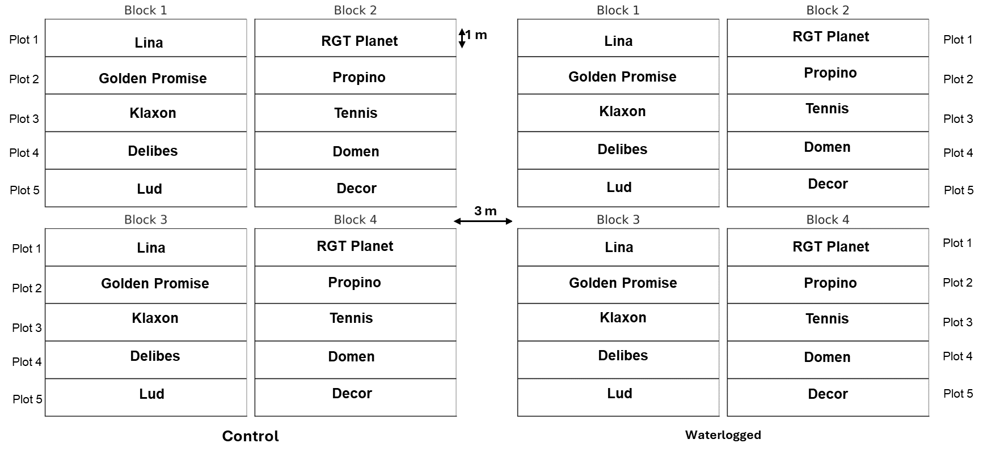

Figure S1. Schematic representation of the field experiment layout, depicting control and waterlogging treatments conducted on 10 barley cultivars.

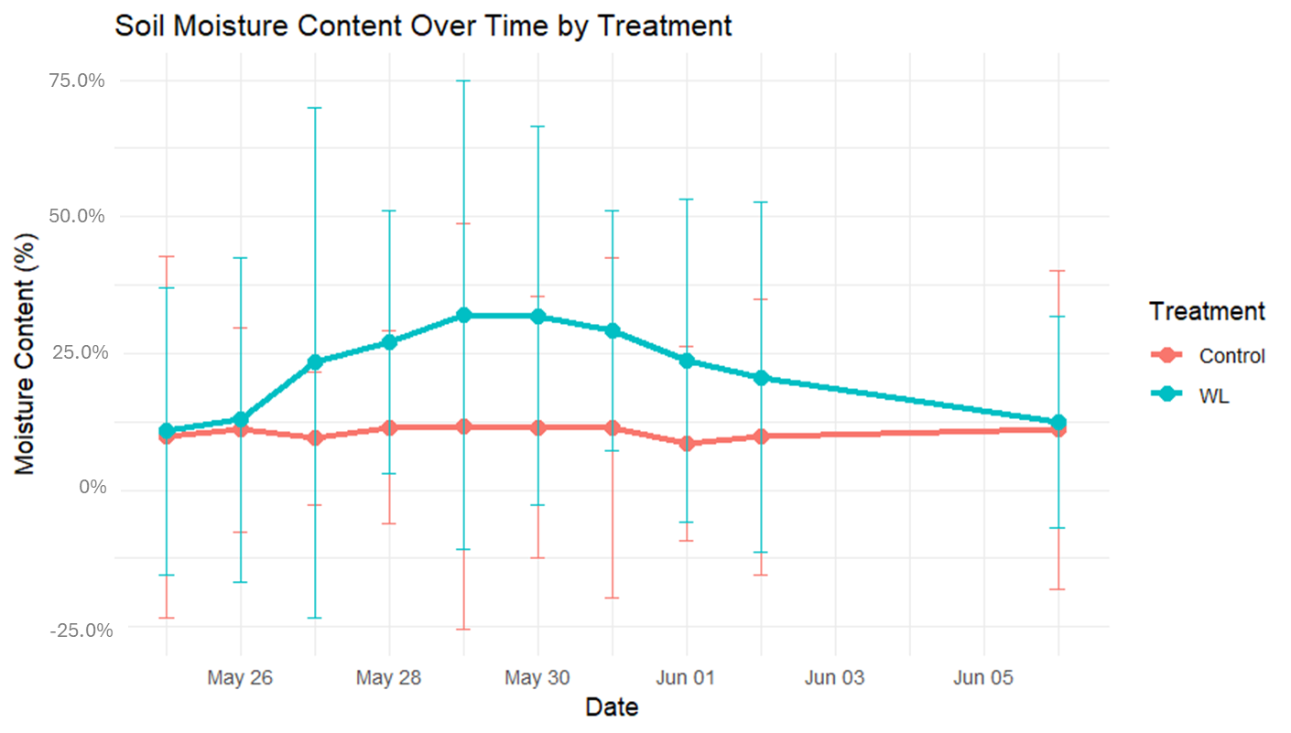
Figure S2. Line graph represents the soil moisture content (%) across each successive day of waterlogging treatment of control and waterlogged field plots. Error bar represents the deviation from the mean value, where WL denotes the waterlogging field.

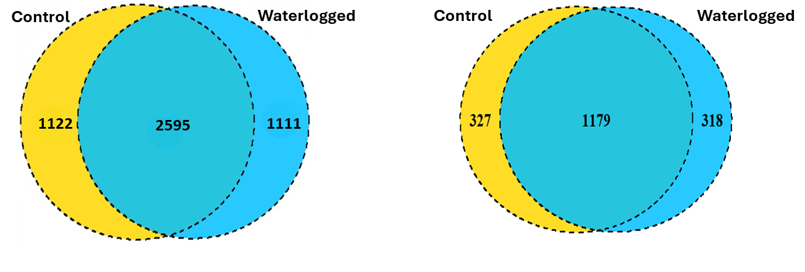
Figure S3: Venn diagrams illustrating the total number of unique and shared ASVs of bacteria (left) and fungi (right) across control and waterlogging conditions, regardless of barley genotypes.

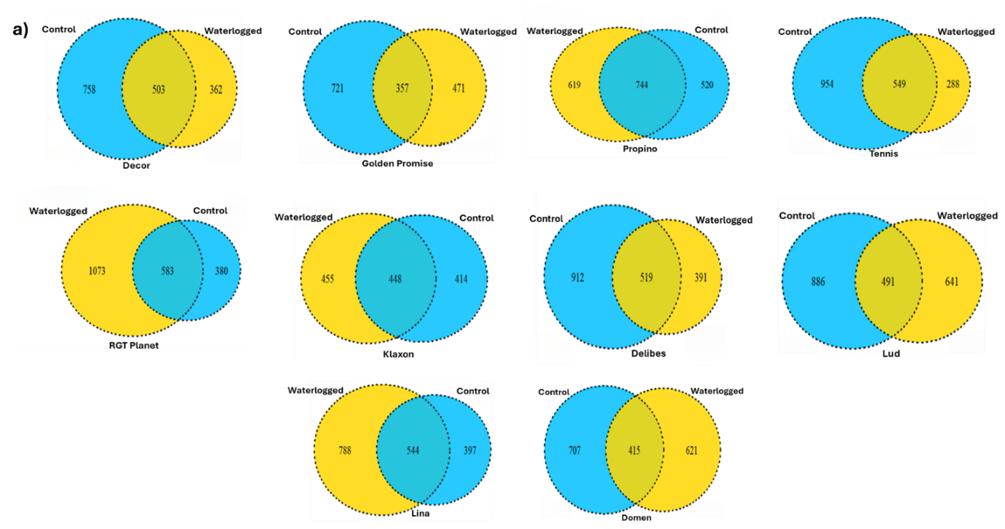

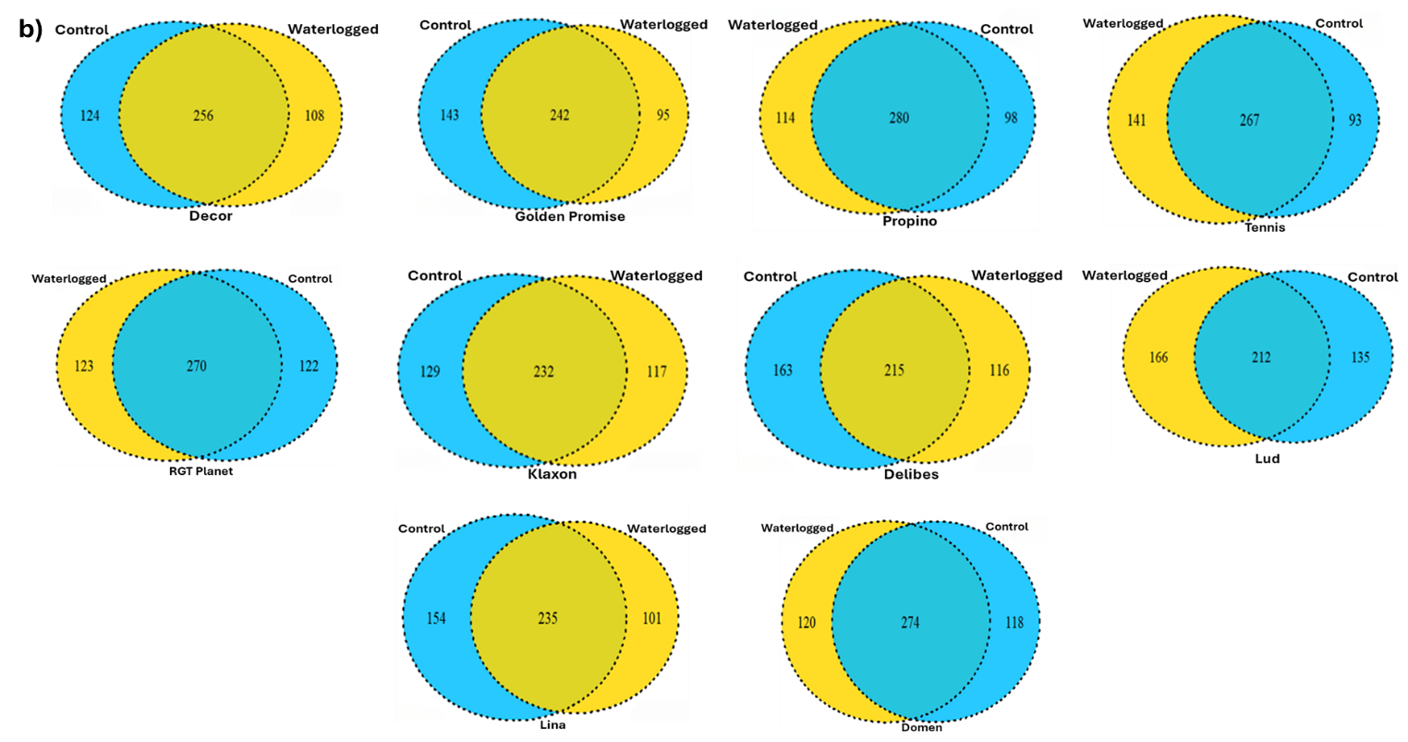
Figure S4: Venn diagrams illustrating the shared and unique bacterial (a) and fungal (b) amplicon sequence variants (ASVs) between control and waterlogged treatments across each of the ten barley cultivars.

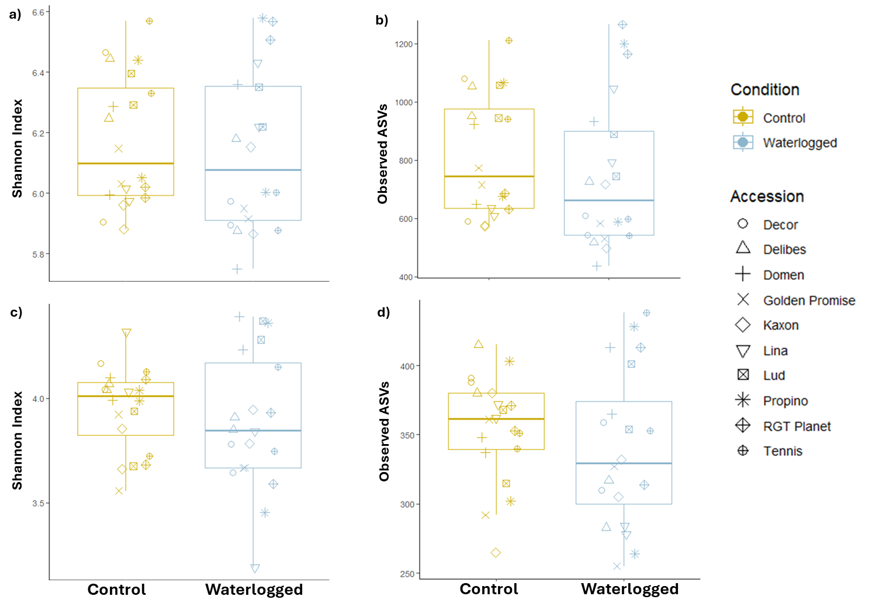

Figure S5: Boxplots showing the distribution of Shannon diversity (left) and Observed ASVs (right) across watering treatments. Panels a) and b) display data for bacteria, while panels c) and d) represent fungi. The boxplots illustrate the median and interquartile range, with each data point corresponding to a barley cultivar.

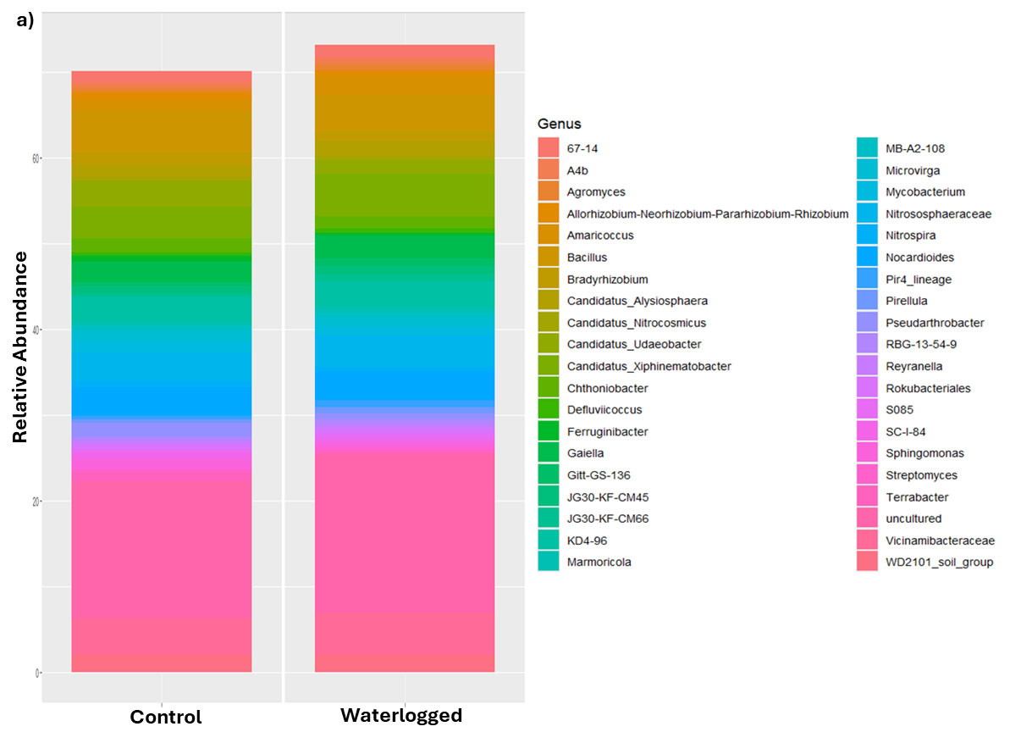
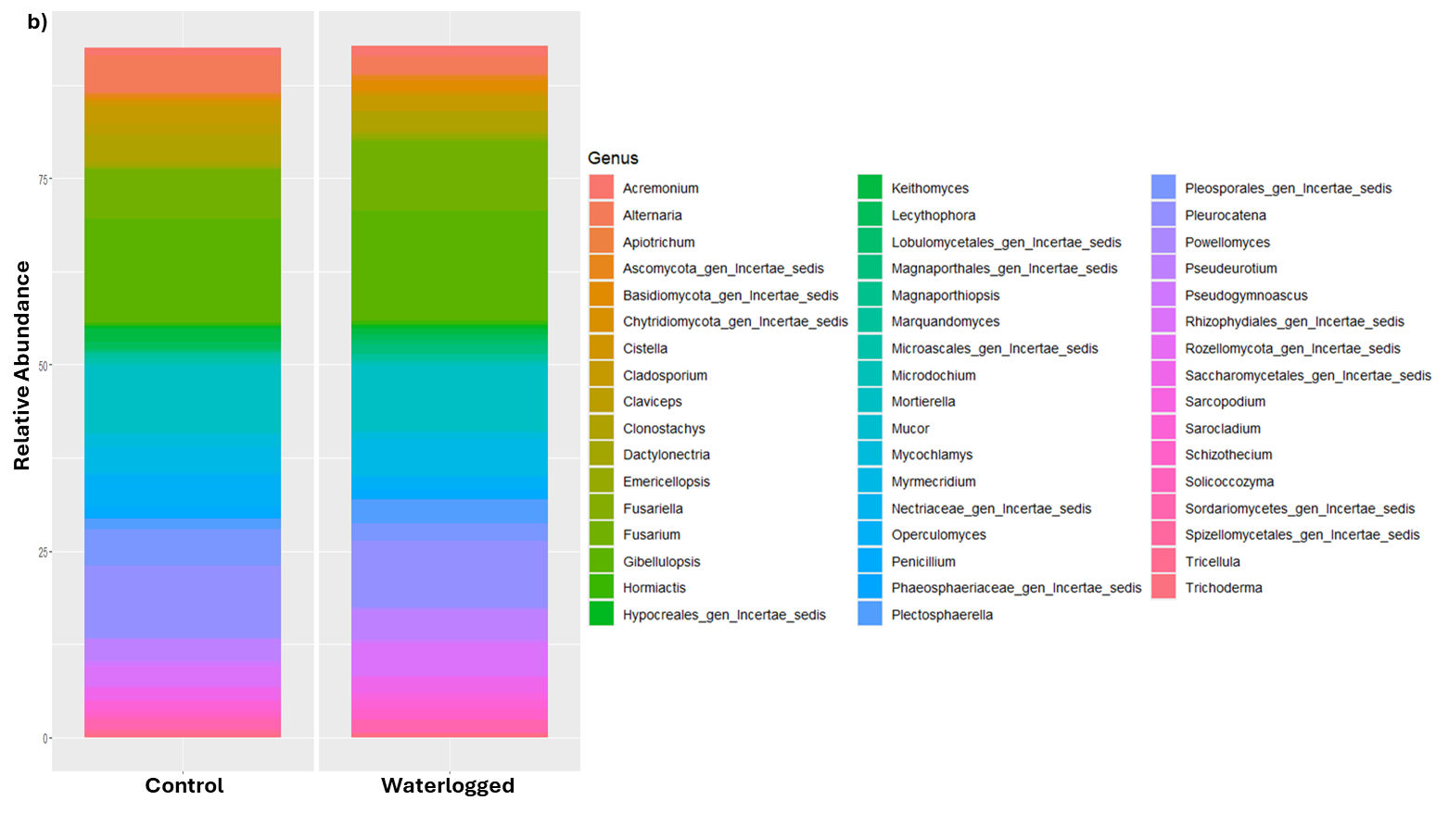
Figure S6: Relative abundance profiles of the top 50 bacterial (a) and fungal (b) genera in control versus waterlogged conditions.

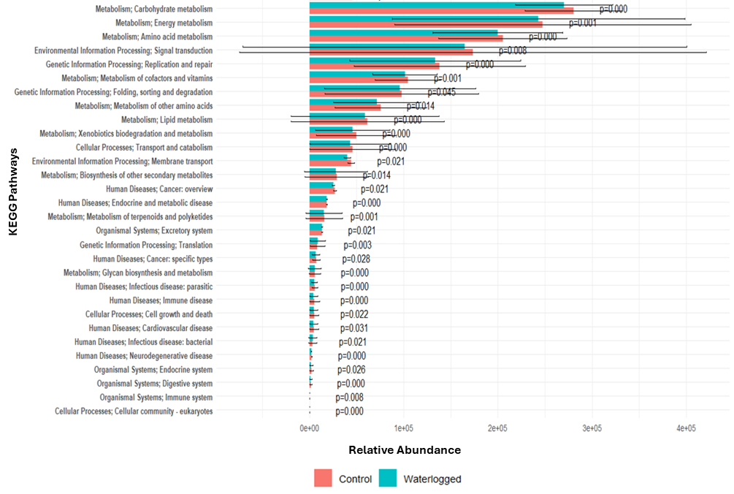
Figure S7: Differential abundance of significant annotated pathways at the Class level between Control and Waterlogged conditions based on the Limma Voom method. Error bars indicate variability, with p-values less than 0.05 showing statistical significance.

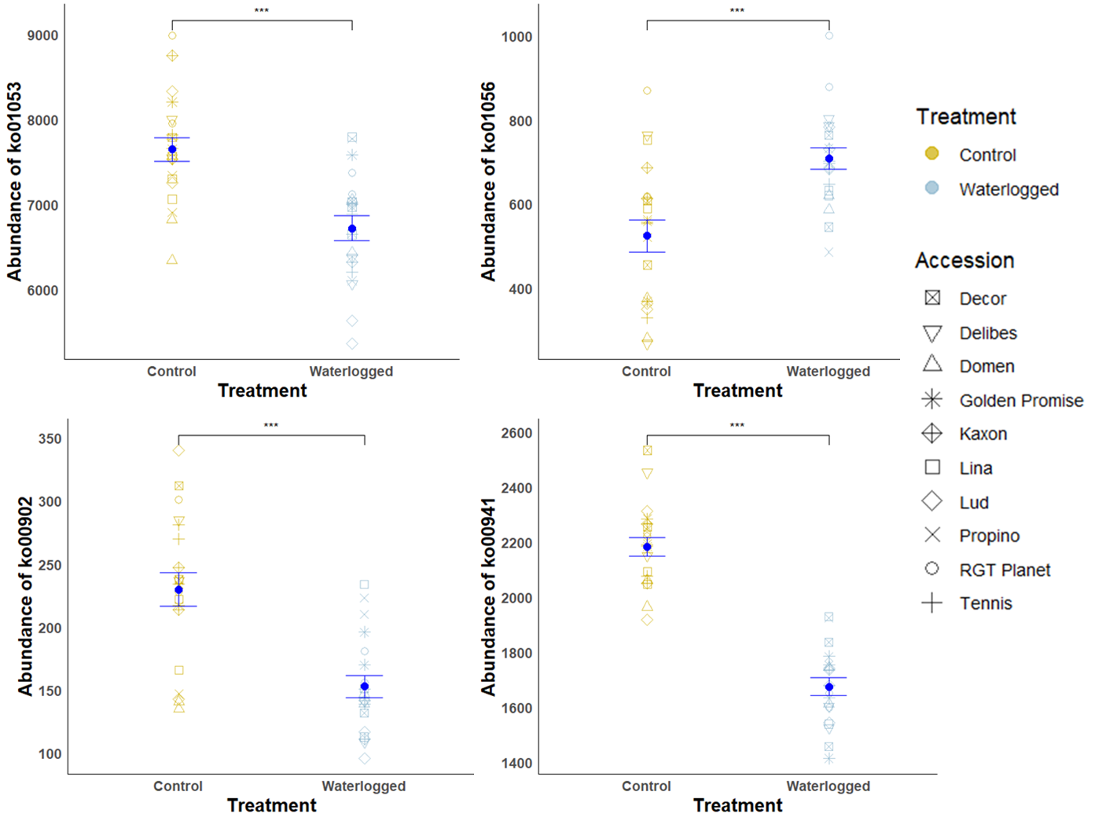
Figure S8: Scatter plots show the abundance of significant features 'Biosynthesis of siderophore group nonribosomal peptides' (KO01053), 'Biosynthesis of type II polyketide backbone' (KO01056), 'Monoterpenoid biosynthesis' (KO00902), and 'Flavonoid biosynthesis' (KO00941) for both control and waterlogged conditions with mean and error bars indicated. Asterisks indicate statistical significance (t-tests, p < 0.05).

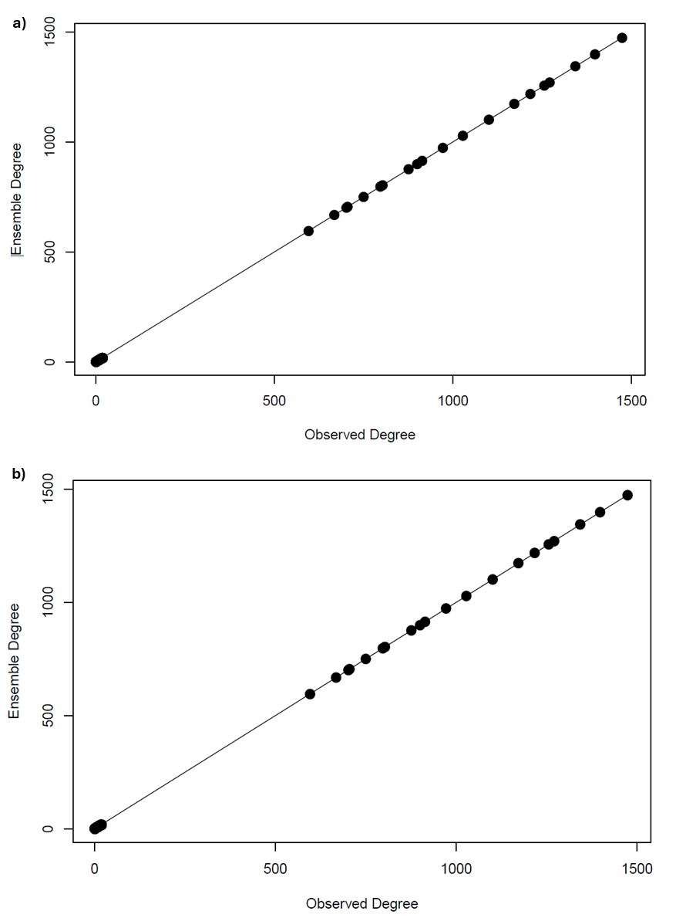
Figure S9: Comparison of observed and ensemble node degrees for canonical network ensemble validation of a) bacterial network, b) fungal network under control and waterlogging conditions.

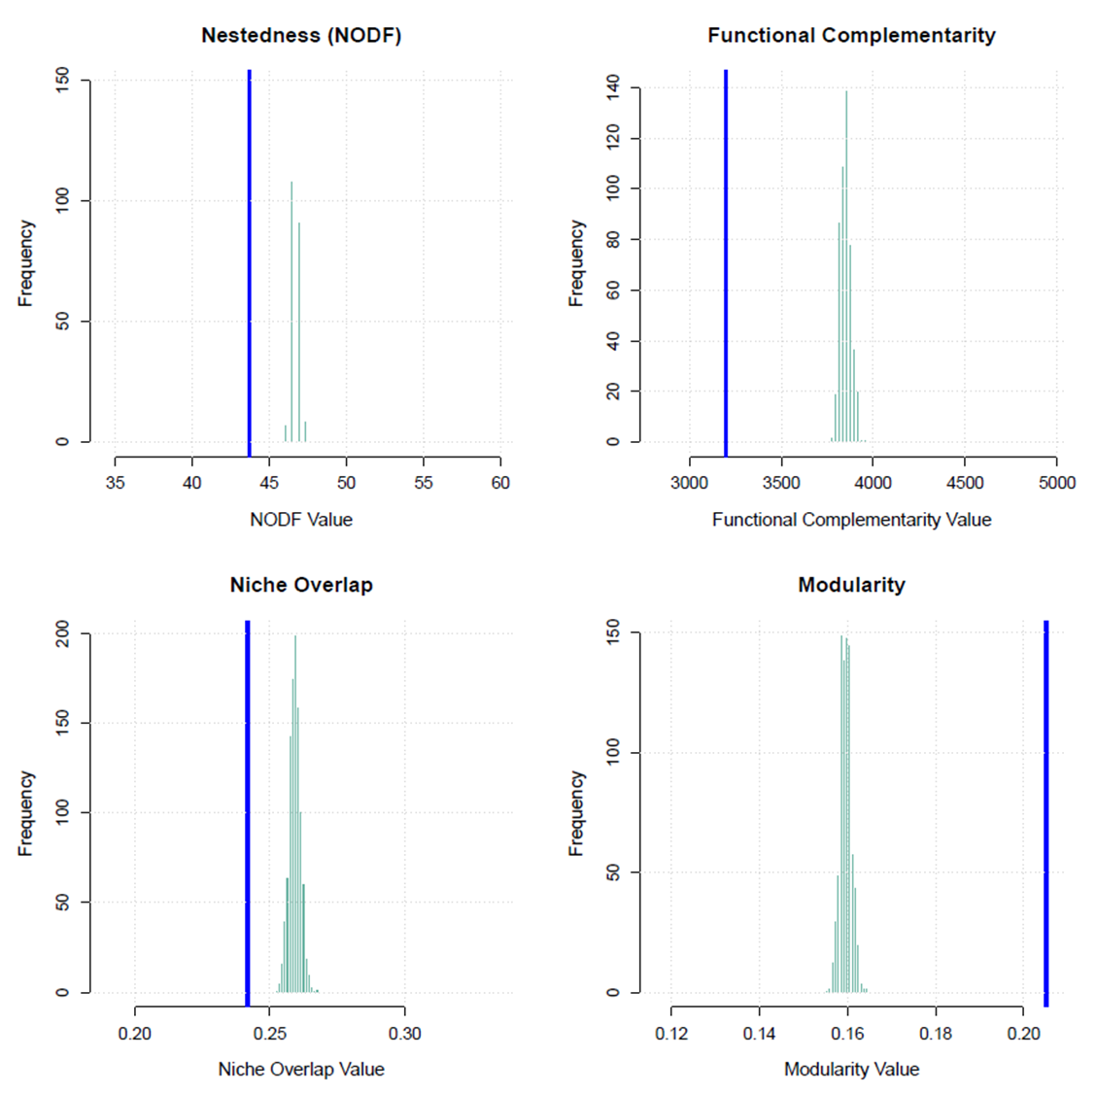

Figure S10: Distribution of four Binary Network Metrics for the Canonical Ensemble of Bacterial Network in control and waterlogging treatment: Comparison of Ensemble (Histogram) and Observed (Blue Line) Values.

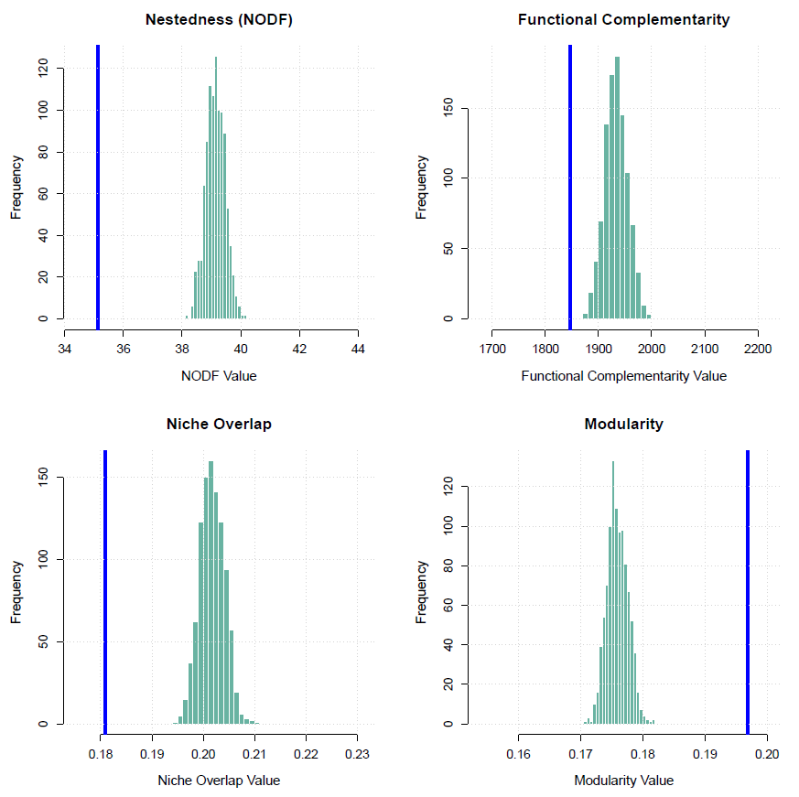

Figure S11: Distribution of Four Binary Network Metrics for the Canonical Ensemble of Fungal Networks in control and waterlogging treatment: Comparison of Ensemble (Histogram) and Observed (Blue Line) Values.

