Full and uncropped western blot for figure 1C

POLR1A GAPDH
Full and uncropped western blot for figure 1D
POLR1A 1 POLR1A 2 POLR1A 3 POLR1A 4 POLR1A 5
POLR1A 6 POLR1A 7 POLR1A 8 POLR1A 9 POLR1A 10
POLR1A 11 POLR1A 12 POLR1A 13 POLR1A 14 POLR1A 15
POLR1A 16 POLR1A 17 POLR1A 18 POLR1A 19

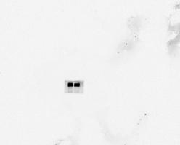
α-Tubulin 1 α-Tubulin 2 α-Tubulin 3 α-Tubulin 4 α-Tubulin 5
α-Tubulin 6 α-Tubulin 7 α-Tubulin 8 α-Tubulin 9 α-Tubulin 10
α-Tubulin 11 α-Tubulin 12 α-Tubulin 13 α-Tubulin 14 α-Tubulin 15
α-Tubulin 16 α-Tubulin 17 α-Tubulin 18 α-Tubulin 19

Full and uncropped western blot for figure 2A

POLR1A α-Tubulin

Full and uncropped western blot for figure 2B

POLR1A α-Tubulin
Full and uncropped western blot for figure 2I

POLR1A Bax

caspase3 cleaved caspase3
caspase9 cleaved caspase9

Bcl2 α-Tubulin

Full and uncropped western blot for figure 3C
IFI27 POLR1A Bax Bcl-2 caspase3
cleaved caspase3 capase9 cleaved caspase9 α-Tubulin

Full and uncropped western blot for figure 5B
POLR1A(v,oe-POLR1A) HDAC1（v,oe-POLR1A） α-Tubulin(v,oe-POLR1A)
POLR1A(sh-NC,sh-POLR1A) HDAC1（sh-NC,sh-POLR1A） α-Tubulin(c,sh-POLR1A)

Full and uncropped western blot for figure 6B
IP.POLR1A(IgG,POLR1A) IP.USP36(IgG,POLR1A） input POLR1A(IgG,POLR1A)

Input USP36(IgG,POLR1A) Input.α-Tubulin(IgG,POLR1A)

IP.POLR1A(IgG,USP36) IP.USP36(IgG,USP36) input.POLR1A(IgG,USP36)
Input.USP36 input.α-Tubulin

Full and uncropped western blot for figure 6C
α-Tubulin (sh-NC,sh-usp36) USP36(sh-NC,sh-USP36) POLR1A（chx）sh-NC
α-Tubulin（chx）sh-NC POLR1A(chx) sh-USP36 α-Tubulin (chx) sh-USP36

Full and uncropped western blot for figure 6E
α-Tubulin (MG132) USP36(MG132) POLR1A(MG132)

Full and uncropped western blot for figure 6F
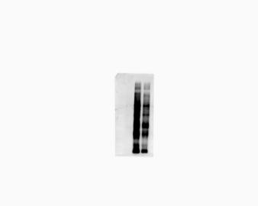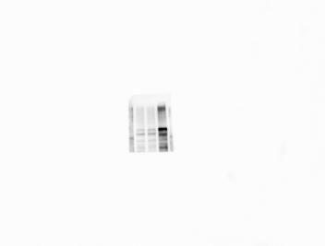
Ip.myc Ip.Flag Input.His
Input.Flag Input.α-Tubulin

Full and uncropped western blot for figure 6G
Ip.myc Ip.Flag Input.Flag
Input.His Input.α-Tubulin

Full and uncropped western blot for figure 7A
Ip.Flag Ip.myc Input.myc
Input.Flag Input.His Flag.α-Tubulin

Full and uncropped western blot for figure 7B
Ip.Flag Ip.Myc Input.Myc Input.Flag
Input.His Input.α-Tubulin

Full and uncropped western blot for figure 7D
Ip.His Ip.Flag Input.Flag Input.His

Full and uncropped western blot for figure 7F
Ip.FlagI p.His Input.His Input.Flag

Full and uncropped western blot for Supplymentary Figure 1A
POLR1A(sh-NC,sh-POLR1A) α-Tubulin(sh-nc,sh-POLR1A)

Full and uncropped western blot for Supplymentary Figure 1B
POLR1A(vector,oe-POLR1A) α-Tubulin(vector,oe-POLR1A)

Full and uncropped western blot for Supplymentary Figure 1I
POLR1A Bax caspase3
cleaved caspase3 Caspase 9 Cleaved caspase9
Bcl-2 α-Tubulin

Full and uncropped western blot for Supplymentary Figure 2B
Bax caspase3 cleaved caspase3
Caspase9 cleaved caspase9 α-Tubulin
Full and uncropped western blot for Supplymentary Figure 2C

Bcl-2 Caspase3 cleaved caspase3
IFI27 Bax α-Tubulin
POLR1A caspase9 cleaved caspase9

Full and uncropped western blot for Supplymentary Figure 3C
POLR1A.ip(IgG,POLR1A) USP36.IP(IgG,POLR1A) POLR1A.inPUT.(IgG,POLR1A)
α-Tubulin USP36.input(IgG,POLR1A)

α-Tubulin.input(IgG,usp36) USP36.input(IgG,USP36) USP36.Ip(IgG,USP36)
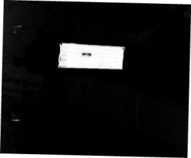

POLR1A.input(IgG,USP36) POLR1A.ip(IgG,POLR1A)

Full and uncropped western blot for Supplymentary Figure 3D

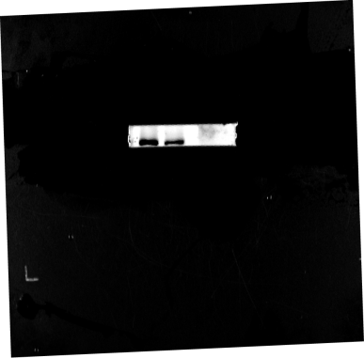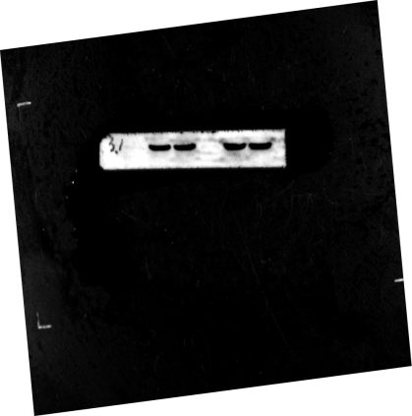
USP36 α-Tubulin
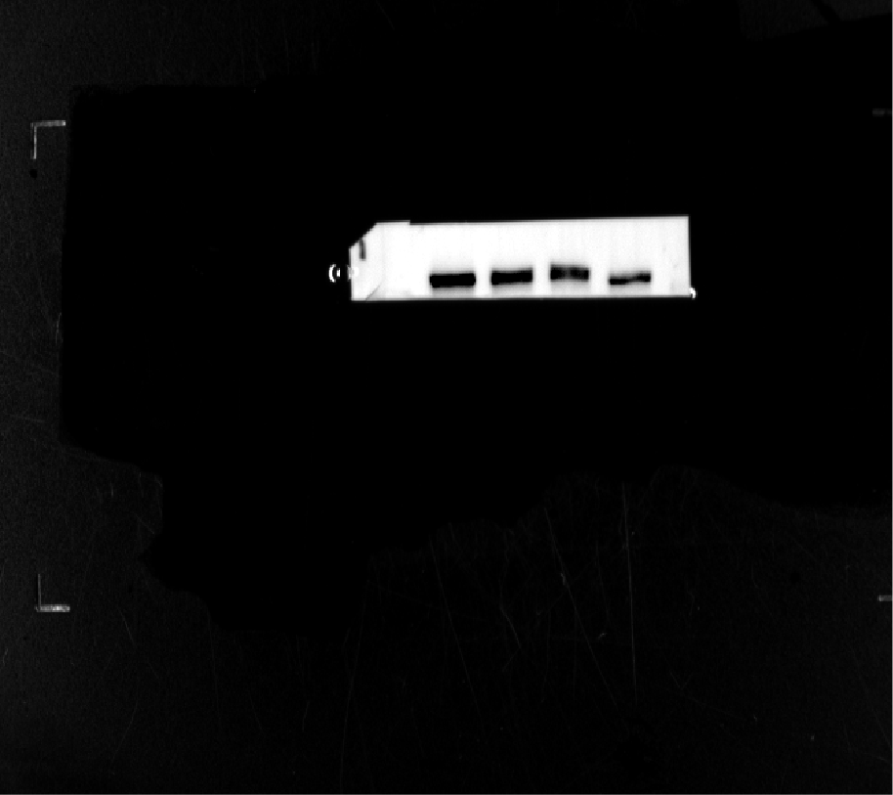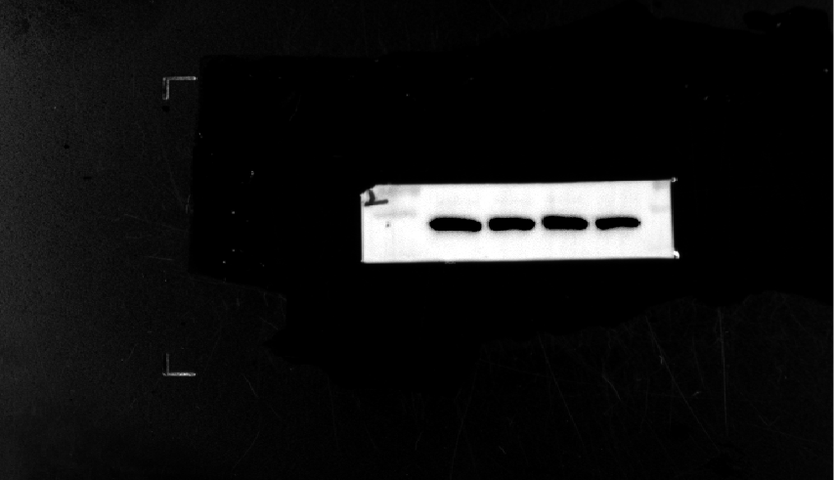
POLR1A α-Tubuin
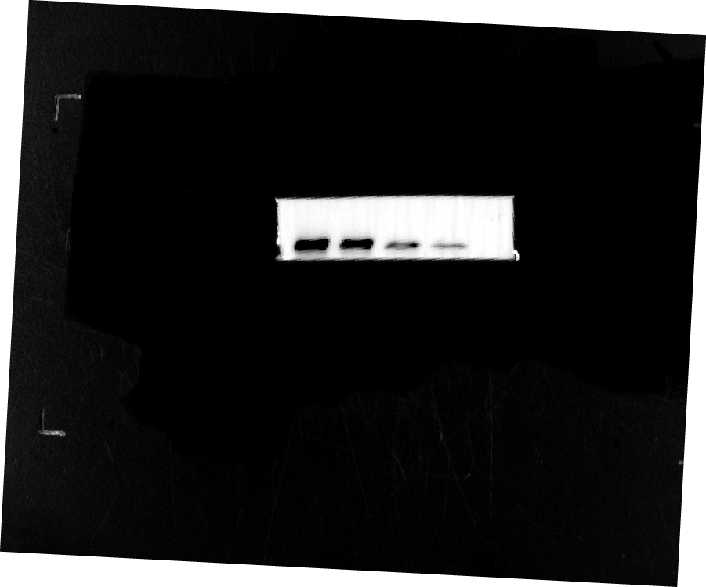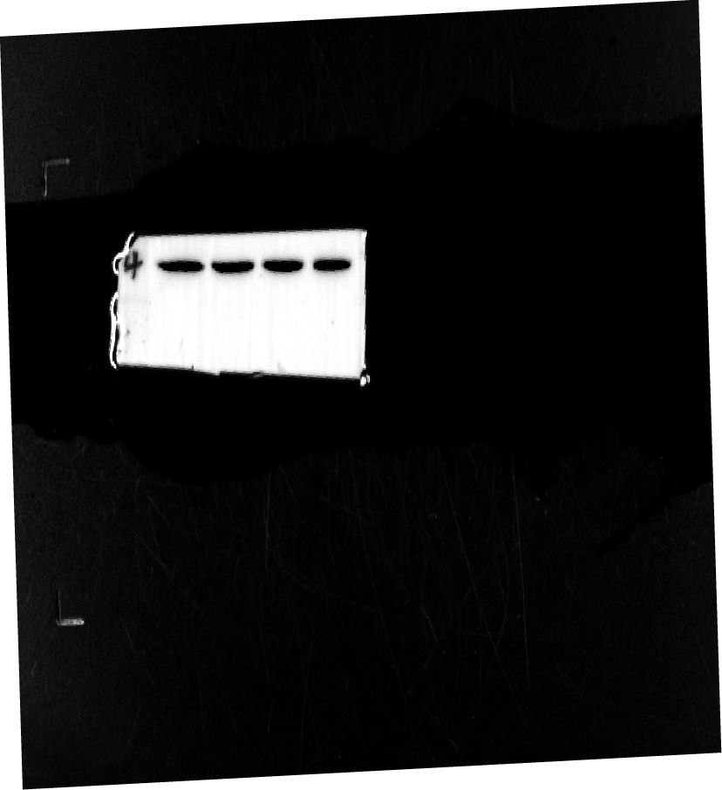
POLR1A α-Tubulin

