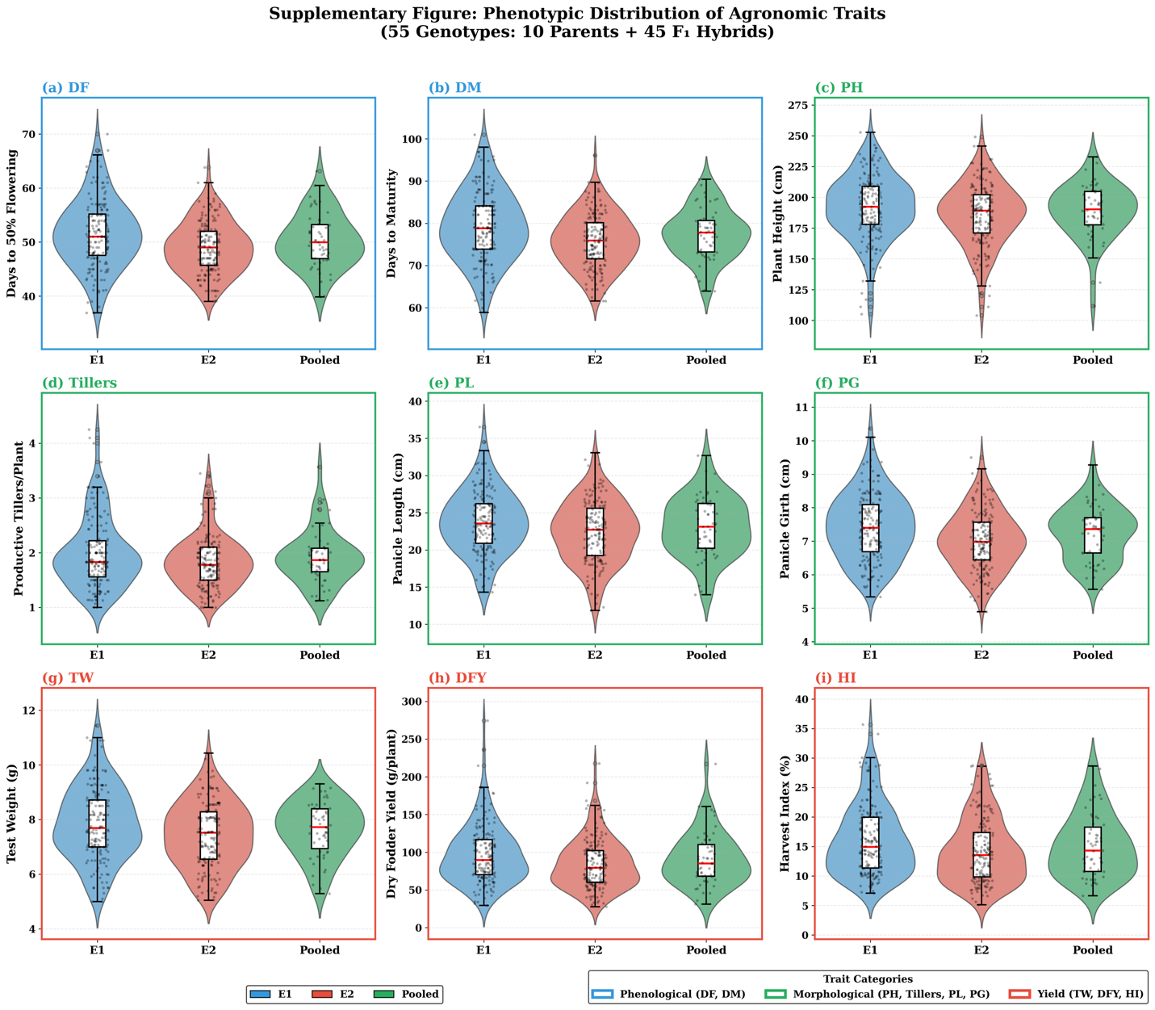
Fig. S1 Phenotypic distribution of agronomic traits across environments in 55 pearl millet genotypes (10 parents + 45 F₁ hybrids). Violin-box plots showing distribution of (a) days to 50% flowering (DF), (b) days to maturity (DM), (c) plant height (PH), (d) productive tillers/plant, (e) panicle length (PL), (f) panicle girth (PG), (g) test weight (TW), (h) dry fodder yield (DFY), and (i) harvest index (HI) under E1 (normal sowing), E2 (late sowing), and pooled environments. Traits are color-coded by category: Phenological (blue), Morphological (green), and Yield (red). Box plots within violins indicate median (red line) and interquartile range.

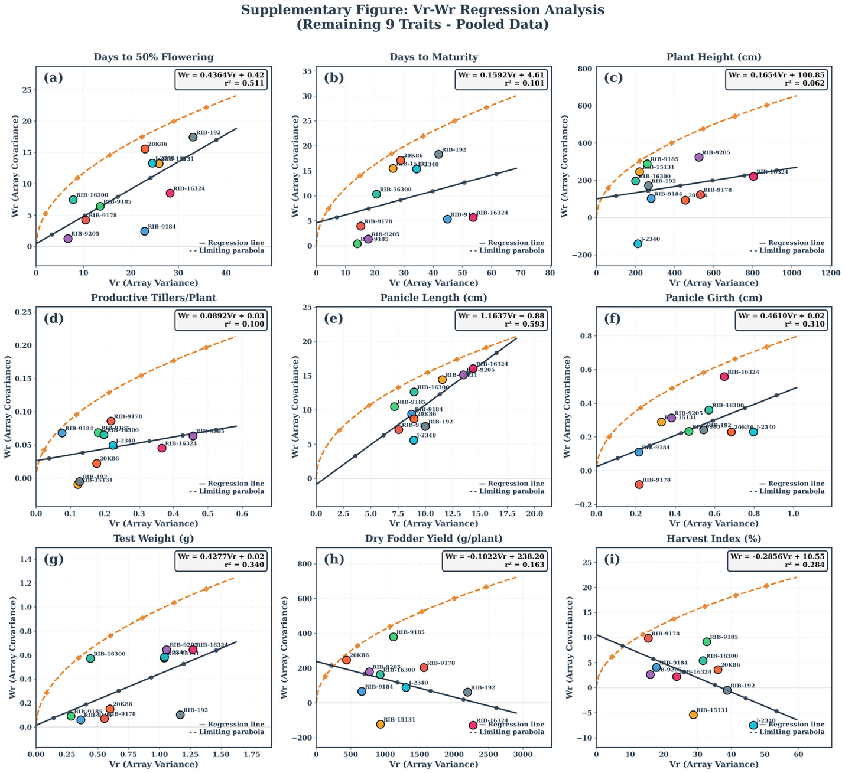
Fig. S2 Vr-Wr regression analysis (Hayman’s graphical approach) for nine agronomic traits in pearl millet (pooled data). (a) Days to 50% flowering, (b) Days to maturity, (c) Plant height, (d) Productive tillers/plant, (e) Panicle length, (f) Panicle girth, (g) Test weight, (h) Dry fodder yield, and (i) Harvest index. Solid lines represent regression of Wr (array covariance) on Vr (array variance); dashed curves indicate limiting parabola. Regression equations and r² values are shown for each trait. Parents positioned near the origin possess dominant alleles; those farther from origin carry recessive alleles.

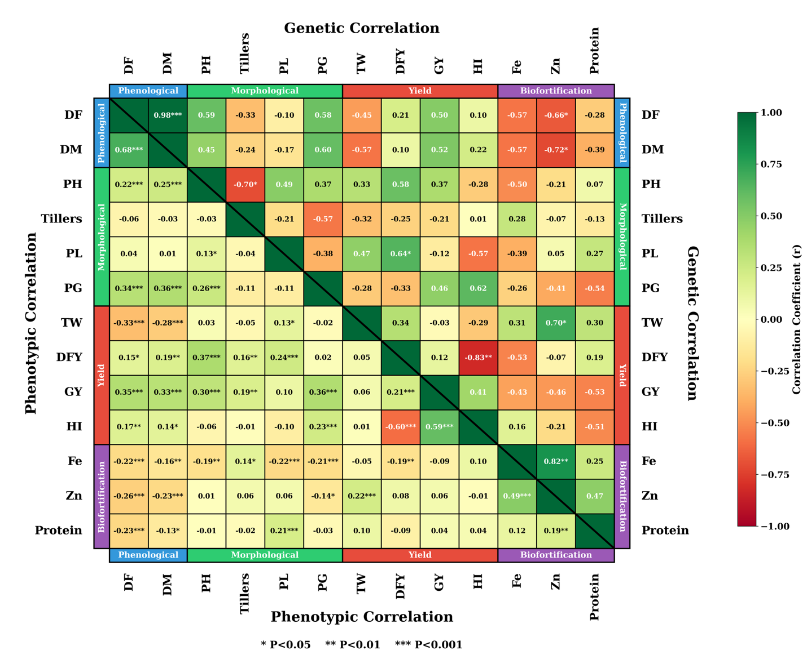
Fig. S3 Split heatmap displaying genetic (upper triangle) and phenotypic (lower triangle) correlation coefficients among 13 traits in pearl millet. Traits grouped into four categories: Phenological (DF, DM), Morphological (PH, Tillers, PL, PG), Yield (TW, DFY, GY, HI), and Biofortification (Fe, Zn, Protein). Color scale indicates correlation magnitude and direction (green = positive; red = negative). Significance levels indicated as: P<0.05, P<0.01, P<0.001. Notable correlations include Fe-Zn (rg = 0.82), DF-DM (rg = 0.98*), and DFY-HI (rg = -0.83**).

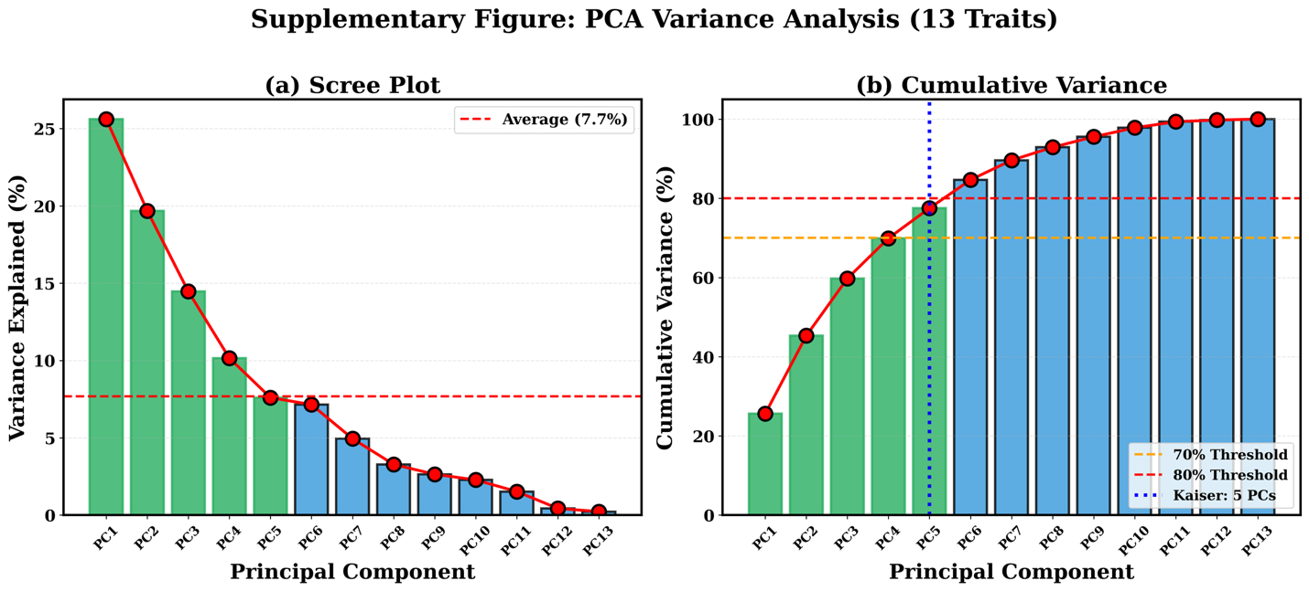
Fig. S4 Principal component analysis (PCA) variance distribution for 13 traits in pearl millet. (a) Scree plot showing individual variance explained by each principal component; red dashed line indicates average variance (7.7%). (b) Cumulative variance plot with threshold lines at 70% (orange) and 80% (red); blue dotted line indicates Kaiser criterion (eigenvalue >1) retaining first five PCs. PC1 through PC5 cumulatively explained 77.6% of total phenotypic variation. Green bars indicate PCs with above-average contribution; blue bars indicate below-average contribution.

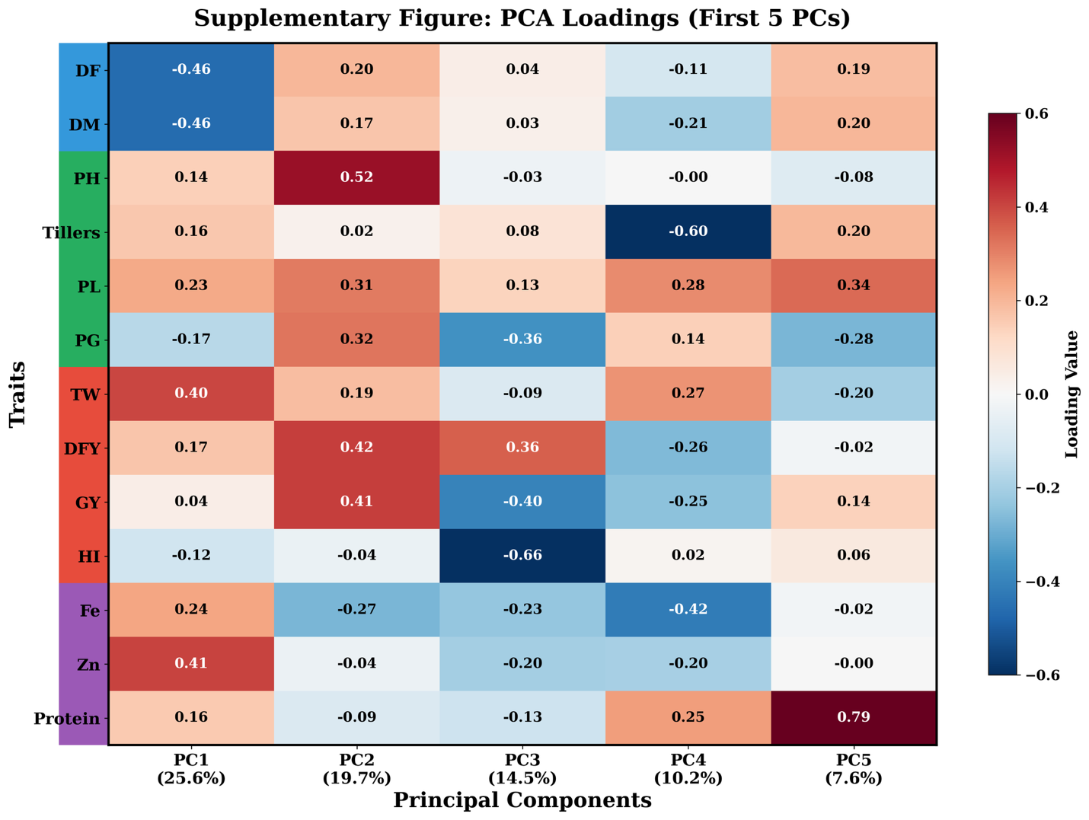
Fig. S5 Heatmap of PCA loadings for the first five principal components across 13 traits in pearl millet. PC1 (25.6%) loaded positively on Zn (0.41), TW (0.40) and negatively on DF (-0.46), DM (-0.46). PC2 (19.7%) associated with PH (0.52), DFY (0.42), GY (0.41). PC3 (14.5%) loaded negatively on HI (-0.66), GY (-0.40). PC4 (10.2%) associated negatively with Tillers (-0.60), Fe (-0.42). PC5 (7.6%) strongly loaded on Protein (0.79). Color scale: red = positive loading; blue = negative loading. Trait categories indicated by colored bars: Phenological (blue), Morphological (green), Yield (red), Biofortification (purple).

