Supplementary appendix
Table S1 Definitions of severe hypertriglyceridemia in each included trial
Stroes et al., 2024 | Patients who had fasting triglyceride levels of 880 mg per deciliter (9.9 mmol per liter) or higher⁸.
Martson et al.,2025  CORE-TIMI 72a | Fasting triglycerides (TG) ≥ 500 mg/dL (5.65 mmol/L) at both the Run-in period and the Qualification Period as follows: a. Fasting TG ≥ 500 mg/dL (5.65 mmol/L) at Screening run-in visit. If the fasting TG is < 500 mg/dL and ≥ 350 mg/dL (3.95 mmol/L), up to 2 additional tests may be performed, with the average of the tests used to be considered eligible. Fasting TG ≥ 500 mg/dL (5.65 mmol/L) at Screening Qualification visit. If the fasting TG is < 500 mg/dL and ≥ 350 mg/dL (3.95 mmol/L), up to 2 additional tests may be performed with the average of the tests used for qualification⁹.
Martson et al.,2025  CORE-TIMI 72a | Fasting triglycerides (TG) ≥ 500 mg/dL (5.65 mmol/L) at both the Run-in period and the Qualification Period as follows: a. Fasting TG ≥ 500 mg/dL (5.65 mmol/L) at Screening run-in visit. If the fasting TG is < 500 mg/dL and ≥ 350 mg/dL (3.95 mmol/L), up to 2 additional tests may be performed, with the average of the tests used to be considered eligible. Fasting TG ≥ 500 mg/dL (5.65 mmol/L) at Screening Qualification visit. If the fasting TG is < 500 mg/dL and ≥ 350 mg/dL (3.95 mmol/L), up to 2 additional tests may be performed with the average of the tests used for qualification⁹.
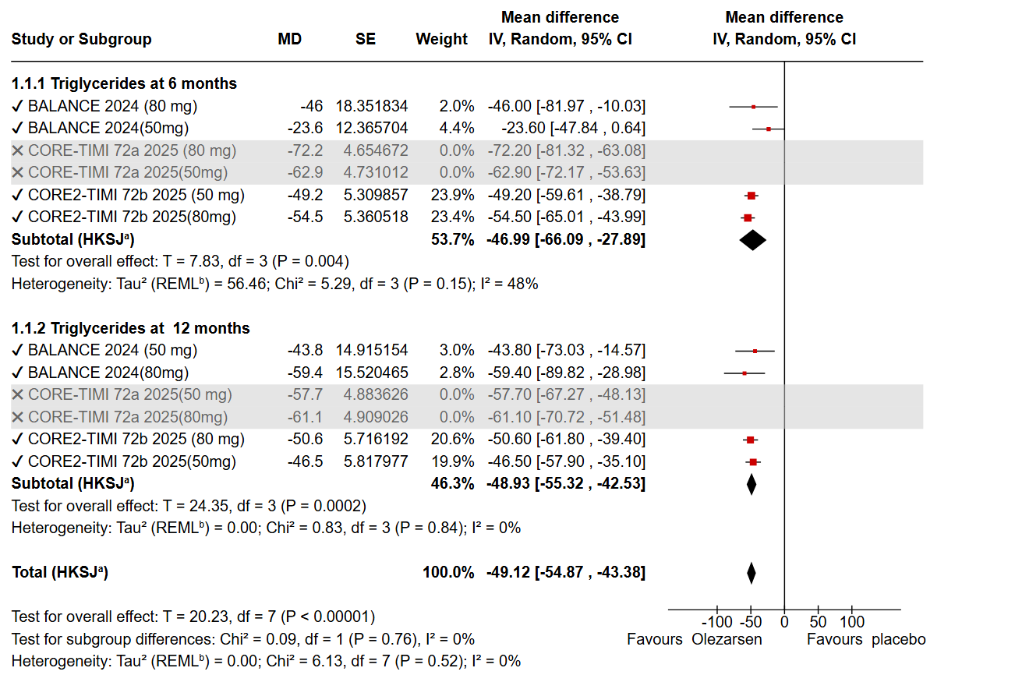Fig. S1 Significant reduction of heterogeneity in TG outcome after sensitivity analysis
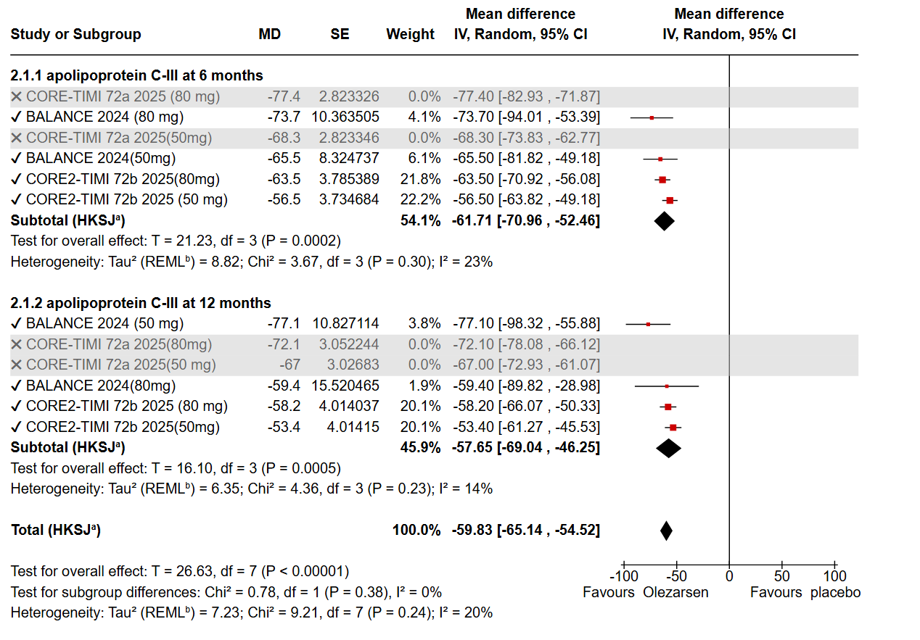Fig. S2 Significant reduction of heterogeneity in apolipoprotein C-III outcome after sensitivity analysis
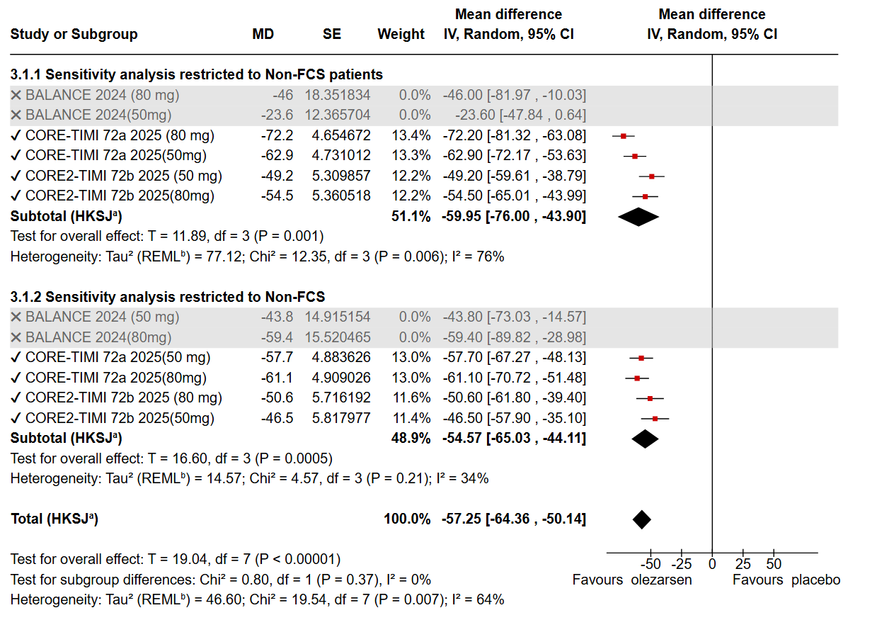Fig. S3 Sensitivity analysis restricted to the Non-FCS population for TG
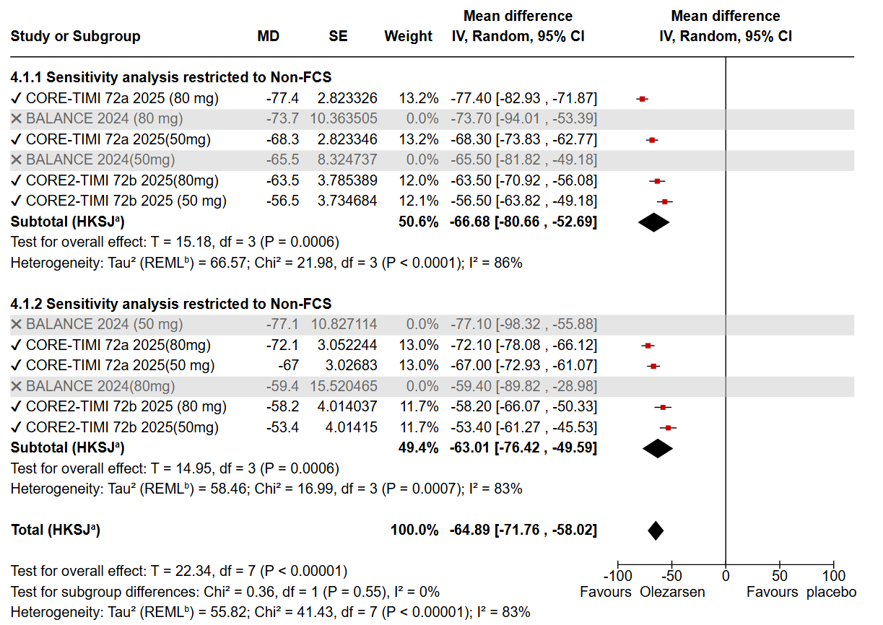Fig. S4 Sensitivity analysis restricted to the Non-FCS population for apolipoprotein C-III
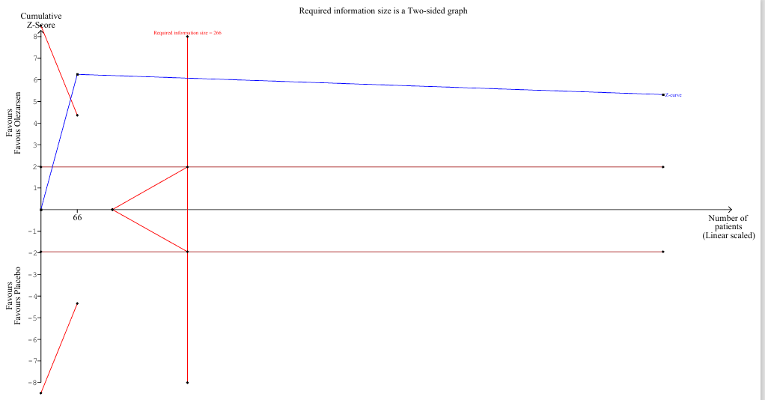Fig. S5 Trial sequential graph for pancreatitis. Olezarsen vs. placebo in pancreatitis using the power of significance to detect a 7.5% absolute difference (Olezarsen 1.2% vs. 8.7%). The required information size was 266 (vertical red line). The cumulative z-curve (blue line with small squares representing each trial) crosses both the traditional boundary (horizontal red line) and the superiority boundary (trial sequential monitoring boundary) (concave red line), indicating evidence is conclusive (True positive)
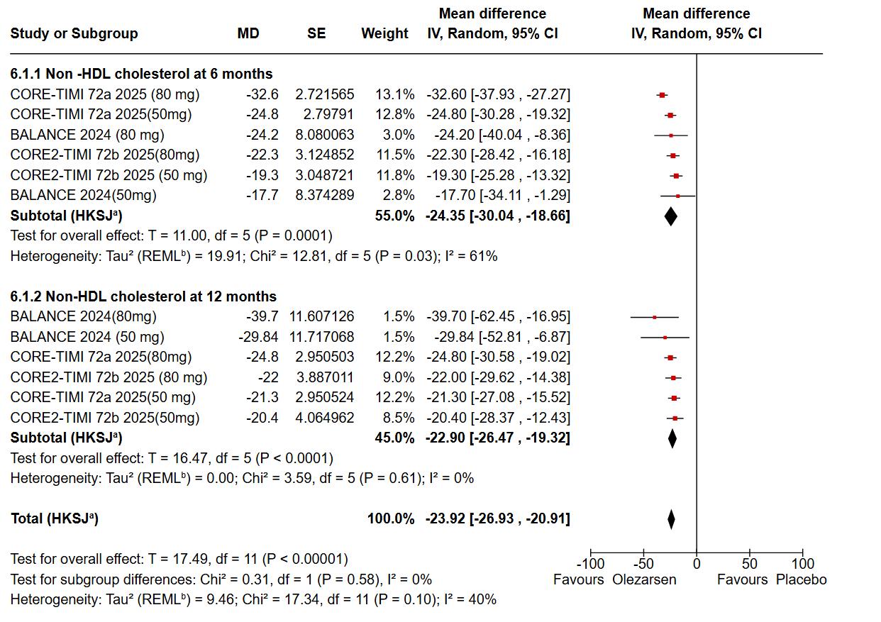Fig. S6 Significant reduction in non-HDL-C level in the olezarsen group
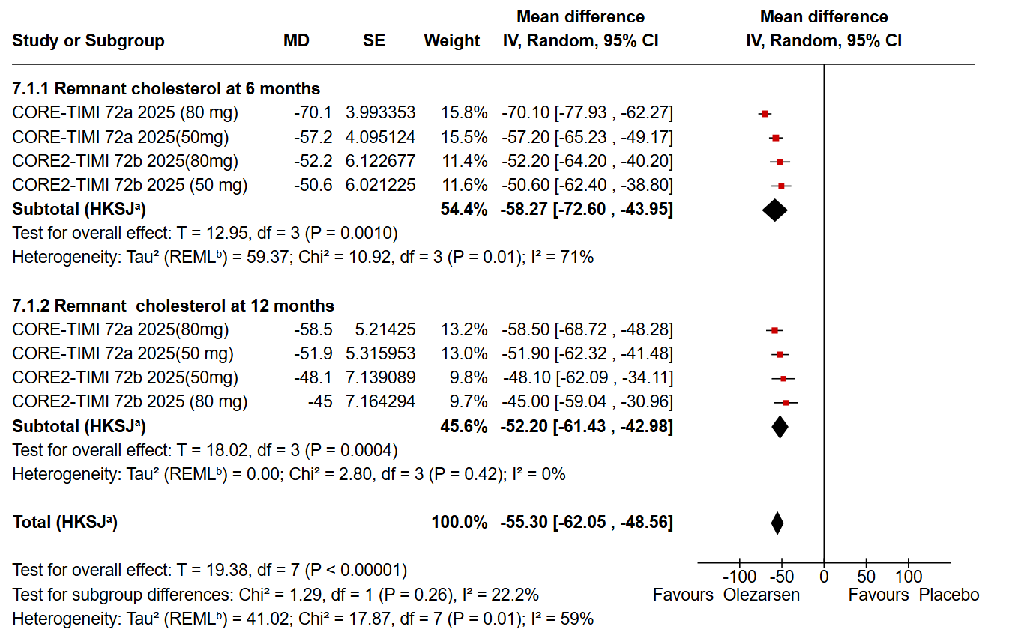Fig. S7 Significant reduction in Remnant cholesterol(RC) in the olezarsen group
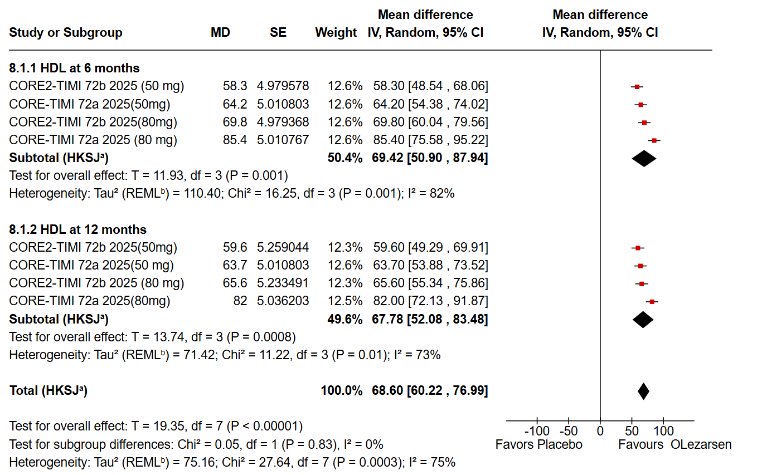
Fig. S8 Significant increase in HDL-C in the olezarsen group
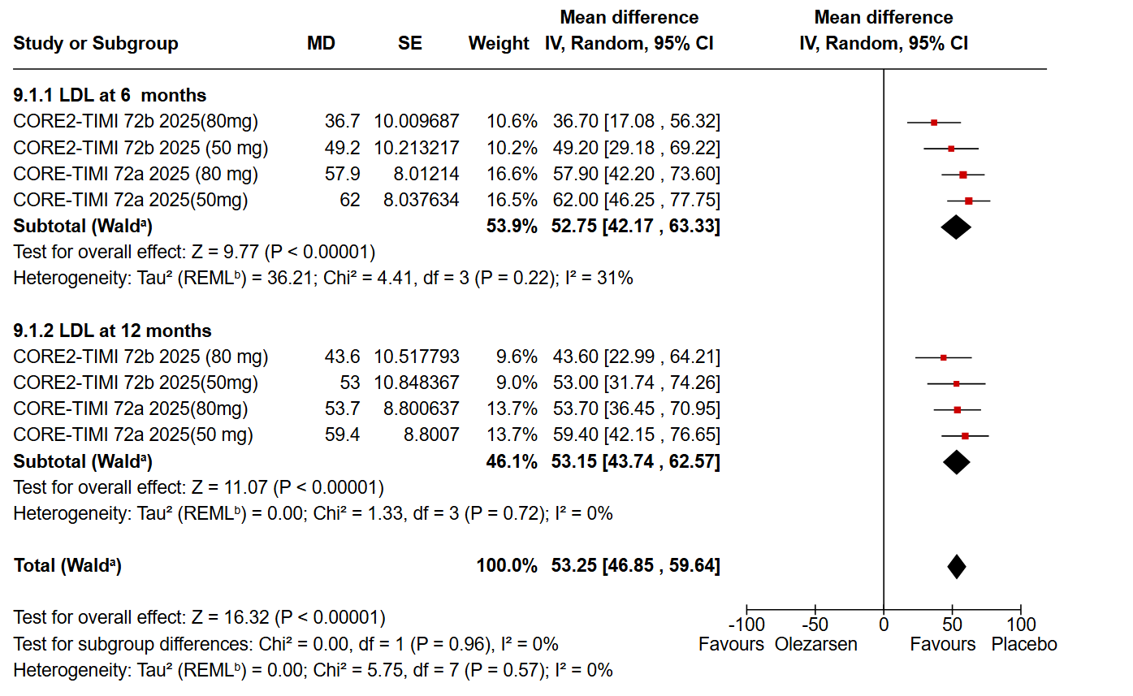Fig. S9. Significant increase in LDL-C in the olezarsen group
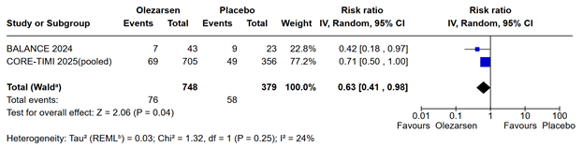
Fig. S10A Reduced serious adverse events with olezarsen
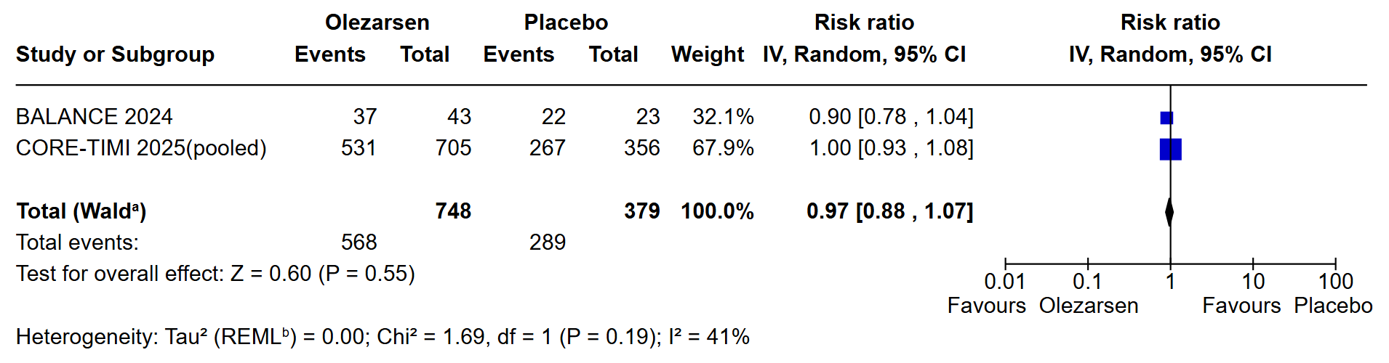
Fig.S10B No significant any adverse events in the olezarsen group
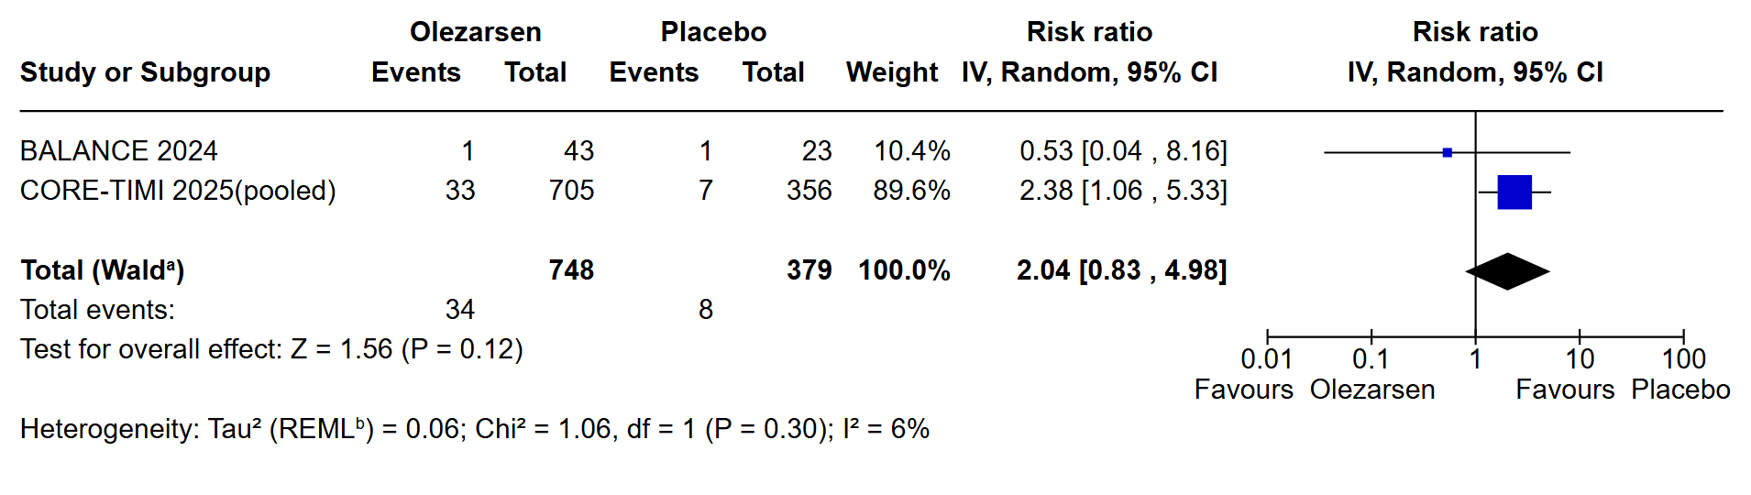
Fig.S10C No significant difference in hepatic enzyme (AST≥3ULN) elevation
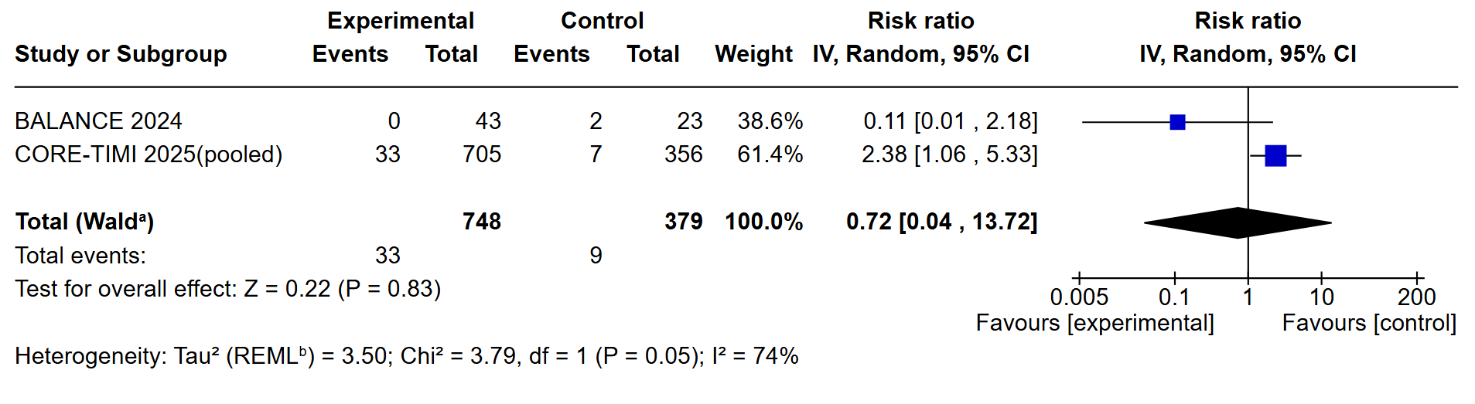
Fig.S10D No significant difference in hepatic enzymes (ALT≥3ULN) elevations
Outcomes | № of participants  (studies)  Follow-up | Certainty of the evidence  (GRADE) | Relative effect  (95% CI) | Anticipated absolute effects
 |  |  |  | Risk with Placebo | Risk difference with Olezarsen
Acute pancreatitis  assessed with: Number of events | 1127  (3 RCTs) | ⨁⨁⨁⨁  High | RR 0.21  (0.09 to 0.48) | 69 per 1,000 | 54 fewer per 1,000  (from 62 fewer to 36 fewer)
Triglycerides at 6 months | 1127  (3 RCTs) | ⨁⨁⨁⨁  Moderateª | - | The mean triglycerides at 6 months was -4.82 percent | MD 54.41 percent lower  (70.85 lower to 37.97 lower)
Triglycerides at 12 months | 1127  (3 RCTs) | ⨁⨁⨁⨁  Moderateª | - | The mean triglycerides at 12 months was -3.56 percent | MD 54.37 percent lower  (61.19 lower to 47.55 lower)
APO C-III levels at 6 months | 1127  (3 RCTs) | ⨁⨁⨁⨁  Moderateª | - | The mean APO C-III levels at 6 months were -6.79 percent | MD 67.16 percent lower  (75.39 lower to 58.94 lower)
APO C-III levels at 12 months | 1127  (3 RCTs) | ⨁⨁⨁⨁  Moderateª | - | The mean APO C-III levels at 12 months was -7.03 percent | MD 64.03 percent lower  (73.11 lower to 54.95 lower)
Serious adverse events  assessed with: Event number | 1127  (3 RCTs) | ⨁⨁⨁⨁  High | RR 0.63  (0.41 to 0.98) | 153 per 1,000 | 57 fewer per 1,000  (from 90 fewer to 3 fewer)
Any adverse event  assessed with: Event number | 1127  (3 RCTs) | ⨁⨁⨁⨁  High | RR 0.97  (0.88 to 1.07) | 763 per 1,000 | 23 fewer per 1,000  (from 92 fewer to 53 more)
a Substantial heterogeniety,partially explained by leave-one-out analysis.
Table S2 GRADE assessment Of outcomes
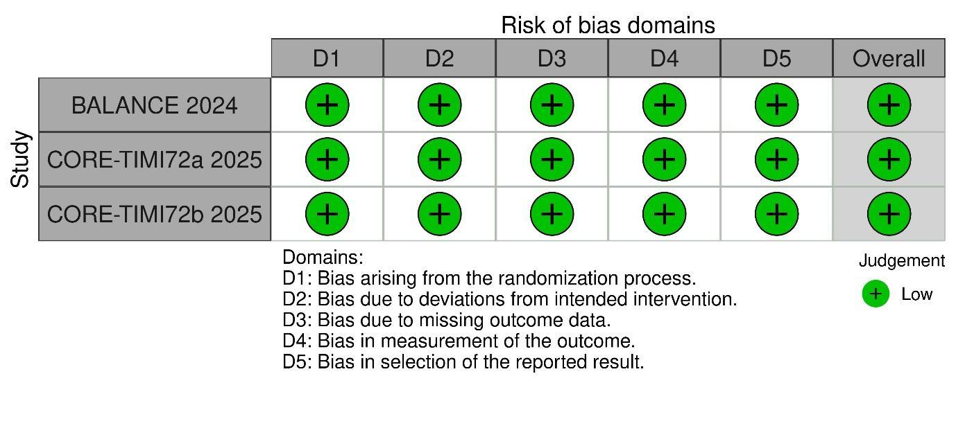

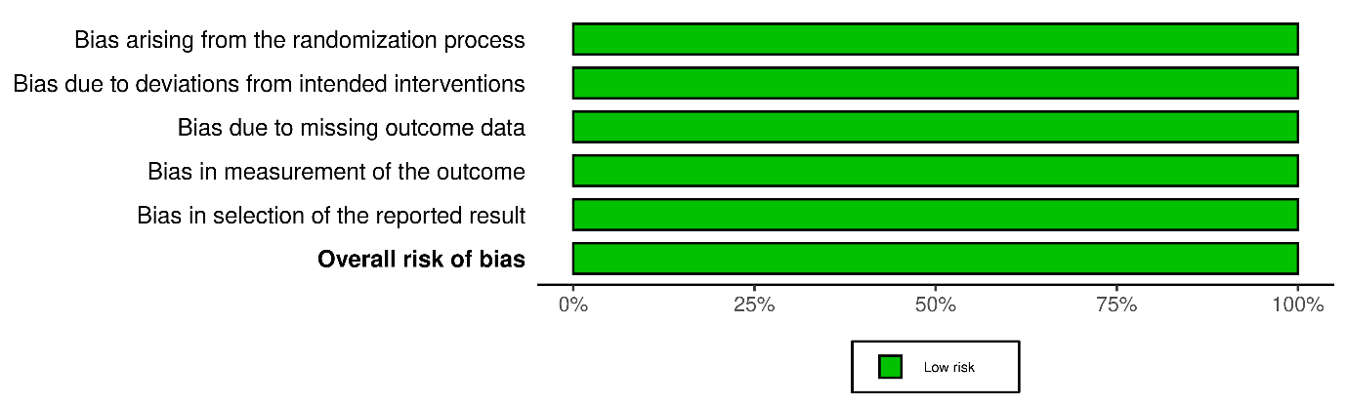Fig. S11 The Risk of Bias assessment (RoB2) tool for bias assessment
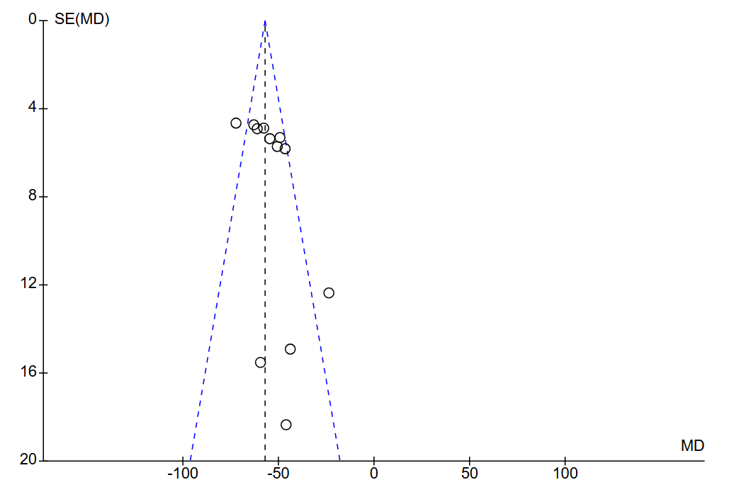
Fig S12A Funnel plot for Triglycerides

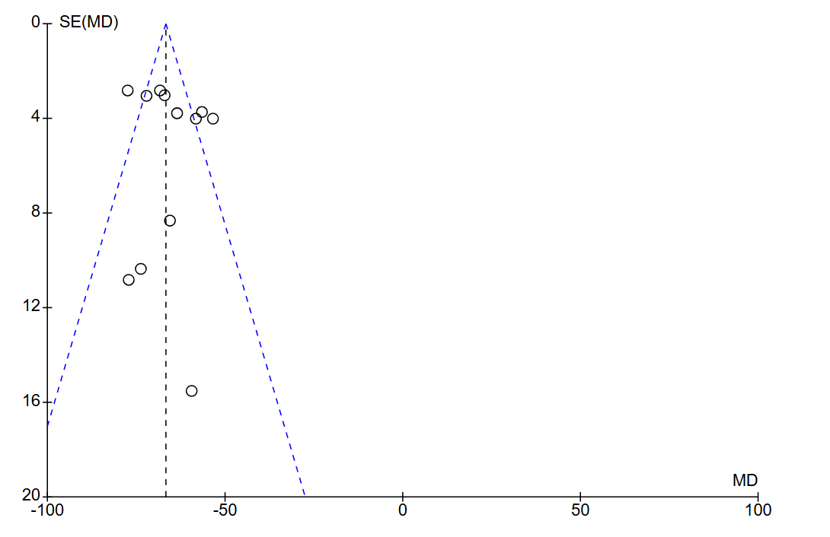
Fig. S12B Funnel plot for apolipoprotein C-III

