Supplementary Information for:

Non-canonical sex chromosome evolution revealed by extreme heterogeneity in homomorphic Y chromosome differentiation in the common frog

Fantin Carpentier^{1*}, Paris Veltsos^{1,2*†}, Ezgi Unal¹, Kelsey L. Doucette³, Ricard Fontseré¹, Alan Brelsford⁴, Melissa A. Toups^{2,3}, Nicolas Perrin², Wen-Juan Ma^{1,2*†}

1. Research group of Ecology, Evolution and Genetics, Biology Department, Vrije Universiteit Brussel, Brussels, Belgium
2. Department of Ecology and Evolution, University of Lausanne, Lausanne, Switzerland
3. Department of Biology, University of Louisiana at Lafayette, Lafayette, LA, USA
- Evolution Ecology and Organismal Biology Department, University of California, Riverside, CA, USA

*Equal contribution:
The two authors contribute to the work equally.

†Correspondence:
wen-juan.ma@vub.be
paris.veltsos@vub.be

This PDF file includes:
Figs. S1 to S27

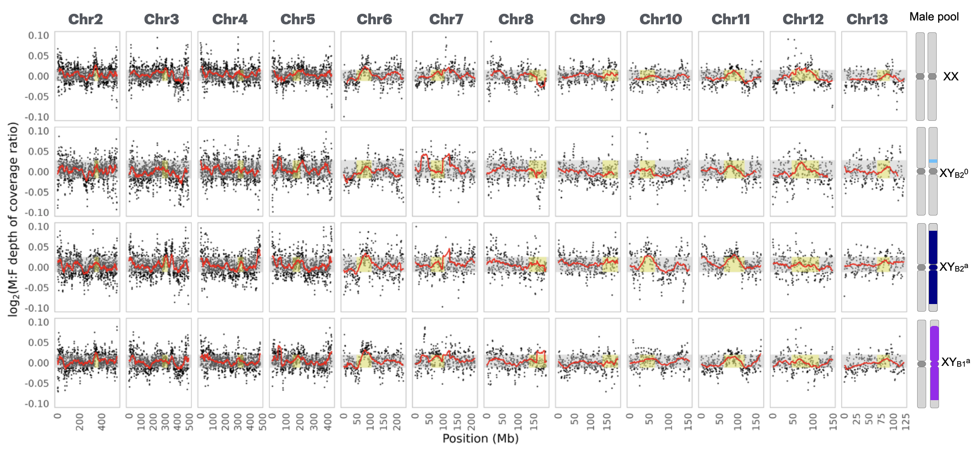

Figure S1: Log₂ male-to-female read coverage ratio between each male pool and the female pool. Each male pool (XX, Y_{B2}⁰, Y_{B1}ª, and Y_{B2}ª) was compared to the female pool along each of the 12 autosomes (chr2 to chr13). The dots represent average read coverage ratio between each male and female pools within 1 Mb overlapping window (stride = 500 kb). The red line indicates the rolling mean (window size = 50 Mb). The grey rectangle marks the central 95% of the rolling mean of autosomal values. Yellow zones indicate tentative centromeric regions.

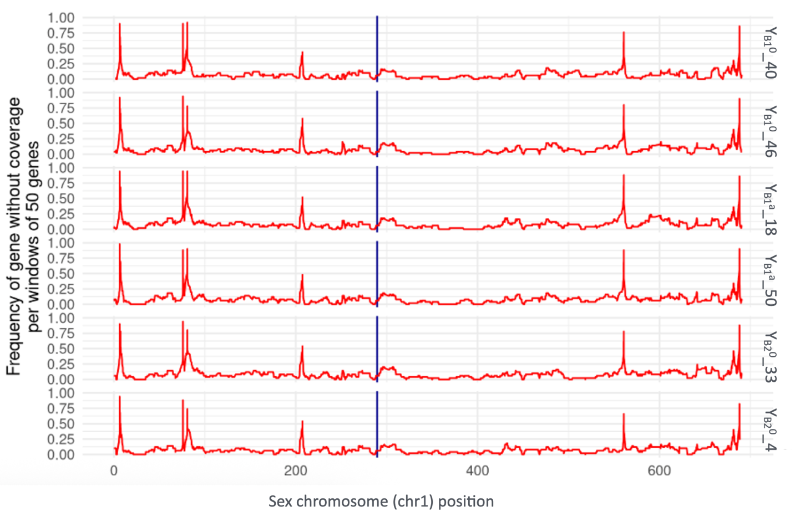
Figure S2: Frequency plot of genes in a non-overlapping window of 50 genes with zero coverage support when mapping to the XX reference genome, along the sex chromosome for the 6 double haploid YY individuals. The blue vertical line is the region for sex-linked marker at genes of Dmrt1 and Dmrt3.

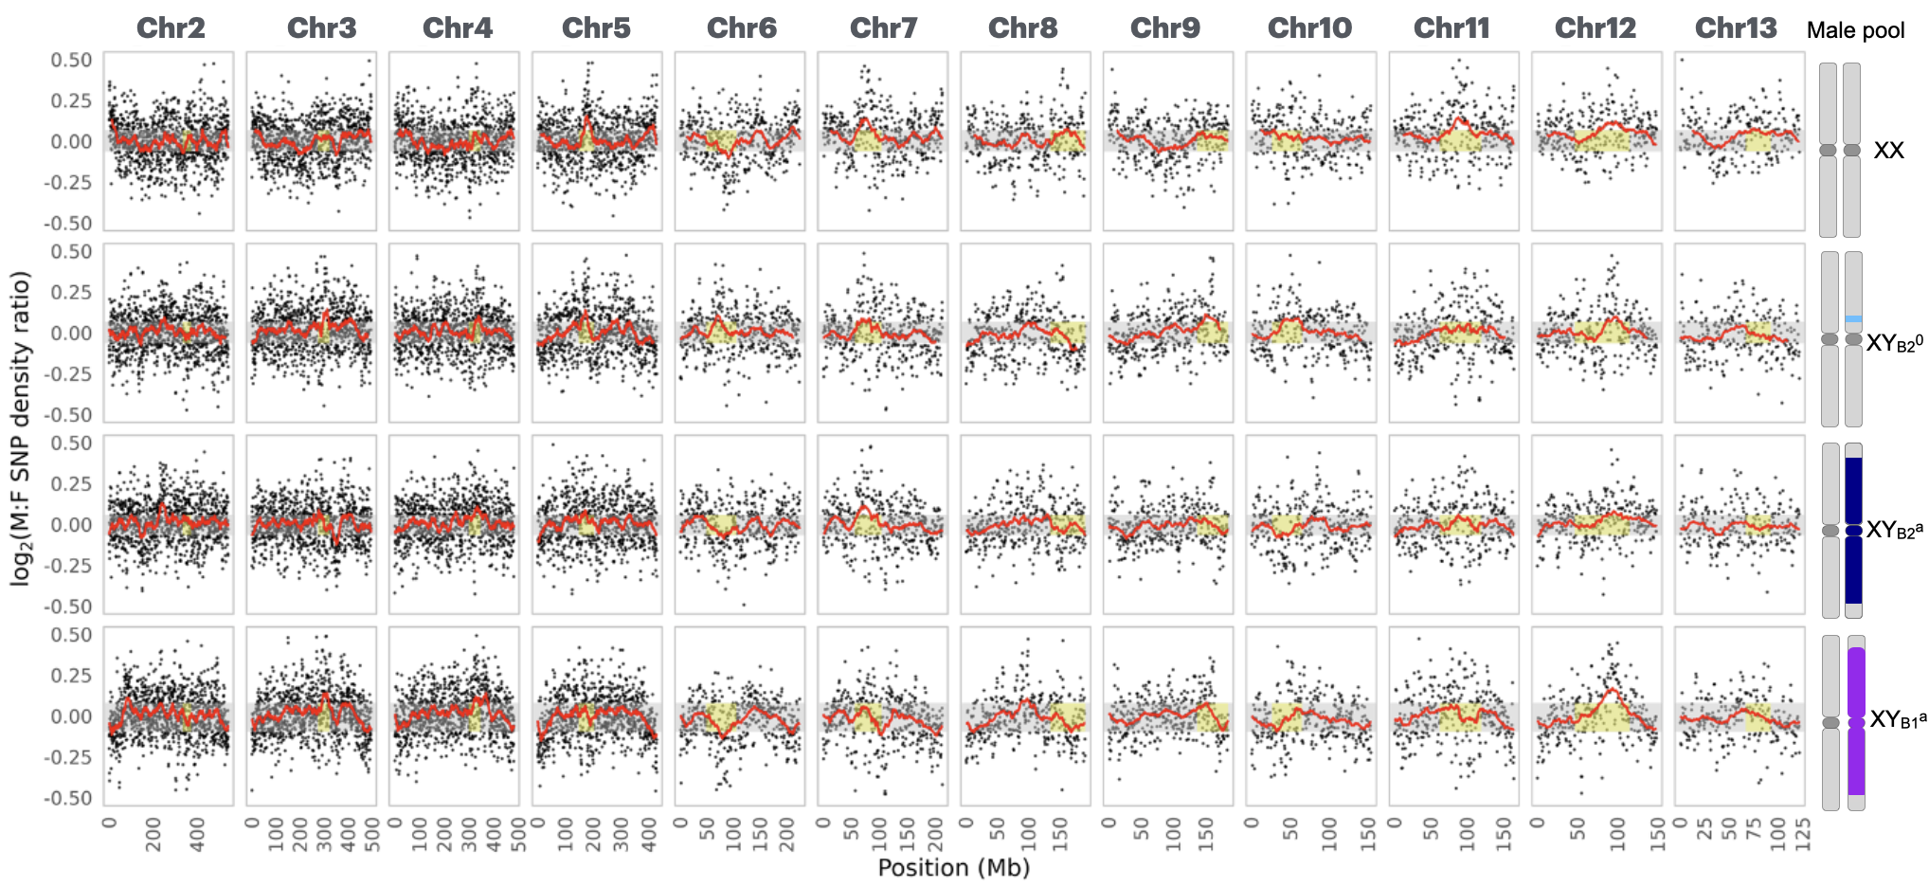
Figure S3: Log₂ male-to-female SNP density ratio between each male and the female pool. Each male pool (XX, YB₂⁰, YB₁ª, and YB₂ª) was compared to the female pool along each of the 12 autosomes. The dot represents the average SNP density ratio within 1 Mb overlapping window. The red line indicates the rolling mean (window size = 50 Mb). The grey rectangle marks the central 95% of the rolling mean of autosomal values. Yellow zones indicate tentative centromeric regions.

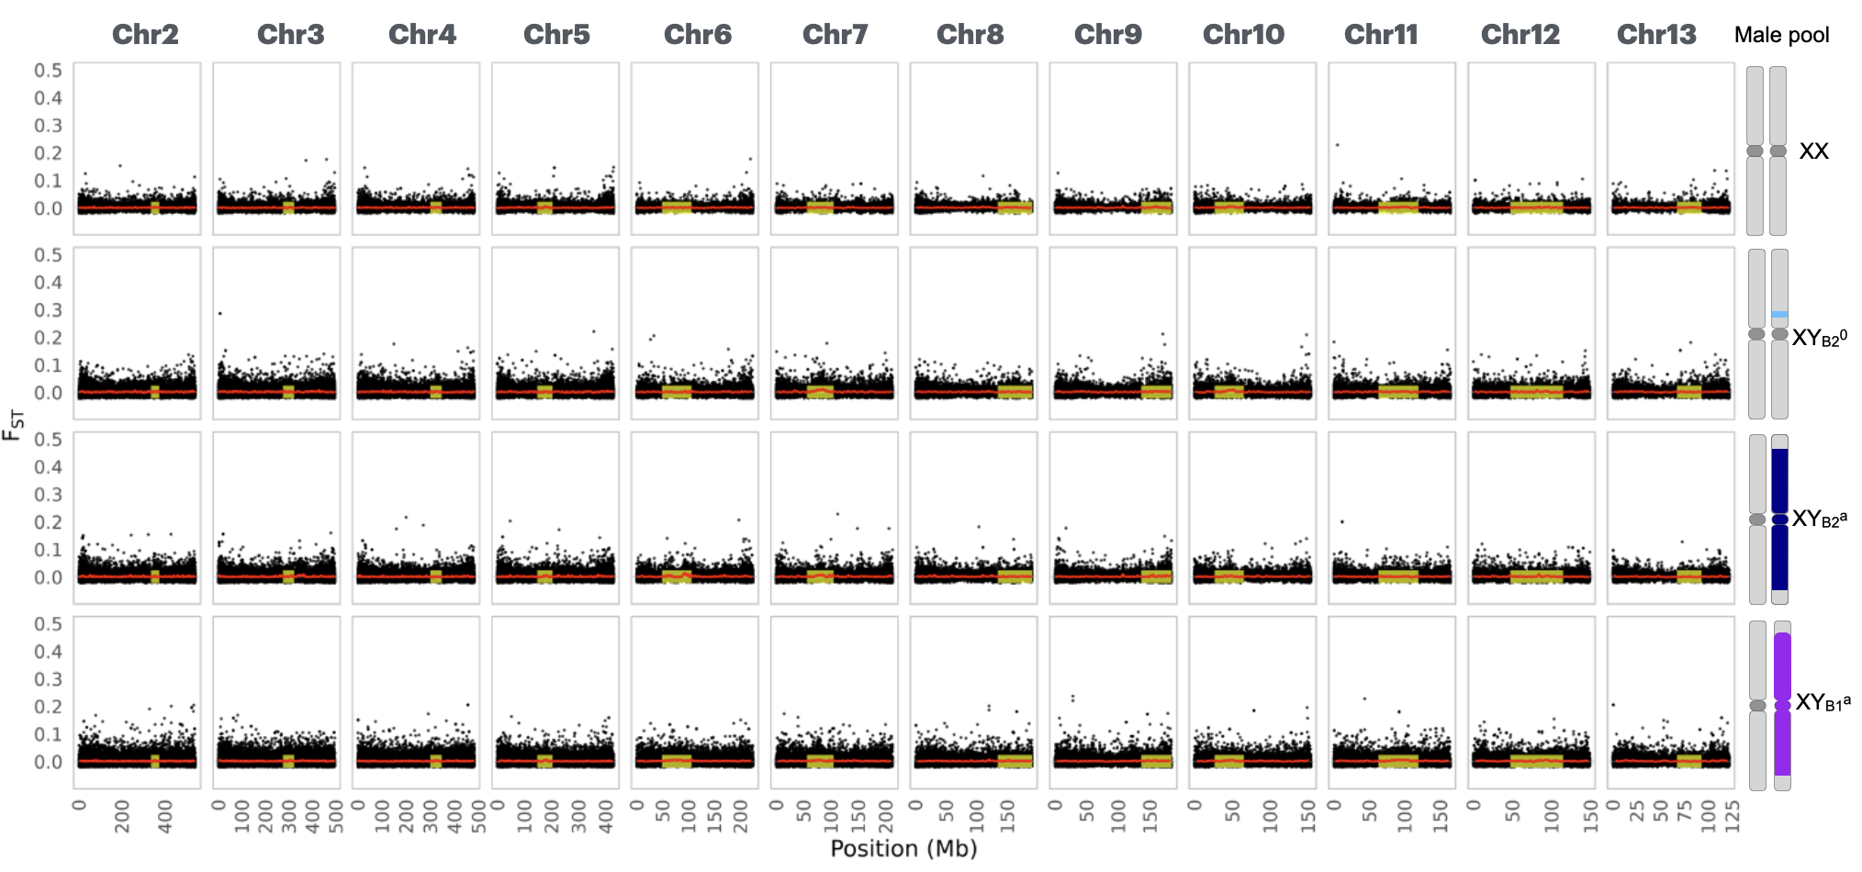

Figure S4: F_{ST} between each male pool and the female pool. Each male pool (XX, YB₂⁰, YB₁ª, and YB₂ª) was compared to the female pool along each of the 12 autosomes. The dot represents the average F_{ST} within a 10kb overlapping window (stride = 5kb) between each male and female pools. The grey rectangle marks the central 95% of the rolling mean of autosomal values. Yellow zones indicate tentative centromeric regions.

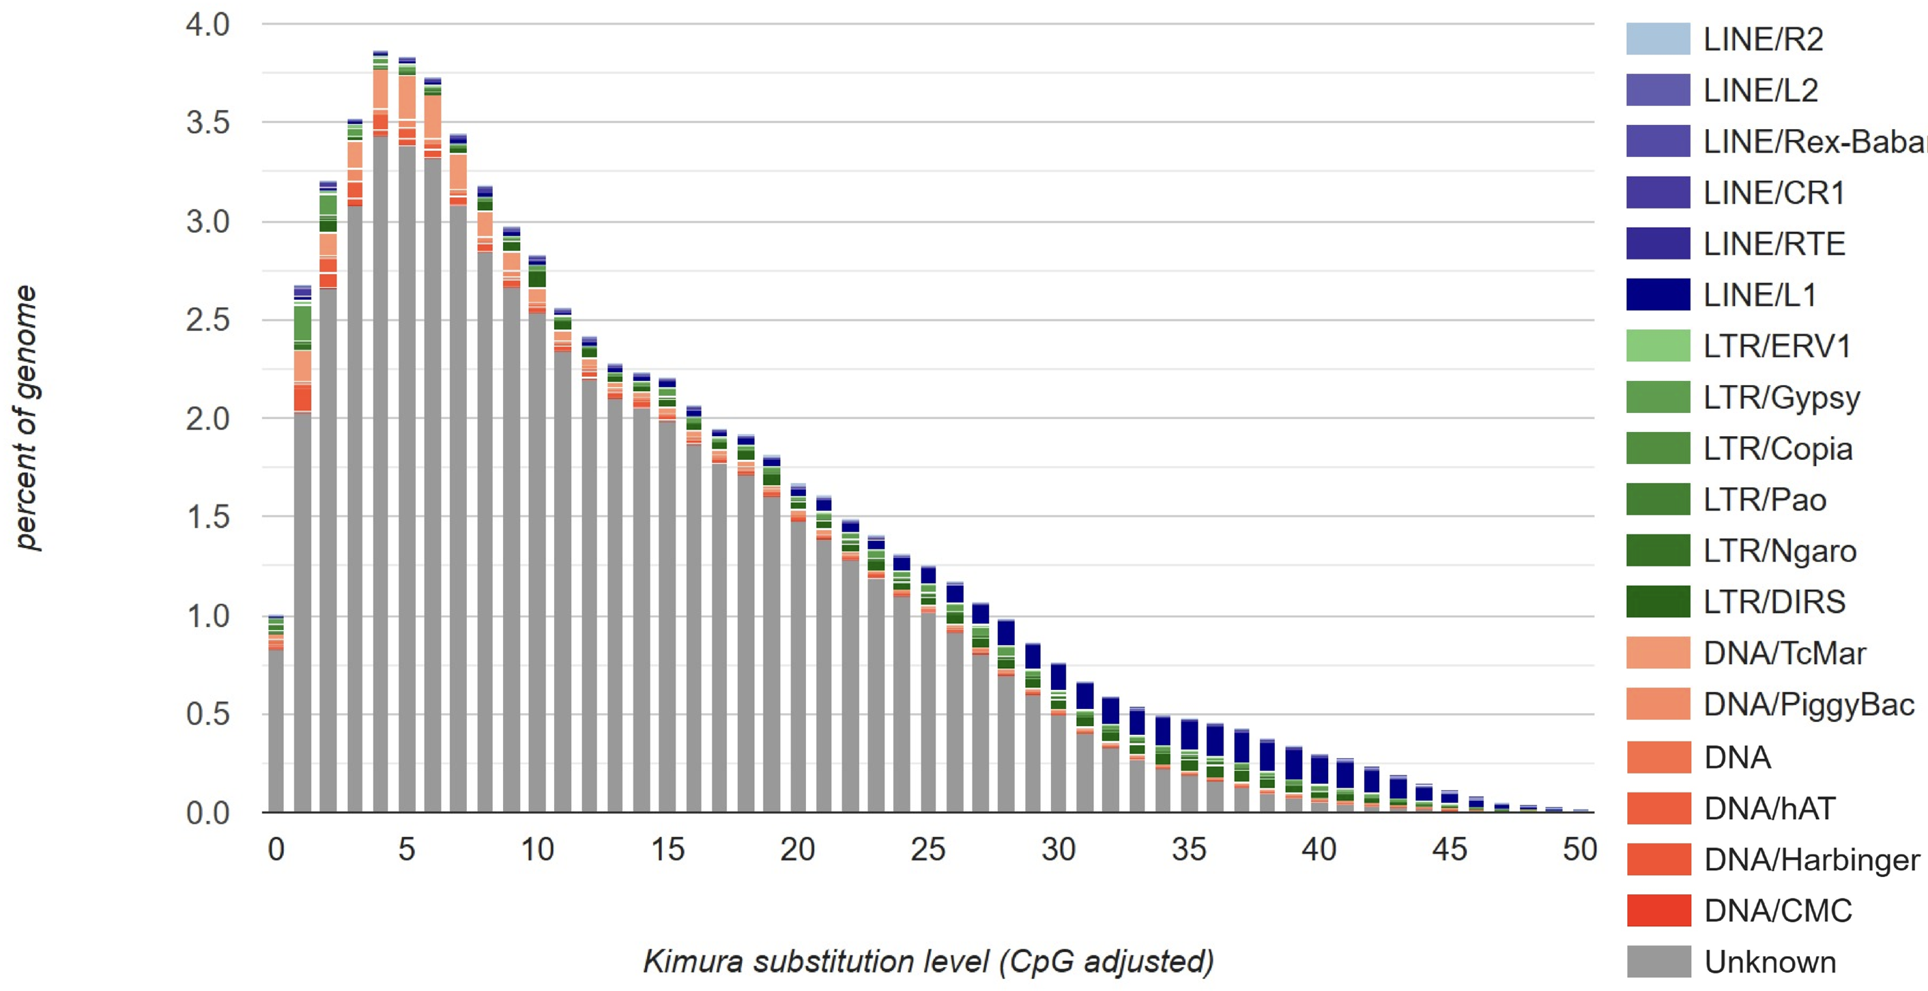

Figure S5. TE divergence landscape inferred by the kimura substitution level, and the smaller values indicate low divergence. The TE library is conducted with de novo annotation of the reference genome R. temporaria.

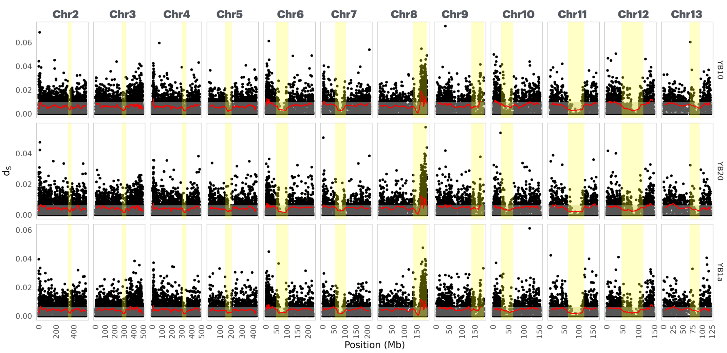
Figure S6. Computed d_{S} along each of 12 autosomes between each of the three type of Y haplotypes and the reference XX genome. The grey rectangle marks the central 95% of the rolling mean of autosomal values. Yellow zones indicate tentative centromeric regions.

(a)
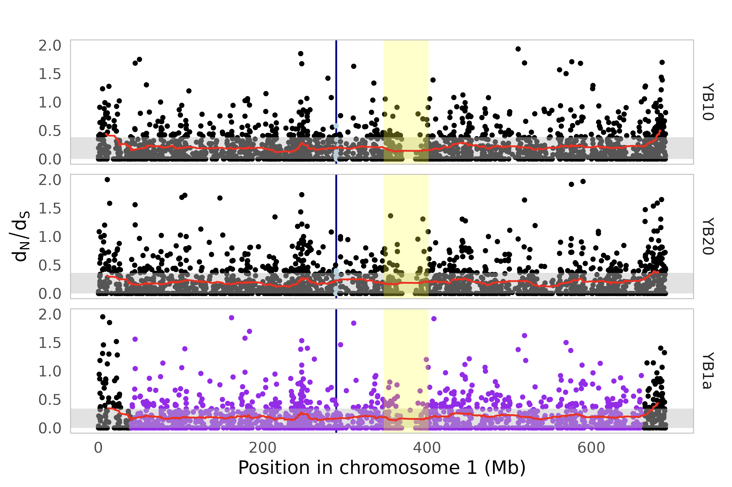
(b)
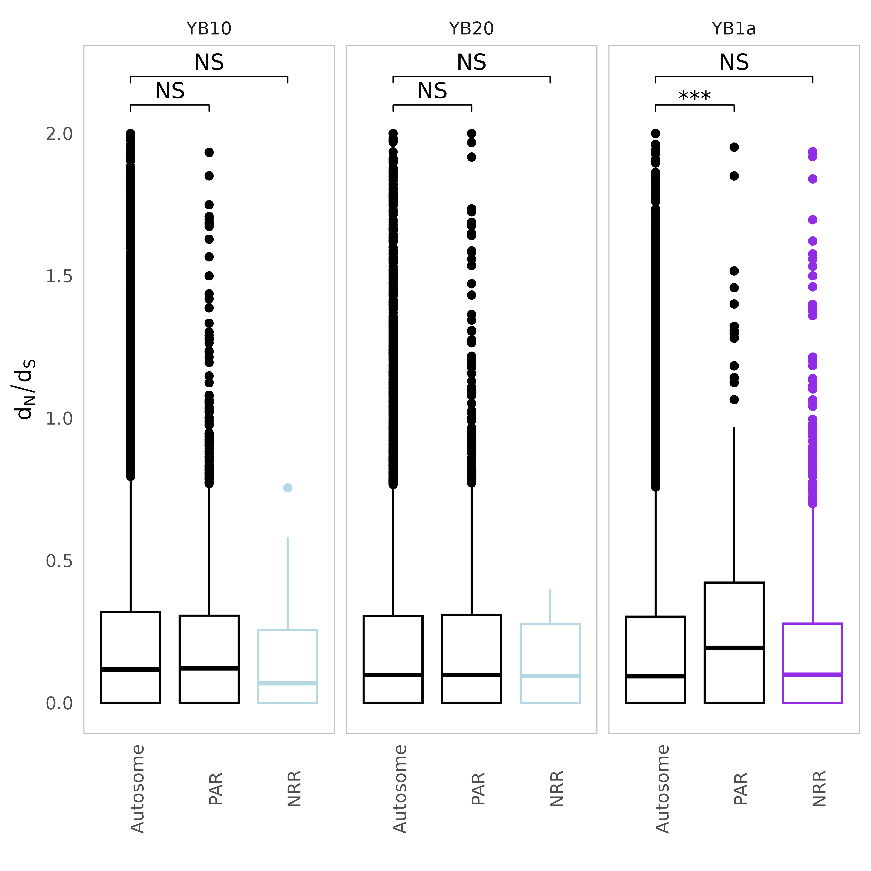
Figure S7. Computed d_{N}/d_{S} between each of the three types of Y haplotypes and the reference XX genome. (a) d_{N}/d_{S} along the sex chromosome. The vertical blue line is the region including Dmrt1 and Dmrt3 genes. (b) Boxplot of d_{N}/d_{S} values between genomic compartments with significance indicated from permutation test.

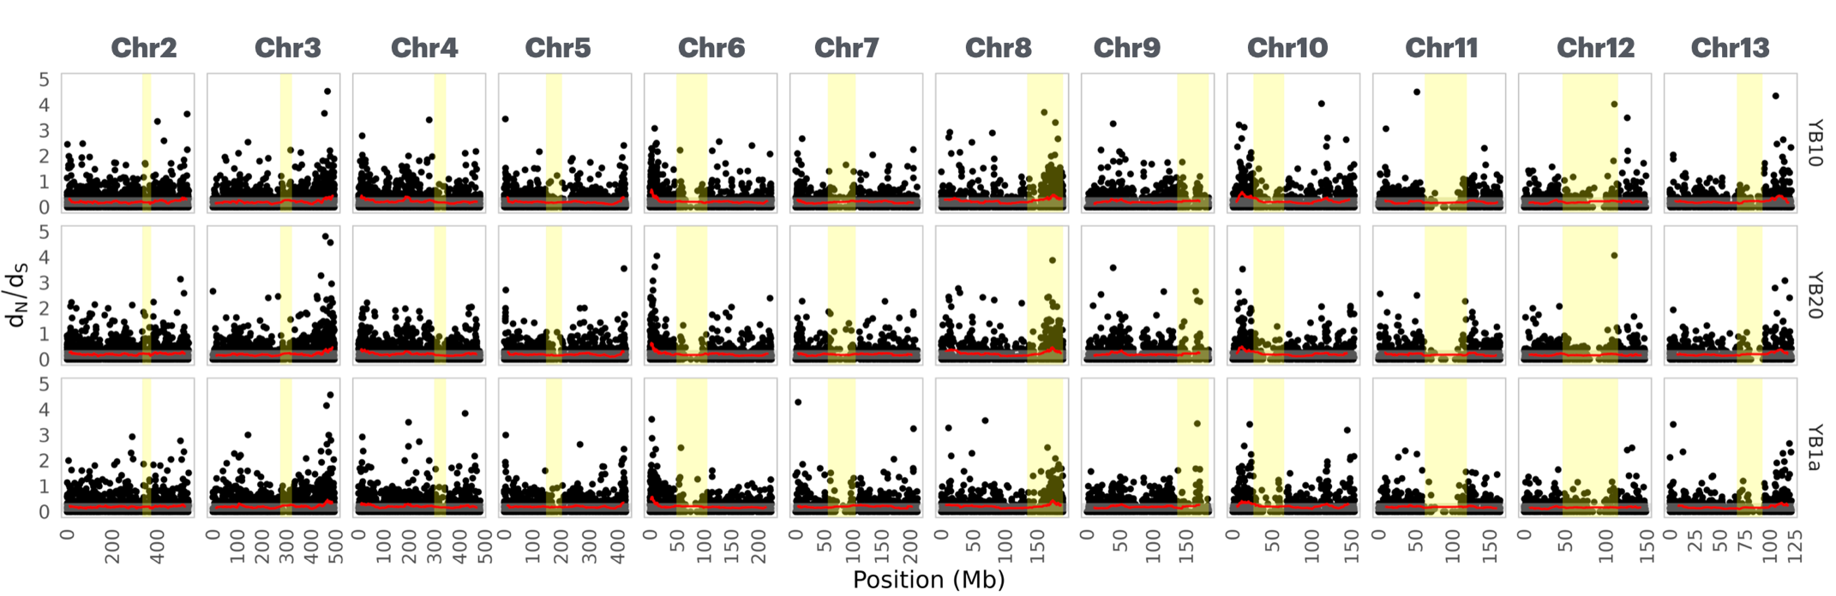

Figure S8. Computed d_{N}/d_{S} along each of the 12 autosomes between each of the three type of Y haplotypes and the reference XX genome. The grey rectangle marks the central 95% of the rolling mean of autosomal values. Yellow zones indicate tentative centromeric regions.

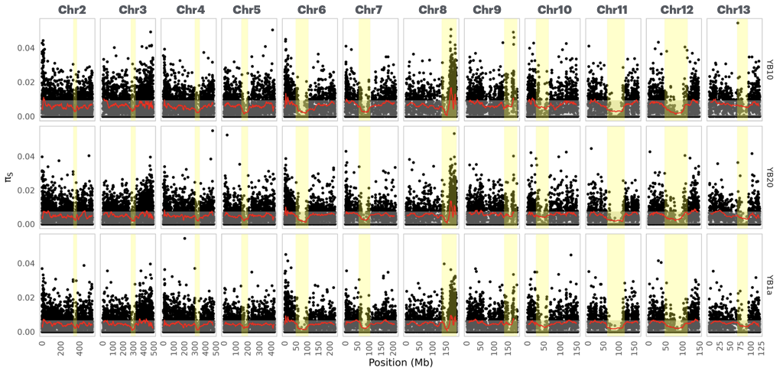
Figure S9. Computed π_{S} along each of 12 autosomes between each of the three type of Y haplotypes and the reference XX genome. The grey rectangle marks the central 95% of the rolling mean of autosomal values. Yellow zones indicate tentative centromeric regions.

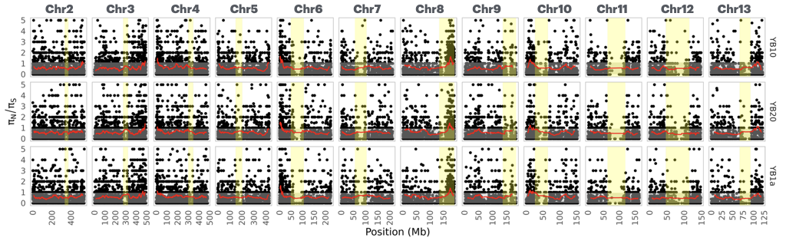
Figure S10. Computed π_{N}/π_{S} along each of the 12 autosomes between each of the three type of Y haplotypes and the reference XX genome. The grey rectangle marks the central 95% of the rolling mean of autosomal values. Yellow zones indicate tentative centromeric regions.

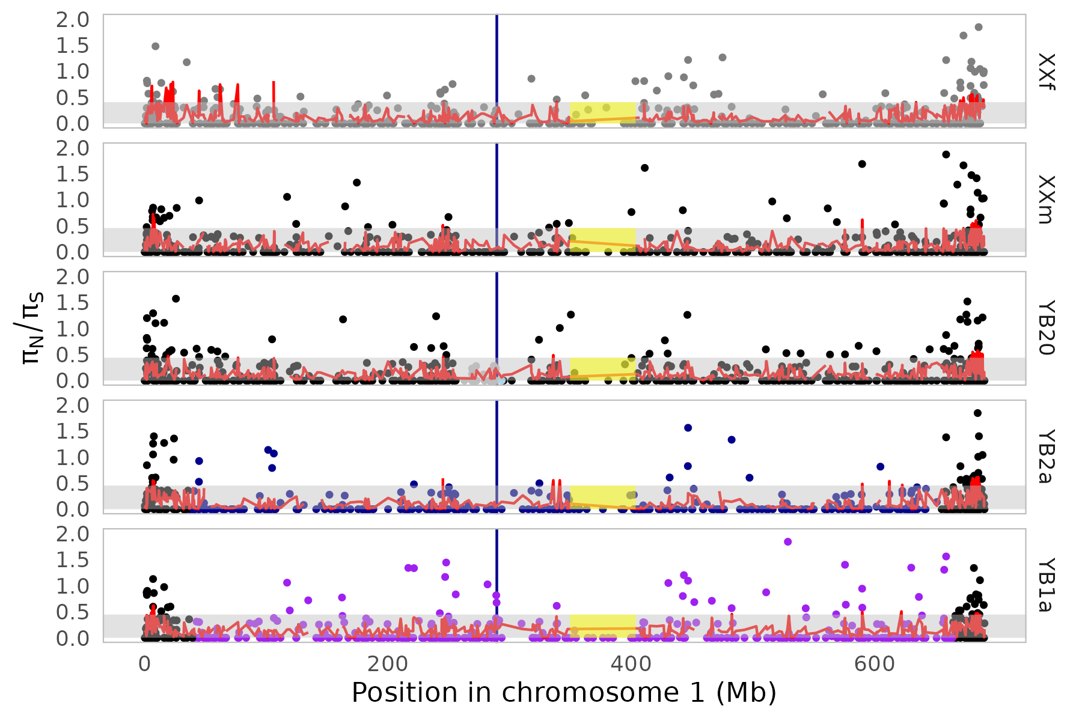
Figure S11. Computed π_{N}/π_{S} between each of the five pool and the reference XX genome. The vertical blue line is the region including Dmrt1 and Dmrt3 genes.

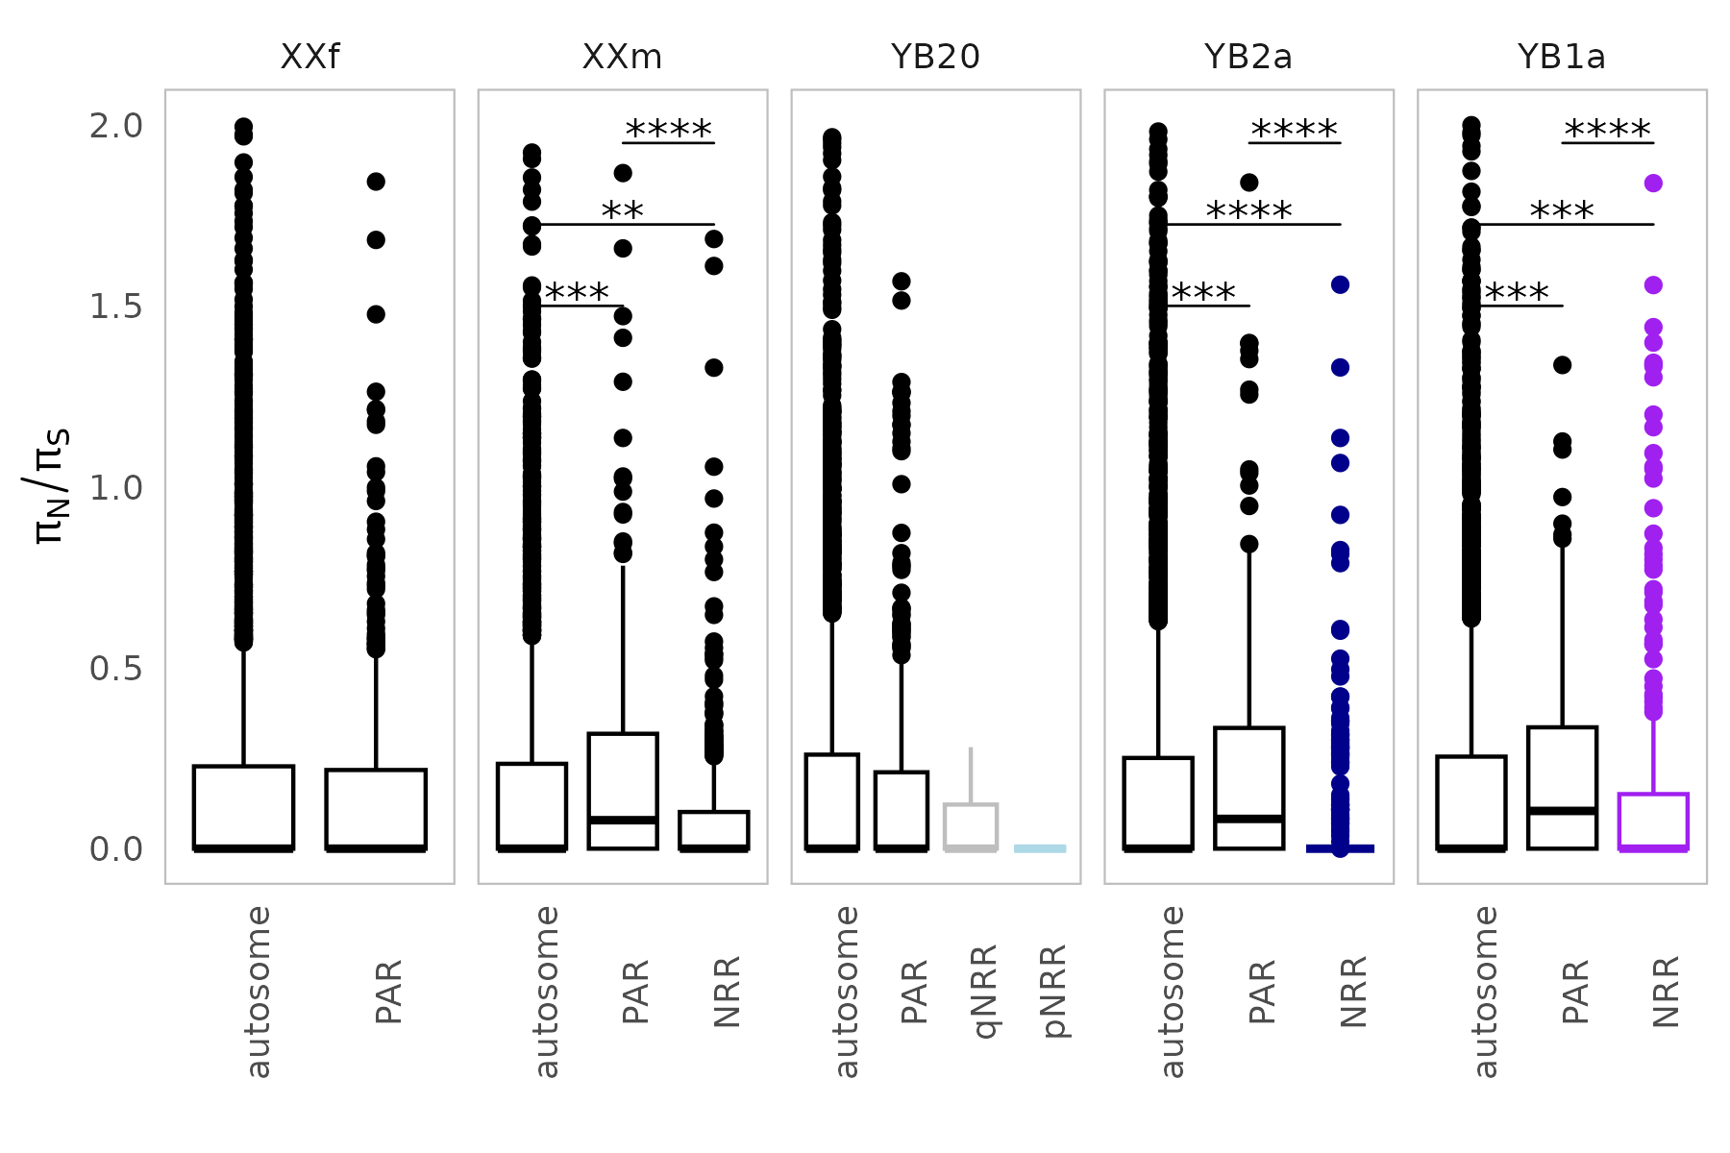
Figure S12. Computed π_{N}/π_{S} between each of the five pool and the reference XX genome. The vertical blue line is the region including Dmrt1 and Dmrt3 genes.

a)
b)

Figure S13. Major allele ratio along the sex chromosome for the female, and three types of males in both gonad (a) and brain tissues (b) from the Meitreile population. We computed the major allele ratio in sliding windows of 500 SNPs using the rollmean function in the R package zoo.

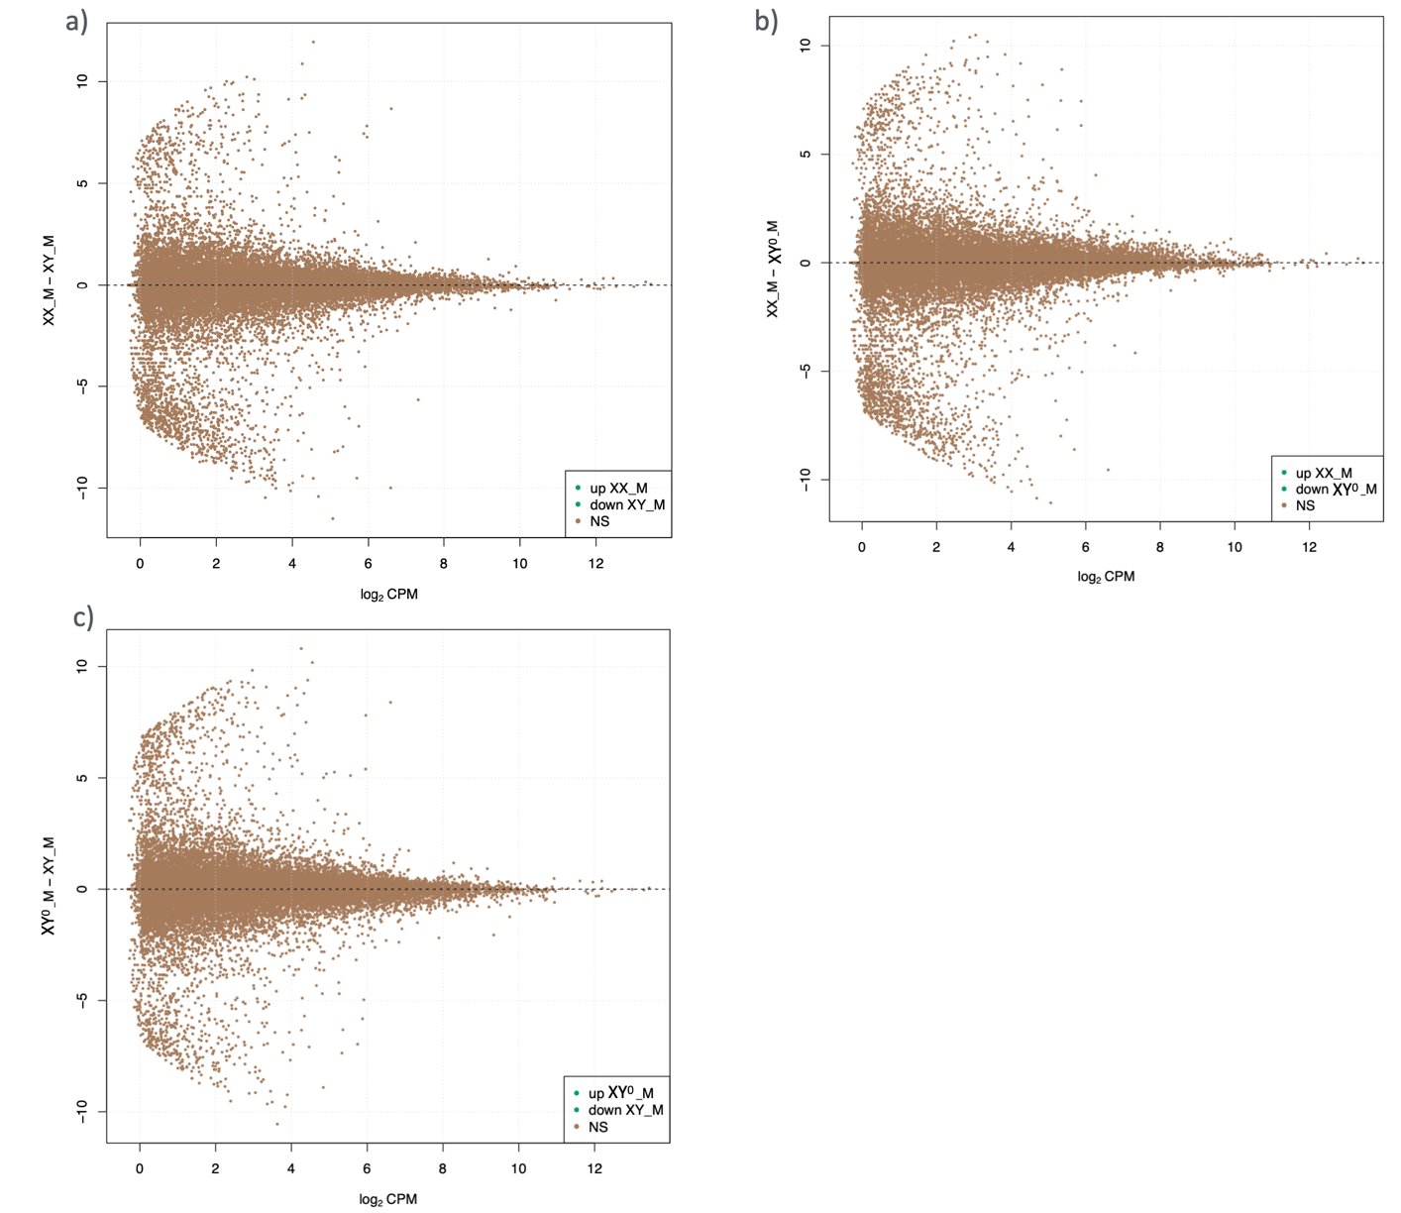

Figure S14. Differential expression analyses in testes for pairwise male-male comparison among all three genotypes with varying Y differentiation levels. (a) XX male vs XY male; (b) XX male vs XY⁰ male; and (c) XY⁰ male vs XY male.

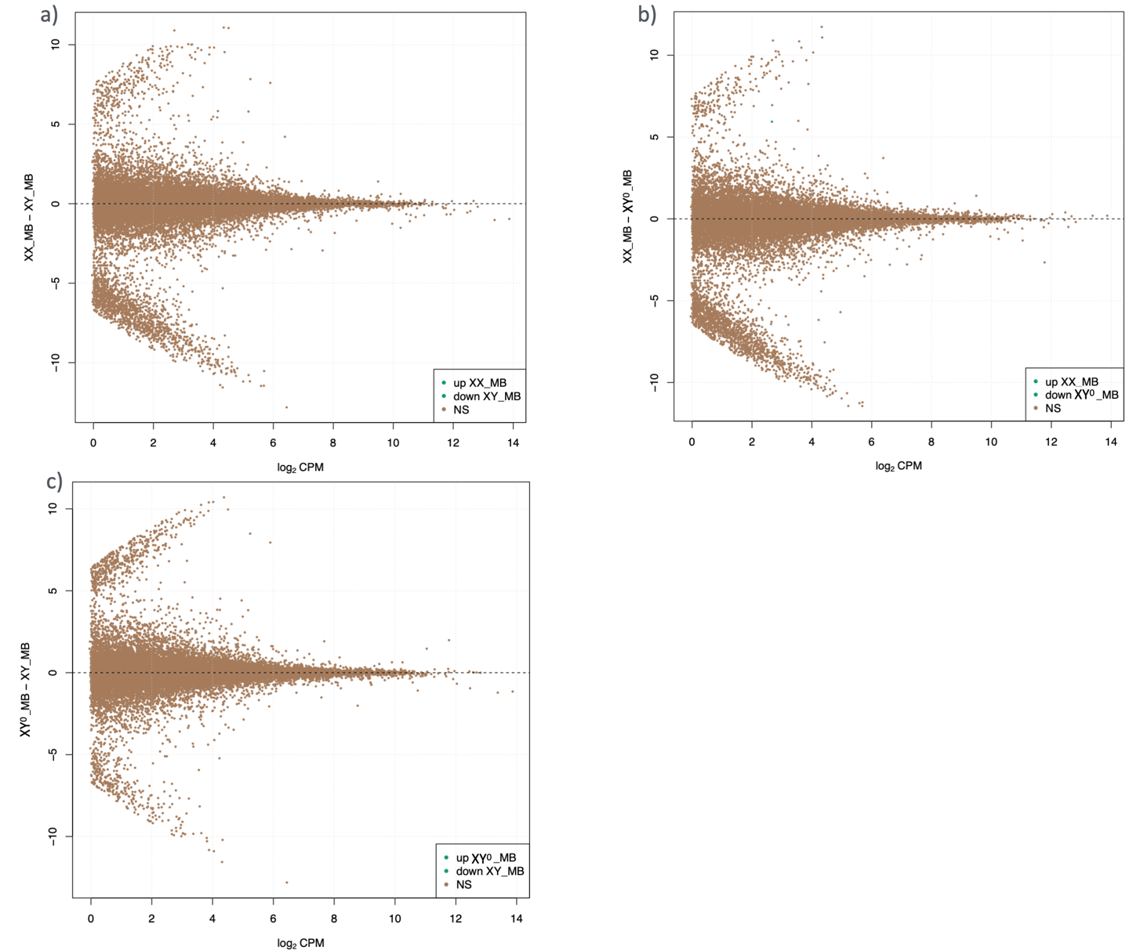

Figure S15. Differential expression analyses in brain tissues for pairwise male-male comparison among all three genotypes with varying Y differentiation levels. (a) XX male vs XY male; (b) XX male vs XY⁰ male; and (c) XY⁰ male vs XY male.

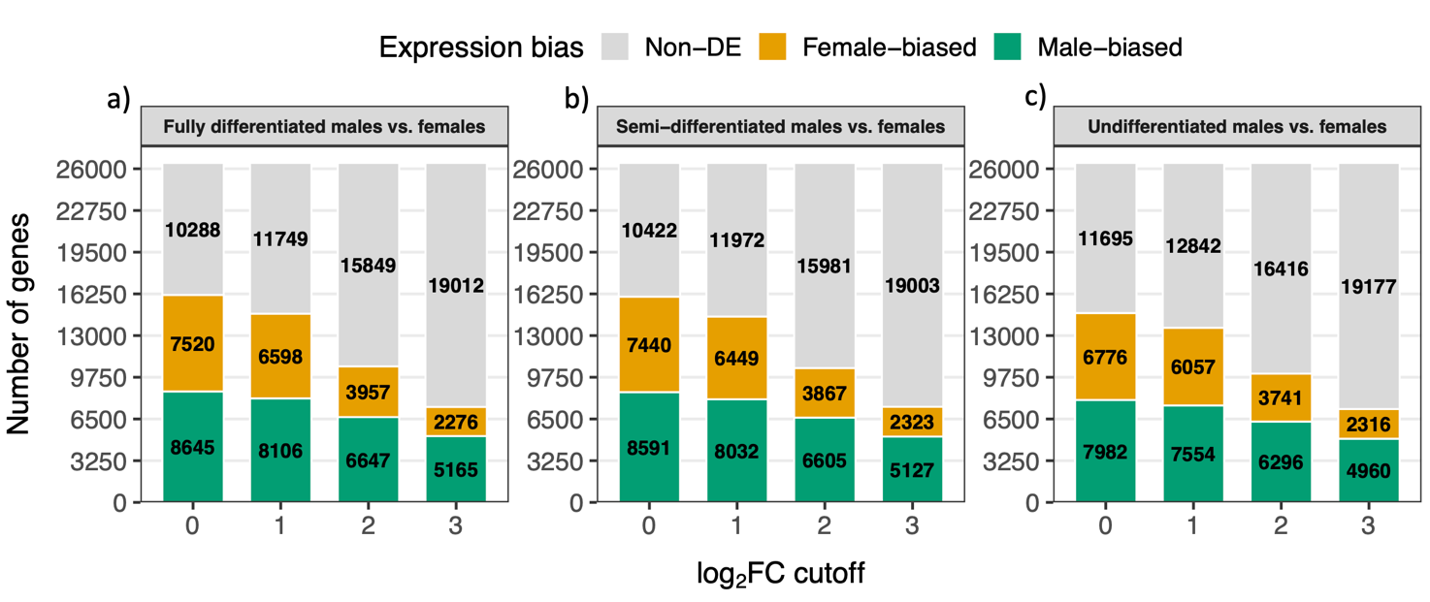

Figure S16. Summary number of differential expression analyses in gonad tissues between females and males with all three genotypes with varying Y differentiation levels, with FDR < 0.05 and |log2(male/female)| cutoff of >= 0, >= 1, >= 2 and >= 3 respectively. (a) XY male vs XX female; (b) XY⁰ male vs XX female; and (c) XX male vs XX female.

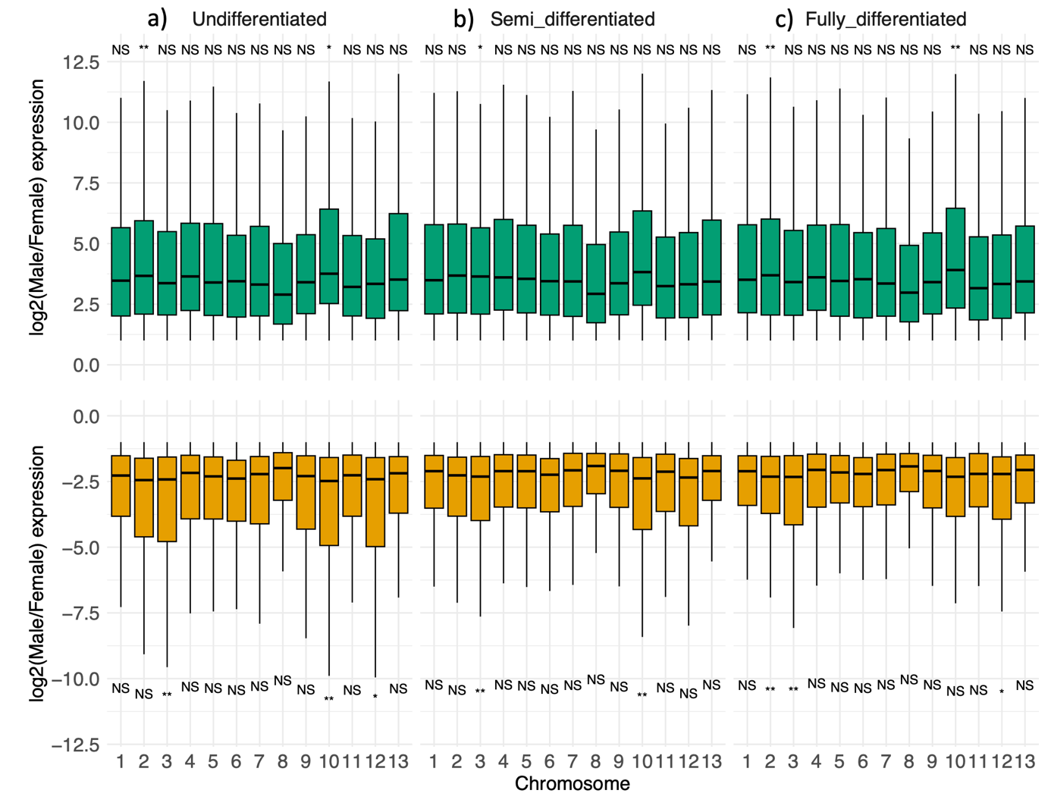

Figure S17. Boxplot for distribution of differentially expressed genes in gonad tissues between females and males with all three genotypes with varying Y differentiation levels, as well as the permutation tests, with FDR < 0.05 and |log2(male/female)| cutoff >= 1. Permutation test (FDR-corrected): * < 0.05, ** < 0.01, *** < 0.001. (a) XX male vs XX female; (b) XY⁰ male vs XX female; and (c) XY male vs XX female.

Figure S18. Barplot for the number of sex-biased genes in gonad tissues between females and males across genomic compartments with full-differentiated Y and semi-differentiated Y. Orange are female-biased genes, green are male-biased genes.

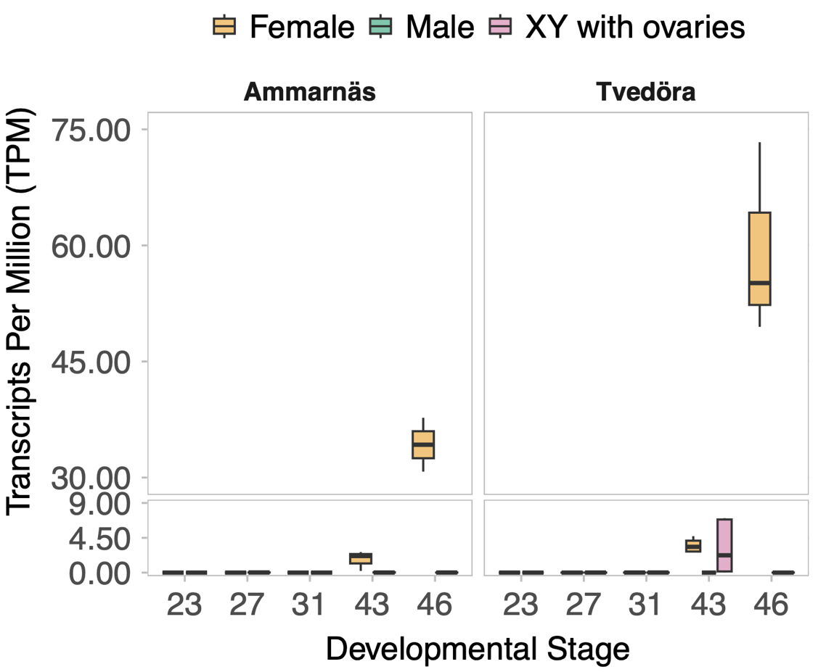

Figure S19. Loc120943612 gene expression in TPM (transcript per million) across developmental stages (G23, 27, 31, 43 and 46) from the published RNAseq data of the whole individual, in populations with fully-differentiated XY in Ammarnäs (north Sweden), with semi-differentiated XY⁰ males in Tvedöra (south Sweden).

Figure S20. Dmrt1 gene expression in TPM (transcript per million) across developmental stages (G23, 27, 31, 43 and 46) from the published RNAseq data of the whole individual, in populations with fully-differentiated XY in Ammarnäs (north Sweden), with semi-differentiated XY⁰ males in Tvedöra (south Sweden).

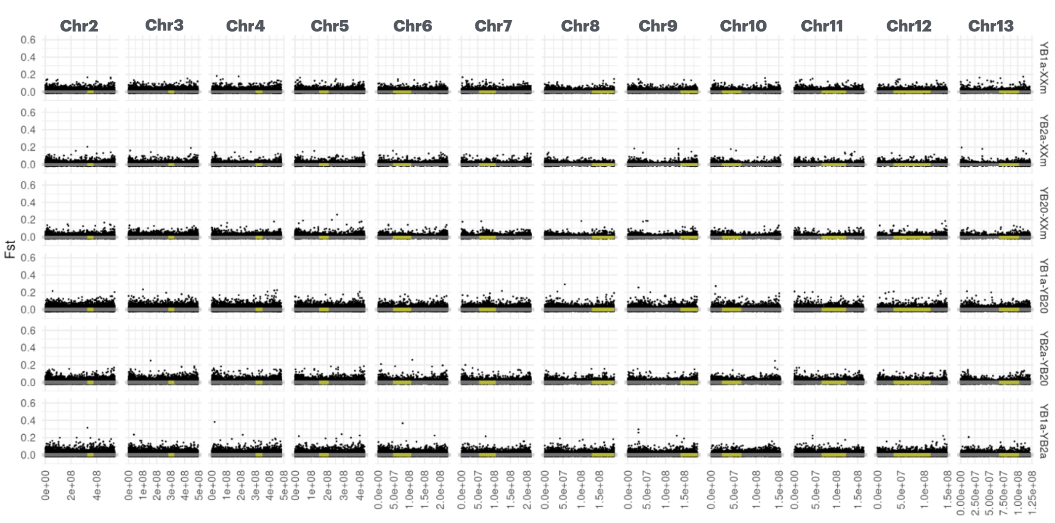

Figure S21. Autosomal F_{ST} among male pools. For each of the 12 autosomal contigs and among male pools (XXm, YB20, YB1a, and YB2a), each dot represents the average F_{ST} between the male pools within a 10kb overlapping window (stride = 5kb). The grey rectangle marks the central 95% of the autosomal value distribution. Yellow intervals show centromeric regions.

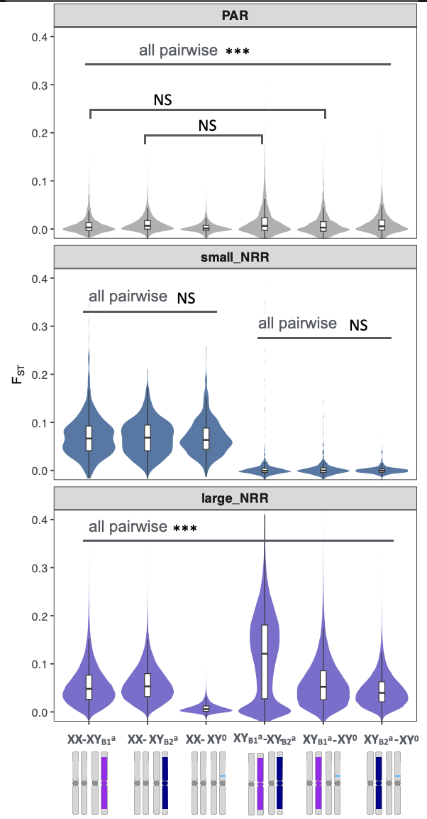
Figure S22. Distribution of genetic differentiation, F_{ST}, across sex-chromosome compartments including pseudoautosomal region (PAR), small non-recombining region (small NRR), and large non-recombining region (large NRR), for pairwise male–male comparisons. F_{ST} values are shown as violin plots with embedded boxplots. No significant differentiation was detected among male pools in small NRR, whereas differed significantly among comparisons in the large NRR. Statistical significance was assessed using pairwise Wilcoxon tests with Benjamini–Hochberg correction (*** P < 0.001; NS, not significant).

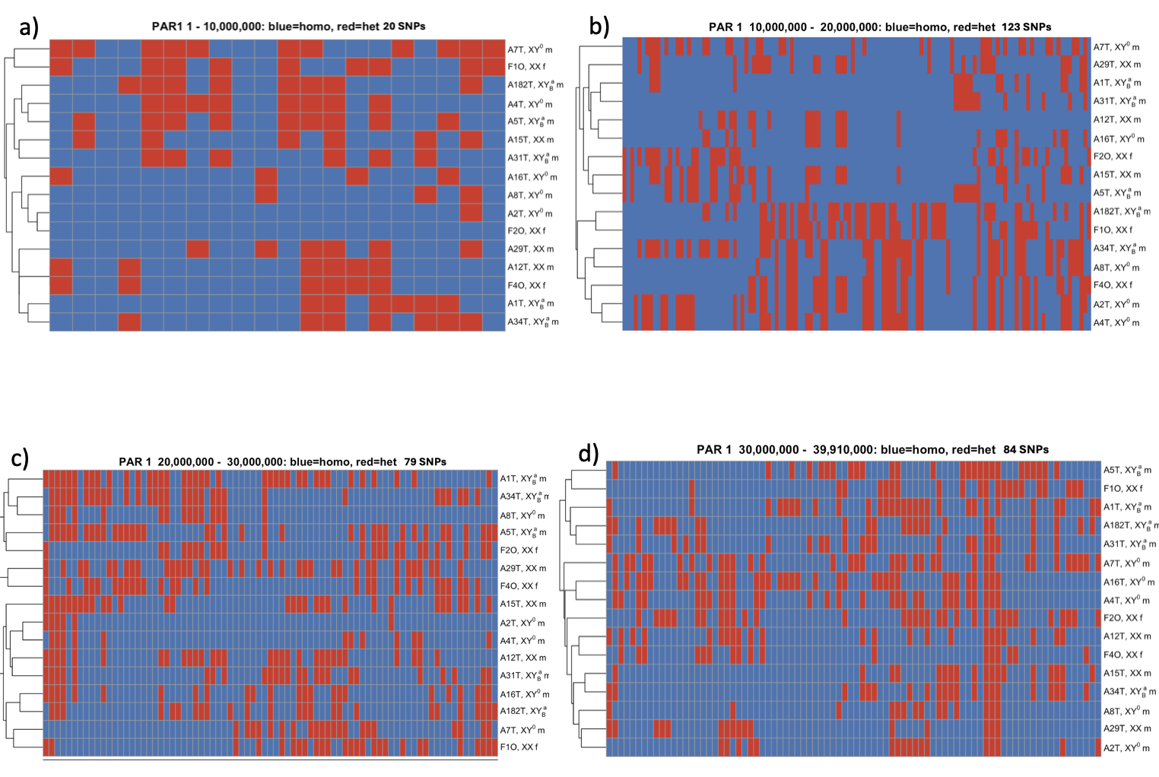

Figure S23. Clustering dendrograms based on SNPs derived from RNA-seq read mappings of male and female gonad and brain tissues to the reference genome, illustrating patterns of homozygosity and heterozygosity along PAR1 region. Each dendrogram was generated from SNP sets extracted using a 10-Mb sliding window (a, b, c and d accordingly).

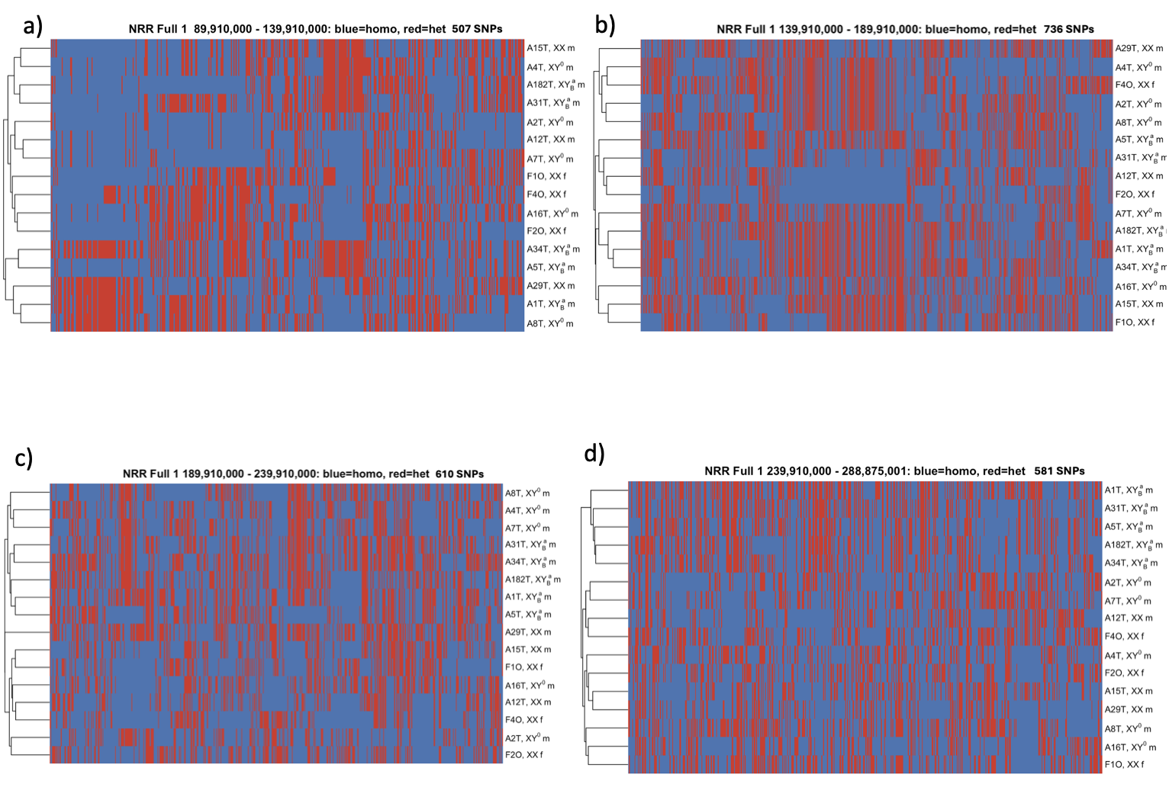
Figure S24. Clustering dendrograms based on SNPs derived from RNA-seq read mappings of male and female gonad and brain tissues to the reference genome, illustrating patterns of homozygosity and heterozygosity along large NRR part1. Each dendrogram was generated from SNP sets extracted using 50 Mb sliding window (a, b, c, d accordingly).

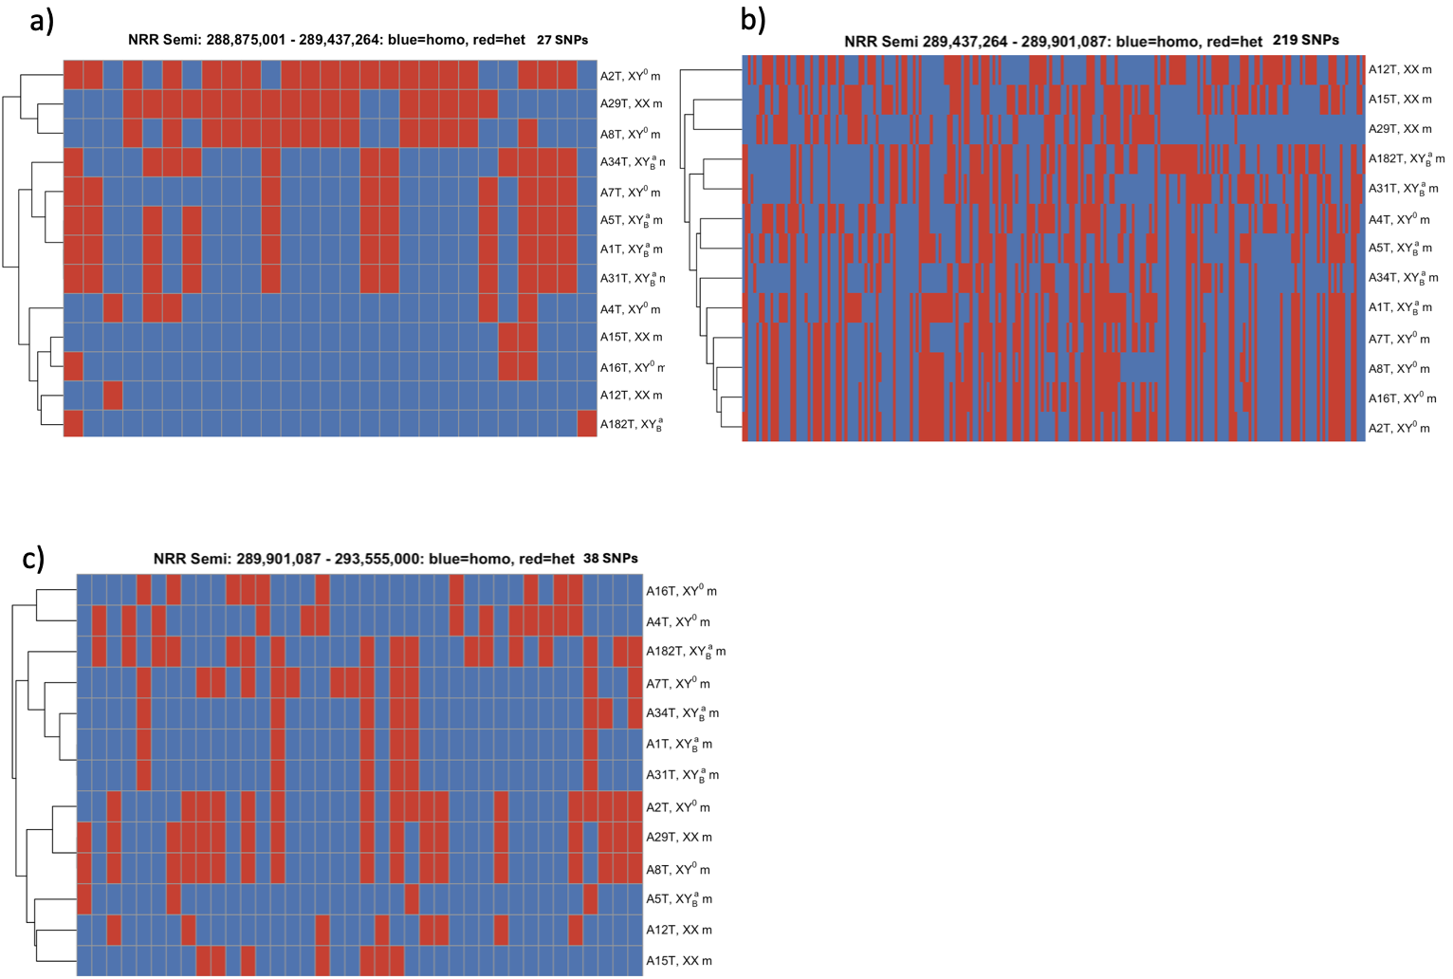

Figure S25. Clustering dendrograms based on SNPs derived from RNA-seq read mappings of male and female gonad and brain tissues to the reference genome, illustrating patterns of homozygosity and heterozygosity along PAR1. Each dendrogram was generated from SNP sets extracted using 3 divided window, genes upstream of Dmrt1 (a), Dmrt1, Dmrt3 and Dmrt2 (b), and genes downstream of Dmrt2 (c).

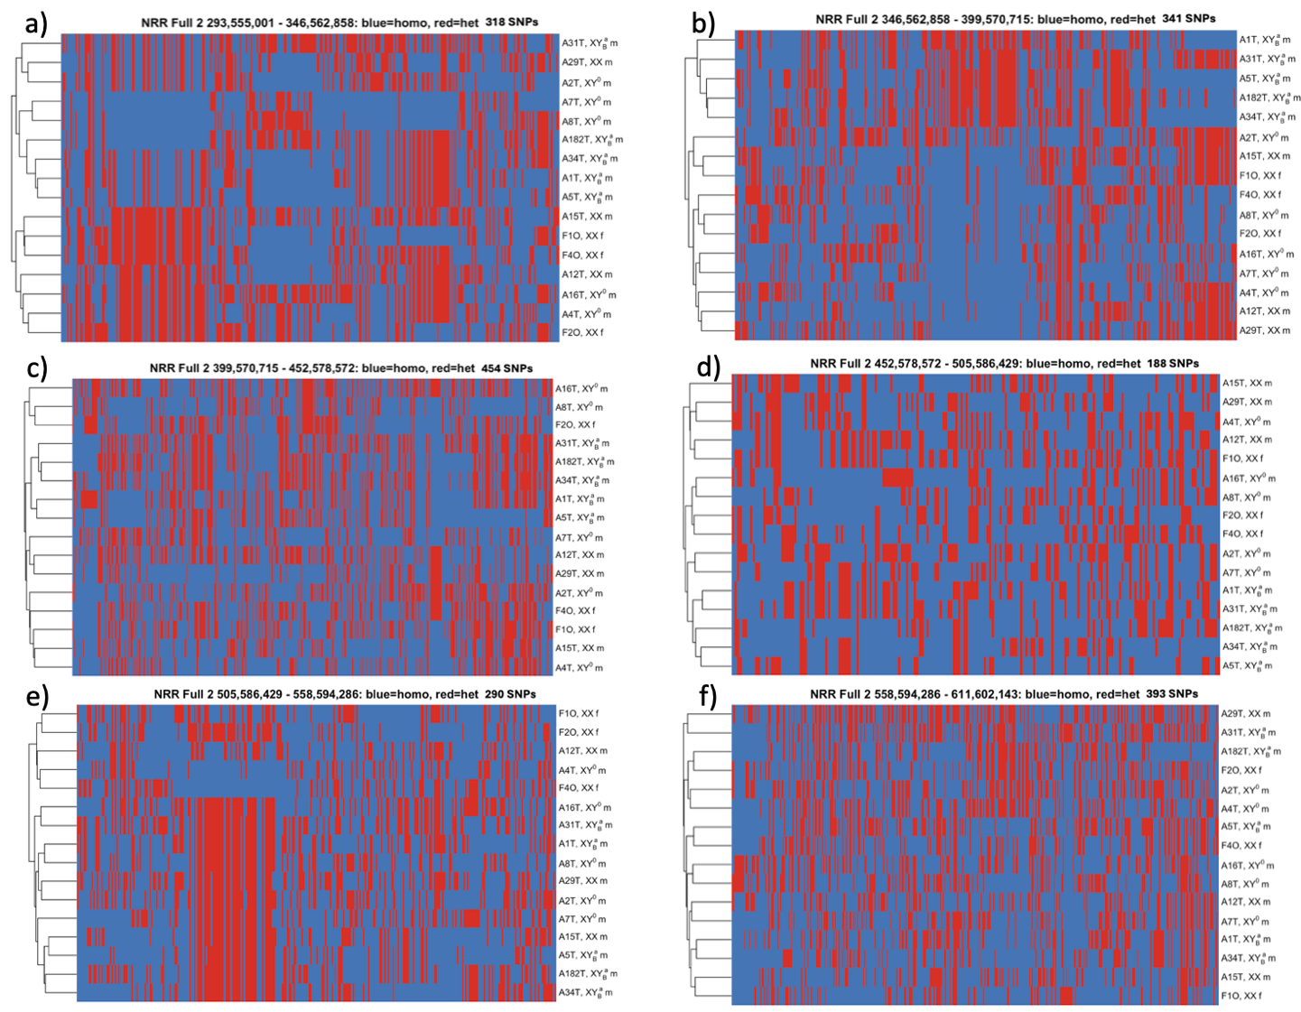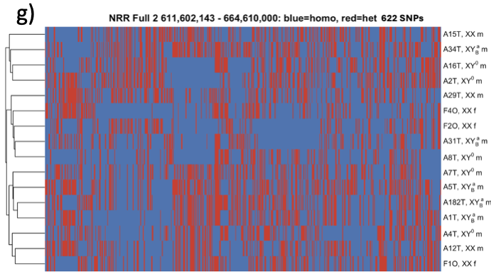

Figure S26. Clustering dendrograms based on SNPs derived from RNA-seq read mappings of male and female gonad and brain tissues to the reference genome, illustrating patterns of homozygosity and heterozygosity along large NRR part2. Each dendrogram was generated from SNP sets extracted using 50 Mb sliding window (a, b, c, d, e, f, and g accordingly).

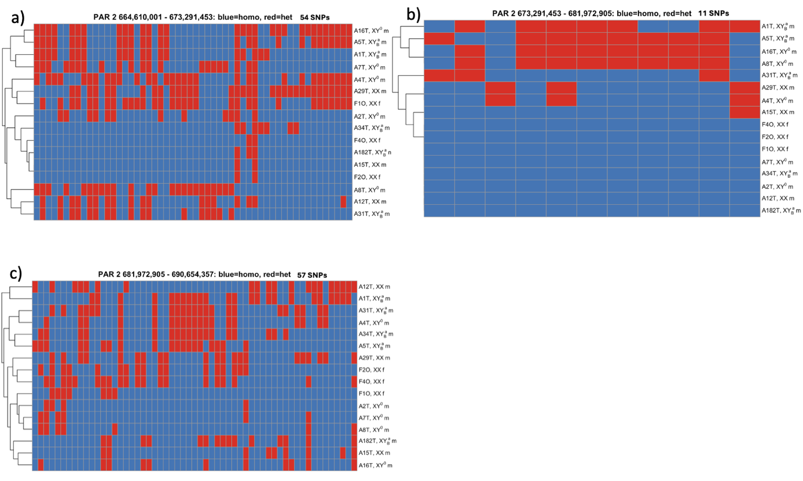
Figure S27. Clustering dendrograms based on SNPs derived from RNA-seq read mappings of male and female gonad and brain tissues to the reference genome, illustrating patterns of homozygosity and heterozygosity along PAR2 region. Each dendrogram was generated from SNP sets extracted using a 10-Mb sliding window (a, b, c accordin

