Supplementary material for: Delaval A, Andrade H, Nilsen T, Vollen T, Lavezza R, Larsen TE, Bruvold IM, Berg E and Albert OT. Distribution and life-history of spurdog (Squalus acanthias) along the Norwegian coast inferred from a five-year fishery-independent longline survey.
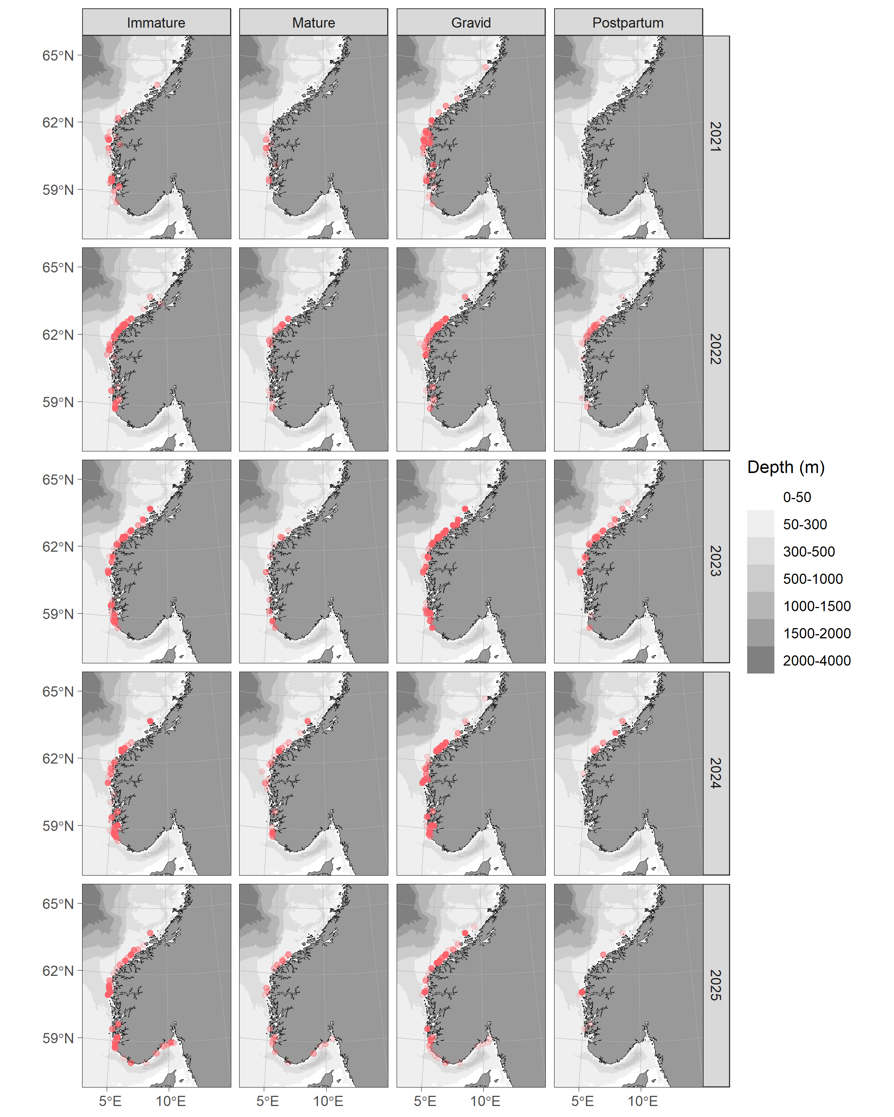
Supplementary figure 1: Distribution of females across years, with maturity stages grouped into four categories.

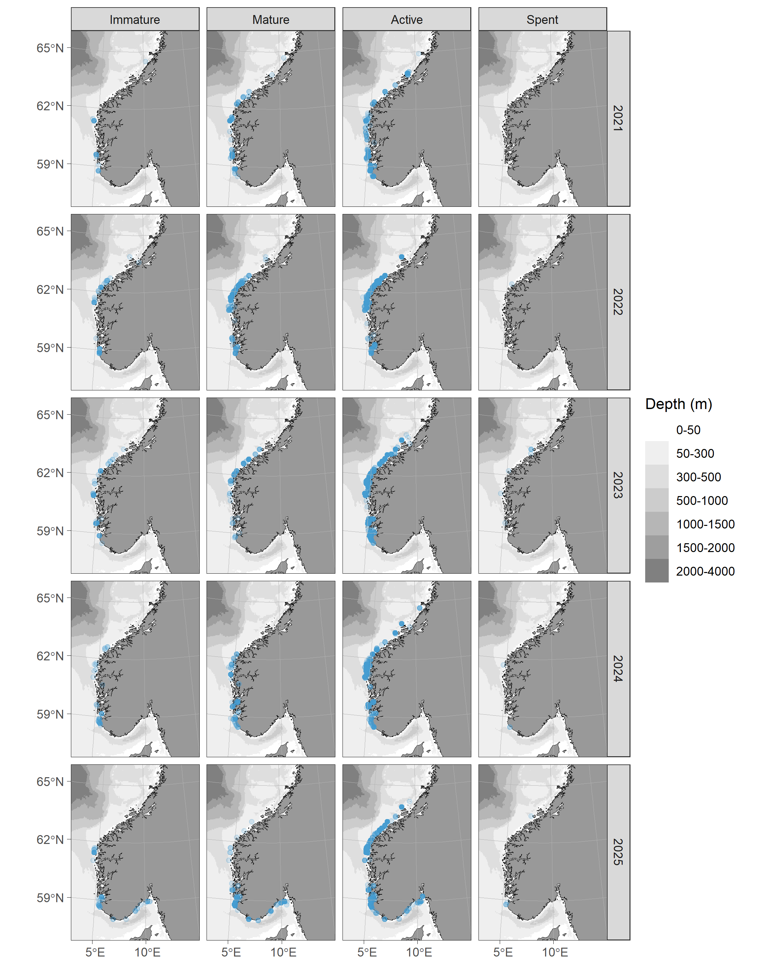
Supplementary figure 2: Distribution of females across years, with maturity stages grouped into four categories.

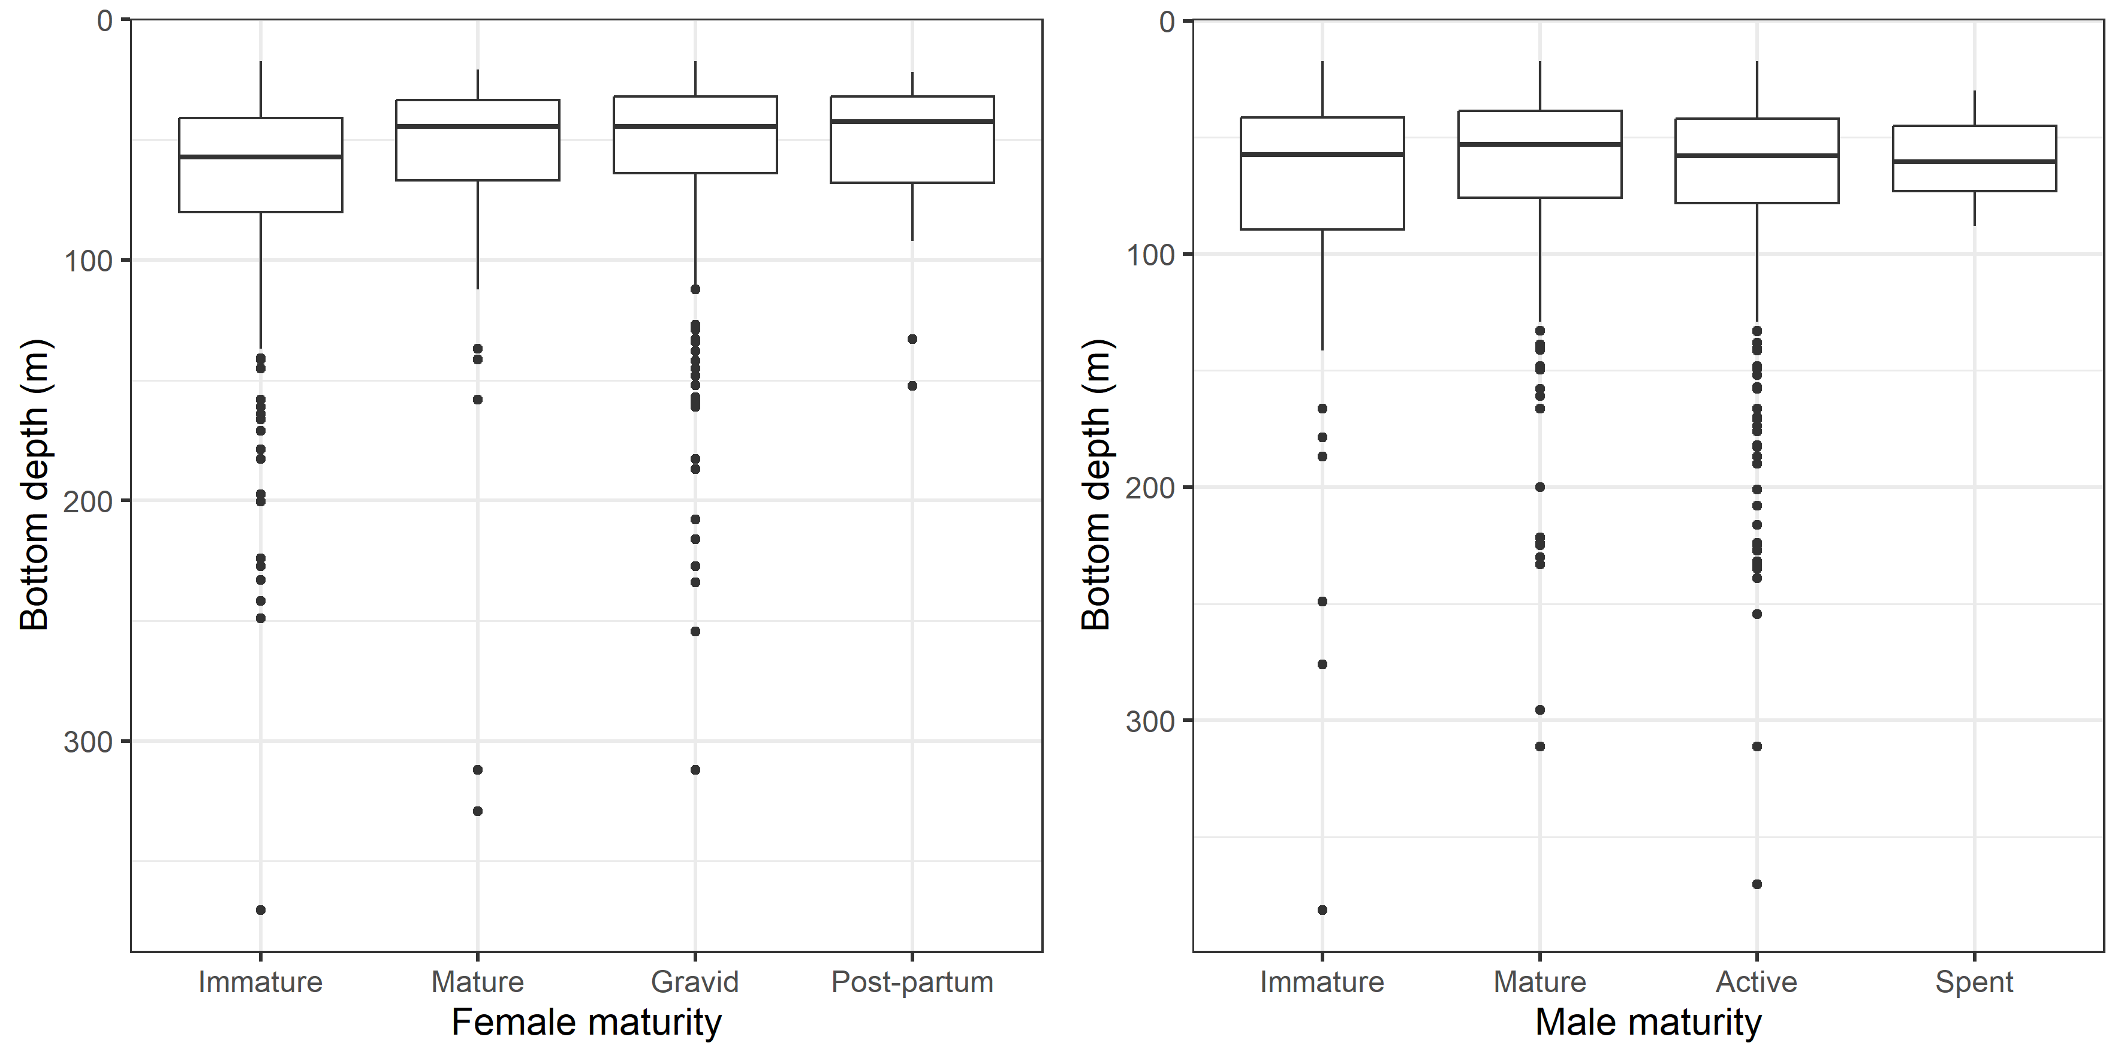
Supplementary figure 3: Bottom depth distributions of longline deployments with catches of females (left) and males (right) at different maturity stages.

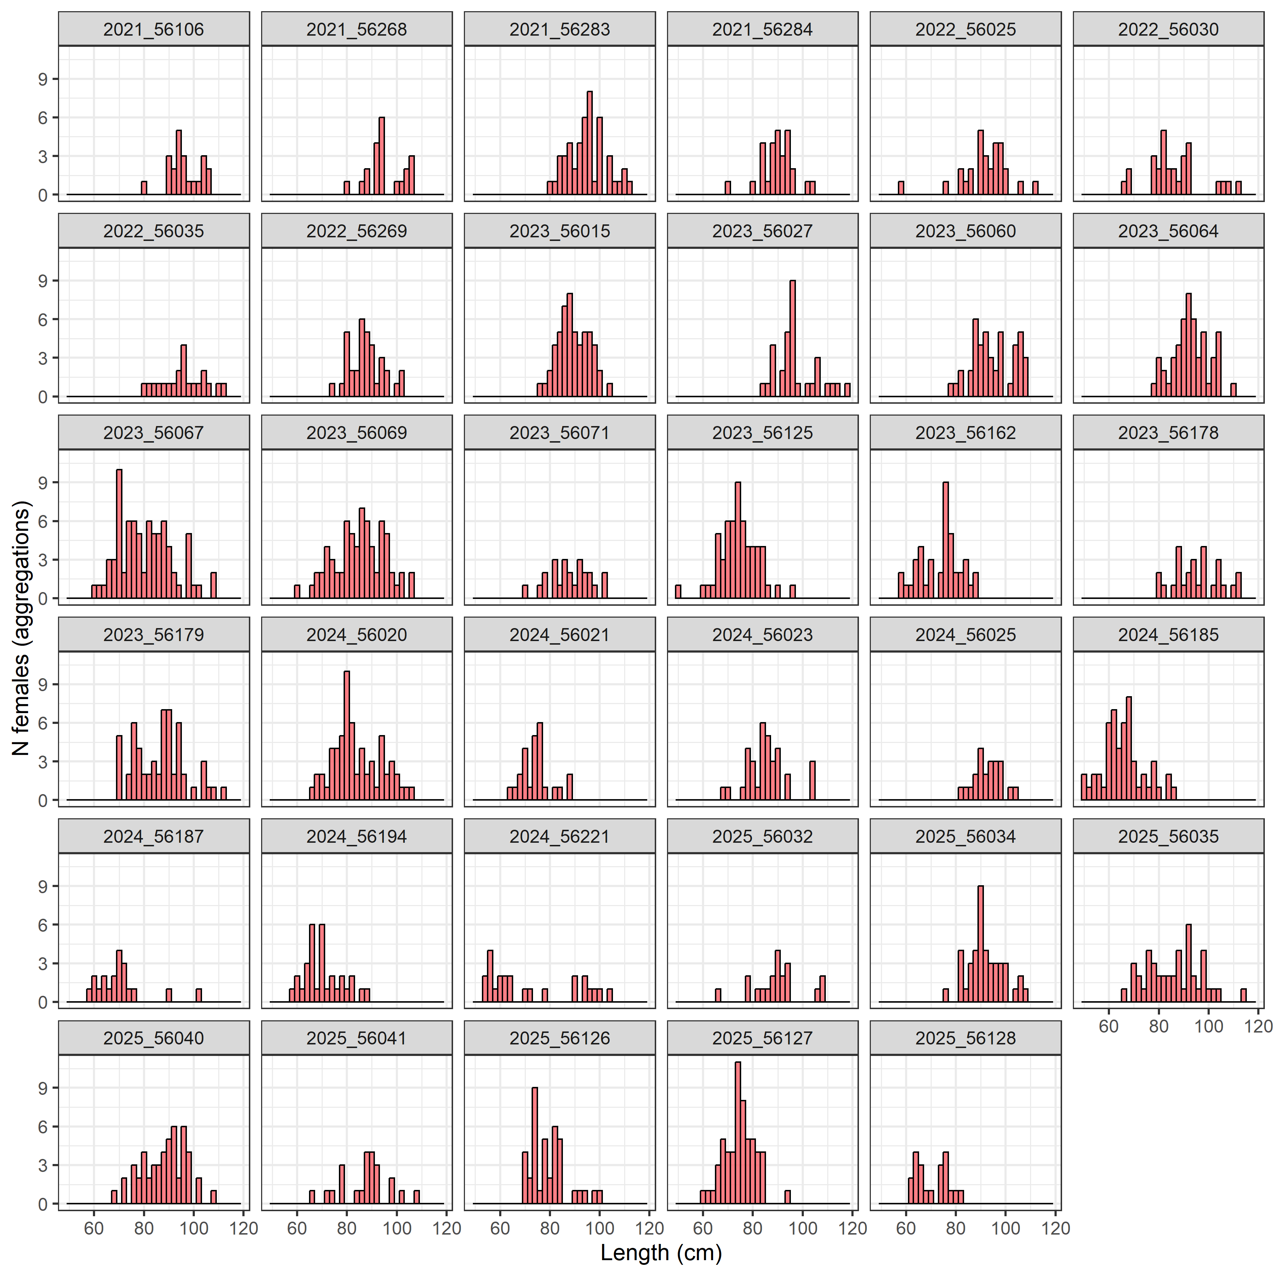
Supplementary figure 4: Size distributions of females caught at 32 stations identified as female-biased aggregation sites. Facet names indicate unique year and station numbers.

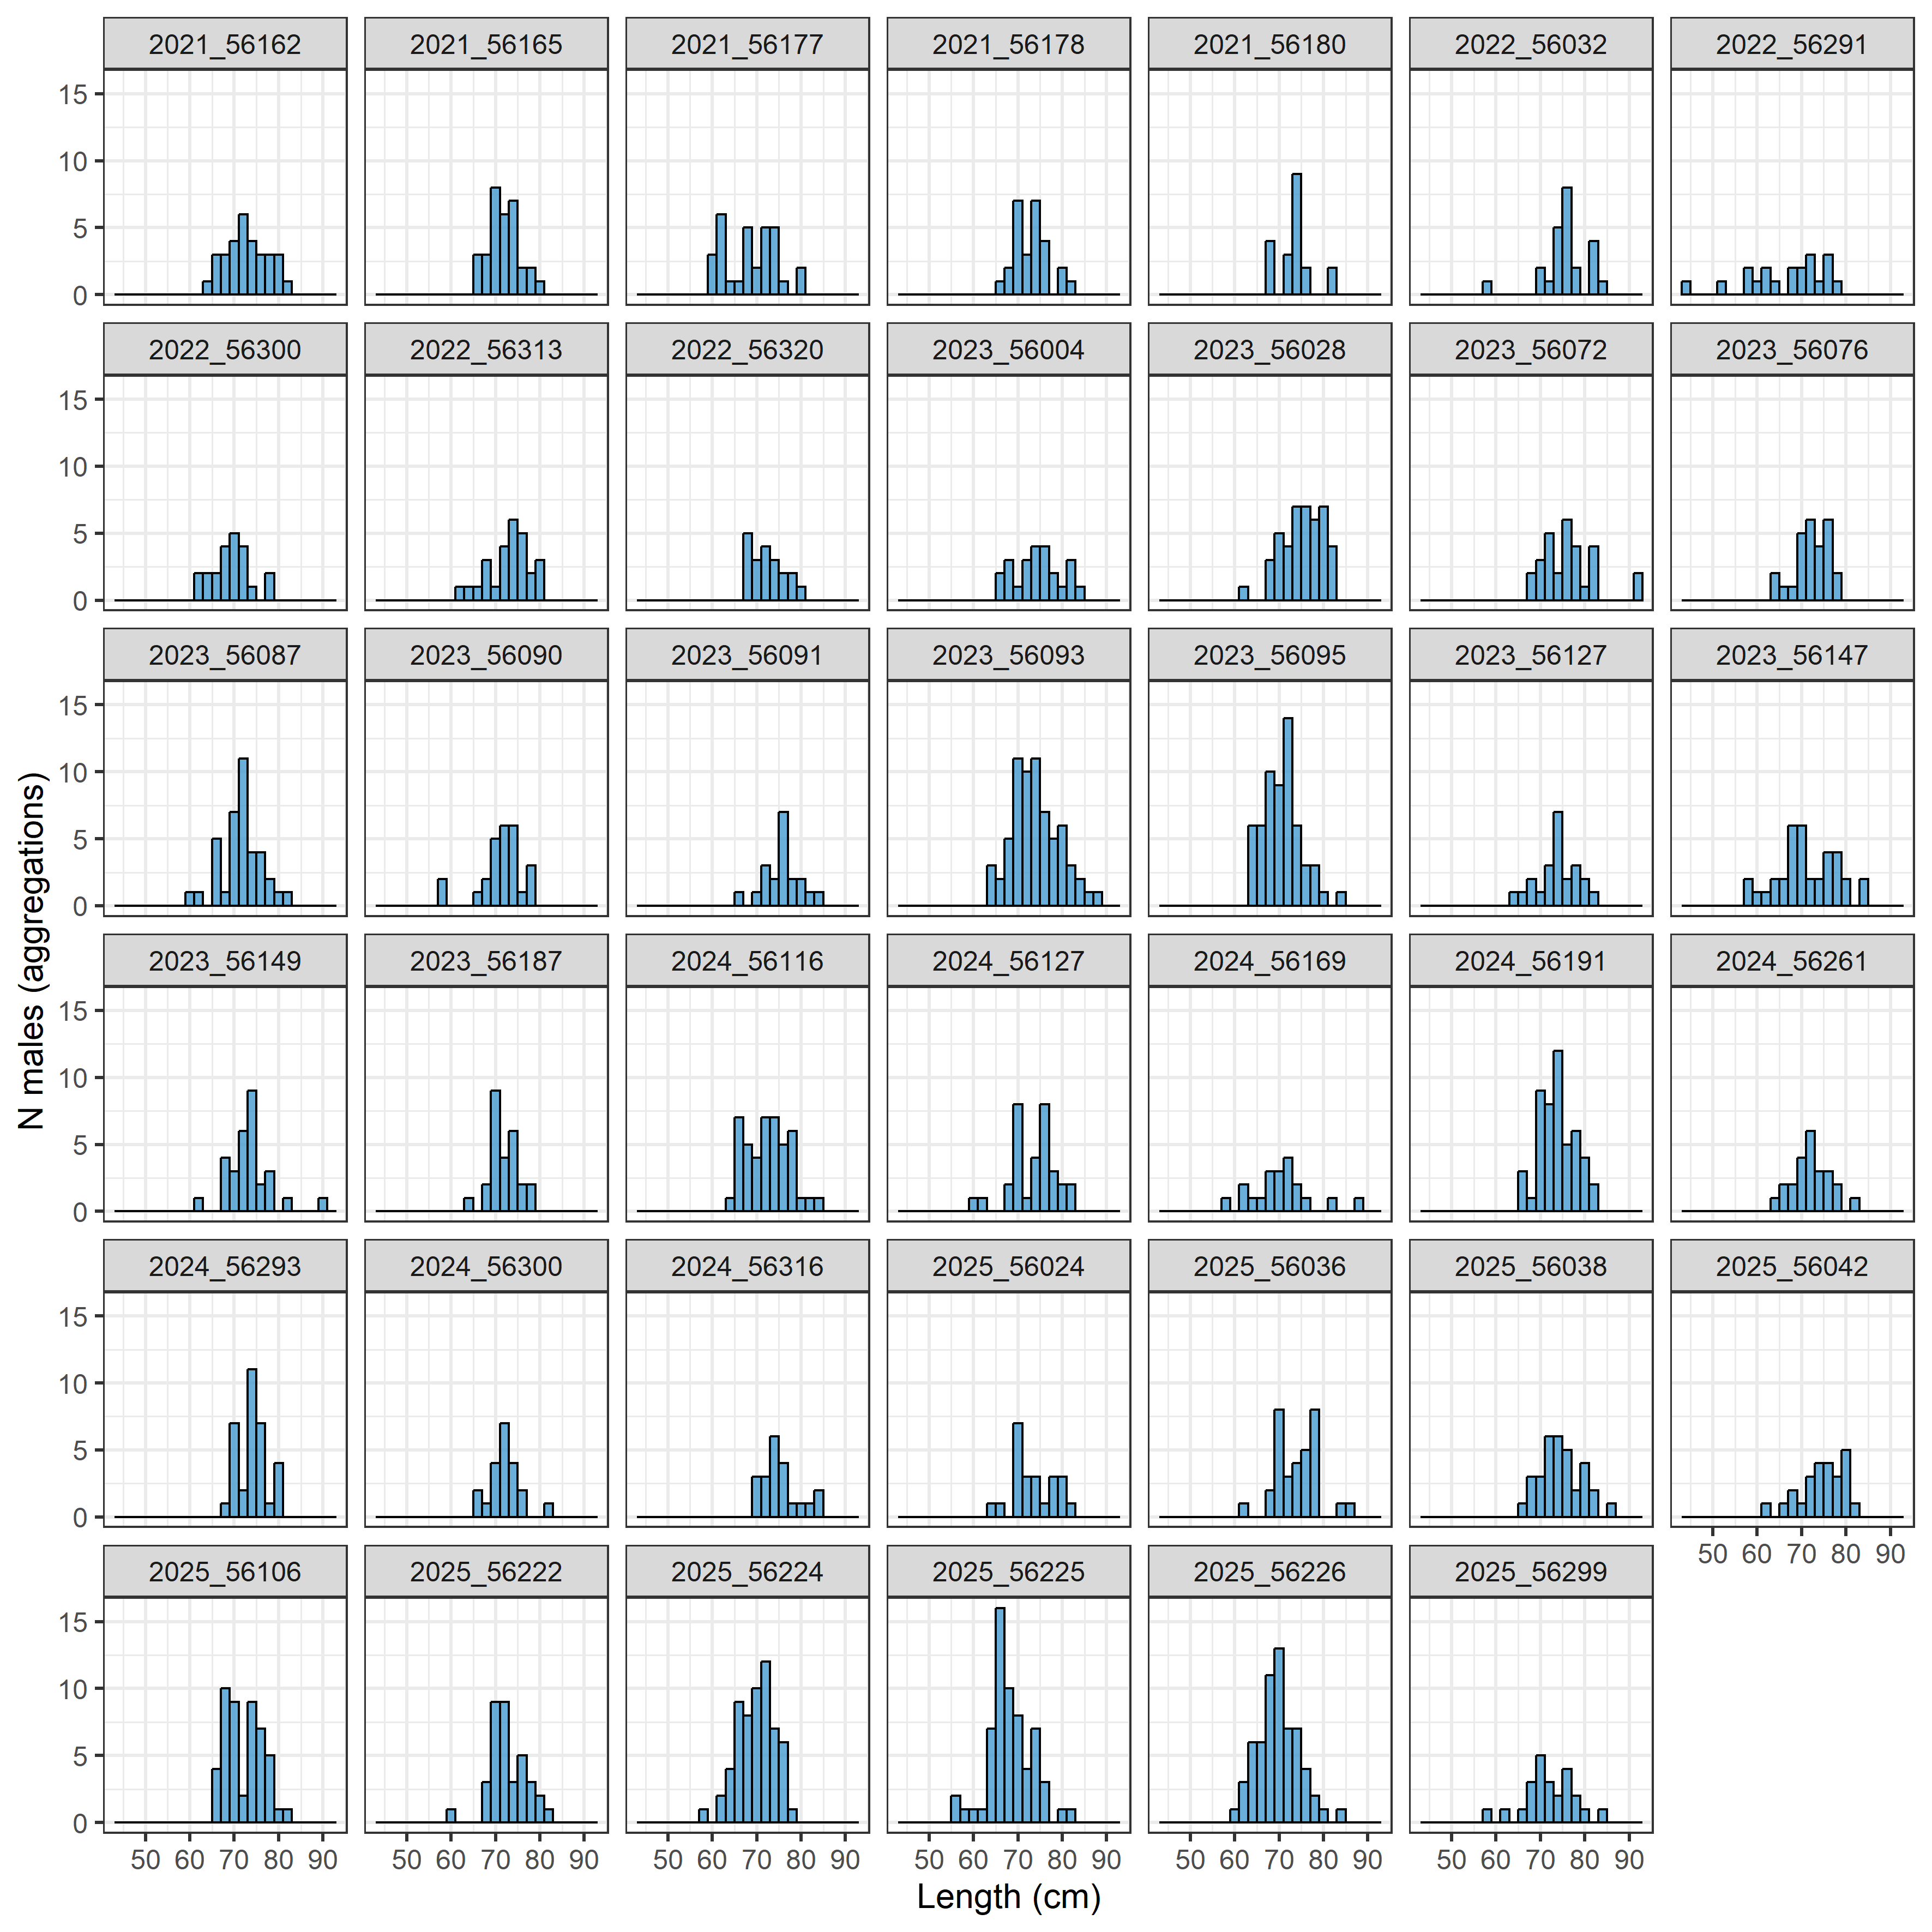
Supplementary figure 5: Size distributions of males caught at 40 stations identified as male-biased aggregation sites. Facet names indicate unique year and station numbers.

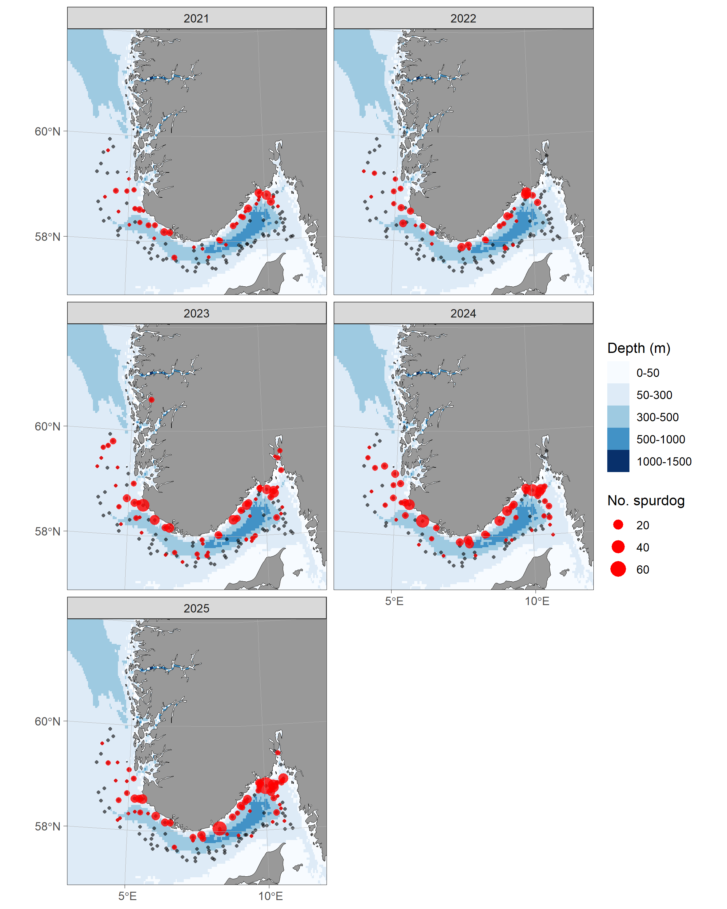
Supplementary figure 6: Catches of spurdog during the annual winter shrimp trawl survey in the Skagerrak between 2021-2025.

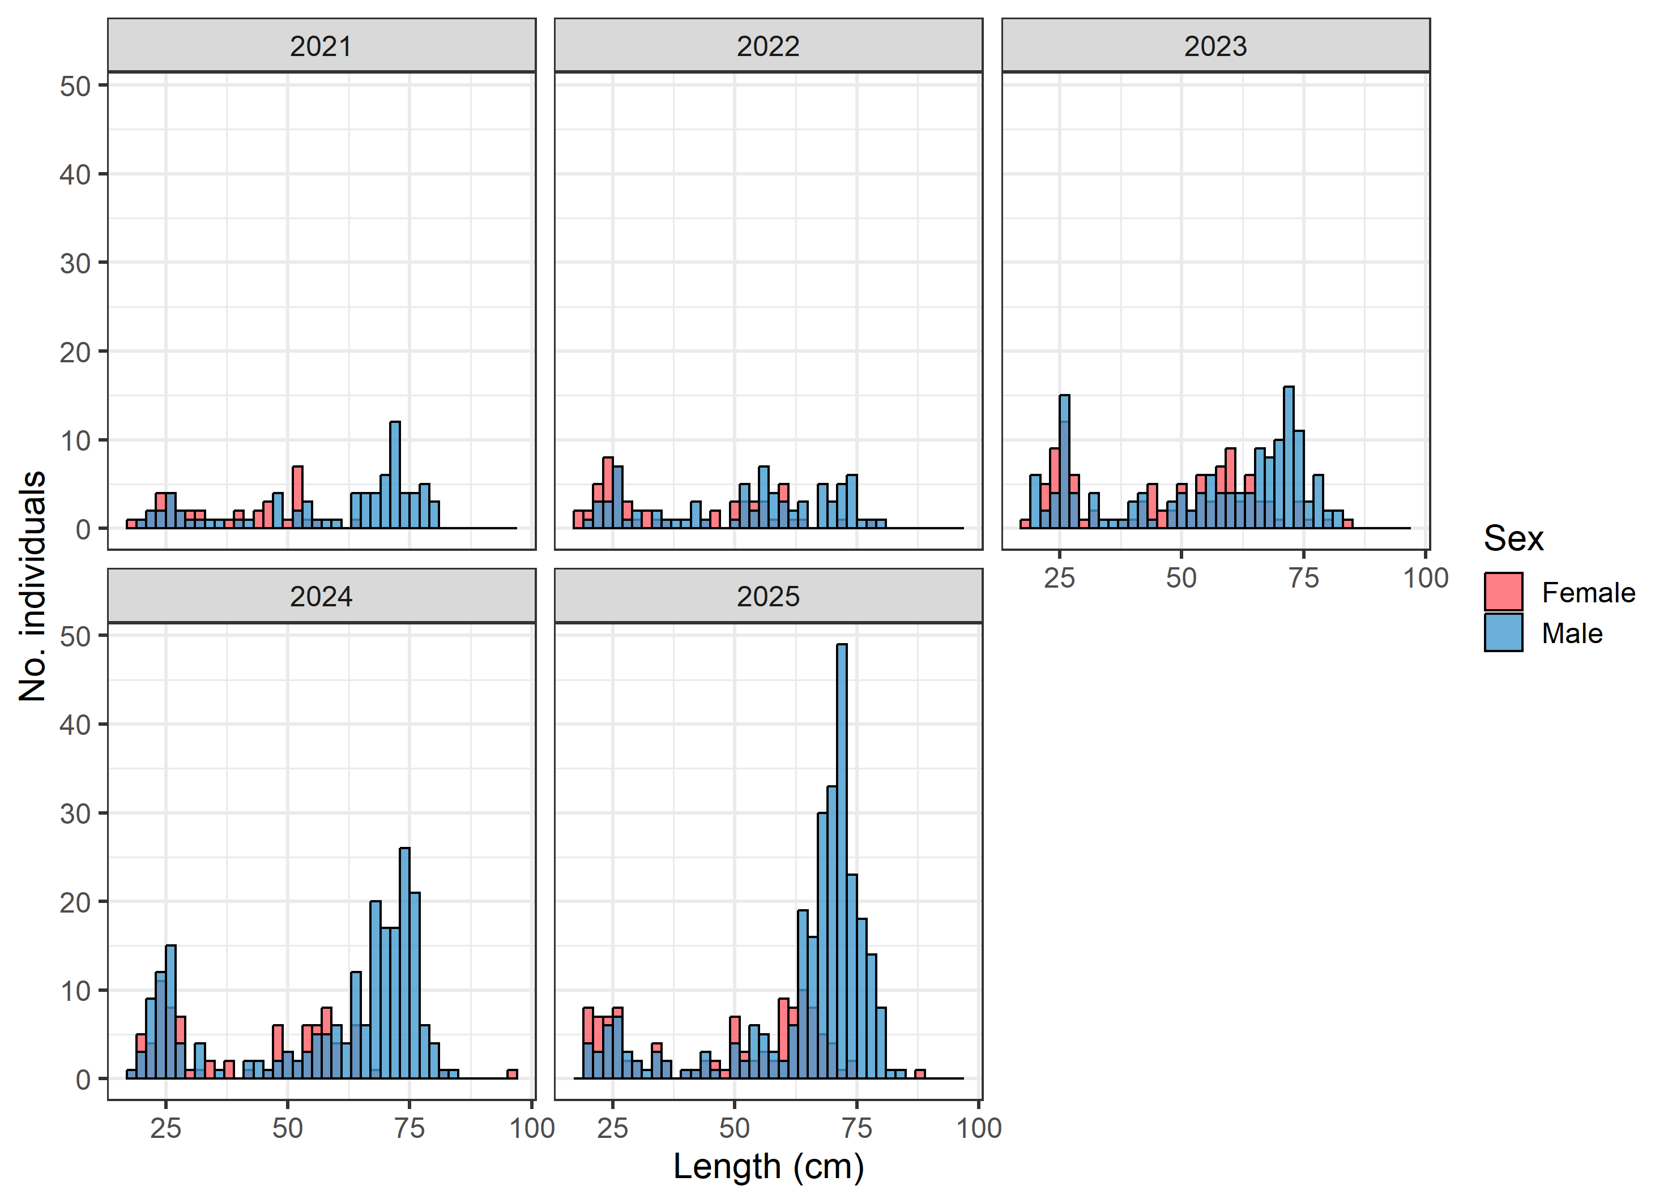
Supplementary figure 7: Size distribution of spurdog caught during the annual winter shrimp trawl survey in the Skagerrak between 2021-2025.

Supplementary table 1: Maturity stages for male and female spurdog, registered under the variable “specialstage” in the raw data file, available from the Norwegian Marine Data Centre (NMDC).
Maturity stage | Female | Male
1 | Immature  Eggs not visible, or very small. Uteri and shell (oviducal) glands narrow and string-like. | Immature  Claspers are flexible and shorter than the pelvic fins. Small, undeveloped testes and string-like sperm ducts.
2 | Maturing  Small-to-medium sized eggs. Uteri and shell glands developing. | Maturing  Claspers are flexible and equal to or longer than the pelvic fins. Testes are developing and sperm ducts are starting to coil.
3 | Mature  Large, yellow eggs of similar size in the ovaries. Fully developed shell glands and uteri with thick walls. | Mature  Claspers are calcified and longer than the pelvic fins. Fully developed testes and coiled, sperm-filled sperm ducts.
4 | Early pregnancy  Uteri contain yolk. Embryos not visible. | Active  Like stage 3, but pressing on the sperm ducts through the lower abdominal wall causes sperm secretions.
5 | Mid-pregnancy  Uteri contain visible embryos with relatively large yolk sacs. | Spent  Claspers are fully developed, like stage 3, but testes are smaller and flaccid. Sperm ducts are empty.
6 | Late pregnancy  Uteri contain fully developed embryos with small or absent yolk sacs.
7 | Post-partum  Uteri fully expanded and reddish. Ovaries contain large, yellow eggs of similar size.
8/9* | Regenerating  Ovaries contain large, yellow eggs of similar size. Uteri are enlarged, but not flaccid.
*Regenerating female spurdog may be registered as stages 8 or 9 across various surveys in IMR’s database, depending on survey-specific sampling protocols.

Supplementary table 2: Qualitative readability score for age-reading of the second dorsal spine, registered under the variable “readability” in the raw data file, available from the Norwegian Marine Data Centre (NMDC).
Readability score | Description
1 | High certainty
2 | Some uncertainty
3 | Difficult to read or unreadable
9 | Damaged or missing

