Liver-directed lentiviral gene therapy corrects hemophilia A mice and achieves normal-range factor VIII activity in non-human primates

Authors: Michela Milani¹, Cesare Canepari^{1,2}, Tongyao Liu³, Mauro Biffi¹, Fabio Russo¹, Tiziana Plati¹, Rosalia Curto¹, Susannah Patarroyo-White³, Douglas Drager³, Ilaria Visigalli¹, Chiara Brombin⁴, Paola Albertini¹, Eduard Ayuso⁵, Christian Mueller³, Andrea Annoni¹, Luigi Naldini^{1,2,*}, Alessio Cantore^{1,2,*}

Affiliations:
¹San Raffaele Telethon Institute for Gene Therapy, IRCCS San Raffaele Scientific Institute; Milan, Italy.
²Vita-Salute San Raffaele University; Milan, Italy.
³Sanofi; Waltham, MA USA.
⁴University Center for Statistics in the Biomedical Sciences, Vita-Salute San Raffaele University; Milan, Italy.
⁵INSERM UMR1089, University of Nantes, CHU de Nantes; 44093 Nantes, France.

*These authors share senior authorship
*To whom correspondence should be addressed: cantore.alessio@hsr.it, naldini.luigi@hsr.it

Supplementary methods

Transgene generation
Codon-optimization of human BDD-FVIII transgene was performed by taking into consideration the codon-adaptation index, G/C content, Matrix Attachment Region-like sequences, destabilizing sequences, potential promoter binding sites, other cis acting negative regulatory elements, as described in the patent WO 2019/152692. The full sequences of coFVIII and coFVIII.XTEN are available in the patent WO 2019/152692 under the name of SEQ ID 71 and SEQ ID 72, respectively.

Plasmid construction
Plasmid pCCLsin.cPPT.ET.FVIII-BDD.142T, pCCLsin.cPPT.ET.coFVIII.142T and pCCLsin.cPPT.ET.coFIX.XTEN.142T were constructed by standard cloning techniques, by exchanging the gene synthesized different versions of the human FVIII cDNA (DNA 2.0) with FIX into the previously described pCCLsin.cPPT.ET.canineFIX.142T (NheI-SalI) (9).

LV titration
For LV titration, 1x10⁵ 293T cells were transduced with serial LV dilutions in the presence of polybrene (8 μg/ml). Genomic DNA (gDNA) was extracted 14 days after transduction, using Maxwell 16 Cell DNA Purification Kit (Promega), following manufacturer’s instructions. VCN was determined was determined by ddPCR, starting from 5-20 ng of template gDNA using primers (HIV fw: 5’-T ACTGACGCTCTCGCACC-3’; HIV rv: 5’-TCTCGACGCAGGACTCG-3’) and a probe (FAM 5’-ATCTCTCTCCTTCTAGCCTC-3’) designed on the primer binding site region of LV. The amount of endogenous DNA was quantified by a primers/probe set designed on the human telomerase gene (Telo fw: 5’-GGCACACGTGGCTTTTCG-3’; Telo rv: 5’-GGTGAACCTCGTAAGTTTATGCAA-3’; Telo probe: VIC 5’-TCAGGACGTCGAGTGGACACGGTG-3’ TAMRA) or the human GAPDH gene (Applied Biosystems HS00483111_cm). The PCR reaction was performed with each primer (900 nM) and the probe (250 nM, 500nM for Telo) following manufacturer’s instructions (Biorad), read with QX200 reader and analyzed with QuantaSoft software (Biorad). Infectious titer, expressed as TU/mL, was calculated using the formula TU/mL = (VCNx100,000x(1/dilution factor). LV physical particles were measured by HIV-1 Gag p24 antigen immunocapture assay (Perkin Elmer) following manufacturer’s instructions. LV specific infectivity was calculated as the ratio between infectious titer and physical particles.

VCN determination
For experiment with Huh7 or Hepa1.6 cell lines, DNA was extracted using Maxwell 16 Tissue DNA Purification Kit (Promega), following manufacturer’s instructions. For mice experiments, DNA was extracted from whole liver or whole spleen samples using Maxwell® 16 Tissue DNA Purification Kit (Promega), DNA was extracted from fractionated/sorted liver cells using DNeasy Blood & Tissue Kit (Qiagen) or QIAamp DNA Micro Kit (Qiagen), according to cell number. VCN was determined in Huh7 samples as described above (see “LV titration”). VCN in murine DNA line was determined by ddPCR, starting from 5-20 ng of template gDNA using a primers/probe set designed on the primer binding site region of LV (see “LV titration” above). The amount of endogenous murine DNA was quantified by a primers/probe set designed on the murine sema3a gene (Sema3A fw: 5’-ACCGATTCCAGATGATTGGC-3’; Sema3A rv: 5’-TCCATATTAATGCAGTGCTTGC-3’; Sema3A probe: HEX 5’-AGAGGCCTGTCCTGCAGCTCATGG-3’ BHQ1). The PCR reaction was performed with each primer (900 nM) and the probe (250 nM) following manufacturer’s instructions (Biorad), read with QX200 reader and analyzed with QuantaSoft software (Biorad). VCN in NHP DNA was determined as described above (see “LV titration”). The amount of endogenous DNA was quantified by a primers/probe set designed on the TATA-Box Binding Protein Associated Factor 7 (TAF7) gene, (Applied Biosystems RH 02916247_s1), amplifying both the human and NHP TAF7 genes. This analytical method was validated in compliance with the Organization for Economic Co-operation and Development (OECD) Principles of Good Laboratory Practice (GLP) in terms of accuracy (deviation vs. nominal VCN ≤ 15% until VCN=0.007), specificity, intra-assay precision (coefficient of variation ≤ 3%), inter-assay precision (coefficient of variation ≤ 6%) and linearity (R² ≥ 0.98) within the range of 9.7 copies/reaction – 28,776 copies/reaction for TAF7 and 4.8 copies/reaction – 149,380 copies/reaction for HIV. The lower limit of VCN quantification was 0.007, which resulted within the accuracy criteria (deviation vs. nominal VCN ≤ 15%). The lower limit of VCN detection was 0.0003, calculated based on the lower limit of detection of the HIV system.

Fractionation and sorting of liver cell sub-populations
The mouse liver was perfused (15 mL/min) via the inferior vena cava with 12.5 mL of the following solutions at subsequent steps: 1) PBS EDTA (0.5 mM), 2) HBSS (Hank’s balanced salt solution, Gibco) and HEPES (10 mM), 3) HBSS-HEPES 0.03% Collagenase IV (Sigma). The digested mouse liver tissue was harvested, passed through a 70μm cell strainer (BD Biosciences) and processed into a single-cell suspension. This suspension was subsequently centrifuged three times (30, 25 and 20 g, for 3 minutes, at room temperature) to obtain hepatocytes-containing pellets. The nPC-containing supernatant was centrifuged (650 g, 7 minutes, at room temperature) and recovered cells were loaded onto a 30/60% Percoll (Sigma) gradient (1,800 g, for 20 minutes at room temperature). nPC interface was collected and washed twice. The nPC were subsequently incubated with the following monoclonal antibodies: e-fluor 450-conjugated anti-CD45 (30-F11, e-Bioscience), Allophycocyanin (APC)-conjugated anti-CD31 (MEC13.3, BD Biosciences), phycoerythrin (PE)-conjugated F4/80 (CI:A3-1, Biorad), PE-Cy5-conjugated anti-CD45R/B220 (from BD Biosciences), PE-Cy7-conjugated anti-CD11c (N418, e-Bioscience). nPC subpopulations (LSEC, KC, pDC) were sorted by FACS, BD FACSAria™ Fusion Cell Sorter (BD Biosciences); the nPC contaminating the PC suspension, were removed by FACS excluding cells labeled by APC-conjugated anti-CD31/anti-CD45 cocktail, thus obtaining sorted hepatocytes (Hep) using BD FACSMelody™ Cell Sorter (BD Biosciences). NHP liver pieces obtained at necropsy were chopped, washed twice in PBS and three times in washing medium (DMEM, ThermoFisher, 1% FBS, Hyclone, penicillin and streptomycin 100 IU/mL, Lonza) and digested with 5mL/g of digestion solution (EBSS, Hyclone, collagenase A 2.5mg/mL, Sigma, dispase II 2.5mg/mL, ThermoFisher) for 10 minutes at 37°C. Then tissue was digested for additional 2 hours with 5mL/g of digestion solution at 37°C on a shaker (135-150 rpm). At the end of the digestion, cells were washed in cold washing medium (4 minutes at 120g) and then the nPC-containing supernatant was processed as for the murine liver. After Percoll (Sigma) gradient separation, cells were washed twice and incubated with the following monoclonal antibodies: APC-conjugated anti-CD45 (D058-1283, BD pharmingen), FITC-conjugated anti-CD31 (WM59, BD pharmingen) and APC-H7-conjugated anti-HLA-DR (G46-6, BD pharmingen). nPC subpopulations (LSEC, KC) were sorted by FACS, BD FACSAria™ Fusion Cell Sorter (BD Biosciences). LSEC were sorted as CD45-negative / CD31-positive, while KC were sorted as CD45-positive / HLA-DR-positive.

Cell cultures and in vitro experiments
293T and Huh7 cell lines were maintained in Iscove's modified Dulbecco's medium (IMDM, Sigma) supplemented with 10% fetal bovine serum (FBS, Hyclone), 4 mM glutamine (Lonza), penicillin and streptomycin 100 IU/mL (Lonza). Hepa1.6 cell line was maintained in Dulbecco's Modified Eagle Medium (DMEM, Sigma) supplemented with 10% fetal bovine serum (FBS, Hyclone), 4 mM glutamine (Lonza), penicillin and streptomycin 100 IU/mL (Lonza). All cells were maintained in a 5% CO₂ humidified atmosphere at 37° C. All cell lines were routinely tested for mycoplasma contamination. Huh7 or Hepa1.6 cell lines were transduced for 24 hours then cultured for 14 days before gDNA extraction and VCN determination (see “VCN determination”). 250,000 cells were then plated and after 72 hours the supernatant was collected and hFVIII concentration was assessed by ELISA (see “FVIII assays”).

Flow cytometry
Flow cytometry analyses were performed using a FACSCanto analyzer (BD Biosciences), equipped with DIVA Software. Blood was collected from mice from retro-orbital plexus and 20µL were directly stained with 20µL of antibody mix (see below for details) for 20 minutes at 4°C in the dark. Cells were then fixed with 500µL of Lyse/Fix Buffer 1X (BD Biosciences, Phosflow 558049) for 10 minutes at 37°C, washed with PBS or MACS buffer (PBS pH 7.2 0.5% BSA, 2mM EDTA), treated with Fc Receptor-Block (Miltenyi Biotec) and then re-suspended in the buffer used for washing.
CD3 BUV737 Pacific Blue, clone 17A2 (eBioscience, 1:250)
CD45 PE-Cy7, clone 30-F11 (Invitrogen, 1:250)
CD4 BV786, clone RM4-4 (BD Biosciences, 1:250)
CD8 PB, clone 53-6.7 (BD Biosciences, 1:250)
CD19 APC, clone RA3-6B2 (BD Biosciences, 1:250)
B220 PE, clone 1D3 (BD Biosciences, 1:250)

Cytokine and anti-VSV.G Abs ELISA
The concentrations of cytokines and chemokines were determined in NHP serum by a magnetic-based multiplex ELISA 26 analytes (NHP XL Cytokine Luminex Performance Premixed Panel, R&D systems or Human cytokine A Premixed Magnetic Luminex Performance Assay, R&D systems, for IL18 and IL1-RA), following manufacturer’s instructions. The concentrations of anti-VSV.G Abs were determined in NHP serum by ELISA, coating with recombinant VSV.G (Alpha Diagnostic Intl.) 1μg/mL and developing with a HRP conjugated mouse anti-monkey IgG Ab (Southern Biotech 1:10,000).

RNA extraction and ddPCR
RNA extraction was performed using Maxwell 16 LEV simplyRNA Tissue Kit (Promega), according to manufacturer’s instructions and reverse transcribed using the SuperScript IV VILO kit (11766050; ThermoFisher Scientific). LV gene expression was assessed by ddPCR starting from 25-50 ng of template cDNA using a primers/probe set designed on the WPRE region of LV (WPRE: primer fw 5’-GGCTGTTGGGCACTGACAAT-3’; primer rv 5’-ACGTCCCGCGCAGAATC-3’; probe FAM 5’-TTTCCTTGGCTGCTCGCCTGTGT-3’ NGB). Taf7 was used as reference gene (see “VCN determination”) The PCR reaction was performed with each primer (900 nM) and the probe (250 nM) following manufacturer’s instructions (Biorad), read with QX200 reader and analyzed with QuantaSoft software (Biorad).

LV BATCH code |  | PDE-B17084 | PDE-B17092 | PDE-B17139 | PDE-B17172 | PDE-B18025 | PDE-B18029 | PDE-B18049
Particles | μg p24/mL | 41.0 | 36.3 | 64.8 | 34.0 | 43.7 | 58.7 | 23.5
Titer | TU/mL | 1.2x10⁸ | 1.6x10⁸ | 1.6x10⁸ | 3.1x10⁸ | 4.9x10⁸ | 4.6x10⁸ | 9.3x10⁷
Infectivity | TU/ng p24 | 2.9x10³ | 4.4x10³ | 2.4x10³ | 9x10³ | 1.1x10⁴ | 7.8x10³ | 3.9x10³
Transgene Activity | - | Positive | Positive | Positive | Positive | Positive | Positive | Positive
FVIII protein | ng/mL | 36 | 136 | 45 | 54 | 37 | 35 | 23
Total DNA | μg/mL | 7.2 | 9.4 | 9.1 | 7.0 | 9.2 | 9.2 | 6.3
Producer cell protein | ng/mL | 1149 | 876 | 1194 | 774 | 933 | 1003 | 602
Endotoxin | EU/mL | 0.2 | <0.2 | 0.47 | 0.6 | 0.23 | <0.2 | <0.2
Sterility | - | Sterile | Sterile | Sterile | Sterile | Sterile | Sterile | Sterile
Total volume | Total mL | 85 | 91 | 86 | 96 | 85 | 86.5 | 72
Transgene |  | coFVIII.XTEN | coFVIII.XTEN | coFVIII.XTEN | coFVIII | coFVIII | coFVIII | coFVIII.XTEN

Supplementary Table 1 Large-scale LV batches. The table shows the results of selected quality control assays performed on the large-scale purified LV batches. EU: endotoxin units. TU: transducing units.

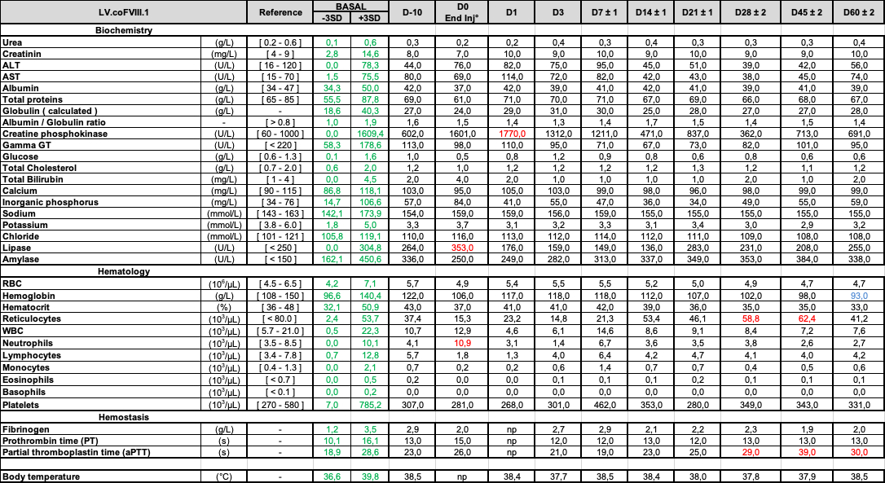

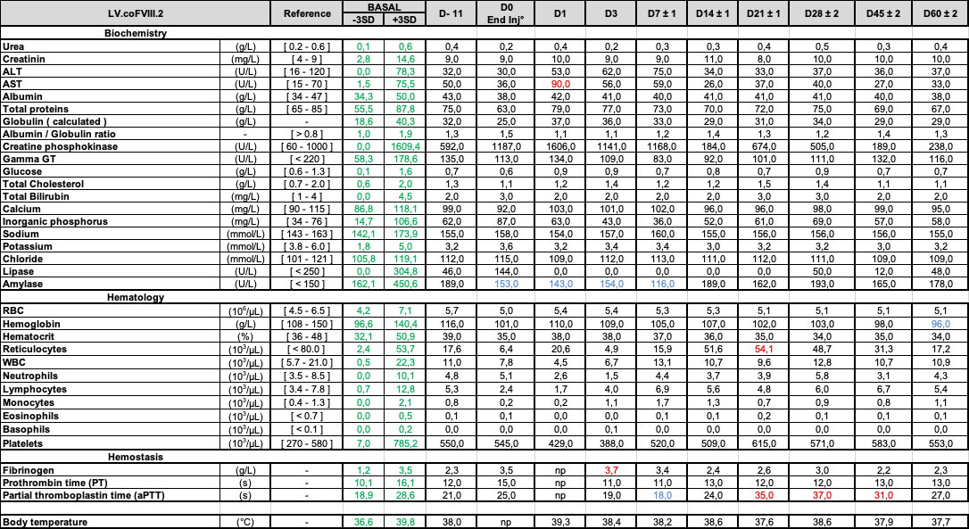

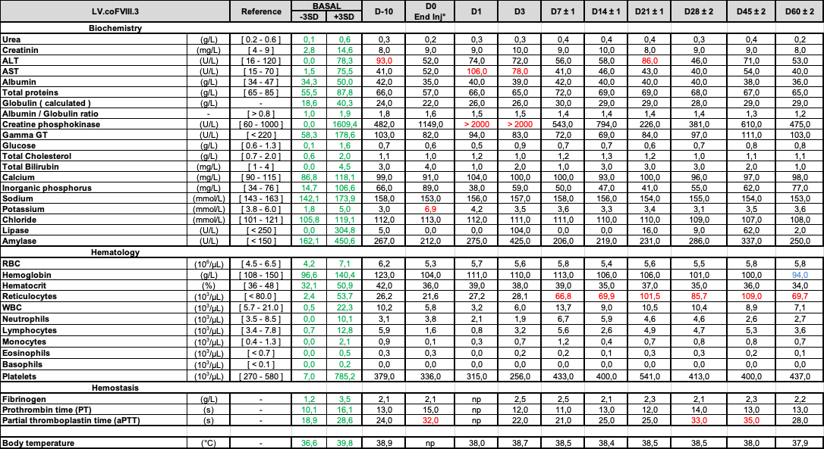

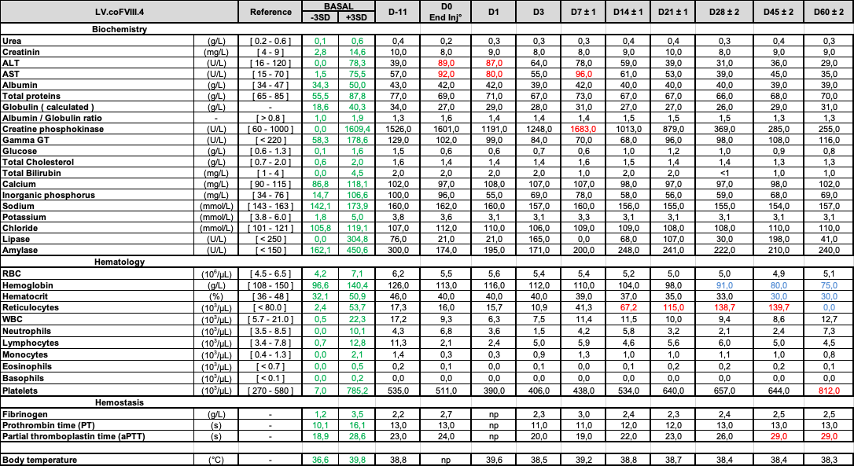

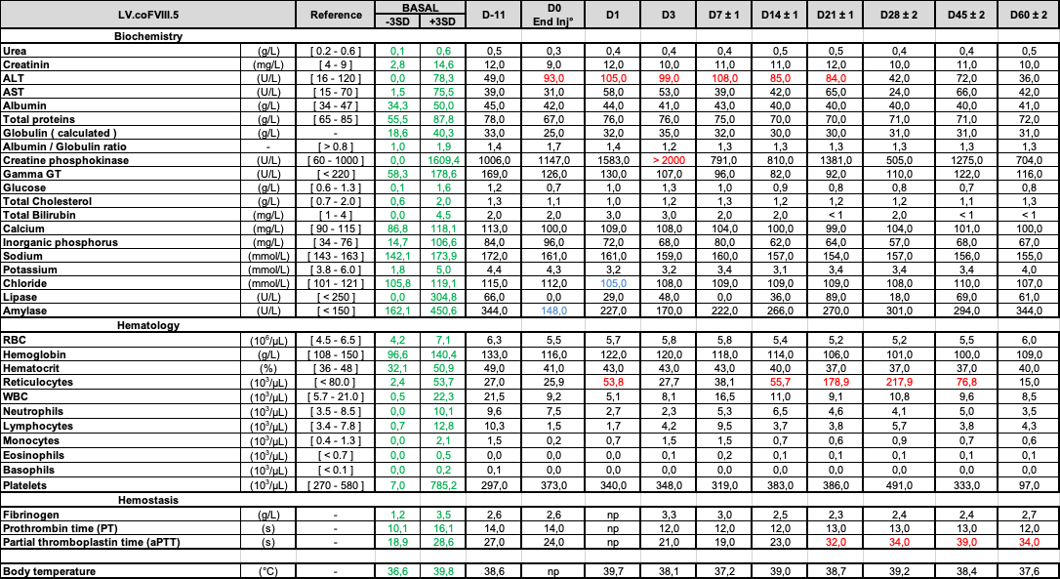

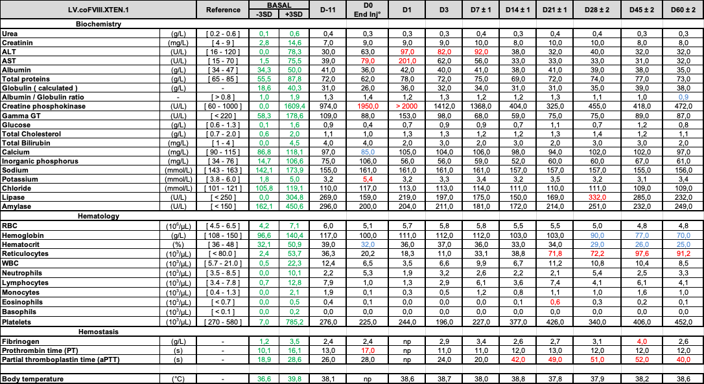

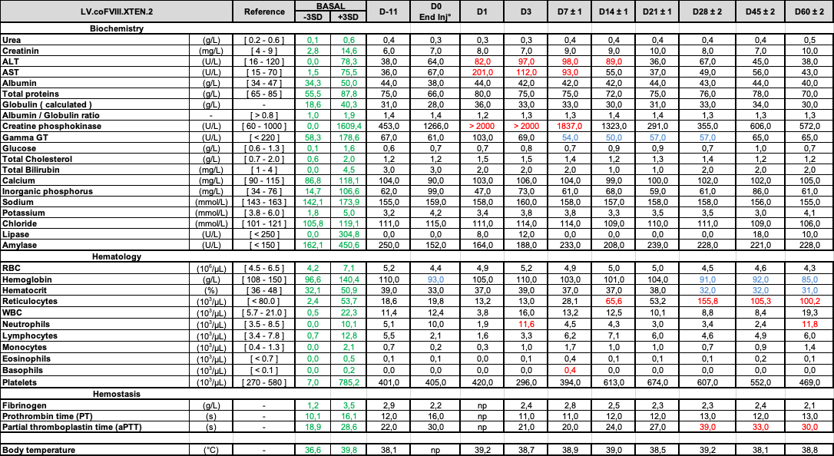

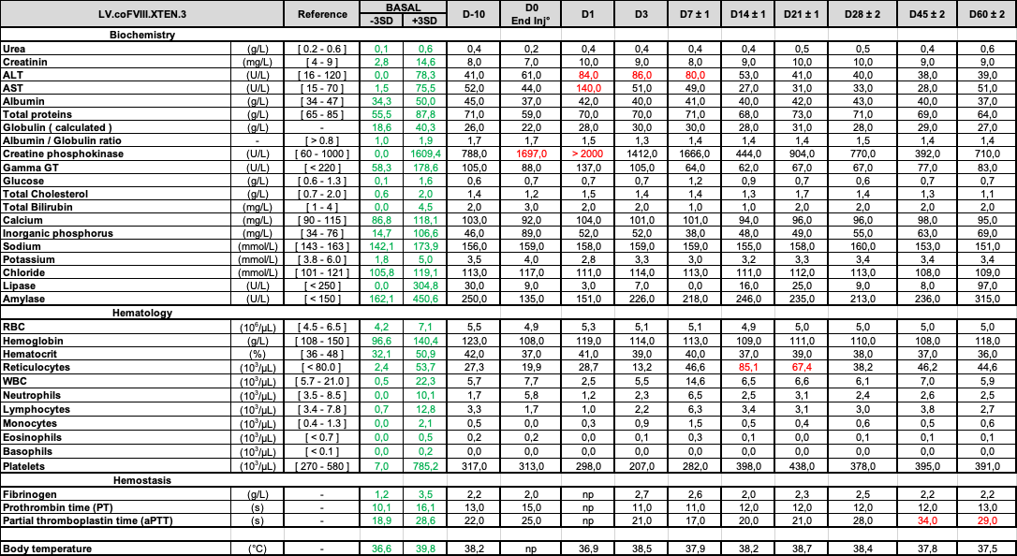

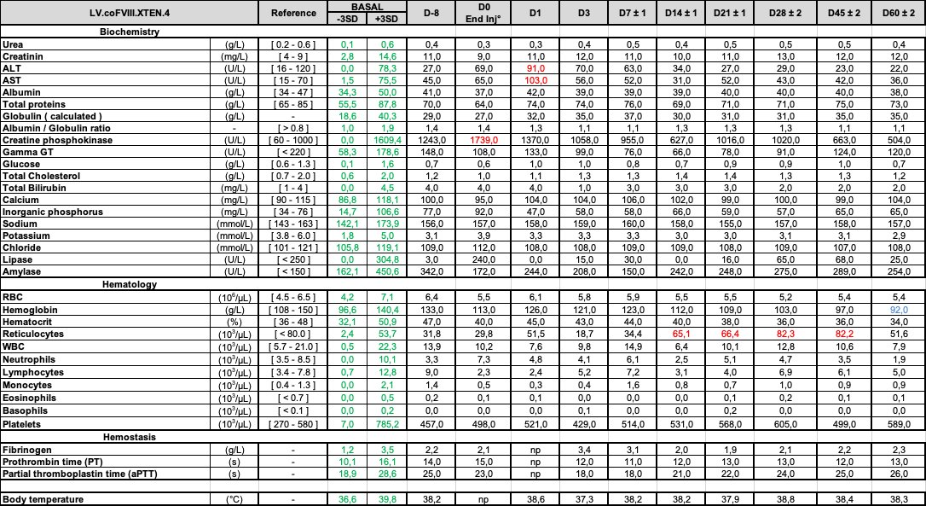

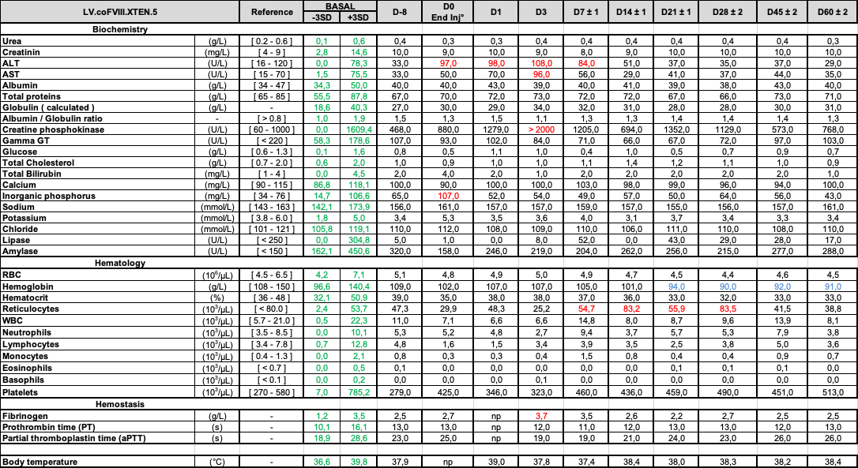

Supplementary Tables 2-11 Clinical biochemistry, hematology and hemostasis following i.v. administration of LV in NHP. The tables show the results of clinical biochemistry, hematology and hemostasis parameters in serum or plasma samples of the indicated NHP analyzed at the indicated time (days) before or after LV administration. The normal reference values for Macaca Fascicularis are shown in the column “Reference” and the mean±3 SD calculated on a pool of 38 pre-LV samples taken from 19 animals are shown in the column “Basal Range”. Values lower than basal range are shown in blue; values higher than basal range are shown in red. RBC: red blood cells WBC: white blood cells. Gamma GT: gamma-glutamiltranspeptidase.

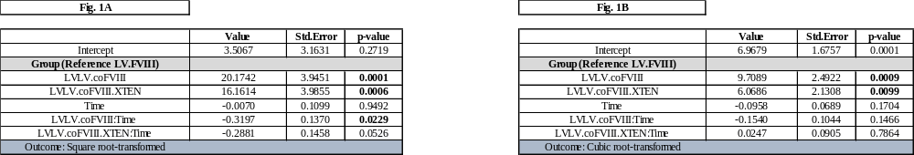

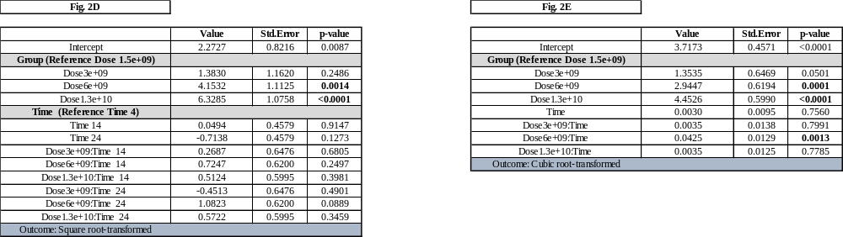

Supplementary Table 12 Statistical analyses. Results of LME model analysis on Fig. 1a, b and Fig. 2d, e, as indicated.

Supplementary Figures
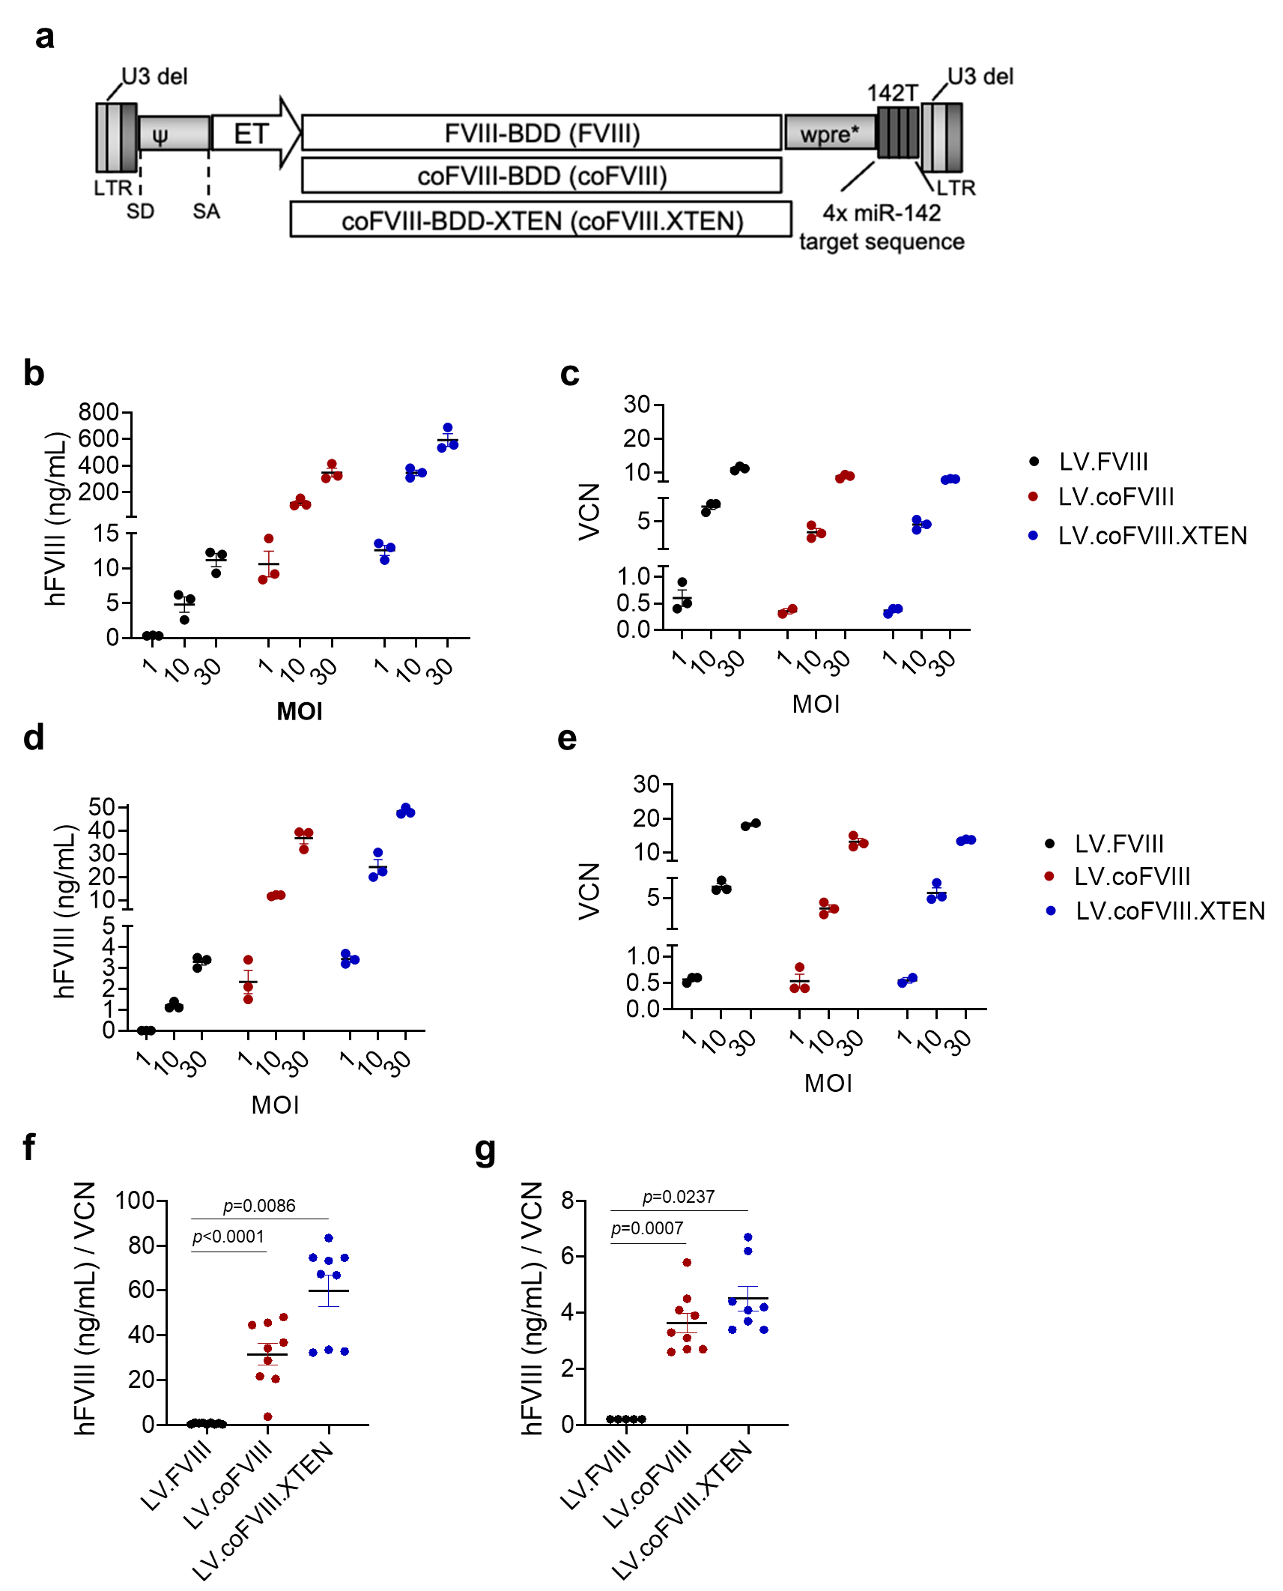
Supplementary Fig. 1 FVIII transgene evaluation in vitro in human and murine hepatocyte cell lines. a Schematic representation of the third-generation Self Inactivating (SIN) lentiviral vectors (proviral form) used in this work. U3 del: deletion of the promoter/enhancer of the HIV Long Terminal Repeats (LTR)]; SD: splicing donor site; SA: splicing acceptor site; ψ: packaging signal; Wpre*: mutated woodchuck hepatitis virus post-transcriptional regulatory element; 142T: miR-142 target sequence made of 4 tandem copies of a sequence perfectly complementary to miR-142; Hepatocyte-specific Enhanced Transthyretin (ET) promoter composed of synthetic hepatocyte-specific enhancers and transthyretin promoter. The B domain deleted (BDD), codon-usage optimized (co), and codon-usage optimized XTENylated cDNA of human factor VIII (FVIII-BDD (4374 bp), coFVIII (4374 bp), coFVIII.XTEN (4824 bp)) were used as transgenes. b-e hFVIII measured in the supernatant (b, d) and VCN (c, e) of Huh7 cells (b, c) or Hepa1.6 cells (d, e) transduced in triplicate with the indicated LV at the indicated multiplicity of infection (MOI). 250,000 cells were seeded and supernatant was collected 72 hours post seeding. f, g hFVIII output normalized on VCN in Huh7 cells (f) or Hepa1.6 cells (g). Codon-optimized transgene output is increased at all tested doses compared to wt transgene. Kruskal-Wallis test followed by post hoc analysis using Dunn’s test and adjusting p-values with Bonferroni’s approach (only comparisons against the reference control groups have been considered).

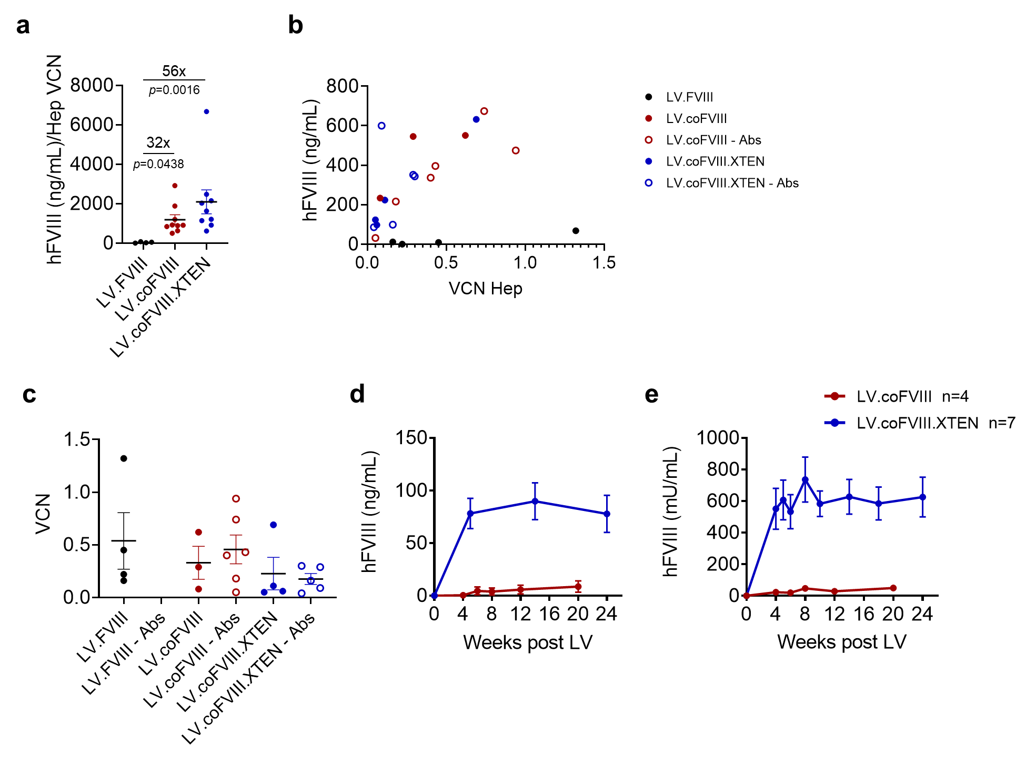

Supplementary Fig. 2 FVIII transgene selection in HemoA mice. a Single values and mean with SEM of hFVIII at plateau (mean of antigen concentration at 8-12-20-26 wks for each mouse shown in Fig. 1) normalized on VCN in purified hepatocytes (Hep). Codon-optimization of FVIII transgene allowed 32-fold increase in FVIII output per LV copy for LV.coFVIII and 56-fold increase for LV.coFVIII.XTEN compared to LV.FVIII. Kruskal-Wallis test followed by post hoc analysis using Dunn’s test and adjusting p-values with Bonferroni’s approach (only comparisons against the reference control groups have been considered). b Scatterplot displaying the relationship between hFVIII output at plateau and VCN in purified Hep. FVIII output well correlated with Hep VCN (R_{S}=0.400 for LV.FVIII, p=0.7500; R_{S}=0.800 for LV.coFVIII, p=0.0138; R_{S}=0.767 for LV.coFVIII.XTEN, p=0.0369), also in mice that mice that at the end of the experiment developed anti-hFVIII Abs (empty dots), Spearman’s rank-order correlation coefficient has been computed. c Single values and mean with SEM of VCN in mice shown in Fig. 1. d, e Direct comparison of the concentration of hFVIII antigen (d) or activity (e) in the plasma of HemoA LV-treated mice at 1.3e10 TU/Kg shown in Fig. 2a, b (LV.coFVIII-treated) compared to mice shown in Fig. 2d, e (LV.coFVIII.XTEN-treated).

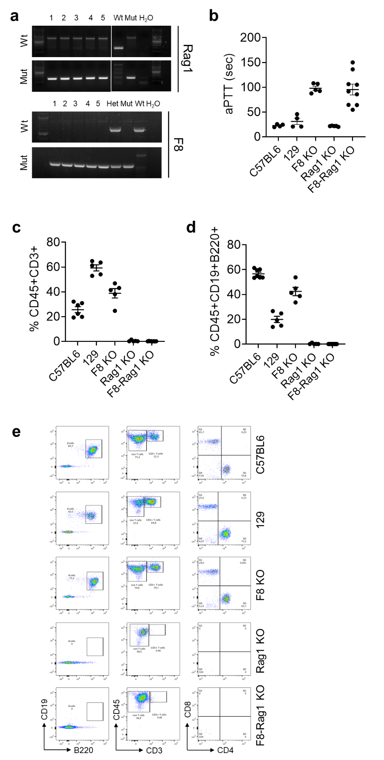

Supplementary Fig. 3 Phenotype and genotype characterization of F8–Rag1 double knock out (KO) mice. a Representative PCR amplicons of wt or mutated (mut) Rag1 (top) or F8 (bottom) locus in the indicated representative mice from the colony. Expected amplicons: Rag1_{wt} = 192base pairs (bp); Rag1_{mut} = 197bp; F8_{wt} = 620bp; F8_{mut} = 420bp. A wt mouse, a known Rag1 or F8 KO mouse (Mut) and a heterozygous mouse (Het, available only for F8) are included as controls. b Single values and mean with SEM of activated partial thromboplastin clotting time (aPTT) measured in the plasma of Rag1 KO, F8 KO, F8-Rag1 double KO or wt mice, as indicated. c-e Single values and mean with SEM of T (c) or B lymphocytes (d) measured in the circulation of Rag1 KO, F8 KO, F8-Rag1 double KO or wt mice, as indicated. Representative plots and gating strategy are shown in (e).

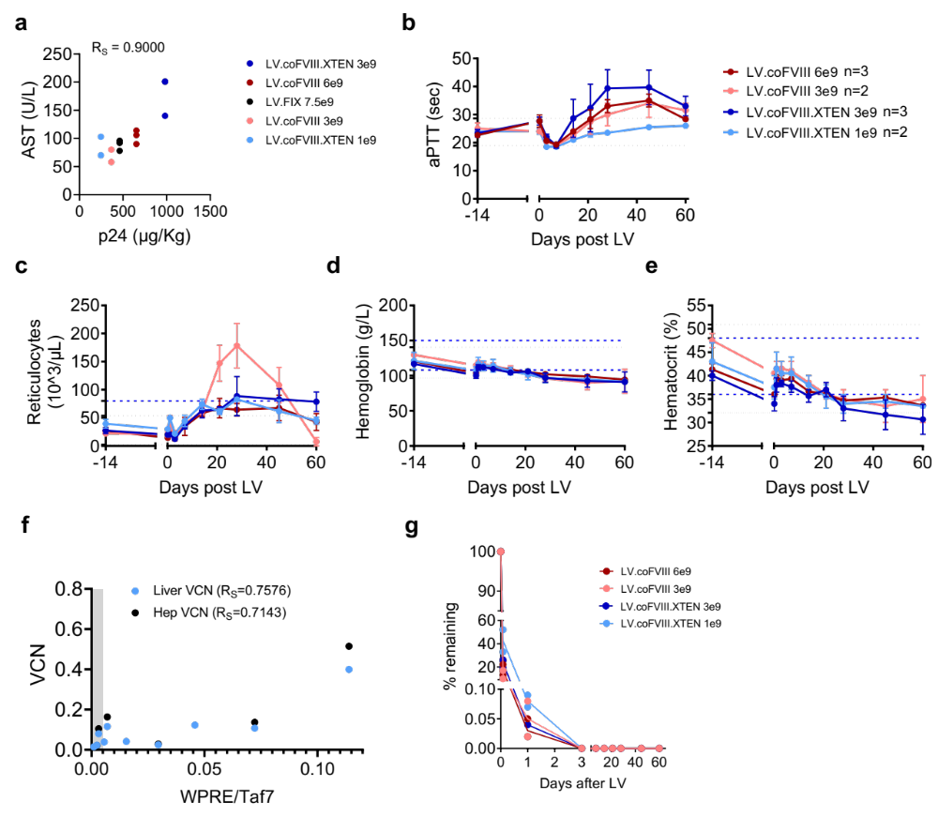

Supplementary Fig. 4 Blood chemistry, hematology and hemostasis following in vivo LV gene therapy in NHP. a Scatterplot displaying the relationship between LV particle dose (measured as HIV Gag p24 µg/Kg, X axis) and serum concentration of AST (Y axis, R_{S}=0.9, p=0.0833) at 24 hours after LV administration in LV-treated NHP, as indicated. Spearman’s rank-order correlation coefficient has been computed. b-e Mean with SEM (n=3) or range (n=2) of aPTT (b), counts of reticulocytes (c), concentration of hemoglobin (d) and hematocrit % (e) of NHP treated with LV.coFVIII (n=3 6x10⁹ TU/kg; n=2 3x10⁹ TU/kg), or with LV.coFVIII.XTEN (n=3 3x10⁹ TU/kg; n=2 1x10⁹ TU/kg) at the indicated time after LV administration. The black dotted lines show the mean±3SD calculated on a pool of 38 pre-LV samples taken from 19 animals; the blue dashed lines show the normal reference values for Macaca Fascicularis. f Scatterplot displaying the relationship between WPRE expression normalized on the endogenous TAF7 gene on RNA extracted from different liver lobes of LV-treated NHP shown in Fig. 5b (X axis) and their VCN (Y axis) in total liver shown in Fig. 5a (light blue dots, R_{S}=0.7576, p=0.0149), or calculated Hep VCN shown in Fig. 5d (black dots, R_{S}=0.7143, p=0.1361). The grey area represents mean WPRE background signal in the spleen. Spearman’s rank-order correlation coefficient has been computed. g Percentage of the serum concentrations of LV particles (measured as HIV Gag p24) recovered at the indicated time (hours) after administration of LV, as indicated, relative to the total amount of administered LV particles.

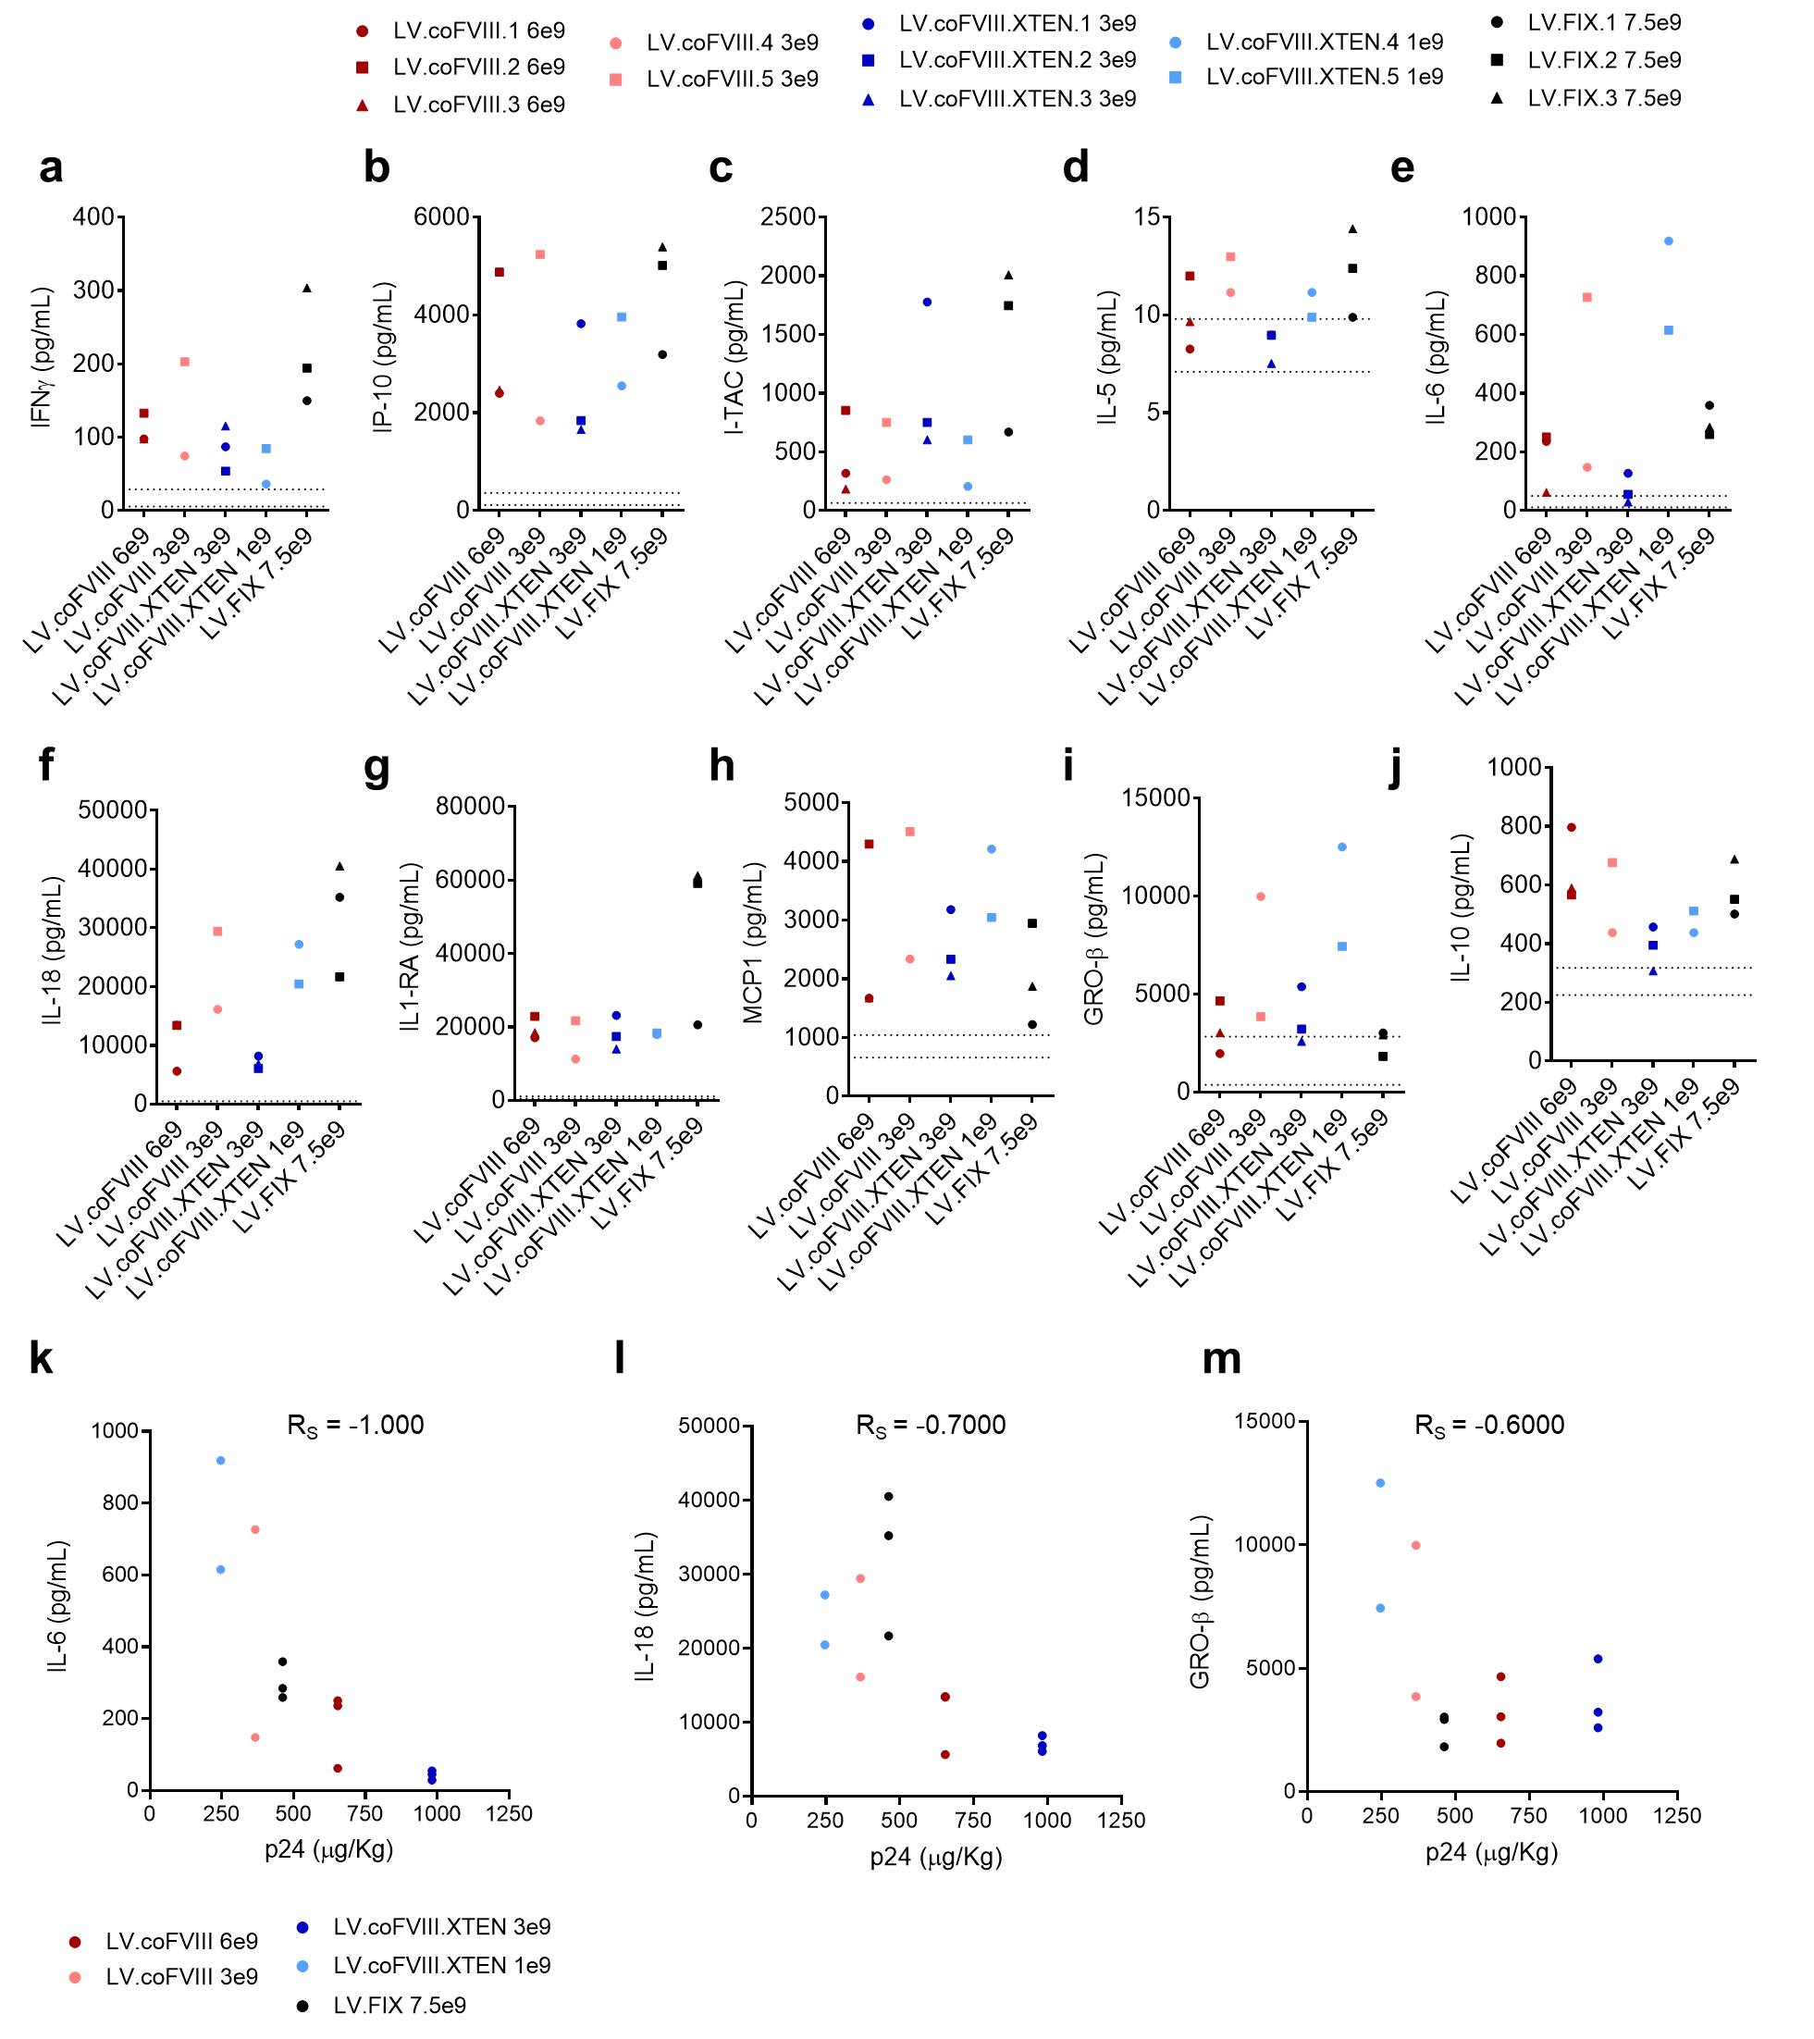

Supplementary Fig. 5 Cytokine response following in vivo LV gene therapy in NHP. a-j Single values of concentration of IFNγ (a), IP-10 (b), I-TAC (c), IL-5 (d), IL-6 (e), IL-18 (f), IL-1RA (g), MCP1 (h), GRO-β (i) and IL-10 (j) in the serum of LV-treated NHP, as indicated, at peak (24-48 hours post LV administration). Black dotted lines are mean±1SD calculated on a pool of pre-LV samples taken from 20 animals. k-m Scatterplot displaying the relationship between LV particle dose (measured as HIV Gag p24 µg/kg, X axis) and serum concentration of IL-6 (k, R_{S}=-1, p=0.0167), IL-18 (l, R_{S}=-0.7, p=0.2333) and GRO-β (m, R_{S}=-0.6, p=0.3500) at peak in LV-treated NHP, as indicated. Spearman’s rank-order correlation coefficient has been computed.

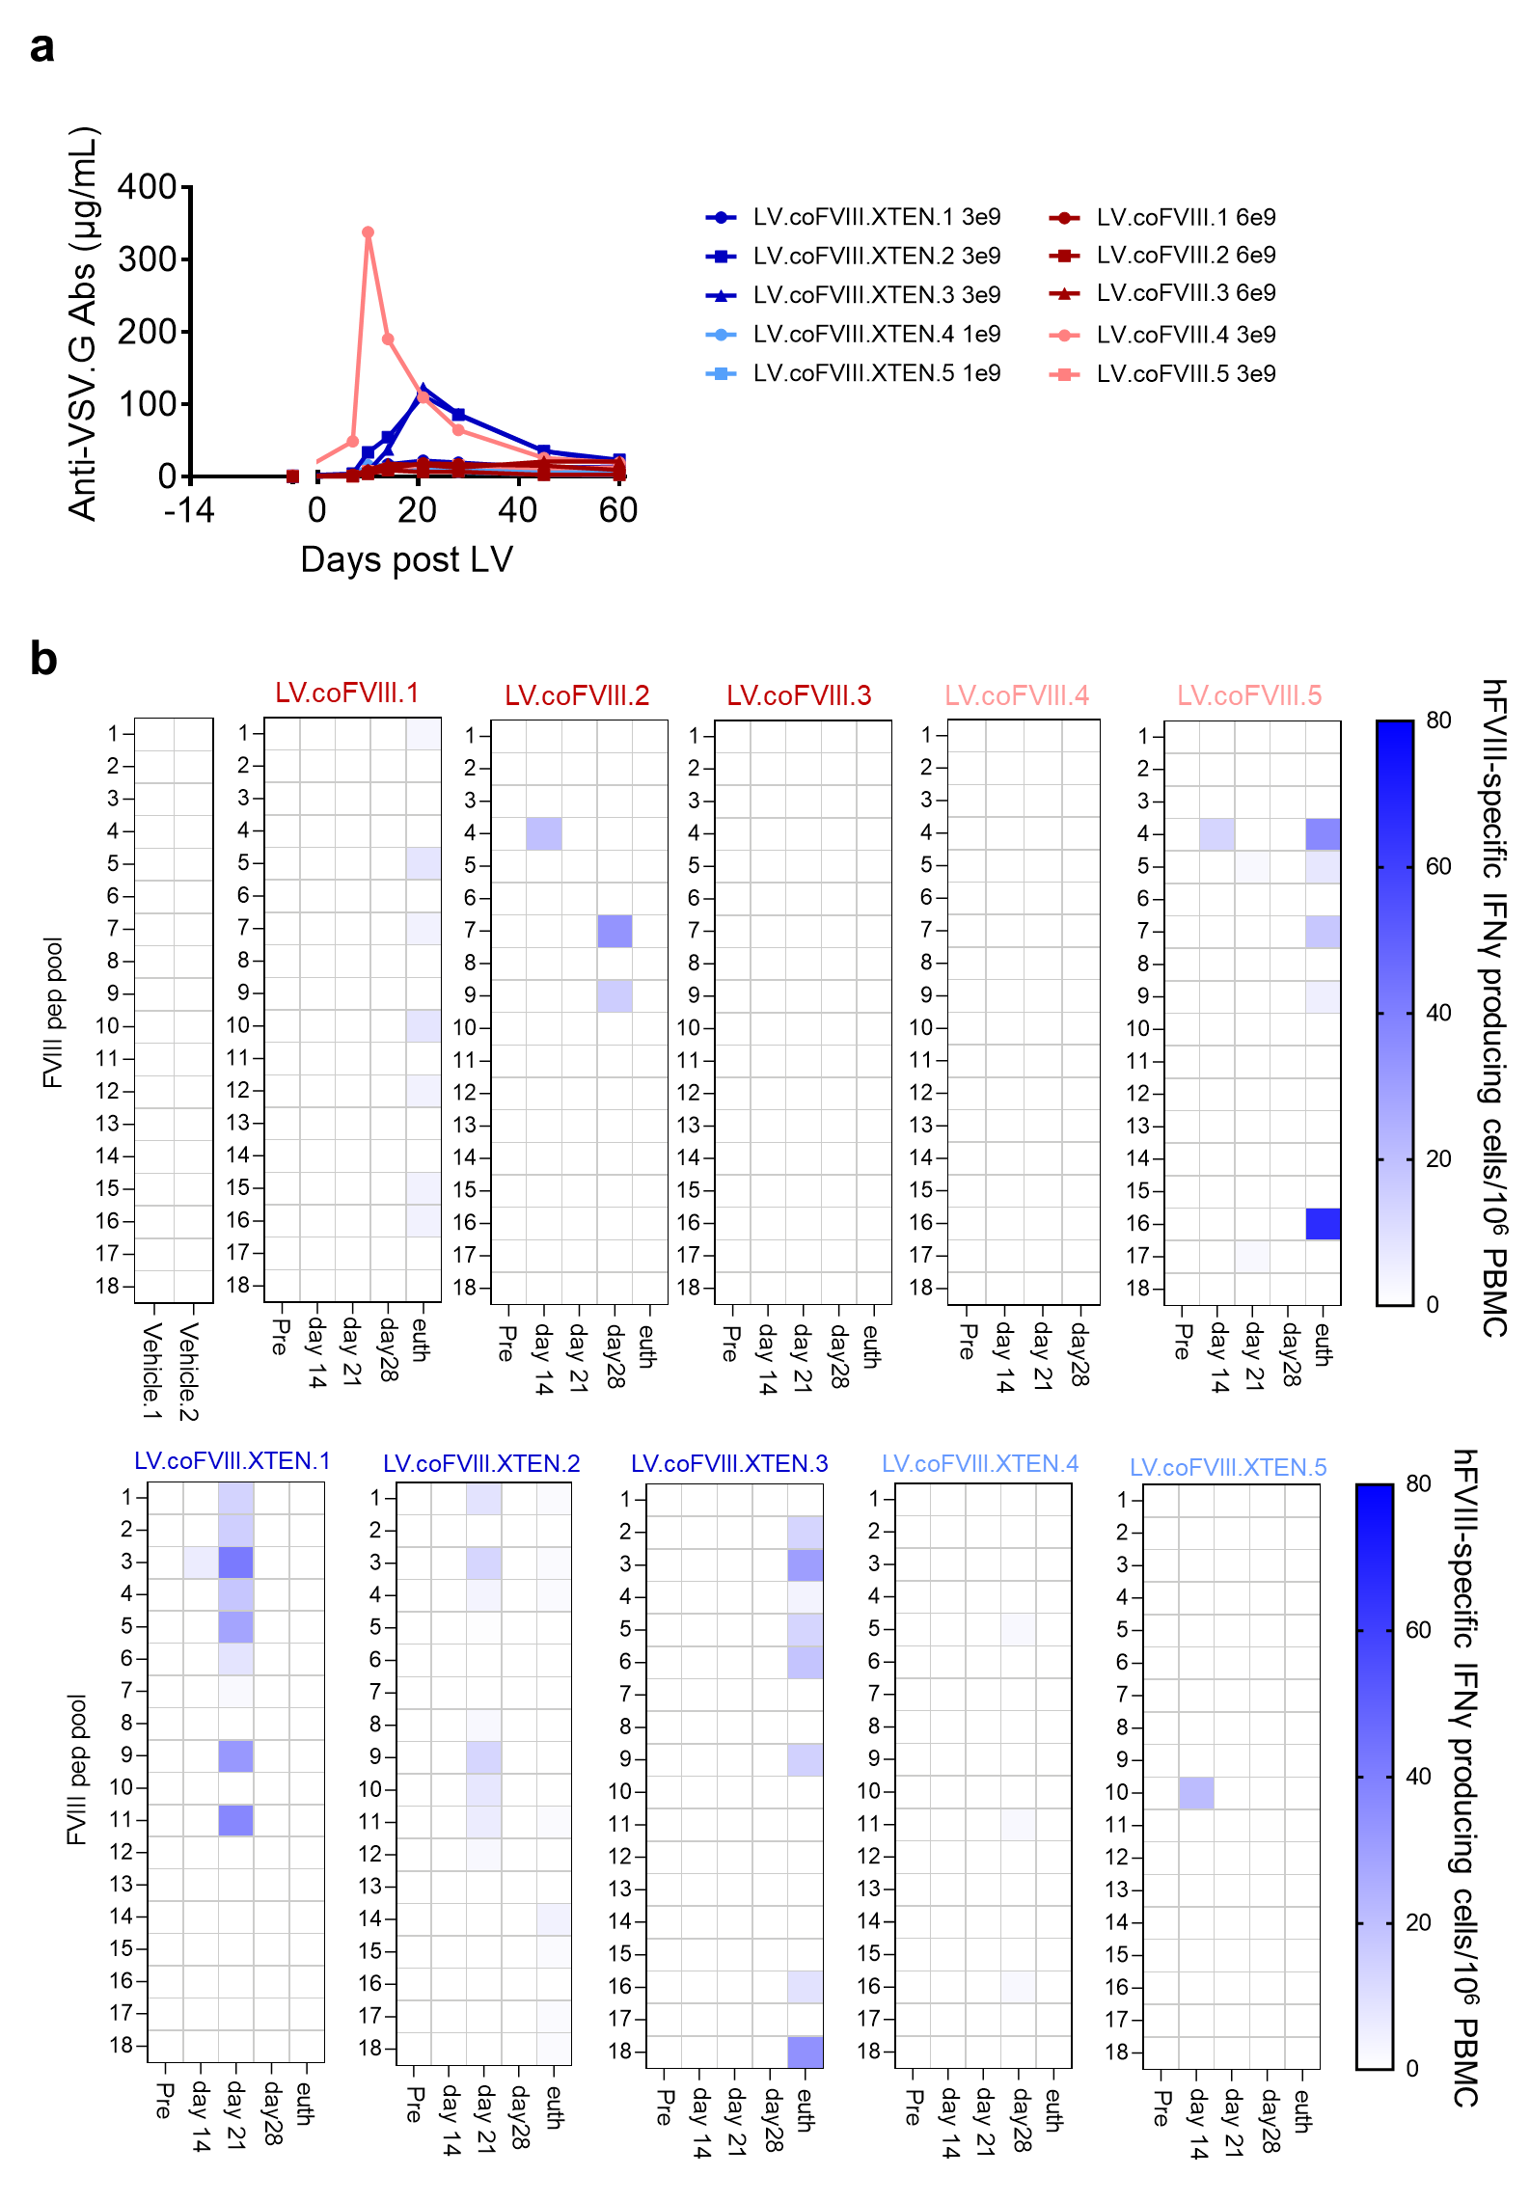

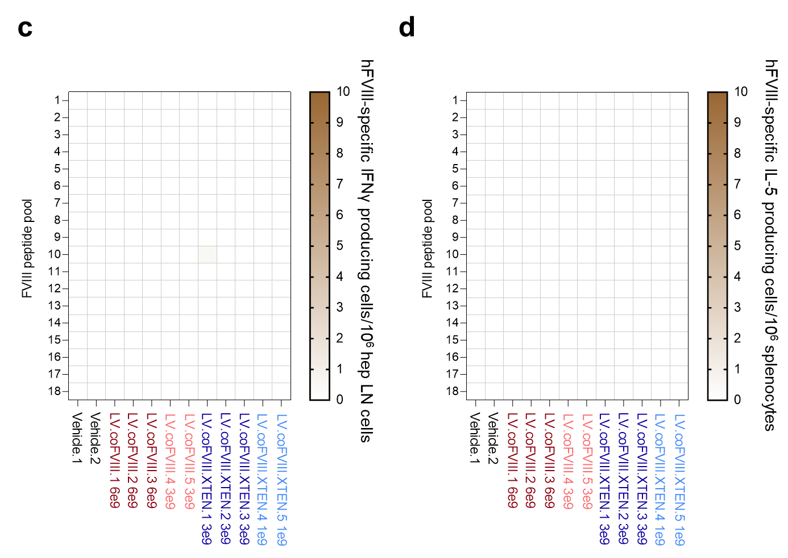

Supplementary Fig. 6 Immune response following in vivo LV gene therapy in NHP. a Single values of serum concentration of anti-VSV.G Abs at the indicated time after LV administration in LV-treated NHP, as indicated. b Heatmap reporting the frequency of hFVIII-specific IFNγ producing cells/10⁶ peripheral blood mononuclear cells (PBMC) overtime in NHP treated as indicated on top of panels. The 18 pools of FVIII peptides cover the entire transgenes encoded by administered LV. c, d Heatmap reporting the frequency of hFVIII-specific IFNγ producing cells/10⁶ hepatic lymph-node cells (hep LN, c) or IL-5 producing cells/10⁶ splenocytes (d) of NHP treated as indicated.

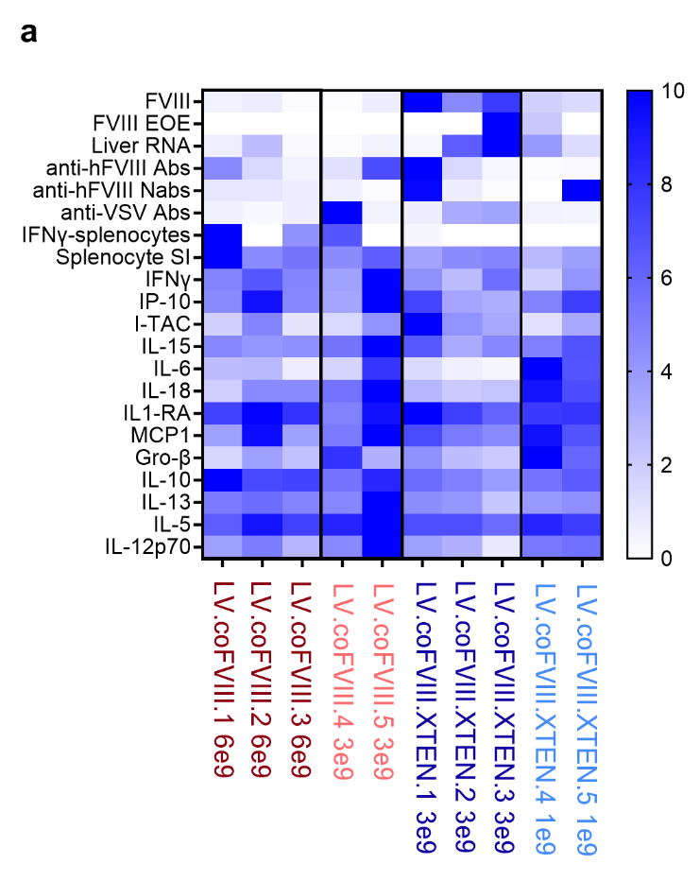

Supplementary Fig. 7 Visual summary of the main results of in vivo LV gene therapy in NHP. a All indicated data in NHP treated as indicated have been re-set on a scale in which the highest value measured for each parameter has been set to 10 and all the other values have been rescaled accordingly. EOE: end of experiment; Nabs: neutralizing antibodies; IFNγ-splenocytes: hFVIII-specific IFNγ producing cells/10⁶ splenocytes; SI: stimulation index.

