Grain Size
The grain size analysis, were performed in Dokuz Eylul University Engineering Faculty Mining Engineering Department using the HORIBA brand Laser Scattering Particle Size Distribution Analyzer LA-950 device. Analyses were performed by spinning in water and reading with a laser using a 1.550 Refractive Index, and the results were obtained. In the grain size analysis, the median size of the BT-01 level was found to be 42.08 µm, while it was found to be 36.42 µm for the BT-02 level (Fig. 1). There are also differences in mode values ​​between the two levels: 63.055 µm for BT-01, 55.175 µm for BT-02. Grain size values ​​for the two tephra levels are bimodal. While the sorting value for BT-01 is 1.47 and the sorting value for BT-02 is 1.38, it is observed that both levels are poorly sorted and BT-01 level is relatively poorly sorted than BT-02 level. In general, it has been concluded that the grains belonging to the BT-01 level are coarser, which is compatible with the results obtained from microscope studies. Because the grain size measuring device can recognize spherical-shaped grains or small axis of tubular shaped particles, maximum grain size could not be measured in this section, but maximum grains were measured under the microscope.
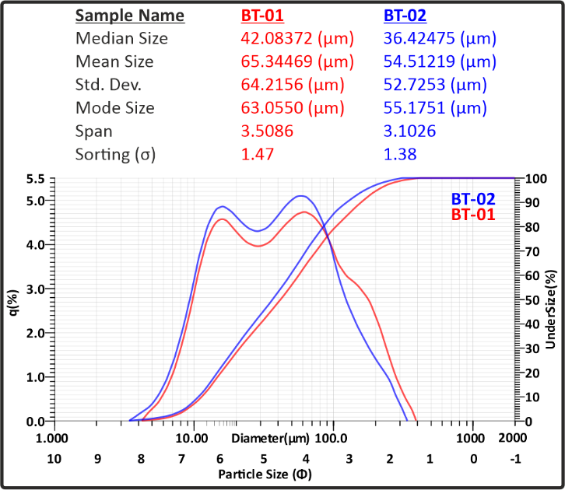
Fig. 1 Grain size graph belongs to BT levels.
Geochemistry
The major element compositions were acquired at the Cukurova University Central Research Laboratory (CUMERLAB) by wet-chemical analyses. The samples were decomposed using an HF–HClO₄ mixture, and major element compounds were determined using ICP-OES, with a precision better than ±5%. The Laser Ablation-Inductively Coupled Plasma-Mass Spectrometry (LA-ICP-MS) system was used for the trace element and REE analyses (Gao et al. 2002; Woodhead et al. 2007). CUMERLAB is hosting an ESI NWR213 laser system attached to a Perkin Elmer NexION 2000P mass spectrometer. Glass shards were extracted from the BT and mounted before grinding and polishing. The polished glasses were ablated by a laser beam at 7-9 J and 100 µm size. A He carrier gas was used to carry the ablated gas to ICP-MS. Helium gas mixed with nitrogen was used as the carrier gas, whereas argon gas was used for the plasma in the ICP-MS. ²⁹Si was used for internal standard, and NIST 612, NIST 610, AGV-2, and BCR-2 were used for external calibration (Jochum et al. 2005 and 2011). The AGV-2 and BCR-2, natural reference materials, were also used as unknowns during the analytical session to monitor internal accuracy. The Iolite V4 is used for data reduction and processing (Woodhead et al. 2007; Paton et al. 2011)
In the geochemical analyses, the major oxide results of the analyses performed using ICP-OES from bulk tephra and LA-ICP-MS from single volcanic glass grains are given in detail in (Table 1). According to the results of major oxide analyses normalized to 100%, the SiO₂ ratio of BT tephra is between 71.40% and 71.99%. The trace element and REE element results obtained from the LA-ICP-MS analyses performed on six different single grains are given in Table 1. The Zr values ​​of BT tephra vary between 282.25 and 358.87 ppm, and the Ba values ​​vary between 534.36 and 619.58 ppm. When examining the geochemical values of BT tephra, it is observed that the results are relatively consistent with one another. (Table 1).

Table 1: Geochemical Results of BT tephra (n=6)
Sample | BT 1 | BT 2 | BT 3 | BT 4 | BT 5 | BT 6
SiO₂ (%) | 71.51 | 71.85 | 71.61 | 71.99 | 71.60 | 71.40
TiO₂ | 0.35 | 0.30 | 0.33 | 0.30 | 0.33 | 0.36
Al₂O₃ | 15.89 | 15.97 | 15.91 | 16.00 | 15.91 | 15.87
FeO_{(T)} | 1.83 | 1.70 | 1.74 | 1.69 | 1.85 | 1.80
MnO | 0.07 | 0.06 | 0.07 | 0.07 | 0.07 | 0.07
MgO | 0.40 | 0.37 | 0.36 | 0.33 | 0.36 | 0.39
CaO | 2.38 | 2.15 | 2.40 | 2.02 | 2.32 | 2.57
Na₂O | 3.70 | 3.72 | 3.71 | 3.73 | 3.71 | 3.69
K₂O | 3.81 | 3.83 | 3.82 | 3.83 | 3.81 | 3.80
P₂O₅ | 0.07 | 0.06 | 0.05 | 0.05 | 0.05 | 0.06
Sum | 100 | 100 | 100 | 100 | 100 | 100
Be (ppm) | 1.66 | 4.92 | n.a. | 2.08 | 4.42 | 0.90
B | 21.55 | 44.11 | 1.32 | 23.08 | 29.92 | n.a.
S | 1032.03 | 509.87 | 471.84 | 629.40 | 713.26 | 660.12
Sc | 12.13 | 13.17 | 12.02 | 12.66 | 13.89 | 13.92
Ti | 1912.72 | 1622.19 | 1835.65 | 1652.97 | 1788.85 | 1963.20
V | 5.81 | 4.98 | 6.61 | 4.24 | 5.79 | 5.65
Cr | 29.47 | 29.36 | 27.26 | 23.04 | 16.46 | 15.41
Mn | 508.01 | 428.79 | 501.47 | 463.49 | 464.66 | 497.24
Co | 1.52 | 1.87 | 2.38 | 1.84 | 1.95 | 2.19
Ni | 1.20 | n.a. | 0.06 | n.a. | 4.77 | n.a.
Cu | 13.54 | 18.57 | 15.26 | 13.65 | 25.41 | 5.79
Zn | 40.48 | 29.37 | 45.25 | 27.02 | 31.58 | 28.77
Ga | 18.45 | 20.35 | 18.78 | 18.86 | 20.08 | 18.94
Ge | 1.67 | 2.21 | 1.59 | 0.44 | 1.50 | 2.56
As | 1.69 | 1.88 | 7.15 | 5.02 | 5.28 | 7.22
Se | n.a. | 2.64 | 3.21 | n.a. | 0.02 | 2.86
Rb | 117.83 | 105.24 | 124.04 | 110.40 | 117.47 | 106.31
Sr | 74.78 | 58.63 | 68.03 | 58.72 | 64.36 | 70.37
Y | 48.75 | 41.25 | 46.50 | 42.07 | 48.43 | 47.69
Zr | 340.72 | 293.06 | 344.67 | 282.25 | 317.79 | 358.87
Nb | 9.28 | 8.80 | 10.31 | 8.04 | 9.53 | 11.10
Mo | 2.78 | 2.42 | 1.30 | 1.67 | 3.54 | 1.29
Sn | 3.71 | 1.76 | 2.56 | 1.96 | 2.46 | 1.71
Sb | 0.35 | 0.54 | 0.36 | 0.21 | 0.43 | 0.50
Cs | 3.59 | 3.29 | 3.40 | 3.05 | 3.19 | 3.64
Ba | 565.68 | 546.18 | 534.77 | 591.84 | 534.36 | 619.58
La | 35.84 | 37.07 | 36.53 | 37.15 | 37.18 | 39.42
Ce | 71.59 | 74.69 | 76.85 | 78.74 | 76.42 | 79.15
Pr | 7.08 | 7.23 | 7.51 | 7.23 | 7.69 | 8.85
Nd | 23.92 | 23.24 | 25.17 | 25.22 | 25.26 | 25.99
Sm | 5.13 | 4.03 | 4.51 | 4.71 | 4.70 | 5.21
Eu | 0.58 | 0.71 | 0.56 | 0.62 | 0.69 | 0.89
Gd | 4.30 | 4.75 | 4.43 | 5.75 | 5.09 | 5.11
Tb | 0.95 | 0.86 | 0.80 | 0.89 | 0.94 | 1.00
Dy | 6.72 | 7.17 | 5.51 | 7.55 | 7.78 | 7.43
Ho | 1.84 | 1.43 | 1.38 | 1.87 | 1.87 | 1.91
Er | 5.80 | 6.10 | 5.89 | 5.66 | 6.43 | 6.16
Tm | 0.84 | 0.57 | 1.00 | 0.79 | 0.87 | 0.79
Yb | 4.20 | 5.06 | 4.26 | 4.56 | 5.16 | 4.93
Lu | 0.64 | 0.52 | 0.57 | 0.61 | 0.73 | 0.74
Hf | 6.21 | 6.60 | 6.36 | 6.18 | 7.41 | 7.87
Ta | 0.86 | 0.51 | 0.58 | 0.70 | 0.77 | 0.57
W | 1.14 | 2.39 | 1.77 | 1.03 | 4.15 | 1.57
Pb | 14.91 | 16.68 | 14.23 | 14.23 | 14.76 | 16.44
Bi | 0.08 | 0.21 | n.a. | 0.11 | 0.11 | 0.19
Th | 20.57 | 18.37 | 21.03 | 22.88 | 20.51 | 22.94
U | 5.88 | 5.20 | 5.65 | 6.86 | 5.84 | 6.42

References
Gao S, Liu X, Yuan H, Hattendorf B, Günther D, Chen L, Hu S (2002) Determination of forty-two major and trace elements in USGS and NIST SRM glasses by laser ablation-inductively coupled plasma-mass spectrometry. Geostandards Newsletter 26:181-196. https://doi.org/10.1111/j.1751-908X.2002.tb00886.x
Jochum KP, Nohl U, Herwig K, Lammel E, Stoll B, Hofmann AW (2005) GeoReM: A new geochemical database for reference materials and isotopic standards. Geostandards and Geoanalytical Research 29:333-338. https://doi.org/10.1111/j.1751-908X.2005.tb00904.x
Jochum KP, Weis U, Stoll B, Kuzmin D, Yang Q, Raczek I, Jacob DE, Stracke A, Birbaum K, Frick DA, Günther D, Enzweiler J (2011) Determination of reference values for NIST SRM 610–617 glasses following ISO guidelines. Geostandards and Geoanalytical Research 35:397-429. https://doi.org/10.1111/j.1751-908X.2011.00120.x
Paton C, Hellstrom J, Paul B, Woodhead J, Hergt J (2011) Iolite: Freeware for the visualization and processing of mass spectrometric data. JAAS 26:2508-2518. https://doi.org/10.1039/C1JA10172B
Woodhead JD, Hellstrom J, Hergt JM, Greig A, Maas R (2007) Isotopic and elemental imaging of geological materials by laser ablation inductively coupled plasma-mass spectrometry. Geostandards and Geoanalytical Research 31:331-343. https://doi.org/10.1111/j.1751-908X.2007.00104.x

