Supplementary
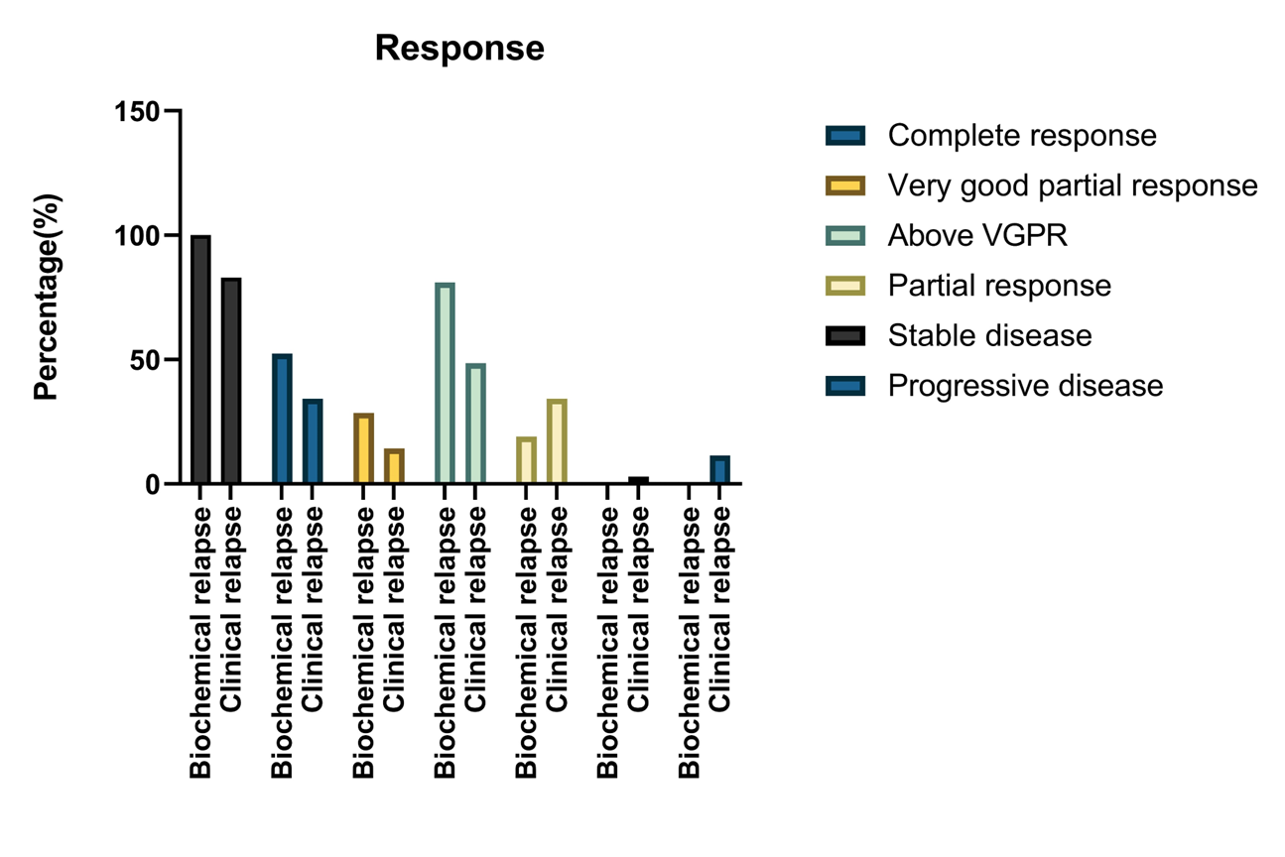
Supplementary 1
This figure illustrates the responses observed in biochemical relapse versus clinical relapse.

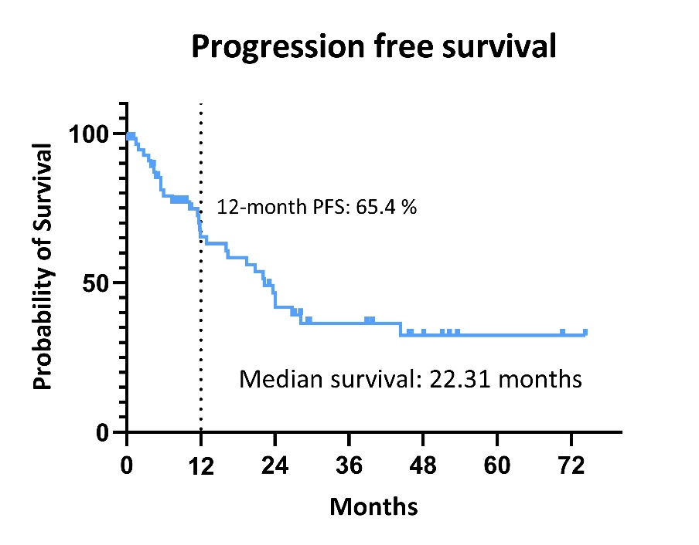
Supplementary 2(a)
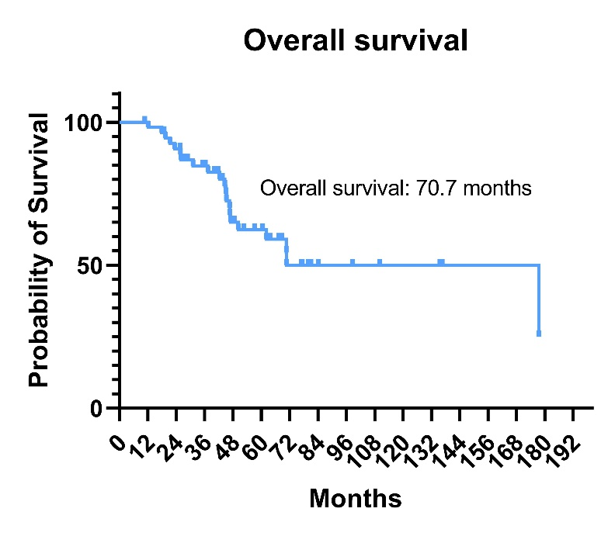
Supplementary 2(b)
Progression-free survival(2a) and overall survival(2b) for the overall population.
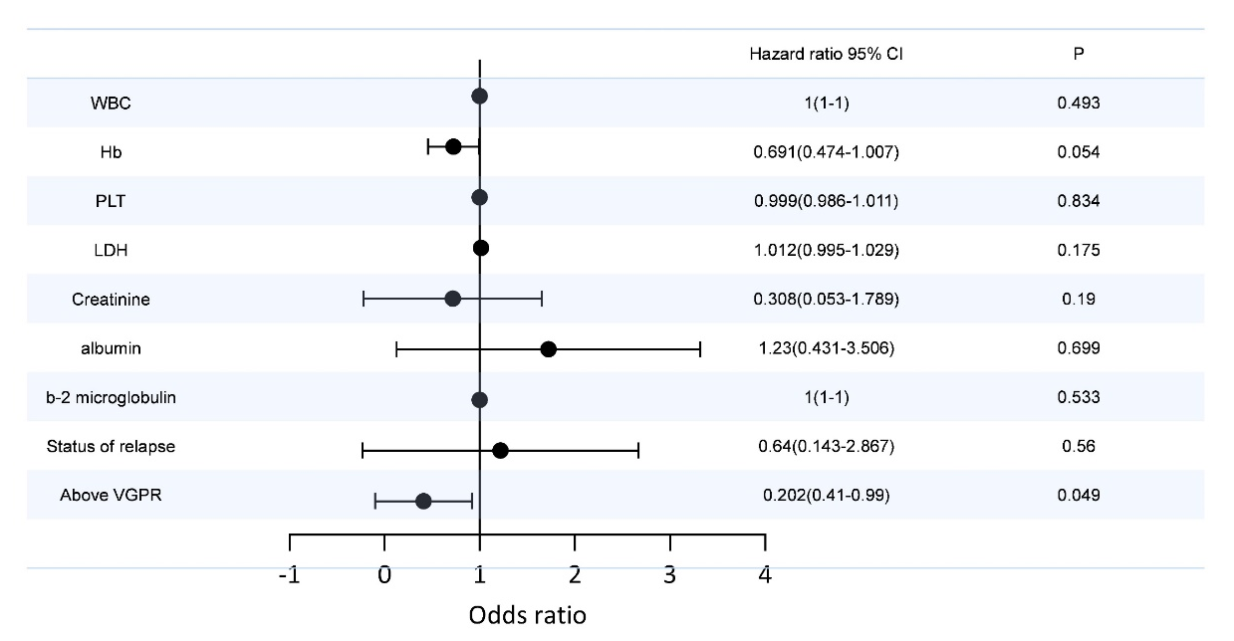
Supplementary 3
Forest plot assessing the association of maintenance therapy with lenalidomide and dexamethasone.

