Sex

Age
Schizophrenia Spectrum

Depression Severity*

?
Antidepressant
Class (SSRI vs SNRI)

Incident Bipolar Disorder

Genetic Liability*

Substance Use Disorder
Prior Antidepressant

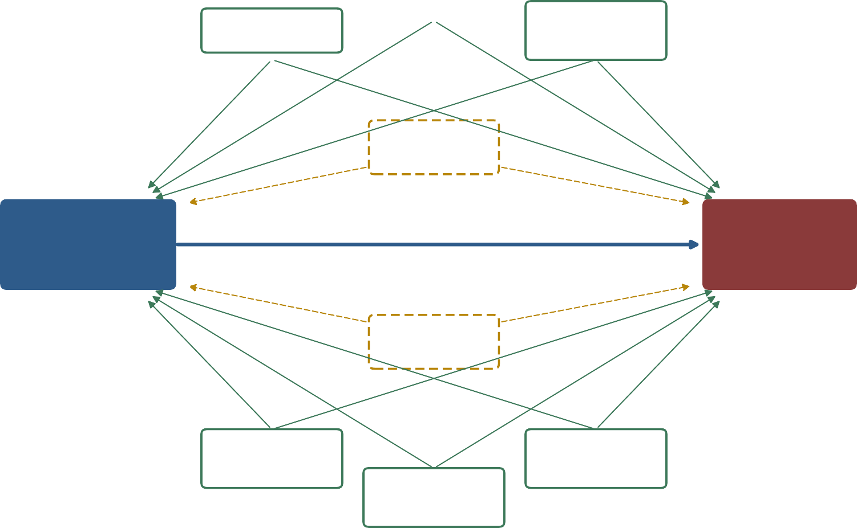
Prior Antipsychotic

Exposure  Outcome  Measured Confounder  Unmeasured Confounder*

*Unmeasured confounders represent potential sources of residual confounding

