Supplementary materials

X.1. Sensitivity analyses
2005 2012 2021
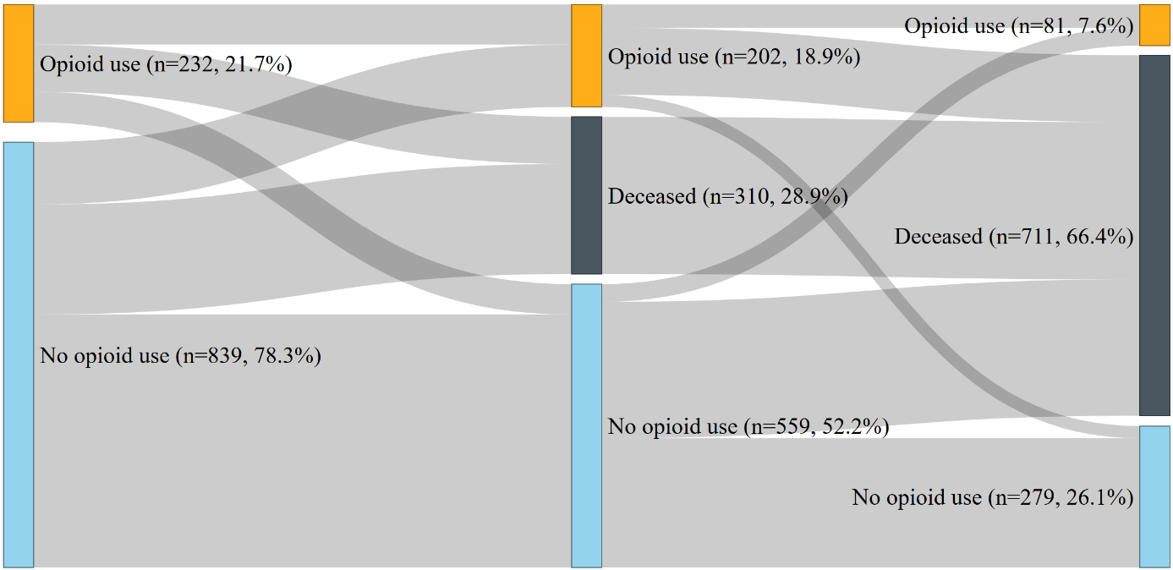

Figure S1. Sankey plot depicting longitudinal transitions in chronic pain status and mortality among COPD patients (N=1,071) from 2005-2021. Chronic pain was defined as use of pain medication (≥2 dispensed physician-prescribed opioid medications during the period). Node width represents the number of patients in each state. Flow width represents the number of patients transitioning between states. Orange nodes - chronic pain present; blue nodes - no chronic pain; grey nodes: deceased.

Table S1. Sequential predictors of all-cause mortality among 1071 COPD patients, from 2005 to 2021.
 | Hazard ratio | 95%CI | P-value
Block I. AIC: 9188.2
Chronic pain | 1.66 | 1.41-1.96 | <0.001
Block II. AIC: 9006.6; Δχ² = 187.59, p = <0.001
Chronic pain | 1.72 | 1.47-2.03 | <0.001
Age | 1.08 | 1.07-1.10 | <0.001
Male sex | 0.93 | 0.80-1.09 | 0.37
Education level | 0.93 | 0.88-0.97 | 0.002
Block III. AIC: 8880; Δχ² = 130.58, p = <0.001
Chronic pain | 1.52 | 1.29-1.80 | <0.001
Age | 1.07 | 1.06-1.09 | <0.001
Male sex | 0.94 | 0.81-1.10 | 0.45
Education level | 0.94 | 0.89-0.99 | 0.01
Breathlessness | 1.39 | 1.29-1.49 | <0.001
Emotional distress | 1.03 | 0.98-1.08 | 0.30
Block IV. AIC: 8753.6; Δχ² = 128.42, p = <0.001
Chronic pain | 1.25 | 1.05-1.48 | 0.01
Age | 1.06 | 1.05-1.08 | <0.001
Male sex | 0.92 | 0.79-1.08 | 0.31
Education level | 0.91 | 0.86-0.96 | 0.001
Breathlessness | 1.34 | 1.25-1.44 | <0.001
Emotional distress | 1.01 | 0.96-1.07 | 0.64
Multimorbidity | 1.44 | 1.35-1.53 | <0.001
Note. This was a sequential or nested Cox proportional hazards with time-dependent exposures at 2005 and 2012, and all-cause mortality as a continuous-time outcome from 2005 to 2021. Multimorbidity, diagnoses from the Elixhaser comorbidity index, excluding chronic respiratory disease. Chronic pain status was defined as having recently used opioid medication (≥2 dispensed physician-prescribed opioid medications during the period).

Table S2. Sequential associations with recurrent respiratory-related hospital visits in 1071 COPD patients, from 2005 to 2021.
 | Hazard ratio | 95%CI | P-value
Block I. AIC: 101072.9
Chronic pain | 1.06 | 1.01-1.12 | 0.02
Block II. AIC: 101057.6; Δχ² = 27.37, p = <.001
Chronic pain | 1.13 | 1.07-1.19 | <.001
Age | 0.91 | 0.85-0.96 | 0.002
Male sex | 0.96 | 0.87-1.07 | 0.47
Education level | 0.92 | 0.86-0.98 | 0.007
Block III. AIC: 100735.6; Δχ² = 330.01, p = <.001
Chronic pain | 0.97 | 0.92-1.02 | 0.20
Age | 0.83 | 0.77-0.89 | <.001
Male sex | 1.01 | 0.91-1.12 | 0.82
Education level | 0.93 | 0.87-0.99 | 0.02
Breathlessness | 1.30 | 1.19-1.42 | <.001
Emotional distress | 1.42 | 1.33-1.52 | <.001
Block IV. AIC: 100721.8; Δχ² = 17.81, p = <.001
Chronic pain | 0.92 | 0.87-0.97 | 0.002
Age | 0.82 | 0.77-0.88 | <.001
Male sex | 1.00 | 0.90-1.12 | 0.93
Education level | 0.91 | 0.85-0.97 | 0.006
Breathlessness | 1.29 | 1.19-1.40 | <.001
Emotional distress | 1.41 | 1.32-1.51 | <.001
Multimorbidity | 1.06 | 1.00-1.13 | 0.04
Note. This was a sequential or nested joint gamma frailty model with time-dependent exposures at 2005 and 2012, and recurrent respiratory-related hospital visits (Anderson-Gill formulation) and all-cause mortality (terminal event) as continuous-time outcomes from 2005 to 2021. Note that in the table, only the recurrent event part of the model is reported. Multimorbidity, present diagnoses from the Elixhaser comorbidity index, excluding chronic respiratory disease. Chronic pain status was defined as having recently used opioid medication (≥2 dispensed physician-prescribed opioid medications during the period).

Table S3. Anderson-Gill recurrent event analysis including all-cause hospital visits as events: Recurrent-only models (no terminal event).
 |  | Hazard ratio | 95% CI | P-value
Block I.
 | Chronic pain | 1.31 | 1.24-1.37 | <.001
Block II.
 | Chronic pain | 1.30 | 1.24-1.37 | <.001
 | Age | 1.00 | 0.96-1.04 | 0.84
 | Education level | 0.94 | 0.89-0.99 | 0.01
 | Male sex | 1.01 | 0.98-1.04 | 0.58
Block III.
 | Chronic pain | 1.29 | 1.23-1.35 | <.001
 | Age | 0.98 | 0.94-1.02 | 0.25
 | Education level | 0.95 | 0.90-1.00 | 0.05
 | Male sex | 1.01 | 0.98-1.04 | 0.38
 | Emotional distress | 1.08 | 1.04-1.11 | <.001
 | Breathlessness | 1.14 | 1.11-1.17 | <.001
Block IV.
 | Chronic pain | 1.13 | 1.07-1.19 | <.001
 | Age | 0.92 | 0.88-0.96 | <.001
 | Education level | 0.95 | 0.90-0.99 | 0.03
 | Male sex | 0.98 | 0.95-1.01 | 0.20
 | Emotional distress | 1.06 | 1.02-1.09 | <.001
 | Breathlessness | 1.11 | 1.08-1.14 | <.001
 | Multimorbidity | 1.24 | 1.21-1.27 | <.001
Note. Anderson-Gill recurrent event models with Weibull baseline hazard. The models included no terminal event component, as these failed to converge. Outcome: All-cause hospital visits (any diagnosis). Exposure: Chronic pain medication (≥4 N02 prescriptions in 2005-2006 or 2012-2013). Continuous covariates standardized (HR per 1 SD increase). Missing values imputed stochastically. N = 1071 patients, 31900 recurrent events.

X.2. Praxis self-report survey

Below is an English translation of the self-report survey completed by all participants in Praxis 1. Note that the version used during data collection was in Swedish. The Swedish version can be viewed and downloaded from the Praxis study web page (Formulär – PRAXIS-Studien).

PRAXIS 1 survey

Questions about your lung disease
- How old are you? …… years
- Are you? ☐ Female ☐ Male
- Which lung disease do you have? Tick the option(s) you feel match your situation.
☐ COPD ☐ Asthma ☐ Chronic bronchitis ☐ Other: ____________________ ☐ Don’t know
☐ Have never had airway problems

Questions about your medication
- Have you used a short-acting bronchodilator (e.g., Bricanyl, Ventoline, Airomir, Buventol) during the last week due to airway symptoms?
☐ Yes ☐ No ☐ Don’t know
- Have you used inhaled corticosteroids (e.g., Pulmicort, Flutide, Becotide, Asmanex, Beclomet) during the last 6 months?
☐ Regularly ☐ Occasionally ☐ No ☐ Don’t know
- Have you used Atrovent during the last 6 months?
☐ Regularly ☐ Occasionally ☐ On single occasions ☐ No ☐ Don’t know
- Have you used Spiriva during the last 6 months?
☐ Regularly ☐ Occasionally ☐ No ☐ Don’t know
- Have you used a long-acting bronchodilator (e.g., Serevent or Oxis) during the last 6 months?
☐ Regularly ☐ Occasionally ☐ No ☐ Don’t know
- Have you taken extra doses of a long-acting bronchodilator (e.g., Oxis or Serevent) during the last week?
☐ Yes ☐ No ☐ Don’t know
- Have you used Seretide or Symbicort (combination of long-acting bronchodilator and corticosteroid) during the last 6 months?
☐ Regularly ☐ Occasionally ☐ No ☐ Don’t know
- Have you taken extra doses of Symbicort or Seretide during the last week?
☐ Yes ☐ No ☐ Don’t know
- Because your lung disease worsened, have you needed to take steroid tablets (Betapred or Prednisolone) at any time during the last 6 months?
☐ Yes, once
☐ Yes, on two different occasions
☐ Yes, on more than two different occasions
☐ Use steroid tablets regularly
☐ No
- During the last year, have you been prescribed medication that prevents osteoporosis?
☐ Yes ☐ No ☐ Don’t know

Questions about your symptoms
- Have you woken up due to coughing, wheezing, or breathing problems during the last week?
☐ Yes, one night ☐ Yes, several nights ☐ No
- Have you sought urgent care from a GP/family doctor/primary care clinic due to worsening of your lung disease during the last 6 months?
☐ Yes, once ☐ Yes, twice ☐ Yes, more than twice ☐ No
- Have you sought urgent hospital care due to worsening of your lung disease during the last 6 months?
☐ Yes, once ☐ Yes, twice ☐ Yes, more than twice ☐ No
- Have you been admitted to hospital due to your lung disease during the last 6 months?
☐ Yes, once ☐ Yes, twice ☐ Yes, more than twice ☐ No
- Overall, how would you describe the severity of your lung disease?
☐ Very mild ☐ Mild ☐ Moderately severe ☐ Severe ☐ Very severe ☐ Have no lung disease
- To what extent, and in which of the following situations, are you troubled by shortness of breath? Choose the option(s) that best fit you.
☐ I only get short of breath when I exert myself heavily, not when I take a brisk walk or walk uphill.
☐ I get short of breath when I take a brisk walk or walk uphill.
☐ I get short of breath when walking on level ground at the same pace as someone my age.
☐ I get so short of breath walking on level ground that I have to stop, even though I set the pace myself.
☐ I get short of breath when washing myself or getting dressed.
- During the last 6 months, have you at any time been absent from work because of your lung disease?
☐ Yes, on one occasion ☐ Yes, on two occasions ☐ Yes, on more than two occasions ☐ No, never ☐ Do not work
- If you answered yes to question 20:
How many total days during the last 6 months have you been absent from work due to your lung disease?
Answer: …… days

Questions about your healthcare contacts
- Where do you usually go for follow-up/regular check-ups for your lung disease? More than one option may apply.
☐ GP/Family doctor/Primary care doctor
☐ Occupational health physician
☐ Hospital (respiratory or internal medicine clinic)
☐ Private respiratory specialist
☐ Asthma/COPD nurse
☐ Other option
☐ Not with anyone
- Do you know which doctor is responsible for the treatment of your lung disease?
☐ Yes ☐ No
- Have you received written instructions/treatment plan on how to change your medication if your lung disease worsens?
☐ Yes ☐ No ☐ Don’t know
- Have you received an influenza vaccination in the last 12 months?
☐ Yes ☐ No ☐ Don’t know
- Have you received a pneumonia (pneumococcal) vaccination in the last 5 years?
☐ Yes ☐ No ☐ Don’t know

Other questions
- What is the highest level of education you have completed?
☐ Attended school less than 5 years
☐ Elementary/compulsory school
☐ Lower secondary school
☐ 2-year upper secondary school or vocational school
☐ 3–4-year upper secondary school
☐ University/college, 2.5 years or shorter (less than 120 credits/points)
☐ University/college, 3 years or longer (more than 120 credits/points)
- How tall are you? …… cm
- How much do you weigh? …… kg
- Do you smoke?
☐ No, I have never smoked regularly
☐ No, I have stopped smoking
☐ Yes, I smoke occasionally
☐ Yes, I smoke daily
- If you smoke or previously smoked daily: How many years have you smoked daily? …… years
- (Answer if you smoke or stopped smoking within the last 5 years.)
Have you been offered help from healthcare services to stop smoking?
☐ Yes ☐ No ☐ I don’t know
- (Answer if you smoke or stopped smoking within the last 5 years.)
Have you received stop-smoking support from healthcare services, either individually at specific visits or in a group?
☐ Yes ☐ No ☐ I don’t know

The last 7 days (circle one number for each question)
Please circle the number for the answer that best describes how you have felt during the last 7 days.
(Only one answer for each question.)

How often, on average, during the last 7 days, have you felt:
- Short of breath during rest?
- Short of breath during physical activity?
- Worried that you will catch a cold or that your breathing will worsen?
- Depressed (down) because of your breathing problems?
Scale: 0 = Never, 1 = Almost never, 2 = A few times, 3 = Several times, 4 = Many times, 5 = Very many times, 6 = Almost all the time

In general, during the last 7 days, for how much of the time:
- Did you cough?
- Did you cough up phlegm/mucus?
Scale: 0 = Never … 6 = Almost all the time (use the same 0–6 scale above)

On average, how limited have you been in these activities during the last 7 days because of your breathing problems:
- Strenuous physical activities (such as climbing stairs, hurrying, exercising)?
- Moderate physical activities (such as walking, housework, carrying things)?
- Daily activities at home (such as dressing, washing yourself)?
- Social activities (such as talking, spending time with children, visiting friends/relatives)?
Scale:
0 = Not limited at all, 1 = Very little limited, 2 = Somewhat limited, 3 = Moderately limited, 4 = Very limited, 5 = Extremely limited, 6 = Totally limited / or not possible to perform

Consent
“I hereby give my consent for de-identified copies of medical records to be sent to the Lung and Allergy Clinic, Uppsala University Hospital (Akademiska sjukhuset), Uppsala, according to the attached information.”
Date: __________ Signature: _____________________________
Name (printed): __________________________________

