A new biological indicator of extremely degraded habitats in areas of agricultural industry in Poland

SUPPLEMENTARY MATERIAL

Tab. S1. Method of calculating the average annual number of animals
First stage | - Livestock staying in a given technological group for one year or longer:
First stage | Animal throughput = (initial state + final state) / 2
First stage | - Livestock staying in a given technological group for less than one year:
First stage | Animal throughput = heads sold + heads reclassified + [(dead animals + animals slaughtered out of necessity) / 2] + [(final state – initial state) / 2]
Second stage | - Farm animals staying in a given technological group for less than a year:
Second stage | Average annual status = (Animal throughput x number of months spent in the technology group)/12 months
Second stage | - Livestock staying in a given technological group for one year or longer:
Second stage | Average annual status = (initial state + final state)/2

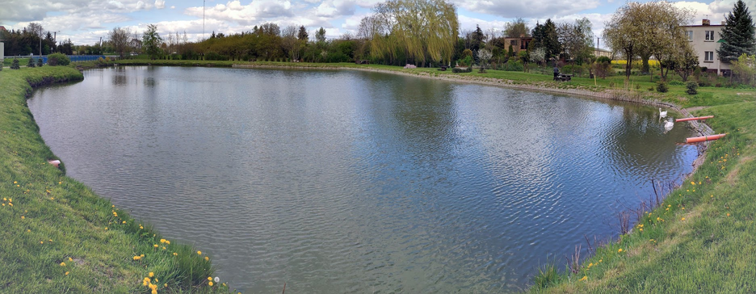
Fig. S1. Pond (WG) in the central part of the village at location F1
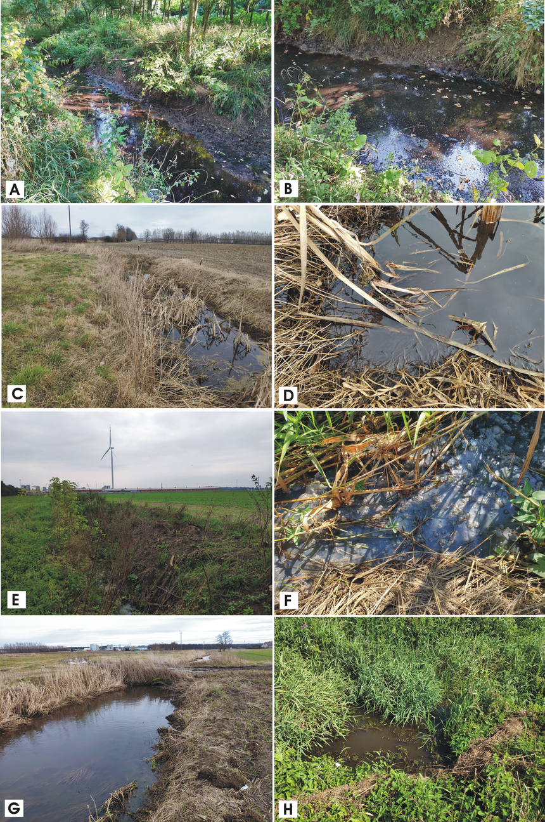
Fig. S2. Water sampling locations on the Pogona River: A&B – PN1; C&D – DP1; E&F – DP2; G&H – PN2
Tab. S2. Characteristics of livestock numbers and ammonia emissions in the analyzed farms at location F2
No. | Type of livestock | Animal stocking [heads] | Animal stocking [LSU]* | Average annual stock [heads] | Ammonia emission  [NH₃ t/year]
1 | American mink | 986 888 | 2 467 | 493 443 | 834
2 | American mink | 532 000 | 1 330 | 266 000 | 450
3 | Broiler chickens | 817 014 | 3 268 | 814 971 | 261
4 | Broiler chickens | 113 400 | 454 | 113 400 | 36.3
5 | Chicken poultry | 75 524 | 302 | 75 524 | 24.2
6 | Chicken poultry | 55 678 | 223 | 55 678 | 17.8
7 | Pigs | 7 172 | 1 004 | 7 172 | 38.9
8 | American mink | 83 600 | 209 | 41 800 | 70.6
LSU – livestock unit (1 = 500 kg]
Source: own calculations and summaries based on EIA Reports

Tab. S3. Extreme values ​​recorded in Polish rivers in 2003-2015
Parameter | Unit | Value
Parameter | Unit | min. | max.
pH | - | 4.3 | 9.1
Conductivity | mS/cm⁻¹ | 0.008 | 4.456
Alkalinity | mg CaCO₃/L⁻¹ | 20.0 | 585.0
Phosphates (PO₄) | mg/L⁻¹ | 0.005 | 27.5
P_{tot} | mg/L⁻¹ | 0.0033 | 11.9
N-NO₂ | mg/L⁻¹ | 0.0 | 0.9
N-NO₃ | mg/L⁻¹ | 0.0 | 28.0
N-NH₃ | mg/L⁻¹ | 0.0 | 53.6
N_{org} (N-NH₃) | mg/L⁻¹ | 0.2 | 25.8
N_{tot} | mg/L⁻¹ | 0.21 | 32.2
Dissolved oxygen (O₂) | mg/L⁻¹ | 0.4 | 14.0
Source: own research

Tab. S4 . Values of physicochemical parameters of the tested water in the pond at location F1 and the Pogona River and its tributaries (F2)
Parameter | Unit | WG |  | PN1 |  | DP1 |  | DP2 |  | PN2
Parameter | Unit | min. | max. | min. | max. | min. | max. | min. | max. | min. | max.
pH | - | 6.7 | 10 | 7.2 | 8.8 | 7.2 | 8.1 | 7.2 | 8.4 | 7.1 | 8.6
Conductivity | mS/cm⁻¹ | 0.945 | 2.92 | 0.968 | 1.437 | 0.238 | 1.911 | 0.708 | 4.05 | 1.092 | 1.516
Alkalinity | mg CaCO₃/L⁻¹ | 105 | 165 | 120 | 450 | 90 | 500 | 150 | 1500 | 300 | 700
Phosphates (PO₄) | mg/L⁻¹ | 0.04 | 2.8 | 0.03 | 3.65 | 5.6 | 16.8 | 0.13 | 35 | 0.48 | 8.05
P_{tot} | mg/L⁻¹ | 0.33 | 2.05 | 0.05 | 4.66 | 2.38 | 18 | 0.24 | 59.5 | 0.45 | 2.8
N-NO₂ | mg/L⁻¹ | 0.002 | 0.011 | 0.014 | 0.17 | 0.348 | 5.868 | 0.04 | 0.26 | 0.18 | 2.075
N-NO₃ | mg/L⁻¹ | 0.2 | 1.0 | 1.0 | 25.6 | 0.03 | 31.2 | 1.0 | 40.0 | 0.8 | 32
N-NH₃ | mg/L⁻¹ | 0.3 | 9.3 | 4.0 | 28.88 | 1.6 | 5.8 | 2.65 | 205 | 1.5 | 34
N_{org}  (N-NH₃) | mg/L⁻¹ | 3.1 | 24.86 | 3.8 | 13.68 | 2.18 | 5.96 | 0.15 | 195.4 | 0.48 | 5.77
N_{tot} | mg/L⁻¹ | 3.9 | 34.4 | 16.2 | 45.1 | 17.4 | 44.1 | 17.3 | 440.5 | 10.1 | 42.8
K | mg/L⁻¹ | 27.4 | 64.1 | 7.7 | 29.2 | 8.7 | 24.9 | 6.5 | 357.6 | 9.5 | 32.9
Ca | mg/L⁻¹ | 37.9 | 117.7 | 56.9 | 139.8 | 13.4 | 266 | 115.9 | 237.2 | 125.7 | 208.4
Na | mg/L⁻¹ | 69.7 | 163.0 | 25.4 | 95.3 | 4.9 | 157.6 | 16.3 | 268.0 | 33.8 | 110.8
Source: own research

Tab. S5. Groundwater parameters at the tested points in location F1
Parameter | Unit | P1 |  | P2 |  | P3 |  | P4 |  | P5
Parameter | Unit | min. | max. | min. | max. | min. | max. | min. | max. | min. | max.
pH | - | 7.2 | 7.7 | 7.2 | 7.8 | 7.2 | 7.8 | 5.7 | 7.6 | 7.23 | 8.16
Conductivity | mS/cm⁻¹ | 0.706 | 0.975 | 0.566 | 1.12 | 0.602 | 0.945 | 0.189 | 0.587 | 0.207 | 0.937
Alkalinity | mg CaCO₃/L⁻¹ | 220 | 890 | 170 | 1260 | 210 | 400 | 10 | 110 | 75 | 380
Phosphates (PO₄) | mg/L⁻¹ | 1.7 | 15.8 | 0.27 | 9.48 | 0.1 | 2.3 | 0.14 | 7.04 | 0.25 | 2.28
P_{tot} | mg/L⁻¹ | 0.6 | 13.33 | 0.15 | 17.44 | 0.22 | 1.17 | 0.1 | 2.51 | 0.15 | 2.31
N-NO₂ | mg/L⁻¹ | 0.004 | 5.02 | 0.004 | 1.135 | 0.012 | 0.44 | 0.002 | 0.014 | 0.004 | 0.108
N-NO₃ | mg/L⁻¹ | 0.4 | 38.0 | 1.0 | 24.0 | 3.9 | 14.8 | 0.2 | 1.2 | 0.2 | 3.8
N-NH₃ | mg/L⁻¹ | 4.8 | 53.3 | 0.95 | 46.0 | 0.3 | 1.75 | 0.4 | 3.55 | 0.45 | 8.1
N_{org}  (N-NH₃) | mg/L⁻¹ | 2.5 | 18.94 | 2.08 | 29.6 | 1.04 | 6.57 | 2.68 | 8.21 | 2.98 | 12.29
N_{tot} | mg/L⁻¹ | 23.36 | 76.3 | 10.81 | 76.64 | 8.4 | 18.31 | 4.6 | 12.16 | 5.80 | 15.05
K | mg/L⁻¹ | 29.7 | 91.5 | 3.0 | 88.1 | 3.4 | 5.9 | 6.3 | 26.5 | 2.94 | 10.9
Ca | mg/L⁻¹ | 44.6 | 130.1 | 38.7 | 193 | 48 | 149.6 | 23.5 | 86.1 | 27.5 | 140.7
Na | mg/L⁻¹ | 3.0 | 18.6 | 6.5 | 27.8 | 4.9 | 13.7 | 2.2 | 40.4 | 1.83 | 24.22
Source: own research
Tab. S6. Physicochemical parameters of well water at locations F1 and F2
Parameter | Unit | S1 |  | S2 |  | S3 | S4 |  | S5
Parameter | Unit | min. | max. | min. | max. | - | min. | max. | min. | max.
pH | - | 7.4 | 7.9 | 7.3 | 7.9 | 7.8 | 6.3 | 7.5 | 6.5 | 7.5
Conductivity | mS/cm⁻¹ | 0.973 | 1.404 | 0.774 | 1.05 | 0.979 | 0.55 | 0.56 | 1.003 | 1.028
Alkalinity | mg CaCO₃/L⁻¹ | 400 | 610 | 240 | 300 | 315 | 240 | 460 | 358 | 375
Phosphates (PO₄) | mg/L⁻¹ | 0.29 | 1.26 | 1.46 | 3.42 | 0.06 | 0.14 | 0.14 | 0.08 | 0.09
P_{tot} | mg/L⁻¹ | 0.16 | 0.58 | 0.6 | 1.64 | 0.11 | 0.07 | 0.07 | 0.05 | 0.29
N-NO₂ | mg/L⁻¹ | 0.003 | 0.836 | 0.004 | 0.016 | 0.006 | 0.006 | 0.007 | 0.008 | 0.018
N-NO₃ | mg/L⁻¹ | 0.2 | 4 | 4.2 | 6.6 | 0.4 | 0.2 | 1.4 | 1.5 | 3.1
N-NH₃ | mg/L⁻¹ | 0.34 | 1.2 | 0.19 | 0.49 | 0.43 | 0.43 | 0.45 | 0.14 | 0.58
N_{org}  (N-NH₃) | mg/L⁻¹ | 1.74 | 12.98 | 1.49 | 14.78 | 2.54 | 2.35 | 2.37 | 4.46 | 6.58
N_{tot} | mg/L⁻¹ | 2.4 | 17.1 | 7.0 | 21.8 | 3.4 | 3.0 | 4.2 | 6.5 | 9.8
K | mg/L⁻¹ | 62.6 | 200.5 | 14.2 | 22.3 | 7.3 | 8.8 | 10.3 | 19.9 | 21.0
Ca | mg/L⁻¹ | 41.3 | 132.7 | 53.8 | 160.2 | 118.6 | 76.3 | 209 | 88.7 | 208.4
Na | mg/L⁻¹ | 10.9 | 155.4 | 12.7 | 21.0 | 6.9 | 8.3 | 8.8 | 37.8 | 44.3
S1, S2 and S3 = F1 area; S4 and S5 = F2 area
Source: own research

Tab. S7. Parametry jakościowe opadów zarejestrowanych w lokalizacji F1 i F2
Parameter | Unit | R1 |  | R2 |  | R3 |  | R4
Parameter | Unit | min. | max. | min. | max. | min. | max. | min. | max.
pH | - | 6.5 | 8 | 5.5 | 8.8 | 5.4 | 7.5 | 6.4 | 8.8
Conductivity | mS/cm⁻¹ | 0.01 | 0.12 | 0.01 | 0.42 | 0.01 | 0.15 | 0.01 | 0.09
Alkalinity | mg CaCO₃/L⁻¹ | 5 | 45 | 10 | 205 | 5 | 70 | 10 | 15
Phosphates (PO₄) | mg/L⁻¹ | 0.02 | 0.64 | 0.04 | 51.2 | 0.06 | 1.7 | 0.01 | 0.15
P_{tot} | mg/L⁻¹ | 0.02 | 0.54 | 0.08 | 18.9 | 0.05 | 1.43 | 0.07 | 0.27
N-NO₂ | mg/L⁻¹ | 0.004 | 0.195 | 0.003 | 0.12 | 0.003 | 0.039 | 0.002 | 0.02
N-NO₃ | mg/L⁻¹ | 0.3 | 4.0 | 0.2 | 20.0 | 0.3 | 1.0 | 0.4 | 1.1
N-NH₃ | mg/L⁻¹ | 0.28 | 4.55 | 0.33 | 5.58 | 0.6 | 3.11 | 0.23 | 1.74
N_{org}  (N-NH₃) | mg/L⁻¹ | 2.2 | 10.6 | 2.4 | 44.8 | 2.1 | 19.1 | 3.1 | 18.2
N_{tot} | mg/L⁻¹ | 3.8 | 13.8 | 3.5 | 50.7 | 3.1 | 21.2 | 3.9 | 19.4
K | mg/L⁻¹ | 0.1 | 189.3 | 0.5 | 43.7 | 0.1 | 21.9 | 0.0 | 1.0
Ca | mg/L⁻¹ | 0.0 | 82.5 | 0.0 | 28.7 | 0.0 | 11.2 | 0.0 | 7.4
Na | mg/L⁻¹ | 0.0 | 18.4 | 0.2 | 11.2 | 0.0 | 2.7 | 0.0 | 33.3
R1. R2 and R3 = F1 area; R4 = F2 area
Source: own research

