Table 1 Components of the original modified SERVQUAL
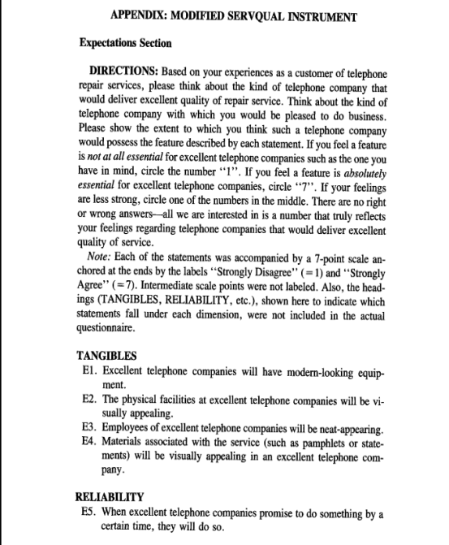

Table 1 Continued
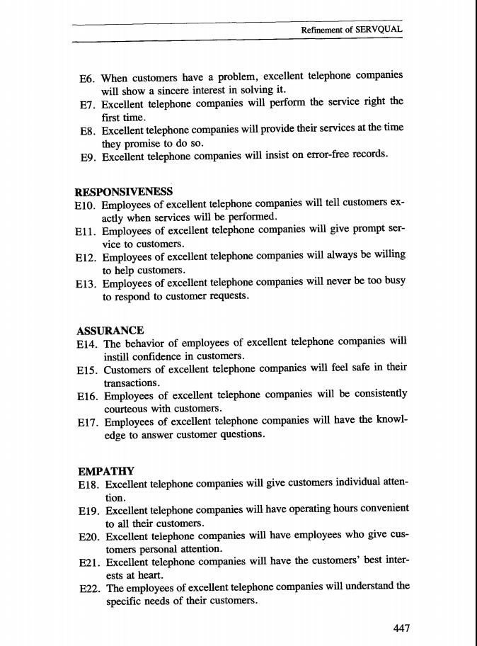
Table 1 Continued
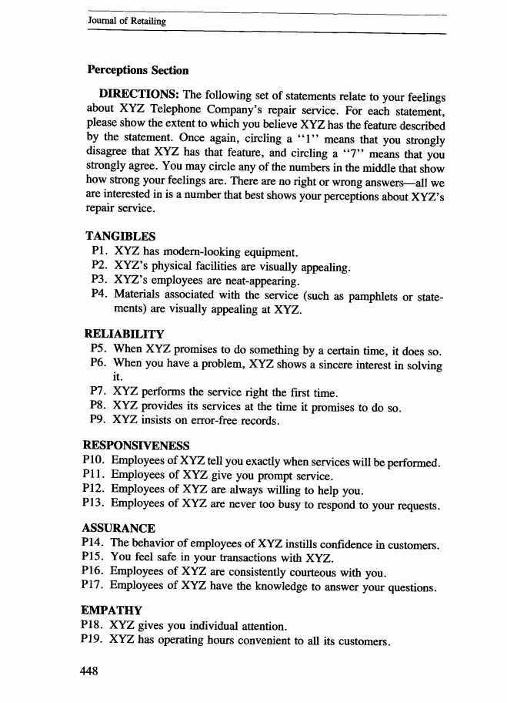

Table 1 Continued
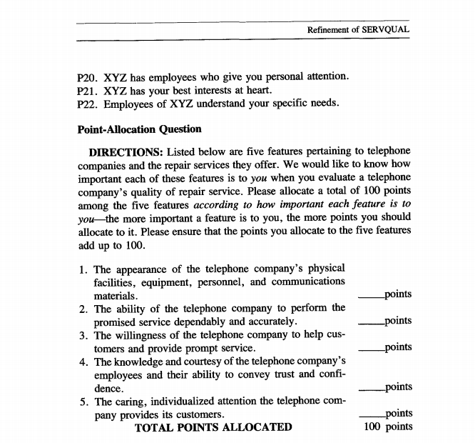

Table 2 Items of the SERVQUAL scale questionnaire used in our study
Expectation section | Perception section
Tangibles (physical facilities, equipment and appearance of personnel) | Tangibles (physical facilities, equipment and appearance of personnel)
E1. The Screening Centre will have modern-looking equipment. | P1. The Screening Centre has have modern-looking equipment.
E2. The Screening Centre‘s physical facilities will be visually appealing. | P2. The Screening Centre‘s physical facilities are visually appealing.
E3. The Screening Centre‘s workers will be neat-appearing. | P3. The Screening Centre‘s workers are neat-appearing.
E4. Materials associated with the service will be visually appealing. | P4. Materials associated with the service are visually appealing.
Reliability (ability to perform the promised service dependably and accurately) | Reliability (ability to perform the promised service dependably and accurately)
E5. When the Screening Centre promises to do something by a certain time, it will do so. | E5. When the Screening Centre promises to do something by a certain time, it does so.
E6. When the patient or you have a problem, the Screening Centre will show a sincere interest in solving it. | E6. When the patient or you have a problem, the Screening Centre shows a sincere interest in solving it.
E7. The Screening Centre will perform the service right the first time. | E7. The Screening Centre performs the service right the first time.
E8. The Screening Centre will provide its service at the time it promises to do so. | E8. The Screening Centre provides its service at the time it promises to do so.
E9. The Screening Centre will insist on error-free records. | E9. The Screening Centre insists on error-free records.
Responsiveness (willingness to help patients and families and provide prompt service) | Responsiveness (willingness to help patients and families and provide prompt service)
E10. Workers at the Screening Centre will tell you exactly when the care will be performed. | E10. Workers at the Screening Centre tell you exactly when the care will be performed.
E11. Workers at the Screening Centre will give the patient prompt care. | E11. Workers at the Screening Centre give the patient prompt care.
E12. Workers at the Screening Centre will always be willing to help you and the patient. | E12. Workers at the Screening Centre are always willing to help you and the patient.
E13. Workers at the Screening Centre will never be too busy to respond to the patient’s or your requests. | E13. Workers at the Screening Centre are never too busy to respond to the patient’s or your requests.
Assurance (including competence, courtesy, credibility and security) | Assurance (including competence, courtesy, credibility and security)
E14. The behavior of the workers at the ICU will instill confidence in the patient and the family. | E14. The behavior of the workers at the ICU instills confidence in the patient and the family.
E15. You will feel safe for the patient’s care by the Screening Centre. | E15. You feel safe for the patient’s care by the Screening Centre.
E16. Workers at the Screening Centre will be consistently courteous with the patient and the family. | E16. Workers at the Screening Centre are consistently courteous with the patient and the family.
E17. Workers at the Screening Centre will have the knowledge to answer your questions. | E17. Workers at the Screening Centre have the knowledge to answer your questions.
Empathy (caring and individualised attention that the Screening centre provides to its patients and families) | Empathy (caring and individualised attention that the Screening centre provides to its patients and families)
E18. The Screening Centre will give you and the patient individual attention. | E18. The Screening Centre gives you and the patient individual attention.
E19. The Screening Centre will have operating hours convenient to its patients and families. | E19. The Screening Centre has operating hours convenient to its patients and families.
E20. The Screening Centre will have workers who give the patient and the family personal attention. | E20. The Screening Centre has workers who give the patient and the family personal attention.
E21. The Screening Centre will have the best interest of the patient and the family at heart. | E21. The Screening Centre has the best interest of the patient and the family at heart.
E22. Workers at the Screening Centre will understand the special needs of the patient and the family. | E22. Workers at the Screening Centre understand the special needs of the patient and the family.

Table 3 Upper Gastrointestinal Cancer Screening Questionnaire
Measure | Description
Service Quality | Expectation section | Perception section
 | Tangibles (physical facilities, equipment and appearance of personnel) | Tangibles (physical facilities, equipment and appearance of personnel)
 | E1. The Screening Centre will have modern-looking equipment. | P1. The Screening Centre has have modern-looking equipment.
 | E2. The Screening Centre‘s physical facilities will be visually appealing. | P2. The Screening Centre‘s physical facilities are visually appealing.
 | E3. The Screening Centre‘s workers will be neat-appearing. | P3. The Screening Centre‘s workers are neat-appearing.
 | E4. Materials associated with the service will be visually appealing. | P4. Materials associated with the service are visually appealing.
 | Reliability (ability to perform the promised service dependably and accurately) | Reliability (ability to perform the promised service dependably and accurately)
 | E5. When the Screening Centre promises to do something by a certain time, it will do so. | P5. When the Screening Centre promises to do something by a certain time, it does so.
 | E6. When the patient or you have a problem, the Screening Centre will show a sincere interest in solving it. | P6. When the patient or you have a problem, the Screening Centre shows a sincere interest in solving it.
 | E7. The Screening Centre will perform the service right the first time. | P7. The Screening Centre performs the service right the first time.
 | E8. The Screening Centre will provide its service at the time it promises to do so. | P8. The Screening Centre provides its service at the time it promises to do so.
 | E9. The Screening Centre will insist on error-free records. | P9. The Screening Centre insists on error-free records.
 | Responsiveness (willingness to help patients and families and provide prompt service) | Responsiveness (willingness to help patients and families and provide prompt service)
 | E10. Workers at the Screening Centre will tell you exactly when the care will be performed. | P10. Workers at the Screening Centre tell you exactly when the care will be performed.
 | E11. Workers at the Screening Centre will give the patient prompt care. | P11. Workers at the Screening Centre give the patient prompt care.
 | E12. Workers at the Screening Centre will always be willing to help you and the patient. | P12. Workers at the Screening Centre are always willing to help you and the patient.
 | E13. Workers at the Screening Centre will never be too busy to respond to the patient’s or your requests. | P13. Workers at the Screening Centre are never too busy to respond to the patient’s or your requests.
 | Assurance (including competence, courtesy, credibility and security) | Assurance (including competence, courtesy, credibility and security)
 | E14. The behavior of the workers at the ICU will instill confidence in the patient and the family. | P14. The behavior of the workers at the ICU instills confidence in the patient and the family.
 | E15. You will feel safe for the patient’s care by the Screening Centre. | P15. You feel safe for the patient’s care by the Screening Centre.
 | E16. Workers at the Screening Centre will be consistently courteous with the patient and the family. | P16. Workers at the Screening Centre are consistently courteous with the patient and the family.
 | E17. Workers at the Screening Centre will have the knowledge to answer your questions. | P17. Workers at the Screening Centre have the knowledge to answer your questions.
 | Empathy (caring and individualised attention that the Screening centre provides to its patients and families) | Empathy (caring and individualised attention that the Screening centre provides to its patients and families)
 | E18. The Screening Centre will give you and the patient individual attention. | P18. The Screening Centre gives you and the patient individual attention.
 | E19. The Screening Centre will have operating hours convenient to its patients and families. | P19. The Screening Centre has operating hours convenient to its patients and families.
 | E20. The Screening Centre will have workers who give the patient and the family personal attention. | P20. The Screening Centre has workers who give the patient and the family personal attention.
 | E21. The Screening Centre will have the best interest of the patient and the family at heart. | P21. The Screening Centre has the best interest of the patient and the family at heart.
 | E22. Workers at the Screening Centre will understand the special needs of the patient and the family. | P22. Workers at the Screening Centre understand the special needs of the patient and the family.
Satisfaction | SAT1. I am satisfied with the screening service I received in this screening centre.
 | SAT2. My decision to visit this screening centre has been a wise one.
 | SAT3. The screening services I received corresponded to my current needs.
Behavioural intention | BI1. I will recommend other people to use the screening  services offered by this screening centre.
BI2. I will consider this screening centre my first choice if I need
medical services in the future.
 | BI3. I will tell other people good things about screening centre.
Discomfort | DIS13. The physician was [not] too rough when performing the screening.
 | DIS14. I [did not have] a lot of pain during the procedure.
 | DIS15. The procedure was more comfortable than I expected.
 | DIS16. I was [not] embarrassed by the procedure.
Baseline characteristics | BC1. Gender: 1. Male; 2. Female
 | BC2. Age:
 | BC3. Marital status: 1: Never married; 2: Married; 3: Separated (separated due to relationship discord); 4: Divorced; 5: Widowed
 | BC4. Highest Educational Degree: 1: No formal schooling; 2: Primary school; 3: Junior high school; 4: Senior high school (including secondary/technical school); 5: College; 6: Undergraduate; 7: Postgraduate and above; 99: Not available
 | BC5. Occupatipn: 1: Agricultural, forestry, livestock and fishery workers; 2: Workers; 3: Administrative and managerial staff; 4: Professional and technical staff (doctors, teachers, scientists); 5: Sales and service workers; 6: Domestic work; 7: Private owners; 8: Leaving/retired; 9: Non-working/lay-off; 10: Other or not easily classified;
 | BC6. Residence: 1: Rural; 2: Urban
 | BC7. Average annual household income (Yuan): 1: less than 10,000; 2: 1,000 ~ 29,000; 3: 3,000 ~ 49,000; 4: 5,000 ~ 69,000; 5: 7,000 ~ 89,000; 6: 9,000 ~ 109,000; 7: 11,000 ~ 199,000; 8: 200,000 and above
 | BC8. Health self-assessment：1.Very good; 2.Better; 3. General; 4. Poor
 | BC9. I was very anxious about having the procedure: 1.Yes; 2. No
 | BC10. Experience with endoscopy before: 1.Yes; 2. No
 | BC11. Time taken from home to our screening centre (minute): 1.Less than 30; 2. 30-60; 3. 60 and above
 | BC12. Purpose of participating in the screening: 1.Medical check-ups without disease; 2. Disease review
 | BC13. Experience of examination/visit at this Hospital before: 1.Yes; 2. No
 | B14. Do you have any common chronic diseases (hypertension, diabetes or hyperlipidemia) ?: 1.Yes; 2. No

