Nanoscale Imaging of Biomolecules using Molecule Anchorable Gel-enabled Nanoscale In-situ Fluorescence Microscopy

Authors
Aleksandra Klimas^{1±}, Brendan Gallagher^{1±}, Piyumi Wijesekara², Sinda Fekir^{3,4}, Donna B. Stolz⁵, Franca Cambi^{6,7}, Simon Watkins⁵, Alison L. Barth¹, Christopher I. Moore^{3,4}, Xi Ren², Yongxin Zhao¹⁺

Affiliations
¹Department of Biological Sciences, Carnegie Mellon University, Pittsburgh, Pennsylvania, USA. ²Department of Biomedical Engineering, Carnegie Mellon University, Pittsburgh, Pennsylvania, USA. ³Department of Cell Biology, Center for Biologic Imaging, University of Pittsburgh, Pittsburgh, Pennsylvania. ⁴Department of Neuroscience, Brown University, Providence, Rhode Island, USA. ⁵Carney Institute for Brain Science, Brown University, Providence, Rhode Island, USA. ⁶Center for Biologic Imaging, Department of Cell Biology, University of Pittsburgh, Pittsburgh, Pennsylvania ⁷Veterans Administration Pittsburgh, Pittsburgh, Pennsylvania. ⁸Department of Neurology/PIND, University of Pittsburgh, Pittsburgh, Pennsylvania, USA

±These authors contributed equally to this work
Aleksandra Klimas, Brendan Gallagher
⁺Correspondence to yongxinz@andrew.cmu.edu

Supplementary Note 1: Exploration of Anchoring and Homogenization Buffers
We gelled deparaffinized and antibody labeled FFPE kidney pieces with the MANGIFY monomer solution containing 0.05% (v/v) methacrolein (Supplementary Fig. 2a) allowing the samples to still be homogenized by proteinase K (ProK) digestion, which is typically used to ensure isotropic expansion in most ExM protocols.^{1,2} To quantify protein retention (Fig. 1d,e; Supplementary Fig. 2e; Supplementary Table 2), we compared average fluorescence of N-Hydroxysuccinimide (NHS) ester-dye conjugates, which bind to primary amines, before and after processing with the MAGNIFY protocol. To compare to previous protocols, FFPE kidney samples were prepared following the modified expansion pathology (ExPath) protocol.^{1,3} With this protocol, the samples were gelled in a monomer solution containing 15% (w/v) SA, 5% (w/v) AA, 0.1% (w/v) Bis, and 11.7% (w/v) NaCl along with 0.01% (w/v) 4HT, 0.2% (v/v) TEMED, and 0.2% (w/v) APS after overnight incubation with 0.05 mg/mL AcX. After homogenization with ProK digestion buffer (50 mM Tris (pH 8), 25 mM EDTA, 0.5% w/v TritonX, 0.8M NaCl, 2 units/mL ProK) for 3 hours at 60ºC, only 3.08 ± 0.46% s.e.m. (n = 9 technical replicates) of pre-expansion NHS fluorescence was observed (Fig. 1d). Meanwhile samples anchored with 0.05% (v/v) methacrolein using the MAGNIFY gel chemistry measured 14.54 ± 1.07% s.e.m. (n = 12 technical replicates) of pre-expansion NHS fluorescence (Fig. 1d) when homogenized under the same conditions. Similarly, for PFA fixed mouse brain tissue anchored with 0.1% (v/v) methacrolein or 0.05 mg/mL AcX using the MAGNIFY gel chemistry measured 6.19 ± 0.34% s.e.m. (n = 20 technical replicates) and 7.7% ± 0.41% s.e.m. (n = 20 technical replicates), respectively, retained fluorescence after 2 hours homogenization with ProK (Fig. 1d; Supplementary Table 2). Additionally, lipid retention between the two conditions was comparable for PFA fixed mouse brain tissue (Supplementary Fig. 2e; Supplementary Table 3), where lipid retention measured by retained fluorescence of DiD was 18.13 ± 0.44% s.e.m. (n = 20 technical replicates) and 17.06 ± 0.8% s.e.m. (n = 20 technical replicates) for 0.1% (v/v) methacrolein anchoring and AcX anchoring, respectively, after 2 hours homogenization with ProK.
To better preserve protein epitopes during expansion, we sought to replace the strong protease digestion of ProK. Protocols such as magnified analysis of the proteome (MAP)⁴ utilize a non-enzymatic surfactant based tissue denaturing solution, but we found this to be incompatible with both AcX and methacrolein based anchoring (Supplementary Fig. 2b). Pulling from the ExPath¹ protocol and clearing protocols such as CUBIC,⁵ we found that the addition of EDTA and urea, respectively, to a non-ionic surfactant based solution could adequately homogenize tissues and preserve biomolecules (Supplementary Figure 2c) while providing isotropic expansion. Indeed, both EDTA and urea were necessary to adequately homogenize samples anchored with methacrolein (Supplementary Figure 2d). Both AcX and methacrolein anchored FFPE kidney samples retained fluorescence after homogenizing using a non-ionic surfactant-based buffer (10% (w/v) SDS, 8M urea, 25 mM EDTA, 2x PBS pH 7.5 at RT) for 60 hours at 80 ºC (Fig. 1d; Supplementary Fig. 2e). AcX anchored samples retained 2.94 ± 0.57% s.e.m. (n = 14 technical replicates) NHS fluorescence which was comparable to the ProK homogenized samples. Meanwhile, samples anchored with 0.05% (v/v) methacrolein retained 13.63 ± 1.86% s.e.m. (n = 8 technical replicates) under the same conditions. Similarly, PFA fixed mouse brain tissue retained48.44 ± 1.49% s.e.m. (n = 20 technical replicates) and 12.82 ± 0.77% s.e.m. (n = 20 technical replicates) NHS fluorescence for 0.1% methacrolein and AcX anchored samples, respectively, when homogenized for 4 and 8 hours, respectively, at 80ºC (Fig. 1d; Supplementary Table 2). Under the same conditions, MAGNIFY showed improved lipid retention, where 0.1% (v/v) methacrolein anchored samples retained 98.10 ± 2.36% s.e.m. (n = 30 technical replicates) DiD fluorescence and AcX anchored samples retained 74.50 ± 2.47% s.e.m. (n = 20 technical replicates) after homogenizing for 4 and 8 hours, respectively in hot surfactant (Fig. 2a; Supplementary Fig. 2e; Supplementary Table 3).
To improve biomolecule retention, we found that increasing the methacrolein to 0.25% (v/v) for FFPE kidney samples preserved 58.54% ±7.08% s.e.m. (n = 14 technical replicates) of the NHS signal after homogenization for 60 hours at 80 ºC using a surfactant-based buffer (Supplementary Fig. 2e). Similar to methacrolein concentration, homogenization time was tissue-type dependent (Supplementary Table 1), where mechanically tougher and more heavily fixed tissues such as FFPE kidney took longer to homogenize compared to softer tissue such as PFA fixed mouse brain. We also found the expansion factor was dependent on methacrolein concentration, where both over and under anchoring led to smaller expansion factors (Supplementary Fig. 4) and the optimal methacrolein concentration was tissue-type dependent (Supplementary Table 1).

Supplementary Note 2: Exploration of Gel Chemistry
To optimize gel chemistry, we first attempted to replicate the X10 protocol,⁶ where N,N- dimethylacrylamide acid (DMAA) was used to obtain larger expansion factors. We first made a gelling solution of 26.7% (w/v) DMAA and 6.4% (w/v) SA was prepared in water. After dissolving, a 3.6% (w/v) stock solution of KPS was added to a final concentration 0.36% (w/v) KPS. After vortexing, TEMED (100% w/w) was added to a final concentration of 0.4% (v/v). To replicate ExPath gelling conditions, we chose to omit the nitrogen purging step. When applied to FFPE kidney pieces treated with AcX prior to gelling, incomplete expansion and non-isotropic expansion was observed in samples homogenized in a non-ionic surfactant-based buffer (10% (w/v) SDS, 8M urea, 25 mM EDTA, 2x PBS pH 7.5 at RT) for 60 hours at 80 ºC (Supplementary Fig. 2c). Additionally, these tissue gels were not mechanically sturdy and only had an expansion factor of ~6X when expanded in water (Supplementary Table 6; Supplementary Fig. 4).
To provide better expansion in a sturdy gel, we chose to supplement the ExPath gelling solution with a small amount of DMAA. To find the optimal gel composition, we varied DMAA, (SA, N,N′-Methylenebisacrylamide (Bis), and acrylamide (AA) concentrations and prepared blank gels and compared their expansion in water. From the rapid ExPath protocol, we knew increasing SA and AA concentrations provided a sturdier gel to compensate for the lower Bis concentration, which increased the expansion factor.³ We ultimately found a hydrogel formula composed of 4% (w/v) DMAA, 34% (w/v) SA, 10% (w/v) AA, and 0.01% (w/v) Bis (Supplementary Table 7) provided the optimal expansion factor and sturdiness to expand an array of tissue types. We also varied the initiator, ammonium persulfate (APS), and inhibitor, 4-hydroxy-TEMPO (4HT), concentrations and polymerized the blank gels at different temperatures and found that a slightly higher APS concentration and slightly lower 4HT concentration compared to the ExPath protocol in gels polymerized at 37 ºC provided the best expansion factor (Supplementary Table 8). It should also be noted the blank gel expansion factors are slightly smaller than that of the tissue-gel hydrogel due to different components contributed to the hydrogel by the tissue.
To test the mechanical sturdiness of the gel, we compared the MAGNIFY gel chemistry to other gels using the method developed for the Ten-fold Robust Expansion Microscopy (TREx) protocol (Supplementary Fig. 4, Supplementary Table 9).⁷ The TREx gel is comprised of 11% (w/v) SA, 14.5% (w/v) AA, 0.005-0.015% (w/v) Bis, and 1x PBS along with 0.15% (v/v) TEMED, and 0.15% (w/v) APS. Briefly, blank gels were made in a 2 mL Eppendorf tube and then cut into half cylinders. The gels were then expanded in water and the deformation index was calculated by taking the ratio of radius of deformation to the radius of the gel. For the TREx protocol, higher crosslinker concentrations (150 ppm Bis) compared to the reported values (50 and 90 ppm Bis) were needed to produce a deformation index less than 0.5. Although both the high crosslinker TREx gel and MAGNIFY had similar expansion factors (5.9× in water), MAGNIFY had a much lower deformation index of 0.03 compared to the 0.28 deformation index of the high crosslinker TREx gel.
Interestingly, the crosslinking provided by the DMAA also had an anchoring effect; FFPE kidney samples anchored with 0% (v/v) methacrolein (Supplementary Fig. 2c) retained 2.43 ± 0.83% s.e.m. (n = 8 technical replicates) and 4.40 ± 0.64% s.e.m. when homogenized for 60 hours at 80 ºC using a surfactant-based buffer and with ProK homogenization using this gel chemistry.

Supplementary Note 3: Use of SOFI with MAGNIFY
We chose to pair MAGNIFY with SOFI as SOFI can work on standard fluorophores⁸ images can be generated with under 100 time points⁸, and it has been shown to work on 3D datasets^{8,9}. SOFI was performed on expanded samples with custom MATLAB code, where images were corrected for drift, intensity and deconvolved (Lucy-Richardson method). The SOFI processing used in MAGNIFY-SOFI is based on CryoSOFI code¹⁰, but only second-order cross-correlation was performed and the code was modified to function in 3D (Supplemental Fig. 6). We noted that the axial resolution increase is limited as Z-planes were not captured simultaneously⁹.

Supplementary Tables
Supplementary Table 1: Condition optimization for different tissue types
Tissue Type | Fixation | Methacrolein | Hom. Time | Hom. Temp. | Expansion Factor
Human Kidney | FFPE | 0.25% | 60 h | 80C | 8.64± 0.24 (N = 4)*
Human Lymph Node | FFPE | 0.25% | 60 h | 80C | 8.46± 0.47 (N = 5)*
Human Tonsil | FFPE | 0.25% | 60 h | 80C | 8.62 ± 0.27 (N = 6)*
Human Colon | FFPE | 0.25% | 60 h | 80C | 9.67 ± 0.35 (N = 3)*
Human Thyroid | FFPE | 0.25% | 60 h | 80C | 10.75 ± 0.35 (N = 3)*
Human Prostate | FFPE | 0.25% | 60 h | 80C | 10.38 ± 0.57 (N = 3)*
Human Breast | FFPE | 0.25% | 60 h | 80C | 9.03 ± 0.22 (N = 3)*
Human Thymus | FFPE | 0.25% | 60 h | 80C | 10.00 ± 0.37 (N = 3)*
Human Brain | FFPE | 0.25% | 10 h | 80C | 8.36 ± 0.25 (N = 3)*
Human Lung | FFPE | 0.25% | 60 h | 80C | 10.77± 0.61 (N = 3)*
Human Liver | FFPE | 0.25% | 60 h | 80C | 10.13± 0.60 (N = 3)*
Human Uterus | FFPE | 0.25% | 60 h | 80C | 8.00 ± 0.28 (N = 3)*
Human Placenta | FFPE | 0.25% | 60 h | 80C | 8.75 ± 0.37 (N = 3)*
Human Skin | FFPE | 0.25% | 60 h | 80C | 9.39 ± 0.30 (N = 3)*
Mouse Brain | PFA | 0.1% | 8 h | 80C | 11.18 ± 1.87 (N = 3)*†
Lung Organoid | PFA | 0.1% | 8 h | 80C | 9.9 ± 2.1 (N=3)
* Error in terms of s.e.m. over N technical replicates.
† Mouse brain expansion factor was calculated by measuring different nuclei sizes in mouse striatum before and after expansion.

Supplementary Table 2: Protein Retention for tissues under different anchoring and homogenization conditions.
 | Anchoring |  | Homogenization |  | Protein Retention
Tissue | Type | Conc. | Type | Time | %Retention | SEM | N
Kidney | Methcarolein | 0.25% | Surfactant | 60h | 61.99 | 6.66 | 13
Kidney | Methcarolein | 0.05% | Surfactant | 60h | 13.63 | 1.86 | 8
Kidney | Methcarolein | 0.00% | Surfactant | 60h | 2.42 | 0.28 | 8
Kidney | AcX | 0.05 mg/mL | Surfactant | 60h | 2.94 | 0.57 | 14
Kidney | Methcarolein | 0.05% | ProK | 3h | 14.54 | 1.07 | 12
Kidney | AcX | 0.05 mg/mL | ProK | 3h | 3.08 | 0.46 | 9
Brain | Methcarolein | 0.10% | Surfactant | 4h | 48.44 | 1.49 | 20
Brain | Methcarolein | 0.10% | Surfactant | 8h | 23.76 | 0.69 | 20
Brain | Methcarolein | 0.10% | Surfactant | 12h | 25.56 | 1.62 | 20
Brain | Methcarolein | 0.10% | Surfactant | 16h | 14.20 | 1.06 | 20
Brain | Methcarolein | 0.10% | Surfactant | 24h | 8.09 | 0.47 | 20
Brain | AcX | 0.05 mg/mL | Surfactant | 8h | 12.82 | 0.77 | 20
Brain | Methcarolein | 0.10% | ProK | 2h | 6.19 | 0.34 | 20
Brain | AcX | 0.05 mg/mL | ProK | 2h | 7.72 | 0.41 | 20
Organoid | Methacrolein | 0.10% | Surfactant | 8h | 76.23 | 8.46 | 13
* Error in terms of s.e.m. over N technical replicates.

Supplementary Table 3: Lipid retention in mouse brain under different anchoring and homogenization conditions.
Anchoring |  | Homogenization |  | Lipid Retention
Type | Concentration | Type | Time | %Retention | SEM | N
Methcarolein | 0.10% | Surfactant | 4h | 98.10 | 2.36 | 30
Methcarolein | 0.10% | Surfactant | 8h | 77.05 | 1.80 | 20
Methcarolein | 0.10% | Surfactant | 12h | 73.23 | 2.99 | 20
Methcarolein | 0.10% | Surfactant | 16h | 63.60 | 3.06 | 20
Methcarolein | 0.10% | Surfactant | 24h | 43.07 | 3.06 | 20
AcX | 0.05 mg/mL | Surfactant | 8h | 74.50 | 2.47 | 20
Methcarolein | 0.10% | ProK | 2h | 18.13 | 0.54 | 20
AcX | 0.05 mg/mL | ProK | 2h | 17.06 | 0.80 | 20
* Error in terms of s.e.m. over N technical replicates.

Supplementary Table 4: Validated Primary Antibodies and fluorescent labels for Pre and Post MAGNIFY Staining
Host | Target | Vendor | Catalog Number
Chicken | GFAP | Abcam | ab4674
Chicken | NeuN | Millipore | ABN91
Chicken | Tyrosine Hydroxalase | Abcam | ab76442
Chicken | Vimentin | Abcam | ab24525
Chicken | Vimentin | Abcam | ab24525
Goat | PSD-95 | Abcam | ab12093
Goat | CD4 | R&D Systems | AF-379-SP
Goat | Talin-1 | Novus | AF5456-SP
Mouse | Anti-Actin, α-Smooth Muscle | Sigma Aldrich | A5228
Mouse | Bassoon | Abcam | ab82958
Mouse | Cytokeratin Pan Type I/II | Invitrogen | MA5-13156
Mouse | Synaptophysin | Invitrogen | MA1-213
Mouse | CD11c | Abcam | ab11029
Mouse | CD4 | Origene | UM870010
Mouse | CD8 | Invitrogen | MA1-80231
Mouse | CD8a (Alexa 488) | Invitrogen | 53-0008-82
Mouse | VDACI | Abcam | ab14734
Rabbit | ACTN4 | Sigma Aldrich | HPA001873
Rabbit | Alpha-Internexin (INA) | Sigma Aldrich | HPA008057
Rabbit | Amyloid Precursor Protein (APP) | Sigma Aldrich | HPA001462
Rabbit | Anti-ATPase Inhibitory Factor 1 (ATPIF1) | Millipore | ABC137
Rabbit | GABRA1 | Proteintech | 12410-1-AP
Rabbit | GABRB1 | Proteintech | 20183-1-AP
Rabbit | GluR2 | Proteintech | 11994-1-AP
Rabbit | Synaptophysin | Proteintech | 17785-1-AP
Rabbit | CCR5 | Proteintech | 17476-1-AP
Rabbit | CD45 | Abcam | ab10558
Rabbit | IL2 | Proteintech | 26156-1-AP
Rabbit | IL-6 | Proteintech | 21865-1-AP
Rabbit | TCR alpha Antibody | Novus | NBP2-52684
 | Wheat Germ Agglutinin (WGA) CF640R | Biotium | 29026
 | NHS-ATTO-488 | Sigma Aldrich | 41698
 | NHS-ATTO-532 | Sigma Aldrich | 88793
 | Succinimidyl Ester (NHS) CF 555 | Biotium | 92130
 | Vybrant™ DiD cell-labeling solution | Invitrogen | V-22887
 | Vybrant™ DiO cell-labeling solution | Invitrogen | V-22886
 | Lycopersicon Esculentum (Tomato) Lectin (LEL) | Vector Labs | DL-1174-1

Supplementary Table 5: Secondary antibodies used for pre- and post-MAGNIFY staining.
Reactivity | Host | Conjugate | Vendor | Catalog Number
Rabbit | Goat | DyLight550 | Invitrogen | SA5-10033
Rabbit | Goat | CF555 | Biotium | 20232
Rabbit | Goat | Alexa Fluor 488 | Invitrogen | A11034
Rabbit | Goat | CF640R | Biotium | 20202
Rabbit | Donkey | CF488A | Biotium | 20015
Mouse | Goat | Alexa Fluor 488 | Invitrogen | A11001
Mouse | Goat | CF568 | Biotium | 20301
Mouse | Donkey | CF555 | Biotium | 20037
Mouse | Donkey | CF640R | Biotium | 20177
Chicken | Goat | Alexa Fluor 488 | Invitrogen | A11039
Chicken | Goat | DyLight 488 | Invitrogen | SA5-10070
Chicken | Goat | DyLight 550 | Invitrogen | SA5-10033
Chicken | Goat | CF488A | Biotium | 20020
Chicken | Goat | CF555 | Biotium | 20034
Chicken | Goat | CF640 | Biotium | 20084
Goat | Donkey | CF647 | Biotium | 20829
Streptavidin |  | CF 640 | Biotium | 292037

Supplementary Table 6: Comparison of expansion factors for different hydrogel chemistries for different tissue types.
Components Concentrations |  |  |  |  |  |  | Expansion Factor
DMAA | SA | AA | Bis | NaCl | PBS | Anchoring | Human Kidney | Mouse Brain
4 | 34 | 10 | 0.01 | 1 | 1 | Methacrolein | 8.14 | 10.6
0 | 15 | 5 | 0.05 | 11.7 | 1 | AcX | 5.54 | N/A
26.7 | 6.4 | 0 | 0 | 0 | 0 | AcX | 6.03 | N/A
*PBS given in terms of 1x PBS concentration. N,N-Dimethylacrylamide (DMAA), Sodium acrylate (SA), Acrylamide (AA), N,N′-Methylenebisacrylamide (Bis), NaCl given in terms of w/v%.

Supplementary Table 7: Exploration of different hydrogel chemistries and their respective expansion factors of blank gels in water.
Components Concentrations
DMAA | SA | AA | Bis | NaCl | PBS | APS | 4HT | Ex Factor
1.5 | 37 | 15 | 0.01 | 1 | 1 | 1:50 | 1:500 | 6.5 (n=2)
2 | 34 | 10 | 0.01 | 1 | 1 | 1:30 | 0 | 7.76
2 | 34 | 10 | 0.01 | 1 | 1 | 1:50 | 1:500 | 7.5 (n=2)
4 | 30 | 10 | 0.01 | 1 | 1 | 1:30 | 0 | 6.45
4 | 34 | 10 | 0.01 | 1 | 1 | 1:30 | 0 | 7.86
4 | 33 | 10 | 0.01 | 1 | 1 | 1:50 | 1:500 | 7.5 (n=2)
8 | 30 | 10 | 0.01 | 1 | 1 | 1:30 | 0 | 7.46
0 | 15 | 5 | 0.05 | 11.7 | 1 | 1:30 | 0 | 6.5
0 | 8.6 | 2.5 | 0.075 | 11.7 | 1 | 1:30 | 0 | 6
*PBS given in terms of 1x PBS concentration. N,N-Dimethylacrylamide (DMAA), Sodium acrylate (SA), Acrylamide (AA), N,N′-Methylenebisacrylamide (Bis), NaCl given in terms of w/v%.

Supplementary Table 8: Gelling Conditions for MAGNIFY Gel.
Temp | APS | 4HT | Ex Factor
45C | 1:50 | 1:500 | 7
45C | 1:40 | 1:500 | 8
45C | 1:30 | 1:500 | 8
45C | 1:50 | 1:250 | 7
45C | 1:40 | 1:250 | 8
45C | 1:30 | 1:250 | 7.5
37C | 1:50 | 1:500 | 8
37C | 1:40 | 1:500 | 8.5
37C | 1:30 | 1:500 | 8
37C | 1:50 | 1:250 | 7.5
37C | 1:40 | 1:250 | 8
37C | 1:30 | 1:250 | 7

Supplementary Table 9: Deformation testing of different gel chemistries
Gel
 | DMAA | SA | AA | Bis | NaCl | PBS | Deformation |  | EF | N
MAGNIFY | 4 | 34 | 10 | 0.01 | 1 | 1 | 0.03± 0.01 |  | 5.9±0.28 | 4
TREx (Low Bis) | 0 | 11 | 14.5 | 0.005 | 0 | 1 | N/A
TREx (Med. Bis) | 0 | 11 | 14.5 | 0.009 | 0 | 1 | 0.51± 0.10 |  | 6.6±0.10 | 4
TREx (High Bis) | 0 | 11 | 14.5 | 0.015 | 0 | 1 | 0.28± 0.09 |  | 5.9±0.27 | 3
ExPath | 0 | 15 | 5 | 0.05 | 11.7 | 1 | 0.04± 0.02 |  | 4.3±0.14 | 4
*Errors given in terms of s.e.m.
**PBS given in terms of 1x PBS concentration. N,N-Dimethylacrylamide (DMAA), Sodium acrylate (SA), Acrylamide (AA), N,N′-Methylenebisacrylamide (Bis), NaCl given in terms of w/v%.

Supplementary Table 10: Gelling Solution Recipe
Component | Stock Concentration* | Amount (mL) | Final Concentration
N,N-dimethylacrylamide (DMAA) |  | 0.416 | 4
Sodium acrylate (SA) | 50 | 6.8 | 34
Acrylamide | 66.7 | 1.499 | 10
N,N′-Methylenebisacrylamide | 2 | 0.05 | 0.01
Sodium chloride | 30 | 0.333 | 1
PBS | 10x | 1 | 1x
Total Volume |  | 10 mL
* Note All concentrations given in g/100 mL except PBS

Supplementary Table 11: List of Chemicals and Reagents
Step | Reagent | Acronym | Vendor | Catalog Number
Gelling | N,N-dimethylacrylamide | DMAA | Sigma Aldrich | 274135
 | Sodium acrylate | SA | AK Scientific | R624
 | Sodium acrylate | SA | Santa Cruz Biotechnology | sc-236893B
 | Acrylamide | AA | Sigma Aldrich | A8887
 | N,N′-Methylenebisacrylamide | BIS | Sigma Aldrich | M7279
 | 4-hydroxy-TEMPO | 4HT | Sigma Aldrich | 176141
 | Sodium chloride | NaCl | Sigma Aldrich | S6191
 | Phosphate Buffered Saline, 10x Solution | PBS | Fischer Scientifc | BP399-1
 | Acryloyl-X, SE | AcX | Invitrogen | A20770
 | Ammonium persulfate | APS | Sigma Aldrich | A3678
 | N,N,N′,N′-Tetramethylethylenediamine | TEMED | Sigma Aldrich | T9281
 | Methacrolein |  | Sigma Aldrich | 133035
Homogenizing | Ethylenediaminetetraacetic acid 0.5 M | EDTA | VWR | BDH7830-1
 | Triton X-100 |  | Sigma Aldrich | T8787
 | Tris Base |  | Fischer Scientifc | BP152-1
 | Sodium chloride | NaCl | Sigma Aldrich | S6191
 | Proteinase K (Molecular Biology Grade) | ProK | Thermo Scientific | EO0491
 | Phosphate Buffered Saline, 10x Solution | PBS | Fischer Scientifc | BP399-1
 | Sodium dodecyl sulfate | SDS | Sigma Aldrich | L3771
 | Urea |  | Sigma Aldrich | U5378
Other | Sodium citrate tribasic dihydrate |  | Sigma Aldrich | C8532-1KG
 | Xylenes |  | Sigma Aldrich | 214736
 | Ethanol |  | Pharmco | 111000200
 | SuperBlock Bloacking Buffer in PBS |  | Thermo Scientific | 37515
 | Heparin |  | Sigma Aldrich | H3393
 | DAPI |  | Thermo | 62248

Supplementary Figures
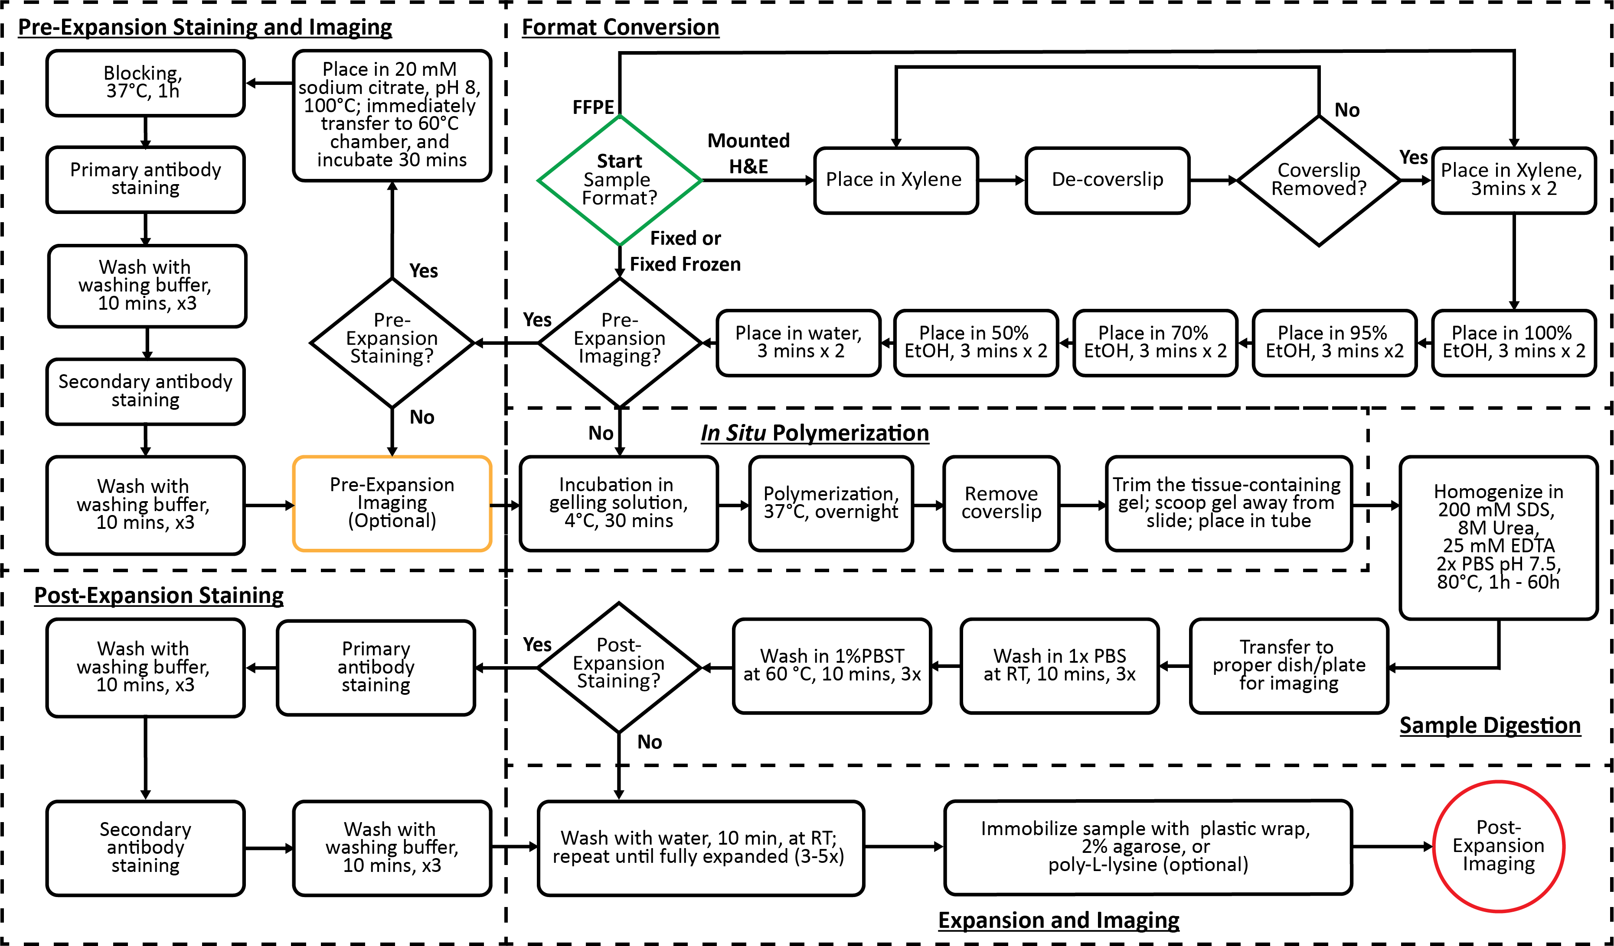
Supplementary Figure 1: The full workflow for MAGNIFY.

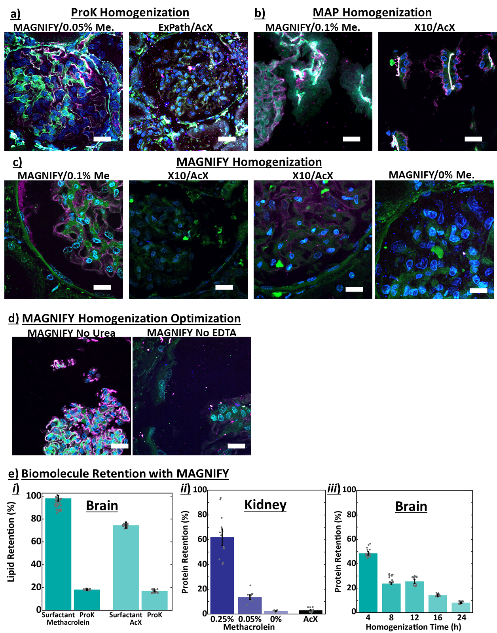

Supplementary Figure 2 Comparison of anchoring, homogenization, and gelling strategies. (a) Deparaffinized and stained FFPE kidney samples were gelled according to the MAGNIFY or ExPath protocols and were incubated in the ExPath homogenization buffer (50 mM Tris pH 8, 25 mM EDTA, 0.5% w/v TritonX, 0.8M NaCl) with Proteinase K diluted by 1:200 (final concentration 4 units/mL) for 3 hours at 60 °C. Final expansion factors: 4.2 (MAGNIFY) and 3.3 (ExPath). (b) Kidney samples prepared with the MAGNIFY protocol anchored with 0.1% (v/v) methacrolein, X10 protocol anchored with AcX, and the MAGNIFY protocol showed severe cracking due to incomplete homogenization when expanded in water after homogenizing for 60h at 80°C in the MAP homogenization buffer (200 mM SDS, 200 mM NaCl, and 50 mM Tris in water pH 9 at RT). (c) Samples prepared with the MAGINFY protocol anchored with 0.1% (v/v) methacrolein, ExPath protocol anchored with AcX, and the x10 protocol anchored with AcX could be expanded in water after homogenization using a non-ionic surfactant buffer (10% w/v SDS, 8M Urea, 25 mM EDTA, 2x PBS, pH 7.5 at RT) for 60h at 80°C. However, the x10 prepared samples had less even homogenization and smaller expansion compared to the MAGNIFY sample. Some anchoring is present in samples without an anchoring agent, most likely due to the crosslinking capability of DMAA. Optimal anchoring was observed in 0.25% (v/v) methacrolein anchored kidney samples. Expansion factors: 7.9 (MAGNIFY/0.1%Me.) and 6.0 (X10). (d) When urea or EDTA were removed from the non-ionic surfactant buffer, insufficient homogenization led to incomplete expansion and severe cracking in FFPE kidney samples homogenized for 60h at 80°C. Gels were expanded in water and representative maximum intensity projection images were obtained at 10x magnification. Scale bar 100 mm (absolute scale) Blue DAPI, green NHS, magenta WGA. (e) Protein and Lipid retention for mouse brain and human kidney. (i) Lipid retention measured as DiD fluorescence retention for mouse brain homogenized in surfactant versus ProK for tissues anchored with 0.1% methacrolein or AcX. N = 20 technical replicates. Error bars in terms of s.e.m. (ii) Protein retention of human kidney measured as NHS fluorescence retention processed with MAGNIFY versus ExPath and anchored with different conditions and homogenized in hot surfactant for 60 hours. N = 13, 8, 8, and 9 technical replicates. (iii) Protein retention of mouse brain measured as NHS fluorescence retention processed with MAGNIFY and anchored with 0.1% methacrolein and homogenized in hot surfactant over time. N = 20 technical replicates.
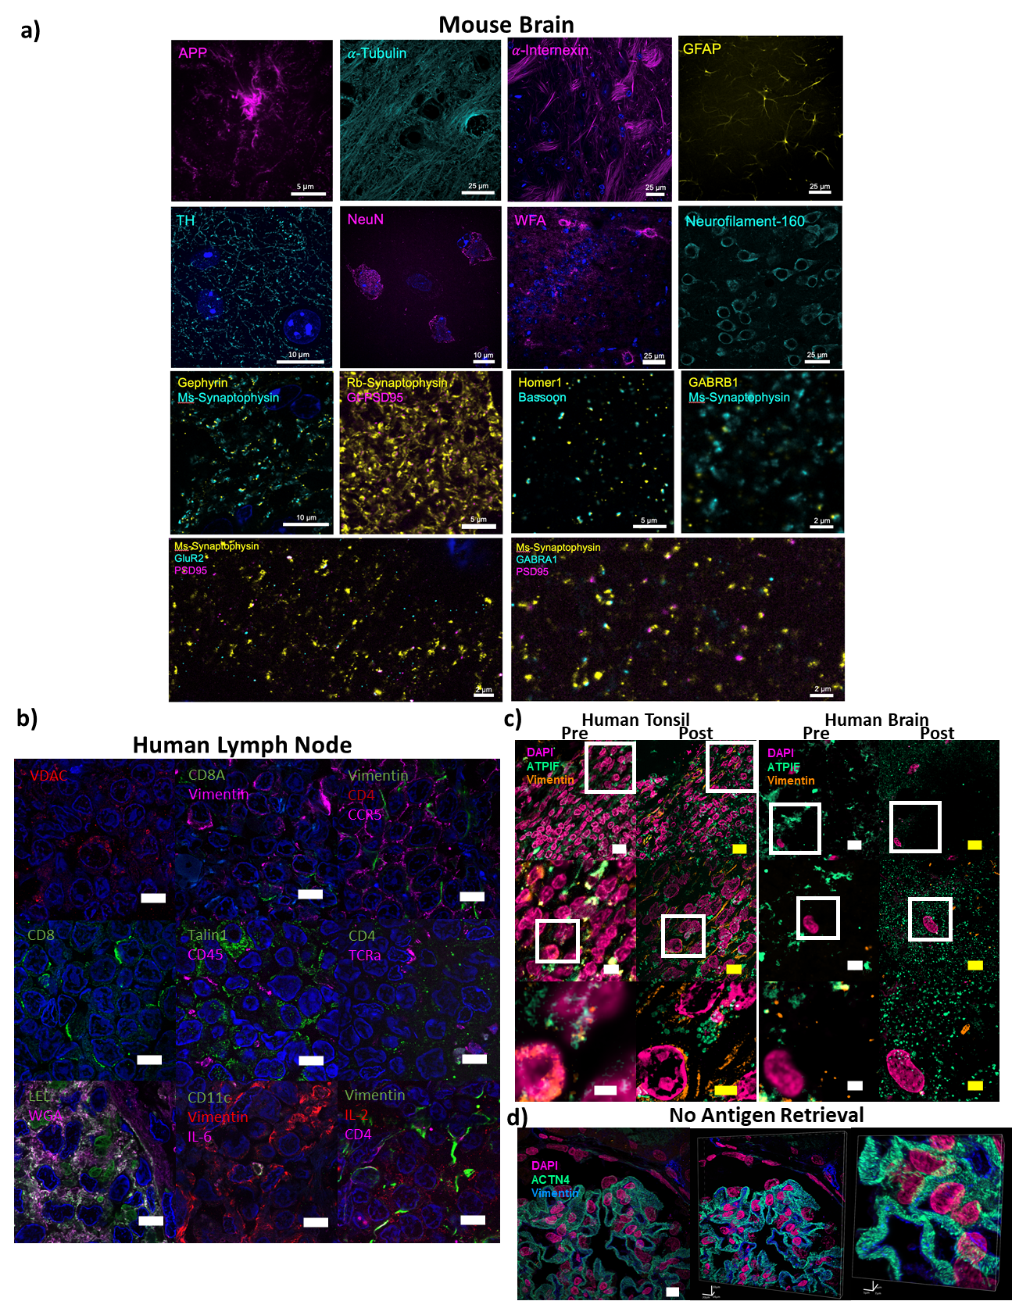

Supplementary Figure 3: Examples of Post Expansion Staining with MAGNIFY. (a) Paraformaldehyde-fixed 30µm mouse brain sections were gelled according to the MAGNIFY protocol using 0.1%-1% (v/v) methacrolein and were homogenized using a non-ionic surfactant buffer (10% w/v SDS, 8M Urea, 5-25 mM EDTA, 1-2x PBS, pH 7.5 at RT) for 4-8h at 80°C. After expansion, samples were stained with indicated primary antibodies in 1x PBS overnight. After washing, samples were stained with DAPI and relevant secondary antibodies. After staining, samples were washed in 1x PBS and imaged at 10x (APP, GFAP, WFA, Neurofilament-160) or 40x (𝛼-Tubulin, 𝛼-Internexin, TH, NeuN, all synaptic markers) magnification. Blue, DAPI. (b) Deparaffinized human lymph node samples purchased from US Biomax were gelled according to the MAGNIFY protocol using 0.1% (v/v) methacrolein and were homogenized using a non-ionic surfactant buffer (10% w/v SDS, 8M Urea, 5-25 mM EDTA, 1-2x PBS, pH 7.5 at RT) for 26-32h at 80°C. After expansion, samples were stained with indicated primary antibodies in staining buffer overnight. After washing, samples were stained with DAPI and relevant secondary antibodies. After staining, samples were washed in 1xPBS and imaged at 40x magnification. Scale bar 50 um (absolute scale) Blue DAPI. (c) MAGNIFY improves post expansion staining. Human tonsil (left) and brain (right) FFPE samples were imaged at 40x (top left, scale bar 10 μm, middle left scale bar 5μm, bottom left scale bar 2 μm). The white box indicates the field of view of the higher magnification images. The samples were then processed with the MAGNIFY protocol, and the same fields of view were imaged post-expansion in water at 10x (top right, scale bar, 10 μm biological scale) and 40x (middle right scale bar 5μm, bottom right scale bar 2 μm; biological scale). Post expansion images were projected over 4-17 z slices. Expansion factors in water were8.04× (tonsil), 8.36× (brain). Staining of ATIPF and vimentin improve with post expansion staining. Magenta, DAPI; Green, ATPIF; Orange, Vimentin. (d) MAGNIFY does not require antigen retrieval. MAGNIFY protocol achieves good post expansion staining without the need for antigen retrieval pre-expansion. Scale bar 25 μm (absolute scale). Foot processes in kidney podocytes can still be resolved. Magenta, DAPI; Green, ACTN4, Blue, Vimentin.

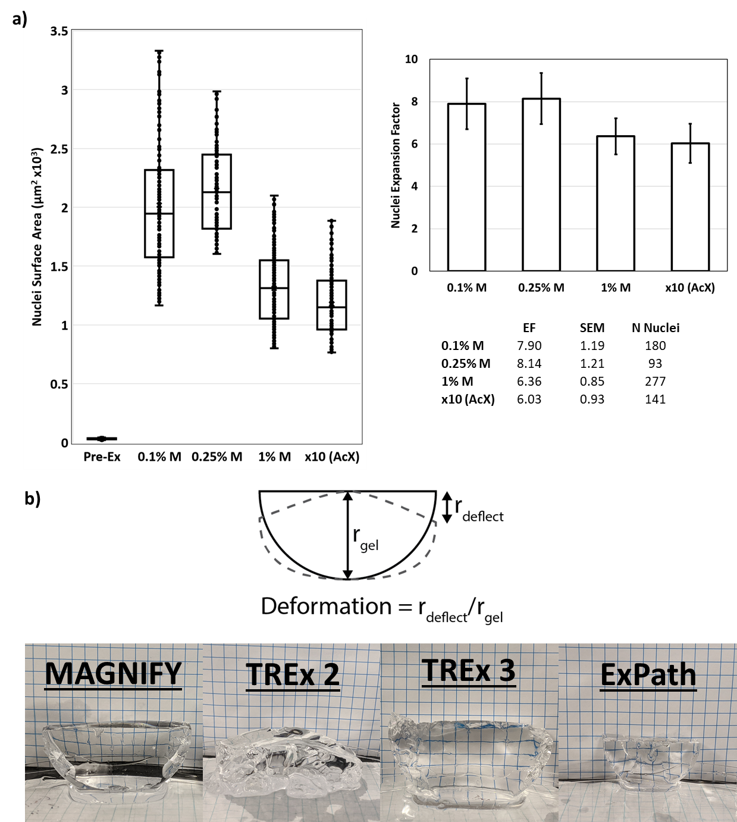
Supplementary Figure 4: Exploration and characterization of MAGNIFY gel chemistry. (a) Estimation of Expansion Factors for Gelling and Anchoring Strategies. Kidney samples prepared with the x10 protocol or MAGNIFY with different methacrolein concentrations. All samples were homogenized for 60 hours at 80 °C. (b) Measurement of Deformation of different gel chemistries. Blank gels were prepared in 2 mL Eppendorf tubes and gelled at 37 °C or 45 °C and fully expanded in water. Deformation was calculated in the same method described in the TREx paper⁷, by taking the ratio of the radius of deformation to the radius of the gel. Squares are 5 mm.

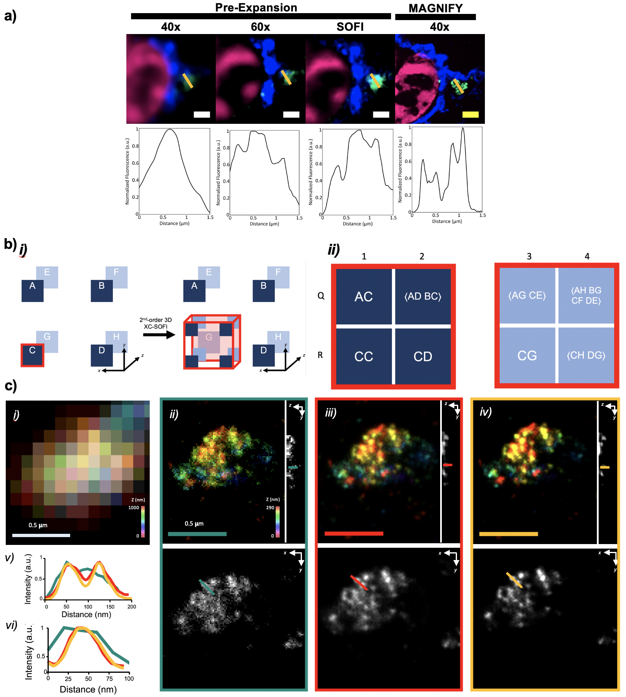Supplementary Figure 5: Overview of SOFI (a) Second-order SOFI improves resolution pre-expansion. Top: Placenta tissue imaged pre-expansion at both 40x and 60x and post-expansion at 40x. Bottom: line profile of ATPIF channel indicated by orange line. 60x images were generated by performing a maximum intensity projection over 50 time points. This same set of images at 60x was processed using second-order SOFI with deconvolution. Resolution is seen to improve. Post-expansion images of the MAGNIFY processed sample show greater resolution enhancement. Scale bar: 1 μm (post-expansion 8.75 μm). Magenta: DAPI, Green: ATPIF, Blue: Pan-Keratin. (b) Generation of 3D XC-SOFI images (i). Each pixel in the original image becomes eight in the 2nd – order 3D XC-SOFI image by calculating its correlation with neighboring pixels. (ii). The generation of each new pixel in the 2nd – order 3D XC-SOFI image is given. For example, New Pixel R1 is given by calculating the autocorrelation of Pixel C in the original image, while New Pixel R2 is given by calculating the correlation between Pixels C and D. The values of New Pixels Q2, Q3, Q4, and R4 were calculated by averaging the correlations of multiple sets of Original Pixels. (c) Three-dimensional resolution improvement with MAGNIFY-SOFI. (i). A color-coded Z-projection of a pre-synapse stained for synaptophysin in a mouse brain before MAGNIFY. (ii). A separate synaptophysin stained pre-synapse in a mouse brain after MAGNIFY. Top: Color-coded Z-projection of the synapse. Individual presynaptic vesicles are beginning to be resolved. Right: YZ view of the pre-synapse. Green line demarcates where line profile in (vi) is taken. Bottom: Single XY plane of the synapse. Green line demarcates where line profile in (v) is taken. (iii). As in (ii) but after 2nd-order 3D XC-SOFI. (iv). As in (ii) but after 3rd-order 3D XC-SOFI. (v). XY intensity line profiles showing increased resolving power of MAGNIFY-SOFI. (vi). YZ intensity line profiles showing increased resolving power of MAGNIFY-SOFI.

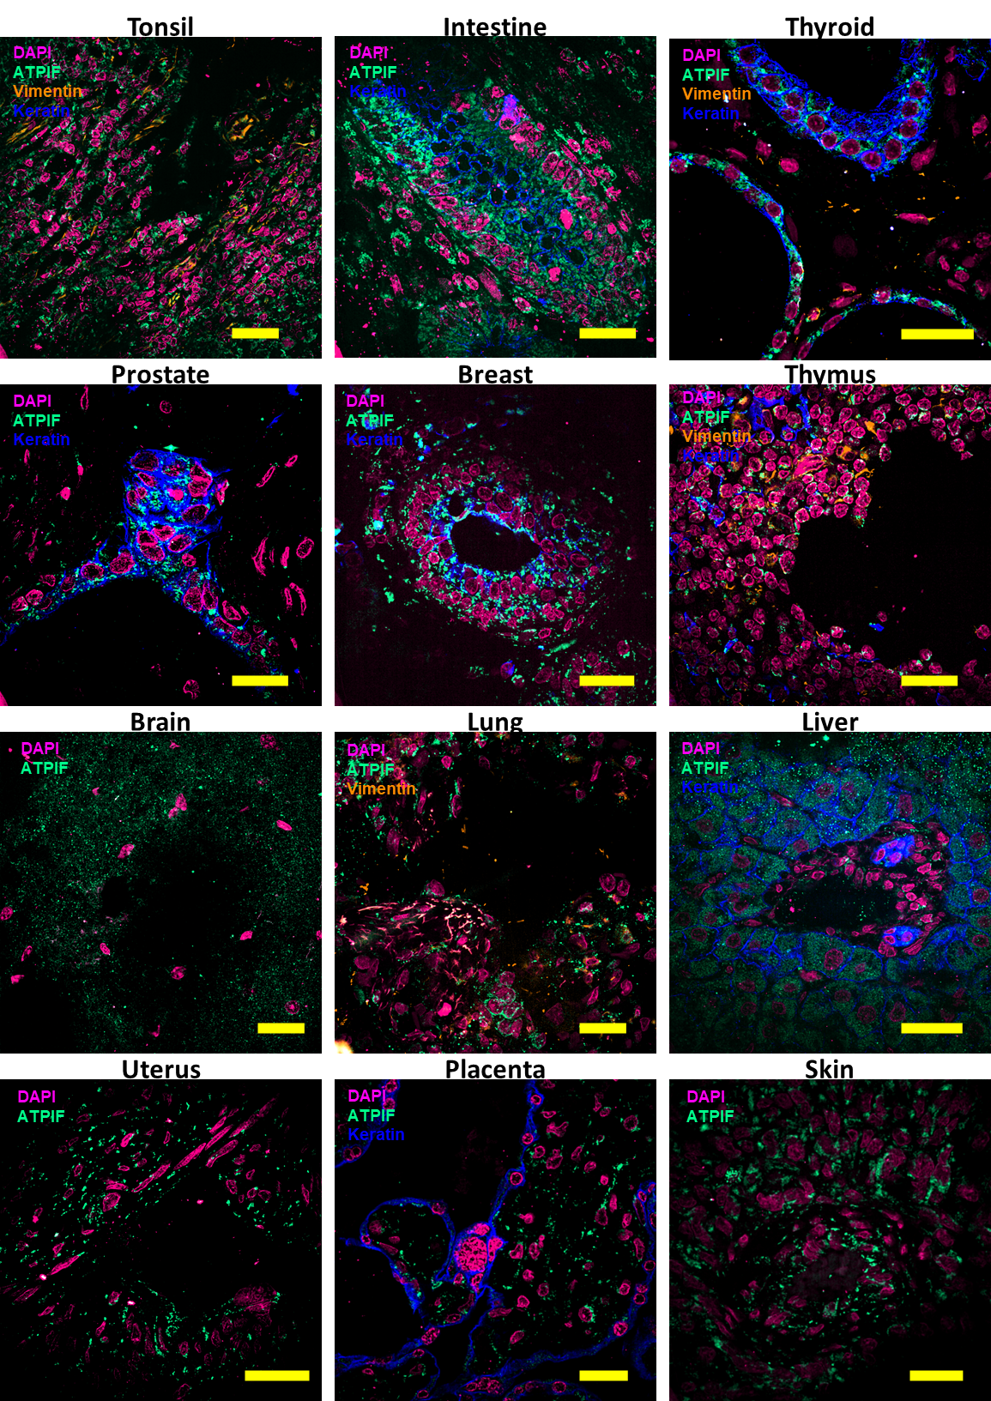
Supplementary Figure 6: Successful expansion of multiple human tissue types processed using the MAGNIFY framework. Images were obtained at 10× magnification. Scale bars are 25 μm (biological scale). Expansion factors are given in Supplementary Table 1.
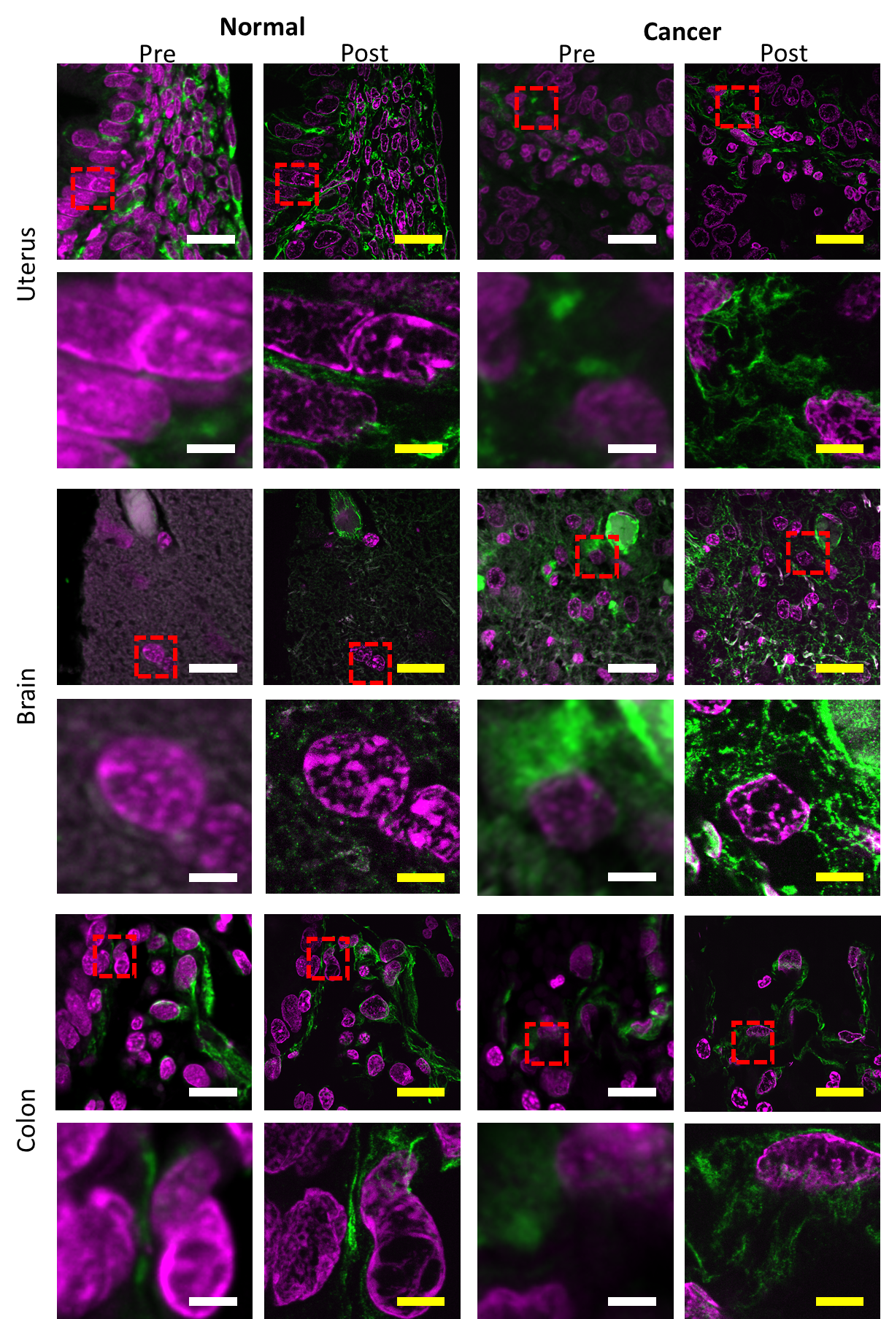
Supplementary Figure 7: Images of various tissue types for both normal (left images) and cancerous (right images) human tissues. From top to bottom, different rows show different tissue types as labeled (e.g., prostate, lung, breast, etc.). Within each block of images for a given tissue disease type, there are four images shown. The left column shows two images, the top of which is a field of view (scale bar, 20 μm), and the bottom of which zooms into the area outlined in the top image by a red dash box (scale bar, 4 μm). The right column within the four images shows the same fields of view as are shown in the left column, but post-expansion (Scale bars are kept in the same biological scale: top images, 20 μm; bottom images, 4 μm; expansion factors 4.2×, in 1/10× PBS buffer); Green, vimentin; Magenta, DAPI.

Supplementary Video 1. 3D rendering of a fully expanded MAGNIFY processed human FFPE kidney tissue stained with DAPI (magenta), ACTN4 (orange), and WGA (blue) taken at 40× magnification.

Supplementary Video 2. 3D rendering of a fully expanded MAGNIFY processed human FFPE colon tissue stained with DAPI (magenta), ATPIF (green), and Cytokeratin Pan Type I/II (blue) taken at 40× magnification.

Supplementary Video 3. 3D rendering of a fully expanded MAGNIFY processed human FFPE placenta tissue stained with DAPI (magenta), ATPIF (green), and Cytokeratin Pan Type I/II (blue) taken at 40× magnification.

Supplementary Video 4. 3D rendering of a fully expanded MAGNIFY processed human FFPE breast tissue stained with DAPI (magenta), ATPIF (green), and Cytokeratin Pan Type I/II (blue) taken at 40× magnification.

Supplementary Video 5. 3D rendering of an expanded human urinary bladder cancer tissue section stained with DAPI (white), DNA FISH probe against centromere binding protein B box motif CEPN-B (cyan), DNA FISH probe against telomere motif TelC, and WGA (yellow) taken at 40× magnification.

Supplementary Video 6. 3D rendering of an SST neuron in MAGNIFY processed mouse brain stained with DAPI (white), anti-GFP (blue), synaptophysin (magenta) and PSD95 (green) expanded in 1x PBS and taken at 40× magnification.

Supplementary Video 7. 3D rendering of SST dendrites in MAGNIFY processed mouse brain stained with DAPI (white), anti-GFP (blue), synaptophysin (magenta) and PSD95 (green) expanded in 1x PBS and taken at 40× magnification.

Supplementary Video 8. 3D rendering of SST dendrites in MAGNIFY processed mouse brain stained with DAPI (white), anti-GFP (blue), synaptophysin (magenta) and PSD95 (green) expanded in 1x PBS and taken at 40× magnification.

Supplementary Video 9. 3D rendering of a MAGNIFY-SOFI image stack of fully expanded ependymal cilia and basal bodies from the ependymal cell lining in the adult mouse brain stained with NHS-ATTO-488 taken at 40× magnification.

References
1. Zhao, Y. et al. Nanoscale imaging of clinical specimens using pathology-optimized expansion microscopy. Nat. Biotechnol. 35, 757–764 (2017).
2. Tillberg, P. W. et al. Protein-retention expansion microscopy of cells and tissues labeled using standard fluorescent proteins and antibodies. Nat. Biotechnol. 34, 987–992 (2016).
3. Bucur, O. et al. Nanoscale imaging of clinical specimens using conventional and rapid-expansion pathology. Nat. Protoc. 15, 1649–1672 (2020).
4. Ku, T. et al. Multiplexed and scalable super-resolution imaging of three-dimensional protein localization in size-adjustable tissues. Nat Biotech 34, 973–981 (2016).
5. Susaki, E. A. et al. Whole-brain imaging with single-cell resolution using chemical cocktails and computational analysis. Cell 157, 726–739 (2014).
6. Truckenbrodt, S. et al. X10 expansion microscopy enables 25‐nm resolution on conventional microscopes. EMBO Rep. e45836 (2018). doi:10.15252/embr.201845836
7. Damstra, H. G. J. et al. Visualizing cellular and tissue ultrastructure using Ten-fold Robust Expansion Microscopy (TREx). bioRxiv 2021.02.03.428837 (2021). doi:10.1101/2021.02.03.428837
8. Dertinger, T. et al. Fast, background-free, 3D super-resolution optical fluctuation imaging (SOFI). Proc. Natl. Acad. Sci. U. S. A. 106, 22287–22292 (2009).
9. Dertinger, T., Xu, J., Naini, O. F., Vogel, R. & Weiss, S. SOFI-based 3D superresolution sectioning with a widefield microscope. Opt. Nanoscopy 1, 1–5 (2012).
10. Moser, F. et al. Cryo-SOFI enabling low-dose super-resolution correlative light and electron cryo-microscopy. Proc. Natl. Acad. Sci. U. S. A. 116, 4804–4809 (2019).

