Supplementary Information
For Manuscript:
“Mining Function Availability and Factors Influencing User Satisfaction with Nutrition Apps: A Comparative Study”

Contents
Supplementary Figure 1-8 2
Supplementary Tables 1-19 7
Supplementary Notes 1-5 26

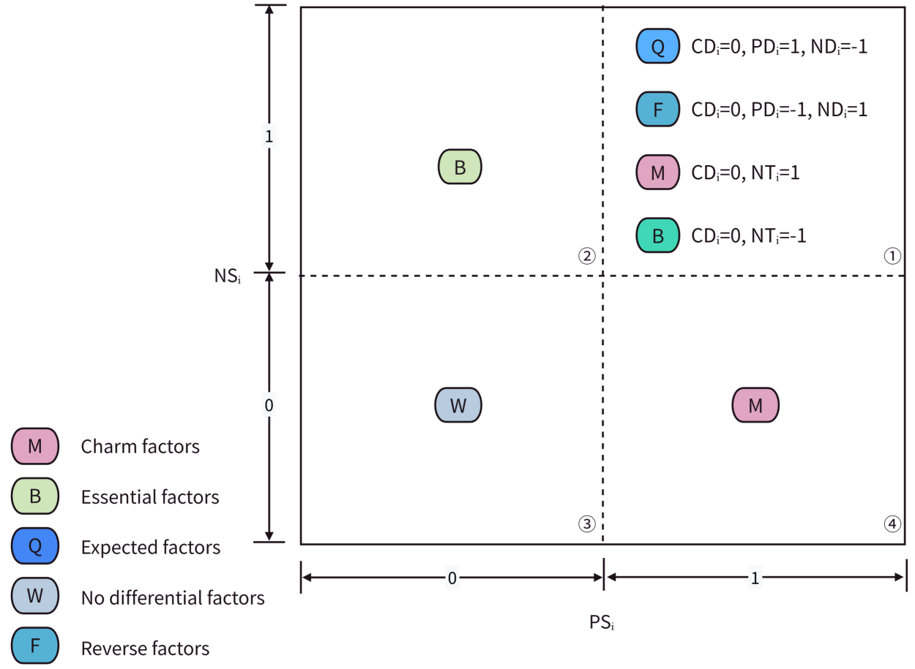
Supplementary Figure 1: Determination model diagram for user satisfaction influence factor attribute classification.
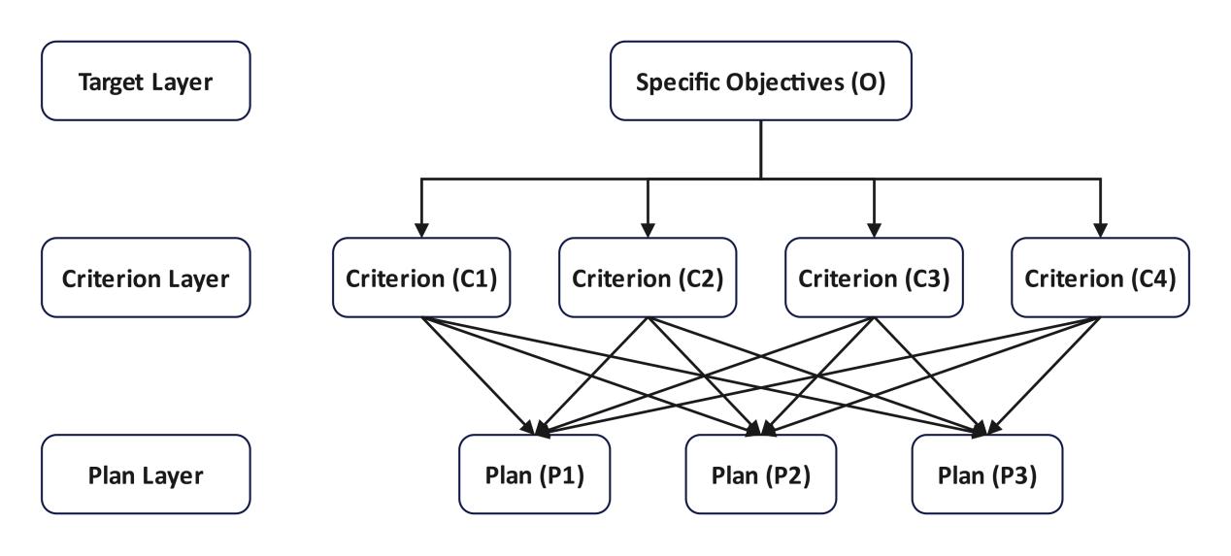
Supplementary Figure 2: Structural Model Diagram of the Analytic Hierarchy Process. The fundamental principle of the Analytic Hierarchy Process (AHP) is to decompose the objectives of a complex decision-making problem into multiple judgment criteria, and then further break down these criteria into multiple indicators. This forms a multi-level analytical structure model, thereby transforming the complex decision-making problem into a ranking problem of relative priorities among different indicators under the overall objective.

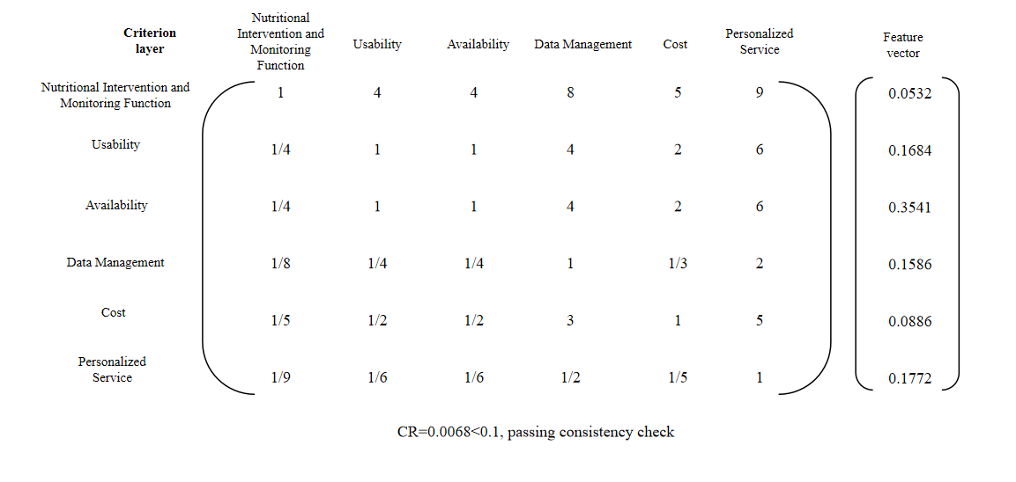
Supplementary Figure 3: Criterion layer judgment matrix of China’s user satisfaction evaluation indicator system.

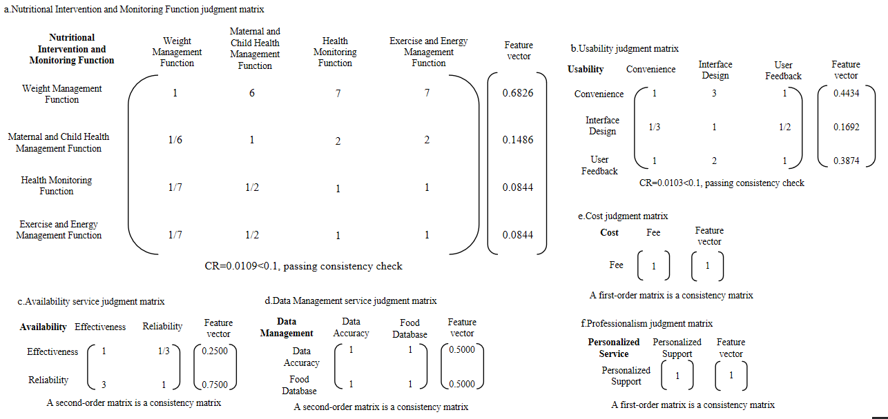
Supplementary Figure 4: Criterion layer judgment matrix of China’s user satisfaction evaluation indicator.
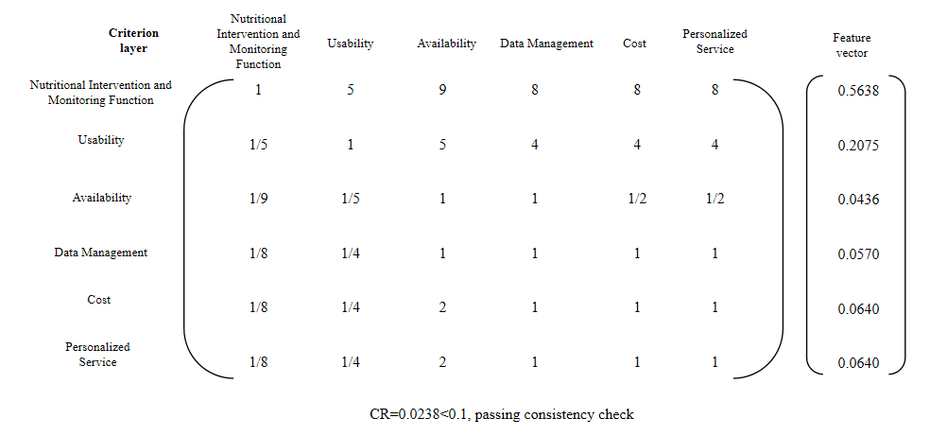
Supplementary Figure 5: Criterion layer judgment matrix of the US user satisfaction evaluation indicator system.

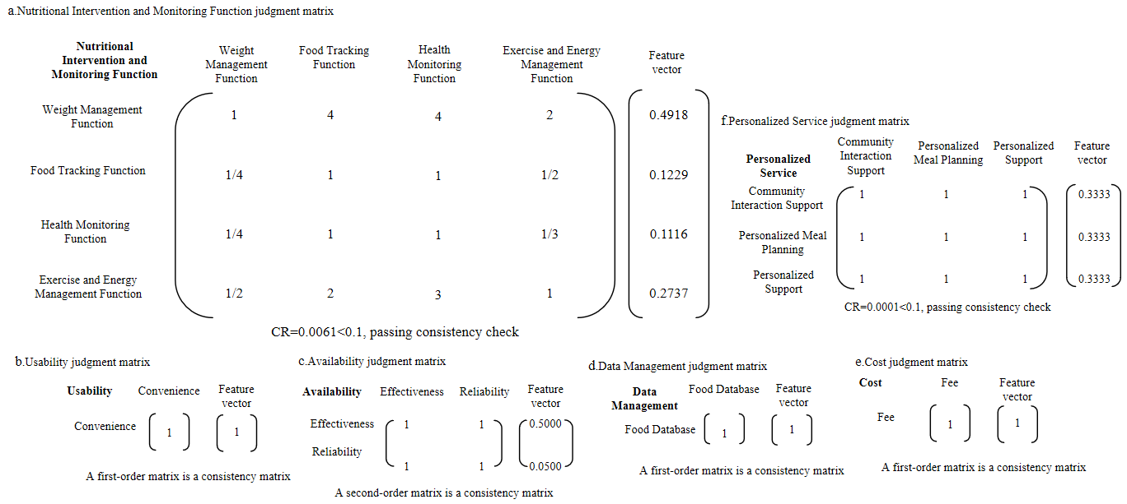
Supplementary Figure 6: The indicator layer judgment matrix of the US user satisfaction evaluation indicator system.
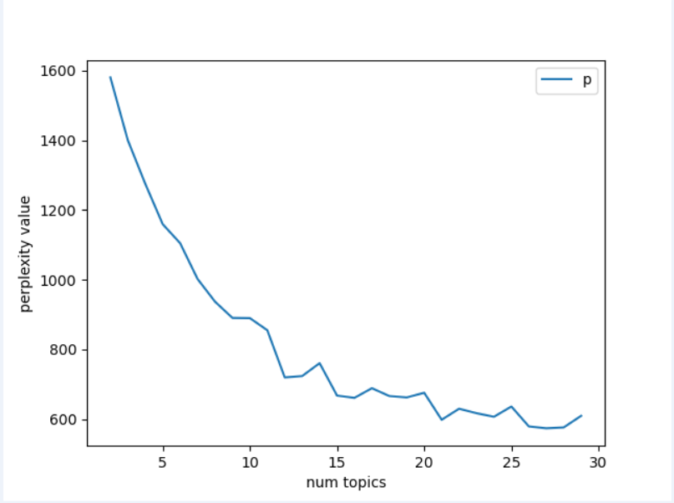
Supplementary Figure 7: Topics perplexity score (rang between 2 and 29 topics) of Chinese reviews. num = number.

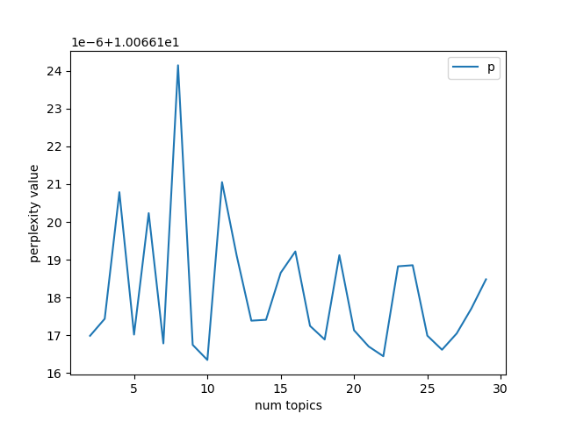
Supplementary Figure 8: Topics perplexity score (rang between 2 and 29 topics) of English reviews. num = number.
Supplementary Table 1: Inclusion and exclusion criteria for nutrition Apps.
Inclusion/exclusion criteria | Standard content
Inclusion criterion 1 (IC1) | The search terms were“健康”, “营养”, “热量”, “饮食”, and “食谱”for Chinese App Store and “health”, “nutrition”, “calories”, “diet”, and “recipe”for English App Store.
Inclusion criterion 2 (IC2) | The app had update and maintenance records within the past two years.
Inclusion criterion 3 (IC3) | Apps belonging to the health and nutrition categories.
Inclusion criterion 4 (IC4) | The target users are primarily individuals at nutritional risk or in need of nutritional improvement.
Exclusion criterion 1 (EC1) | The app's primary function is not improving dietary health, nor is it purely fitness-oriented, purely knowledge-based, or solely a recipe collection.
Exclusion criterion 2 (EC2) | The app is primarily designed for specific hospitals or medical institutions, as well as nutritionist training and educational institutions.
Exclusion criterion 3 (EC3) | The app's interface language is neither Chinese nor English.
Exclusion criterion 4 (EC4) | As of the retrieval date, the number of user reviews for the app on the app store platform was less than 30.

Supplementary Table 2: Input of prompt words for topic naming and description.
Steps | Prompt | Input data
Topic naming | You are an expert in the field of nutrition, currently conducting a study on user satisfaction with nutrition apps. After performing topic clustering on online user reviews using LDA, 13/12 related topics have been generated, each containing 30 main keywords. Please name these 13/12 topics separately, with each topic name being within 6 words. | The 30 main keywords corresponding to each of the 13/12 topics.
Topic description | Please provide an interpretation for each of the above-named 13/12 topics, describing the content of each topic in one sentence. The sentences should be in plain language and accurately summarize the topic content. | The names of the 13/12 topics and their corresponding 30 main keywords.
Topic classification | Please categorize the 13/12 topics based on their commonalities, aiming for approximately 3 to 6 categories. Name each major category and provide an explanation. | The names of the 13/12 topics and their corresponding 30 main keywords.

Supplementary Table 3: Codes, names, specific meanings, and value assignment methods for each indicator in the influencing factor attribute classification discrimination model.
Indicator code | Indicator name | Indicator specific meaning and value assignment method
${\text{T}}_{\text{i}}$ (Theme) | Evaluated Variable Factor | Indicates to themes identified through clustering of user reviews that significantly influence user satisfaction or dissatisfaction.
${\text{PS}}_{\text{i}}$ (Positive Significance) | Significance of PD on User Satisfaction | Indicates whether theme i significantly influences PD in user satisfaction. A value of 1 indicates significant influence, while 0 indicates no significant influence.
${\text{NS}}_{\text{i}}$ (Negative Significance) | Significance of ND on User Satisfaction | Indicates whether theme i significantly influences ND in user satisfaction. If it has a significant effect, the value is 1; if not, the value is 0.
${\text{PD}}_{\text{i}}$ (Positive Direction) | The sign of the PD coefficient for user satisfaction | Indicates whether the coefficient for topic i's PD on user satisfaction is positive or negative. If positive, the value is 1; if negative, the value is -1.
${\text{ND}}_{\text{i}}$ (Negative Direction) | Sign of User Satisfaction ND Coefficient | Indicates whether the coefficient indicating the ND of theme i on user satisfaction is positive or negative. If it is positive, the value is 1; if it is negative, the value is -1.
${\text{CD}}_{\text{i}}$ (Coefficient Difference) | Significance of PD/ND Coefficient Difference | Indicates the significance of the coefficient indicating the PD and ND effects of theme i on user satisfaction. If the two coefficients exhibit a significant difference, the value is 1; if no significant difference exists, the value is 0.
${\text{NT}}_{\text{i}}$ (Number Tendency) | Quantitative Distribution of Positive and Negative Ratings | Indicates the quantitative relationship between positive and negative reviews among all user reviews corresponding to topic i. If positive reviews outnumber negative ones, the value is 1; otherwise, it is -1.

Supplementary Table 4: Frequency percentages of user satisfaction evaluation metrics for Chinese and US users.
Country | Guideline layer | Indicator layer | Indicator frequency proportion
China | Nutrition intervention and monitoring function (32.63%) | Weight management function | 25.49%
China | Nutrition intervention and monitoring function (32.63%) | Maternal and child health management function | 5.23%
China | Nutrition intervention and monitoring function (32.63%) | Health monitoring function | 1.09%
China | Nutrition intervention and monitoring function (32.63%) | Exercise and energy management function | 0.82%
China | Software usability (21.19%) | Convenience | 10.38%
China | Software usability (21.19%) | Interface design | 2.95%
China | Software usability (21.19%) | User feedback | 7.86%
China | Software availability (21.42%) | Effectiveness | 6.29%
China | Software availability (21.42%) | Reliability | 15.13%
China | Data management (7.50%) | Data accuracy | 4.76%
China | Data management (7.50%) | Food database | 2.74%
China | Software cost (15.69%) | Fee | 15.69%
China | Personalized services (1.56%) | Personalized support | 1.56%
US | Nutrition intervention and monitoring function (45.91%) | Weight management function | 21.46%
US | Nutrition intervention and monitoring function (45.91%) | Food tracking function | 5.98%
US | Nutrition intervention and monitoring function (45.91%) | Health monitoring function | 2.55%
US | Nutrition intervention and monitoring function (45.91%) | Exercise and energy management function | 15.92%
US | Software usability (25.56%) | Convenience | 25.56%
US | Software availability (2.84%) | Effectiveness | 2.37%
US | Software availability (2.84%) | Reliability | 0.47%
US | Data management (5.96%.) | Food database | 5.96%
US | Software cost (9.73%) | Fee | 9.73%
US | Personalized services (10.35%) | Community interaction support | 5.73%
US | Personalized services (10.35%) | Personalized meal planning | 2.39%
US | Personalized services (10.35%) | Personalized support | 2.23%

Supplementary Table 5: Importance scale of the user satisfaction evaluation index system for Chinese and US users.
Level of importance | Scale value | China index frequency proportion difference | US index frequency proportion difference
Equally important | 1 | [0.00%, 3.53%] | [0.00%, 5.05%]
Slightly important | 3 | (7.06%, 10.59%] | (10.10%, 15.15%]
Fairly important | 5 | (14.12%, 17.65%] | (20.20%, 25.25%]
Very important | 7 | (21.18%, 24.71%] | (30.30%, 35.35%]
Absolutely important | 9 | (28.24%, +∞) | (40.40%, +∞)
Other | 2, 4, 6, 8 | Among the differences in proportions across different importance levels. | Among the differences in proportions across different importance levels.

Supplementary Table 6: The comprehensive weights of the user satisfaction evaluation index system for Chinese users.
Target layer | Guideline layer | Guideline layer weight | Indicator layer | Indicator layer weight | Comprehensive weights
User satisfaction | Nutrition intervention and monitoring function | 5.32% | Weight management function | 68.26% | 3.63%
User satisfaction | Nutrition intervention and monitoring function | 5.32% | Maternal and child health management function | 14.86% | 0.79%
User satisfaction | Nutrition intervention and monitoring function | 5.32% | Health monitoring function | 8.44% | 0.45%
User satisfaction | Nutrition intervention and monitoring function | 5.32% | Exercise and energy management function | 8.44% | 0.45%
User satisfaction | Software usability | 16.84% | Convenience | 44.34% | 7.47%
User satisfaction | Software usability | 16.84% | Interface design | 50.00% | 2.69%
User satisfaction | Software usability | 16.84% | User feedback | 16.92% | 2.85%
User satisfaction | Software availability | 35.41% | Effectiveness | 38.74% | 6.52%
User satisfaction | Software availability | 35.41% | Reliability | 25.00% | 8.85%
User satisfaction | Data management | 15.86% | Data accuracy | 75.00% | 26.56%
User satisfaction | Data management | 15.86% | Food database | 50.00% | 7.93%
User satisfaction | Software cost | 8.86% | Fee | 50.00% | 7.93%
User satisfaction | Personalized services | 17.72% | Personalized support | 100.00% | 8.86%

Supplementary Table 7: Combination consistency test and overall consistency test of the Chinese user satisfaction evaluation indicator system.
 | Determining Matrix Hierarchy | Weight | CI | RI | CR（N） | CR*
Guideline layer | Target layer - guideline layer | 1 | 0.01 | 1.36 | 0.0068<0.1 | 0.0068<0.1
Indicator layer | Nutrition intervention and monitoring function - indicator layer | 0.0532 | 0 | 0 | 0<0.1 | 0.0068<0.1
Indicator layer | Software usability - indicator layer | 0.1684 | 0 | 0 | 0<0.1 | 0.0068<0.1
Indicator layer | Software availability - indicator layer | 0.3541 | 0 | 0 | 0<0.1 | 0.0068<0.1
Indicator layer | Data management - indicator layer | 0.1586 | 0 | 0 | 0<0.1 | 0.0068<0.1
Indicator layer | Software cost - indicator layer | 0.0886 | 0 | 0 | 0<0.1 | 0.0068<0.1
Indicator layer | Personalized services - indicator layer | 0.1772 | 0 | 0 | 0<0.1 | 0.0068<0.1
CR(N) denotes the combined consistency coefficient of the Nth level, and CR* represents the overall consistency coefficient of the evaluation index system.

Supplementary Table 8: The comprehensive weights of the user satisfaction evaluation index system for US users.
Target layer | Guideline layer | Guideline layer weight | Indicator layer | Indicator layer weight | Comprehensive Weights
User satisfaction | Nutrition intervention and monitoring function | 56.38% | Weight management function | 49.18% | 27.73%
User satisfaction | Nutrition intervention and monitoring function | 56.38% | Food tracking function | 12.29% | 6.93%
User satisfaction | Nutrition intervention and monitoring function | 56.38% | Health monitoring function | 11.16% | 6.29%
User satisfaction | Nutrition intervention and monitoring function | 56.38% | Exercise and energy management function | 27.37% | 15.43%
User satisfaction | Software usability | 20.75% | Convenience | 100.00% | 20.75%
User satisfaction | Software availability | 4.36% | Effectiveness | 50.00% | 2.18%
User satisfaction | Software availability | 4.36% | Reliability | 50.00% | 2.18%
User satisfaction | Data management | 5.70% | Food database | 100.00% | 5.70%
User satisfaction | Software cost | 6.40% | Fee | 100.00% | 6.40%
User satisfaction | Personalized services | 6.40% | Community interaction support | 33.33% | 2.13%
User satisfaction | Personalized services | 6.40% | Personalized meal planning | 33.33% | 2.13%
User satisfaction | Personalized services | 6.40% | Personalized support | 33.33% | 2.13%

Supplementary Table 9: Combination consistency test and overall consistency test of the US user satisfaction evaluation indicator system.
 | Determining Matrix Hierarchy | Weight | CI | RI | CR（N） | CR*
Guideline layer | Target layer - guideline layer | 1 | 0.032 | 1.36 | 0.0238<0.1 | 0.0238<0.1
Indicator layer | Nutrition intervention and monitoring function - indicator layer | 0.5638 | 0 | 0 | 0<0.1 | 0.0238<0.1
Indicator layer | Software usability - indicator layer | 0.2075 | 0 | 0 | 0<0.1 | 0.0238<0.1
Indicator layer | Software availability - indicator layer | 0.0436 | 0 | 0 | 0<0.1 | 0.0238<0.1
Indicator layer | Data management - indicator layer | 0.0570 | 0 | 0 | 0<0.1 | 0.0238<0.1
Indicator layer | Software cost - indicator layer | 0.0640 | 0 | 0 | 0<0.1 | 0.0238<0.1
Indicator layer | Personalized services - indicator layer | 0.0640 | 0 | 0 | 0<0.1 | 0.0238<0.1
CR(N) denotes the combined consistency coefficient at the Nth level, and CR* represents the overall consistency coefficient of the evaluation index system.
Supplementary Table 10: List of clinical guidance documents related to nutrition intervention.
Docunment categorization | Release  date | File name | Publishing unit | File type | Guidance content
China | 2024.02 | "Dietary Guidelines for Adult Hyperuricemia and Gout (2024 Edition)” | General Office of the National Health Commission, National Institute for Nutrition and Health, China CDC | Clinical guidelines | Hyperuricemia and gout diet
China | 2024.02 | "Dietary Guidelines for Adult Obesity (2024 Edition)” | General Office of the National Health Commission, National Institute for Nutrition and Health, China CDC | Clinical guidelines | Obesity diet
China | 2024.02 | "Dietary Guidelines for Childhood and Adolescent Obesity (2024 Edition)” | General Office of the National Health Commission, National Institute for Nutrition and Health, China CDC | Clinical guidelines | Childhood and adolescent obesity diet
China | 2024.02 | "Dietary Guidelines for Adult Chronic Kidney Disease (2024 Edition)” | General Office of the National Health Commission, National Institute for Nutrition and Health, China CDC | Clinical guidelines | Chronic kidney disease diet
China | 2024.12 | "Guiding Principles for Weight Management (2024 Edition)” | General Office of the National Health Commission, National Institute for Nutrition and Health, China CDC | Clinical guidelines | Weight management
China | 2024.10 | "Guidelines for the Diagnosis and Treatment of Obesity (2024 Edition)” | General Office of the National Health Commission, National Institute for Nutrition and Health, China CDC | Clinical guidelines | Diagnosis and treatment of obesity
China | 2023.01 | "Dietary Guidelines for Adult Hyperlipidemia (2023 Edition)” | General Office of the National Health Commission, National Institute for Nutrition and Health, China CDC | Clinical guidelines | Hyperlipidemia diet
China | 2023.01 | "Dietary Guidelines for Growth Retardation in Children and Adolescents (2023 Edition)” | General Office of the National Health Commission, National Institute for Nutrition and Health, China CDC | Clinical guidelines | Growth retardation diet
China | 2023.01 | "Dietary Guidelines for Adult Diabetes (2023 Edition)“ | General Office of the National Health Commission, National Institute for Nutrition and Health, China CDC | Clinical guidelines | Diabetes diet
China | 2023.01 | ”Dietary Guidelines for Adult Hypertension (2023 Edition)” | General Office of the National Health Commission, National Institute for Nutrition and Health, China CDC | Clinical guidelines | Hypertensive diet
China | 2025.02 | "Guidelines for Infant and Young Child Feeding Assessment Services (Trial)” | General Office of the National Health Commission | Clinical guidelines | Infant and young child feeding assessment
China | 2022.02 | "Scientific Research Report on Dietary Guidelines for Chinese Residents (2021)” | Chinese Nutrition Society | Investigation report | Dietary guidelines research
China | 2022.04 | ”Dietary Guidelines for Chinese Residents (2022)” | Chinese Nutrition Society | Clinical guidelines | General population diet
China | 2024.12 | "Expert Consensus on Precision Nutrition and Disease Prevention and Control” | Chinese Nutrition Society |  | Precision nutrition
  Expert consensus
China | 2024.06 | “Guiding Principles for Hypertension Nutrition and Exercise (2024 Edition)” | General Office of the National Health Commission | Clinical guidelines | Hypertension nutrition and exercise
China | 2024.06 | “Guiding Principles for Hyperglycemia Nutrition and Exercise (2024 Edition)” | General Office of the National Health Commission | Clinical guidelines | Hyperglycemia nutrition and exercise
China | 2024.06 | “Guiding Principles for Hyperlipidemia Nutrition and Exercise (2024 Edition)” | General Office of the National Health Commission | Clinical guidelines | Hyperlipidemia nutrition and exercise
China | 2024.06 | “Guiding Principles for Hyperuricemia Nutrition and Exercise (2024 Edition)” | General Office of the National Health Commission | Clinical guidelines | Hyperuricemia nutrition and exercise
China | 2022.01 | “Guidelines for Infant and Young Child Feeding and Nutrition in Childcare Institutions (Trial)” | General Office of the National Health Commission | Clinical guidelines | Infant and young child feeding in childcare
China | 2017.11 | “Dietary Guidance for High-Temperature Workers” | General Office of the National Health Commission | Clinical guidelines | High-temperature worker diet
China | 2018.04 | “Dietary Guidance for Patients with Gestational Diabetes Mellitus” | General Office of the National Health Commission | Clinical guidelines | Gestational diabetes diet
China | 2025.10 | “Implementation Guidelines for Population Nutrition and Health Intervention Research” | Chinese Nutrition Society | Clinical guidelines | Nutrition intervention research
China | 2025.08 | “Expert Consensus on Nutritional Therapy for Common Chronic Diseases (2025 Edition)” | Chinese Medical Association |  | Chronic disease nutritional therapy
  Expert consensus
China | 2025.04 | “Guidelines for the Diagnosis and Application of Malnutrition in Adult Patients (2025 Edition)” | Chinese Medical Association | Clinical guidelines | Malnutrition diagnosis
China | 2023.09 | “Guidelines for Nutritional Support Therapy in Critically Ill Elderly Chinese Patients (2023 Edition)” | Chinese Medical Association | Clinical guidelines | Critically ill elderly nutrition
China | 2022.09 | “Chinese Guidelines for Medical Nutrition Therapy of Diabetes (2022 Edition)” | Chinese Nutrition Society | Clinical guidelines | Diabetes medical nutrition therapy
US | 2020.12 | “2020-2025 Dietary Guidelines for Americans” | the U.S. Departments of Agriculture, Health and Human Services | Clinical guidelines | General population diet
US | 2025.11 | “Provision and Access to Nutrition Care for the Prevention and Treatment of Malnutrition in Older Adults Within Long-Term Care and Community Settings: A Consensus Statement of the Academy of Nutrition and Dietetics” | Academy of Nutrition and Dietetics | Expert consensus | Older adult malnutrition care
US | 2024.07 | “Prevention and Treatment of Malnutrition in Older Adults Living in Long-Term Care or the Community: An Evidence-Based Nutrition Practice Guideline” | Academy of Nutrition and Dietetics | Clinical guidelines | Older adult malnutrition
US | 2023.12 | “Saturated Fat Intake and the Prevention and Management of Cardiovascular Disease in Adults: An Academy of Nutrition and Dietetics Evidence-Based Nutrition Practice Guideline” | Academy of Nutrition and Dietetics | Clinical guidelines | Cardiovascular disease nutrition
US | 2023.03 | “Nutrition and Physical Activity: General Population Evidence-Based Nutrition Practice Guideline” | Academy of Nutrition and Dietetics, American Council on Exercise | Clinical guidelines | Nutrition and physical activity
US | 2024.12 | “Diabetes Type 1 Pediatrics” | Academy of Nutrition and Dietetics | Clinical guidelines | Pediatric type 1 diabetes nutrition management
US | 2024.01 | “Malnutrition in Older Adults” | Academy of Nutrition and Dietetics | Clinical guidelines | Older adult malnutrition management
US | 2023.03 | “Nutrition and Physical Activity: General Population” | Academy of Nutrition and Dietetics | Clinical guidelines | General population nutrition and physical activity
US | 2022.10 | “Adult Weight Management” | Academy of Nutrition and Dietetics | Clinical guidelines | Adult weight management
US | 2022.02 | “Chronic Obstructive Pulmonary Disease Nutrition Management” | Academy of Nutrition and Dietetics | Clinical guidelines | COPD nutrition management
US | 2018.05 | “Gestational Diabetes Nutrition Management” | Academy of Nutrition and Dietetics | Clinical guidelines | Gestational diabetes nutrition management
US | 2018.05 | “Management of Heart Failure in Adults” | Academy of Nutrition and Dietetics | Clinical guidelines | Heart failure nutrition management
US | 2017.09 | “Hypertension Nutrition Management” | Academy of Nutrition and Dietetics | Clinical guidelines | Hypertension nutrition management
US | 2023.09 | “Guidelines for parenteral nutrition in preterm infants” | The American Society for Parenteral and Enteral Nutrition | Clinical guidelines | Preterm infant parenteral nutrition
International | 2025.10 | “Global nutrition targets 2030: topical briefs on maternal, infant and young child nutrition” | WHO | Investigation report | Maternal and child nutrition targets
International | 2023.12 | “Saturated Fatty Acid and Trans-Fatty Acid Intake for Adults and Children” | WHO | Clinical guidelines | Fatty acid intake
International | 2024.06 | “Adolescent Health Indicators for Measuring the Global Action for Adolescent Health Recommendations” | WHO | Investigation report | Adolescent health indicators
International | 2024.06 | “Global Guidance on Monitoring Healthy Diets” | WHO | Clinical guidelines | Healthy diet monitoring
International | 2025.04 | “Use of Low-Sodium Salt: Summary of WHO Guidelines” | WHO | Clinical guidelines | Low-sodium salt use

Supplementary Table 11: Artificial validation of LLM's topic naming results.
Serial number | Indicator information |  | Score |  |  |  |  | Expert scoring
Serial number | Evaluation index | Meaning explanation | 1 | 2 | 3 | 4 | 5 | Expert 1 | Expert 2
1 | Name accuracy | The topic name can  fully cover the core keywords of the topic | Completely disagree | Disagree | Neutral | Agree | Completely agree | 5 | 5
1 | Name accuracy | The topic name can  precisely summarize  the core semantics of  the topic | Completely disagree | Disagree | Neutral | Agree | Completely agree | 4 | 4
2 | Describe interpret ability | The theme description  is clear and easy to understand | Completely disagree | Disagree | Neutral | Agree | Completely agree | 5 | 5
2 | Describe interpret ability | There is no ambiguity  in the topic description | Completely disagree | Disagree | Neutral | Agree | Completely agree | 4 | 5
3 | Rationality of classification | The parent theme can  reflect the common characteristics of the  child themes | Completely disagree | Disagree | Neutral | Agree | Completely agree | 5 | 5
3 | Rationality of classification | The name of the parent  topic can encompass the core semantics of all the child topics | Completely disagree | Disagree | Neutral | Agree | Completely agree | 5 | 5
Expert evaluation consistency = Number of consistent/Total number of items = 5/6 = 83.3%
Expert 1 recognition = Self-assessment score/Total evaluation score = 28/30 = 93.3%
Expert 2 recognition = Self-assessment score/Total evaluation score = 29/30 = 96.3%

Supplementary Table 12: Examples of reviews for each topic in Chinese reviews.
Topics | Reviews (example)
Topic 1: Weight management function | 就像一位贴身的健康管家，帮我记录体重变化，设定合理目标，看着进度条满满真的很有动力！
Topic 2: Reliability | APP用起来很稳定，从没丢过数据，把我的健康信息交给它，感觉很放心。
Topic 3: Data accuracy | 查到的食物热量和营养信息都很准，让我能安心安排每日饮食，不用担心算错。
Topic 4: User feedback | 提出的建议很快就被采纳更新了，客服回应也很及时，感觉有被认真对待。
Topic 5: Maternal and child health management function | 为宝妈和宝宝设计了特别的营养方案，像一位专业的营养师，陪伴我们度过关键时期。
Topic 6: Convenience | 上手特别快，操作简单明了，家里长辈也能轻松学会用起来，一点都不复杂。
Topic 7: Fee | 花的钱很值，会员功能强大，性价比超高，是一笔对自己健康的超值投资。
Topic 8: Interface design | 界面清新又可爱，看着很舒服，每天打开记录心情都变成一种享受。
Topic 9: Health monitoring function | 不仅能记饮食，连我的睡眠、喝水情况都照顾到了，帮我养成全方位的好习惯。
Topic 10: Exercise and energy management function | 运动后看看消耗了多少卡路里，特别有成就感，帮我更好地平衡吃和动。
Topic 11: Effectiveness | 坚持用下来真的瘦了，指标正常了，效果实实在在，特别有成就感！
Topic 12: Food database | 扫一下食物条形码就能知道营养构成，饮食报告让我清楚自己的营养短板。
Topic 13: Personalized support | 根据我的身体和目标推荐专属食谱，好像为我一个人定制的营养方案一样贴心。

Supplementary Table 13: Examples of reviews for each topic in English reviews.
Topics | Reviews (example)
Topic 1: Weight management Function | It helps me scientifically record and analyze weight changes and manage health goals.
Topic 2: Convenience | Straightforward operation, a clear interface, and exceptionally user-friendly.
Topic 3: Food database | Quickly query detailed nutritional information of foods and analyze dietary structure.
Topic 4: Exercise and energy management function | Records exercise data, calculates energy expenditure, and balances intake and expenditure.
Topic 5: Fee | Evaluates the reasonableness of the app's pricing and its cost-effectiveness.
Topic 6: Food tracking function | Conveniently records daily meals and effortlessly tracks daily food intake.
Topic 7: Personalized meal planning | Generates personalized recipes based on my individual circumstances, addressing the dilemma of "what to eat."
Topic 8: Health monitoring function | Comprehensively records multiple health indicators such as sleep and water intake.
Topic 9: Reliability | The application operates stably, ensures data security, and is trustworthy.
Topic 10: Community interaction support | Users can exchange encouragement among themselves, fostering a positive atmosphere of mutual support.
Topic 11: Effectiveness | After actual use, it has proven significantly effective in improving health.
Topic 12: Personalized support | Capable of providing recommendations fully tailored to my personal needs.

Supplementary Table 14: Multicollinearity analysis for model 1 (China).
Influencing factor | Tolerance | VIF
Topic 1: Weight management function | 0.95 | 1.06
Topic 2: Reliability | 0.98 | 1.02
Topic 3: Data accuracy | 0.98 | 1.02
Topic 4: User feedback | 0.97 | 1.03
Topic 5: Maternal and child health management function | 0.99 | 1.01
Topic 6: Convenience | 0.96 | 1.04
Topic 7: Fee | 0.91 | 1.11
Topic 8: Interface design | 0.98 | 1.02
Topic 9: Health monitoring function | 0.97 | 1.03
Topic 10: Exercise and energy management function | 0.99 | 1.01
Topic 11: Effectiveness | 0.95 | 1.05
Topic 12: Food database | 0.97 | 1.03
Topic 13: Personalized support | 0.99 | 1.01
Dependent variable: positive rating deviations

Supplementary Table 15: Multicollinearity analysis for model 2 (China).
Influencing factor | Tolerance | VIF
Topic 1: Weight management function | 0.95 | 1.06
Topic 2: Reliability | 0.98 | 1.02
Topic 3: Data accuracy | 0.98 | 1.02
Topic 4: User feedback | 0.97 | 1.03
Topic 5: Maternal and child health management function | 0.99 | 1.01
Topic 6: Convenience | 0.96 | 1.04
Topic 7: Fee | 0.91 | 1.11
Topic 8: Interface design | 0.98 | 1.02
Topic 9: Health monitoring function | 0.97 | 1.03
Topic 10: Exercise and energy management function | 0.99 | 1.01
Topic 11: Effectiveness | 0.95 | 1.05
Topic 12: Food database | 0.97 | 1.03
Topic 13: Personalized support | 0.99 | 1.01
Dependent variable: positive rating deviations

Supplementary Table 16: Multicollinearity analysis for model 1 (US).
Influencing factor | Tolerance | VIF
Topic 1: Weight management function | 0.90 | 1.11
Topic 2: Convenience | 0.83 | 1.21
Topic 3: Food database | 0.96 | 1.04
Topic 4: Exercise and energy management function | 0.85 | 1.18
Topic 5: Fee | 0.96 | 1.04
Topic 6: Food tracking function | 0.96 | 1.04
Topic 7: Personalized meal planning | 0.99 | 1.01
Topic 8: Health monitoring function | 0.97 | 1.03
Topic 9: Reliability | 0.99 | 1.01
Topic 10: Community interaction support | 0.97 | 1.03
Topic 11: Effectiveness | 0.98 | 1.02
Topic 12: Personalized support | 0.98 | 1.02
Dependent variable: negative rating deviations

Supplementary Table 17: Multicollinearity analysis for model 2 (US).
Influencing factor | Tolerance | VIF
Topic 1: Weight management function | 0.90 | 1.11
Topic 2: Convenience | 0.83 | 1.21
Topic 3: Food database | 0.96 | 1.04
Topic 4: Exercise and energy management function | 0.85 | 1.18
Topic 5: Fee | 0.96 | 1.04
Topic 6: Food tracking function | 0.96 | 1.04
Topic 7: Personalized meal planning | 0.99 | 1.01
Topic 8: Health monitoring function | 0.97 | 1.03
Topic 9: Reliability | 0.99 | 1.01
Topic 10: Community interaction support | 0.97 | 1.03
Topic 11: Effectiveness | 0.98 | 1.02
Topic 12: Personalized support | 0.98 | 1.02
Dependent variable: negative rating deviations

Supplementary Table 18: Attribute discrimination index of factors influencing user satisfaction (China).
Influencing factor | Positive significance | Negative significance | Positive direction | Negative direction | Coefficient difference | Number tendency
Topic 1: Weight management function | 1 | 1 | -1 | 1 | 1 | 1
Topic 2: Reliability | 1 | 1 | 1 | -1 | 1 | 1
Topic 3: Data accuracy | 1 | 1 | -1 | 1 | 1 | 1
Topic 4: User feedback | 1 | 1 | -1 | 1 | 1 | 1
Topic 5: Maternal and child health management function | 1 | 1 | 1 | -1 | 1 | 1
Topic 6: Convenience | 1 | 1 | -1 | 1 | 1 | 1
Topic 7: Fee | 1 | 1 | -1 | 1 | 1 | 1
Topic 8: Interface design | 1 | 1 | 1 | -1 | 1 | 1
Topic 9: Health monitoring function | 1 | 1 | 1 | -1 | 1 | 1
Topic 10: Exercise and energy management function | 1 | 1 | 1 | -1 | 1 | 1
Topic 11: Effectiveness | 1 | 1 | -1 | 1 | 1 | 1
Topic 12: Food database | 1 | 1 | 1 | -1 | 1 | 1
Topic 13: Personalized support | 1 | 1 | -1 | 1 | 1 | 1

Supplementary Table 19: Attribute discrimination index of factors influencing user satisfaction (US).
Influencing factor | Positive significance | Negative significance | Positive direction | Negative direction | Coefficient difference | Number tendency
Topic 1: Weight management function | 1 | 1 | 1 | -1 | 1 | 1
Topic 2: Convenience | 0 | 1 | 1 | -1 | 1 | 1
Topic 3: Food database | 1 | 1 | -1 | 1 | 1 | 1
Topic 4: Exercise and energy management function | 1 | 1 | 1 | -1 | 1 | 1
Topic 5: Fee | 1 | 1 | -1 | 1 | 1 | 1
Topic 6: Food tracking function | 1 | 1 | 1 | -1 | 1 | 1
Topic 7: Personalized meal planning | 1 | 1 | 1 | -1 | 1 | 1
Topic 8: Health monitoring function | 0 | 1 | 1 | -1 | 1 | 1
Topic 9: Reliability | 1 | 0 | 1 | -1 | 1 | 1
Topic 10: Community interaction support | 1 | 1 | -1 | 1 | 1 | 1
Topic 11: Effectiveness | 1 | 1 | -1 | 1 | 1 | 1
Topic 12: Personalized support | 1 | 1 | -1 | 1 | 1 | 1

Supplementary Note 1: Detailed summarization process for nutritional self-management task requirements.
With the advancement of nutritional science and the accumulation of health management experience, nutrition intervention and self-management have gradually evolved into a systematic practice model, clarifying essential operational requirements such as dietary assessment, nutritional goal setting, dietary behavior recording, and personalized meal planning. This management model may exhibit significant variations across different cultural contexts and population needs. Consequently, relevant institutions periodically synthesize the latest scientific evidence and practical experience to update clinical nutrition guidance documents and refine the operational requirements necessary for nutritional self-management, thereby guiding professional practice and public health management. These clinical nutrition guidance documents encompass various forms, including clinical guidelines, expert consensuses, practice recommendations, and dietary guidelines. Developed by nutritionists, clinicians, and public health experts, they integrate clinical observations, evidence-based research findings, and expert opinions to systematically outline the core tasks and processes involved in nutrition management. Only through effective interventions based on these scientifically derived operational requirements can users' nutritional status be tangibly improved. As an emerging nutrition management tool, nutrition-focused mobile health apps must design their functionalities based on evidence, fully addressing the operational requirements for nutritional self-management defined in clinical guidance documents to realize their health promotion value. Therefore, compiling clinical nutrition guidance documents from various countries and international organizations and summarizing the primary operational requirements for nutritional self-management are of significant importance for analyzing the functional usability of nutrition apps.
Given the differences in nutrition management models and operational requirements across countries and regions, this study selected China and the United States as research subjects. The latest nutrition-related clinical guidance documents issued by the two countries were summarized, and guidelines from international organizations such as the World Health Organization (WHO) were included as supplements. First, a systematic investigation was conducted to identify authoritative institutions in the field of nutrition management in China and the United States. For instance, in China, these include the National Health Commission, the Chinese Nutrition Society, and the Chinese Center for Disease Control and Prevention, while in the United States, relevant institutions include the U.S. Department of Agriculture, the Academy of Nutrition and Dietetics, and the National Academy of Sports Medicine. The latest nutrition guidelines, consensus statements, recommendations, and dietary guidance documents published by these institutions were retrieved and obtained from their official websites. Second, keywords such as "nutrition," "dietary guidelines," "clinical nutrition," and "expert consensus" were used to search relevant academic literature in Chinese and English databases, including CNKI, Web of Science, and PubMed. Guiding documents issued by authoritative institutions in the two countries were screened from the search results. Third, experts in nutrition and clinical nutrition were consulted to supplement any potentially overlooked national or international nutrition guidance documents. Fourth, global nutrition guidance documents were obtained from the official websites of international organizations such as the World Health Organization (WHO) to supplement the national documents. Finally, the nutrition clinical guidance documents obtained from official websites, academic journals, expert consultations, and international sources were summarized by country. Information such as the issuing country/institution, publication date, document title, issuing unit, document type, core content, and original links was extracted and organized. The collection and screening of all documents were conducted under the guidance of experts in nutrition and public health.
Under the guidance of domain experts, this study employed inductive content analysis to systematically review and extract requirements from clinical nutrition guidance documents in both China and the United States, aiming to identify the core operational requirements for users' nutritional self-management in both countries. First, all included nutrition guidance documents were thoroughly reviewed to extract recommendations and requirements related to nutritional self-management, such as nutrient intake assessment, dietary planning, and recording and adjustment of dietary behaviors. Subsequently, all operational requirements identified in the documents of each country were summarized, deduplicated, categorized, and integrated to form distinct sets of operational requirements for nutritional self-management for Chinese and American users. Finally, experts in nutrition and clinical nutrition were invited to review and validate the scientific rigor and completeness of the operational requirement sets for both countries.

Supplementary Note 2: Detailed process of satisfaction modeling based on the Two-Factor Theory.
According to the Two-Factor Theory, the factors influencing user satisfaction and dissatisfaction are asymmetric. To deeply investigate the key factors affecting users' satisfaction and dissatisfaction with nutrition apps, this study selected PD and ND as dependent variables to reflect users' positive satisfaction and negative dissatisfaction, respectively. Concurrently, the topics derived from LDA clustering were used as independent variables, with the probability distribution of each review across different topics serving as the values of these variables, thereby representing users' experiences and focus in specific dimensions. Furthermore, to standardize the data scale, the probability distribution of the independent variables was normalized (Formula 1), ensuring that the values fall within the [0, 1] interval.
$y_{i}=\frac{x_{i}−\min_{1≤j≤n}\left\{x_{j}\right\}}{\max_{1≤j≤n}\left\{x_{j}\right\}−\min_{1≤j≤n}\left\{x_{j}\right\}}$ （1）
Since the dependent variables PD and ND are left-censored truncated data, which can only take values of zero or positive numbers, this study employed the Tobit model—effective for handling left-censored truncated variables—to analyze the factors influencing user satisfaction and dissatisfaction. The specific model definitions are provided in Formulas 2 and 3. Here, β_{k} denotes the correlation coefficient between the k-th topic χ_{ki} of review i and the user satisfaction measures (PD_{i} and ND_{i}), k represents the number of topics included in the model, and δ_{i} is the error term. To ensure the absence of multicollinearity in the statistical analysis, the variance inflation factor (VIF) for both the positive and negative deviation models was calculated in advance.
${PD}_{i}=\sum_{K=1}^{K}{β_{PD,k} χ_{ki}} + δ_{PD,i}$ （2）
${ND}_{i}=\sum_{K=1}^{K}{β_{ND,k} χ_{ki}} +δ_{ND,i}$ （3）
To further investigate the asymmetry in the factors influencing user satisfaction and dissatisfaction with nutrition apps, this study employed the Wald test to examine differences in the absolute values of coefficients for the same variable between the positive and negative rating deviation models. If a statistically significant difference exists between the absolute value of a factor's coefficient in the positive deviation model and that in the negative deviation model, it indicates that the factor exhibits asymmetry in its influence on user satisfaction and dissatisfaction. The construction of the Tobit models and the Wald tests were performed using Stata 16.0, with the statistical significance level set at a two-sided p < 0.05.

Supplementary Note 3: Kano attribute classification.
(1) Charm Factors. Charm factors are solely related to user satisfaction. Meeting these factors significantly enhances user satisfaction, but their absence does not increase dissatisfaction. In the following two scenarios, factors influencing user satisfaction can be classified as charm factors, as indicated by “M” in Supplementary Figure 1) The factor significantly influences positive rating bias but has no significant effect on negative rating bias. That is, ${PS}_{i}$=1, ${NS}_{i}$=0; 2) The factor significantly influences both positive and negative rating biases, with statistically significant differences in the coefficients for positive and negative biases, and a greater number of positive reviews than negative ones. That is, ${\text{PS}}_{\text{i}}$=1, ${\text{NS}}_{\text{i}}$=0, ${\text{CD}}_{\text{i}}$=1, ${\text{NT}}_{\text{i}}$=1.
(2) Essential Factors. Essential factors are exclusively associated with user dissatisfaction. Failure to meet these factors significantly increases user dissatisfaction, but providing them does not enhance user satisfaction. In the following two scenarios, factors influencing user satisfaction can be classified as essential factors, as indicated by “B” in Supplementary Figure 1) The factor significantly influences negative rating bias but has no significant effect on positive rating bias. That is, ${\text{PS}}_{\text{i}}$=0, ${\text{NS}}_{\text{i}}$=1; 2) The factor significantly influences both positive and negative rating bias, with statistically significant differences in the coefficients for positive and negative bias, and a greater number of negative comments than positive ones. That is, ${\text{PS}}_{\text{i}}$=0, ${\text{NS}}_{\text{i}}$=1, ${\text{CD}}_{\text{i}}$=1, ${\text{NT}}_{\text{i}}$=-1.
(3) Expectation Factors. Expectation factors simultaneously influence both user satisfaction and dissatisfaction, exerting a symmetrical positive effect on both. Providing such factors significantly enhances user satisfaction, while their absence significantly increases dissatisfaction. When a factor influencing user satisfaction exhibits significant effects on both positive and negative rating biases, with no significant difference between the coefficients of these biases, and where the positive rating bias coefficient is positive while the negative rating bias coefficient is negative, that factor is classified as an expectation factor. That is, ${\text{PS}}_{\text{i}}$=1, ${\text{NS}}_{\text{i}}$=1, ${\text{CD}}_{\text{i}}$=0, ${\text{PD}}_{\text{i}}$=1, ${\text{ND}}_{\text{i}}$=-1, as illustrated by “Q” in Supplementary Figure 1.
(4) Indifferent Factors. Indifferent factors have no impact on user satisfaction or dissatisfaction. Whether or not such factors are provided, they do not alter users' levels of satisfaction or dissatisfaction. When a factor influencing user satisfaction shows no significant effect on either positive or negative scoring biases, it is classified as an indifferent factor. That is, ${\text{PS}}_{\text{i}}$= 0 , ${\text{NS}}_{\text{i}}$= 0, as indicated by “W” in Supplementary Figure 1.
(5) Reverse Factors. Reverse factors simultaneously influence both user satisfaction and dissatisfaction, exerting symmetrically opposite effects on each. The presence of such factors significantly increases user dissatisfaction, while their absence significantly enhances satisfaction. When a factor influencing user satisfaction simultaneously exerts a significant effect on both positive and negative rating biases, with no significant difference between the coefficients of these biases, and where the positive bias coefficient is negative while the negative bias coefficient is positive, the factor is classified as a reverse factor. That is, ${\text{PS}}_{\text{i}}$=1, ${\text{NS}}_{\text{i}}$=1, ${\text{CD}}_{\text{i}}$=0, ${\text{PD}}_{\text{i}}$=-1, ${\text{ND}}_{\text{i}}$=1, as illustrated by “F” in Supplementary Figure 1.

Supplementary Note 4: Establishment of the user satisfaction evaluation index system.
- Formulation of the user satisfaction evaluation index system framework
This paper formulates the frameworks for the user satisfaction evaluation index systems of Chinese and US users based on the results of LDA topic modeling and Tobit analysis, respectively. For the Chinese user satisfaction evaluation index system framework, firstly, the 13 factors that significantly impact user satisfaction are designated as specific indicators of the Chinese index system framework. These include weight management function, maternal and child health management function, health monitoring function, exercise and energy management function, convenience, interface design, user feedback, effectiveness, reliability, data accuracy, food database, fee, and personalized support. Secondly, based on the relationship between specific topics and topic categories in the LDA topic model, the six topic categories corresponding to the 13 topics are assigned as the criteria within the criterion level. These criteria include nutrition intervention and monitoring function, software usability, software availability, data management, software cost, and personalized services. Finally, user satisfaction is established as the ultimate objective at the target level. For the US user satisfaction evaluation index system framework, firstly, the 12 factors that significantly impact user satisfaction are designated as specific indicators of the US index system framework. These include weight management function, food tracking function, health monitoring function, exercise and energy management function, convenience, effectiveness, reliability, food database, fee, community interaction support, personalized meal planning, and personalized support. Secondly, the six topic categories corresponding to the 12 topics in the LDA topic model are assigned as the criteria within the criterion level. These criteria include nutrition intervention and monitoring function, software usability, software availability, data management, software cost, and personalized services. Finally, user satisfaction is established as the ultimate objective at the target level.
- Calculation of index weights for the user satisfaction evaluation index system
This study constructed importance judgment matrices for each indicator based on the proportion of user reviews. The importance weights of each indicator were calculated using the Analytic Hierarchy Process (AHP) according to these judgment matrices, and the consistency of the results was verified through hierarchical single-level ranking and overall ranking. First, the frequency percentages of each indicator in the Chinese and US user satisfaction evaluation index systems were calculated separately based on the proportion of reviews corresponding to each topic. The frequency percentage of each criterion was then calculated by summing the frequency percentages of all indicators within the same criterion level. The calculation results are shown in Supplementary Table 4. Among them, the indicators with the highest frequency percentages in the Chinese and US user satisfaction evaluation index systems were weight management function and convenience (China: 25.49%, US: 25.56%), respectively, and their corresponding criterion in both systems was nutrition intervention and monitoring function (China: 32.63%, US: 45.91%). Next, the 1–9 importance scales for the Chinese and US user satisfaction evaluation index systems were determined based on the maximum differences in frequency percentages among the indicators and criteria. The results are presented in Supplementary Table 5. Here, the unit importance scale for the Chinese system was 3.53%, meaning that for every additional 3.53% difference in frequency percentage between one indicator and another, its importance scale increases by 1. The unit importance scale for the US system was 5.05%, meaning that for every additional 5.05% difference in frequency percentage, the importance scale increases by 1. Finally, based on the importance scale tables, judgment matrices for the criterion and indicator levels of the Chinese and US user satisfaction evaluation index systems were constructed separately. The importance weights of the indicators were calculated using the Analytic Hierarchy Process, and the consistency of the results was verified through hierarchical single-level ranking and overall ranking.
For the calculation of indicator weights in the Chinese user satisfaction evaluation index system, the first step involved hierarchical single-level ranking and consistency testing. A judgment matrix for the criterion level was constructed based on the importance scale table of the Chinese user satisfaction evaluation index system. The importance weights of each criterion were calculated through hierarchical single-level ranking, and the consistency of the results was verified, as shown in Supplementary Figure 2. The normalized maximum eigenvector of the criterion-level judgment matrix was [0.0532, 0.1684, 0.3541, 0.1586, 0.0886, 0.1772], with a consistency ratio (CR) value of 0.0068, indicating that the consistency test was passed. Subsequently, judgment matrices were constructed for the indicators within each of the six criteria. The importance weights of each indicator were calculated through hierarchical single-level ranking, and the consistency of the results was verified, as shown in Supplementary Figure 3. Among them, the normalized maximum eigenvector for the nutrition intervention and monitoring function judgment matrix was [0.6826, 0.1486, 0.0844, 0.0844], for the usability judgment matrix was [0.4434, 0.1692, 0.3874], for the availability judgment matrix was [0.2500, 0.7500], for the data management judgment matrix was [0.5000, 0.5000], and the normalized maximum eigenvectors for both the software cost and personalized service judgment matrices were [1]. All matrices were confirmed to be consistent. Next, hierarchical overall ranking and consistency testing were conducted. Based on the importance weights of the criterion and indicator levels, the comprehensive weights of each indicator relative to user satisfaction were calculated using a linear weighted summation method. Combined consistency and overall consistency tests were performed, with results presented in Supplementary Tables 6 and 7. Among these, data accuracy (26.56%), personalized service (8.86%), and reliability (8.85%) were the top three indicators by comprehensive weight in the Chinese user satisfaction evaluation index system. Furthermore, the combined consistency coefficients and overall consistency coefficients for all hierarchical levels were less than 0.1, indicating that the consistency tests were passed.
For the calculation of indicator weights in the US user satisfaction evaluation index system, the first step involved hierarchical single-level ranking and consistency testing. A judgment matrix for the criterion level was constructed based on the importance scale table of the US user satisfaction evaluation index system. The importance weights of each criterion were calculated through hierarchical single-level ranking, and the consistency of the results was verified, as shown in Supplementary Figure 4. The normalized maximum eigenvector of the criterion-level judgment matrix was [0.5638, 0.2075, 0.0436, 0.0570, 0.0640, 0.0640], with a consistency ratio (CR) value of 0.0238, indicating that the consistency test was passed. Subsequently, judgment matrices were constructed for the indicators within each of the six criteria. The importance weights of each indicator were calculated through hierarchical single-level ranking, and the consistency of the results was verified, as shown in Supplementary Figure 5. Among them, the normalized maximum eigenvector for the nutrition intervention and monitoring function judgment matrix was [0.4918, 0.1229, 0.1116, 0.2737]; for the usability, data management, and fee judgment matrices, it was [1] for each; for the availability judgment matrix, it was [0.5000, 0.5000]; and for the personalized service judgment matrix, it was [0.3333, 0.3333, 0.3333]. All matrices were confirmed to be consistent. Next, hierarchical overall ranking and consistency testing were conducted. Based on the importance weights of the criterion and indicator levels, the comprehensive weights of each indicator relative to user satisfaction were calculated using a linear weighted summation method. Combined consistency and overall consistency tests were performed, with results presented in Supplementary Tables 8 and 9. Among these, weight management function (27.73%), convenience (20.75%), and exercise and energy management function (15.43%) were the top three indicators by comprehensive weight in the US user satisfaction evaluation index system. Furthermore, the combined consistency coefficients and overall consistency coefficients for all hierarchical levels were less than 0.1, indicating that the consistency tests were passed.

Supplementary Note 5: User satisfaction evaluation based on the index system.
To more precisely evaluate the satisfaction of Chinese and US users with nutrition mobile health apps, this study used the proportion of positive reviews corresponding to each indicator as the initial satisfaction value for that indicator. Based on the importance weights in the two user satisfaction evaluation index systems, the overall satisfaction of Chinese and US users, as well as their specific satisfaction with each criterion, were separately assessed. The evaluation results are presented in Table 7 of the main text. As shown in the table, Chinese users exhibited relatively high comprehensive satisfaction with nutrition mobile health apps, with an evaluation score of 0.8901 (out of a maximum of 1). At the criterion level, user satisfaction was relatively high for software cost (0.9835) and personalized service (0.9487), whereas it was lower for software availability (0.8187) and nutrition intervention and monitoring function (0.8853). At the indicator level, user satisfaction was relatively high for fee (0.9835) and effectiveness (0.9574), while it was lower for reliability (0.7725) and maternal and child health management function (0.7903). Furthermore, the table shows that US users also demonstrated a relatively high level of comprehensive satisfaction with nutrition mobile health apps, although slightly lower than that of Chinese users (0.8372 vs. 0.8901). At the criterion level, user satisfaction was relatively high for software usability (0.9046) and nutrition intervention and monitoring function (0.8492), whereas it was lower for software cost (0.6795) and data management (0.7217). At the indicator level, user satisfaction was relatively high for convenience (0.9046) and personalized meal planning (0.9010), while it was lower for fee (0.6795) and the food database (0.7217).

