Table A.1. Research green space: features and typo-logical analysis
Type | Site Name | Location and Construction Period | Key Features and Comparable World Heritage Garden
Private garden | Humble Administrator’s Garden | Suzhou, A.D.1509 | One of China’s four great classical gardens and a UNESCO World Heritage site, with exquisite garden architecture from the early sixteenth century, comparable to Kinkaku-ji (Kyoto, Japan), a famous Japanese Zen temple garden integrating Zen Buddhist aesthetics with garden art.
Private garden | He Garden | Yangzhou, A.D. 1862 | Known as the “First Garden of the Late Qing”, featuring attractions like the Rainbow Corridor and Horse Pavilion, built in 1862, comparable to the Palace of Versailles (Versailles, France), an exemplar of European royal garden architecture reflecting French monarchical history.
Public garden | Zhan Garden | Nanjing, A.D.1368 | A national historical site granted to Prince Xu Da as a palace in 1368, combining historical legacy with public park function, comparable to Hampton Court Palace (London, UK), a former royal palace whose gardens similarly serve heritage and recreation purposes.
Public garden | Ming Xiaoling Mausoleum | Nanjing, A.D.1376 | A UNESCO World Heritage site built in 1376, it includes the main tomb complex of Ming Emperor Zhu Yuanzhang with numerous mausoleum structures and stone carvings, comparable to the Taj Mahal (Agra, India), a renowned mausoleum famous for its architecture and large visitor numbers.
Scenic area | Slender West Lake Scenic Area | Yangzhou, A.D.1662 | A lakeside scenic park with garden islets and historic buildings, significant as a Qing dynasty imperial tour site, comparable to the Venice Lagoon (Venice, Italy), an urban waterfront region characterized by water-based scenery and historic architecture, with both attracting many visitors.
Scenic area | Haohe Scenic Area | Nantong, A.D. 958 | The most completely preserved ancient city moat in China, featuring numerous historic relics and waterfront landscapes dating back to 958, comparable to the Oxford section of the River Thames (UK), an urban riverine area with many historic buildings, both serving as central cultural waterways with long histories.

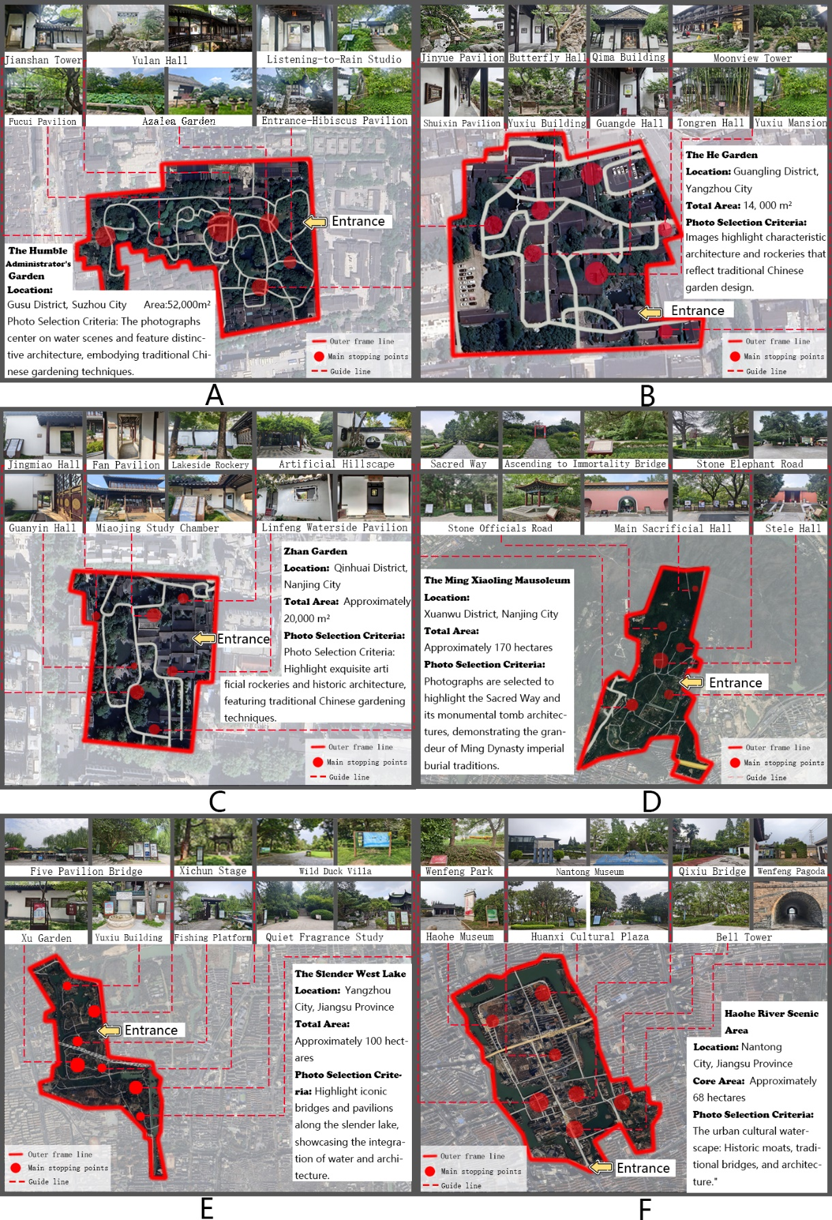
Fig. A.1. Survey route map. (A: Humble Administrator’s Garden; B: He Garden; C: Zhan Garden; D: Ming Xiaoling Mausoleum Scenic Area; E: Slender West Lake Scenic Area; F: Hao River Scenic Area)

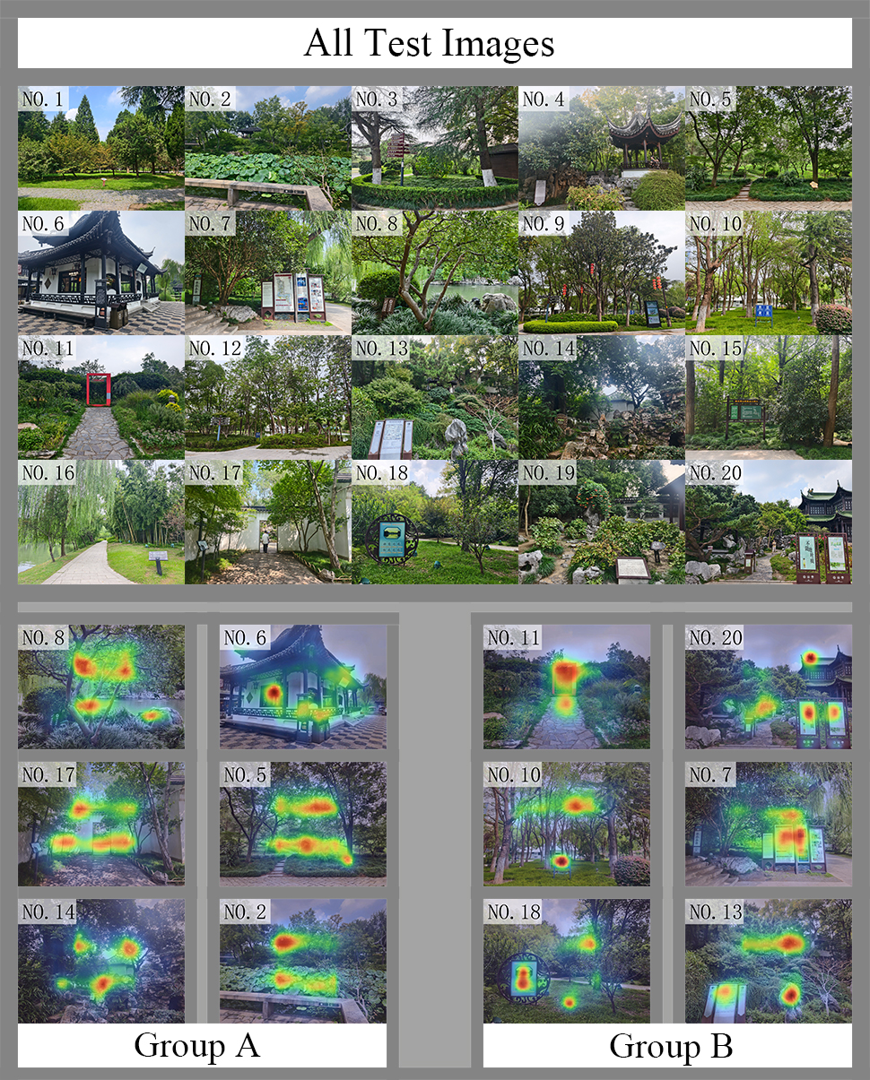
Fig.A.2. Eye tracking result analysis

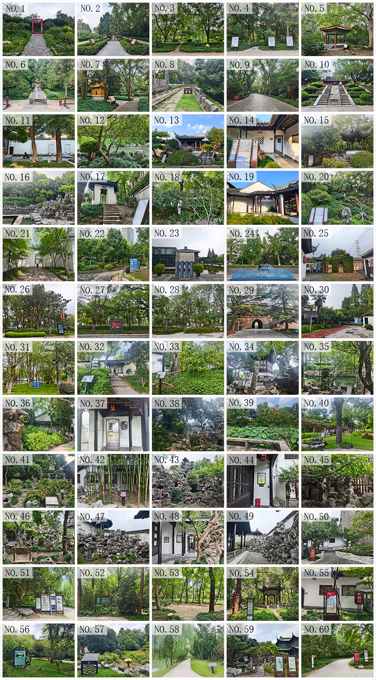
Fig.A.3. Image numbering

Table A.2 Statistics of signage information
Serial Number | Type | Quantity | Area Proportion | Whether Entering Key Sight | Distance from Core Scenic Spots | Affiliated Park
1 | Commercial Advertisements | 1 | 5% | Yes | 10 meters | Ming Xiaoling Mausoleum
2 | Interpretive Panels | 2 | 3% | Yes | 10 meters | Ming Xiaoling Mausoleum
3 | Warning Signs | 1 | 0.5% | No | 15 meters | Ming Xiaoling Mausoleum
4 | Interpretive Panels | 3 | 4% | Yes | 5 meters | Ming Xiaoling Mausoleum
5 | Interpretive Panels | 1 | 2% | No | 8 meters | Ming Xiaoling Mausoleum
6 | Warning Signs | 2 | 1% | Yes | 3 meters | Ming Xiaoling Mausoleum
7 | Interpretive Panels | 1 | 3% | Yes | 5 meters | Ming Xiaoling Mausoleum
8 | Warning Signs | 1 | 2% | Yes | 2 meters | Ming Xiaoling Mausoleum
9 | Guidance System | 2 | 1% | Yes | 50 meters | Ming Xiaoling Mausoleum
10 | Warning Signs | 6 | 1% | Yes | 3 meters | Ming Xiaoling Mausoleum
11 | Warning Signs | 2 | 0.5% | No | 5 meters | Zhan Garden
12 | Warning Signs | 2 | 1% | No | 8 meters | Zhan Garden
13 | Interpretive Panels | 1 | 2% | No | 3 meters | Zhan Garden
14 | Interpretive Panels | 4 | 10% | Yes | 2 meters | Zhan Garden
15 | Interpretive Panels | 1 | 3% | No | 2 meters | Zhan Garden
16 | Warning Signs | 1 | 0.3% | No | 10 meters | Zhan Garden
17 | Interpretive Panels | 1 | 4% | Yes | 1 meter | Zhan Garden
18 | Guidance System | 1 | 1% | No | 15 meters | Zhan Garden
19 | Guidance System | 1 | 0.5% | No | 5 meters | Zhan Garden
20 | Interpretive Panels | 1 | 8% | Yes | 3 meters | Zhan Garden
21 | Guidance System | 1 | 3% | Yes | 15 meters | Haohe Scenic Area
22 | Warning Signs | 2 | 1.5% | Yes | 5 meters | Haohe Scenic Area
23 | Commercial Advertisements | 1 | 15% | Yes | 2 meters | Haohe Scenic Area
24 | Commercial Advertisements | 1 | 20% | Yes | 1 meter | Haohe Scenic Area
25 | Interpretive Panels | 6 | 3% | No | 3 meters | Haohe Scenic Area
26 | Guidance System | 2 | 4.5% | Yes | 8 meters | Haohe Scenic Area
27 | Commercial Advertisements | 1 | 5% | Yes | 10 meters | Haohe Scenic Area
28 | Guidance System | 1 | 1% | No | 6 meters | Haohe Scenic Area
29 | Interpretive Panels | 3 | 0.5% | No | 2 meters | Haohe Scenic Area
30 | Guidance System | 3 | 3.5% | Yes | 4 meters | Haohe Scenic Area
31 | Guidance System | 1 | 2.3% | No | 3 meters | Humble Administrator's Garden
32 | Guidance System | 1 | 4.5% | Yes | 2 meters | Humble Administrator's Garden
33 | Guidance System | 1 | 3.5% | Yes | 2 meters | Humble Administrator's Garden
34 | Warning Signs | 1 | 1% | No | 1 meter | Humble Administrator's Garden
35 | Guidance System | 1 | 6% | Yes | 5 meters | Humble Administrator's Garden
36 | Warning Signs | 1 | 0.2% | No | 3 meters | Humble Administrator's Garden
37 | Guidance System | 1 | 2% | No | 1 meter | Humble Administrator's Garden
38 | Warning Signs | 1 | 0.3% | No | 4 meters | Humble Administrator's Garden
39 | Warning Signs | 2 | 0.3% | No | 1 meter | Humble Administrator's Garden
40 | Warning Signs | 1 | 1% | No | 8 meters | Humble Administrator's Garden
41 | Interpretive Panels | 2 | 5% | Yes | 1 meter | He Garden
42 | Warning Signs | 1 | 2% | Yes | 2 meters | He Garden
43 | Warning Signs | 1 | 0.3% | No | 1 meter | He Garden
44 | Warning Signs | 2 | 3.5% | Yes | 2 meters | He Garden
45 | Warning Signs | 1 | 0.2% | No | 1 meter | He Garden
46 | Warning Signs | 2 | 4% | Yes | 2 meters | He Garden
47 | Warning Signs | 1 | 1% | No | 3 meters | He Garden
48 | Warning Signs | 2 | 3% | No | 3 meters | He Garden
49 | Warning Signs | 1 | 0.2% | No | 1 meter | He Garden
50 | Guidance System | 1 | 5% | Yes | 5 meters | He Garden
51 | Interpretive Panels | 5 | 19% | Yes | 3 meters | Slender West Lake
52 | Commercial Advertisements | 1 | 7% | Yes | 5 meters | Slender West Lake
53 | Guidance System | 1 | 1% | Yes | 2 meters | Slender West Lake
54 | Guidance System | 2 | 6.5% | Yes | 4 meters | Slender West Lake
55 | Warning Signs | 2 | 11% | Yes | 2 meters | Slender West Lake
56 | Warning Signs | 1 | 8% | Yes | 10 meters | Slender West Lake
57 | Interpretive Panels | 2 | 7% | Yes | 1 meter | Slender West Lake
58 | Guidance System | 1 | 1% | No | 5 meters | Slender West Lake
59 | Warning Signs | 2 | 6% | Yes | 3 meters | Slender West Lake
60 | Guidance System | 3 | 7% | Yes | 4 meters | Slender West Lake
Note: Signage dimensions were estimated after measurement with a tape measure, and distances were measured by pacing.
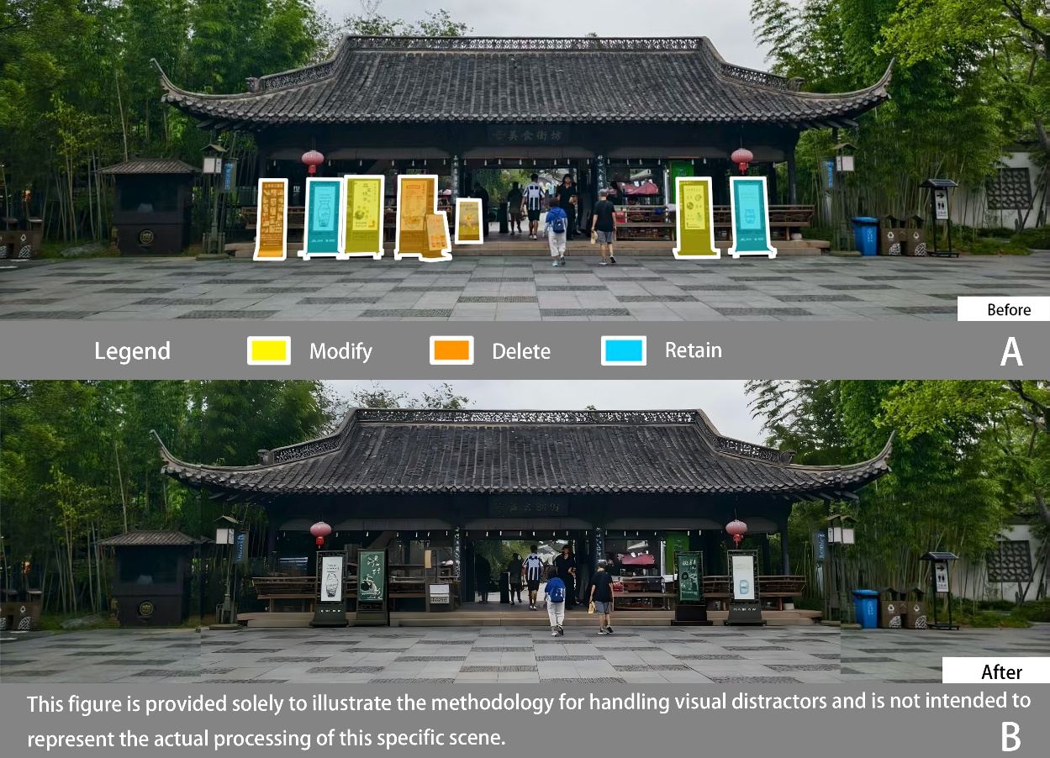
Fig. A.4. Legend Explanation (A is the original image, B is the modified image.)
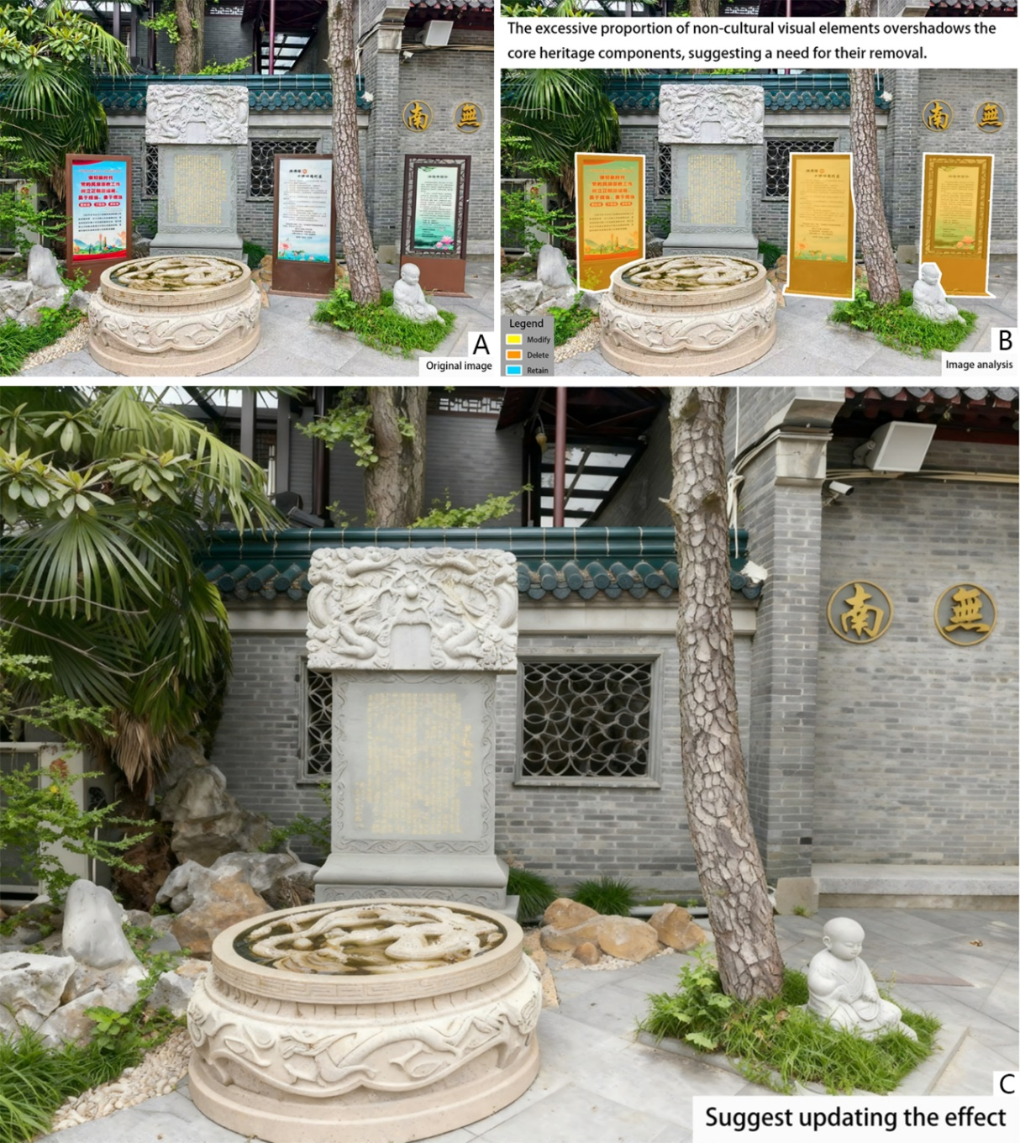
Fig.A.5. Analysis of the stele and surrounding non-cultural elements in the Slender West Lake Scenic Area (A is the original image, B is the analysis image, C is the proposed effect image.)

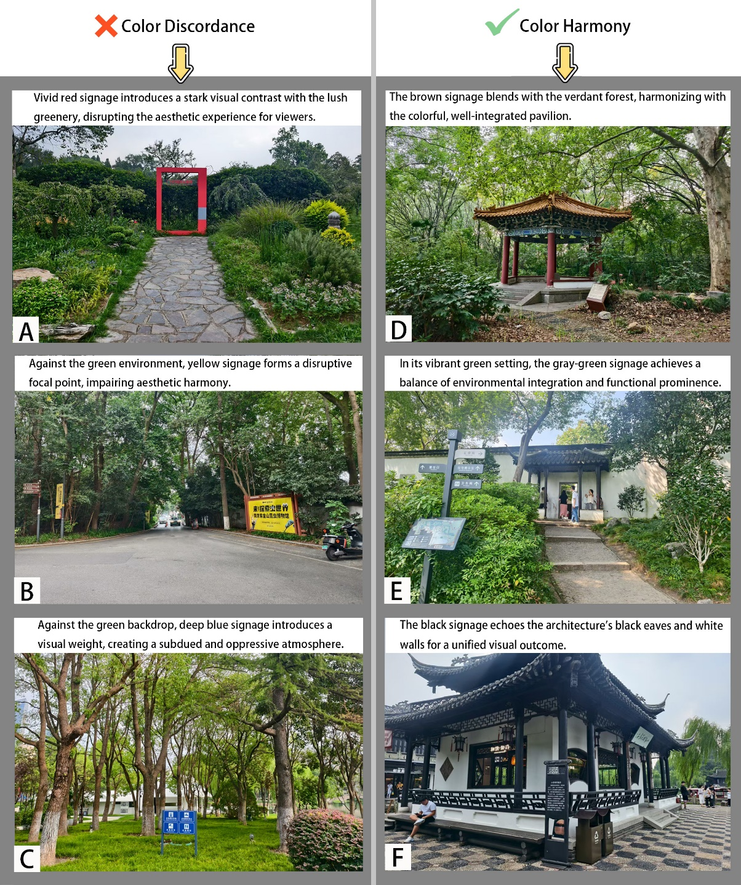
Fig.A.6. Diagram illustrating grouping by color harmony (A–C show color disharmony, while D–F show color harmony.)

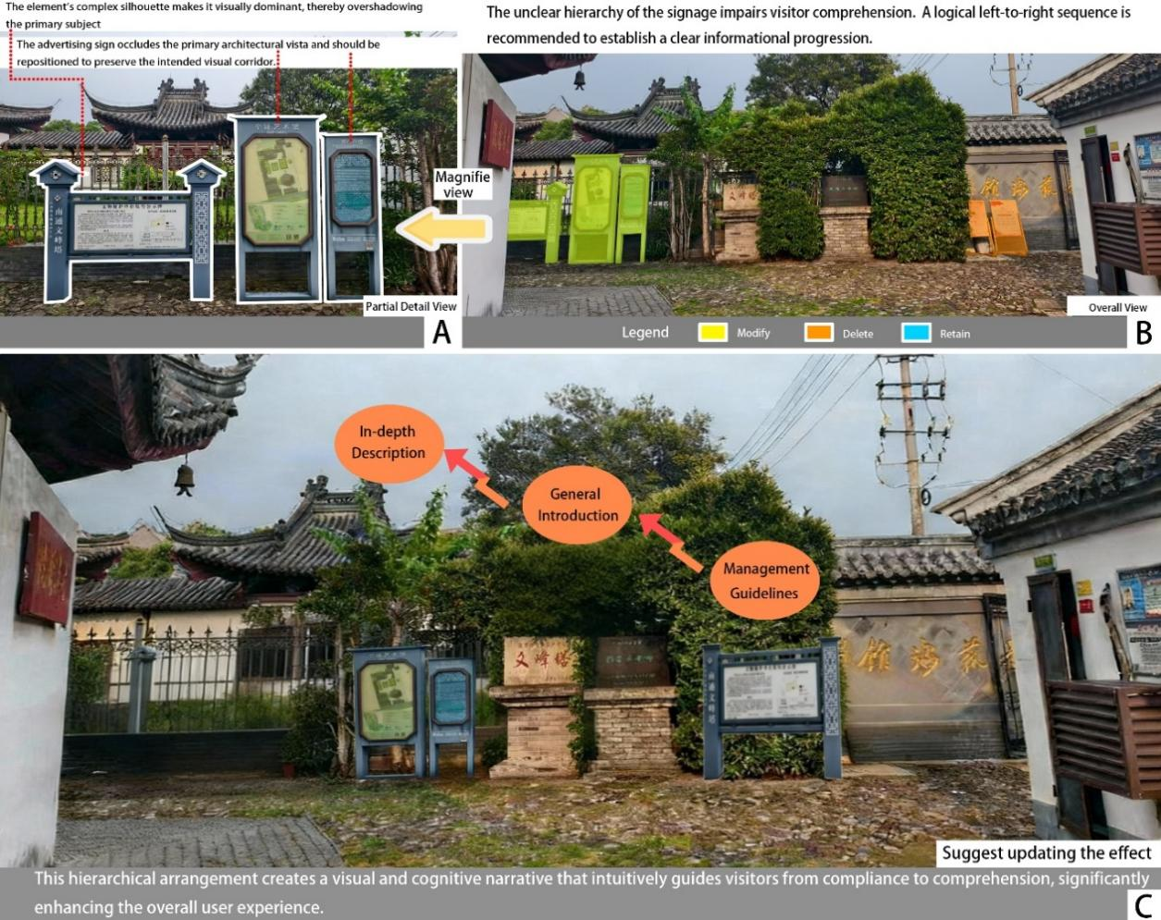
Fig.A.7. Analysis of the entrance signage at Wenfeng Pagoda in the Haohe Scenic Area (A is the original image, B is the analysis image, C is the proposed effect image.)

Table A.3 Interview survey questions
Categories | Classification | Question Title
Attitudes towards visitor reviews: Q1-Q2  The relationship between Visual interference elements and visitors’ experience: Q3, Q4, Q7, Q8  Industry developments and issues: Q5, Q6 | Common questions | Q1: Do you pay attention to the visitor experience of classical gardens? Is the result satisfactory?
 | Common questions | Q2: For gardens with rich historical and cultural heritage, what aspects of evaluations from visitors and online reviews do you most expect to receive? What aspects of negative reviews do you care about the most?
 | Common questions | Q3: Currently, there are a large number of guide signs, commercial advertisements, and warning slogans in classical gardens. Have these elements had a significant impact on visitors' ways of visiting and experiencing? What are the main aspects most severely affected in your opinion?
 | Common questions | Q4: Could you please elaborate on what the interference dimensions of these visual elements are?
 | Managers-only questions | Q5: What is your view on the necessity of setting up these elements? What role do they play in garden management?
 | Managers-only questions | Q6: As a manager, do you anticipate new changes or reforms in the presentation methods of these guide systems, warning slogans, and commercial advertisements in the next five years?
 | Designers-only questions | Q7: What do you think is the biggest difficulty in designing these elements? What are the design priorities?
 | Designers-only questions | Q8: As a designer, what aspects of feedback from visitors regarding the aforementioned visual interference elements do you most hope to receive?

Table A.4 Interview Table for Managers
Category | Summary of Responses | Consensus View | Individual View
Common Questions | Q1: A1: Yes. But I feel the feedback obtained is rather limited.  A2: Yes. The quantity and quality of feedback need improvement.  A3: Same as above  Q2: A1: Expectation: Overall historical and cultural atmosphere.  Negative aspects: Whether commercial elements affect the experience.  A2: Expectation: Historical and cultural display methods.  Negative aspects: Whether the guide is clear.  A3: Expectation: Same as above.  Negative aspects: Whether there are potential safety hazards.  Q3: A1: Yes. The historical atmosphere is damaged.  A2: Yes. It distracts attention from scenery and culture.  A3: Yes. The overall impression is overly commercialized.  Q4: A1: Quantity, color, tone.  A2: Spatial shape, style.  A3: Information hierarchy, context. | Q1: Visitor experience surveys have been conducted, but they are incomplete.  Q2: Expect visitors’ evaluations related to the garden’s historical culture; care about negative reviews regarding commerce, guidance, and safety hazards.  Q3: These elements have a significant impact on visitor experience, affecting aspects like historical atmosphere and attention.  Q4: The interference dimensions of visual elements include quantity, color, shape, space, information hierarchy, and context. | Q1: Only focus on negative feedback comments.  Q2: Create a historical atmosphere.  Q3: Distracts attention, with slight impacts.  Q4: Aspects of quantity, volume, and spatial density distribution.
Manager-Exclusive Questions | Q5: A1: Necessary. It provides economic support.  A2: Necessary. It helps establish order.  A3: Necessary. It conveys cultural information.  Q6: A1: Yes. It will be intelligent and more concealed in form.  A2: Yes. It will be more aesthetic, unified in style, use eco-friendly materials, and have artistic modeling.  A3: Probably yes. Reduce quantity while improving quality, and implement precise delivery. | Q5: Guide signs, commercial advertisements, and warning slogans are necessary; they play roles in visiting, safety, and operation.  Q6: It is expected that the presentation methods of guide systems, commercial advertisements, and warning slogans will change—becoming more intelligent, and integrating culture and environmental protection. | Q1: None.  Q2: Focus on intellectualization.

Table A.5 Interview Table for Designers
Category | Summary of Responses | Consensus View | Individual View
Common Questions | Q1: B1: Yes. Not satisfied; visitor experience needs improvement.  B2: Yes. Failed to meet expected results.  B3: Same as above  Q2: B1: Expectation: Integration degree of visual elements with historical culture.  Negative aspects: Inconsistent design of visual elements.  B2: Expectation: Whether visual elements conform to historical and cultural ambiance.  Negative aspects: Visual elements damage the aesthetic feeling of the garden.  B3: Expectation: Visual elements convey historical and cultural information.  Negative aspects: Visual interference experience.  Q3: B1: Yes. Immersive experience.  B2: Yes. Destroys the overall visual perception.  B3: Yes. Interferes with the effective transmission of cultural information.  Q4: B1: Quantity and volume.  B2: Color and tone.  B3: Information hierarchy, text tone. | Q1: Pay attention to visitor experience; the result is unsatisfactory.  Q2: Expect visitors’ evaluations on the integration of visual elements with historical culture; care about negative reviews related to visual element design, aesthetic feeling, and interference.  Q3: These elements have a significant impact on visitor experience, affecting immersive experience, visual aesthetic feeling, cultural understanding, etc.  Q4: The interference dimensions of visual elements include quantity, shape, space, information hierarchy, context, etc. | Q1: None.  Q2: Aspect of element design.  Q3: None.  Q4: Aspect related to color.
Designer-Exclusive Questions | Q7: B1: Difficulty: Meeting functional needs while highly aligning elements with the garden’s historical and cultural requirements.  Priority: Integrate visual elements into the garden and convey information clearly.  B2: Difficulty: Balancing design and management.  Priority: Spatial position and volume, coordination.  B3: Difficulty: Avoiding a sense of disharmony.  Priority: Enhance cultural connotation and artistic aesthetic feeling.  Q8: B1: Matching degree of shape and style, color coordination degree.  B2: Spatial layout, clarity of information transmission.  B3: Visual elements that cause specific interference experiences. | Q7: The biggest difficulty is aligning visual elements with the style of classical gardens, balancing function and style, etc.; design priorities include integrating elements into the garden, conveying information clearly, and controlling space coordination, etc.  Q8: Hope to receive visitors’ feedback on visual element modeling, color, spatial layout, information transmission, etc. | Q7: None.  Q8: None.

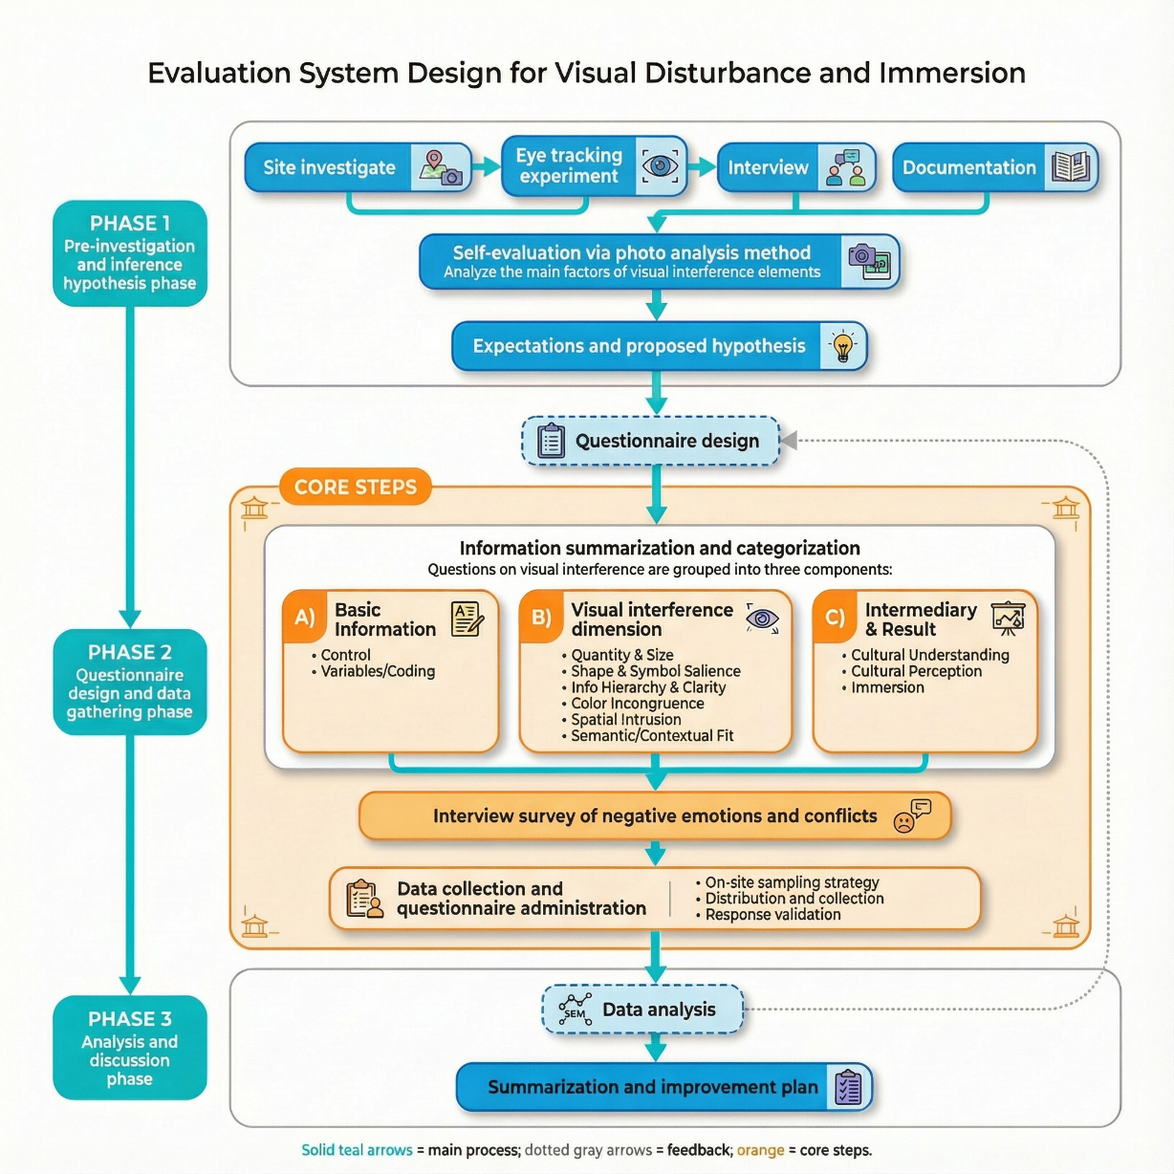
Fig.A.8. Framework and procedures of the evaluation system

Table A.6 Questionnaire survey
Categories |  | Question Title
Basic information of tourists: Q1-Q5 |  | Q1: Is this your first visit to this heritage site?
 |  | Q2: How familiar are you with the history and culture of this heritage site? On a scale of 1 to 5, how would you rate your knowledge?
 |  | Q3: What is your main purpose for visiting today? (Multiple choices allowed)
 |  | Q4: How long do you plan to stay here?
 |  | Q5: Which specific site/location are you evaluating currently?
The impact of the six major factors of visual interference elements on cultural understanding and cultural perception: Q6-Q17 | Quantity/Scale | Q6: There are too many signs/panels unrelated to the culture here, which distract my attention.
 | Quantity/Scale | Q7: Some signs/facilities are too large, obscuring key cultural information.
 | Shape/Symbol salience | Q8: The design of certain signs/installations is too eye-catching, interrupting the perception of the traditional landscape.
 | Shape/Symbol salience | Q9: The style of the icons/graphics on site is inconsistent with traditional patterns, which breaks my immersion.
 | Information hierarchy/Priority | Q10: Directional, warning, and explanatory information are mixed together, making the hierarchy unclear.
 | Information hierarchy/Priority | Q11: The existing information is presented with clear hierarchy, helping me understand the key cultural points.
 | Color discordance | Q12: The colors of some signs/installations are too bright or reflective, disrupting the overall color tone.
 | Color discordance | Q13: These colors do not match my expectations of the traditional colors for this heritage site.
 | Spatial intrusion/Occlusion | Q14: Irrelevant elements appear within key sightlines/main axes/framed views, affecting appreciation.
 | Spatial intrusion/Occlusion | Q15: These elements are too close to the core features or at an inappropriate height, causing obstruction.
 | Contextual consistency | Q16: The wording/translations/tone of the signage are not appropriate for the context, affecting my understanding of the historical information.
 | Contextual consistency | Q17: The cultural expression in the explanations and icons is appropriate and consistent with the site's character.
Tourists' evaluations of cultural understanding, cultural perception, and immersive experience: Q18-Q27 | Cultural understanding (CU) | Q18: I can accurately grasp the historical semantics and symbolic meanings presented here.
 | Cultural understanding (CU) | Q19: I can follow a clear narrative thread to understand the cultural theme of this landscape.
 | Cultural understanding (CU) | Q20: The on-site information does not cause me ambiguity or misinterpretation.
 | Cultural perception (CP) | Q21: I feel the cultural atmosphere is unified and internally consistent.
 | Cultural perception (CP) | Q22: The spirit of the place / artistic conception is clearly expressed, making it easy for me to form an overall impression.
 | Cultural perception (CP) | Q23: The visual language is harmonious with the environment, without a noticeable sense of incongruity.
 | Immersion (IM) | Q24: I remain focused during my viewing and am not easily interrupted.
 | Immersion (IM) | Q25: I can easily imagine myself in the relevant historical context.
 | Immersion (IM) | Q26: Modern functional elements do not significantly disrupt my sense of presence/immersion.
 | Immersion (IM) | Q27: Overall, I feel engaged and willing to stay longer.

Table A.7
Cronbach’s α reliability results for each dimension and the overall scale
Dimension | Scope of Questions | Cronbach’s α
Quantity/Scale | Q6–Q7 | 0.883
Shape/Symbol salience | Q8–Q9 | 0.873
Information hierarchy/Priority | Q10–Q11 | 0.920
Color discordance | Q12–Q13 | 0.870
Spatial intrusion/Occlusion | Q14–Q15 | 0.890
Contextual consistency | Q16–Q17 | 0.936
Cultural understanding (CU) | Q18–Q20 | 0.827
Cultural perception (CP) | Q21–Q23 | 0.926
Immersion (IM) | Q24–Q27 | 0.928
Total Quantity Table | Q6–Q27 | 0.825

Table A.8 KMO and Bartlett sphericity test results
Test indicator | Value | Criteria for judgment | Conclusion
KMO | 0.929 | >0.90 excellent | The data is very suitable for factor analysis
Bartlett’s χ² | 6884.95 | p < 0.001 significant | Reject null hypothesis, suitable for factor analysis
df | 231 | — | —
p | <0.001 | <0.05 significant | Confirm suitability for factor analysis

Table A.9 Preliminary results of the exploratory factor analysis (EFA)
Indicator | Value / Result
Extraction method | PCA (principal component analysis) with Varimax rotation
Number of factors (Kaiser criterion) | 2
Eigenvalues (first two) | 10.59; 4.59
Variance explained | Factor 1: 48.13%; Factor 2: 20.87%
Cumulative variance explained (first two factors) | 69.00%
Major loadings of Factor 1 | Q6–Q17 (Visual disturbance items; Q11 & Q17 are reverse-scored in the dataset)
Major loadings of Factor 2 | Q18–Q27 (Understanding, Perception, and Immersion items)

Table A.10 Results of the confirmatory factor analysis (CFA) measurement model
Latent factor | Observed variable | Standardized factor loading | t | CR | AVE
Visual Disturbance (VD) | Q6 | 0.72 | 11.35
Visual Disturbance (VD) | Q7 | 0.75 | 12.02
Visual Disturbance (VD) | Q8 | 0.70 | 10.88
Visual Disturbance (VD) | Q9 | 0.73 | 11.45
Visual Disturbance (VD) | Q10 | 0.68 | 10.22
Visual Disturbance (VD) | Q11 (R) | 0.65 | 9.87
Visual Disturbance (VD) | Q12 | 0.74 | 11.92
Visual Disturbance (VD) | Q13 | 0.76 | 12.08
Visual Disturbance (VD) | Q14 | 0.71 | 11.02
Visual Disturbance (VD) | Q15 | 0.70 | 10.84
Visual Disturbance (VD) | Q16 | 0.73 | 11.37
Visual Disturbance (VD) | Q17 (R) | 0.69 | 10.75 | 0.93 | 0.58
CU | Q18 | 0.78 | 12.55
CU | Q19 | 0.80 | 12.88
CU | Q20 | 0.77 | 12.23 | 0.88 | 0.61
CP | Q21 | 0.82 | 13.40
CP | Q22 | 0.90 | 14.72
CP | Q23 | 0.85 | 13.96 | 0.92 | 0.73
IM | Q24 | 0.84 | 13.75
IM | Q25 | 0.88 | 14.20
IM | Q26 | 0.86 | 13.88
IM | Q27 | 0.85 | 13.67 | 0.93 | 0.72

Table A.11 Comparison of fit indices across different models
Model type | χ² | df | χ²/df | CFI | TLI | RMSEA | SRMR
Direct-effect mode | 500.8 | 208 | 2.41 | 0.901 | 0.882 | 0.078 | 0.067
Full mediation model | 480.3 | 199 | 2.41 | 0.923 | 0.910 | 0.062 | 0.053
Partial mediation model | 478.0 | 198 | 2.38 | 0.934 | 0.921 | 0.059 | 0.050

Table A.12Theoretical findings, supporting data, and implications
Theoretical finding | Supporting data | Theoretical implication
Visual disturbance reduces cultural experience overall | VD → CP: β = −0.32 (p < 0.01) \nVD → CU: β = −0.25 (p < 0.01) | Visitors do not evaluate individual disturbance types separately but perceive an overall disruption of cultural atmosphere and narrative coherence.
Cultural perception and cultural understanding enhance immersion | CP → IM: β = 0.40 (p < 0.001) \nCU → IM: β = 0.30 (p < 0.001) | The formation of immersion relies on dual processing, involving both atmospheric perception and narrative understanding.
The direct effect of visual disturbance is limited | VD → IM: β = −0.15 (p < 0.05) | Although disturbance has a direct disruptive effect, most of the loss occurs through its erosion of the mediating processes.
The mediation effects are significantly established | Indirect effect: \nCP −0.13 (CI = [−0.21, −0.07]) \nCU −0.08 (CI = [−0.15, −0.03]) | The decline in immersion results from combined degradation across both cognitive and perceptual dimensions.
The overall effect is significantly negative | Total effect: \nβ = −0.36 (p < 0.001) | Visual impurities significantly weaken immersion, underscoring the need for visual environment management in heritage conservation and experience enhancement.

Table A.13 Descriptive statistics and correlations among core constructs
Variable | Mean | SD | 1 | 2 | 3 | 4
1. VD | 2.72 | 0.82 | 1.000
2. CU | 3.43 | 0.79 | -0.267*** | 1.000
3. CP | 3.44 | 0.91 | -0.396*** | 0.759*** | 1.000
4. IM | 3.40 | 0.88 | -0.401*** | 0.748*** | 0.846*** | 1.000
Note: Pearson correlations. *** p < 0.001.

Table A.14 Scenario based differences across six scenarios
Scenario | n | VD | CU | CP | IM
1 | 42 | 2.08 ± 0.84 | 3.78 ± 0.88 | 4.04 ± 0.80 | 3.98 ± 0.76
2 | 37 | 2.82 ± 0.60 | 3.38 ± 0.75 | 3.47 ± 0.76 | 3.44 ± 0.73
3 | 38 | 3.02 ± 0.76 | 3.12 ± 0.68 | 3.12 ± 0.79 | 3.02 ± 0.75
4 | 42 | 2.37 ± 1.03 | 3.48 ± 0.87 | 3.56 ± 1.11 | 3.58 ± 1.11
5 | 83 | 2.80 ± 0.80 | 3.54 ± 0.82 | 3.44 ± 0.92 | 3.47 ± 0.87
6 | 83 | 2.97 ± 0.58 | 3.28 ± 0.63 | 3.20 ± 0.81 | 3.12 ± 0.75
Note: One way ANOVA indicates significant between scenario differences for all constructs:
VD: F(5,319) = 10.87, p < 0.001, η² = 0.146; CU: F(5,319) = 4.00, p = 0.002, η² = 0.059;
CP: F(5,319) = 6.32, p < 0.001, η² = 0.090; IM: F(5,319) = 8.04, p < 0.001, η² = 0.112.

