Structure of glycine N-acyltransferase clarifies its catalytic mechanism

Ana C. Ebrecht¹, Christoffel P.S. Badenhorst², Randy J. Read³, Diederik J. Opperman⁴, Alberdina A. van Dijk¹*
¹ Biochemistry Department, Focus Area Human Metabolomics, North-West University, Potchefstroom, South Africa
²Institute of Biochemistry, Department of Biotechnology and Enzyme Catalysis, Greifswald University, Germany
³Department of Haematology, Cambridge Institute for Medical Research, University of Cambridge, United Kingdom
⁴Department of Microbiology and Biochemistry, University of the Free State, Bloemfontein, South Africa
* albie.vandijk@nwu.ac.za

Supplementary Table 1. X-ray data collection and refinement parameters
Data collection | S-SAD | Native1 | Native2 | Benzoyl-CoA
Beamline DSL | I23 | I03 | I03 | I03
Wavelength (Å) | 2.755 | 0.9762 | 0.9762 | 0.9762
Space group | P 21 21 21 | P 21 21 21 | P 65 | P43 21 2
Cell dimensions a/b/c (Å) | 63.5/64.2/135.8 | 63.1/63.6/135.5 | 96.2/96.2/144.6 | 63.8/63.8/135.3
α/β/γ (°) | 90/90/90 | 90/90/90 | 90/90/120 | 90/90/90
Resolution (Å) | 58.09-1.80 | 37.37-1.25 | 48.09-1.65 | 46.44-1.50
Unique reflections | 48496 | 146849 | 99910 | 45806
Completeness (anomalous) (%) | 93 (86) | 97.5 | 96.7 | 100
I/sig(I) | 11.5 | 16.2 | 18.7 | 8.1
Multiplicity (anomalous) | 6.5 (3.6) | 6.8 | 7.9 | 12.5
R_{meas} (outer shell) | 0.089 (1.0) | 0.048 (2.3) | 0.049 (1.4) | 0.108 (2.4)
CC1/2 (CCano) | 1.0 (0.4) | 1.0 | 1.0 | 1.0
Molecules in ASU | 2 | 2 | 2 | 1
Refinement
R_{work}/R_{free} |  | 0.177/0.208 | 0.180/0.203 | 0.181/0.211
Number of residues modelled |  | 568 | 575 | 284
Average B-factor, all atoms (Å²) |  | 23.0 | 34.0 | 31.0
RMS Bond lengths |  | 0.014 | 0.016 | 0.015
RMS Bond angles |  | 1.79 | 1.87 | 1.77
Ramachandran outliers (%) |  | 0 | 0 | 0
MolProbity score |  | 1.55 | 1.55 | 1.20
Poor rotamers (%) |  | 0.53 | 0.92 | 1.5
Clash score, all atoms |  | 3.88 | 3.06 | 3.35
PDB ID |  | 7PK2 | 7PK1 | 7PK0
Supplementary Table 2. Naturally occurring GLYAT mutations affecting the enzyme’s activity

Mutant | Enzymatic Activity | Position | Interaction
Q61L | Decreased activity | β5 (N-terminus) | Central β-sheet  (N-terminus)  Interface between N- and C-terminal domains
R131H | Decreased affinity for benzoyl-CoA | β2 (N-terminus) | Central β-sheet  (N-terminus)  Interface between N- and C-terminal domains  β10 (active site)
N156S | Increased activity | α5-β6 loop  (C-terminus) | Phosphate moiety of benzoyl-CoA
F168L | Decreased activity and affinity for benzoyl-CoA | β7-β8 loop  (C-terminus) | P-loop
R199C | Decreased activity | α7 (C-terminus) | Active site  Interface between N- and C-terminal domains

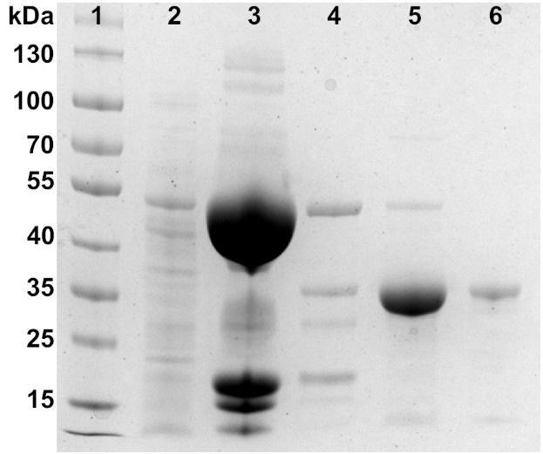

Supplementary Fig. 1 Purification of the bovine GLYAT used for crystallization. The enzyme was expressed as a fusion to a His-tagged SUMO peptide to improve solubility. High levels of soluble expression were obtained for the SUMO-GLYAT fusion. After cleavage with TEV protease, one glycine residue was added to the N-terminus of bGLYAT. An active bGLYAT was purified to near homogeneity, with an estimated yield of 10 mg per litre of culture. Lane 1: molecular weight marker, lane 2: crude extract loaded onto IMAC column, lane 3: purified SUMO-GLYAT fusion, lane 4: TEV protease cleavage of the fusion protein, lane 5: purified bGLYAT after IMAC, lane 6: purified bGLYAT after size exclusion chromatography.

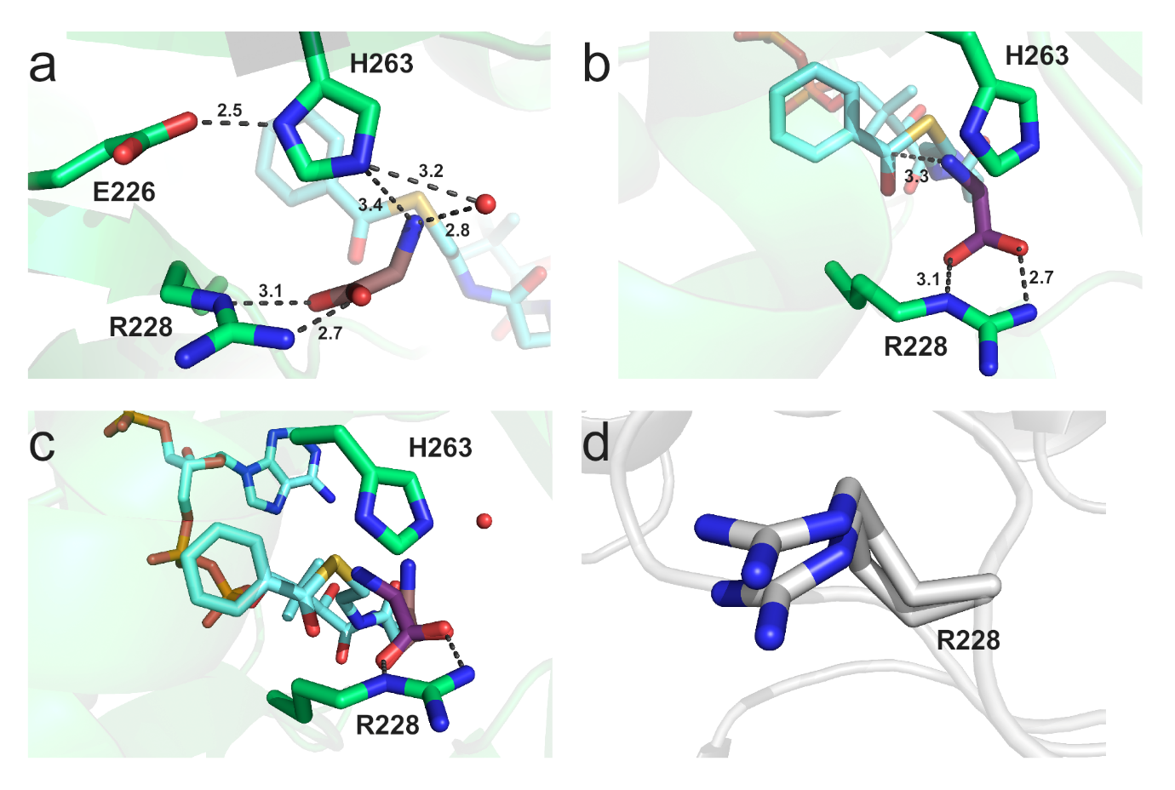
Supplementary Fig. 2 Binding of the acyl acceptor to the active site of bGLYAT. A glycine molecule (purple) was modelled in the position of the acetate bound to Arg228 in two different positions. A The amino group is pointing towards the putative catalytic water. The catalytic dyad (Glu226-His263) is shown pointing toward the substrates and all the distances are displayed. b The second conformation pointing towards the acyl donor is shown. The distance to the carbonyl thiol group is shown with dashed lines. c Superposition of the two conformations predicted for the glycine. The molecule is shown bound to the Arg228. d Different conformations of Arg228 found in one of the copies of the ASU in the apoenzyme structure.

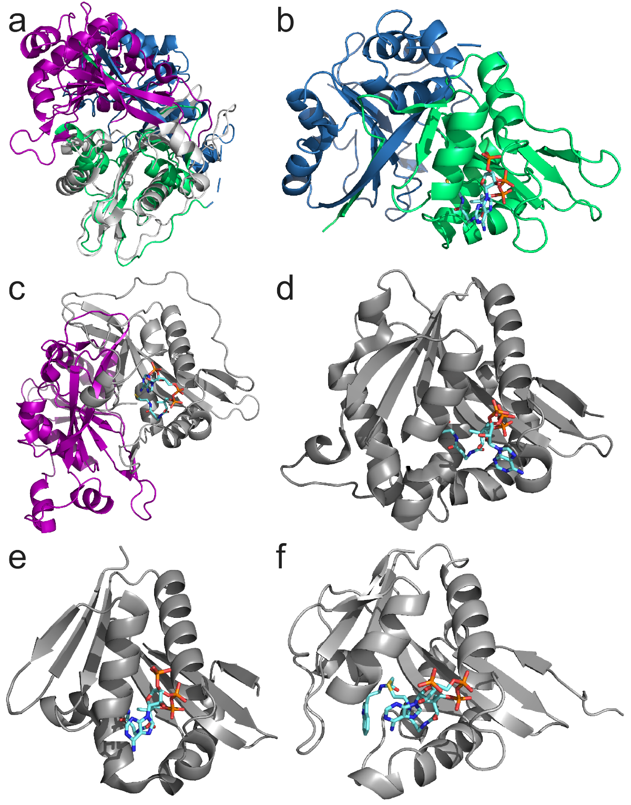
Supplementary Fig. 3 Structural comparison of bGLYAT to other GNAT enzymes. a Structural alignment of bGLYAT to human N-myristoyl transferase (PDB ID 6QRM, Cα RMSD 1.7 Å). The bGLYAT N-terminal domain is displayed in blue, and its C-terminal catalytic domain in green. N-myristoyl transferase is coloured in grey (N-terminal) and purple (C-terminal). b bGLYAT structure displaying the substrate benzoyl-CoA in cyan. c N-myristoyl transferase structure displaying the CoA molecule in cyan. d Drosophila Melanogaster dopamine N-acetyltransferase in complex with acetyl-CoA (3TE4, Cα RMSD 1.7 Å). e Sulfolobus solfataricus protein acetyltransferase (3F8K, Cα RMSD 1.3 Å). f Ovis aries serotonin N-acetyltransferase in complex with the bisubstrate analogue CoA-S-acetyl tryptamine (1CJW, Cα RMSD 1.6 Å).
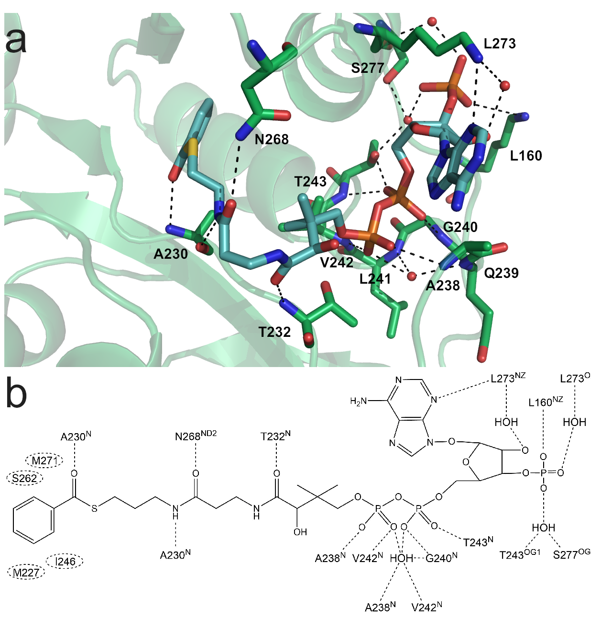
Supplementary Fig. 4 Interaction of benzoyl-CoA with the bGLYAT residues. a Residues from the active site interacting with the acyl donor are displayed. Water molecules are shown as red spheres and hydrogen bonds as black dashed lines. b Structural scheme of the benzoyl-CoA interactions with bGLYAT. Dashed lines indicate hydrogen bonds. Dashed circles show residues stabilizing the benzoyl ring through van der Waals and hydrophobic interactions.

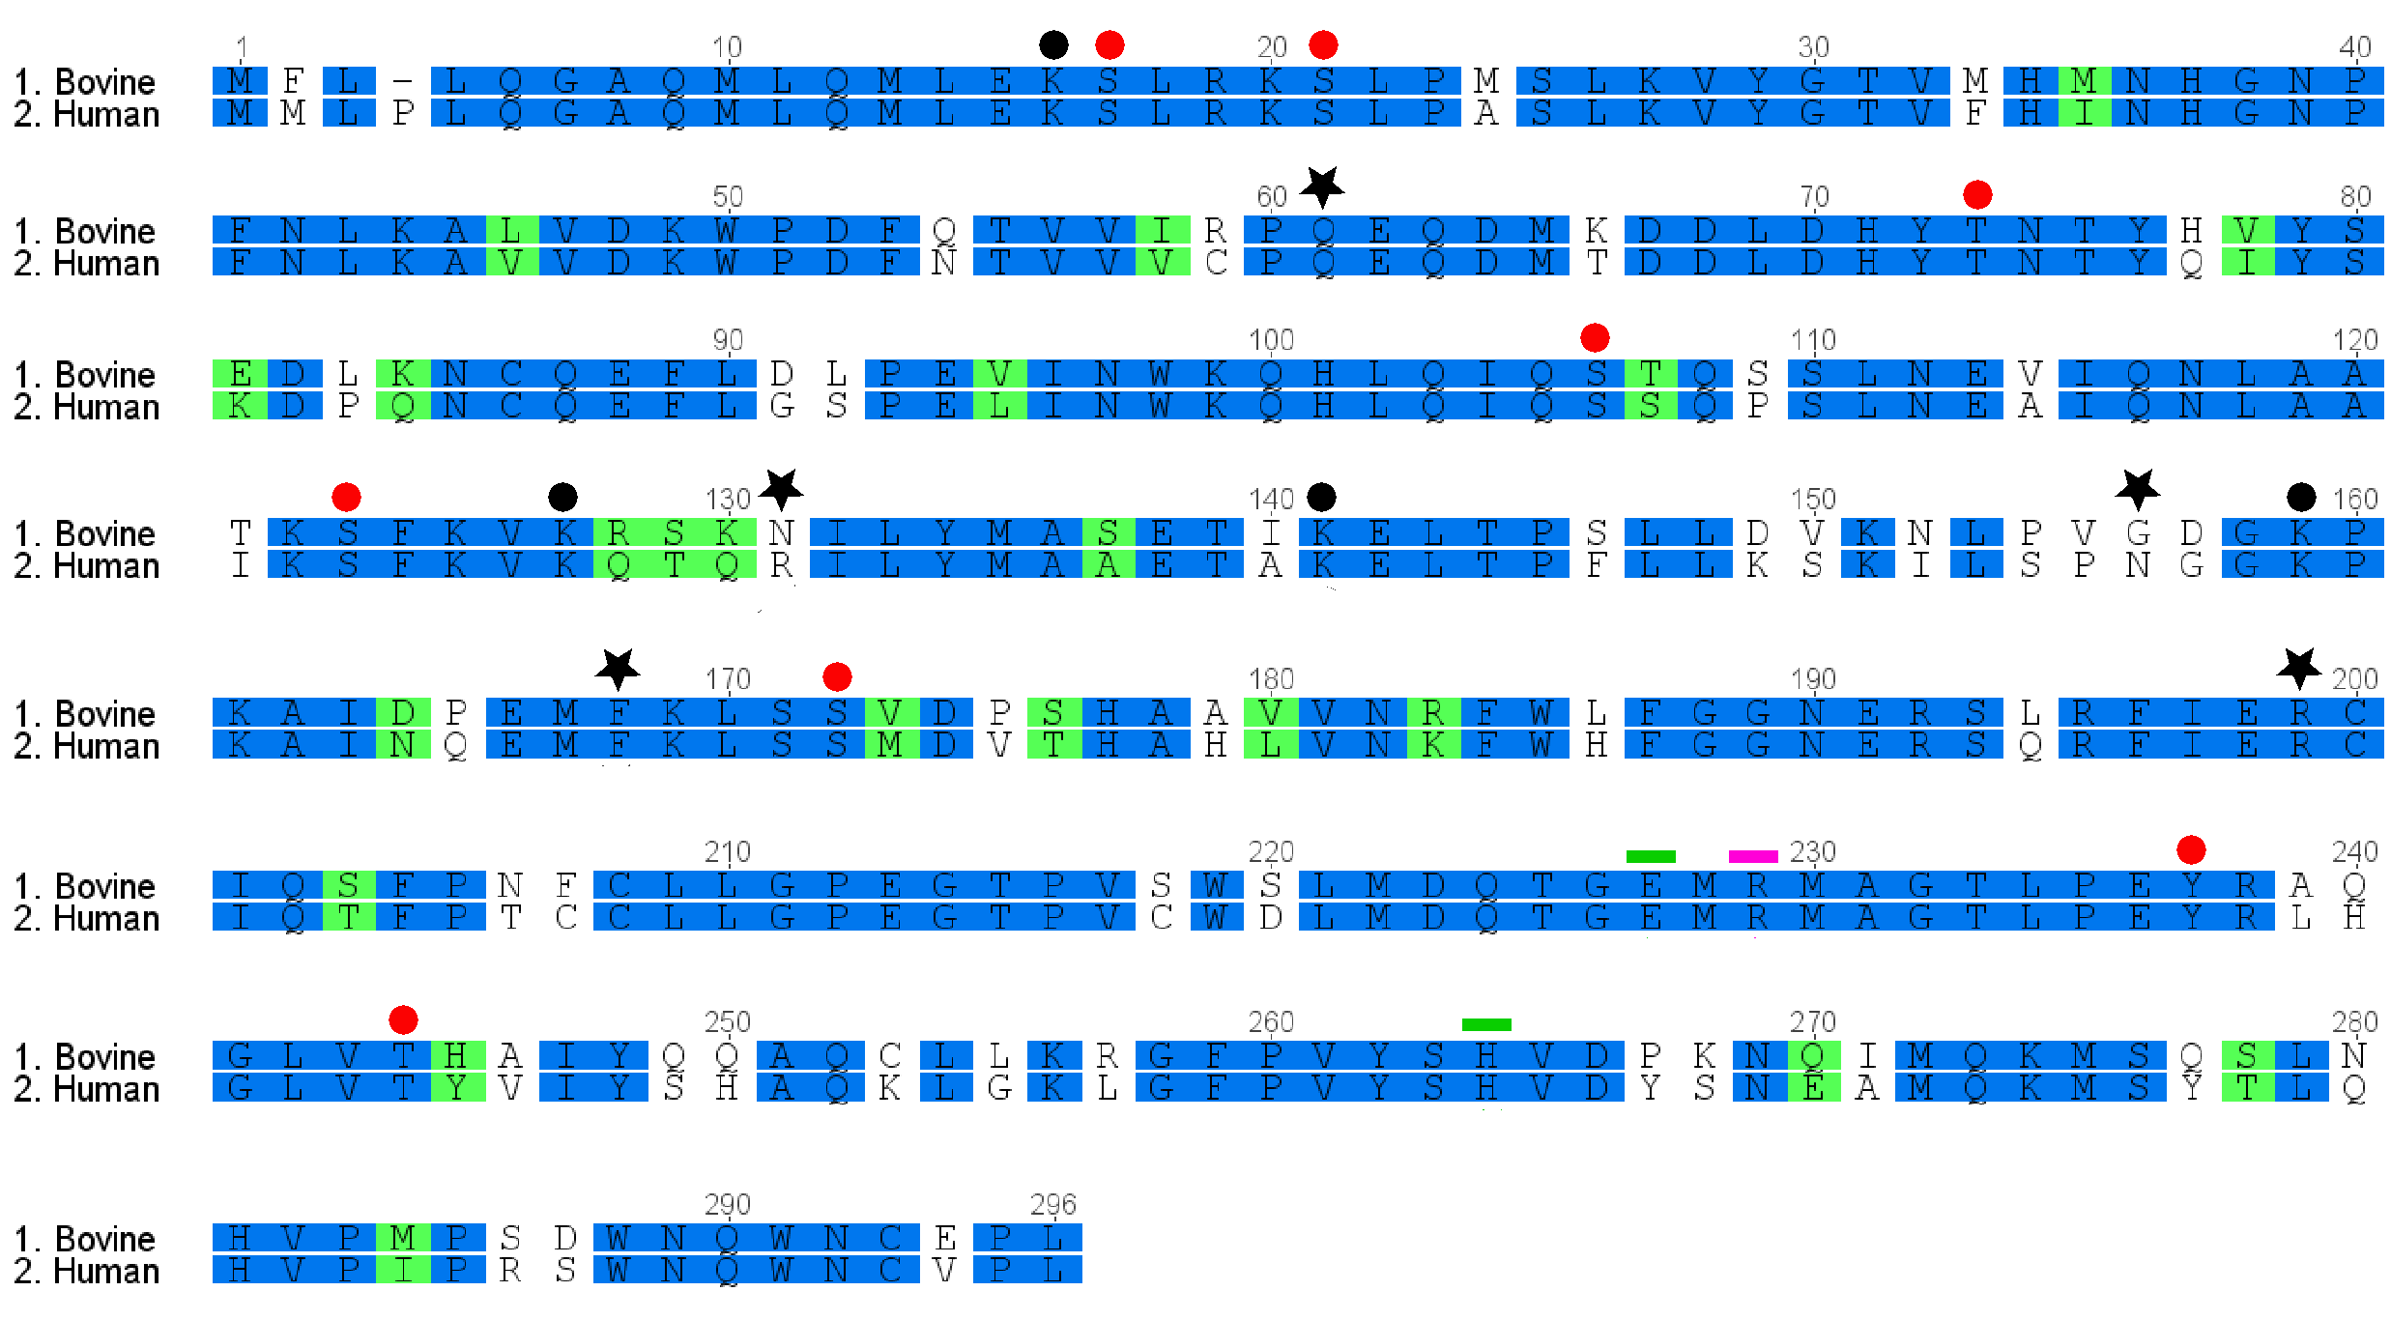Supplementary Fig. 6 Alignment of the bovine and human GLYAT sequences. Identical residues are shown in blue (76% pairwise identity) and similar residues in green (83% similarity). Important residues are marked in the alignment. Known mutations sites in human GLYAT are indicated with stars, the catalytic dyad with green lines, and putative glycine binding residue (Arg228) in pink. Putative lysine acetylation sites are marked with black circles and phosphorylation sites with red circles. Posttranslational modifications were predicted using the online tool GPS-PAIL¹ and GPS 5.0², respectively.
¹Deng, W., Wang, C., Zhang, Y. et al. GPS-PAIL: prediction of lysine acetyltransferase-specific modification sites from protein sequences. Sci. Rep. 6, 39787 (2016). DOI: 10.1038/srep39787
²Wang C, Xu H, Lin S, Deng W, Zhou J, Zhang Y, Shi Y, Peng D, Xue Y. GPS 5.0: An Update on the Prediction of Kinase-specific Phosphorylation Sites in Proteins. Genomics Proteomics Bioinformatics. 18(1):72-80 (2020). DOI: 10.1016/j.gpb.2020.01.001

