Supplementary figures and figure legends
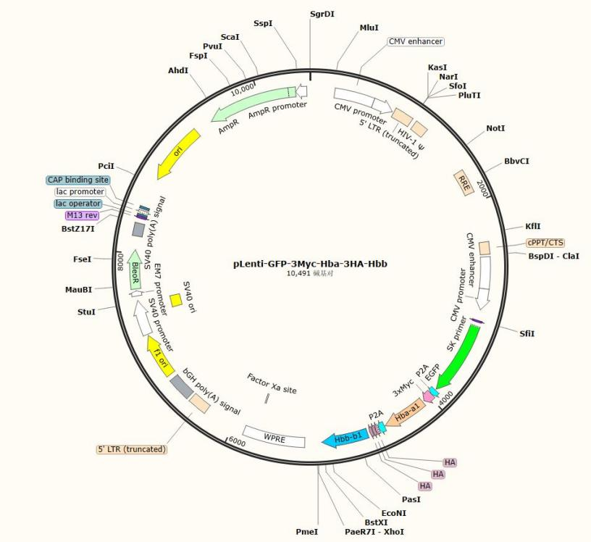
Supplementary Figure 1. Plasmid map of pLenti-GFP-3Myc-Hbα-3HA-Hbβ.

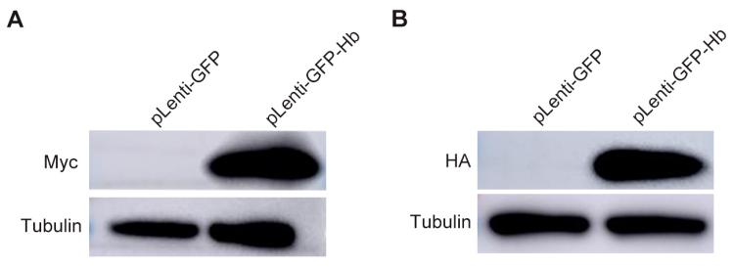
Supplementary Figure 2. Detection of hemoglobin α and β subunits expression by Western blot. (A-B) Western blot analysis of hemoglobin α and β using anti-Myc (A) and Anti-HA (B) antibodies .

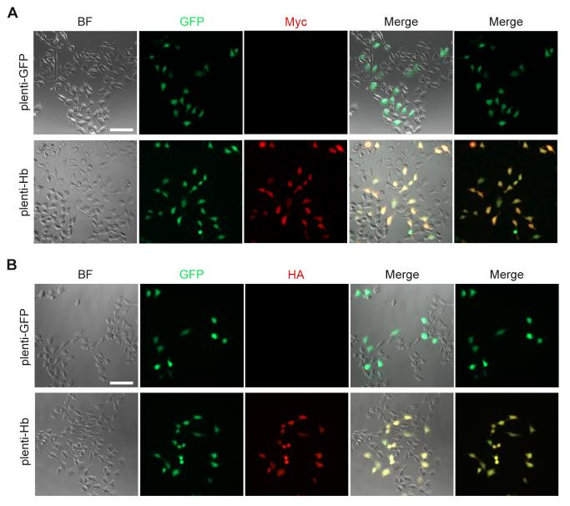
Supplementary Figure 3. Detection of hemoglobin α and β subunits expression by immunofluorescence staining. (A-B) Immunofluorescence staining of hemoglobin α and β using anti- Myc (A) and anti-HA (B) antibodies in infected HEK293 cells.

Supplementary Figure 4. Detection of hemoglobin expression in selected monoclonal cell lines by western blot.

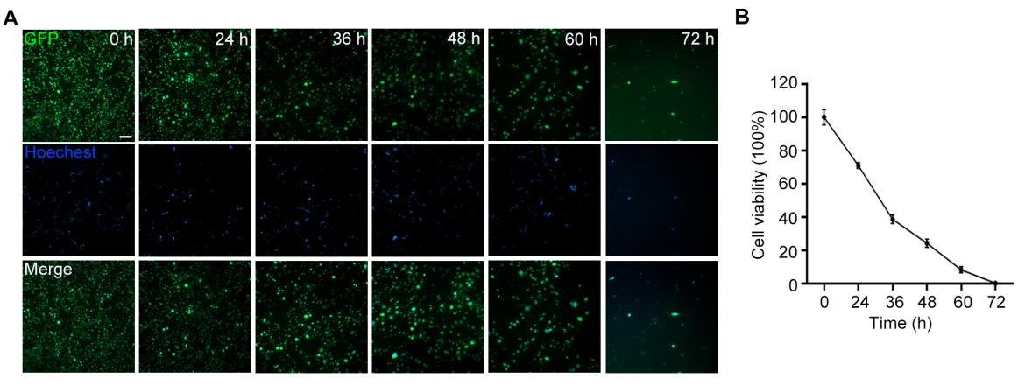
Supplementary Figure 5. Viability of enucleated BMSC-GFP cells. (A) Fluorescence signals of BMSC-GFP cells at different time points after enucleation. Scale bar, 200 μm. (B) Cell viability of enucleated BMSC-GFP at different time points.

