Supplementary material
Jiao-Tai-Wan ameliorates the insulin resistance and lipid metabolism in T2DM rats by regulating neurotransmitters Jianhua Chen¹, Ziqi Jing¹, Xue Wang¹, Chu Li¹, Yanyi Li¹, Zhihui Li¹, Pengkai Ma¹*, Yujie Zhang¹*
¹ School of Chinese Pharmacy, Beijing University of Chinese Medicine, Beijing 102488, China.
* Corresponding author
Yujie Zhang, Beijing University of Chinese Medicine, Advanced Education Park Fangshan District, Beijing 102488, China. Phone: +01052908842; E-mail: zhyj227@126.com
Pengkai Ma, Beijing University of Chinese Medicine, Advanced Education Park Fangshan District, Beijing 102488, China. E-mail: mapengkai1990@126.com

1 Effects of JTW on protein expression of SERT, DAT, NET and GAT-1 in brain of T2DM rats
1.1 Western blotting assays were performed to measure the changes of SERT in brain
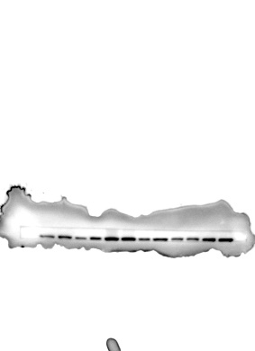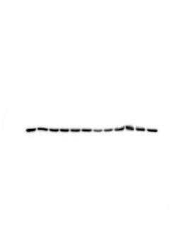
1.2 Western blotting assays were performed to measure the changes of DAT in brain
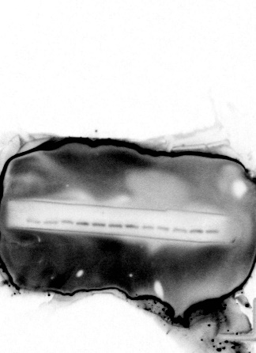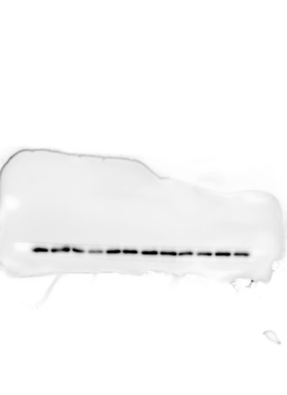

1.3 Western blotting assays were performed to measure the changes of NET in brain
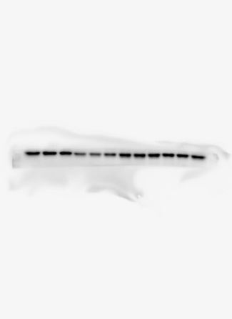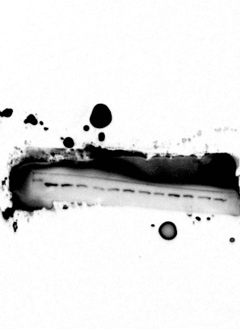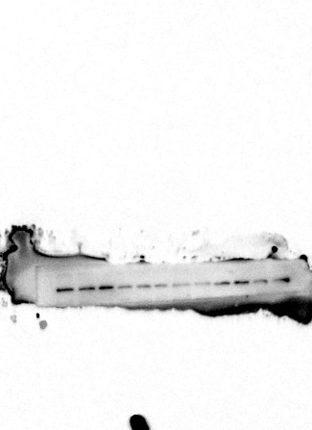
1.4 Western blotting assays were performed to measure the changes of GAT-1 in brain
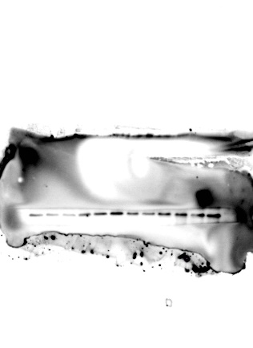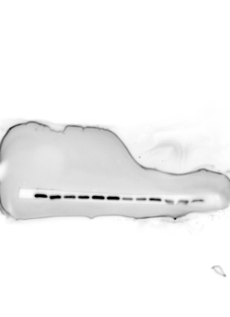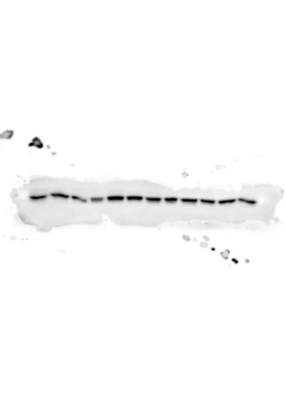
1.5 Western blotting assays were performed to measure the changes of β-actin in brain
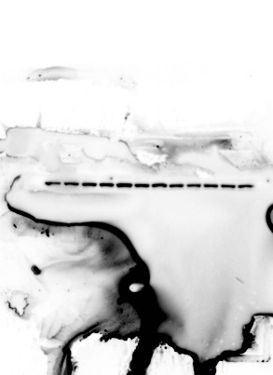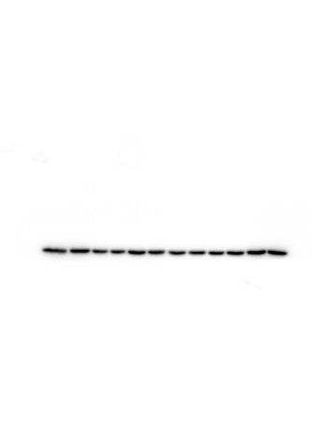

2 Effects of JTW on protein expression of SERT, DAT, NET and GAT-1 in kidney of T2DM rats
2.1 Western blotting assays were performed to measure the changes of SERT in kidney
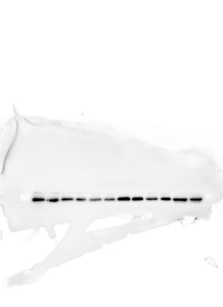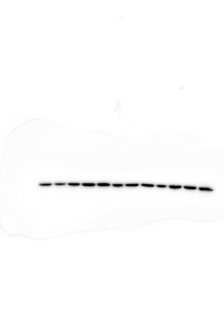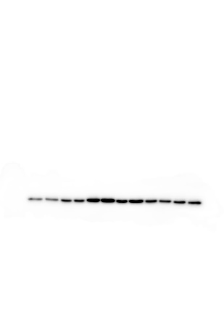
2.2 Western blotting assays were performed to measure the changes of DAT in kidney
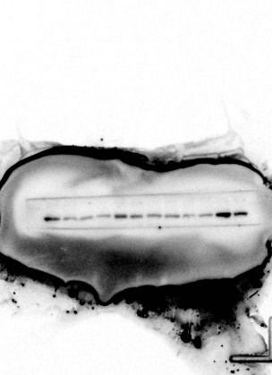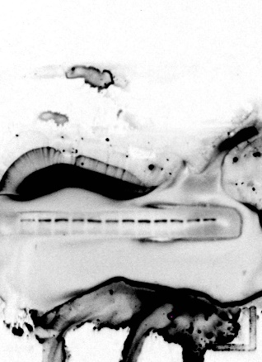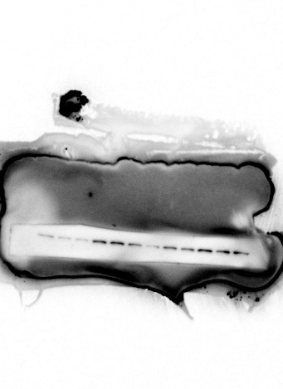
2.3 Western blotting assays were performed to measure the changes of NET in kidney
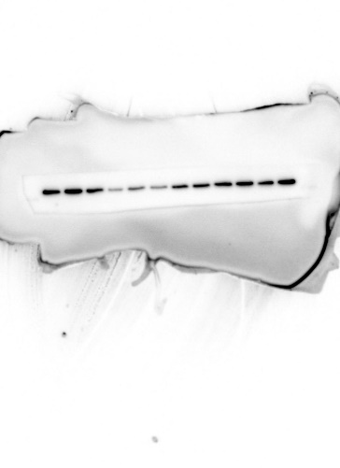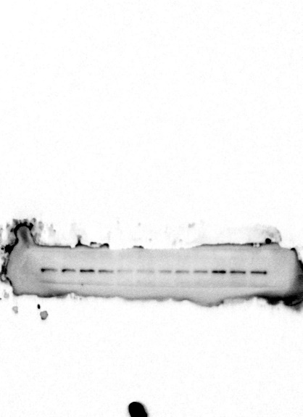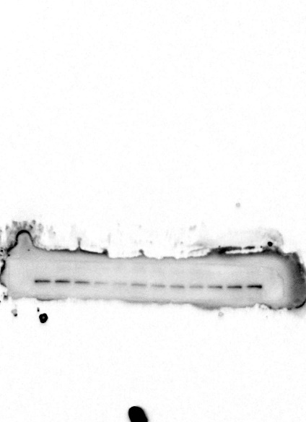
2.4 Western blotting assays were performed to measure the changes of GAT-1 in kidney

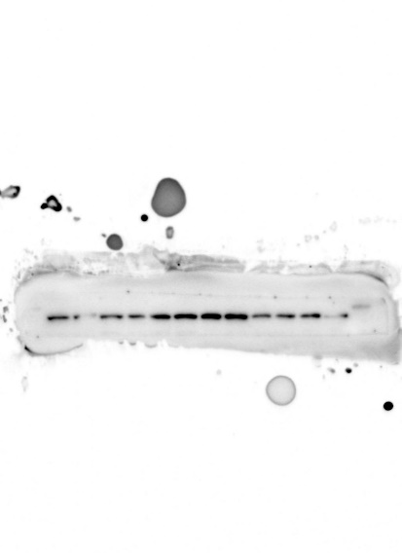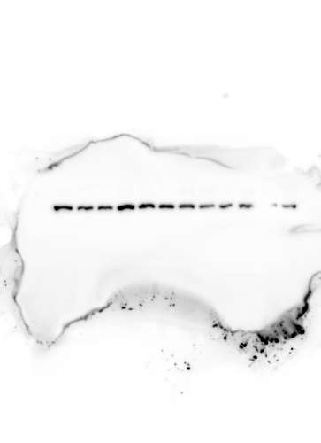
2.5 Western blotting assays were performed to measure the changes of β-actin in kidney
