Supplementary Information for:
Real-time RGB color-tunable upconversion luminescence using a single excitation wavelength

Li Xu,†,‡ Yu Liu,‡ Ziwen Zhou,‡ Danyang Ning,‡ Jing Ren,†,‡ Joan J. Carvajal,†,§ Jianzhong Zhang,*,†,‡ Lu Liu*,†,‡,

†Key Lab of In-fiber Integrated Optics, Ministry Education of China, Harbin Engineering University, Harbin 150001, PR China
‡School of Physics and Optoelectronics Engineering, Harbin Engineering University, Harbin 150001, PR China
§Departament Quimica Fisica i Inorganica, Campus Sescelades, Universitat Rovira i Virgili, Tarragona, E-43007, Spain

E-mail: zhangjianzhong@hrbeu.edu.cn; liulu@hrbeu.edu.cn

Methods
Chemicals.
Lutetium (III) chloride (LuCl₃, 99.9%), ytterbium (III) chloride (YbCl₃, 99.9%), erbium (III) chloride (ErCl₃, 99.9%), thulium (III) chloride (TmCl₃, 99.9%), sodium hydroxide (NaOH, 95%), ammonium fluoride (NH₄F, 96%), oleic acid (OA, 90%), 1-octadecene (ODE, 90%), acetone (99%), isopropanol (99.5%), hexamethyldisilazane (HMDS, 98%), and n-hexane (98%) were purchased from Macklin (Shanghai, China). Sylgard 184, a heat curable polydimethylsiloxane (PDMS) supplied as a two-part kit consisting of pre-polymer (base) and cross-linker (curing agent) components, was purchased from Dow Corning (Midland, America). All chemicals were used as received.
Synthesis of Er:NaYbF₄ and Er/Tm/Yb:NaLuF₄ core-only nanoparticles.
OA capped Er:NaYbF₄ and Er/Tm/Yb:NaLuF₄ nanoparticles were synthesized via a modified thermal decomposition method¹. In a typical experiment, totally 1 mmol of Ln chloride (Ln = Er/Yb or Er/Tm/Yb) methanol solution (1 M), with pre-determined molar ratio, were mixed with 10 mL of OA and 15 mL of ODE in a 50-mL three-necked flask. Under the protection of argon atmosphere, the mixture was heated at 110 °C for 10 min to remove the residual methanol and water in the mixture, and then heated to 180 °C for 40 min to form a transparent solution. After cooling to room temperature, a methanol solution (13 mL) containing NH₄F (4 mmol) and NaOH (2.5 mmol) was added and stirred at 50 °C for 45 min. Next, the solution was rapidly heated to 305 °C, and maintained at this temperature for 1.5 h and then cooled to room temperature. The resulting core-only nanocrystals were precipitated by the addition of ethanol, collected by centrifugation, washed with methanol and ethanol several times, and finally re-dispersed in 10 mL of cyclohexane.
Synthesis of Er:NaYbF₄@NaLuF₄ and Er:NaYbF₄@NaLuF₄@Tm/Yb:NaLuF₄ nanocrystals.
In a typical experiment, 1 mL of the as-synthesized core-only nanocrystals dispersion (corresponding to 0.1 mmol Er:NaYbF₄) was added into a 50-mL flask containing 10 mL of OA and 15 mL of ODE. Under the protection of the argon atmosphere, the mixture was heated to 305 °C and kept at this temperature. Then, the sacrificial solution to form the NaLuF₄ shell, prepared following the similar synthesis route of Er:NaYbF₄ nanocrystals but using only LuCl₃ instead of ErCl₃ and YbCl₃ as the Ln³⁺ source and without the 305 °C reaction, was injected into the flask at a rate of 0.05 mL/min. Finally, the mixture was cooled to room temperature, and the resulting core-shell nanocrystals were precipitated by the addition of ethanol, collected by centrifugation, washed with methanol and ethanol several times, and re-dispersed in 10 mL of cyclohexane. Er:NaYbF₄@NaLuF₄@Tm/Yb:NaLuF₄ core-shell-shell nanocrystals were prepared following a similar route.
Synthesis of upconversion nanocrystals embedded in PDMS flexible film.
PDMS film containing nanocrystals was prepared by a modified reported route². In a typical experiment, 1 mL of acetone, 1 mL of isopropanol, 1 mL of HMDS, 1 mL of n-hexane, and 1 mL of deionized water were first mixed and then the substrate was immersed into the solution to make the surface hydrophobic. Next, the mixture of Sylgard® 184 (containing 1 mL base and 100 μL curing agent) and nanocrystals (2 mL of nanocrystals colloidal solution) was stirred for 3 min to form the precursor colloid. After drying in a vacuum oven for 1 h at room temperature, the precursor colloid was dropped evenly on the substrate placed on a heating plate for curing. Finally, the formed film was peeled off from the substrate for further measurements.
Characterization.
The crystal structures of the as-synthesized nanocrystals were identified by powder X-ray diffraction (XRD, LabX XRD-6100, Shimadzu). The diffraction patterns were recorded in the range of 2θ from 10 to 70° with a resolution of 0.02° per step. The particle morphologies were observed through transmission electron microscopy (TEM, Tecnai G2, EEI). For the spectral measurements, a continuous wave (CW) 980 nm laser diode (LWIRL980-5W, Laserwave) was used as the pumping source. The UC spectra of the different samples were recorded by a customized spectrometer (QM8000, Horiba).
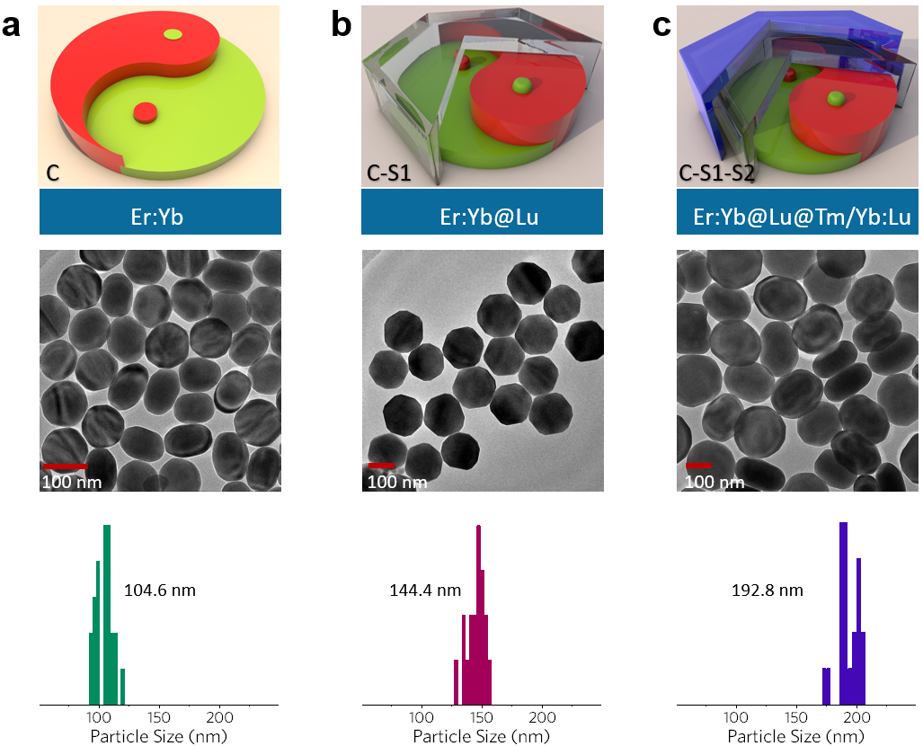
Fig S1. Schematics of the structures, TEM images, and particle size distributions of a) the 1Er:NaYbF₄ core-only, b) the 1Er:NaYbF₄@NaLuF₄ C-S1, and c) the 1Er:NaYbF₄@NaLuF₄@2Tm/30Yb:NaLuF₄ C-S1-S2 nanocrystals. Scale bars in the TEM images are all 100 nm. 50 particles were measured to produce the distribution of the particle sizes.

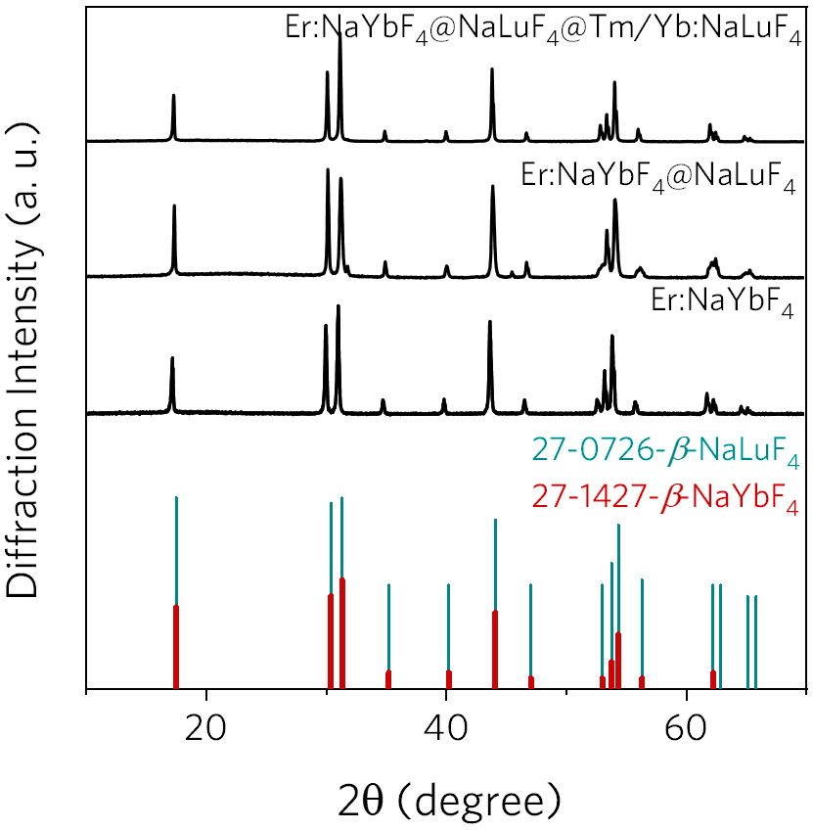
Fig S2. XRD patterns of the core-only, C-S1, and C-S1-S2 nanocrystals, together with the β-NaYbF₄ and β-NaLuF₄ reference patterns, indicating the hexagonal crystalline phase of the formed nanocrystals.

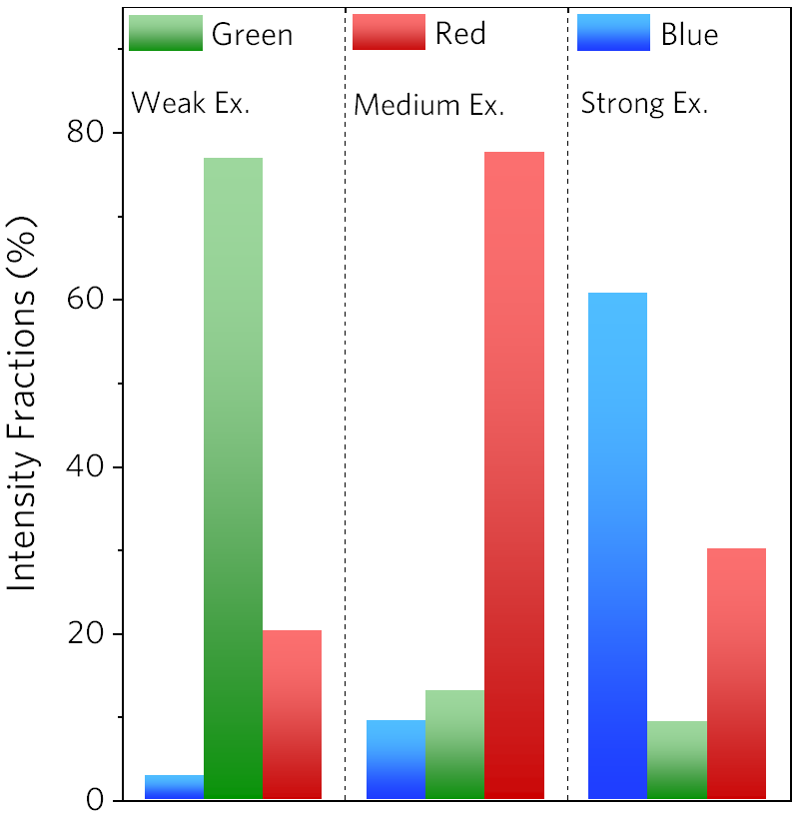
Fig S3. The relative intensities of the green, red, and blue emissions of the as-synthesized color-tunable nanocrystals upon weak, medium, and strong excitation power densities. The overall intensities were normalized to clearly demonstrate the fractions of different emission components.

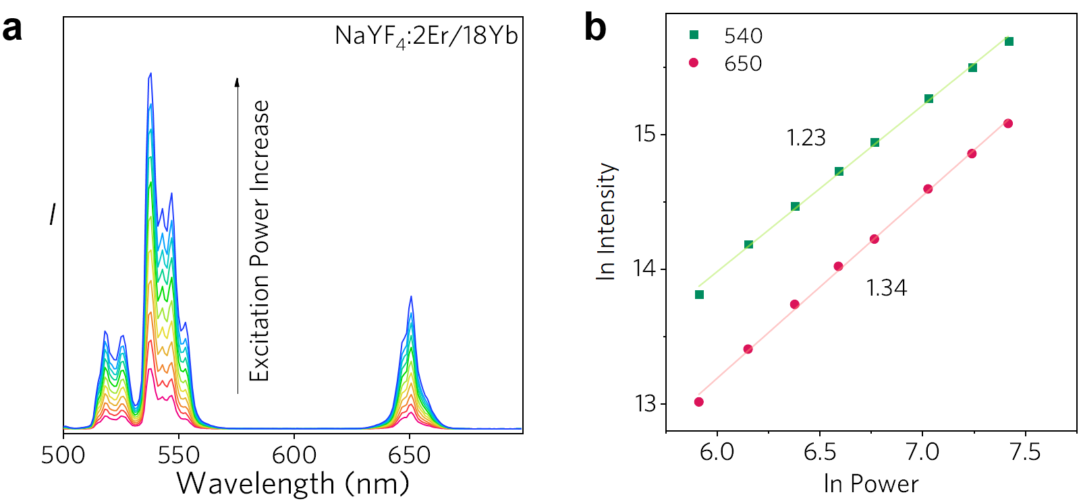
Fig S4. a) Visible spectra and b) ln-ln power dependences of conventional 2Er/18Yb:NaYF₄ nanocrystals upon different excitation power density.

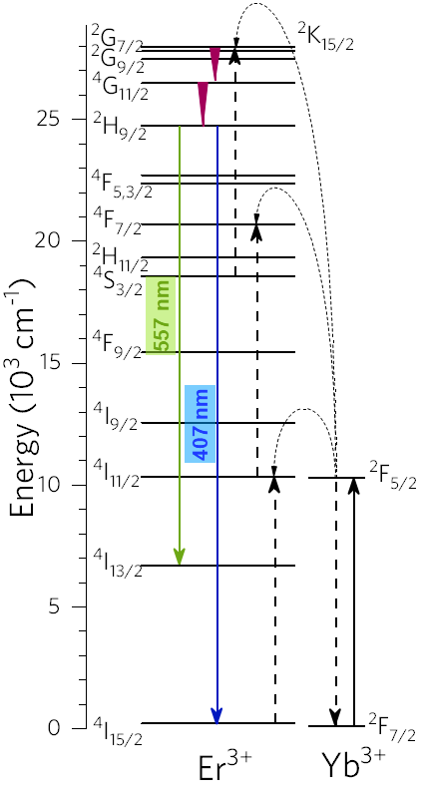
Fig S5. Energy-level diagram depicting the three-photon processes between Er³⁺ and Yb³⁺ under 980 nm excitation to generate the 407 and 557 nm emissions arising from the ²H_{9/2} level of Er³⁺.

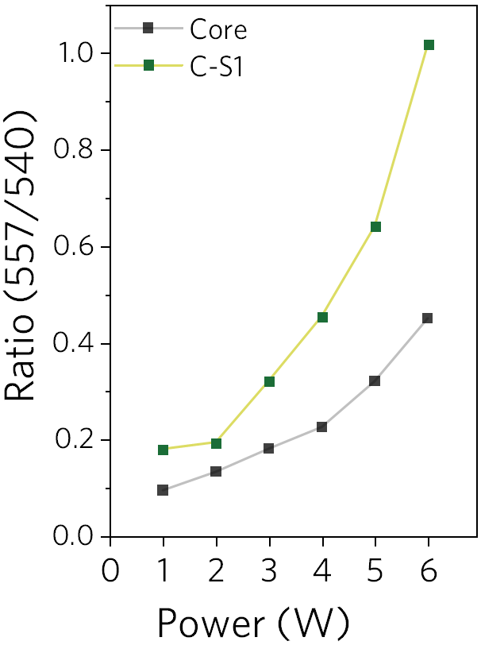
Fig S6. Intensity ratio between the 557 and 540 nm emission bands confirming that the three-photon process plays a more important role in the Er³⁺ upconversion luminescence when increasing the excitation power density.

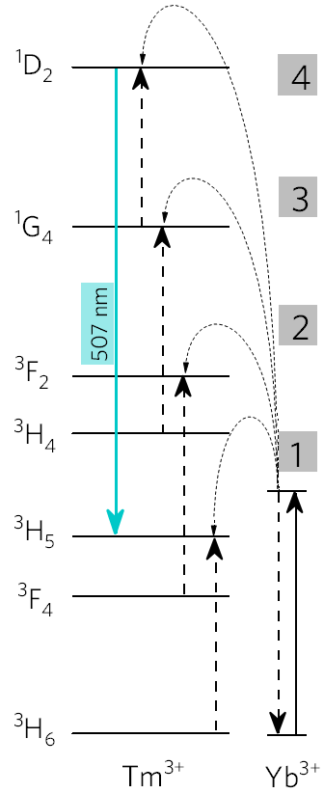
Fig S7. Energy-level diagram depicting the four-photon processes between Tm³⁺ and Yb³⁺ under 980 nm excitation to generate the 507 nm emission arising from the ¹D₂ level of Tm³⁺.

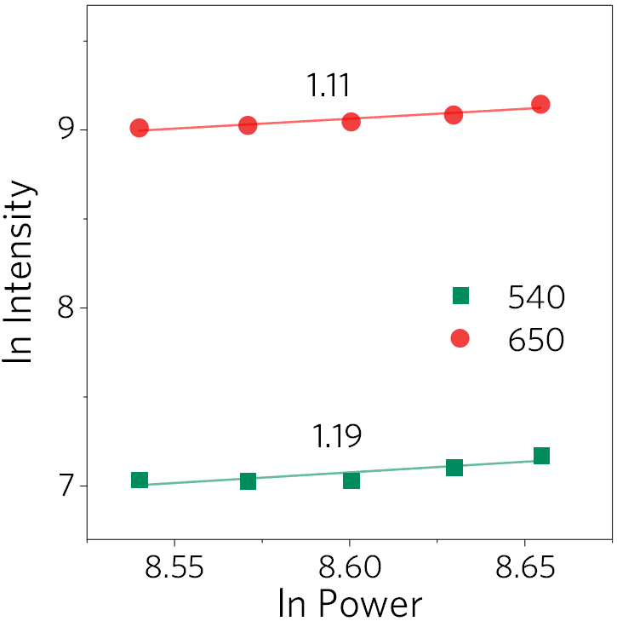
Fig S8. ln-ln power dependences of Er³⁺ green and red emissions upon strong excitation power densities. The slopes indicated in the graph were obtained by linear fittings.

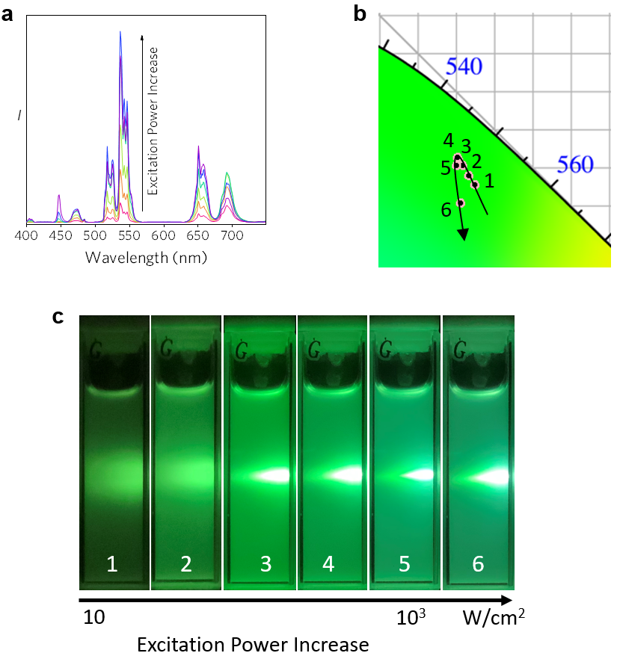
Fig S9. a) Visible spectra, b) CIE diagram (partial view), and c) luminescence photographs of 1Er/2Tm:NaYbF₄ under different laser excitation power densities.

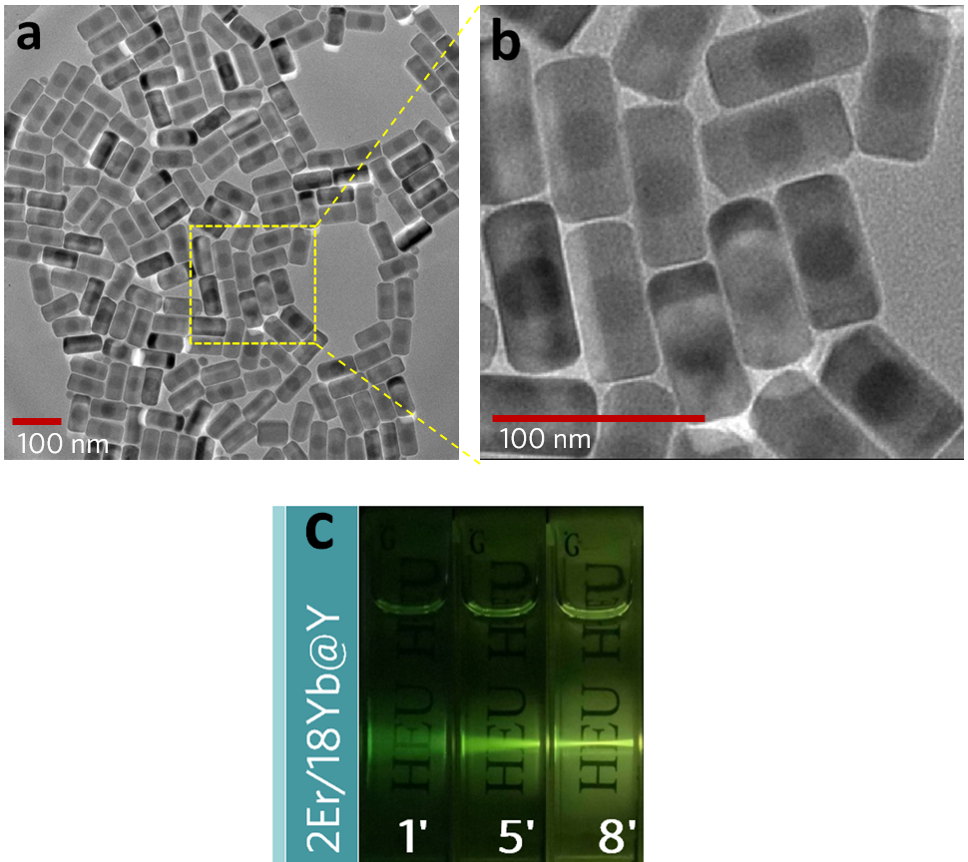
Fig S10. a) TEM image of 2Er/18Yb:NaYF₄@NaYF₄ nanocrystals. b) Enlarged TEM image as labeled in a, in which the core-shell structure can be clearly seen. c) Luminescence images of conventional 2Er/18Yb:NaYF₄@NaYF₄ core-shell nanocrystals upon weak, medium, and strong excitation power densities. The excitation power densities for images 1′, 5′, and 8′ are equal to that for 1, 5, and 8 in Figure 4a, respectively.

Table S1

Sample* | Layer | Year | Color (Low~Mid~High) | Ref.
Ho/Tm/Yb:Y | 1 | 2009 | 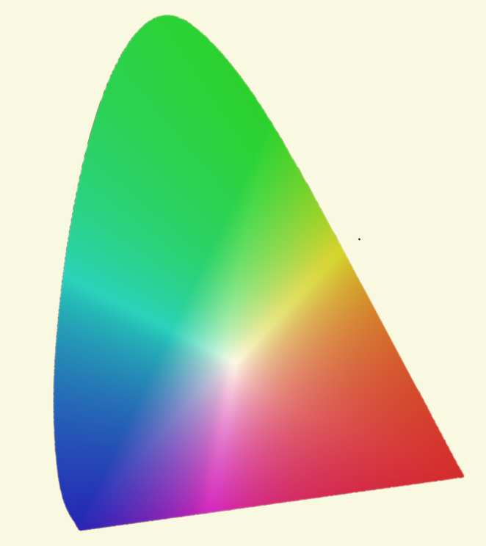  White ~ Blue | 3
Er/Yb:Y@Tm/Yb:Y@Y | 3 | 2010 | Green ~ Blue | 4
Er/Yb:Y₂Ti₂O₇ | 1 | 2013 | Yellow ~ Green | 5
Tm/Yb:Gd@Mn:Gd | 2 | 2015 | Green ~ Blue | 6
Er/Tm/Yb:Gd@Eu:Gd@Y | 3 | 2015 | Green~White~Pink | 7
Er:Gd@Gd@Tm:Gd@Gd | 4 | 2016 | Green ~ White | 8
Er/Yb:Y | 1 | 2017 | Green ~ Orange | 9
Tm/Yb:Gd@Gd@Ho/Yb:Gd@Gd  Ho/Tm/Yb:Gd | 4  1 | 2017 | White ~ Blue  Orange ~ Pink | 10
Er/Tm/Yb:NaGdTiO₄ | 1 | 2018 | Orang ~ Yellow | 11
Er/Tm/Yb:TiO₂ | 1 | 2019 | White ~ Yellow | 12
Eu:Er@Y@Tm:Yb@Y | 4 | 2019 | Green ~ Blue | 13
Er:Yb@Tm:Yb@Y | 3 | 2020 | Green~White~Pink | 14
Er:Yb@Lu@Tm/Yb:Lu | 3 | 2021 | Green~Red~Blue | #
*All the samples were irradiated by ~980 nm Laser
#This Work

References
1 Wang, F., Deng, R. R. & Liu, X. G. Preparation of core-shell NaGdF₄ nanoparticles doped with luminescent lanthanide ions to be used as upconversion-based probes. Nat Protoc 9, 1634-1644 (2014).
2 Savchuk, O. A. et al. Novel low-cost, compact and fast signal processing sensor for ratiometric luminescent nanothermometry. Sensor Actuat a-Phys 250, 87-95 (2016).
3 Yang, L. W., Han, H. L., Zhang, Y. Y. & Zhong, J. X. White emission by frequency up-conversion in Yb³⁺-Ho³⁺-Tm³⁺ triply doped hexagonal NaYF₄ Nanorods. J Phys Chem C 113, 18995-18999 (2009).
4 Boyer, J. C., Carling, C. J., Gates, B. D. & Branda, N. R. Two-way photoswitching using one type of near-infrared light, upconverting nanoparticles, and changing only the light intensity. Journal of the American Chemical Society 132, 15766-15772 (2010).
5 Singh, B. P. et al. Structural and up-conversion properties of Er³⁺ and Yb³⁺ co-doped Y₂Ti₂O₇ phosphors. Physical Chemistry Chemical Physics 15, 3480-3489 (2013).
6 Li, X. Y. et al. Energy migration upconversion in Manganese(II)-doped nanoparticles. Angew Chem Int Edit 54, 13312-13317 (2015).
7 Zhang, C. et al. White-light emission from an integrated ipconversion nanostructure: toward multicolor displays modulated by laser power. Angew Chem Int Edit 54, 11531-11535 (2015).
8 Hu, M. et al. Intense white emission from a single-upconversion nanoparticle and tunable emission colour with laser power. Journal of Materials Chemistry C 4, 6975-6981 (2016).
9 Gao, D. L., Zhang, X. Y., Chong, B., Xiao, G. Q. & Tian, D. P. Simultaneous spectra and dynamics processes tuning of a single upconversion microtube through Yb³⁺ doping concentration and excitation power. Physical Chemistry Chemical Physics 19, 4288-4296 (2017).
10 Shao, Q. Y. et al. Emission color tuning of core/shell upconversion nanoparticles through modulation of laser power or temperature. Nanoscale 9, 12132-12141 (2017).
11 Zhou, A. H. et al. Color-tunable emission by adjusting sensitizer (Yb³⁺) and excitation power of 980 nm in NaGdTiO₄: Yb³⁺/Tm³⁺/Er³⁺ phosphors for light emitting diodes. Journal of Luminescence 194, 225-230 (2018).
12 Dong, J., Li, Y. M., Zheng, W., Wang, R. & Xu, Y. L. Lower power dependent upconversion multicolor tunable properties in TiO2:Yb³⁺/Er³⁺/(Tm³⁺). Ceramics International 45, 432-438 (2019).
13 Lei, L. et al. Dual-mode color tuning based on upconversion core/triple-shell nanostructure. Journal of Materials Chemistry C 7, 3342-3350 (2019).
14 Meng, Z. P., Zhang, S. F. & Wu, S. L. Power density dependent upconversion properties of NaYbF₄: Er³⁺@NaYbF₄: Tm³⁺@NaYF₄ nanoparticles and their application in white-light emission LED. Journal of Luminescence 227, 117566 (2020).

