Supplementary Materials for

Multiple roles of bamboo as a regulator of cyanobacterial bloom in aquatic systems

Aimin Hao, Mengyao Su, Sohei Kobayashi, Min Zhao, Yasushi Iseri

Corresponding Author:
Sohei Kobayashi (koba@wzu.edu.cn), Yasushi Iseri (iseri@wzu.edu.cn)

Table S1. Ingredients in BG-11 and CSi media.
BG-11 |  |  | CSi
Ingredient | Concentration |  | Ingredient | Concentration
NaNO₃ | 1.5 g L⁻¹ |  | Ca(NO₃) ·4H₂O | 0.15 g L⁻¹
K₂HPO₄ | 0.04 g L⁻¹ |  | KNO₃ | 0.1 g L⁻¹
MgSO₄·7H₂O | 0.075 g L⁻¹ |  | MgSO₄·7H₂O | 0.04 g L⁻¹
CaCl₂·2H₂O | 0.036 g L⁻¹ |  | β-Na₂ glycerophosphate·5H₂O | 0.025 g L⁻¹
Citric acid | 0.006 g L⁻¹ |  | Vitamin B₁₂ | 0.1 μg L⁻¹
Ferric ammonium citrate | 0.006 g L⁻¹ |  | Biotin | 0.1 μg L⁻¹
EDTANa₂ | 0.001 g L⁻¹ |  | Thiamine HCl | 10 μg L⁻¹
Na₂CO₃ | 0.02 g L⁻¹ |  | PIV | 6 ml L⁻¹
A5 (Trace mental solution) | 1 ml L⁻¹ |  | HEPES | 0.5 g L⁻¹
 |  |  | Na₂SiO₃·9H₂O | 0.1 g L⁻¹
 |  |  | Soil extract | 30 ml L⁻¹

Fig. S1. Overview of material preparation procedures
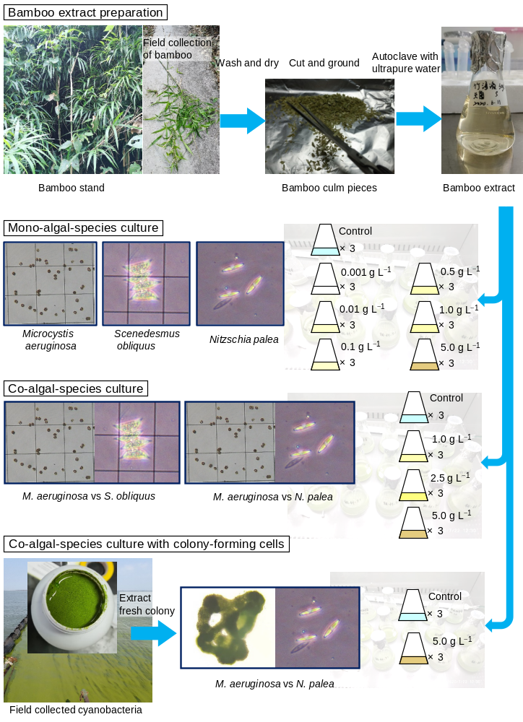

Fig. S2. Fitting a logistic growth curve by estimating intrinsic growth rate (r) and carrying capacity (K).
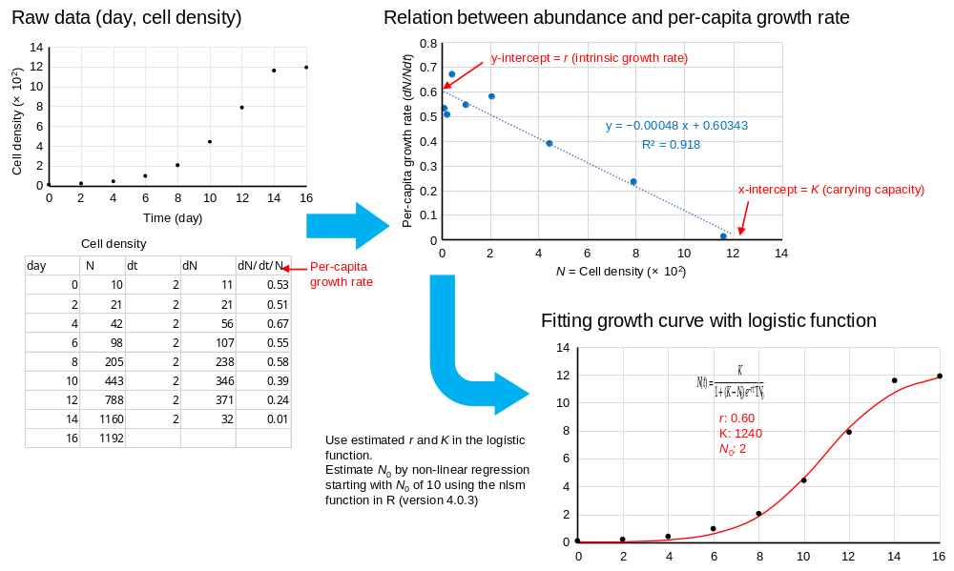

Table S2. Evaluation of MDA content and activities of SOD, POD, and CAT.
Sample preparation | - Count algal cell  - Centrifuge a 10 mL sample at 5000 rpm for 20 min  - Wash by 0.9% sodium chloride solution at 4℃  - Ultrasonic crush of algal cells in ice bath ((crush 3s + interval 10s) × 30)  - Centrifuge at 5000 rpm for 5 min at 4°C, and collect the supernatant  - Add reagents in sample according to the instructions  - Preheat spectrophotometer for 30 minutes, adjust to zero with distilled water
 | Absorbance measurement by spectrometer | Calculation formula | Unit
MDA content | 532 and 600 nm  ΔA = A₅₃₂ − A₆₀₀ | $$\frac{25.8×∆A×V}{n}$$ | nmol cells⁻¹
SOD activity | 560 nm  IR (inhibition rate) = (A_{control} – A_{sample})/A_{control} | $$\frac{11.4×V×\frac{IR}{1-IR}}{n}$$ | U cells⁻¹
POD activity | 470 nm  ΔA = A₄₇₀ (at 1 min) – A₄₇₀ (at 2 min) | $$\frac{2000×∆A×V}{n}$$ | U cells⁻¹
CAT activity | 240 nm  ΔA = A₂₄₀ (initial) – A₂₄₀ (at 1 min) | $$\frac{678×∆A×V}{n}$$ | nmol min⁻¹ cells⁻¹
n: number of algal cells in the sample
V: volume of sample (mL)

