Comprehensive pan-cancer analysis reveals that FBXO2 as a potential

therapeutic target associated with immune infiltration
Ming Wei¹, Huilin Zang², Qianqian Gao¹, Yuan Zhang¹, Jiexia Wen³, Yunhuan Gao¹

¹ Department of Immunology, Nankai University School of Medicine; Nankai University, Tianjin 300071, P.R.China;
² Tianjin Academy of Educational Sciences, Tianjin 300191, P.R.China;
³ State Key Laboratory of Metastable Materials Science and Technology, Yanshan University, Qinhuangdao, Hebei 066004, P.R.China

Correspondence to: Professor Yunhuan Gao, Department of Immunology, Nankai University School of Medicine; Nankai University, No. 94 Weijin Road, Nankai District, Tianjin 300071, P.R.China
E‑mail: gaoyunhuan@nankai.edu.cn
Or Dr Jiexia Wen, State Key Laboratory of Metastable Materials Science and Technology, Yanshan University, No. 438 Hebei Street, Haigang District, Qinhuangdao, Hebei 066004, P.R.China
E‑mail: wenjiexia2010@163.com

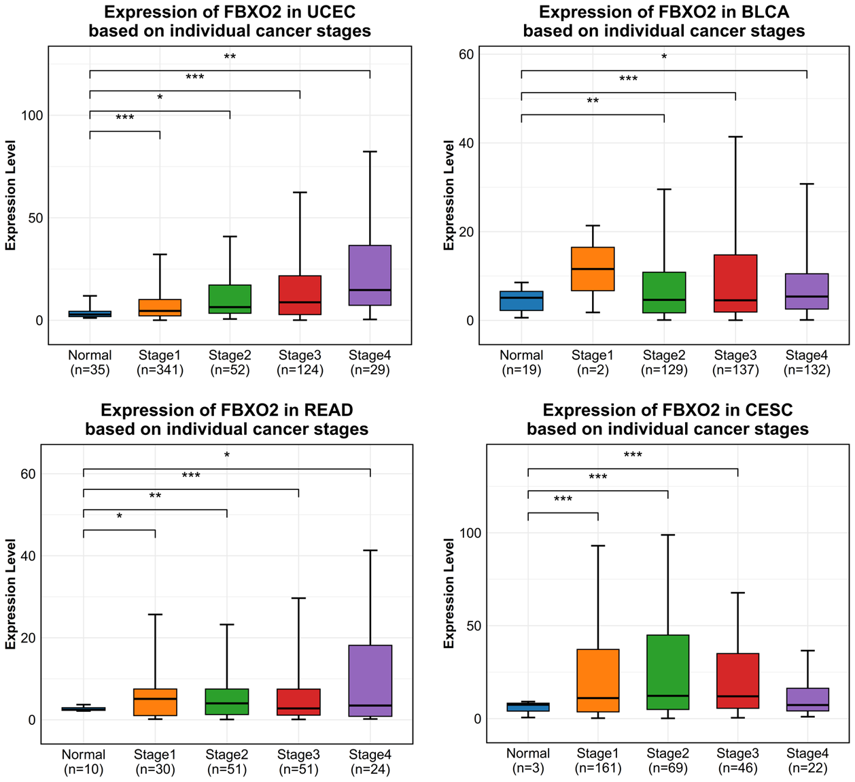
Supplementary Figure 1
Stage-specific FBXO2 expression patterns in UCEC, READ, BLCA, and CESC from the UALCAN database.

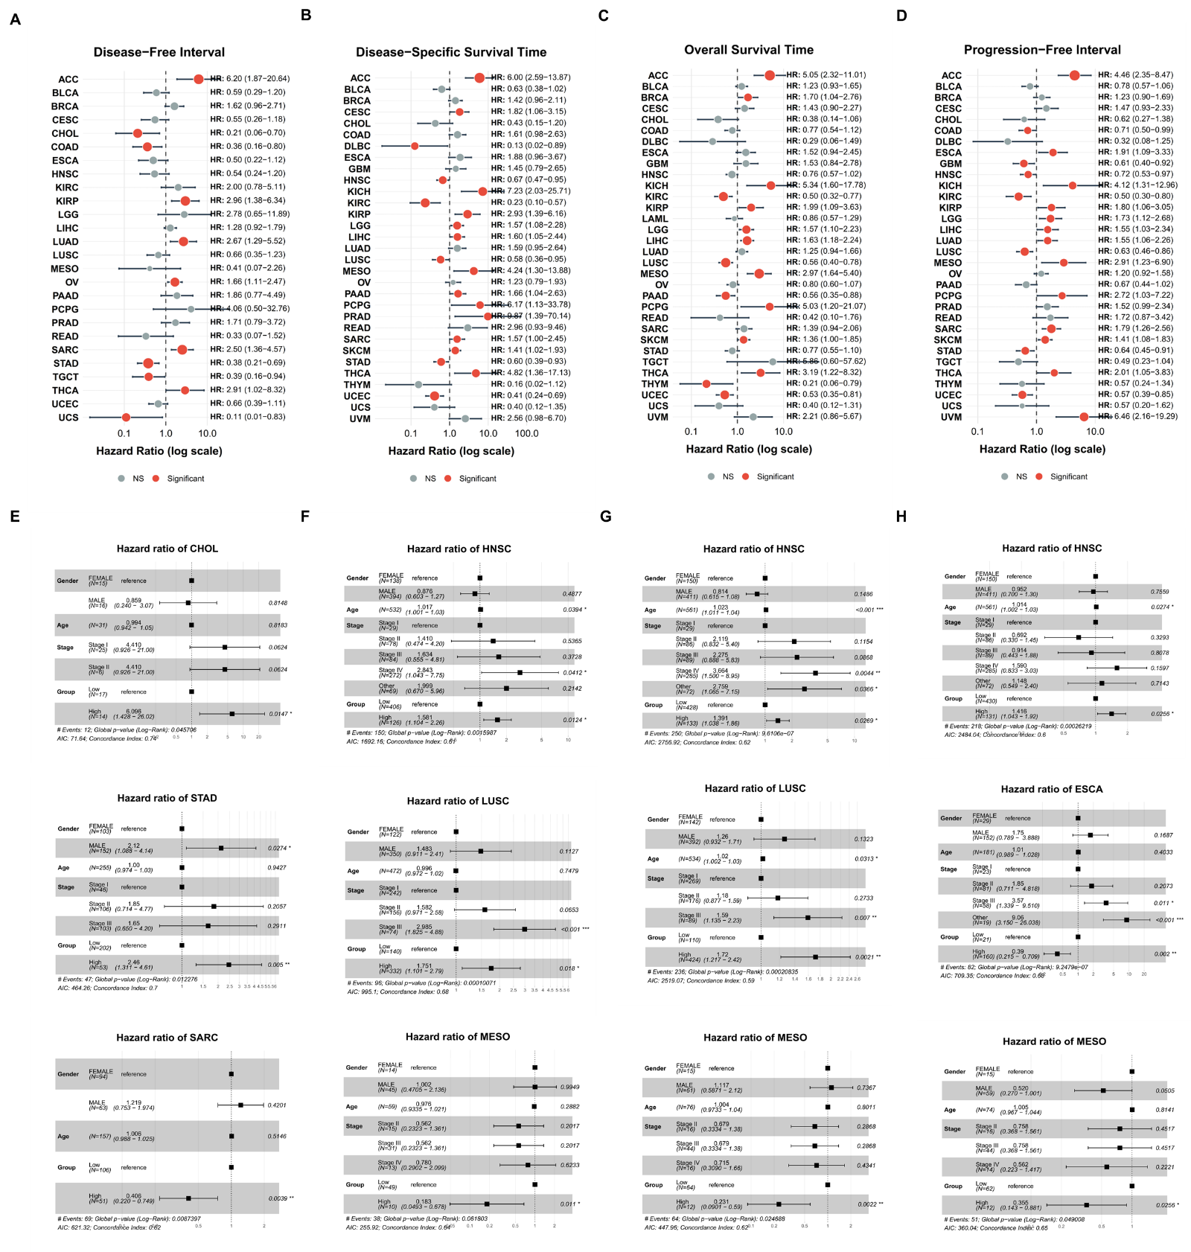
Supplementary Figure 2
Association Between FBXO2 Expression Levels and Multiple Cancer Survival Outcomes. (A-D) Forest plots showing pan-cancer associations between FBXO2 expression and OS, DSS, DFI, and PFI. (E-H) Cox proportional hazards regression analyses demonstrating the prognostic value of FBXO2 expression for disease-free interval (DFI for E), disease-specific survival (DSS for F), overall survival (OS for G), and progression-free interval (PFI for H). Hazard ratios (HRs) with 95% confidence intervals (CIs) quantify the risk associated with relapse-free survival (RFS). Statistical significance was set at p < 0.05.

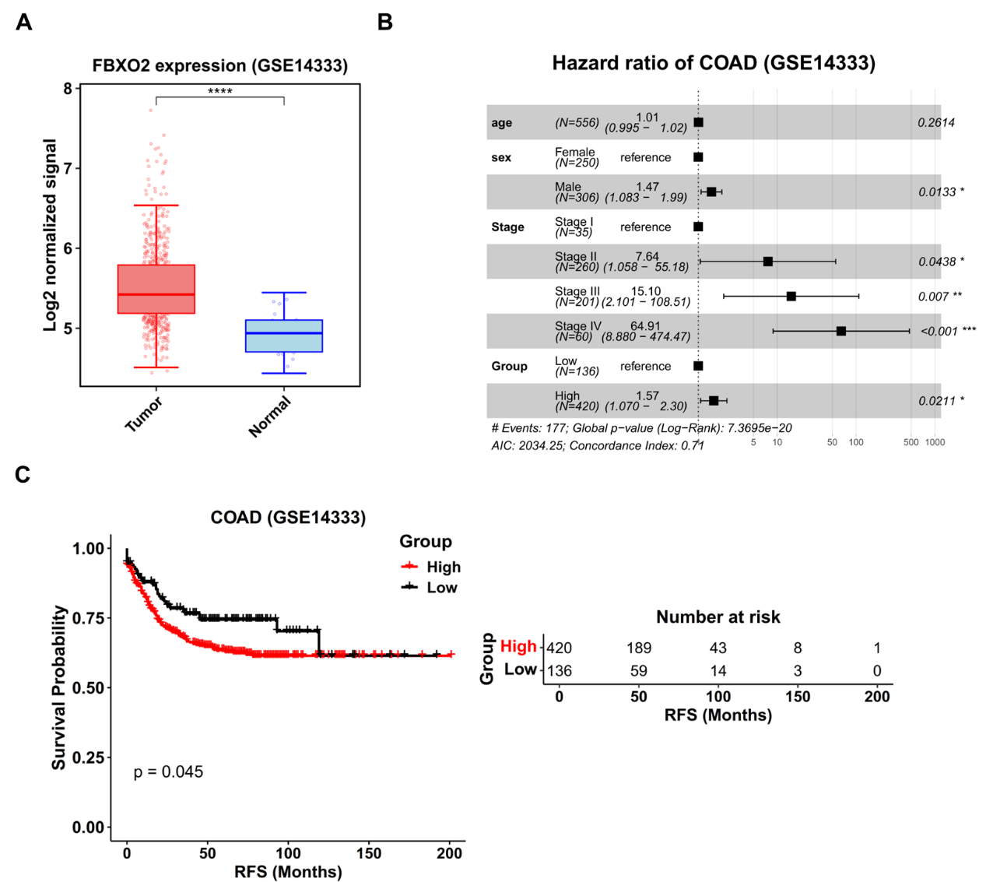
Supplementary Figure 3
Validation of FBXO2 expression and prognostic significance in the GSE39582 cohort. (A) FBXO2 expression in normal vs. tumor tissues. (B) Kaplan-Meier analysis of FBXO2 and relapse-free survival (RFS) (p < 0.045). (C) Cox regression showing an association between FBXO2 expression and RFS (HR = 1.57, 95% CI = 1.070-2.30, p < 0.05).
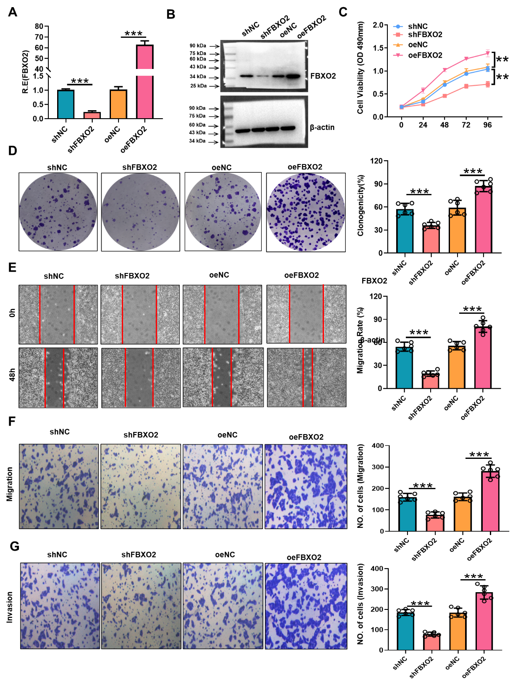
Supplementary Figure 4
FBXO2 enhances proliferation and migration of Caco2 cells. (A) qRT-PCR detection of FBXO2 expression efficiency in Caco2 cells. (B) Western blot validation of FBXO2 protein expression levels. (C) CCK-8 assay detection of cell proliferation activity within 96 hours for each group(n=6). (D) Colony formation assay detection of cell clonogenic ability(n=6). (E) Wound healing assay detection of cell migration ability at 0h and 48h(n=6). (F) Migration assay detection of transmembrane cell count(n=6). (G) Invasion assay detection of transmembrane cell count(n=6).
shFBXO2: knockdown group; shNC: knockdown control; oeFBXO2: overexpression group; oeNC: overexpression control. Data are presented as mean ± SD. Statistical analysis was performed using Student’s t-test; *P < 0.05, **P < 0.01, ***P < 0.001.

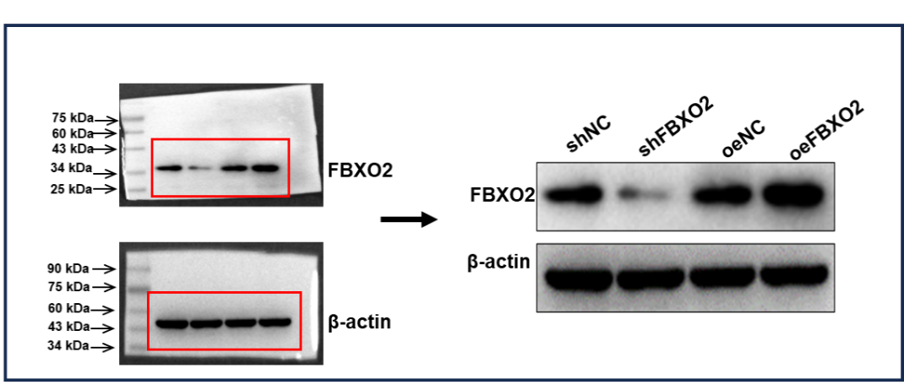
Supplementary Figure 5
A complete gel image corresponding to the Western blot results.
Complete gel image used in Figure 9B, with a red rectangular box indicating the target band area selected for presentation and quantitative analysis. Molecular weight markers are labeled in the images (left).

Table S1. | Reagents and oligoes used in this study.
REAGENT, RESOURCE OR OLIGOES | SOURCE | IDENTIFIER
Antibodies
β-Actin Antibody | Santa Cruz | Cat:sc-47778 RRID: AB_626632
FBXO2 Polyclonal antibody | Proteintech | Cat: 14590-1-AP RRID: AB_2104394
CD56 Polyclonal antibody | Proteintech | Cat: 14255-1-AP RRID: AB_2149421
Oligonucleotides for qRT-PCR
Human GAPDH FW | BGI | 5’-TCAAGAAGGTGGTGAAGCAGG-3’
Human GAPDH REV | BGI | 5’- AGCGTCAAAGGTGGAGGAGTG-3’
Human FBXO2 FW | BGI | 5’- CAACCTTCTGCGTAACCCGT-3’
Human FBXO2 REV | BGI | 5’- CTGTGCTTTGCGACACCACT-3’
shRNAs used in this study
FBXO2 | Ribobio | 5’- CGAGCUCACCGUUAAGCUACU-3’
Cells used in this study
HCT116 | ATCC | CCL-247
Caco-2 | ATCC | HTB-37
Other
DMEM | Gibco | Cat: 11965118
FBS | Gibco | Cat:10099141
Cell Counting Kit-8 | MCE | Cat: HY-K0301
Trizol | Life technologies | Cat:15596018

