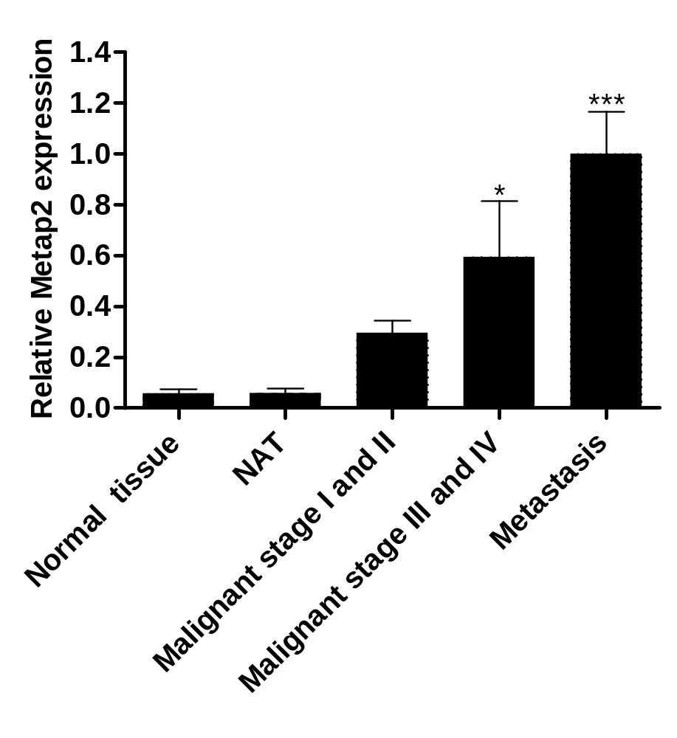

Figure 1S. MetAp2 expression levels are higher in metastatic cancer sites versus primary cancer sites. Samples were visualized using a fluorescent microscope (Olympus IX-73). Analysis of tissue staining was performed by using the ImageJ analysis program. The fluorescently dyed tissue staining intensities were assessed for the different marks by an evaluation of pixels stained per area, followed by normalizing the number of cells represented by blue DAPI nuclei staining. Metastatic tissue sites expressed significantly higher levels of MetAp2 compared with primary sites in patients with cancer stages I or II and III or IV, displaying >40% and >70% higher levels, respectively. The data was divided into 4 main groups: normal tissue, normal tissue adjacent to the tumor (NAT), primary tissue (stages I-IV) and metastatic tissues. n=7-50. *p<0.05 and ***p<0.001, compared with normal tissues. Results are presented as mean ± SEM.

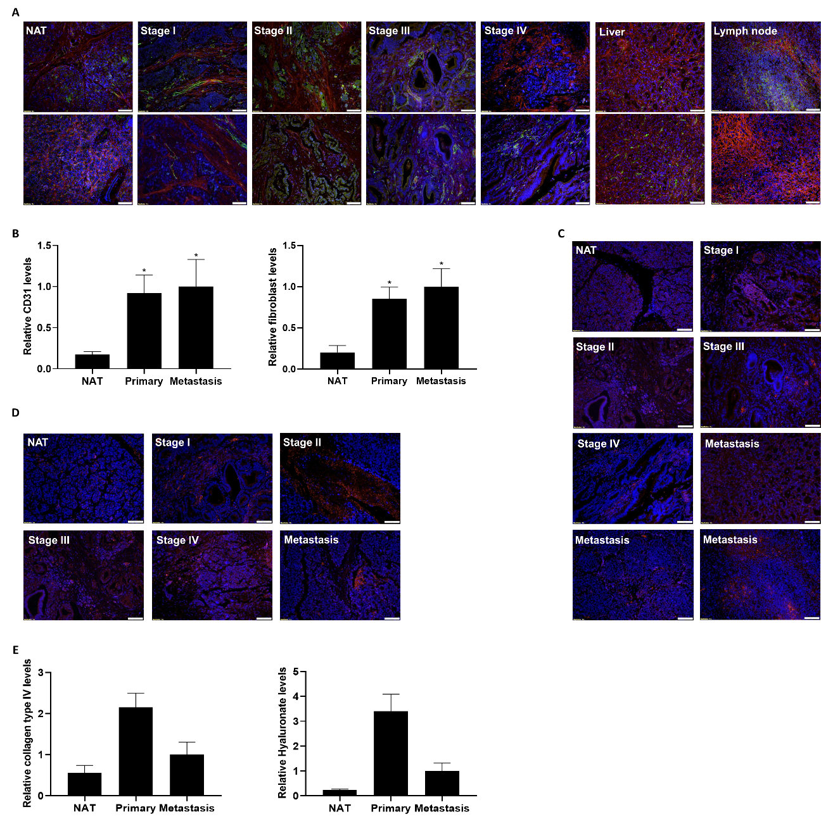

Figure 2S. Tissue samples obtained from human pancreatic-cancer patients expressed high levels of TME components. (A) Pancreatic-cancer tissues stained with anti-fibroblasts (red) and anti-CD31 (green and DAPI (blue). (B) A higher expression level of CD31 and fibroblasts in metastatic cancer organs versus the primary sites. (C) Pancreatic patient-derived cancer tissues stained with anti-collagen IV (red) and DAPI (blue). (D) Tissue specimens stained with anti-hyaluronic acid (red) and DAPI (blue). (E) Higher expression levels of collagen type IV and hyaluronate in primary PDA sites compared with metastatic sites and NAT. Samples were visualized using a fluorescent microscope (Olympus IX-73). Analysis of tissue staining was performed by using ImageJ analysis program. The tissue staining intensities were assessed for the different marks by an evaluation of pixels stained per area, followed by normalizing the number of cells represented by blue DAPI nuclei staining. The data was divided into three main groups: normal tissue adjacent to the tumor (NAT), primary tissue (stages I-IV) and metastatic tissues. n=7-50. *p<0.05, compared with normal tissues. Results are presented as mean ± SEM. Scale bar = 100 μm.
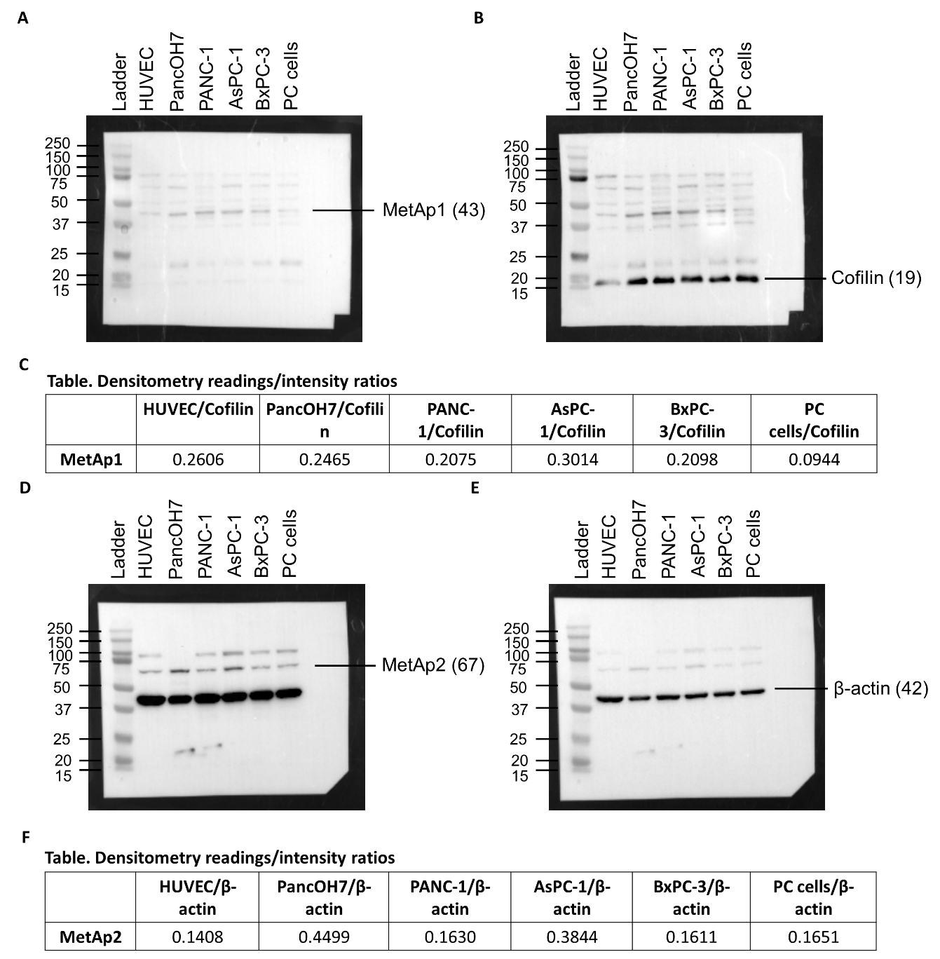

Figure 3S. Basal MetAp1 and MetAp2 expression levels in pancreatic-cancer cells lines, patient-derived pancreatic cancer cells and endothelial cells. Original images of Western Blot results for determining the expression of MetAp1 and MetAp2 in HUVEC, PancOH7, PANC-1, AsPC-1, BxPC-3 and PC cells. (A) MetAp1 (Exposition of 120 sec) and (B) Cofilin of MetAp1 (Exposition of 60 sec) proteins were analyzed by Western blots. (C) Table shows the densitometry readings/intensity ratio of MetAp1 in HUVEC, PancOH7, PANC-1, AsPC-1, BxPC-3 and PC cells. Cofilin (19 kDa) was used as an internal standard for equalizing the samples. The intensity of MetAp1 was divided by the intensity of cofilin. (D) MetAp2 (exposition of 120 sec) and (E) β-actin of MetAp2 (exposition of 10 sec) proteins were analyzed by Western blots. (F) Table shows the densitometry readings/intensity ratio of MetAp2 in HUVEC, PancOH7, PANC-1, AsPC-1, BxPC-3 and PC cells. β-actin (42 kDa) was used as an internal standard for equalizing the samples. The intensity of MetAp2 was divided by the intensity of β-actin.

