Supplementary Information of
Adaptively laser-tagging optofluidic microcavity for single-molecule hydrogen detection across 9-decade concentration span

Note S1. Theoretical analysis.
S1.1 Sensing mechanism of hydrogen detection based on Pt/WO₃ inner-coated microresonator.
In a whispering-gallery-mode (WGM) microcavity, light undergoes continuous total internal reflection along the dielectric boundary. When the circulating optical field satisfies the resonance condition, it becomes confined within the cavity and forms discrete resonant modes. The resonance condition can be expressed as,
( S1 )
where n_{eff}, R and λ denote the effective refractive index, cavity radius, and optical wavelength, respectively, and m is an integer ^{1,2}. The variation in n_{eff} or R leads to a corresponding shift in the resonant wavelength. Silica WGM microcavities fabricated through the melting process typically exhibit exceptionally smooth surfaces. Owing to their extremely low absorption and scattering losses in C-band, these cavities possess ultrahigh Q factors and ultra-narrow resonance linewidths. In addition, functionalization of the microcavity with selective materials can impart or enhance its capability to perceive subtle environmental variations ³.
Figure S1a schematically illustrates the hydrogen sensing mechanism of Pt/WO₃ inner-coated microresonator. When hydrogen gas enters the microchannel, H₂ molecules are catalytically dissociated into hydrogen atoms H_{ad} on the Pt surface. Based on the spillover effect, these hydrogen atoms diffuse through the WO₃ layer, react with lattice oxygen and generate water ^{4,5}. The Pt/WO₃ thin film presents high sensitivity and excellent selectivity toward hydrogen. The overall process is exothermic, and the corresponding reaction pathway and products are illustrated below.
( S2 )
Next, we conducted a quantitative analysis of the hydrogen reaction and heat transfer processes inside the tube. The Langmuir–Hinshelwood (L–H) mechanism is widely employed to describe heterogeneous catalytic kinetics ^{6,7}, and it is equally applicable to the catalytic reactions of hydrogen, encompassing the adsorption, surface reaction, and desorption of gas molecules. The surface catalytic reaction rate v_{r}, can be expressed as,

( S3 )
where k, α_{H}, and α_{O} denote the reaction rate constant and the surface coverage rate of H_{ad} and O²⁻, respectively. K_{H} and K_{O} represent the adsorption equilibrium constants of H_{ad} and O²⁻, while c_{H} and c_{O} correspond to their respective concentrations. Since O²⁻ is enough compared to H_{ad}, it can be treated as a constant. Accordingly, the reaction rate can be simplified as,
( S4 )
where k₀ denotes the maximum surface reaction rate. The reaction between hydrogen and oxygen to generate liquid water is exothermic, with a standard reaction enthalpy ΔH of -283 kJ/mol. Consequently, the heat release power density can be expressed as,
( S5 )
where η denotes the reaction efficiency. The heat generated by the hydrogen oxidation reaction on the film surface is transferred in two directions. On the one direction, convective heat transfer occurs between the inner film surface and the flowing gas inside the tube ^{8,9}, with the corresponding heat power given by S_{i,g} = h_{i}·A_{i}·(T_{i} - T_{g}), where A_{i}, T_{i} and T_{g} are the inner surface area, inner surface temperature, and gas temperature, respectively. The convective heat transfer coefficient is defined as h_{i} = Nu·k_{i}/R_{i}, where Nu is the Nusselt number, which takes a typical value of 3.66 under fully developed laminar flow conditions ¹⁰. k_{i} and R_{i} represent the thermal conductivity of the fluid and the inner radius of the microtube, respectively. On the other direction, conductive heat transfer through the solid film increases the tube wall temperature, expressed as S_{i,s} = k_{s} dT/dr = k_{s}·(T_{i} - T_{o})/L, where k_{s}, T_{o} and L are the thermal conductivity of the solid, the outer surface temperature, and the microtube wall thickness, respectively. Since the microtube surface temperature is higher than that of the outer air, convective heat dissipation occurs from the outer wall to the surrounding air, represented by S_{o,g} = h_{o}·A_{o}·(T_{o} - T_{a}), where h_{o}, A_{o} and T_{a} denote the external convective heat transfer coefficient, outer surface area, and outer air temperature, respectively. Additionally, radiative heat loss from the outer surface can be described by S_{rad} = εσ(T_{o}⁴ – T_{a}⁴), where ε and σ are the emissivity and the Stefan–Boltzmann constant, respectively ¹¹. Under steady-state conditions, the total heat generated by the surface reaction is balanced by the total heat dissipated through convection, conduction, and radiation, as expressed by the following energy conservation equation.
( S6 )
Figure S1b illustrates the variations in gas temperature inside the tube, as well as the temperatures of the inner and outer surfaces of the microtube, as functions of hydrogen concentration. The calculated results reveal that at low hydrogen concentrations, the microtube temperature increases rapidly with rising concentration. However, at higher concentrations, the temperature rise gradually slows down due to the saturation of hydrogen adsorption, kinetic limitations of the gas-phase reaction and the increased temperature difference between the microtube and the ambient environment, which enhances heat dissipation.
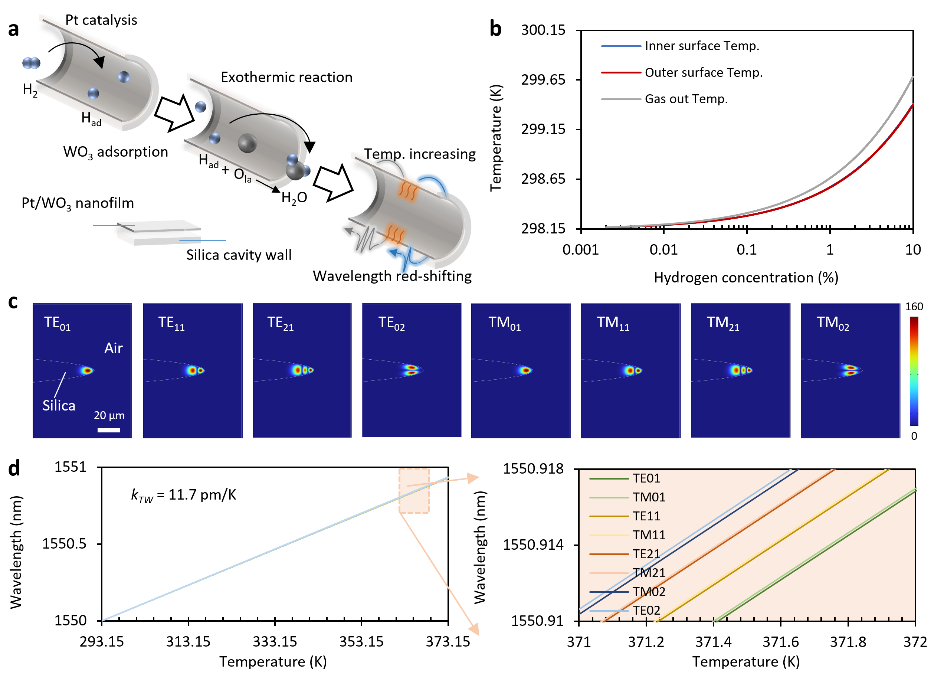

Fig. S1. Analysis of hydrogen induced mode shifting in PCMR. a, Schematic diagram of hydrogen detection mechanism. b, Temperature varied with hydrogen concentration. c, Simulated electrical field distribution of different modes. d, Mode shifting with variation of temperature.
Furthermore, we investigate how the resonant wavelengths of different modes in the microresonator vary with temperature, stemming from the thermo-optic and thermal expansion effects. Based on finite element analysis in COMSOL, we identify four sets of TE/TM modes, as illustrated in Fig. S1c, and calculate the effective refractive indices of each mode. The geometric characteristics of the microresonator inherently limit the number of resonant modes, enabling a clearer analysis of the temperature-dependent shifts. Considering both the thermo-optic and thermal expansion contributions, the temperature variation of the microcavity modifies its effective refractive index and cavity length, thereby inducing a shift in the resonant wavelength, which can be expressed as ^{12,13}
( S7 )
where λ₀ denotes the resonant wavelength of a specific mode in the cold cavity, whiled n_{eff}/dT and dR/dT represent the thermo-optic coefficient and thermal expansion coefficient of the microcavity, respectively. Silica possesses positive thermo-optic and thermal expansion coefficients, implying that as the temperature increases, both the effective refractive index and the radius of the microcavity increase, resulting in a redshift of the resonant modes. Figure S1d illustrates that the wavelengths of all four resonant modes increase linearly with temperature, with an average slope of approximately 11.4 pm/K. The simulated temperature sensitivity is relatively high. A possible reason is that, in practical situations, more heat is dissipated during thermal conduction through the capillary wall. In addition, the attached materials may alter the effective thermal coefficients of the device, leading to a reduced overall temperature response compared with the idealized simulation conditions. Because the effective refractive indices of different modes differ only slightly, the temperature-induced variation among modes remains minimal. When the temperature rises by 80 K, the difference in wavelength shift between modes is only about 1 pm.

S1.2 Noise reduction and sensitivity enhancement by locking with ultrahigh Q microresonator.
The slope locking technique is a laser frequency stabilization scheme that employs a laser servo feedback loop, enabling the laser to lock onto the resonance slope of a high Q factor optical cavity. Specifically, since the optical field within the resonator satisfies the resonance condition and undergoes exponential decay, the transmission or reflection spectrum of the cavity can be well approximated by a Lorentzian resonance profile, expressed as ¹⁴
( S8 )
where Δ = ω - ω₀ and κ = ω₀/Q represent the frequency detuning and the cavity linewidth, respectively, where ω and ω₀ denote the laser frequency and the cavity resonance frequency. As the laser frequency detunes from resonance, the reflected or transmitted optical intensity varies accordingly. Therefore, frequency fluctuations of the laser are converted into intensity fluctuations, which are subsequently transformed into voltage signals through a photodetector and a transimpedance amplifier. The sensitivity of the voltage response to frequency variation can be expressed as:
( S9 )
where G_{T} and R_{PD} denote the gain coefficient of the transimpedance amplifier and the responsivity of the photodetector, respectively, while dP/dω represents the variation of optical power, serving as the error signal for feedback control. To achieve optimal frequency stabilization, the laser is typically locked onto the point of maximum slope on the cavity resonance, where dP/dω reaches its maximum value. By differentiation, the maximum locking sensitivity can be derived as,
( S10 )
where P_{in} is the incident optical power, α is a proportionality factor determined by the cavity response.
It follows that, with the feedback loop parameters fixed, the performance of the slope-locking frequency stabilization scheme is inherently determined by the Q factor of the resonator. A resonator with a higher Q factor exhibits a narrower linewidth and a steeper resonance slope, effectively amplifying the error signal arising from laser frequency fluctuations. Consequently, the system can more precisely detect deviations between the laser actual frequency and the locking point, enabling high signal-to-noise-ratio (SNR) feedback control and thereby achieving superior noise suppression performance.
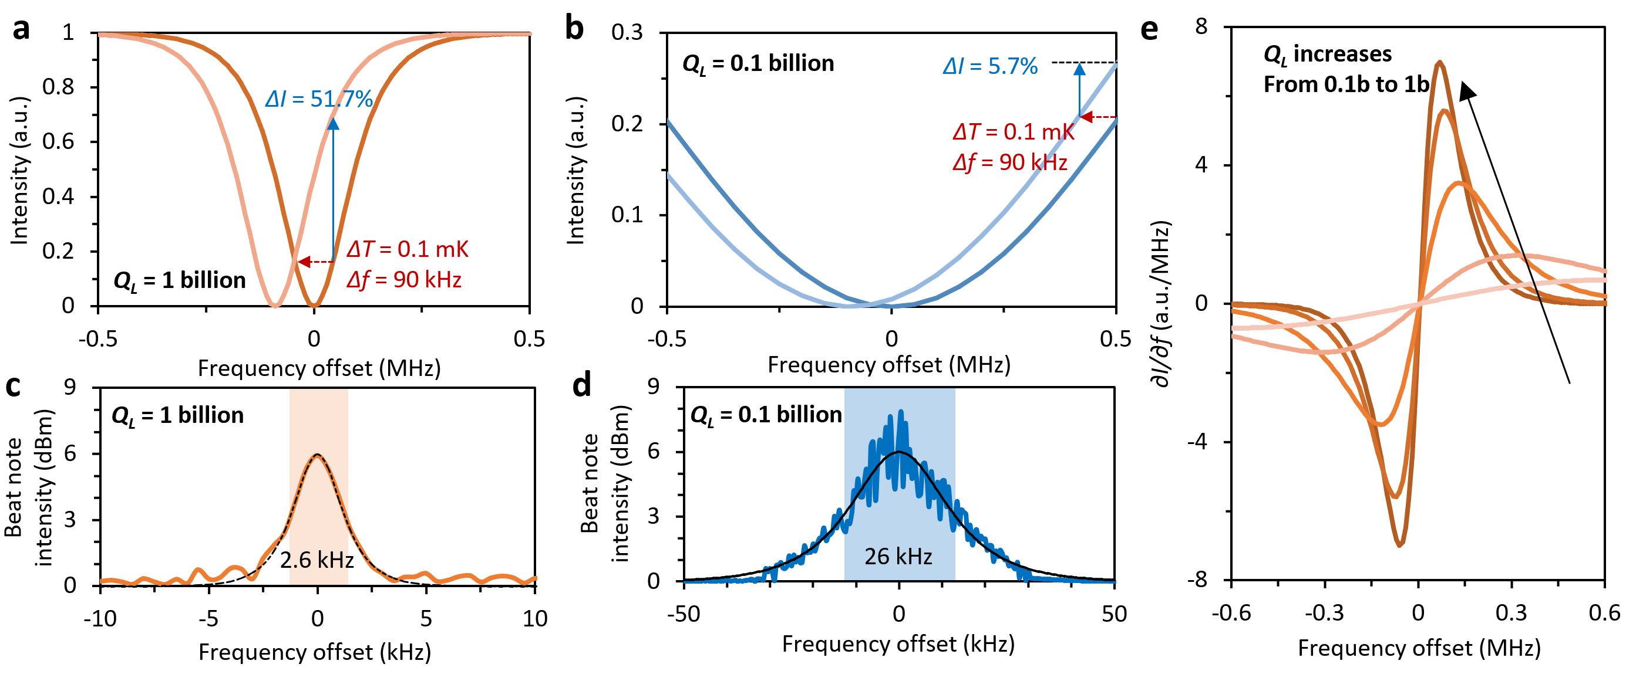

Fig. S2. The performance of sensitivity varied with Q factor. a & b, Frequency resolution comparison between Q factor 1 billion and 0.1 billion with the same temperature increasing. c & d, Resonator beat note comparison between Q factor 1 billion and 0.1 billion. e, The slope sensitivity of different Q factors. Here the black arrow shows Q increases from 0.1 billion to 1 billion.
On the other hand, when the resonator experiences external perturbations, such as temperature variations, its resonant modes shift accordingly. Since the laser frequency is locked to the resonance slope, it tracks the resonance shift in real time. Consequently, a well-designed feedback system can rapidly and precisely capture external changes, which are reflected as laser frequency variations, thereby enhancing the sensing sensitivity. Figure S2 compares the responses of microresonator with different Q factor under identical temperature perturbations. When the cavity temperature changes by 0.1 mK, corresponding to a resonance frequency shift of approximately 90 kHz, the frequency resolution of resonators with loaded Q factors Q_{L} = 10⁹ and Q_{L} = 10⁸ are 51.7% and 5.7%, respectively, as shown in Fig. S2a and S2b. Meanwhile, the beat signal linewidth of the Q_{L} = 10⁹ resonator is about one-tenth that of the Q_{L} = 10⁸ resonator, as illustrated in Fig. S2c and S2d. Figure S2e further demonstrates that as the Q factor of resonator increases from 10⁸ to 10⁹, the locking sensitivity of the laser at various detuning positions increases correspondingly. Notably, for every tenfold increase in Q factor, the sensing signal sensitivity improves by one order of magnitude.

Note S2. Material preparation and device characterization.
S2.1 Material preparation and device fabrication
Figure S3a presents a schematic illustration of the fabrication process for the Pt/WO₃ inner-coated microresonator. The microrod resonator was fabricated using a CO₂ laser reflow technique ^{15,16}, which consists of three main steps, polishing, etching, and annealing. A high-purity silica microtube with a diameter of 2.8 mm and a length of 50 mm was mounted on a motor and rotated at an angular speed of 3000 rpm. The CO₂ laser beam, after being focused by a ZnSe lens, was precisely directed onto the microtube surface, with both the lateral position and focal distance of the lens controlled by an electronic translation stage. During the polishing stage, the lens was positioned such that the laser focus was slightly offset from the microtube surface. A 10W laser beam was scanned laterally across the outer surface three times, effectively removing surface contaminants and forming a smooth, clean, and flat region.
In the etching stage, the lens was adjusted so that the laser focus coincided exactly with the microtube surface. A 6W laser beam was scanned across the previously polished region with an inter-line spacing of 140 μm, alternating between adjacent tracks. This small spacing rapidly reduced the axial curvature of the resonator surface and strongly suppressed the excitation of azimuthal modes, resulting in a low-mode-density microresonator. During the annealing stage, the lens position was modified such that the laser focus was shifted away from the surface and centered at the midpoint between the etched regions. The laser power was increased to 9 W, producing a larger spot size that fully covered the etched disk-like region. The annealing process lasted for 120 seconds, during which the localized high temperature caused the silica to melt and reflow, enabling surface reshaping and significant smoothing. This process yielded a microrod resonator with an ultrahigh Q factor. Through computer-controlled automation, this method enables the fabrication of highly uniform, few-mode, ultrahigh Q factor microrod resonators within just a few minutes.
Meanwhile, the fabrication process of Pt/WO₃ nanoparticles is illustrated in Fig. S3b. First, 41.6 mg of platinum (II) acetylacetonate Pt(O₂C₅H₇), 2 g of WO₃, and 10mL of analytical-grade anhydrous ethanol were thoroughly mixed under vigorous magnetic stirring to form a uniformly dispersed yellow-green slurry. The mixture was then dried at 80 °C for 6 hours, during which ethanol completely evaporated, yielding a Pt(O₂C₅H₇)/WO₃ nanoparticle composite. Subsequently, the obtained nanoparticles were calcined at 350 °C in air for 2 hours, during which the material turned dark gray, indicating successful synthesis of Pt/WO₃ nanoparticle ¹⁷. In this composition, the mass fraction of Pt was approximately 1.0 wt%, an optimized ratio that ensures high catalytic activity while preventing particle agglomeration. During the deposition of the sensing material, the Pt(O₂C₅H₇)/WO₃ composite was re-dispersed in anhydrous ethanol and precisely injected into the inner cavity of the microtube using a micropipette. To achieve uniform coating along the inner surface, the microtube was rotated at 120 r/min and maintained in a nitrogen atmosphere at 60 °C for 3 hours, ensuring complete evaporation of ethanol and homogeneous film formation. Figure S3c shows the resulting hydrogen-sensitive microcavity, where it is evident that the Pt/WO₃ film is smoothly and uniformly deposited along the inner wall of the microtube.
To further elucidate the structural characteristics of both the inner and outer surfaces of the Pt/WO₃ inner-coated microresonator, we conducted detailed characterization using scanning electron microscopy (SEM). As shown in Fig. S3d (left), the overall microrod resonator and its magnified view reveal an exceptionally smooth surface, providing the structural foundation necessary for achieving an ultrahigh Q factor. In contrast, Fig. S3d (right) presents the Pt/WO₃ nanofilm and its corresponding zoom-in image, where distinct porous features as well as rod-like and disk-like morphologies of the sensing material can be clearly observed. Finally, Fig. S3e displays the X-ray diffraction (XRD) pattern of the sensing material, revealing its crystalline structure. The red stars correspond to the diffraction peaks of WO₃, with 2θ values and Miller indices as follows: 23.117° (002), 23.583° (020), 24.367° (200), 26.593° (120), 28.914° (112), 34.167° (220), 41.866° (222), 49.932° (400), and 55.932° (420) (ICSD: 16080). The orange star represents the diffraction peak of PtO₂ at 35.094° (101) (ICSD: 24923), while the green star corresponds to the PtO diffraction peak at 54.780° (112) (ICSD: 164290). These results confirm the coexistence of WO₃, PtO₂, and PtO crystalline phases, indicating successful synthesis of the Pt/WO₃ composite nanostructure with well-defined crystallinity, which underpins its catalytic and sensing performance.
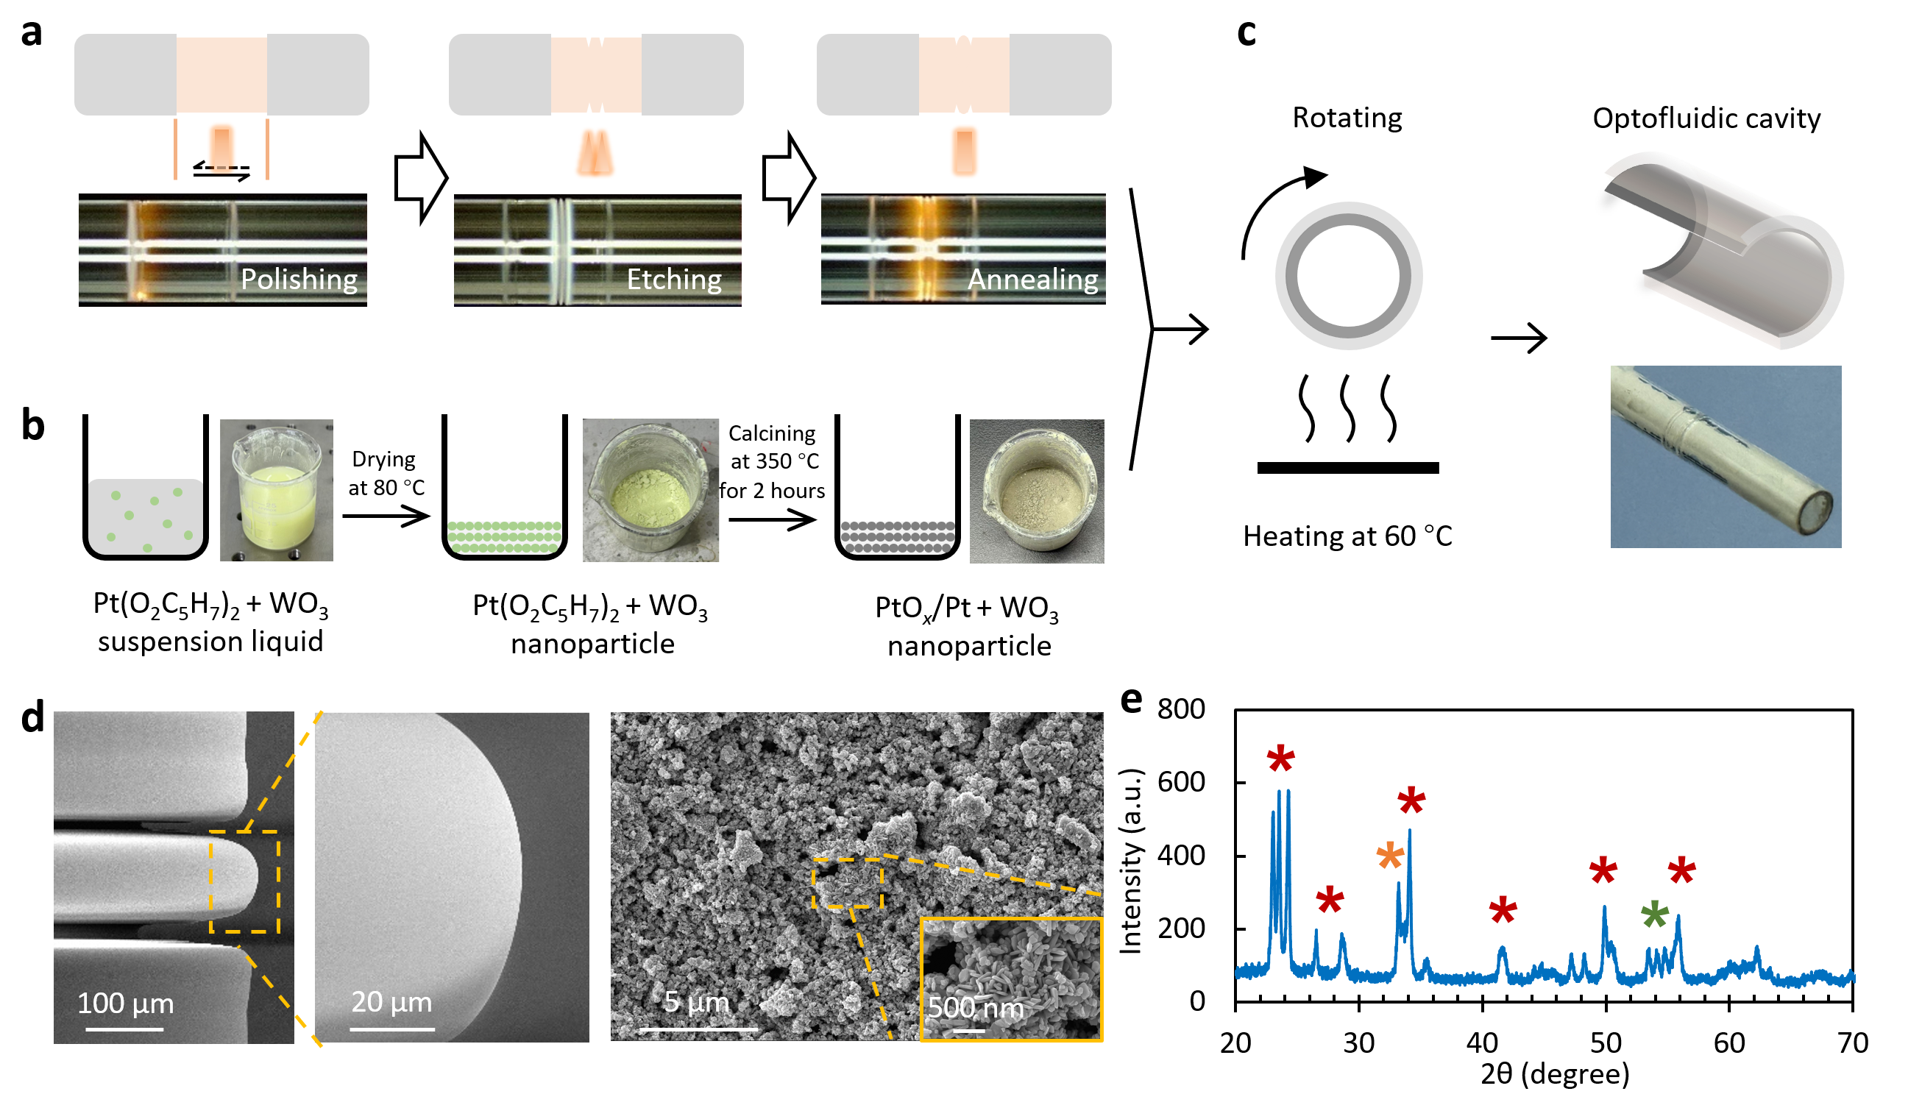

Fig. S3. Device fabrication and characterization. a, Schematic diagram of fabrication process for microrod resonator. b, Fabrication process of Pt/WO₃ nanoparticle. c, Pt/WO₃ nanoparticle deposition on the inner surface of the micro-resonator. d, Scanning electron microscope image of microrod resonator and Pt/WO₃ nanofilm. e, The X-ray diffractometer (XRD) results of Pt/WO₃ nanofilm.
S2.2 The resonances and Q factors of functionalized WGM microcavities.
Functionalized WGM microcavities provide a robust physical foundation for achieving high-sensitivity and high specificity sensing. However, sensitivity enhancement typically relies on the incorporation of functional materials that mediate the interaction between the evanescent optical field and external analytes. This necessarily introduces material field overlap, which can significantly degrade the Q factor of the resonator. Meanwhile, maintaining a low mode density is crucial for reducing the complexity of signal demodulation. Therefore, developing an optimal functionalization strategy that balances sensitivity enhancement, Q factor preservation, and modal purity is of great importance.
Figure S4 compares the transmission spectra and Q factors of three types of functionalized microcavities: a graphene-functionalized microsphere, a graphene-functionalized microrod, and a Pt/WO₃ inner-coated microresonator. For the graphene-functionalized microsphere, a monolayer graphene film was transferred 20° above the equatorial plane of the microcavity using a dry transfer technique. This configuration effectively mitigates Q factor degradation while maintaining a high optical quality, achieving a Q factor of 0.15 billion, as shown in Fig. S4a. However, owing to the standard spherical geometry and gentle surface curvature, the microsphere supports a dense modal structure, with over 200 resonant modes appearing within a single FSR. In contrast, the microrod resonator, due to its axially compressed geometry, strongly suppresses the excitation of transverse modes, resulting in only 10 ~ 30 resonant modes per FSR. Nevertheless, during functionalization, the graphene film can only be transferred onto the equatorial plane, which leads to more pronounced Q factor degradation. As a result, the Q factor decreases to approximately 0.03 billion, as shown in Fig. S4b.
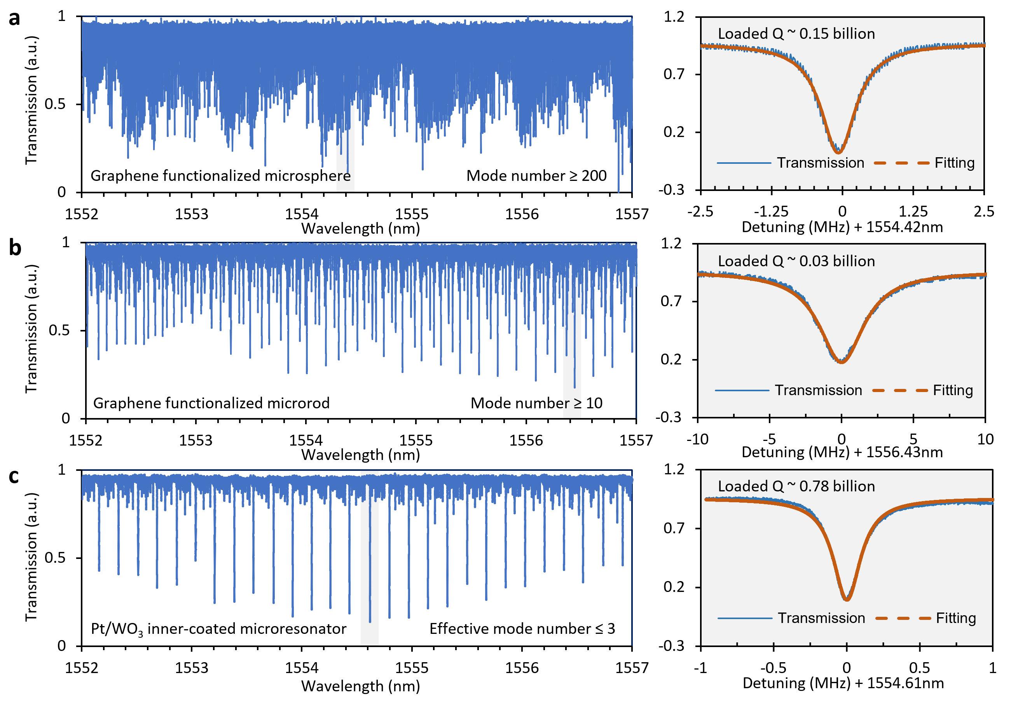

Fig. S4. Comparison of mode number and Q factor. Transmission spectra. Transmission spectrum and Q factor of (a) graphene functionalized microsphere, (b) graphene functionalized microrod and (c) Pt/WO₃ inner-coated microresonator.
In contrast, the Pt/WO₃ inner-coated microresonator achieves enhanced sensing performance while preserving the ultrahigh Q factor by depositing the nanofilm material onto the inner wall of the microcavity. This configuration leverages thermal energy transfer to facilitate sensing interactions, thereby avoiding direct interference between the optical field and the functional material that typically leads to Q factor degradation. Furthermore, compared with the microrod resonator, the present device incorporates a reduced etching interval during fabrication, effectively suppressing polar mode excitation and significantly reducing the number of supported modes.
As shown in Fig. S4c, by appropriately adjusting the polarization state and coupling conditions, the Pt/WO₃ inner-coated microresonator exhibits fewer than one dominant mode per FSR with a coupling depth exceeding 50%, while maintaining a Q factor of 0.78 billion. This combination of ultrahigh optical quality and low modal density establishes a robust structural foundation for high-sensitivity sensing and low-complexity signal demodulation in advanced photonic detection applications.

S2.3 The fabrication consistency of Pt/WO₃ inner-coated microresonator.
Under slow laser scanning, the transmission spectrum of the microcavity varies smoothly with laser detuning, exhibiting a standard Lorentzian lineshape, as shown in Fig. S4c. In contrast, under rapid frequency scanning, the transmission signal evolves over time to reveal a characteristic ringdown behavior, indicative of the cavity’s high optical quality. Figures S5a and S5b present the transmission spectra of a single resonant mode before and after material deposition, respectively. In both cases, a pronounced ringdown tail is observed, confirming the ultrahigh-Q factor nature of the device. Since the functional nanofilm does not directly contact the microrod resonator surface, the Q factor only slightly decreases, from 0.95 billion to 0.94 billion, corresponding to a change of approximately 1%, after deposition, just limited by the fabrication process. To further verify the fabrication reproducibility, seven samples were prepared following the same protocol.
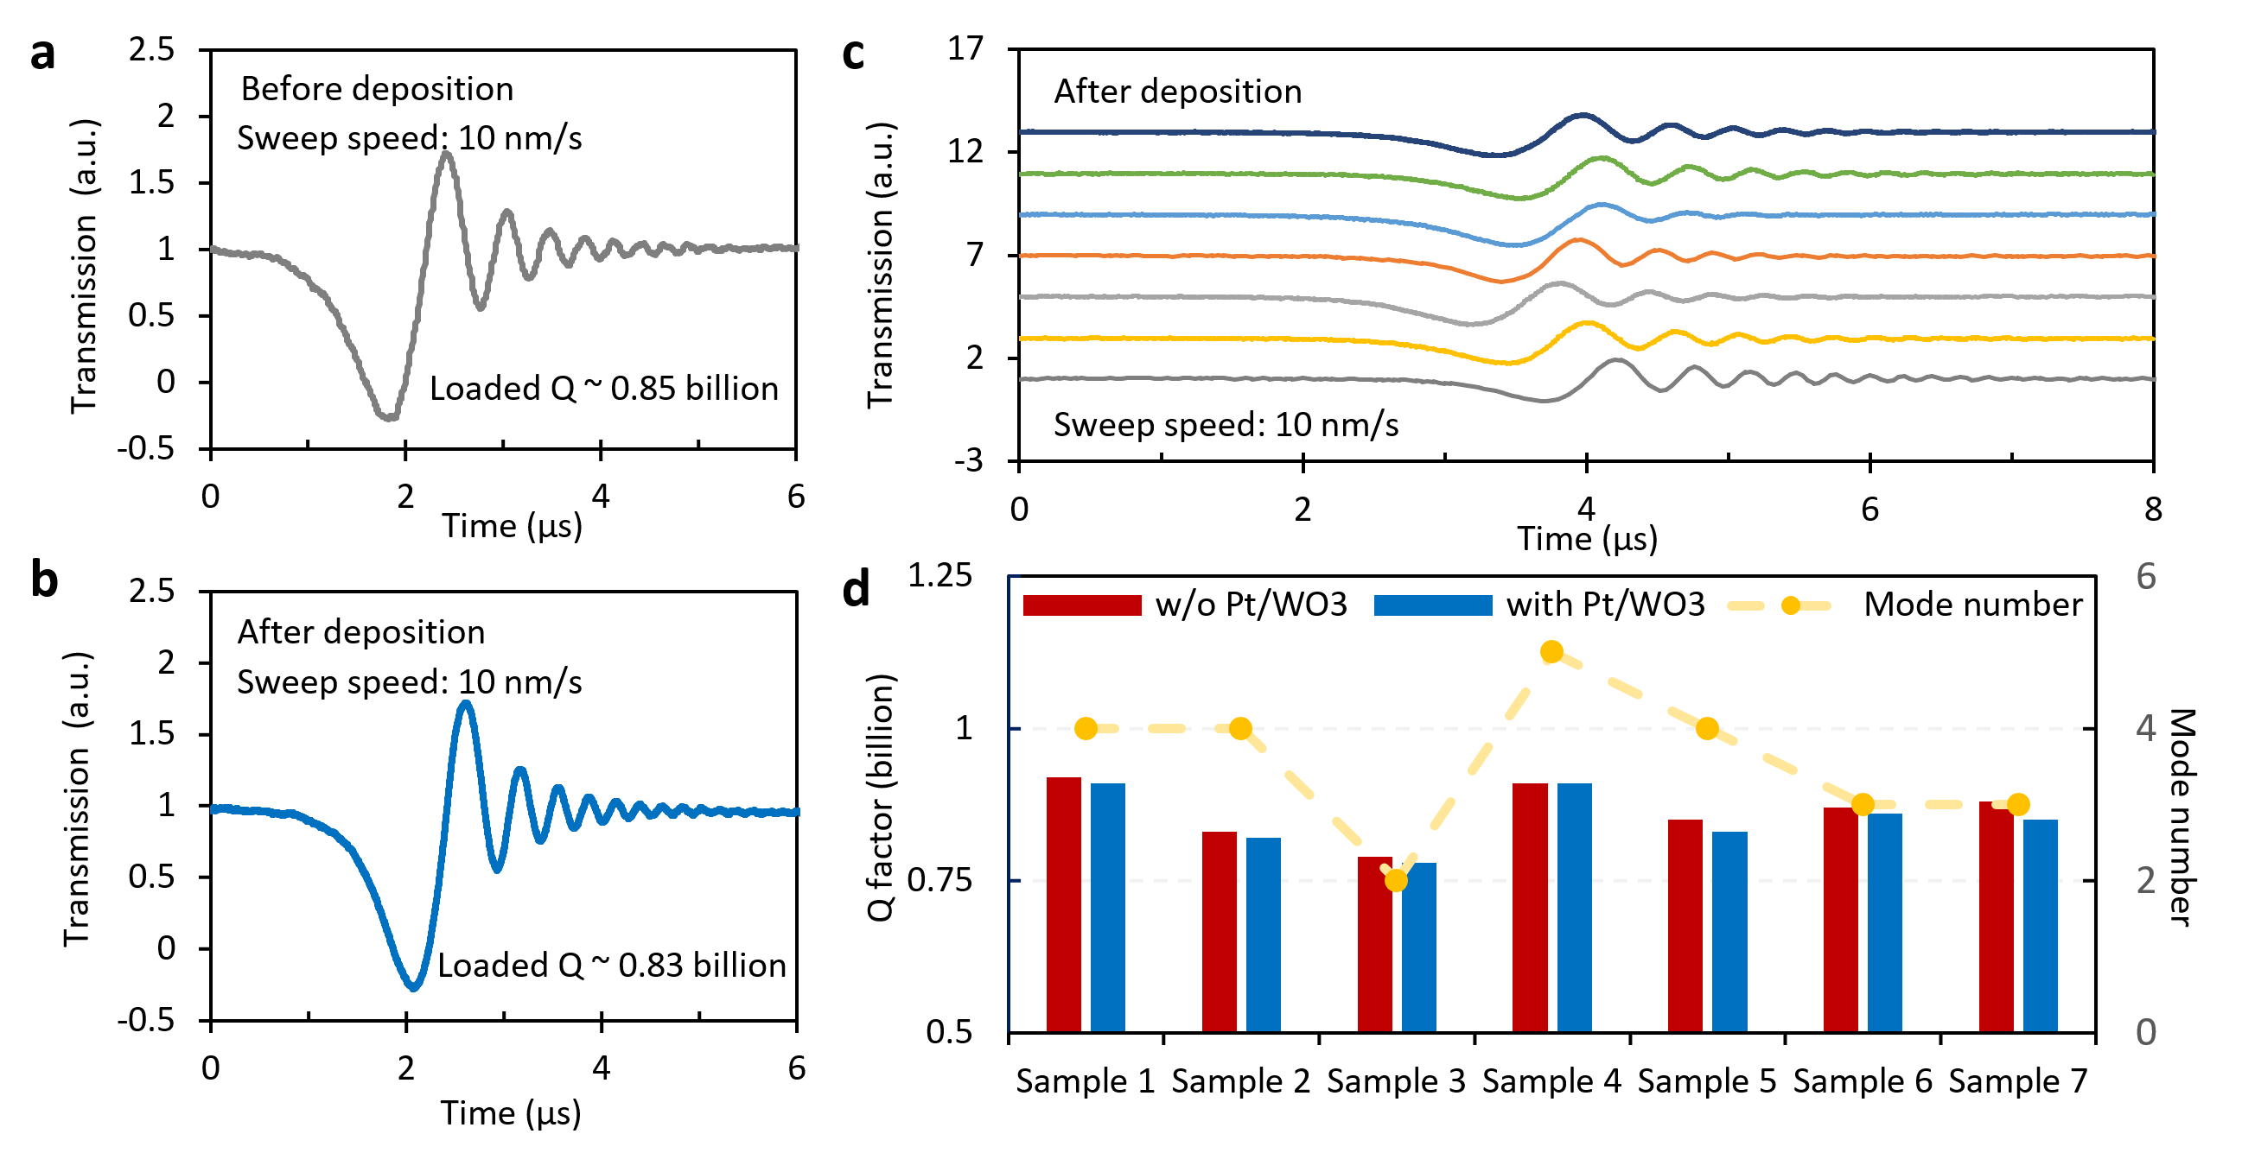

Fig. S5. Q factors of different samples before and after deposition. The Q factor of device before (a) and after (b) Pt/WO₃ nanofilm deposited on device inner surface. The transmission spectrums (c) and Q factor statistics (d) of different samples.
Under critical coupling and a scanning speed of 10 nm/s, all samples exhibited ringdown-shaped transmission spectra, as shown in Fig. S5c. The experimental data were fitted to extract the Q factors, and the statistical results are summarized in Fig. S5d, showing that all devices maintain Q factor between 0.9 and 1 billion, with effective mode numbers ranging from 2 to 5. A slight Q factor reduction was observed after material transfer, likely due to dust adsorption or residual ethanol introduced during the functionalization process. Additionally, cavities supporting fewer optical modes often exhibited somewhat lower Q factors. This can be attributed to minor geometric asymmetries introduced during the etching and annealing processes, which further suppress polar modes but also slightly increase radiation losses of the fundamental mode.

Note S3. Extended measurements.
S3.1 The stabilization performance of laser locked with probe cavity and reference cavity.
To comprehensively evaluate the noise suppression performance of the laser frequency stabilization system, we tested the characteristics of the lasers locked to the probe cavity and the reference cavity, respectively. The experimental setup is illustrated in Fig. S6a. In the sensing loop, a single-frequency laser (NKT Photonics, E15 @ 1550 nm) first passes through a 9:1 fiber coupler. The 10% branch is attenuated by a variable optical attenuator and then coupled into the functionalized microresonator via a tapered fiber. To suppress thermal nonlinear effects in the ultrahigh-Q microcavity, the input optical power is kept below –15 dBm. The transmitted light is detected by an avalanche photodetector (Thorlabs, APD430C), which converts the optical signal into an electrical error signal fed to the laser servo controller (Vescent, D2-125) to provide the feedback for frequency locking. Similarly, in the reference loop, another single-frequency laser (NKT Photonics, E15 @ 1550 nm) is frequency-locked to a ultrastable Fabry-Pérot (F-P) cavity. The reflected light from the F-P cavity is detected and processed by the same servo system for closed-loop stabilization. The error signals from both the probe and reference cavities are monitored in real time on an oscilloscope (Siglent, SDG2122X), as shown in Fig. S6b. In both loops, the remaining 90% optical power from each laser is combined through a 5:5 fiber coupler and sent to a photodetector for optical heterodyne detection. The two closely spaced laser frequencies generate a beat note, which passes through an electrical low-pass filter and is analyzed by an electronic spectrum analyzer (Rohde & Schwarz, FSW43). This beat frequency signal directly reflects variations in gas concentration, serving as the sensing output. Figure S6c displays the optical spectra of both the probe and reference lasers after frequency locking, demonstrating extremely narrow linewidths. Finally, Fig. S6d presents the beat signals between the probe and reference lasers across 1~1000 MHz, exhibiting excellent frequency stability and GHz-scale tunability, confirming the high performance of the dual-cavity locked laser sensing system.

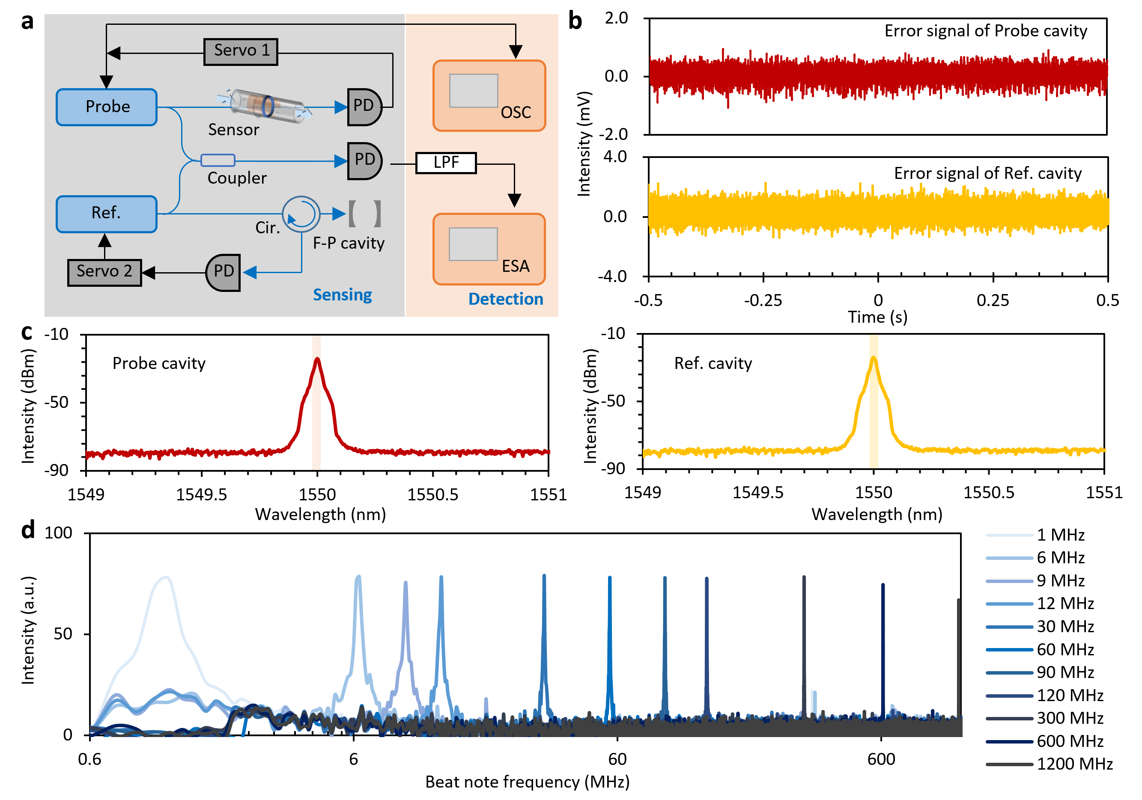

Fig. S6. Stabilization of laser locked with probe and reference cavity. a, The optoelectronic measurement setup of laser stabilization and sensing. PD, photodetector; OSC, oscilloscope; ESA, electronic spectrum analyzer; LPF, low pass filter. b, The electronic feedback signal of probe and reference cavity. c, The optical spectrum of probe and reference cavity. d, Beat note signals of the dual laser locked with probe cavity and reference cavity, respectively.
To further evaluate the noise suppression performance of the sensing and reference lasers, we conducted phase noise and frequency stability measurements. The experimental setup is illustrated in Fig. S7a. The measurement was carried out by beating the test laser (the probe or reference laser) with a fully locked optical frequency comb (Menlo Systems FC 1500-ULNova-ORS, f_{r}ₑₚ = 250 MHz). The beat note signal was detected by an avalanche photodetector (Thorlabs, APD430C), and the electrical signal was analyzed using a phase noise analyzer (Rohde & Schwarz, FSPN 26). Since the frequency comb exhibits ultra-low noise (≤1 × 10⁻¹⁷ at 1 s), its contribution can be negligible compared to that of the test laser. Figures S7b and S7d show the single-sideband phase noises (SSB-PNs) spectra and Allan deviation of the sensing laser before and after locking to the Pt/WO₃ inner-coated microresonator. Owing to the ultrahigh-Q factor of the microresonator, the laser phase noise is significantly suppressed, especially in the low-frequency region, achieving a reduction of ~40 dB at 1 Hz. The Allan deviation results further indicate that the feedback loop gain is well matched to the resonator quality factor, ensuring effective noise suppression.
For the reference laser, which is locked to a higher-Q F-P cavity, the noise suppression effect is even more pronounced. As shown in Fig. S7c and S7e, under side-of-fringe locking, the laser phase noise is reduced to approximately –20 dBc/Hz @ 1 Hz, while the Allan deviation decreases by nearly five orders of magnitude at 1 s. These results clearly demonstrate the superior stability and low-noise characteristics achieved through high-Q cavity-based laser frequency stabilization, forming the foundation for ultrahigh-resolution optical sensing.
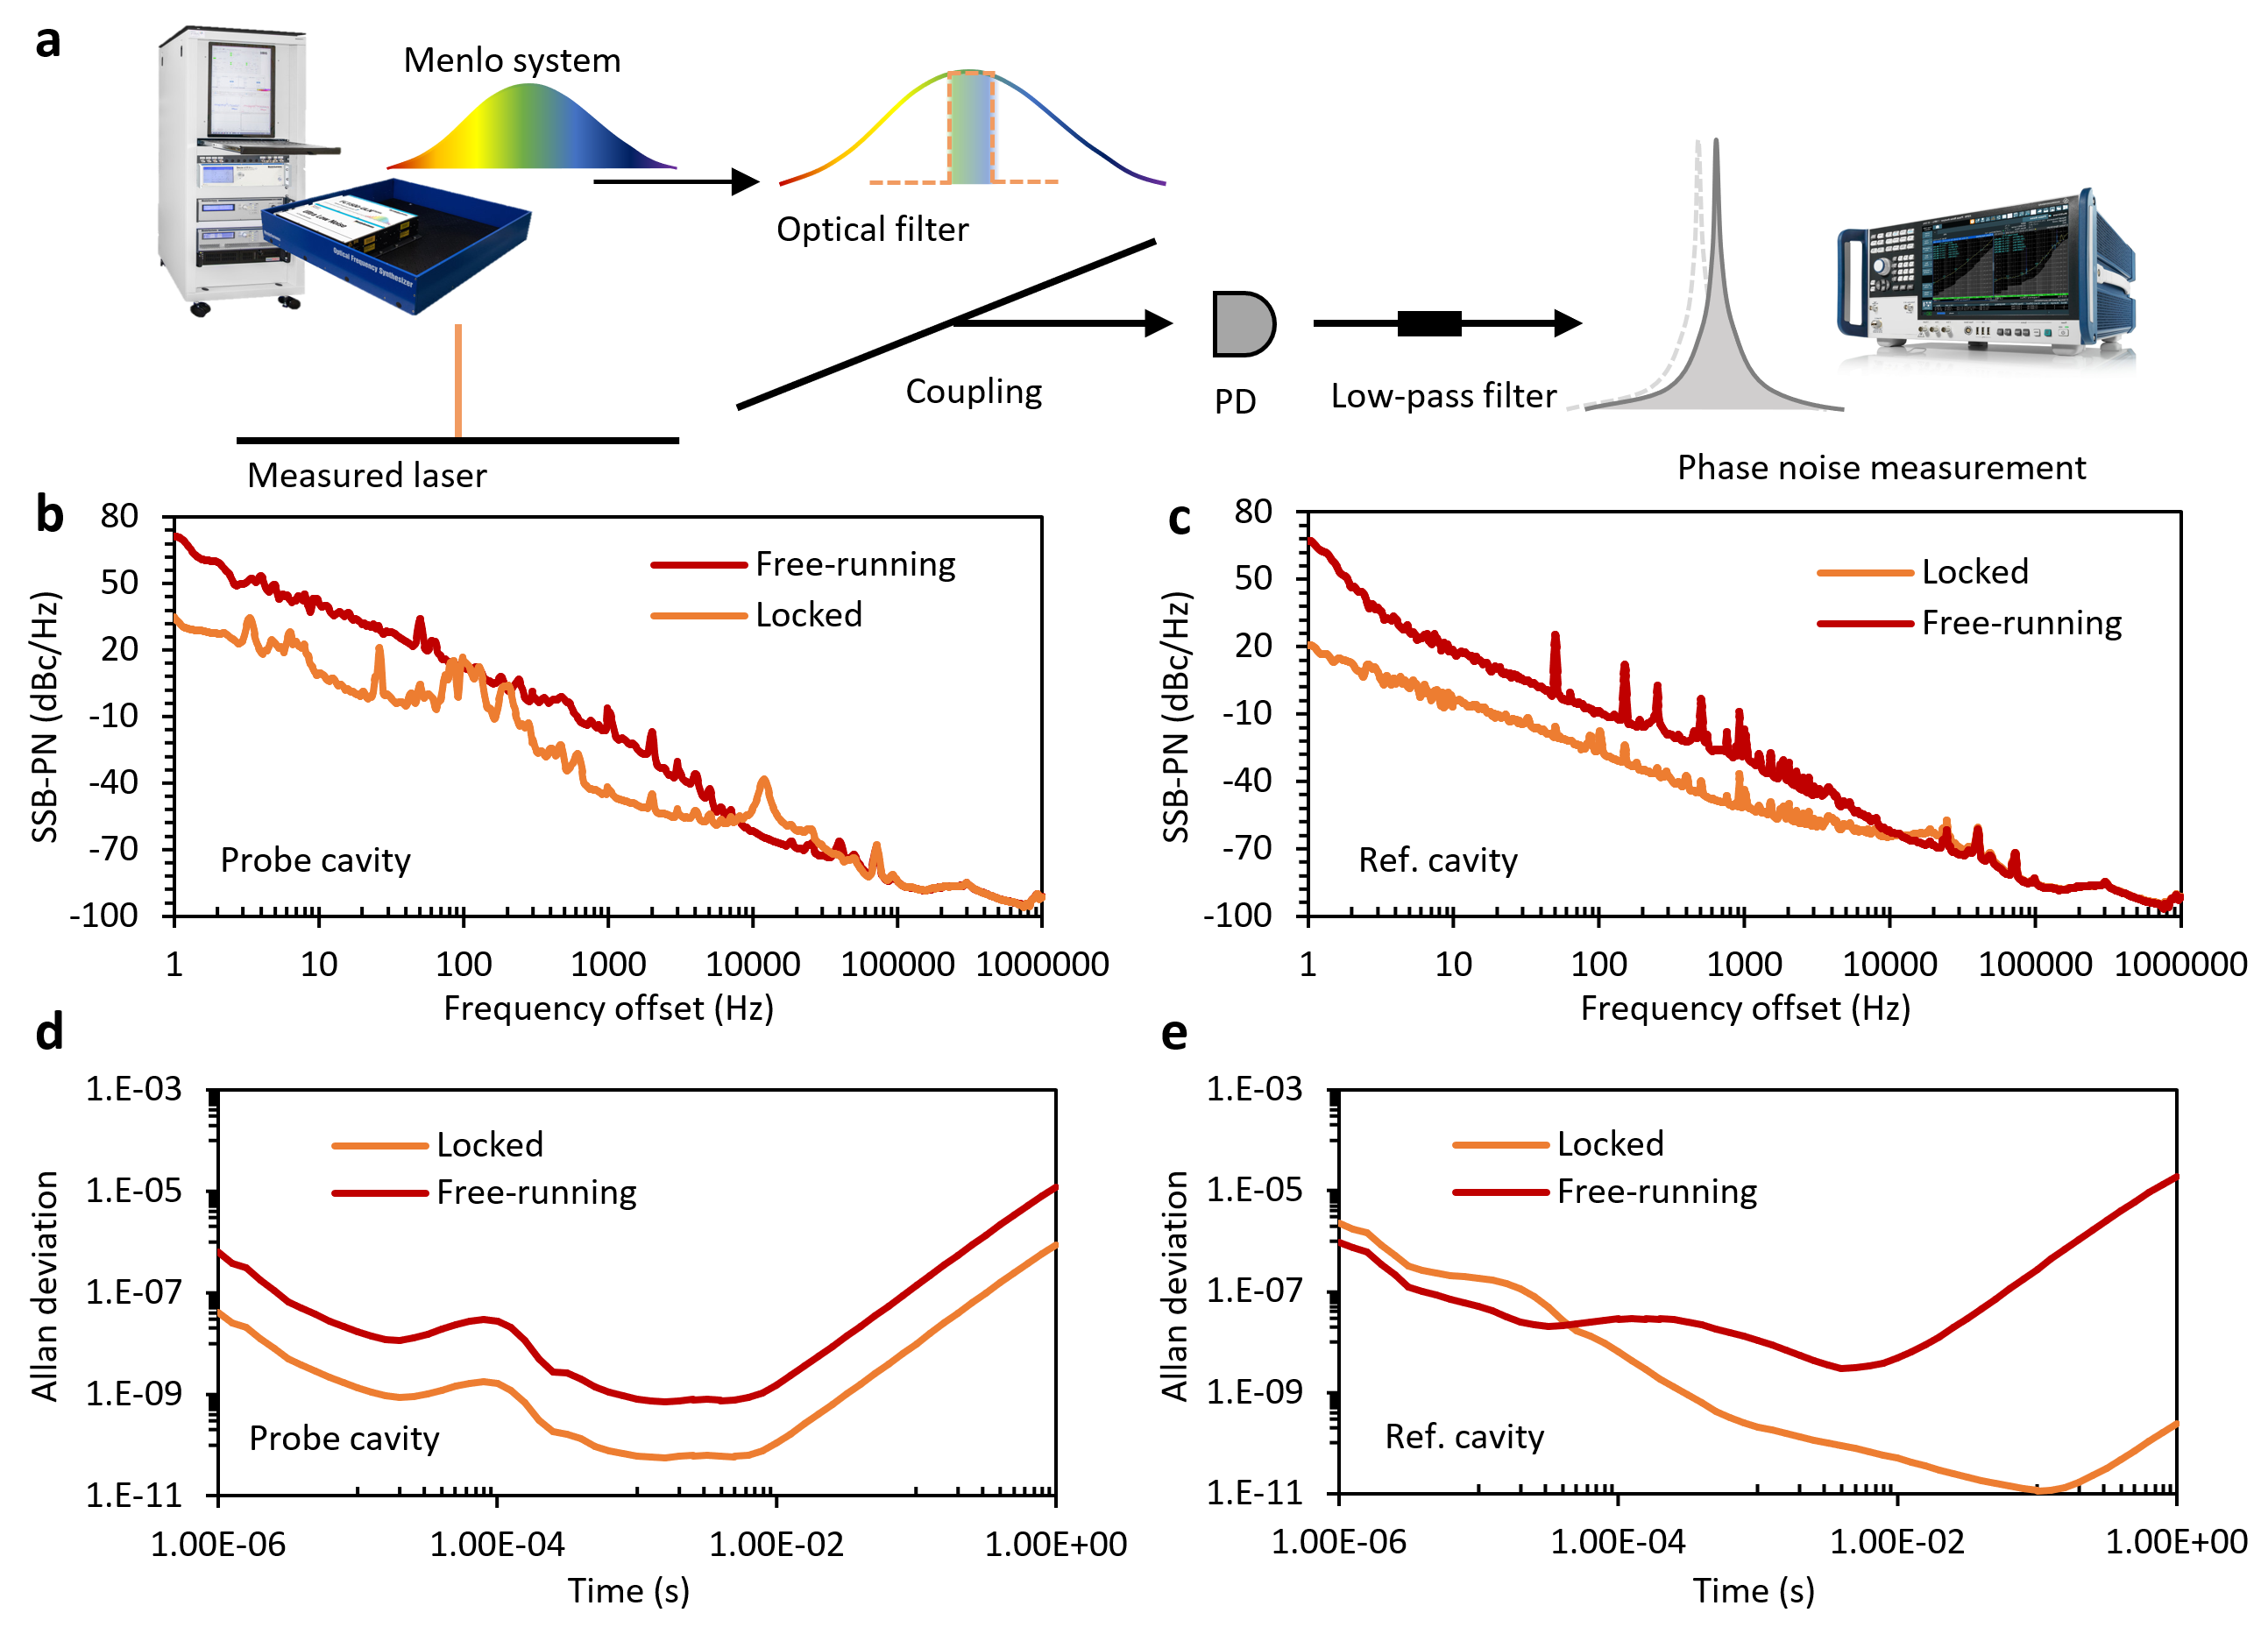

Fig. S7. Noise measurements of probe cavity and reference cavity. a, Optoelectronic noise measurement setup of cavity. PD, photodetector. b&c, Single sideband phase noise of probe cavity and reference cavity. d&e, Allan deviation of probe cavity and reference cavity.
S3.2 The process of gas preparation and injection.
The gas mixing and delivery system consists of gas cylinders, mass flow controllers (MFCs), and a computer control unit, as illustrated in Fig. S8a. High-pressure cylinders are used to store hydrogen standard gases with known concentrations and dilution gases, both connected via precision pressure regulators. The mass flow controllers precisely regulate the output flow rate of each gas, while the computer calculates the gas correction coefficients and flow ratios based on the thermophysical properties of different gases, thereby ensuring accurate concentration control. After being output by the MFCs, the gases are thoroughly mixed to obtain the target concentration gas, which is then used for subsequent sensing and detection. To ensure the accuracy of the standard gas concentration, the minimum available concentration of commercial standard gases is typically 1 ppm. When preparing ultra-low-concentration gases, a large dilution ratio is required. By combining two MFCs with full-scale (F.S.) ranges of 2 L/min and 20 mL/min, each with a precision of 1% F.S., the dilution ratio can be continuously adjusted between 1/10,000 and 1. As shown in Fig. S8a, a 1 ppm hydrogen standard gas can thus be diluted to yield a 0.1 ppb target concentration.
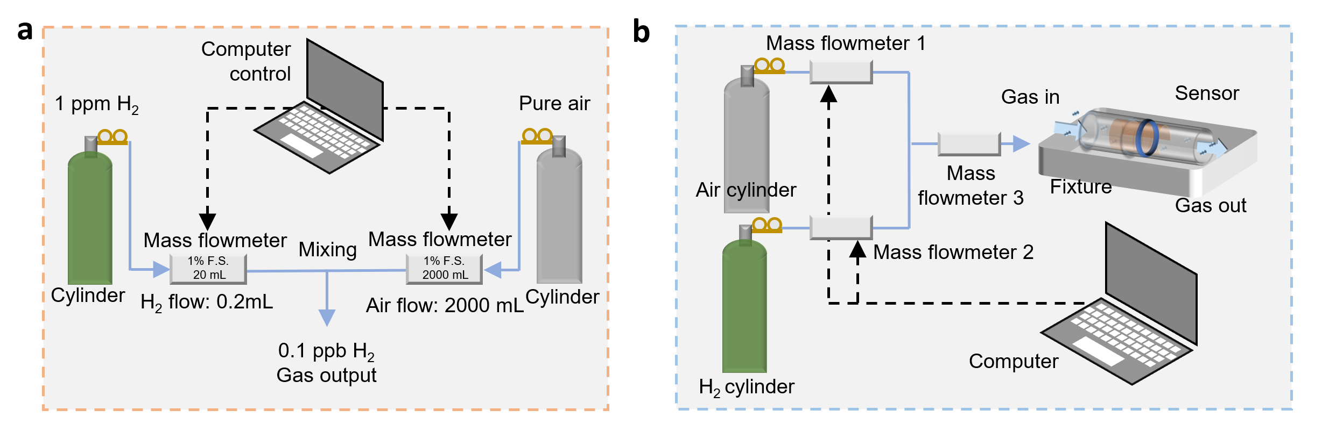

Fig. S8. The schematic diagram of gas injection and preparation. a, Preparation of ultra-low concentration gas. b, Injection process of different concentration hydrogen gas.
The schematic of gas injection based on this configuration is shown in Fig. S8b. Once the gas type and target concentration are preset, hydrogen gases of various concentration gradients are automatically injected into the sensing microresonator. To maintain constant flow velocity, an additional MFC is installed before the device. Owing to the hollow microtube geometry of the resonator, the system eliminates the need for a traditional gas chamber and enables real-time, in situ sensing within a compact configuration. During each sensing cycle, dry air is first introduced into the microresonator to clean the sensing environment and replenish lattice oxygen ions in the Pt/WO₃ sensing layer. The initial beat frequency of the locked laser is recorded at this stage. Next, the target hydrogen gas with a specific concentration is injected at a constant flow rate, and the beat frequency shift is continuously monitored until it reaches a steady state. Finally, dry air is reintroduced to purge the system until the beat frequency returns to its initial value, marking the end of a complete sensing and recovery cycle.
S3.3 The extended results of beat note recoverability with different hydrogen gas concentration.
Figure S9 presents the device response to various hydrogen concentrations. The waterfall plot clearly shows the temporal evolution of the beat-note signal, with a frequency span of 0 ~ 1250 MHz and a time resolution of 1 s. For each concentration, the beat note remains stable initially; upon the introduction of hydrogen, the signal begins to shift and eventually reaches a new steady state. The response time, defined as the time required to reach 90% of the final steady-state shift, is approximately 6 s when 0.1 ppm hydrogen injection. When hydrogen is replaced with dry air, the beat note returns to its initial value, yielding a recovery time of about 8 s with recoverability more than 98%. As the hydrogen concentration increases, the steady-state beat note shift becomes larger, consistent with the increased heat release. Moreover, both the response and recovery times exhibit a slight increase at higher concentrations, limited by the characteristic thermal diffusion time.
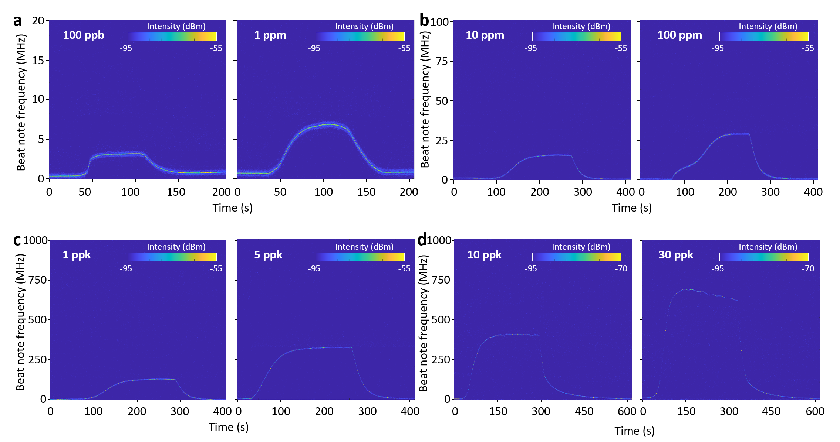

Fig. S9. The beat note waterfall maps of hydrogen concentration with (a) 100 ppb and 1 ppm, (b) 10 ppm and 100 ppm, (c) 1ppk and 5ppk, and (d) 10ppk and 30ppk.

S3.4 Extended discussion about the system encapsulation.
For meeting the potential applications out of laboratory, we package the whole hydrogen sensing microsystem in a compact prototype. Configuration of the module majorly includes a probe laser diode (1550 nm, 14 PIN, Accelink), a reference laser diode (1550 nm, 14 PIN, Accelink), low noise photodetectors (DET01CFC, Thorlabs), a PID tagging feedback loop and a signal processing core in FPGA (XILINX, ACAU15). In optics: 1) the probe laser drives the microfluidic cavity; 2) the reference laser is stabilized by using an ultra-stable F-P micro-resonator. In electronics: 1) after photodetection#1, the sensor modulated probe laser intensity alteration offers the signal for tuning the probe frequency, 2) after photodetection#2, the reflected intensity of the reference laser provides the signal for locking the reference frequency, 3) beat note of the probe laser and the reference laser are obtained after photodetection#3, frequency shift of the dual laser beat note tells the sensing response. We note that since the hydrogen detection relies on local temperature alteration, the whole microsystem requires a macroscopic thermal electrical cooler. In Fig. S10, we show the system configuration: two DFB lasers (i) are respectively locked onto the resonance of the sensing microcavity (ii) and an ultra-stable F-P reference microcavity (iii) through independent feedback loops. All the thermally sensitive components are rigidly fixed on a mechanical holder with a macroscopic temperature controller element. Gas is delivered to the sensor through a silicone hose. The FPGA module (iv) achieves PID control and laser-locking functions in digital electronics.
The experiment begins with an initialization step. The system temperature is allowed to stabilize, and the DFB lasers, photodetectors, and FPGA are activated. Next, the two feedback-locking loops are engaged. Under FPGA control, each laser is rapidly tuned to scan across a microcavity resonance. This scan provides the relationship between laser detuning and transmitted intensity, enabling identification of the optimal locking point. The laser wavelength is then adjusted to the vicinity of this point, and closed-loop stabilization is established based on the generated error signal. The PID parameters are pre-configured according to the microcavity characteristics to ensure minimal locking noise. Gas sensing is then carried out. The inlet of the system is connected to a gas-delivery module to supply a continuous and stable stream of the target gas, while the outlet allows exhaust of the effluent gas. During sensing, the combined optical field from the reference and probe lasers is detected by a photodetector, converted into an electrical beat note, and routed to a spectrum analyzer or the FPGA. The resonance shift induced by gas injection manifests as a corresponding frequency shift in the beat-note signal. Finally, a reset process is performed. Dry air is introduced to purge the device, after which the lasers, photodetectors, and FPGA are powered down.

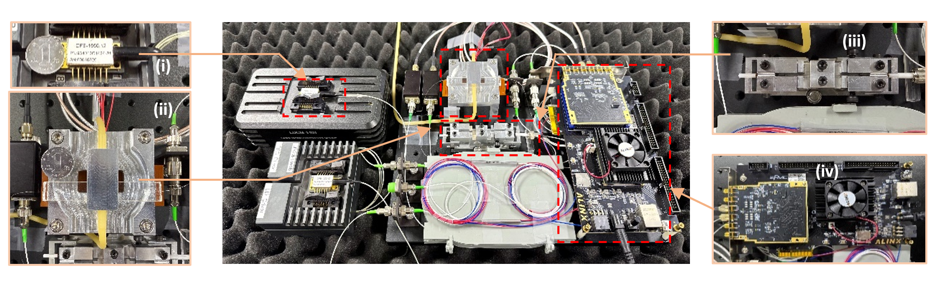

Fig. S10. Hydrogen sensing system architecture. (i) DFB laser, (ii) Microfluidic cavity, (iii) Ultra-stable optical reference cavity, (iv) FBGA processing core.
References
1. Jiang, X., Qavi, A. J., Huang, S. H. & Yang, L. Whispering-Gallery Sensors. Matter 3, 371–392 (2020).
2. Foreman, M. R., Swaim, J. D. & Vollmer, F. Whispering gallery mode sensors. Adv. Opt. Photonics 7, 168 (2015).
3. Guo, Y. et al. Optical Microcavities Empowered Biochemical Sensing: Status and Prospects. Adv. Devices Instrum. 5, 1–28 (2024).
4. Yamaguchi, Y., Imamura, S., Ito, S., Nishio, K. & Fujimoto, K. Influence of oxygen gas concentration on hydrogen sensing of Pt/WO3 thin film prepared by sol–gel process. Sensors Actuators B Chem. 216, 394–401 (2015).
5. Li, Z. et al. Optical fiber hydrogen sensor based on evaporated Pt/WO3 film. Sensors Actuators B Chem. 206, 564–569 (2015).
6. Kumar, K. V., Porkodi, K. & Rocha, F. Langmuir–Hinshelwood kinetics – A theoretical study. Catal. Commun. 9, 82–84 (2008).
7. Baxter, R. J. & Hu, P. Insight into why the Langmuir–Hinshelwood mechanism is generally preferred. J. Chem. Phys. 116, 4379–4381 (2002).
8. Cheng, C. et al. Heat Transfer across the Interface between Nanoscale Solids and Gas. ACS Nano 5, 10102–10107 (2011).
9. Sadik Kakac, Yaman Yener, A. P. Convective Heat Transfer. (CRC Press, 2013).
10. Dharaiya, V. V. & Kandlikar, S. G. Numerical Investigation of Heat Transfer in Rectangular Microchannels Under H2 Boundary Condition During Developing and Fully Developed Laminar Flow. J. Heat Transfer 134, (2012).
11. Cuevas, J. C. & García-Vidal, F. J. Radiative Heat Transfer. ACS Photonics 5, 3896–3915 (2018).
12. Li, B. B. et al. On chip, high-sensitivity thermal sensor based on high- Q polydimethylsiloxane-coated microresonator. Appl. Phys. Lett. 96, 2008–2011 (2010).
13. Dong, C. H. et al. Fabrication of high- Q polydimethylsiloxane optical microspheres for thermal sensing. Appl. Phys. Lett. 94, (2009).
14. Lei, F., Murphy, R. M. J., Ward, J. M., Yang, Y. & Nic Chormaic, S. Bandpass transmission spectra of a whispering-gallery microcavity coupled to an ultrathin fiber. Photonics Res. 5, 362 (2017).
15. Zhang, H. et al. Gas Detection With Switchable Selectivity in a Functionalized-Graphene Integrated Microrod Resonator. Photonic Sensors 15, 250423 (2025).
16. Gao, F. et al. Sub-ppb-level sensitive hydrogen gas sensing based on PDMS-Pt enhanced microrod cavity. Opt. Express 33, 42043 (2025).
17. Wang, C. et al. Highly sensitive fiber grating hydrogen sensor based on hydrogen-doped Pt/WO3. Sensors Actuators B Chem. 404, 135250 (2024).

