Asymmetric architecture toward waveform encoding for motion perception in perovskite photodetectors
Authors
Yang Shi¹, Qingqi Chen¹, Hao Xiong¹, Lin Xiao¹, Yi Zhu¹, Wei Ren¹, Zhilong He², Leilei Gu^{1,3,4*}
Affiliations
¹Qingyuan Research Institute, School of Computer Science, Shanghai Jiao Tong University, Shanghai, China.
²School of Chemistry and Chemical Engineering, Shanghai Jiao Tong University, Shanghai, China.
³Shanghai Artificial Intelligence Laboratory, Shanghai, China.
⁴National Key Laboratory of Advanced Micro and Nano Manufacture Technology, Shanghai Jiao Tong University.
*Corresponding author
Correspondence and requests for materials should be addressed to Leilei Gu.
*Email: leilei.gu@sjtu.edu.cn (Leilei Gu).
Keywords: Motion perception, Waveform encoding, Optical flow estimation, Perovskite photodetector
This PDF file includes:
Supplementary Figures 1-13 (page 2-14)
Supplementary Tables 1 (page 15)
Supplementary Note 1 (page 16-17)
Supplementary Reference (page 18)

Supplementary Fig 1. Energy band diagrams. The inverted MAPbI₃ based photodetectors with the configuration of (a) ITO/perovskite/C₆₀/BCP/Cu and (b) ITO/Al₂O₃/perovskite/C₆₀/BCP/Cu, respectively.

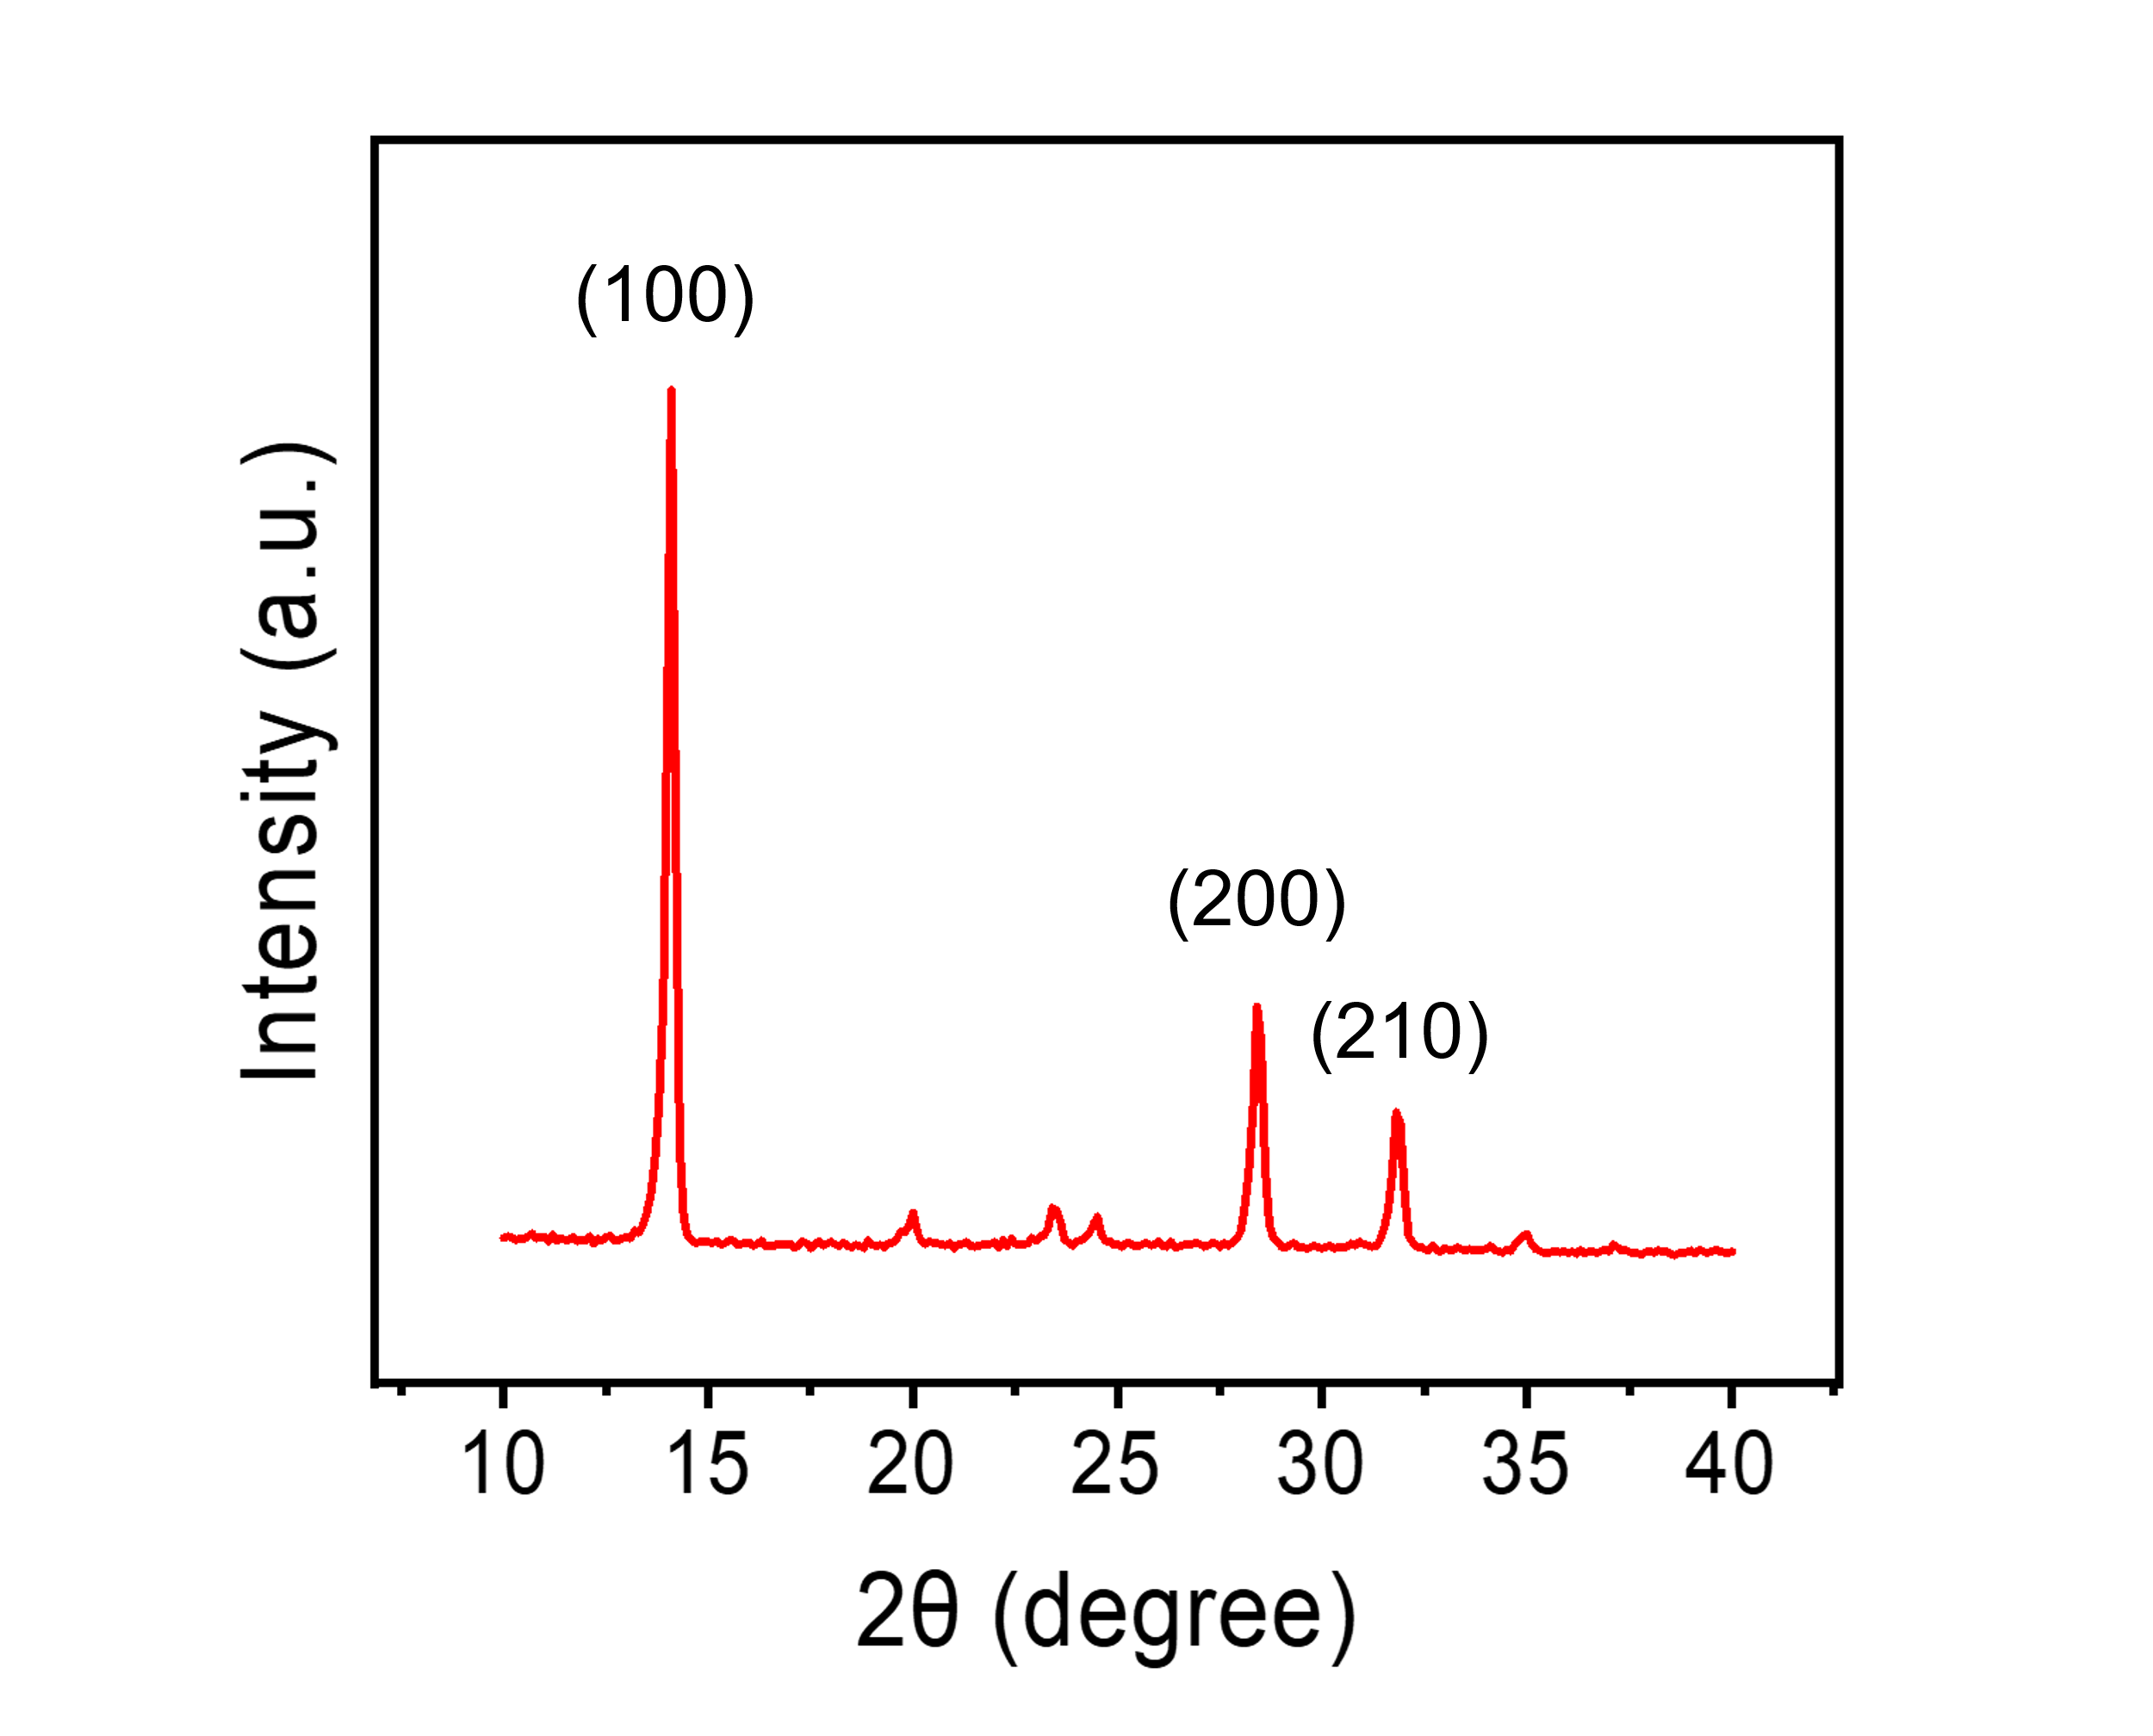
Supplementary Fig 2. Crystallinity characterization. XRD pattern of MAPbI₃ film prepared from perovskite precursor solution.
Supplementary Fig 3. Morphology characterization. Top-view SEM image of MAPbI₃ films deposited on the ITO layer.

Supplementary Fig 4. Characterization of leakage current and crystallinity. (a) J–V characteristics and (b) XRD pattern of Al₂O₃ film deposited by atomic layer deposition (ALD).

Supplementary Fig 5. Response time measurements. (a-b) TPC curves of the MAPbI₃ photodetectors with and without the Al₂O₃ layer, respectively.

Supplementary Fig 6. Optical chopper setup. Illustration of speed and direction measurement based on the MAPbI₃ photodetector.

Supplementary Fig 7. (a) A representative photocurrent response curve. (b) The relationship of the frequency with on-off time.
Supplementary Fig 8. Mechanism of Speed Perception. (a) Photocurrent waveforms of the perovskite photodetector at different motion speeds under a fixed motion direction of 180°, and (b) schematic illustration of their evolution.

Supplementary Fig 9. Typical response curves of the hybrid-type photodetector. The photocurrent response of the device under varying light intensity, motion speed, and direction.

Supplementary Fig 10. Schematic illustration of the neural network. The model consists of four convolutional layers with pooling (Conv 1–Conv 4), followed by an LSTM and an attention mechanism for temporal feature extraction. A ReLU with Dropout layer and a classification head are applied to generate outputs corresponding to light intensity, motion speed, and direction.

Supplementary Fig 11. Validation of the trained model on additional photocurrent data acquired after 6 h interval. Confusion matrices of the trained neural network model for recognizing (a) light intensity, (b) motion direction, and (c) speed based on photocurrent waveforms.

Supplementary Fig S12. Photocurrent response of the hybrid-type photodetector array. Each subplot shows the photocurrent response of individual pixels in the array under varying illumination conditions, highlighting the characteristic waveforms that occur as the object enters and leaves each pixel.

Supplementary Fig S13. Optical flow estimation under occlusion scenario. a Schematic illustration of imaging under occlusion condition. b Frame sequence during the motion of vehicle. c Sustained response curve and the corresponding optical flow estimated using the conventional Farnebäck algorithm. d Hybrid response curve and the corresponding optical flow estimated using hybrid-type photodetector.

Supplementary Table 1. Correspondence between chopper frequency and blade speed. The blade speed was calculated using v=2πrf, where r is the distance between the rotation center and the light beam, and f is the operating frequency of the chopper.
Frequency/Hz | 5 | 40 | 200 | 400 | 800
Speed/ (m s⁻¹) | 0.2 | 1.5 | 7.3 | 14.7 | 29.3

Supplementary Note 1. Traditional optical flow algorithm.
The early optical flow estimation algorithms are fundamentally based on the brightness constancy assumption, which states that the brightness of a pixel remains unchanged as it moves between two consecutive frames. A pixel located at position (x, y) in frame t moves to position $\left(x+δ_{x},y+δ_{y}\right)$ in frame $t+δ_{t}$ over a short time interval $δ_{t}$. According to the brightness constancy assumption, this relationship can be mathematically expressed as:
$$\begin{aligned}I\left(x+δ_{x}, y+δ_{y}, t+δ_{t}\right)=I\left(x,y,t\right)\#\left(1.1\right)\end{aligned}$$
To solve the above equation, the Lucas–Kanade (LK) algorithm¹ assumes that the displacements $δ_{x}$ and $δ_{y}$ between two consecutive frames are sufficiently small, allowing the left-hand side of Eq. (1.1) to be approximated using a first-order Taylor expansion:
$$\begin{aligned}I\left(x+δ_{x}, y+δ_{y}, t+δ_{t}\right)=I\left(x,y,t\right)+\frac{∂I\left(x,y,t\right)}{∂x}δ_{x}+\frac{∂I\left(x,y,t\right)}{∂y}δ_{y}+\frac{∂I\left(x,y,t\right)}{∂t}δ_{t}\#\left(1.2\right)\end{aligned}$$
By eliminating $I(x,y,t)$ from both sides of Eq. (1.2), one obtains the optical flow constraint equation:
$$\begin{aligned}\frac{∂I\left(x,y,t\right)}{∂x}δ_{x}+\frac{∂I\left(x,y,t\right)}{∂y}δ_{y}+\frac{∂I\left(x,y,t\right)}{∂t}δ_{t}=0\#\left(1.3\right)\end{aligned}$$
Since $(x,y)$ denotes the pixel position, the quantities $(\frac{δ_{x}}{δ_{t}},\frac{δ_{y}}{δ_{t}})$ represent the pixel velocity components. Let $u=\frac{δ_{x}}{δ_{t}}$ and $v=\frac{δ_{y}}{δ_{t}}$ denote the horizontal and vertical velocity components, respectively. Equation (1.3) can then be simplified as:
$$\begin{aligned}I_{x}u+I_{y}v+I_{t}=0\#\left(1.4\right)\end{aligned}$$
Equation (1.4) represents the mathematical foundation of the optical flow problem and establishes a constraint for the motion of each pixel in an image. Here, I_{x} and I_{y} denote the partial derivatives of the image intensity with respect to the spatial coordinates $x$ and $y$, while $I_{t}$ denotes the temporal derivative of intensity with respect to time t. However, this equation presents a major challenge: although a constraint can be formed for each pixel, the equation contains two unknowns (u and v) but only one equation, making it an ill-posed (under-constrained) problem that cannot be uniquely solved with limited information.
To further elucidate this issue, Horn and Schunck² introduced a practical interpretation known as the Aperture Problem. Since the observation of image intensity variations is confined to a small local region (e.g., a limited window or “aperture”), the obtained information can be misleading.
To overcome this ill-posed nature, the Lucas–Kanade (LK) method introduces the spatial consistency assumption, which postulates that neighboring pixels within a small window share a common motion velocity (u, v). Therefore, for each pixel within the window, identical optical flow constraint equations can be established. For instance, assuming that all pixels (P₁, P₂, P₃, …, P₂₅) within a 5×5 window exhibit similar motion tendencies, one can obtain 25 optical flow constraint equations while the unknowns remain two ($u$ and $v$), as expressed in Eq. (1.5).
$$\begin{aligned}\left[\begin{matrix}\begin{matrix}I_{x}\left(p_{1}\right) \\ \begin{matrix}I_{x}\left(p_{2}\right) \\ ⋮\end{matrix}\end{matrix} & \begin{matrix}I_{y}\left(p_{1}\right) \\ \begin{matrix}I_{y}\left(p_{2}\right) \\ ⋮\end{matrix}\end{matrix} \\ I_{x}\left(p_{25}\right) & I_{y}\left(p_{25}\right)\end{matrix}\right]\left[\begin{matrix}u \\ v\end{matrix}\right]=-\left[\begin{matrix}I_{t}\left(p_{1}\right) \\ \begin{matrix}I_{t}\left(p_{2}\right) \\ \begin{matrix}⋮ \\ I_{t}\left(p_{25}\right)\end{matrix}\end{matrix}\end{matrix}\right]\#\left(1.5\right)\end{aligned}$$
This method effectively transforms the problem into an overdetermined system of equations, in which the number of equations exceeds the number of unknowns. Consequently, it provides a mathematically feasible solution for estimating the motion velocity of each pixel.

Supplementary Reference
1. Lucas, B. D. & Kanade, T. An iterative image registration technique with an application to stereo vision. in Proceedings of the 7th International Joint Conference on Artificial Intelligence - Volume 2 674–679 (Morgan Kaufmann Publishers Inc., San Francisco, CA, USA, 1981).
2. Horn, B. K. & Schunck, B. G. Determining optical flow. Artif. Intell. 17, 185–203 (1981).

