Supplemental
Table S1. Percent Distribution of Fecal Calprotectin Categories by Diagnosis.
Diagnosis | <50 | 50–119 | 120–249 | 250–499 | ≥500
IBD | 22.1% | 23.7% | 12.9% | 14.1% | 27.3%
IBS | 88.0% | 12.0% | 0.0% | 0.0% | 0.0%
Indeterminate | 20.7% | 37.5% | 20.3% | 15.3% | 6.1%
Microscopic | 16.7% | 8.3% | 41.7% | 33.3% | 0.0%

Table S2. Summary by Diagnostics. Descriptive statistics of fecal calprotectin (µg/g) across diagnostic categories.
Diagnosis | n | mean | sd | min | Q1 | median | Q3
IBD | 249 | 418 | 541 | 5 | 56 | 165 | 556
IBS | 108 | 25.6 | 20.4 | 5 | 9.7 | 17.6 | 35.4
Indeterminate | 261 | 157 | 156 | 5 | 54.7 | 97.1 | 199
Microscopic | 12 | 203 | 156 | 12.9 | 110 | 148 | 352

Table S3. Diagnostic performance of fecal calprotectin thresholds Positive = IBD, Negative = IBS + Indeterminate + Microscopic.
Cutoff (µg/g) | TP | TN | FP | FN | Sensitivity (%) | Specificity (%) | PPV (%) | NPV (%)
50 | 222 | 151 | 272 | 55 | 80.1 | 35.7 | 44.9 | 73.3
150 | 156 | 296 | 127 | 121 | 56.3 | 70.0 | 55.1 | 71.0
250 | 131 | 329 | 94 | 146 | 47.3 | 77.8 | 58.2 | 69.3
500 | 96 | 375 | 48 | 181 | 34.7 | 88.7 | 66.7 | 67.4
Table S4. Fecal calprotectin boxplot and P values across infection status and phenotype.
Phenotype | Infection | Median | Q1 | Q3 | P_value
Microscopic | General infection | 377 | 293 | 424 | 0.107
 | No infection | 145 | 49.5 | 154 | 0.107
IBS | General infection | 18.3 | 10.9 | 34.4 | 0.947
 | No infection | 17.6 | 9.7 | 39.5 | 0.947
IBD | General infection | 199 | 55.6 | 794 | 0.968
 | No infection | 191 | 61.2 | 759 | 0.968
Indeterminate | General infection | 116 | 54 | 278 | 0.694
 | No infection | 95.6 | 61 | 228 | 0.694

Table S5. Fecal calprotectin boxplot values across infection type and phenotype.
Phenotype | Infection | N | Median | IQR
Microscopic | C diff | 12 | 148 | 110.425–351.5
 | General infection | 4 | 377 | 293–424.25
 | No infection | 8 | 145 | 49.5–154.5
 | Other | 3 | 348 | 238–377
 | URI (Viral) | 2 | 252 | 138.425–365.475
 | UTI | 1 | 348 | 348–348
IBS | C diff | 109 | 17.7 | 9.7–37.1
 | GI Parasite | 4 | 30.2 | 16.55–45.375
 | General infection | 52 | 18.3 | 10.9–34.45
 | No infection | 57 | 17.6 | 9.7–39.5
 | Other | 18 | 18.6 | 11.85–32.8
 | URI (Viral) | 24 | 18.3 | 12.075–31.7
 | UTI | 25 | 19.6 | 11.7–34.3
IBD | C diff | 264 | 196 | 58.25–788
 | CNS | 2 | 746 | 514–978
 | GI Parasite | 2 | 59 | 43–75
 | General infection | 147 | 199 | 55.6–794.5
 | No infection | 117 | 191 | 61.2–759
 | Other | 37 | 195 | 69.3–585
 | URI (Viral) | 74 | 218 | 67.425–727.75
 | UTI | 44 | 186 | 40.65–543
Indeterminate | C diff | 271 | 102 | 58–248
 | CNS | 2 | 75.6 | 69.1–82.1
 | GI Parasite | 5 | 350 | 128–449
 | General infection | 157 | 116 | 54–278
 | No infection | 114 | 95.6 | 61–227.5
 | Other | 37 | 137 | 60.1–324
 | URI (Viral) | 77 | 129 | 55.8–280
 | UTI | 76 | 101 | 54.225–171.25

Table S6. Multivariable logistic regression with calprotectin categories. Outcome: Infection within 36 months. Reference groups: Calprotectin <50 µg/g, Diagnosis: IBD

Predictor | Odds Ratio (95% CI) | p value
Calprotectin 50–149 | 0.63 (0.41–0.97) | 0.037
Calprotectin 150–249 | 0.96 (0.52–1.79) | 0.89
Calprotectin 250–499 | 0.91 (0.52–1.61) | 0.75
Calprotectin ≥500 | 0.95 (0.58–1.54) | 0.82
Diagnosis: IBS | 0.62 (0.38–1.02) | 0.061
Diagnosis: Indeterminate | 1.12 (0.80–1.59) | 0.51
Diagnosis: Microscopic colitis | 0.41 (0.11–1.36) | 0.16

Table S7. ROC analysis of fecal calprotectin for infection prediction by diagnosis
Diagnosis | AUC (95% CI)
IBD | 0.52 (0.45–0.59)
IBS | 0.49 (0.39–0.60)
Indeterminate | 0.52 (0.45–0.59)
Microscopic colitis | 0.81 (0.50–1.00)

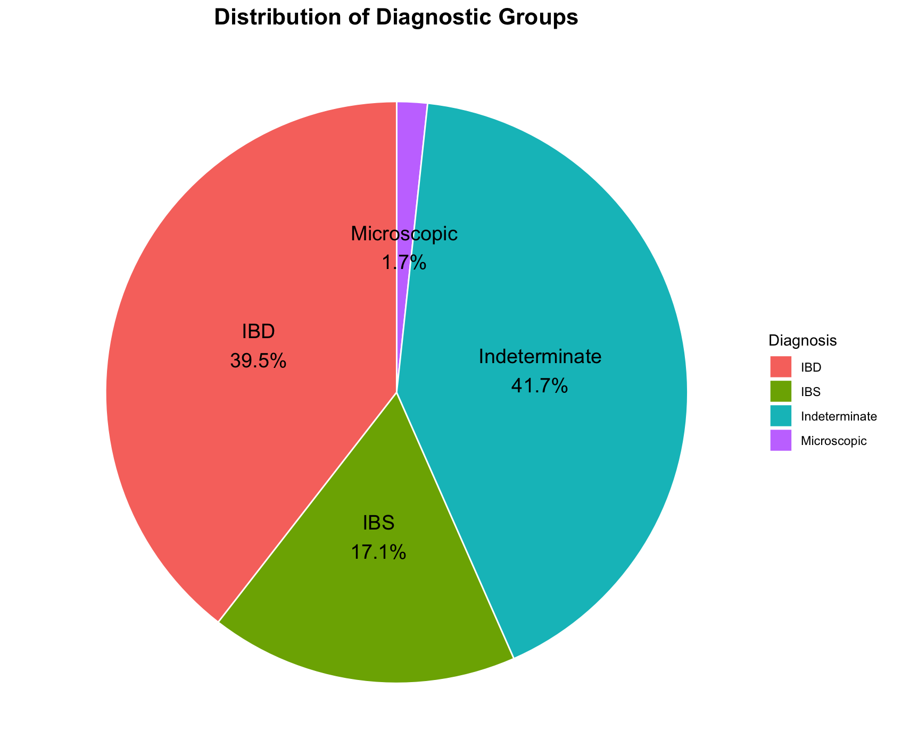
S8. Distribution of Diagnostic Group by FC value in patient population of above stud

