Theoretical and Experimental Investigation of Triphenylamine-Containing Hole Transport Materials with Side-Chain Isomerization
,ª Xiaorui Liu^{b, *}
ª
^{b} School of Chemistry and Chemical Engineering, Southwest University, Chongqing 400715, P. R. China
*Corresponding authors: liuxiaorui@swu.edu.cn (X. Liu)

S1. Experimental Section
S1.1 Computational Details
The ground-state geometry for investigated molecules PD-Cz and MD-Cz were optimized using the B3P86/6-311G(d, p) functional and basis set.^{[1,2]} The energies of all obtained geometries are ensured to be the lowest because the optimized structures do not exhibit imaginary frequency. On this basis, the internal reorganization energy (λ_{h}), absolute hardness (η), and solvation free energy (ΔG) of the molecules were further calculated, and all these calculations were carried out at the same theoretical level. The optical properties of PD-Cz and MD-Cz were calculated by TD-PBE0/6-31G(d) functional and basis set in dichloromethane solution with a polarizable continuum model (PCM).^{[3]} The frontier molecular orbitals (FMO) were analyzed using the Multwfn program, and the electrostatic potential (ESP) maps of the molecules were visualized with the aid of the VMD software.^{[4]} The DFT and TD-DFT calculations were carried out by the Gaussian 09 program.^{[5]}
The MD simulations for isolated HTM molecules were conducted under NPT ensemble conditions, including temperature of 298.15 K, time step of 1 fs, Berendsen pressure coupling (with reference pressure of 1 bar, pressure control time constant of 1 ps, and compression ratio of 4.5×10⁵ bar⁻¹), and velocity scaling temperature coupling (with time-temperature control constant of 0.2 ps). The cutoff distance for van der Waals interactions was set at 1.0 nm. Throughout the entire simulation process, the General Amber Force Field (GAFF) was employed.^{[6,7]} The simulations ran for a duration of 10 ns, and the RESP charges of HTMs were obtained through DFT optimization. The simulation process was assisted by the Multiwfn programs.^{[8]} Furthermore, detailed information regarding the calculations of charge transfer integrals (v), charge transfer rates (k), and hole mobility (µ_{h}) has been reported in our previous work.^{[9]} The site energies, charge transfer integrals and overlap integrals were simulated at the PW91/TZP level using the ADF program.^{[8,10]}
S1.2 Device Fabrication
To measure the photovoltaic performance of PSCs, a structure of FTO/TiO₂/SnO₂/PVK/CHEAI/HTM/Ag were fabricated. The patterned FTO glass (7 Ω per square) were cleaned sequentially washed with detergent, deionized water, acetone, isopropanol in an ultrasonic bath and then dried by flowing air. The compact layer of TiO₂ was prepared by spray pyrolysis of solution (2 M acetylacetone and 0.2 M titanium isopropoxide in isoproponal) on the cleaned FTO substrate at 450 °C for 30 min. The FTO/TiO₂ substrate was cleaned by UVO for 15 min. Then, the substrate was spin coated with a thin layer of SnO₂ nanoparticle film (dilute it with deionized water at a ratio of 1:20) at 4000 rpm for 30 s, and annealed in ambient air at 150 °C for 30 min. The perovskite films were fabricated by a two-step deposition method according to report.^{[12,13]} The 1.5 M PbI₂ 0.075 M RuCl was dissolved in a mixed solvent of DMF/DMSO (volume ratio 9:1). The precursor was spin-coated on FTO/ETLs at 1500 rpm for 30 s and then annealed at 70 ℃ for 1 min. After the PbI₂ film cooled down, the amines salts solution (0.52 M FAI, and 0.13M MACl dissolved in 1 mL IPA) was spin-coated on as-prepared PbI₂ film at 1800 rpm for 30 s. The perovskite precursor films were immediately taken out of the N₂-glovebox and then annealed at 150 ℃ for 15 min in air conditions (relative humidity between ~40%). The CHEAI solution (3 mg in 1 mL IPA) was spin-coated on fabricated perovskite film at 4000 rpm for 30 s and then the film was annealed at 100 °C for 5 min. The Spiro-OMeTAD solution containing 72.3 mg Spiro-MeOTAD, 28.8 μL tBP, and 17.5 μL Li-TFSI (520 mg mL⁻¹ in ACN) was spin-coating at 4000 rpm for 30 s on the top of perovskite film. Through optimization, the optimal concentration of HTMs (PD-Cz and MD-Cz) was determined to be 50 mg mL⁻¹. Among them, PD-Cz and MD-Cz were added with t-BP and Li-TFSI as dopants at an equivalent of 1.8 times that of Spiro-OMeTAD. At last, an 80 nm Ag electrode was thermal-evaporated on the top to obtain the PSCs.
S1.3 The space-charge-limited current (SCLC) hole mobility measurements.
Hole-only devices are fabricated with the structure ITO/PEDOT:PSS/HTM/Ag. The dark J-V characteristics of hole-only devices were measured under N₂ atmosphere inside a glove box. PEDOT:PSS was deposited on the ITO substrate at 5000 rpm for 30 s, followed by annealing at 120 ºC for 30 min. The conditions of spin coating for HTMs are in consistent with the device fabrication. Mobility is extracted by fitting the current density-voltage curves using space charge limited current (SCLC) on basis of the following equation $J=9ε_{θ}ε_{γ}μ_{h}V^{2}/8L^{3}$, where J is the current density, L is the film thickness, $μ_{h }$is the hole mobility, $ε_{γ}$ is the relative dielectric constant of the transport medium ($ε_{γ}=3$ for organic materials), $ε_{θ}$ is the permittivity of free space (8.85 × 10⁻¹² F m⁻¹), V is the internal voltage of the device.
S1.4 Measurements
The ¹H nuclear magnetic resonance (¹H NMR) spectra were obtained from a BRUKER AVANCE NEO 400 MHz NMR Instrument (in DMSO-d₆, 99.8%, Beijing Hwrkchemical Co., Ltd.). The ¹³C nuclear magnetic resonance (¹³C NMR) spectra were obtained from a BRUKER AVANCE NEO 151 MHz NMR Instrument (in DMSO-d₆, 99.8%, Shanghai Meryer Technologies Co., Ltd.). Mass spectra were collected on LCMS-IT-TOF mass spectrometer. UV-vis absorption spectra were measured on a Shimadzu UV-2450 absorption spectrophotometer. Absorption spectra in solution were recorded in dichloromethane solution with an HTM concentration of 10⁻⁵ M. Cyclic voltammetry studies were conducted using a CHI660E system in a typical three-electrode cell with a glass carbon working electrode, a platinum wire counter electrode, and a silver/silver chloride (Ag/AgCl) reference electrode. All electrochemical experiments were carried out under a nitrogen atmosphere at room temperature in an electrolyte solution of 0.1 M tetrabutylammonium hexa-fluorophosphate (Bu₄NPF₆) in dichloromethane at a sweeping rate of 50 mV s⁻¹. The potential of Ag/AgCl reference electrode was internally calibrated by using the ferrocene/ferrocenium redox couple (Fc/Fc⁺). According to the onset oxidation potential of the CV measurements, the highest occupied molecular orbital (HOMO) was estimated based on the vacuum energy level of ferrocene (5.1 eV): HOMO = – (E_{onset} – E_{Fc/Fc+}) – 5.1 eV. The current–voltage (J-V) curves were measured under 100 mW cm⁻² (AM 1.5 G) simulated sunlight using Keithley 2400 in conjunction with a Newport solar simulator (94043A). Film thickness of hole transport layer and perovskite layer were measured by Surfcorder ET200A, Kosaka Laboratory Ltd. Using atomic force microscopy (AFM) to characterize the morphology, the model is CSPM5500A.

S1.5 Synthetic route
S1.6 Synthesis of HTMs
The synthesis route of PD-Cz and MD-Cz is shown in Fig. 3. PD-Cz and MD-Cz were synthesized by Suzuki-Miyaura coupling reaction.
9-(4'-(diphenylamino)-[1,1'-biphenyl]-4-yl)-N3,N3,N6,N6-tetrakis(4-methoxyphenyl)-9H-carbazole-3,6-diamine (PD-Cz)：After assembling the apparatus, vacuum was applied and replaced with argon three times. Under argon protection, 9-(4-bromophenyl)-N3, N3, N6, N6-tetrakis(4-methoxyphenyl)-9H-carbazole-3,6-diamine (0.2093 g, 0.27 mmol), (4-(diphenylamino)phenyl)boronic acid (0.0937 g, 0.32 mmol), and the catalyst Pd(PPh₃)₄ (0.0313 g, 0.027 mmol) were added to a 100 mL three-neck flask. The flask was evacuated and backfilled with nitrogen three times. Subsequently, an aqueous solution of K₂CO₃ (0.3276 g in 1.33 mL H₂O) and 15 mL of toluene were added. The mixture was stirred and refluxed at 110 °C for 24 h. After completion of the reaction, the crude product was extracted with CH₂Cl₂, and the organic phase was dried over anhydrous MgSO₄. Following filtration and removal of the solvent under reduced pressure using a rotary evaporator, the crude product was purified by silica gel column chromatography using PE/EA = 2:1 as the eluent, affording a light-yellow powder, designated as XQ1 (0.2180g, 85.86%). 1H NMR (600 MHz, DMSO-d6) δ 7.87 (d, J = 8.0 Hz, 2H), 7.72 – 7.67 (m, 4H), 7.63 (d, J = 8.0 Hz, 2H), 7.37 – 7.31 (m, 6H), 7.07 (t, J = 8.1 Hz, 10H), 6.87 (d, J = 8.6 Hz, 8H), 6.81 (d, J = 8.6 Hz, 8H), 3.69 (s, 12H), 3.33 (s, 8H). 13C NMR (151 MHz, DMSO) δ 154.82, 147.47, 142.42, 141.79, 139.05, 137.57, 136.18, 133.37, 130.12, 128.15, 127.35, 124.98, 124.83, 124.43, 123.93, 123.88, 123.51, 116.98, 115.17, 111.27, 55.66, 40.05.
9-(3'-(diphenylamino)-[1,1'-biphenyl]-4-yl)-N3,N3,N6,N6-tetrakis(4-methoxyphenyl)-9H-carbazole-3,6-diamine (MD-Cz)：Under a nitrogen atmosphere, 9-(4-bromophenyl)-N³,N³,N⁶,N⁶-tetrakis(4-methoxyphenyl)-9H-carbazole-3,6-diamine (0.3107g, 0.40 mmol), (3-(diphenylamino)phenyl)boronic acid (0.1446g, 0.50 mmol), and Pd(PPh₃)₄ (0.0578 g, 0.05 mmol) were sequentially added to a 100 mL three-neck round-bottom flask. The system was evacuated and backfilled with nitrogen three times. Subsequently, 2.5 mL of an aqueous K₂CO₃ solution (2 M) and 15 mL of 1,4-dioxane were added. The reaction mixture was stirred and refluxed at 110 °C for 24 h. After completion, the crude product was extracted with CH₂Cl₂, and the organic layer was dried over anhydrous MgSO₄. Filtration and removal of the solvent under reduced pressure using a rotary evaporator afforded the crude material, which was further purified by silica gel column chromatography using PE/EA = 2:1 as the eluent, yielding a light-yellow powder identified as XQ2 (0.3217g, 85.52%). 1H NMR (600 MHz, DMSO-d6) δ 7.76 (d, J = 8.1 Hz, 2H), 7.68 (s, 2H), 7.61 (d, J = 8.0 Hz, 2H), 7.42 (d, J = 7.5 Hz, 2H), 7.33 (t, J = 8.0 Hz, 7H), 7.10 – 7.00 (m, 9H), 6.85 (d, J = 9.0 Hz, 8H), 6.82 – 6.78 (m, 8H), 3.68 (s, 12H). 13C NMR (151 MHz, DMSO) δ 154.80, 153.84, 148.54, 147.66, 142.39, 141.83, 141.10, 139.20, 137.45, 136.87, 130.73, 130.08, 128.62, 127.37, 124.89, 124.50, 124.43, 123.95, 123.64, 123.20, 122.00, 121.69, 116.89, 115.15, 111.27, 55.64, 40.05.

S2. Figures
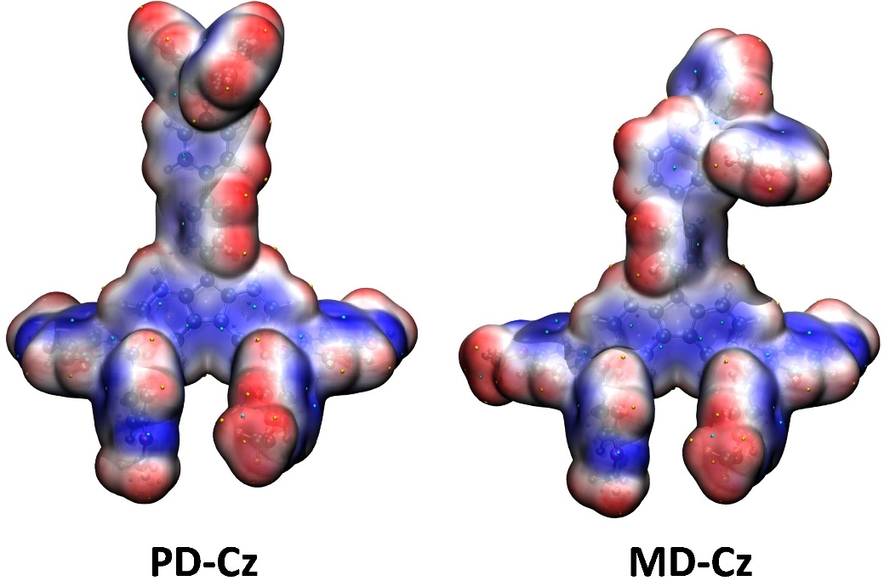
Fig. S1 ESP maps for PD-Cz and MD-Cz.

Fig. S2 ¹H NMR spectrum of PD-Cz.
Fig. S3 ¹³C NMR spectrum of PD-Cz.
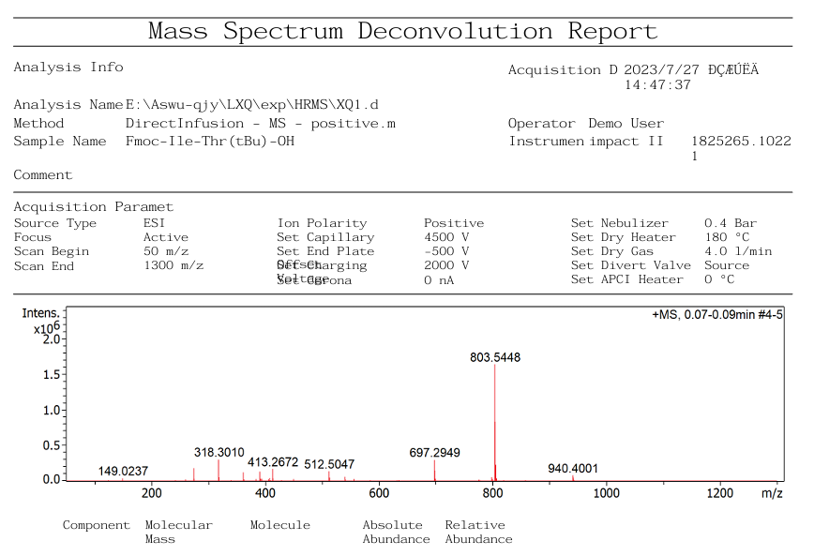
Fig. S4 High resolution mass spectrometry of PD-Cz.
Fig. S5 ¹H NMR spectrum of MD-Cz.
Fig. S6 ¹³C NMR spectrum of MD-Cz.
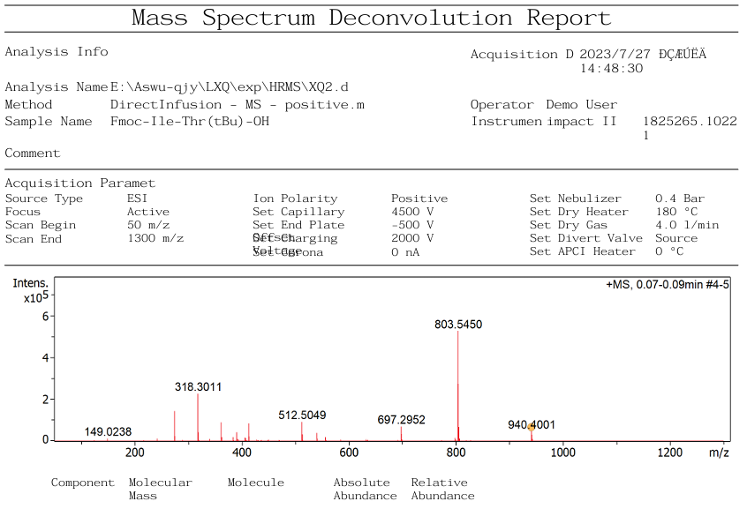
Fig. S7 High resolution mass spectrometry of MD-Cz.
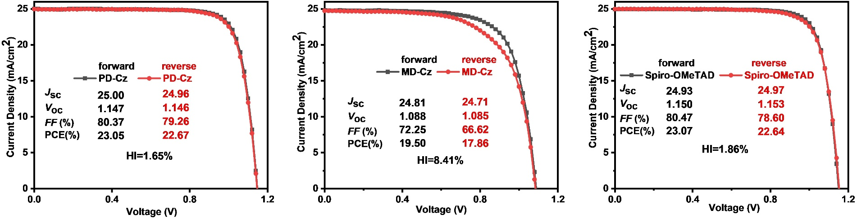
Fig. S8 J-V curves of PSC devices under reverse and forward scans for PD-Cz, MD-Cz and Spiro-OMeTAD.

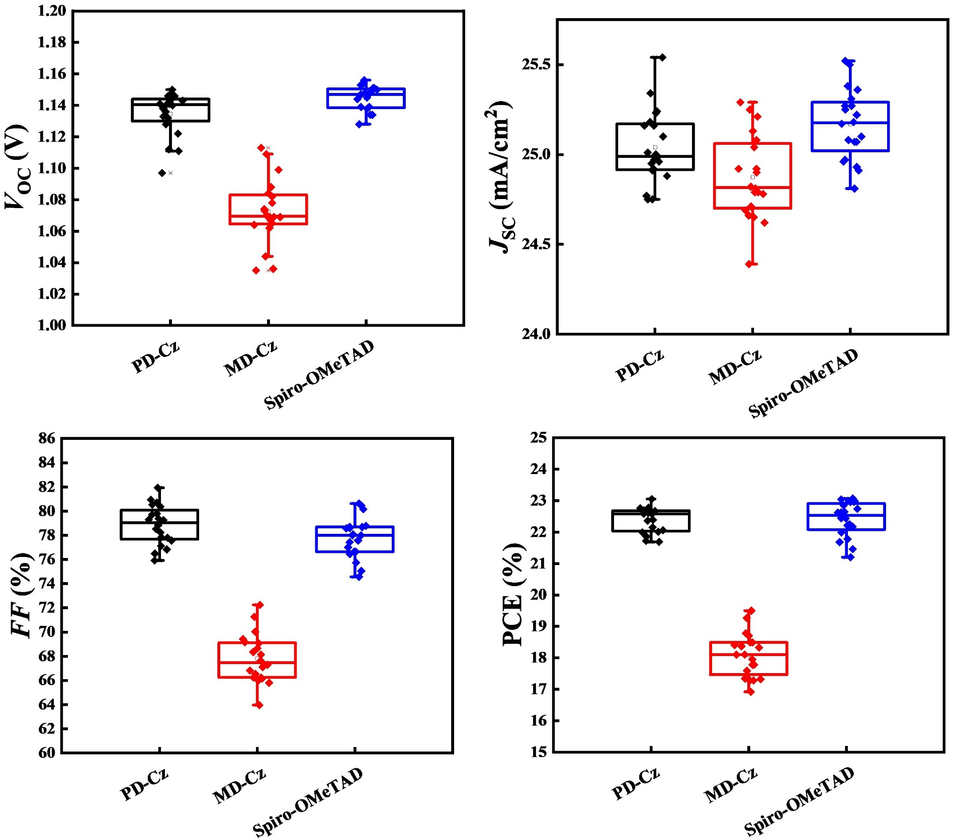
Fig. S9 Box charts of the photovoltaic parameters of PD-Cz, MD-Cz and Spiro-OMeTAD.

Table S1 Experimental results such as optical properties, HOMO/LUMO energy and hole mobility of PD-Cz and MD-Cz.
 | λ_{abs}/nm | λ_{onset}/nm | E_{gap}/eV ª | E_{HOMO}/eV ^{b} | E_{LUMO}/eV ^{c} | Hole mobility/cm²V⁻¹s⁻¹
PD-Cz | 420 | 441 | 2.81 | -5.09 | -2.28 | 1.80×10⁻⁴
MD-Cz | 418 | 440 | 2.82 | -5.10 | -2.28 | 3.78×10⁻⁵

References
[1] S. Ghosh, P. Verma, C. J. Cramer, L. Gagliardi, D. G. Truhlar, Chem. Rev. 2018, 118, 7249.
[2] X. Liu, X. Liu, RSC Adv. 2019, 9, 24733.
[3] J. Tomasi, B. Mennucci, R. Cammi, Chem. Rev. 2005, 105, 2999.
[4] W. Humphrey, A. Dalke, K. Schulten, Journal of Mol. Graph 1996, 14, 33.
[5] M. J. Frisch, G. W. Trucks, H. B. Schlegel, G. E. Scuseria, M. A. Robb, J. R. Cheeseman, G. Scalmani, V. Barone, G. A. Petersson, H. Nakatsuji, X. Li, M. Caricato, A. Marenich, J. Bloino, B. G. Janesko, R. Gomperts, B. Mennucci, H. P. Hratchian, J. V. Ortiz, A. F. Izmaylov, J. L. Sonnenberg, D. Williams-Young, F. Ding, F. Lipparini, F. Egidi, J. Goings, B. Peng, A. Petrone, T. Henderson, D. Ranasinghe, V. G. Zakrzewski, J. Gao, N. Rega, G. Zheng, W. Liang, M. Hada, M. Ehara, K. Toyota, R. Fukuda, J. Hasegawa, M. Ishida, T. Nakajima, Y. Honda, O. Kitao, H. Nakai, T. Vreven, K. Throssell, J. A. Montgomery, Jr., J. E. Peralta, F. Ogliaro, M. Bearpark, J. J. Heyd, E. Brothers, K. N. Kudin, V. N. Staroverov, T. Keith, R. Kobayashi, J. Normand, K. Raghavachari, A. Rendell, J. C. Burant, S. S. Iyengar, J. Tomasi, M. Cossi, J. M. Millam, M. Klene, C. Adamo, R. Cammi, J. W. Ochterski, R. L. Martin, K. Morokuma, O. Farkas, J. B. Foresman, and D. J. Fox, Gaussian 09, revision A.01. Wallingford, CT: Gaussian, Inc.; 2009.
[6] C. I. Bayly, P. Cieplak, W. Cornell, P. A. Kollman, J. Phys. Chem. 1993, 97, 10269.
[7] J. Wang, R. M. Wolf, J. W. Caldwell, P. A. Kollman, D. A. Case, J. Comput. Chem. 2004, 25, 1157.
[8] T. Lu, F. Chen, J. Comput. Chem. 2012, 33, 580.
[9] J. Qi, R. Wang, X. Chen, F. Wu, W. Shen, Wei, M. Li, R. He, X. Liu, J. Mater. Chem. A 2024, 12, 4067.
[10] C. Fonseca Guerra, J. G. Snijders, G. Te Velde, E. J. Baerends, Theor. Chem. Acc. 1998, 99, 391.
[11] A. Torres, L. G. C. Rego, J. Phys. Chem. C 2014, 118, 26947.
[12] Y. Zhao, F. Ma, Z. Qu, S. Yu, T. Shen, H.-X. Deng, X. Chu, X. Peng, Y. Yuan, X. Zhang, J. You, Science 2022, 377, 531.
[13] Q. Jiang, Z. Chu, P. Wang, X. Yang, H. Liu, Y. Wang, Z. Yin, J. Wu, X. Zhang, J. You, Adv Mater 2017, 29, 1703852.

