Synthesis and biological evaluation of xanthone derivatives as anti-cancer agents targeting topoisomerase II and DNA

Xinyue Zhuª, Kan Yangª, Siran Fengª, Yiwen Zhangª, Jinjiao Dongª, Zhenming Liu^{c}, Xiaoqiang Qiao^{a,b*} , Yali Songª
ª Key Laboratory of Pharmaceutical Quality Control of Hebei Province, College of Pharmaceutical Sciences, Hebei University, Baoding, Hebei 071002, China
^{b} Key Laboratory of Medicinal Chemistry and Molecular Diagnosis, Ministry of Education, Hebei University, Baoding, Hebei 071002, China
^{c} State Key Laboratory of Natural and Biomimetic Drugs, School of Pharmaceutical Sciences, Peking University, Beijing 100191, China

Spectra of compounds 7a-7g, 8a-8g, 11a-11g, 12a-12f S1-S81

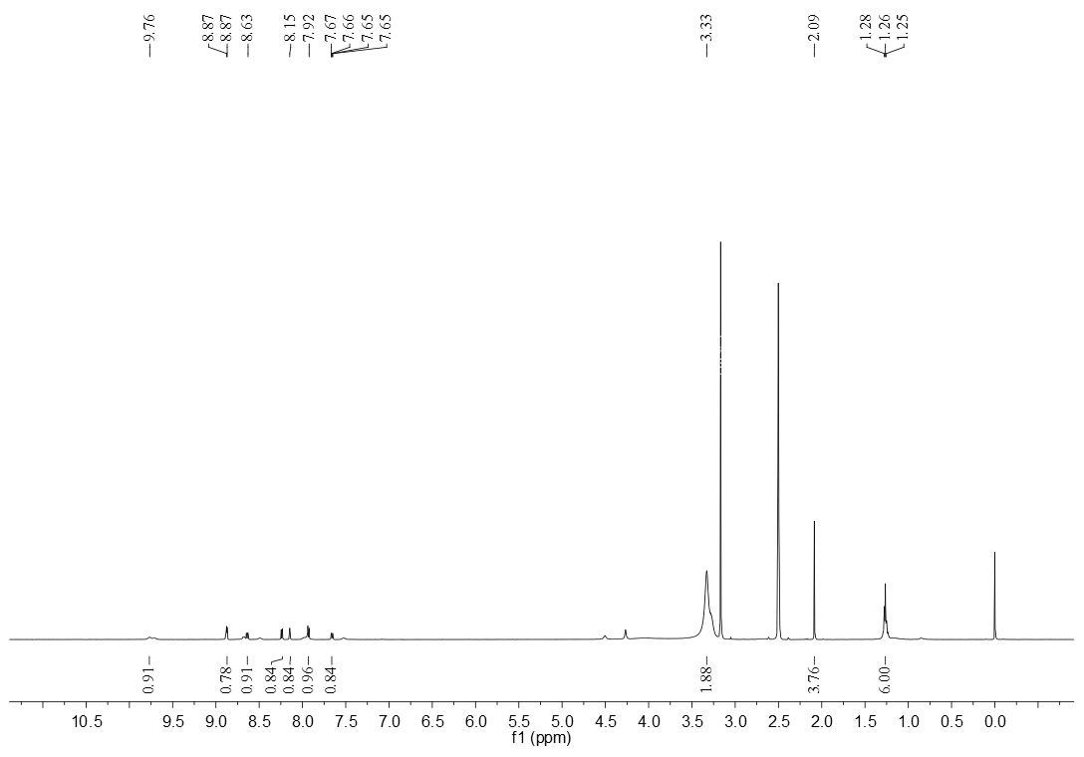
Figure S1. The ¹HNMR spectrum of compound 7a (DMSO-d₆)

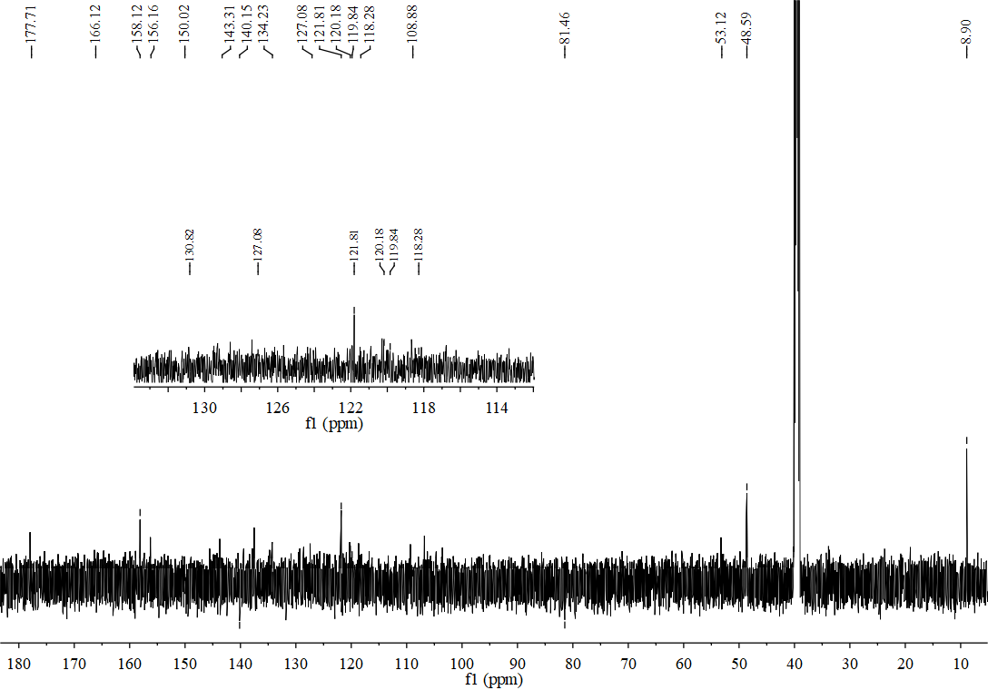
Figure S2. The ¹³CNMR spectrum of compound 7a (DMSO-d₆)

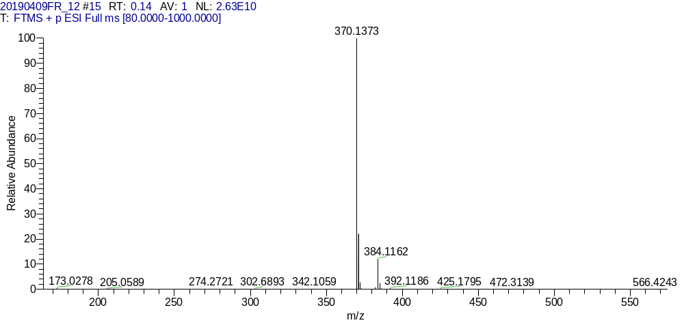
Figure S3. The HR-MS spectrum of compound 7a

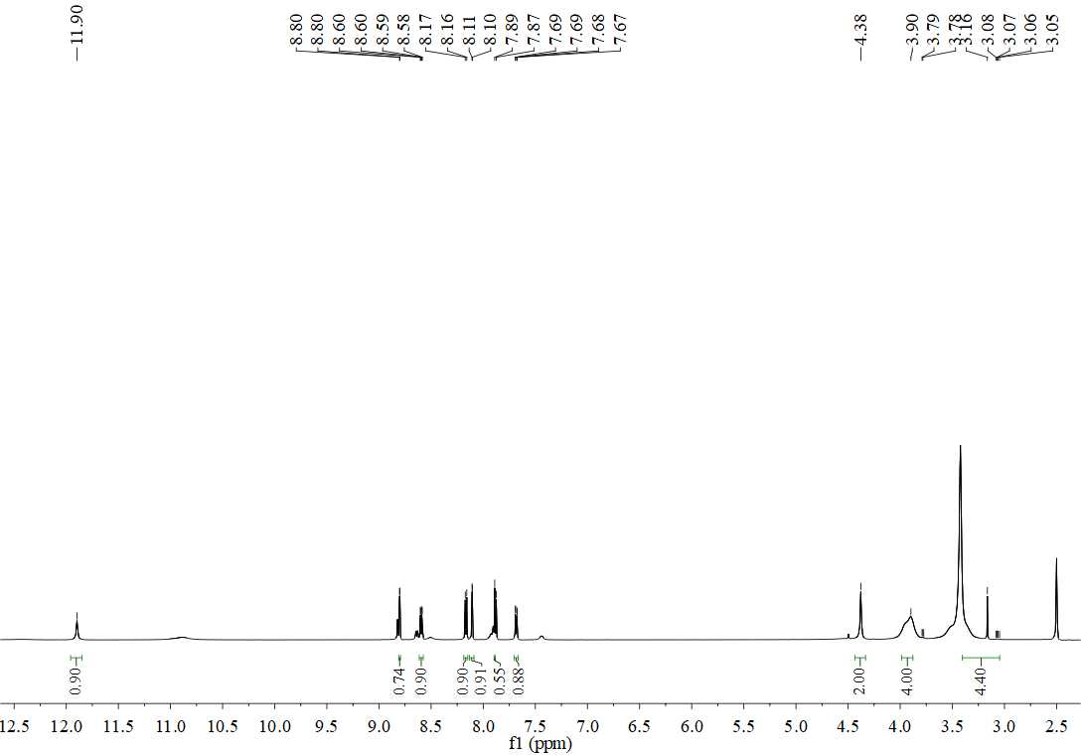
Figure S4. The ¹HNMR spectrum of compound 7b (DMSO-d₆)

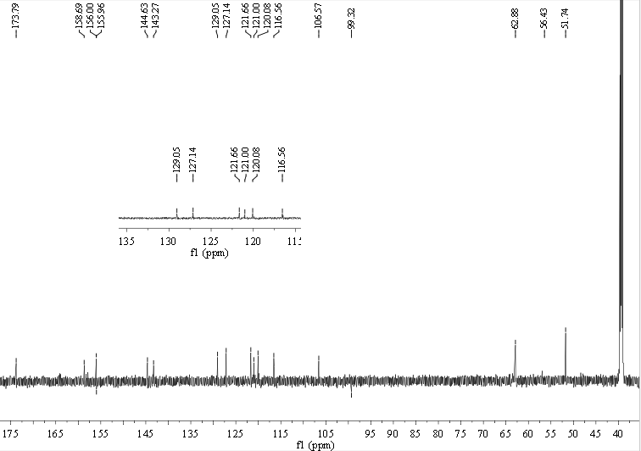
Figure S5. The ¹³CNMR spectrum of compound 7b (DMSO-d₆)

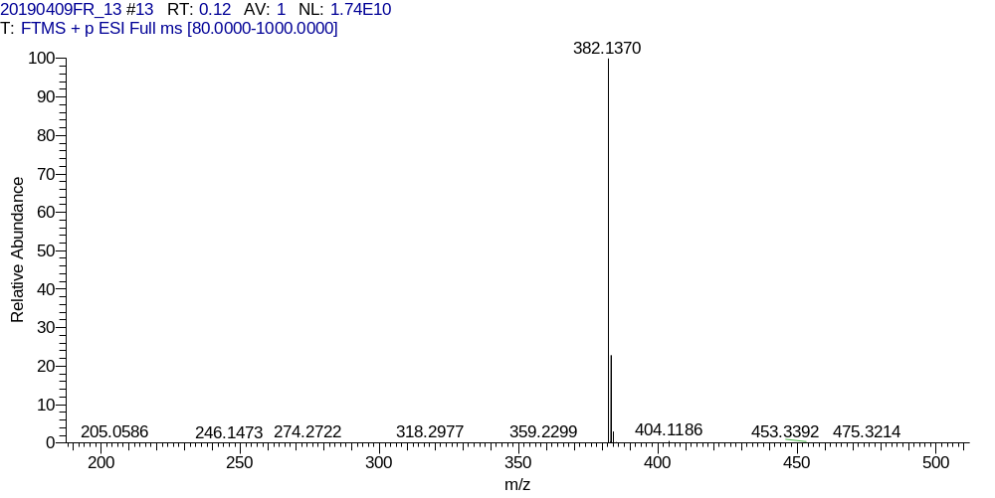
Figure S6. The HR-MS spectrum of compound 7b

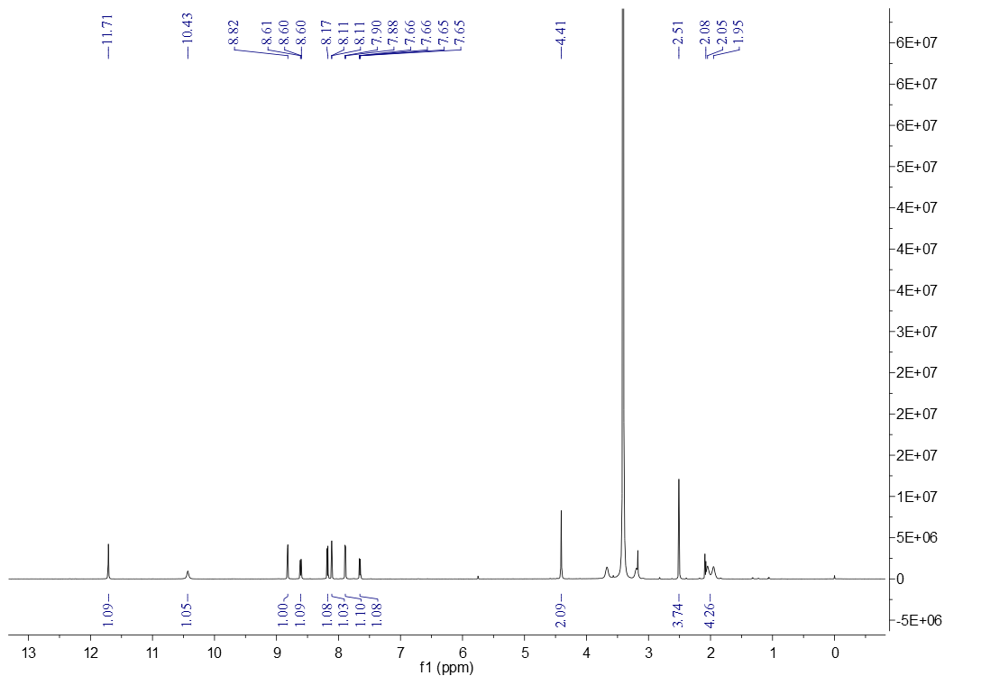
Figure S7. The ¹HNMR spectrum of compound 7c (DMSO-d₆)

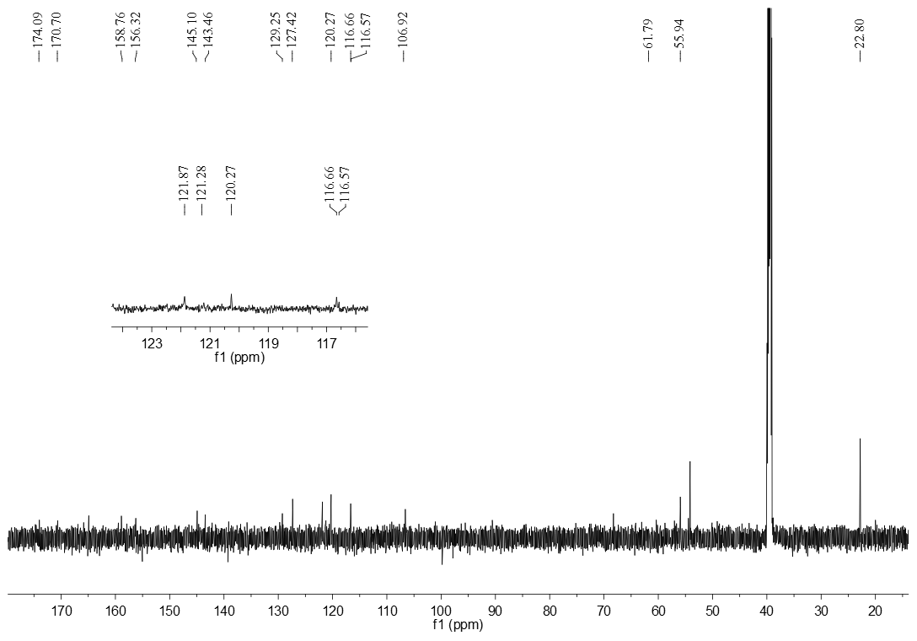
Figure S8. The ¹³CNMR spectrum of compound 7c (DMSO-d₆)

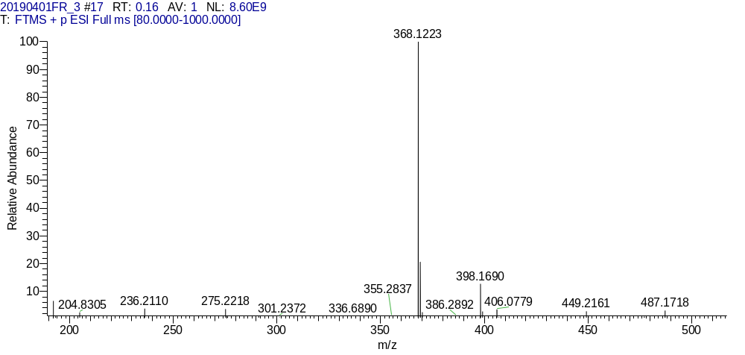
Figure S9. The HR-MS spectrum of compound 7c

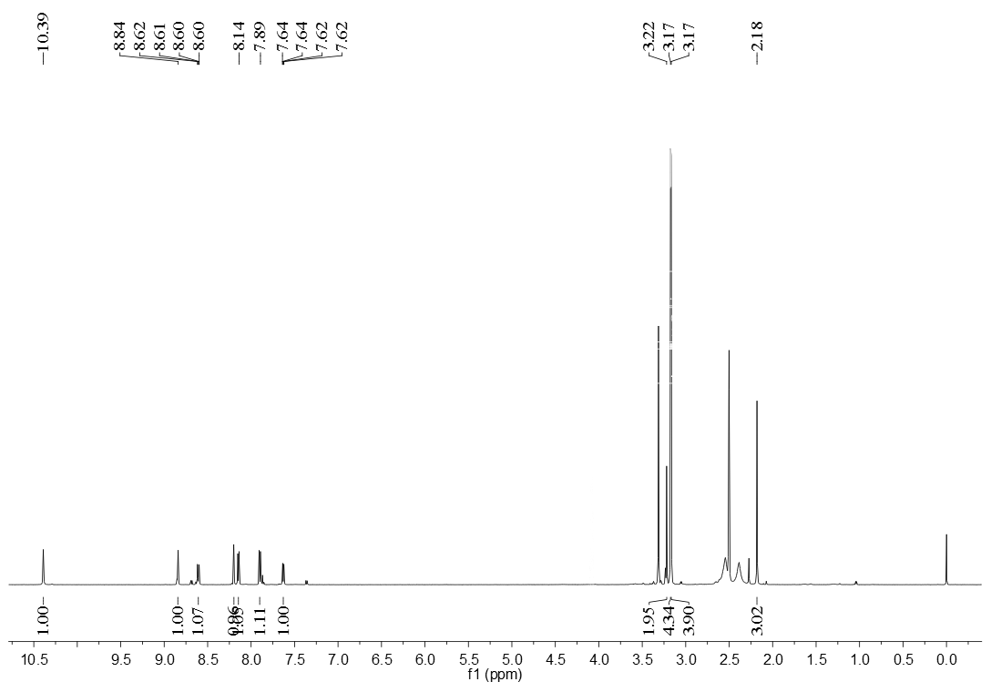
Figure S10. The ¹HNMR spectrum of compound 7d (DMSO-d₆)
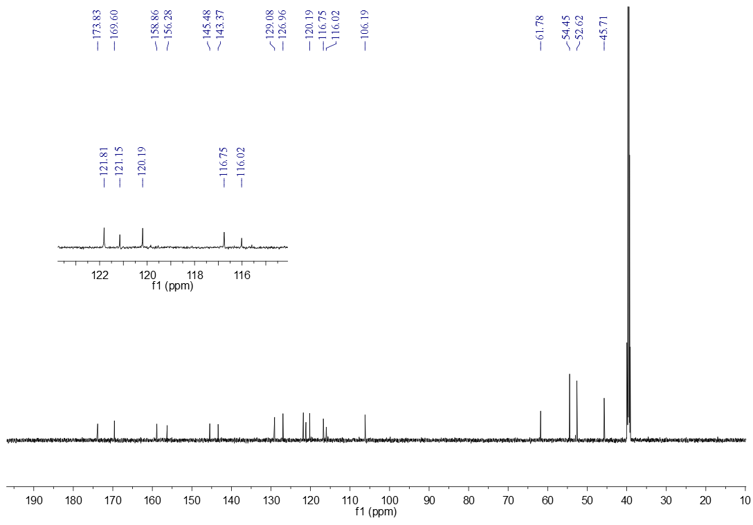
Figure S11. The ¹³CNMR spectrum of compound 7d (DMSO-d₆)

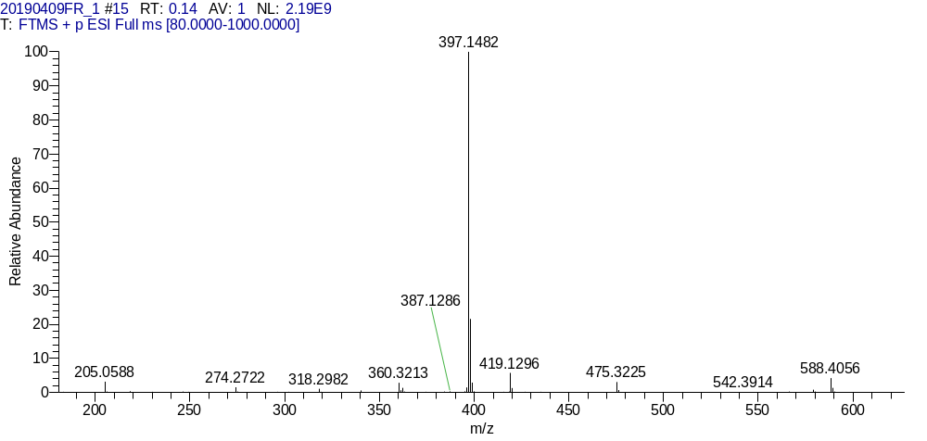
Figure S12. The HR-MS spectrum of compound 7d
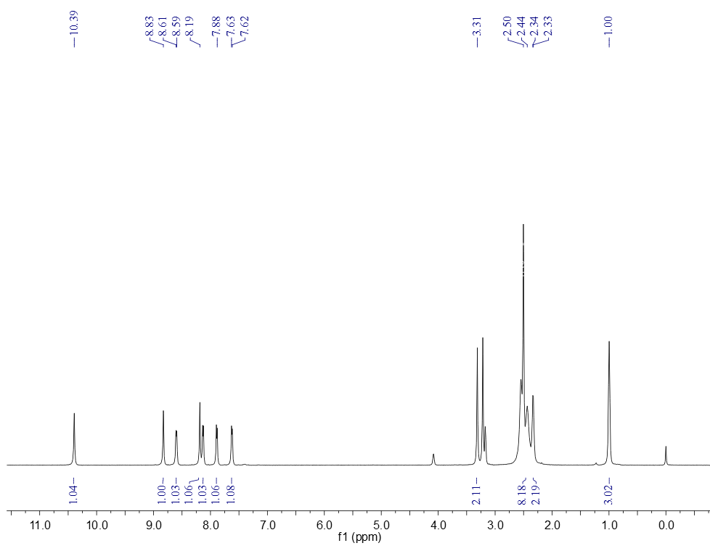
Figure S13. The ¹HNMR spectrum of compound 7e (DMSO-d₆)

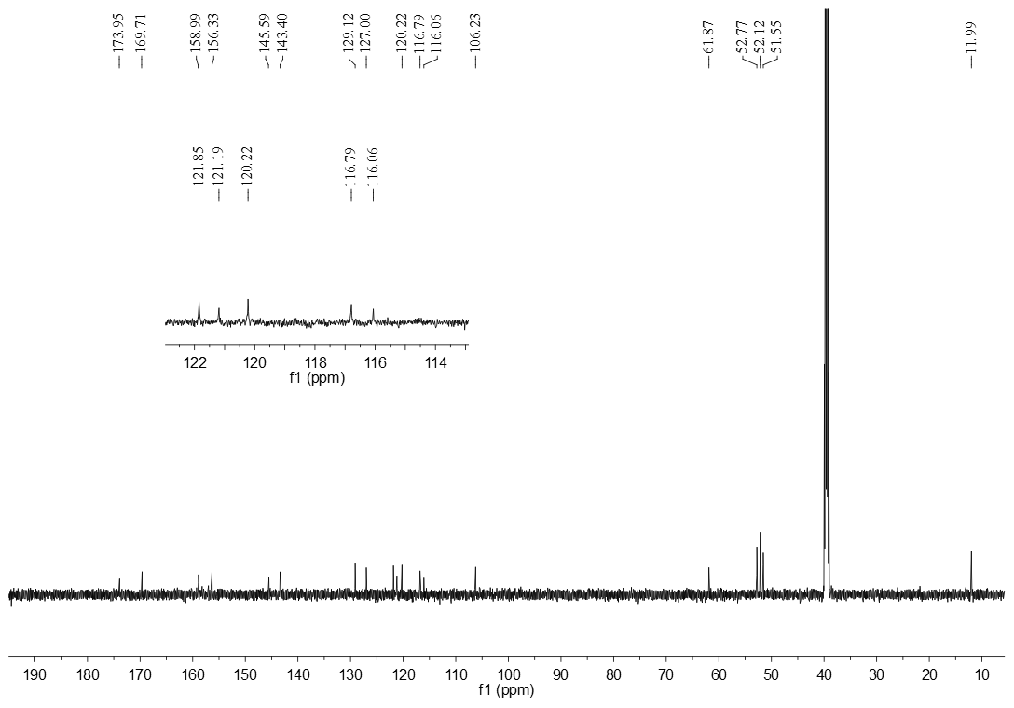 Figure S14. The ¹³CNMR spectrum of compound 7e (DMSO-d₆)

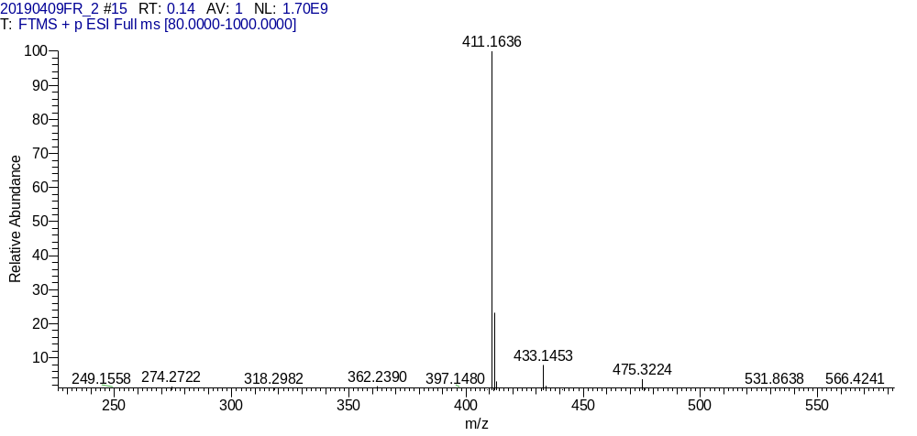
Figure S15. The HR-MS spectrum of compound 7e

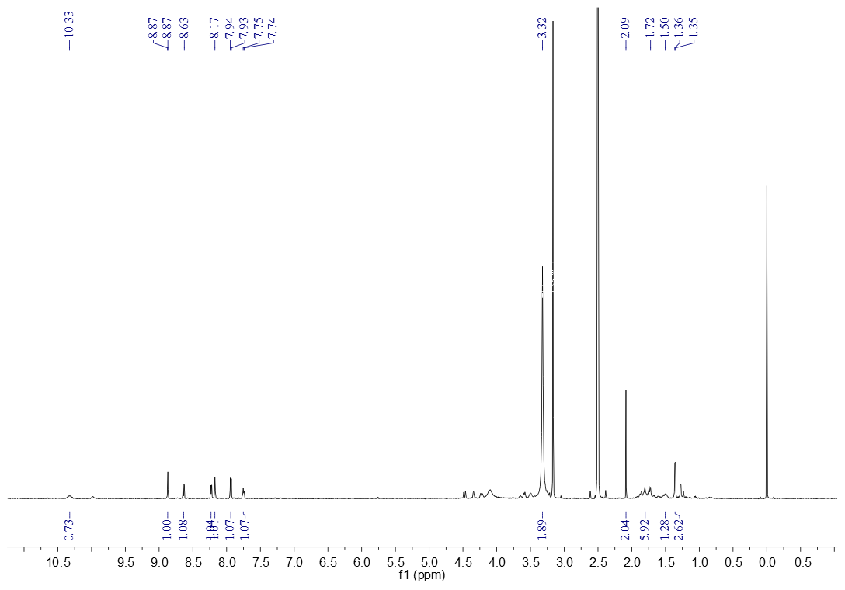 Figure S16. The ¹HNMR spectrum of compound 7f (DMSO-d₆)
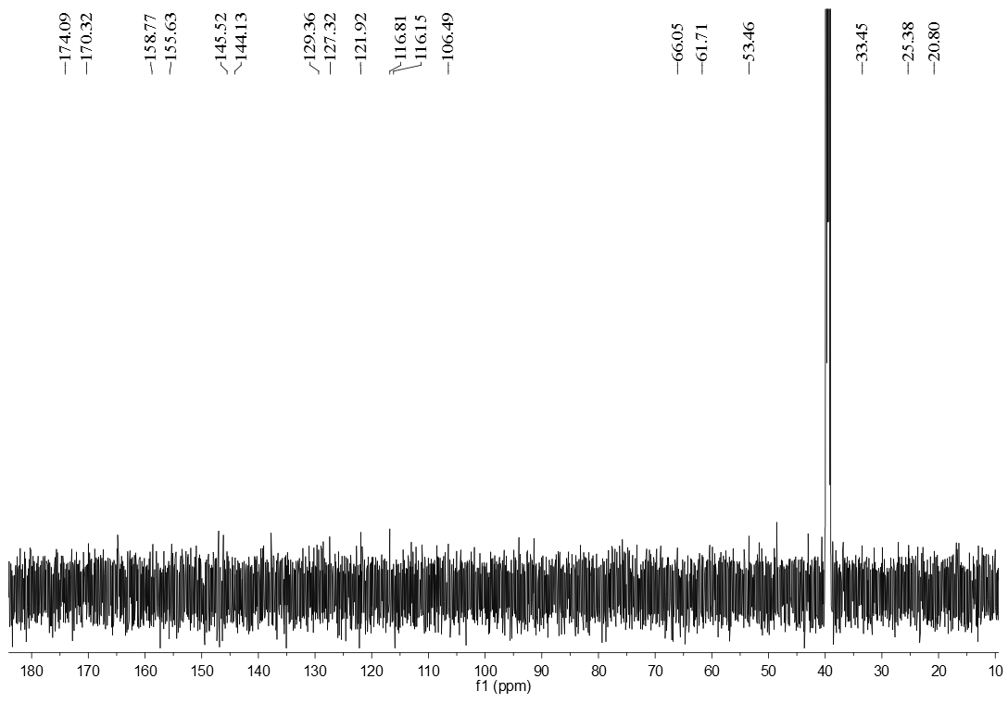
Figure S17. The ¹³CNMR spectrum of compound 7f (DMSO-d₆)

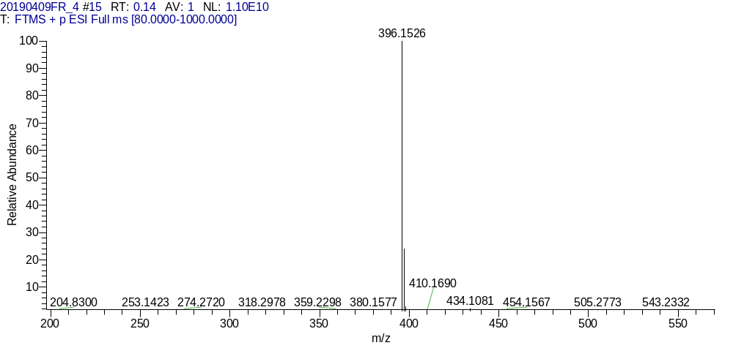
Figure S18. The HR-MS spectrum of compound 7f
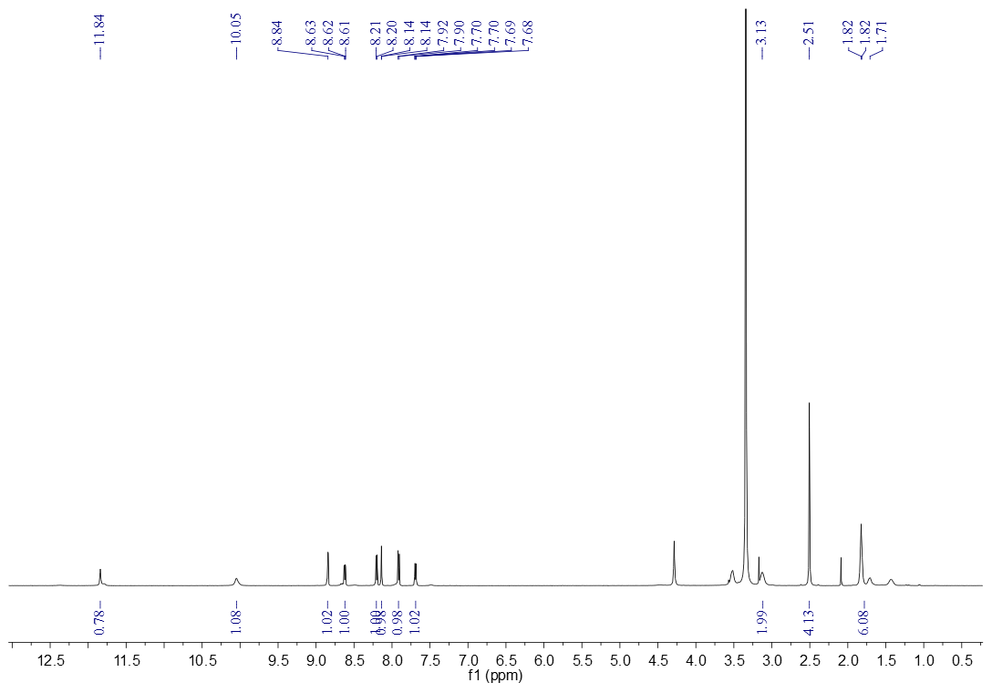 Figure S19. The ¹HNMR spectrum of compound 7g (DMSO-d₆)

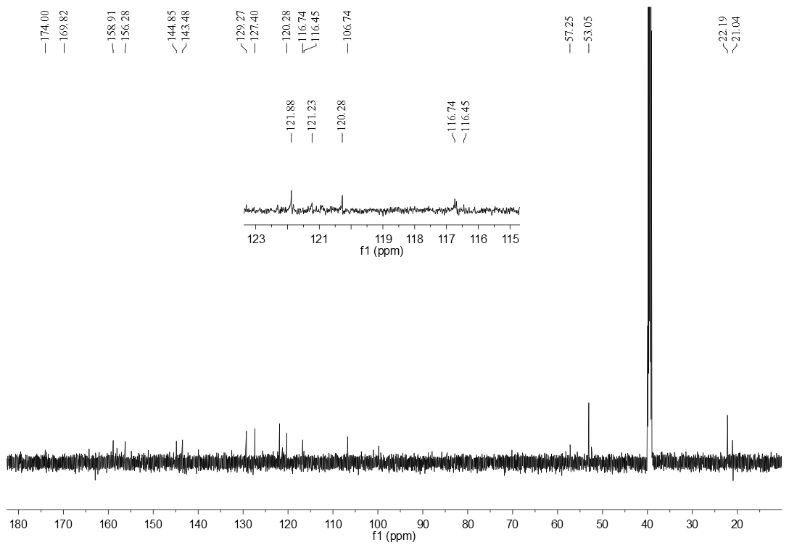 Figure S20. The ¹³CNMR spectrum of compound 7g (DMSO-d₆)

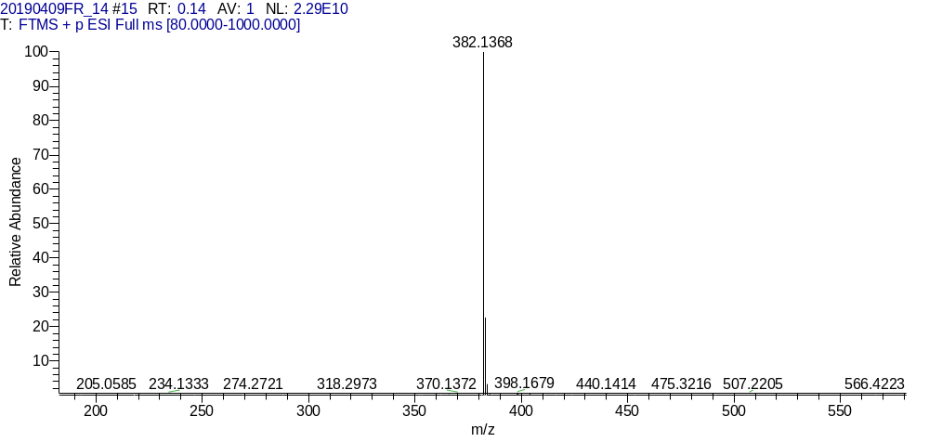
Figure S21. The HR-MS spectrum of compound 7g

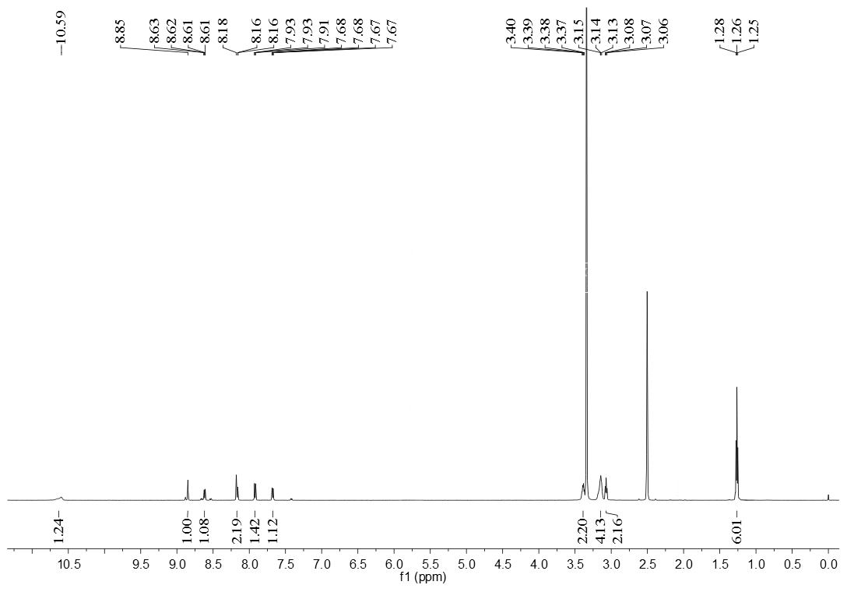 Figure S22. The ¹HNMR spectrum of compound 8a (DMSO-d₆)

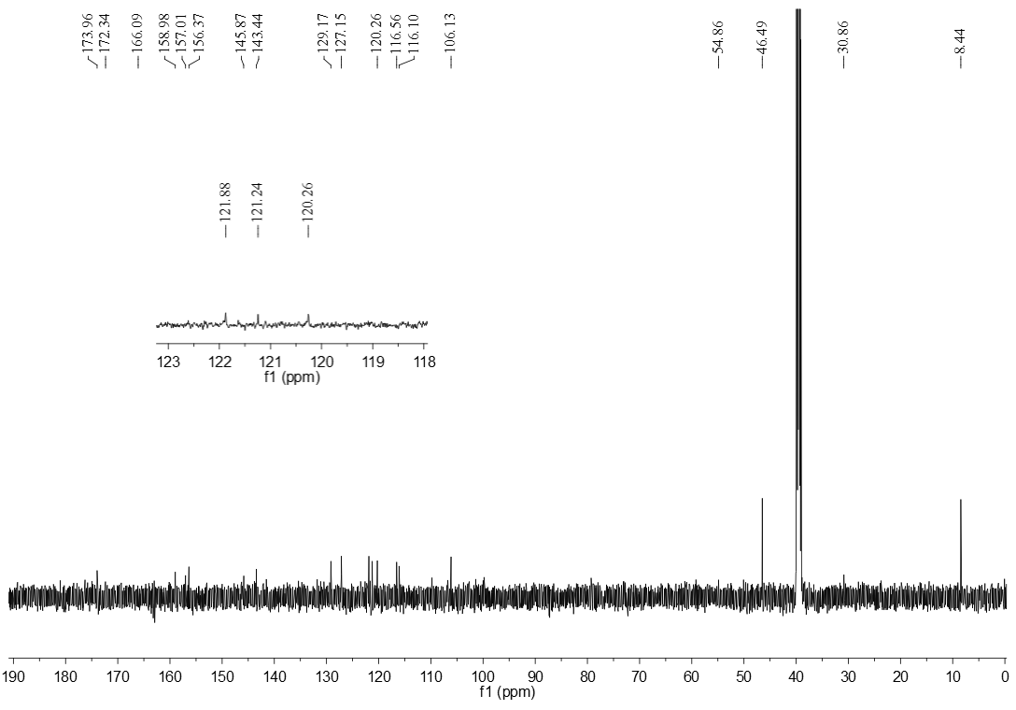 Figure S23. The ¹³CNMR spectrum of compound 8a (DMSO-d₆)

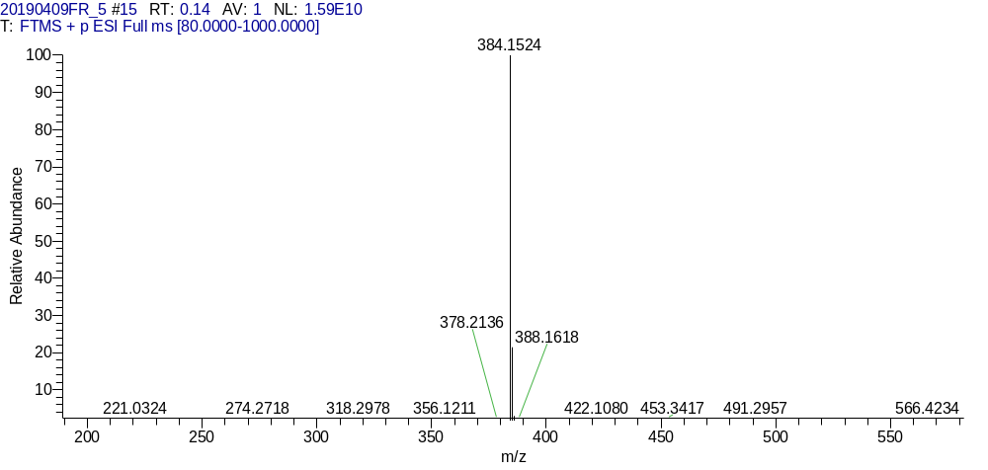
Figure S24. The HR-MS spectrum of compound 8a

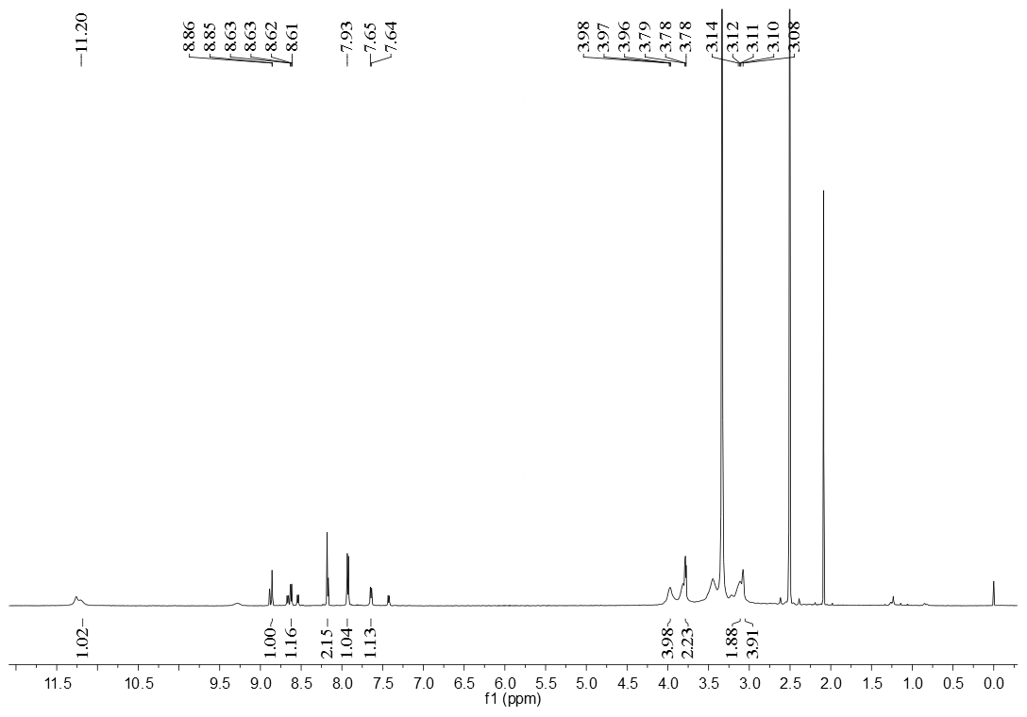 Figure S25. The ¹HNMR spectrum of compound 8b (DMSO-d₆)

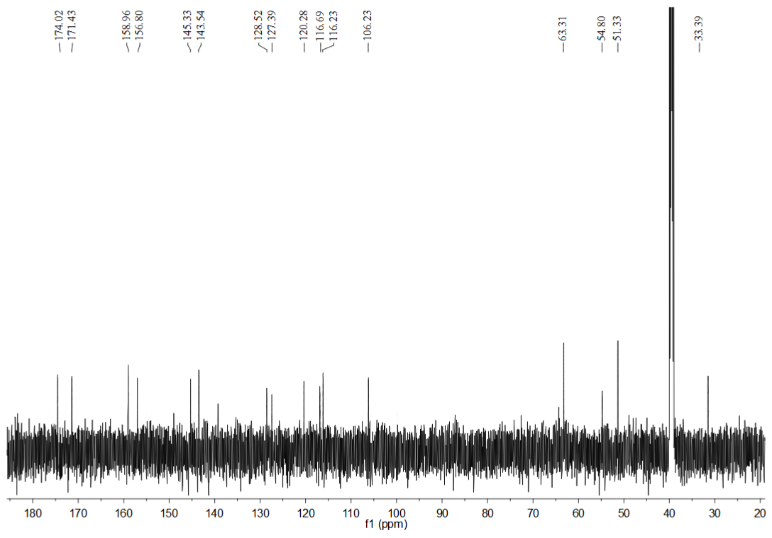 Figure S26. The ¹³CNMR spectrum of compound 8b(DMSO-d₆)
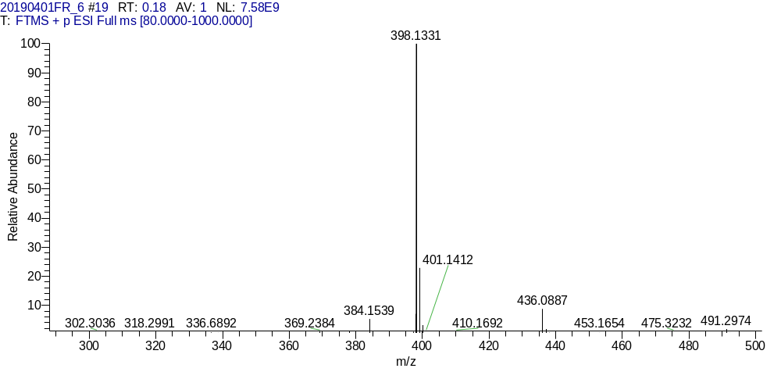
Figure S27. The HR-MS spectrum of compound 8b

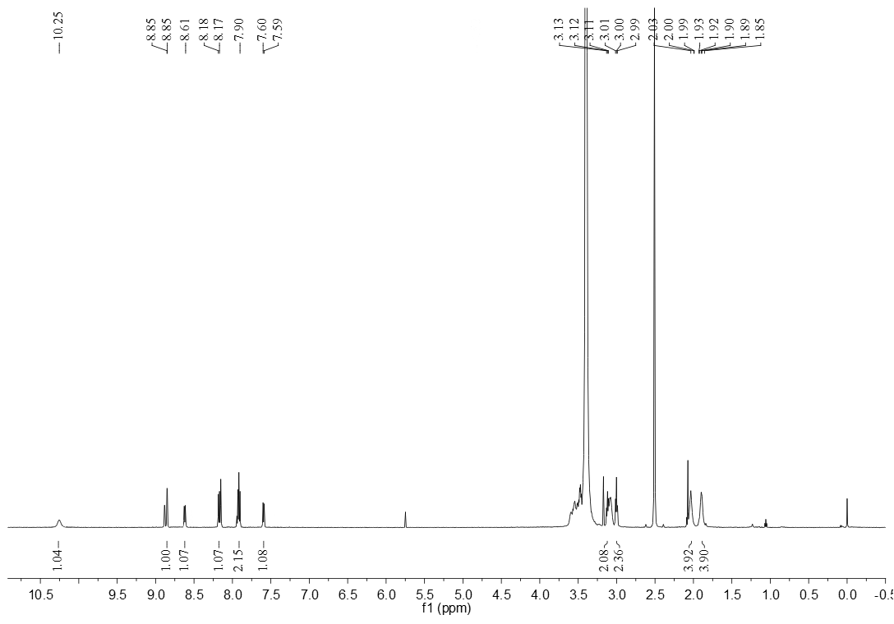 Figure S28. The ¹HNMR spectrum of compound 8c(DMSO-d₆)
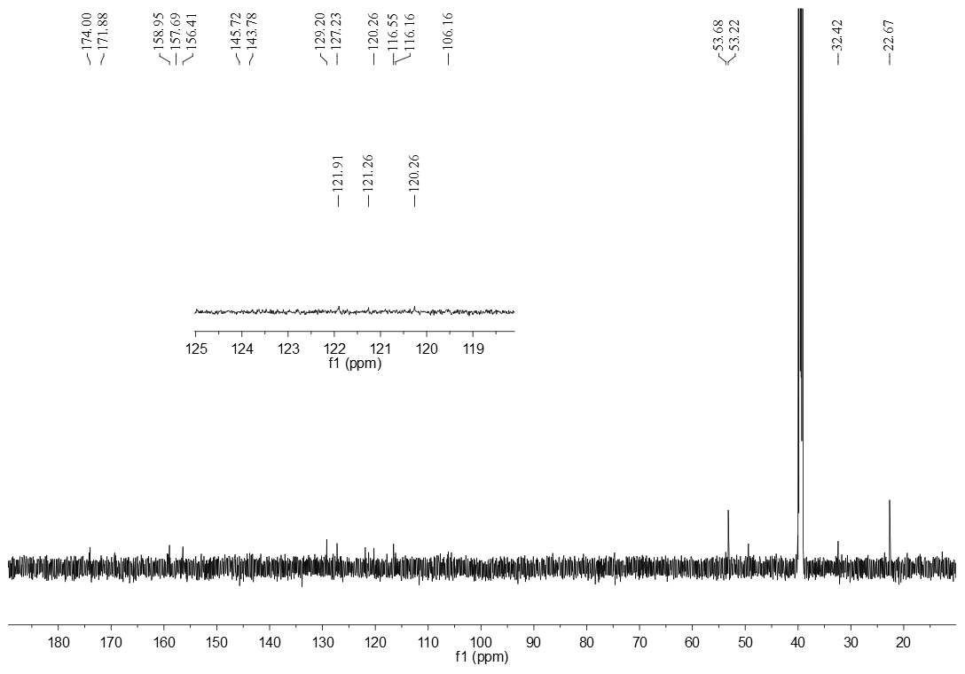
Figure S29. The ¹³CNMR spectrum of compound 8c (DMSO-d₆)

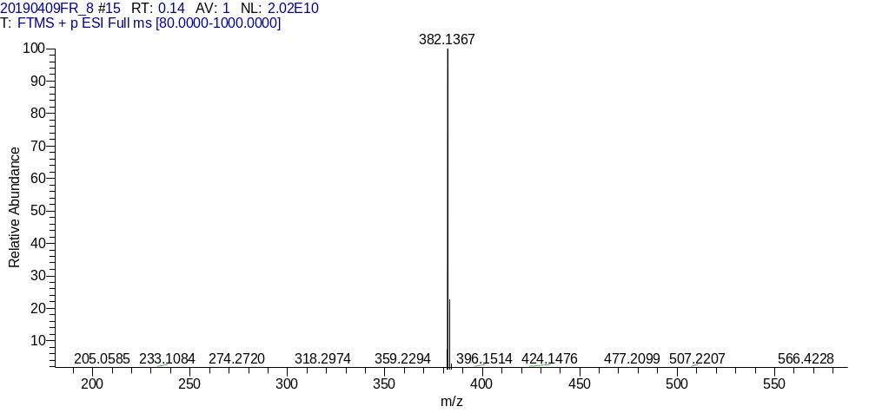
Figure S30. The HR-MS spectrum of compound 8c
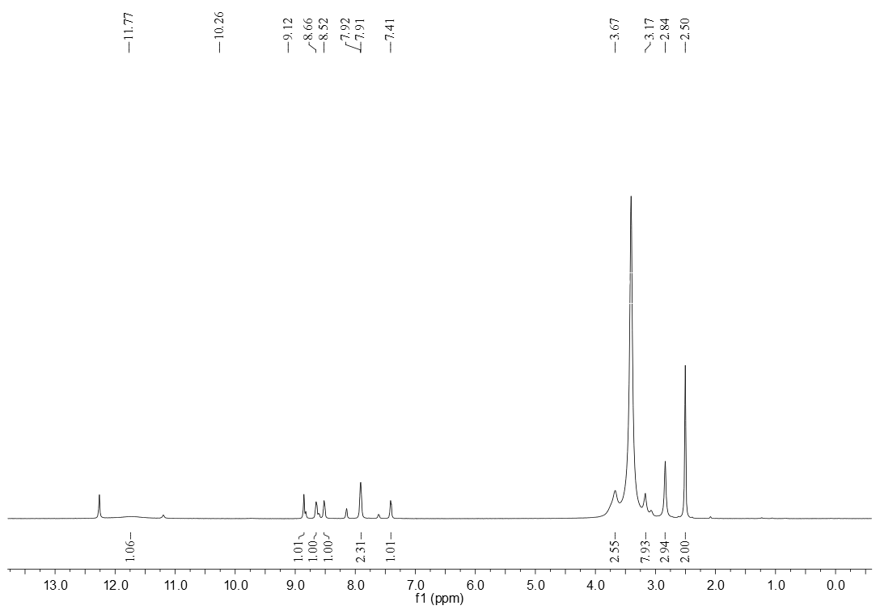
Figure S31. The ¹HNMR spectrum of compound 8d (DMSO-d₆)

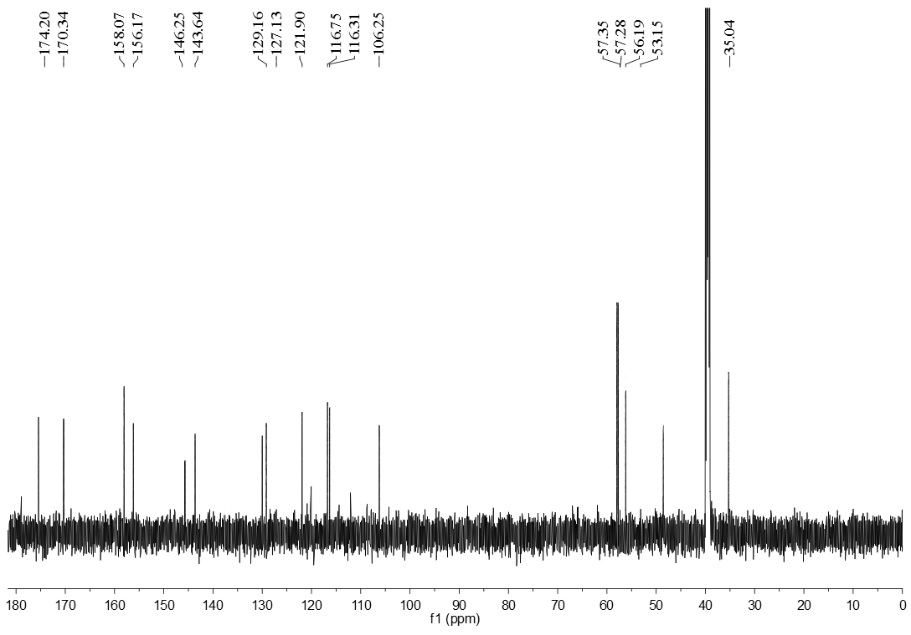 Figure S32. The ¹³CNMR spectrum of compound 8d (DMSO-d₆)

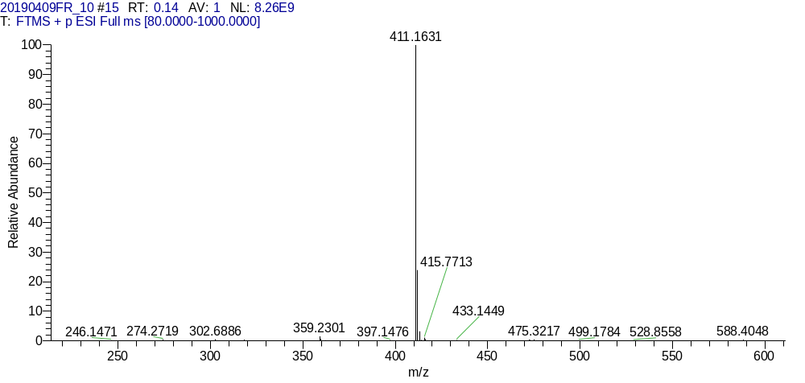
Figure S33. The HR-MS spectrum of compound 8d

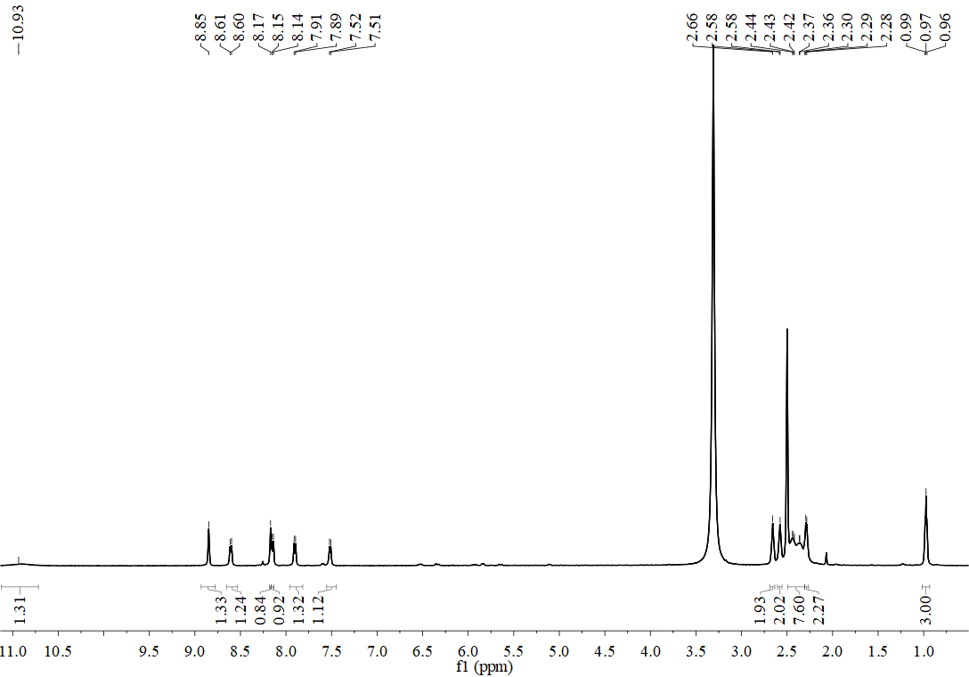
Figure S34. The ¹HNMR spectrum of compound 8e(DMSO-d₆)

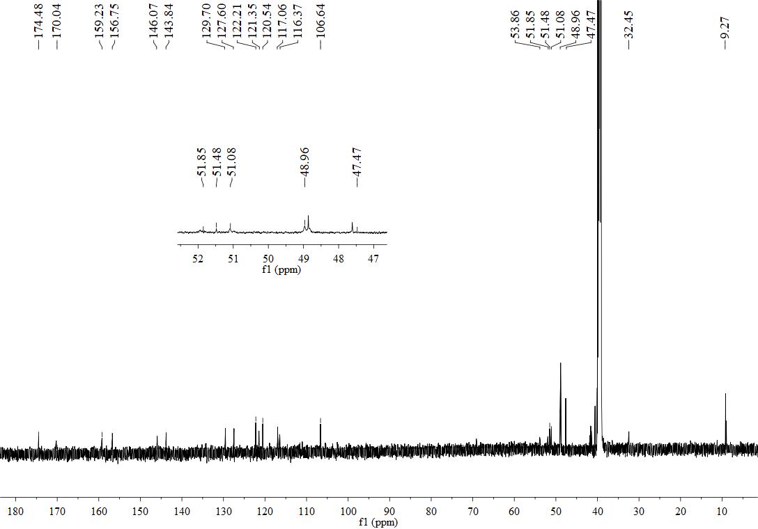
Figure S35. The ¹³CNMR spectrum of compound 8e (DMSO-d₆)

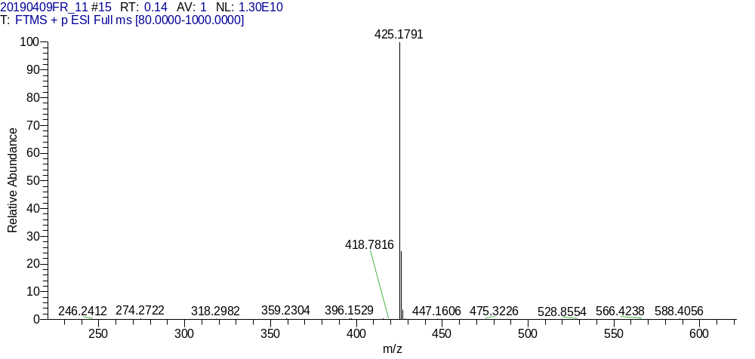

Figure S36. The HR-MS spectrum of compound 8e
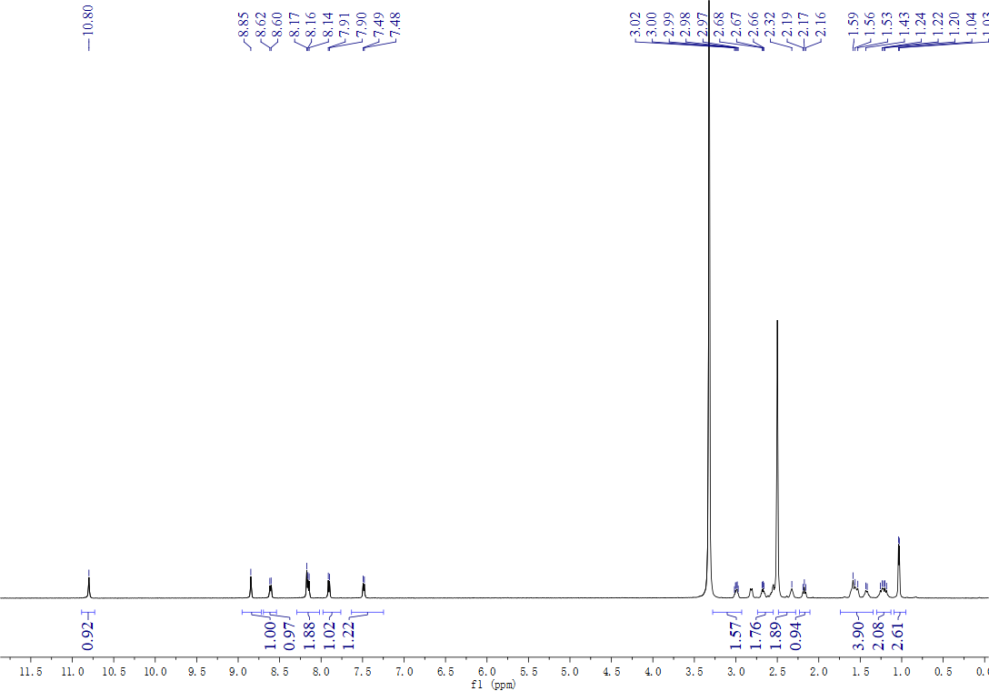
Figure S37. The ¹HNMR spectrum of compound 8f (DMSO-d₆)

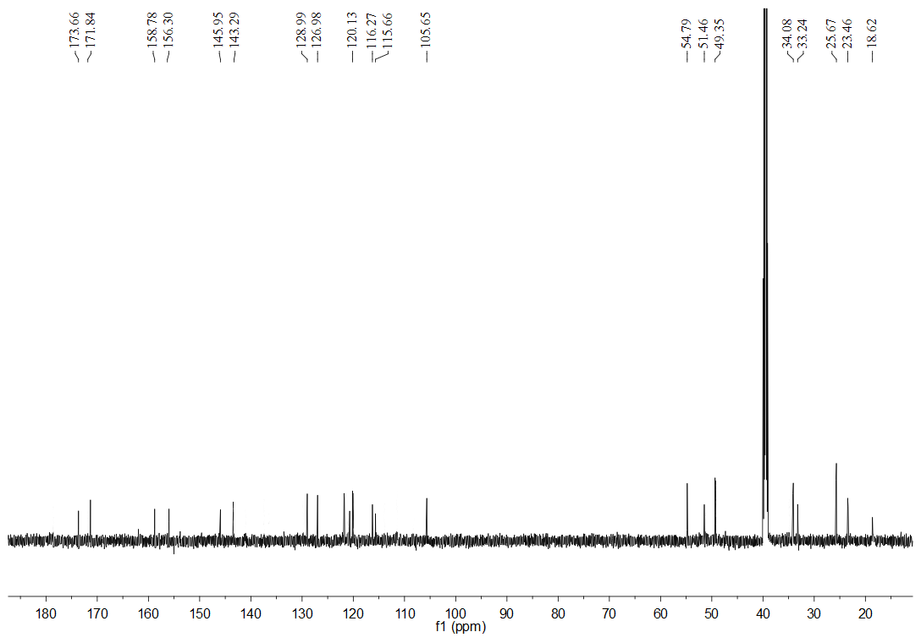 Figure S38. The ¹³CNMR spectrum of compound 8f (DMSO-d₆)
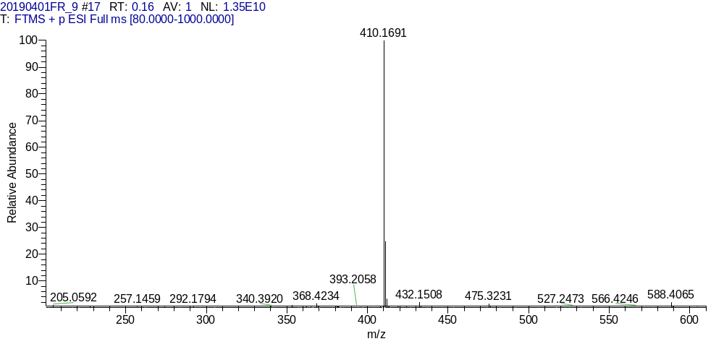
Figure S39. The HR-MS spectrum of compound 8f

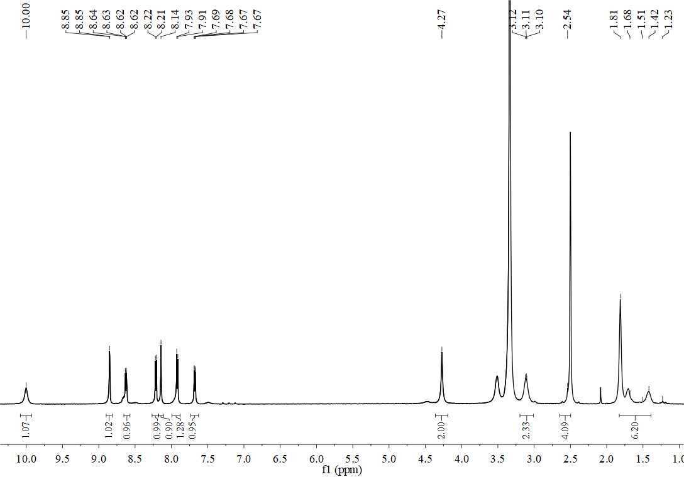
Figure S40. The ¹HNMR spectrum of compound 8g (DMSO-d₆)

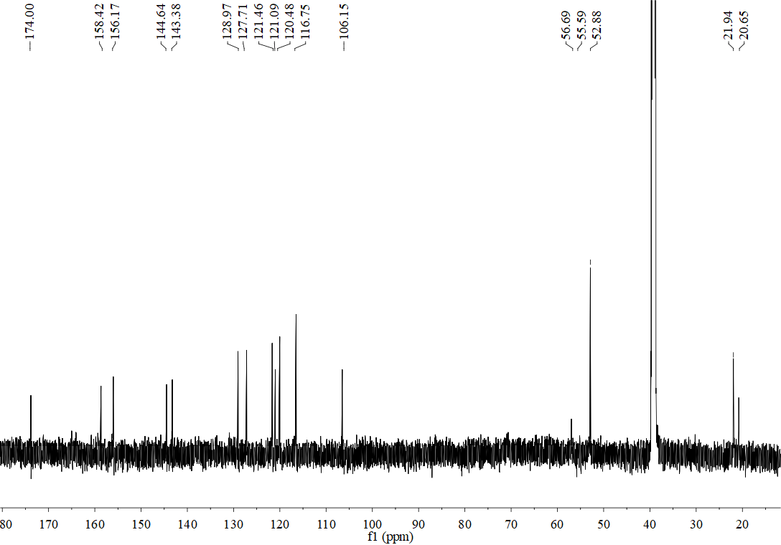
Figure S41. The ¹³CNMR spectrum of compound 8g (DMSO-d₆)

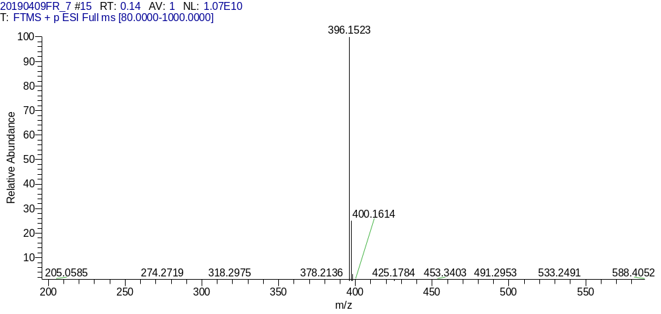
Figure S42. The HR-MS spectrum of compound 8g
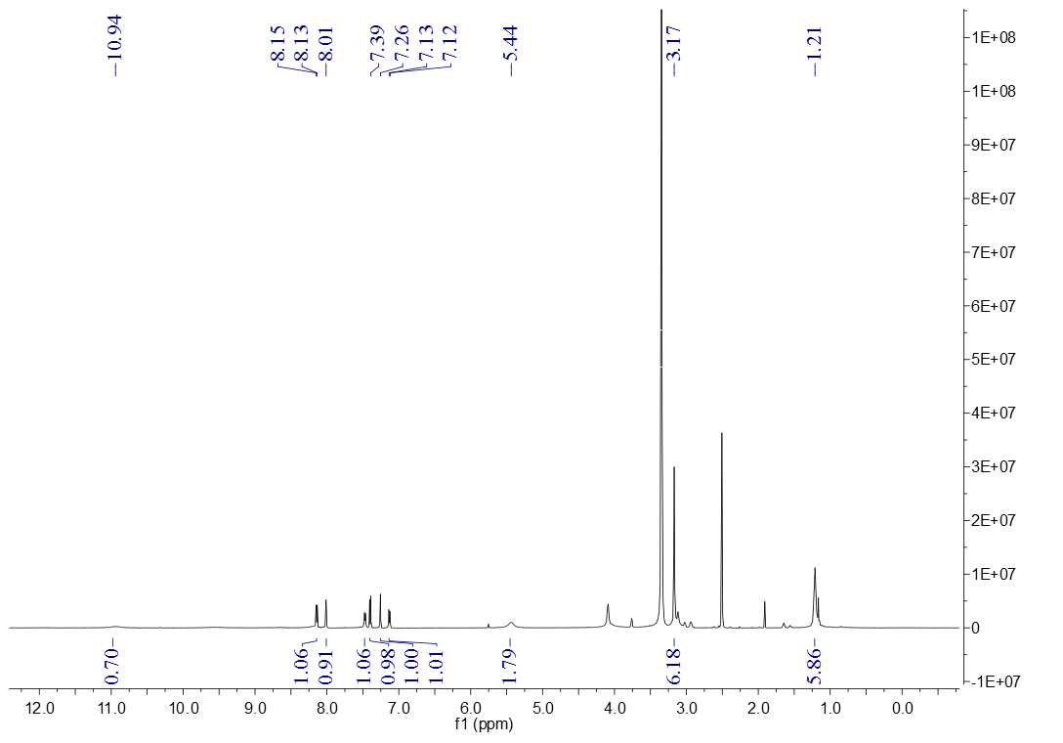
Figure S43. The ¹HNMR spectrum of compound 11a (DMSO-d₆)

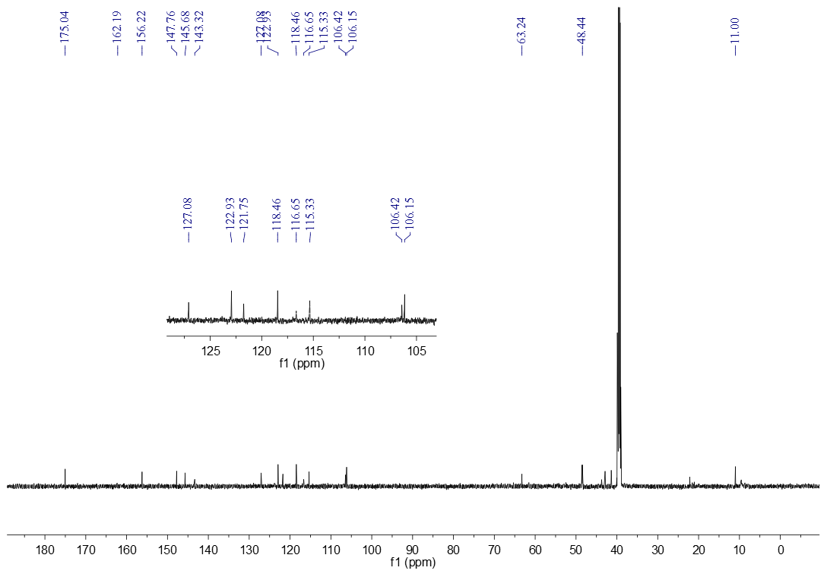 Figure S44. The ¹³CNMR spectrum of compound 11a (DMSO-d₆)

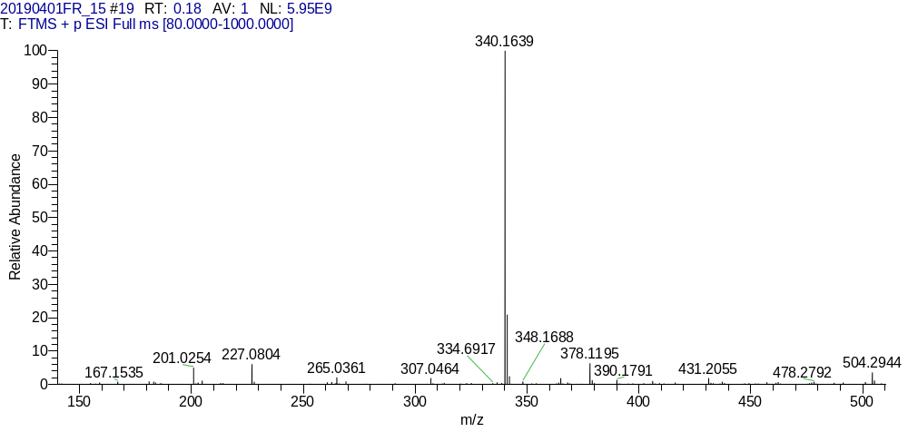
Figure S45. The HR-MS spectrum of compound 11a

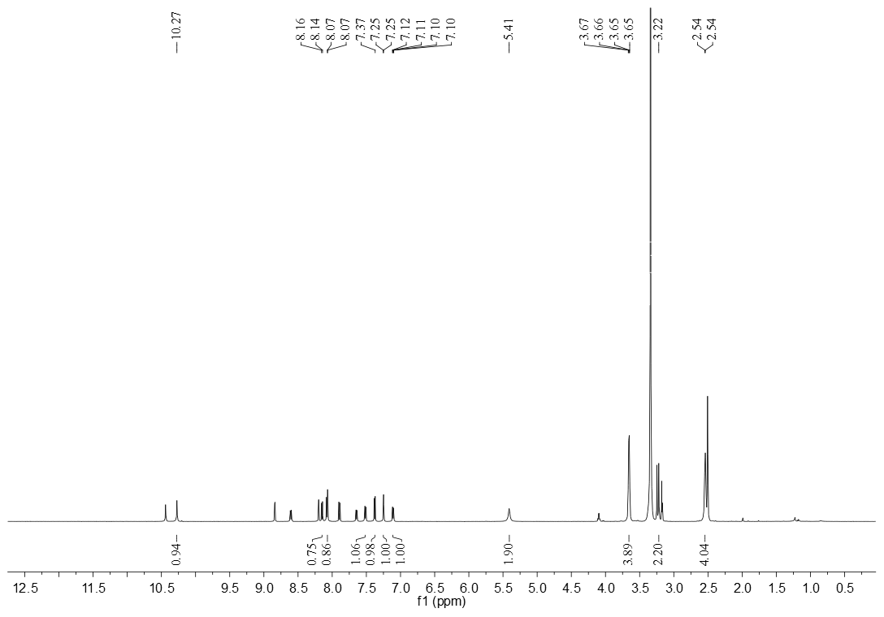 Figure S46. The ¹HNMR spectrum of compound 11b (DMSO-d₆)
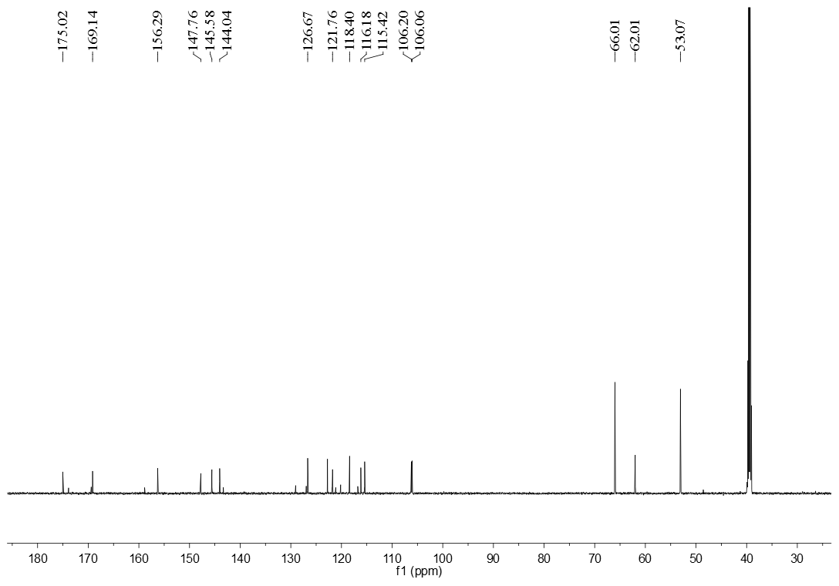 Figure S47. The ¹³CNMR spectrum of compound 11b (DMSO-d₆)

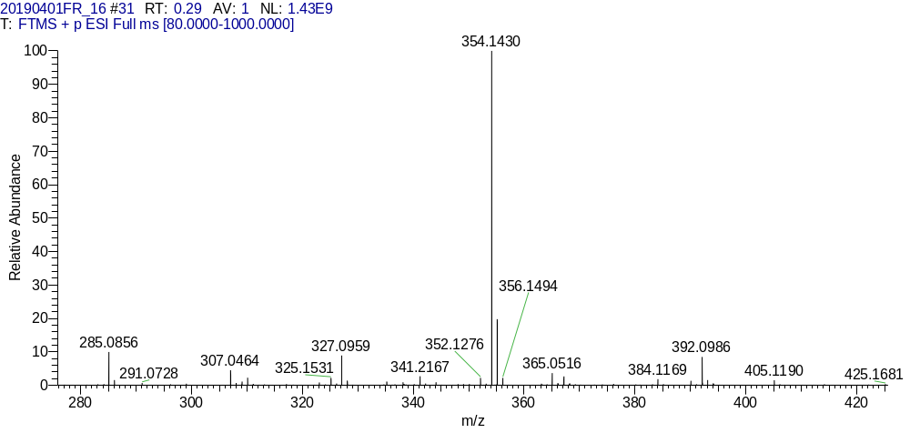
Figure S48. The HR-MS spectrum of compound 11b

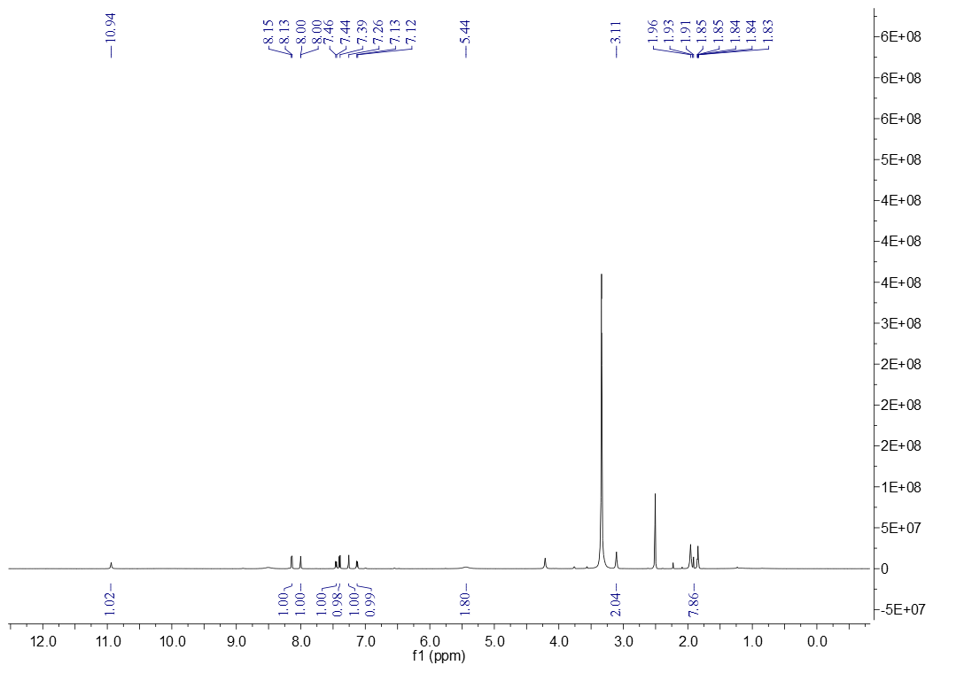
Figure S49. The ¹HNMR spectrum of compound 11c (DMSO-d₆)

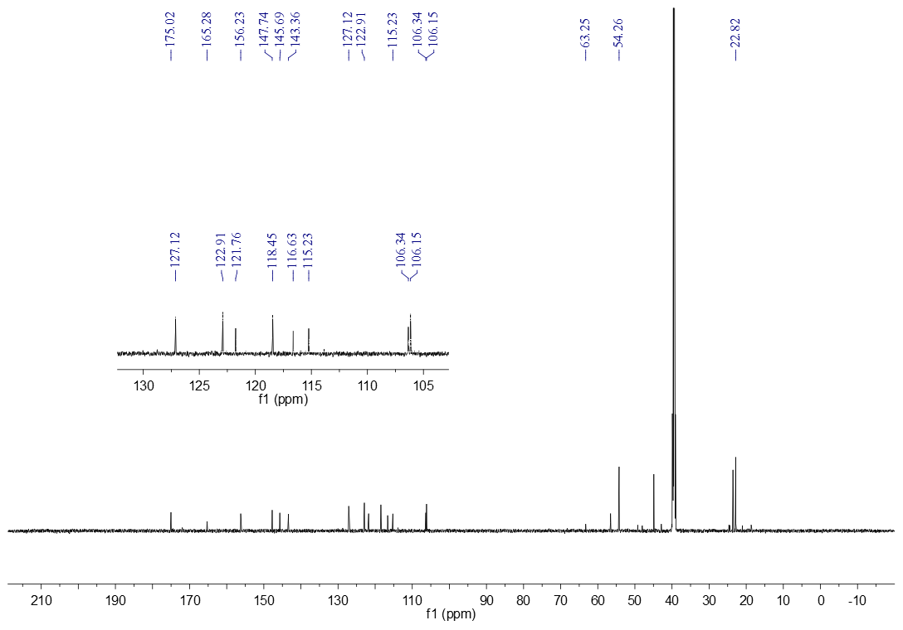 Figure S50. The ¹³CNMR spectrum of compound 11c (DMSO-d₆)
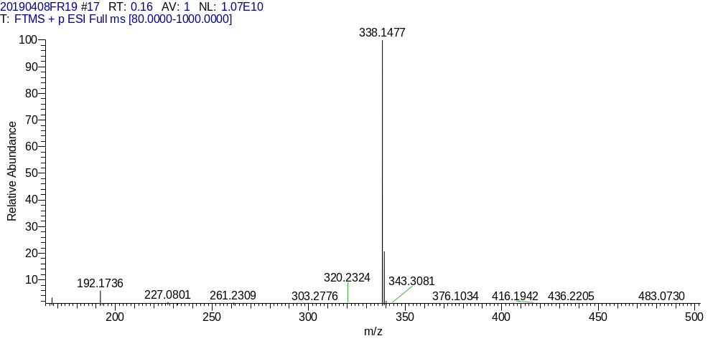
Figure S51. The HR-MS spectrum of compound 11c
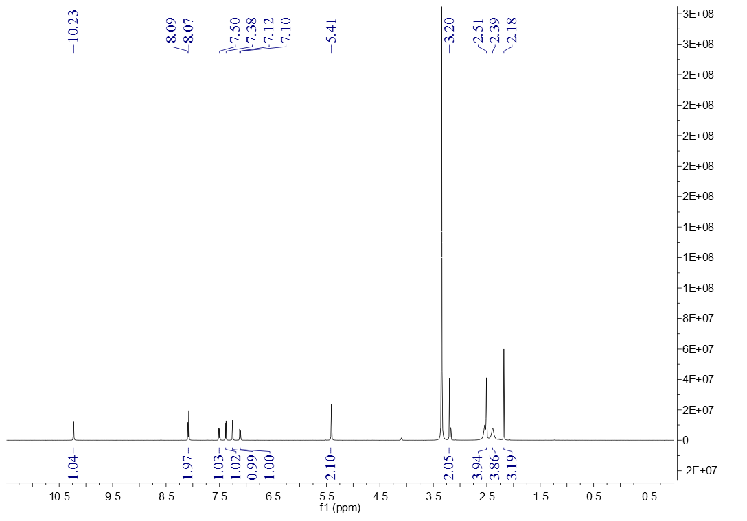
Figure S52. The ¹HNMR spectrum of compound 11d (DMSO-d₆)

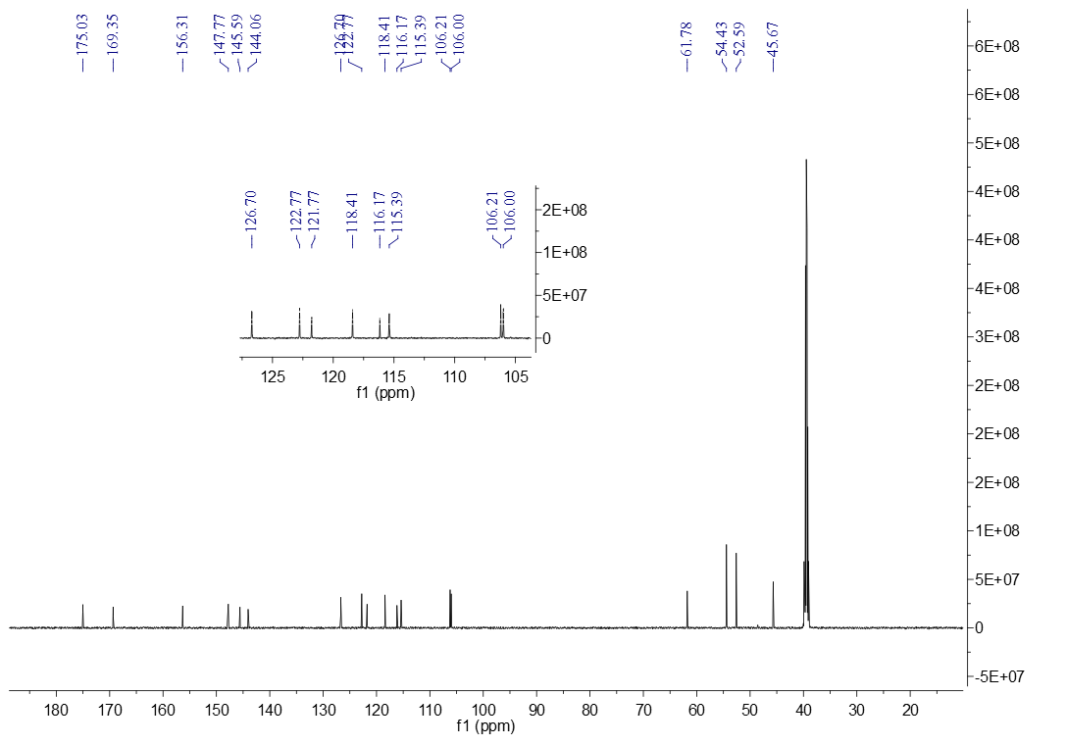
Figure S53. The ¹³CNMR spectrum of compound 11d (DMSO-d₆)

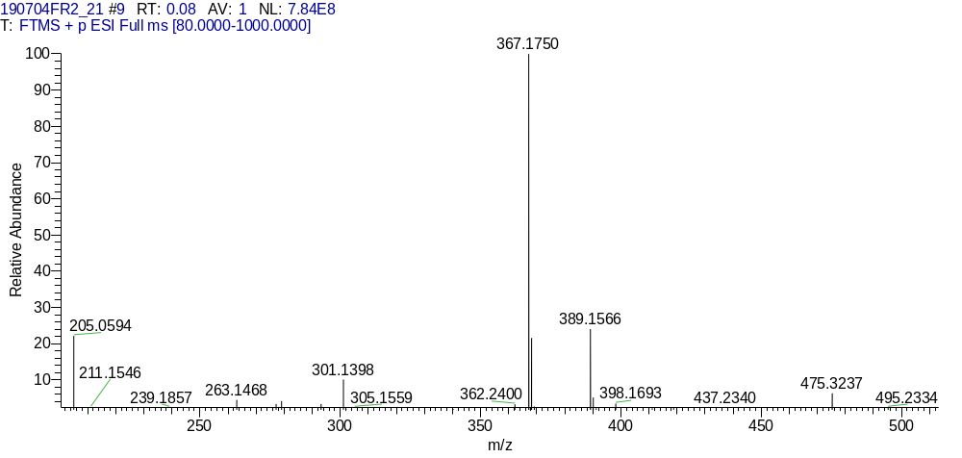
Figure S54. The HR-MS spectrum of compound 11d
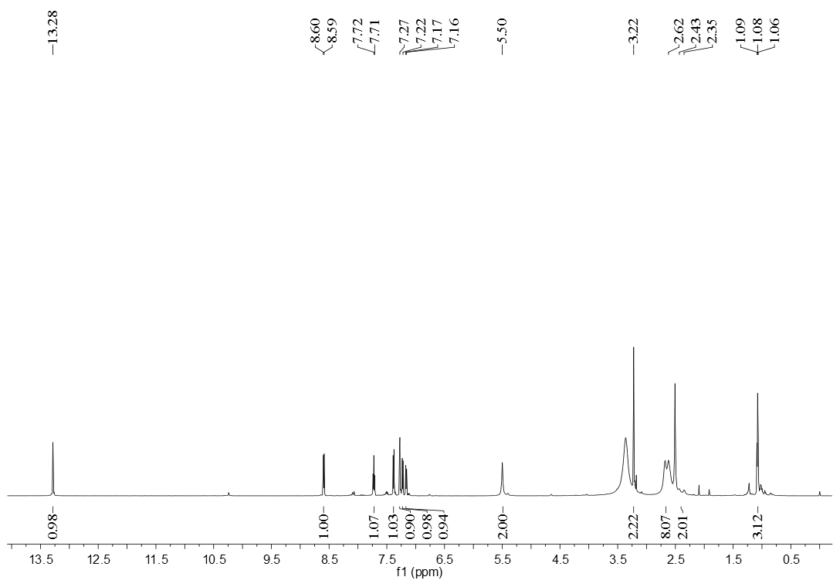 Figure S55. The ¹HNMR spectrum of compound 11e (DMSO-d₆)

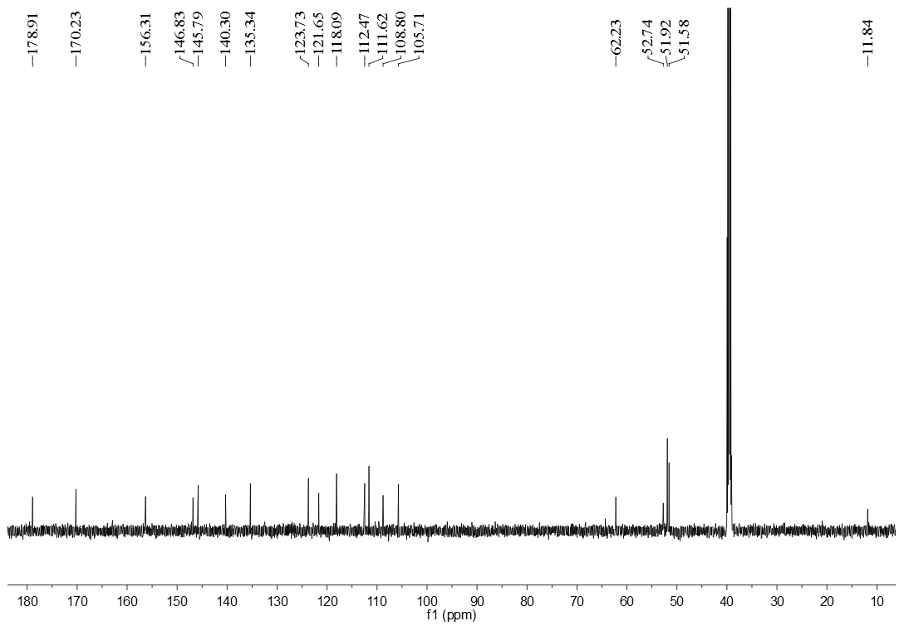 Figure S56. The ¹³CNMR spectrum of compound 11e (DMSO-d₆)

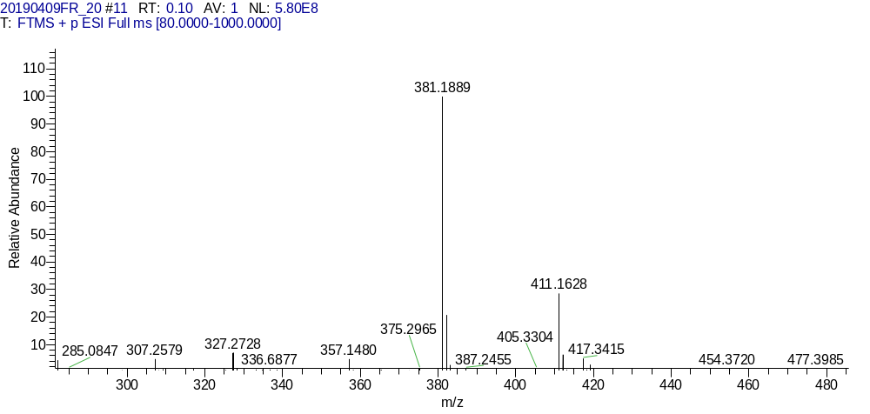 Figure S57. The HR-MS spectrum of compound 11e

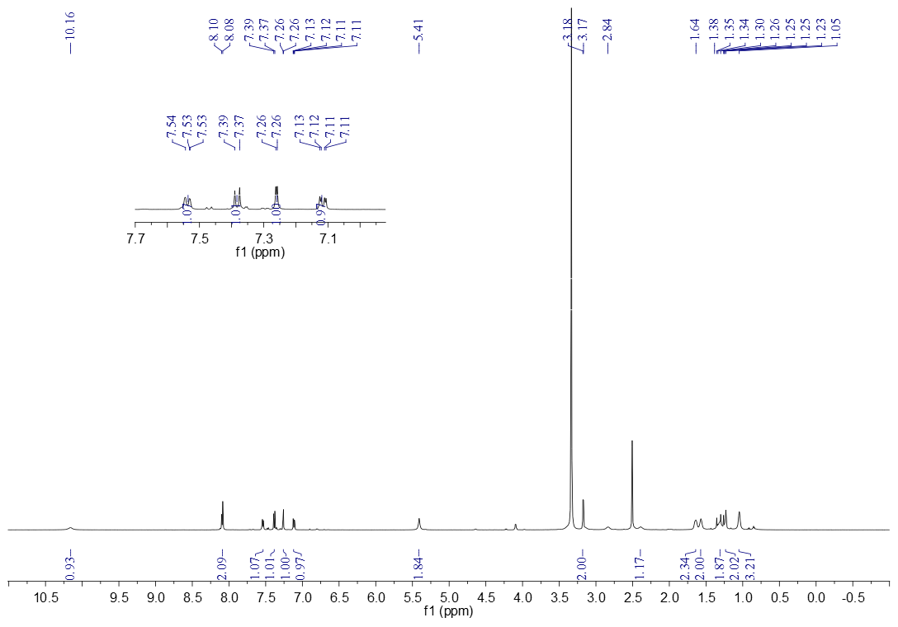 Figure S58. The ¹HNMR spectrum of compound 11f (DMSO-d₆)
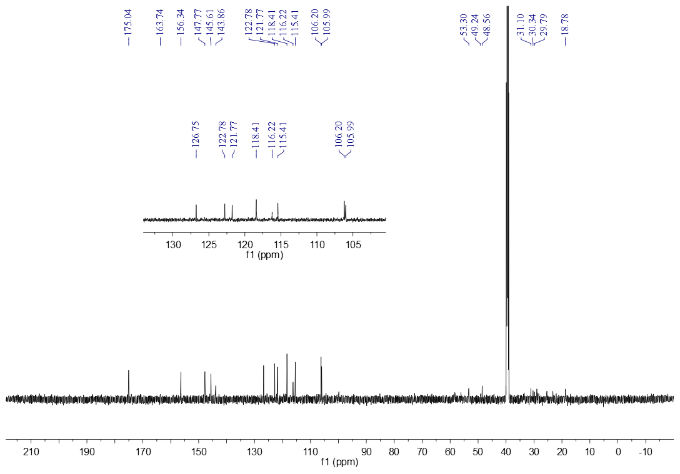 Figure S59. The ¹³CNMR spectrum of compound 11e (DMSO-d₆)

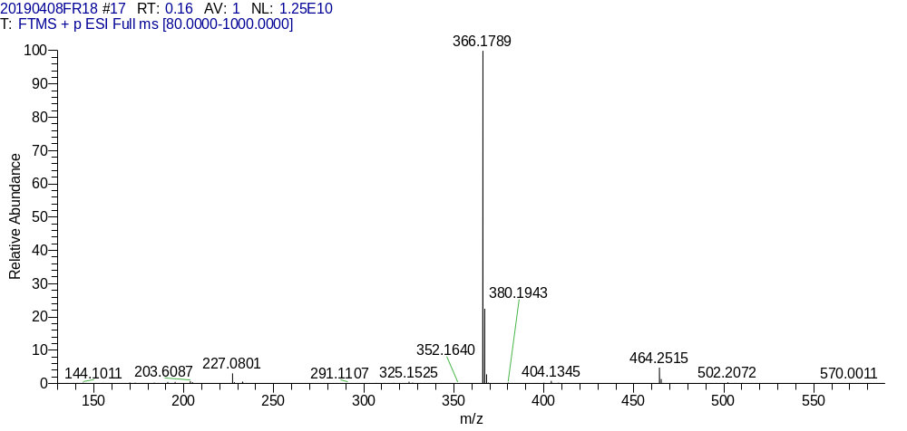
Figure S60. The HR-MS spectrum of compound 11e
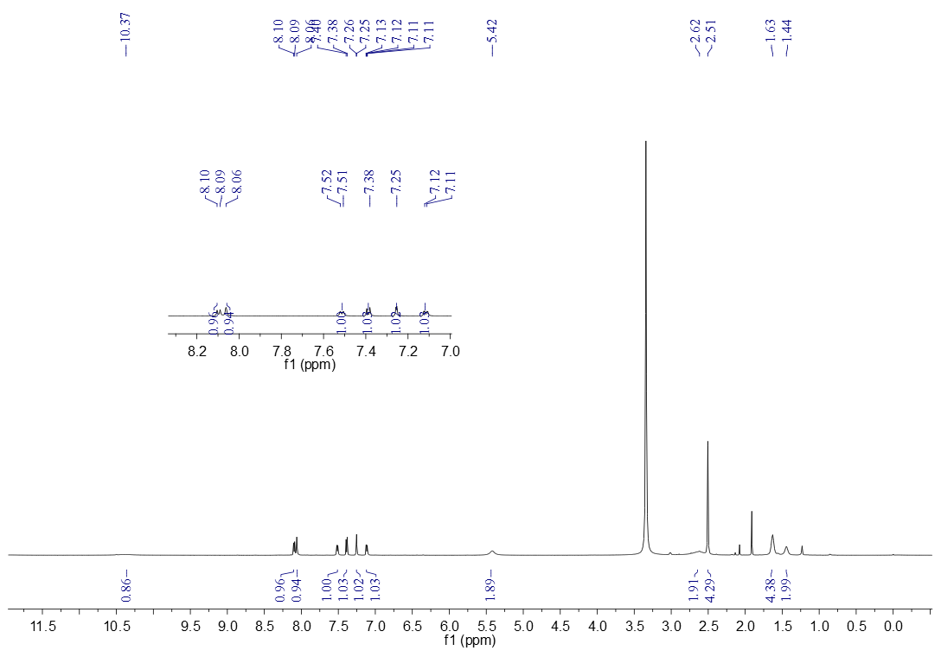 Figure S61. The ¹HNMR spectrum of compound 11g (DMSO-d₆)

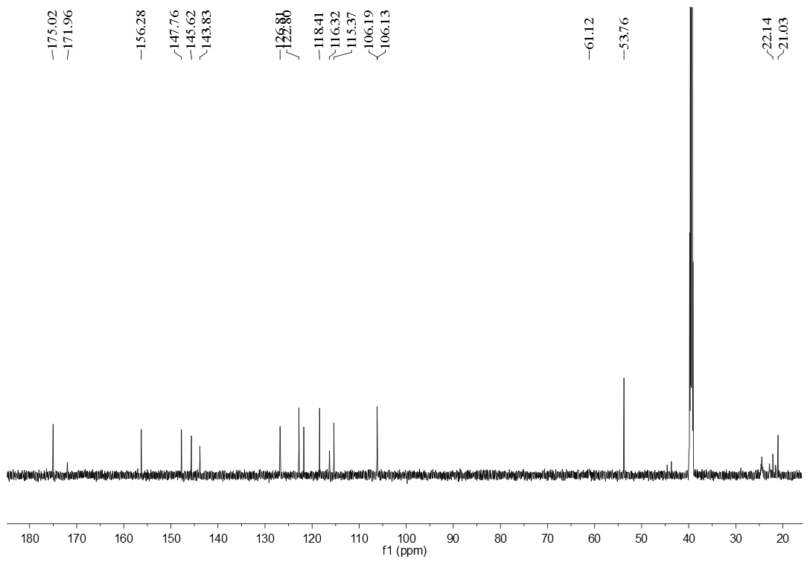
Figure S62. The ¹³CNMR spectrum of compound 11g (DMSO-d₆)

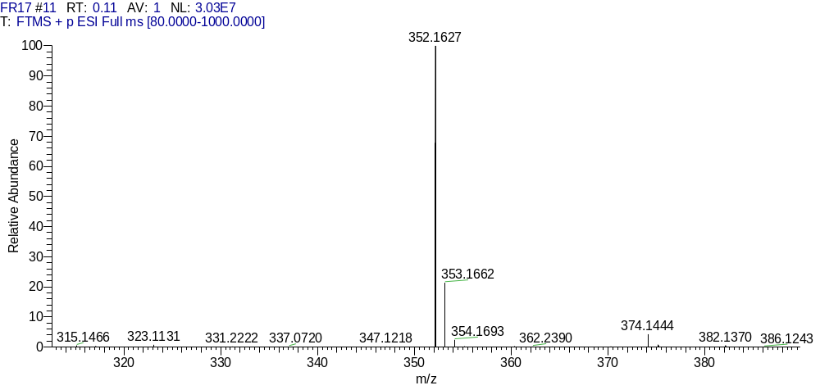
Figure S63. The HR-MS spectrum of compound 11g

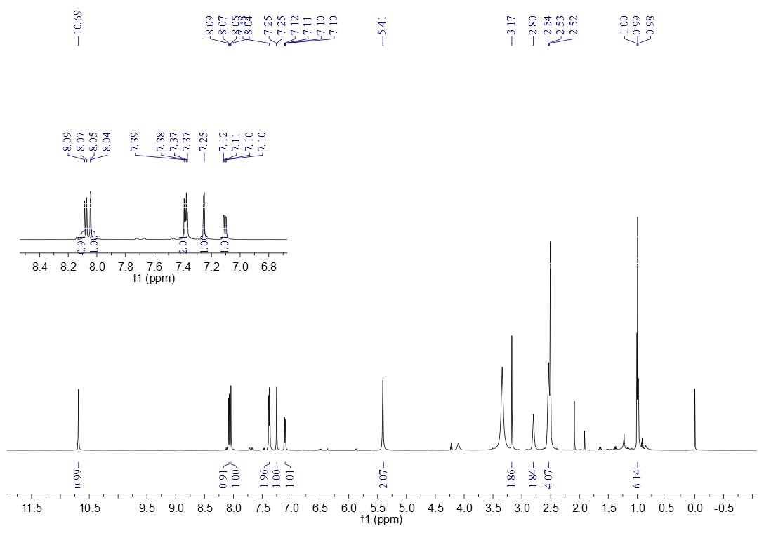 Figure S64. The ¹HNMR spectrum of compound 12a (DMSO-d₆)
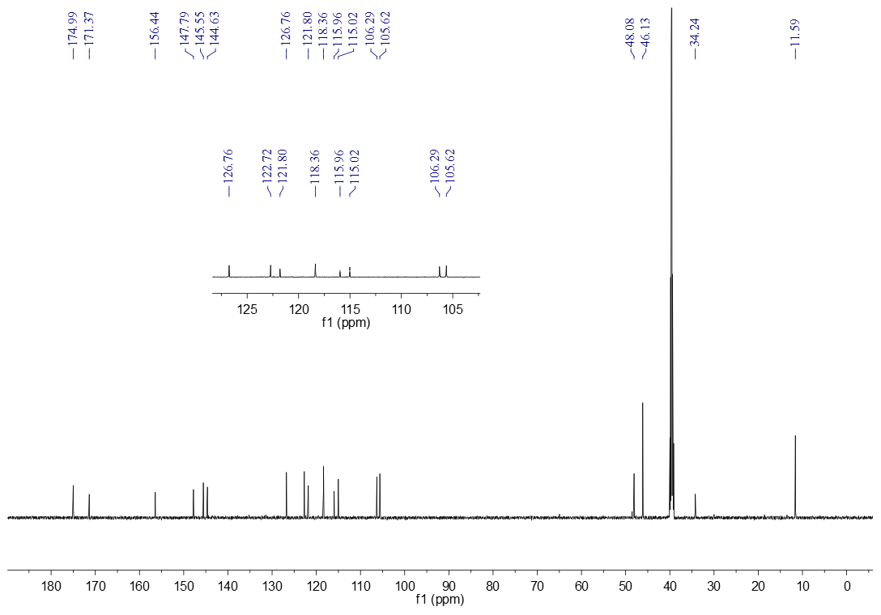 Figure S65. The ¹³CNMR spectrum of compound 12a (DMSO-d₆)

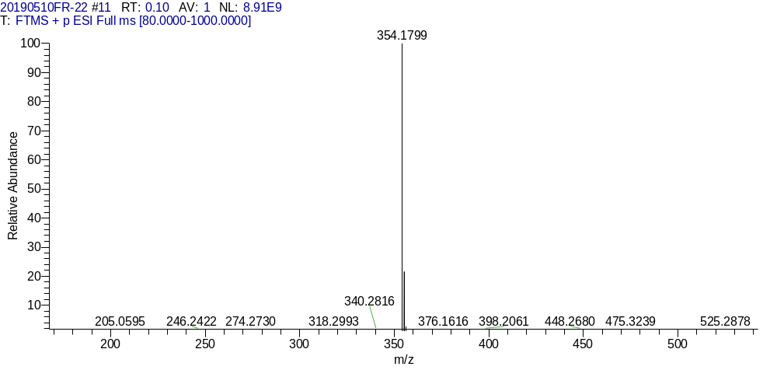
Figure S66. The HR-MS spectrum of compound 12a
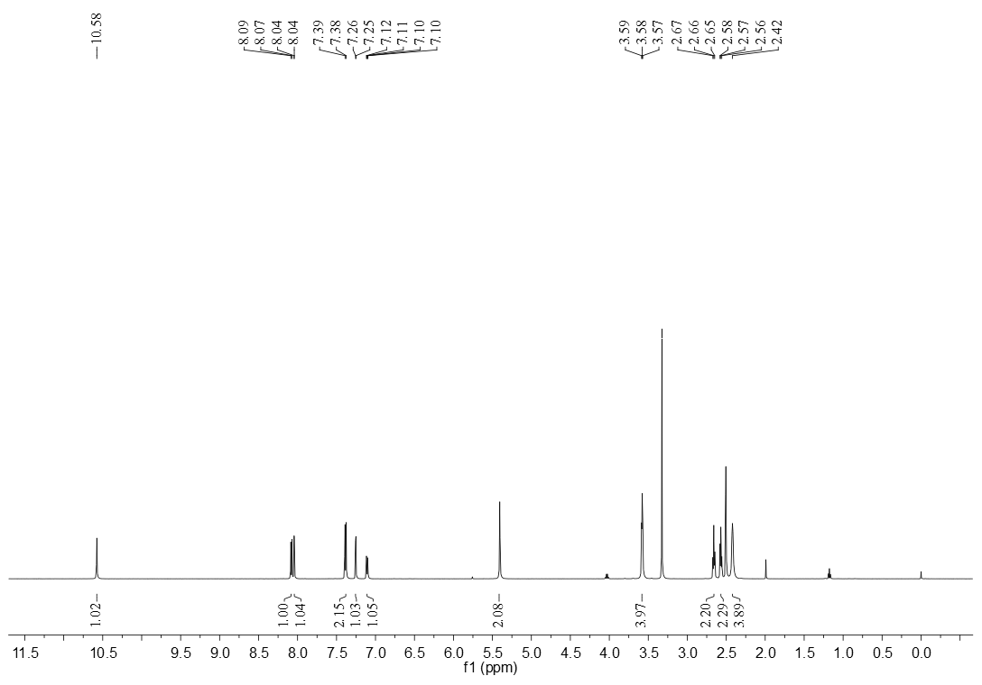 Figure S67. The ¹HNMR spectrum of compound 12b (DMSO-d₆)

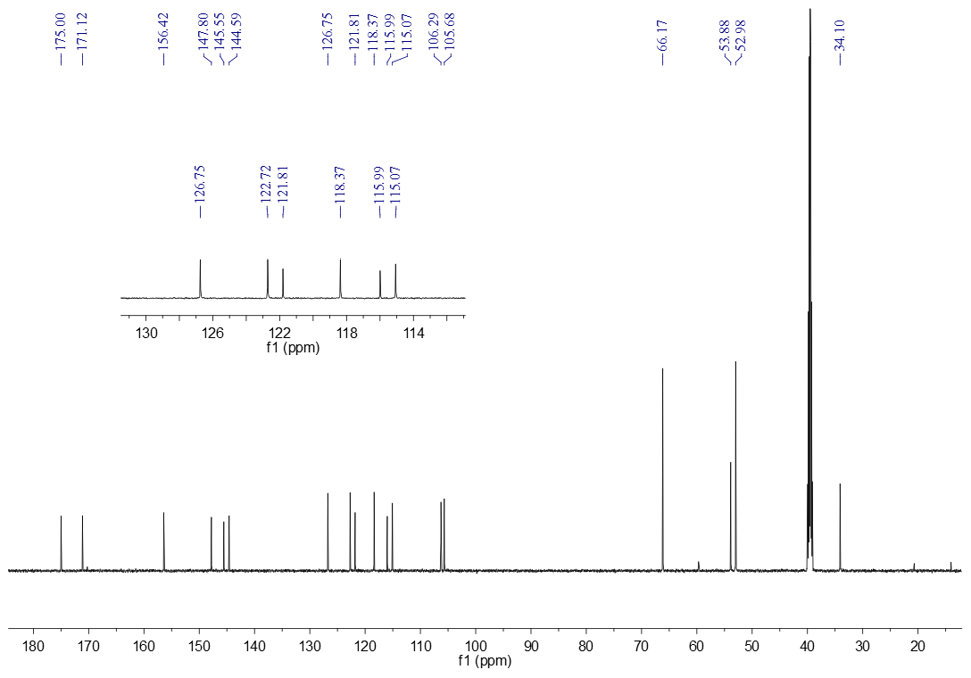
Figure S68. The ¹³CNMR spectrum of compound 12b (DMSO-d₆)
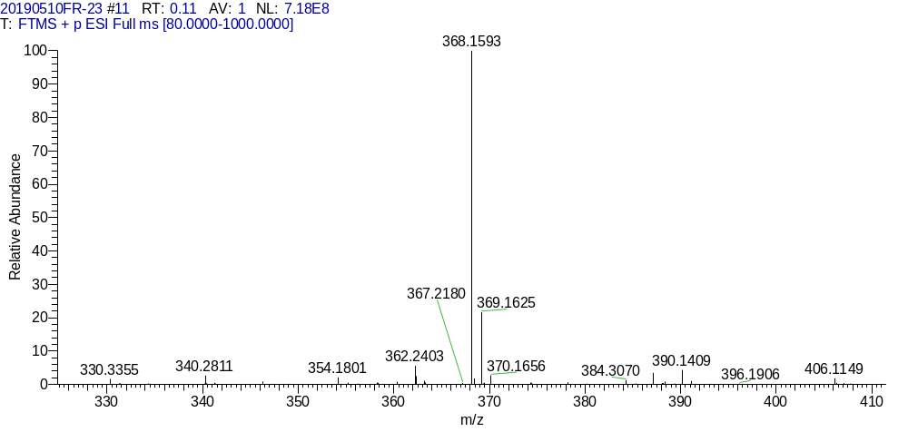
Figure S69. The HR-MS spectrum of compound 12b

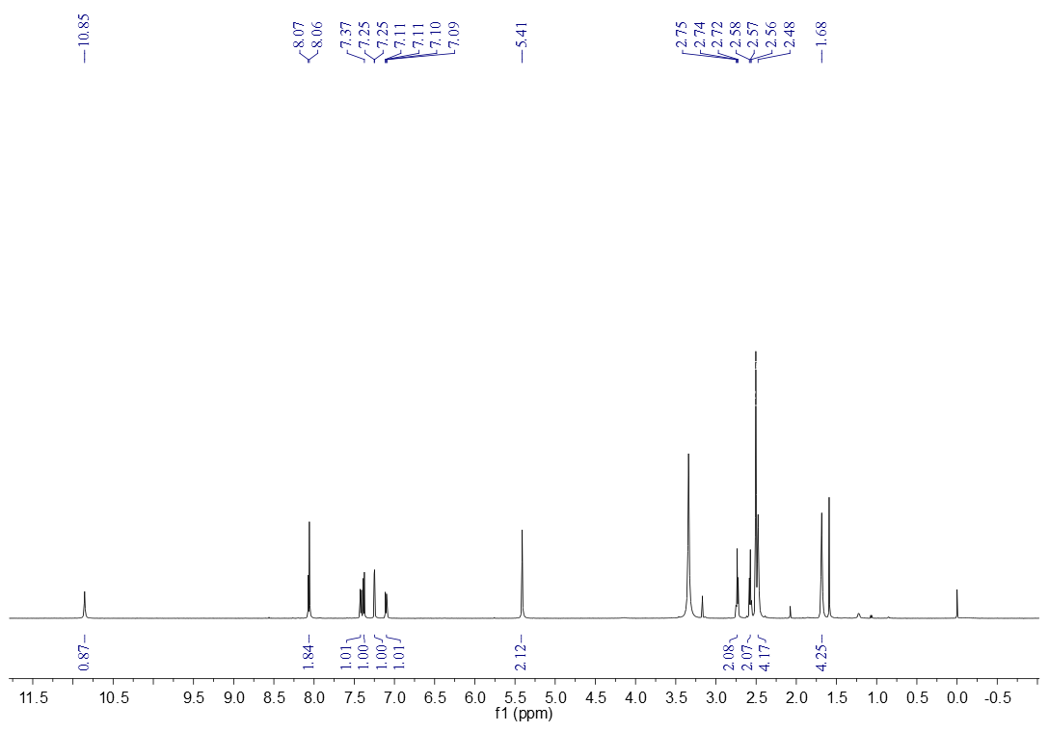 Figure S70. The ¹HNMR spectrum of compound12c (DMSO-d₆)
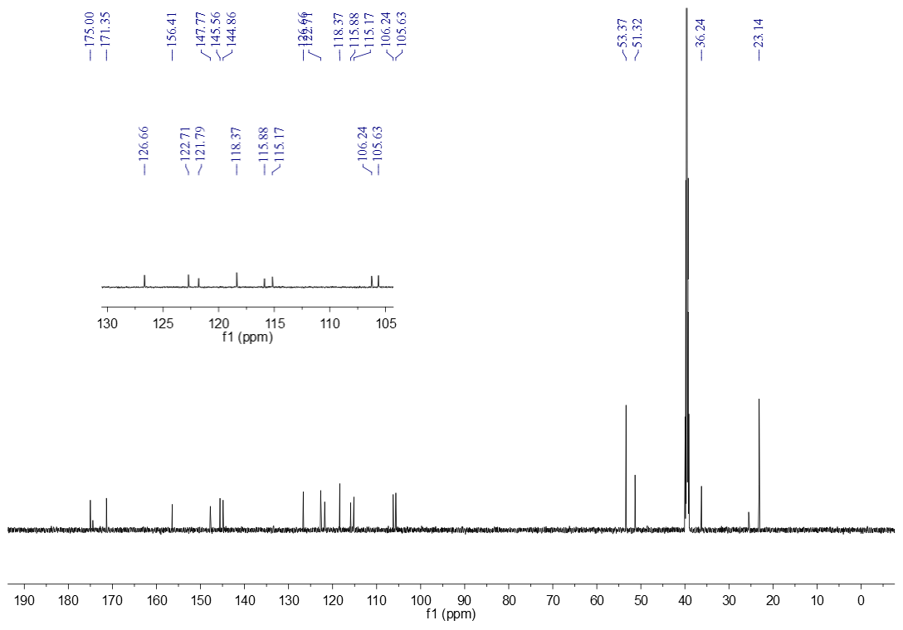 Figure S71. The ¹³CNMR spectrum of compound 12c (DMSO-d₆)

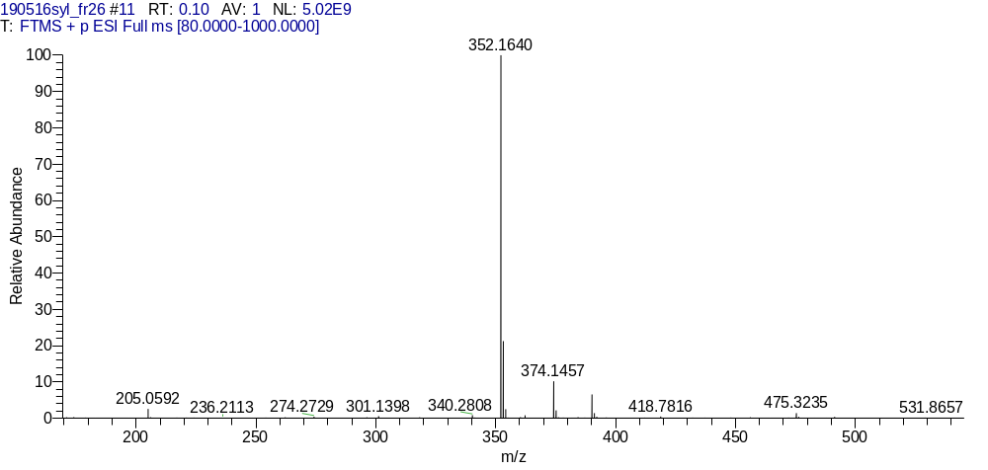
Figure S72. The HR-MS spectrum of compound 12c
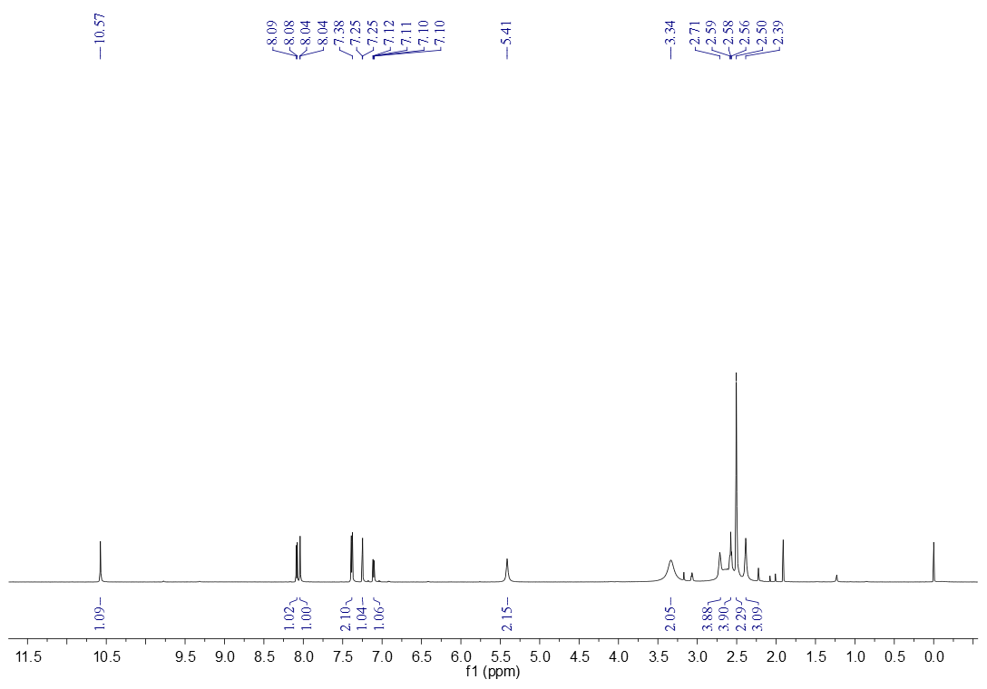 Figure S73. The ¹HNMR spectrum of compound 12d (DMSO-d₆)

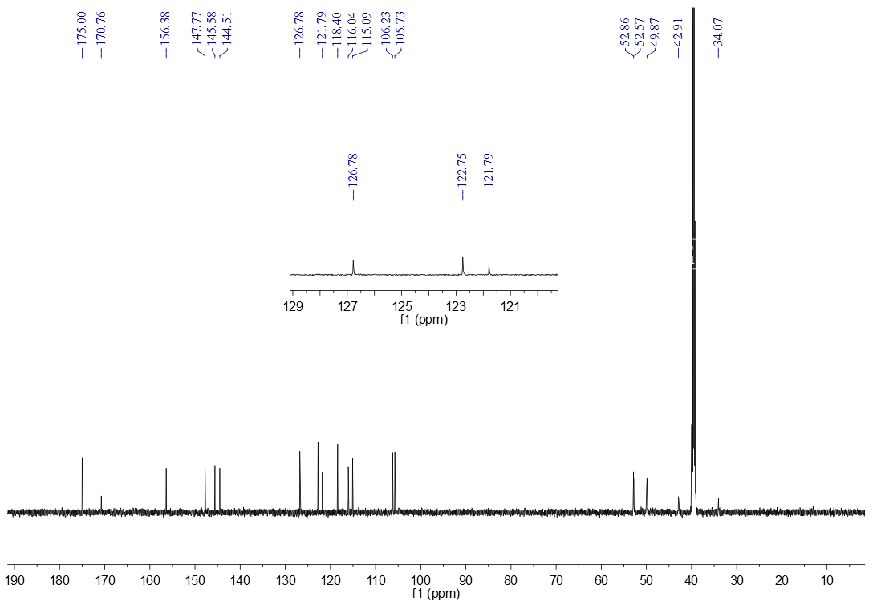 Figure S74. The ¹³CNMR spectrum of compound 12d (DMSO-d₆)
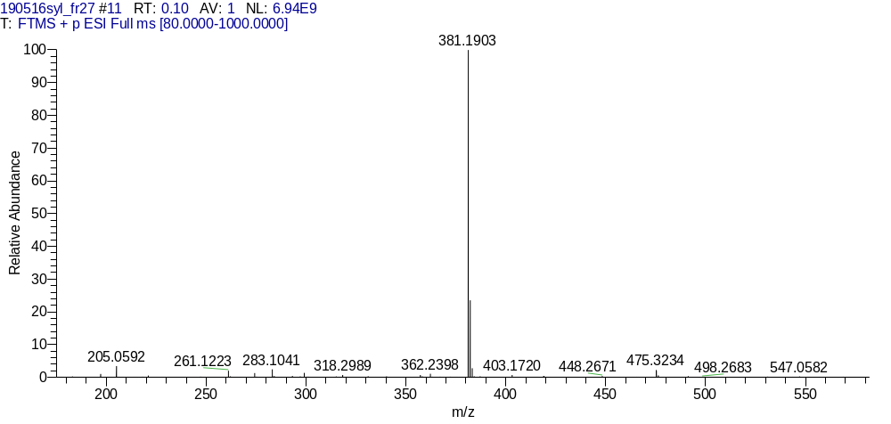
Figure S75. The HR-MS spectrum of compound 12d

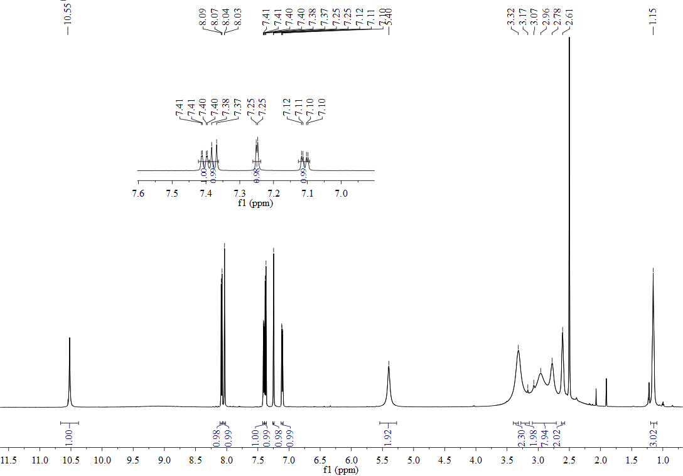
Figure S76. The ¹HNMR spectrum of compound 12e (DMSO-d₆)

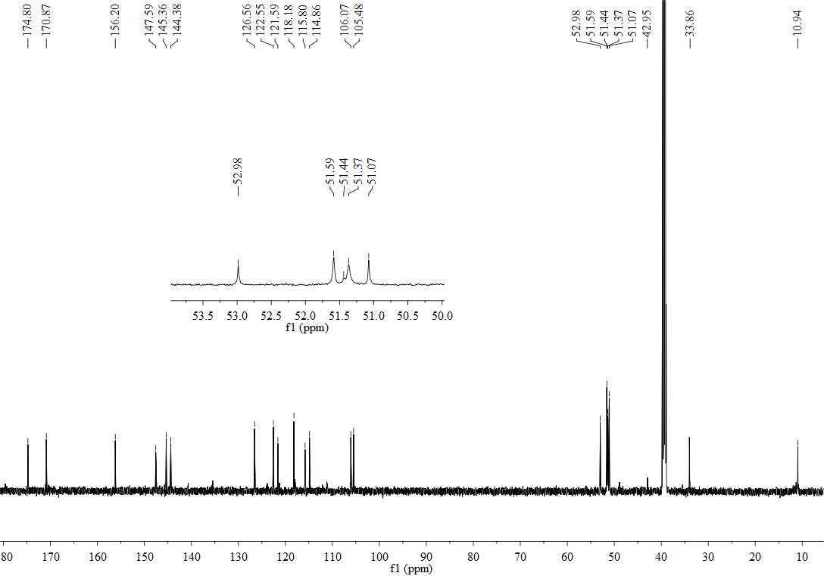
Figure S77. The ¹³CNMR spectrum of compound 12e (DMSO-d₆)

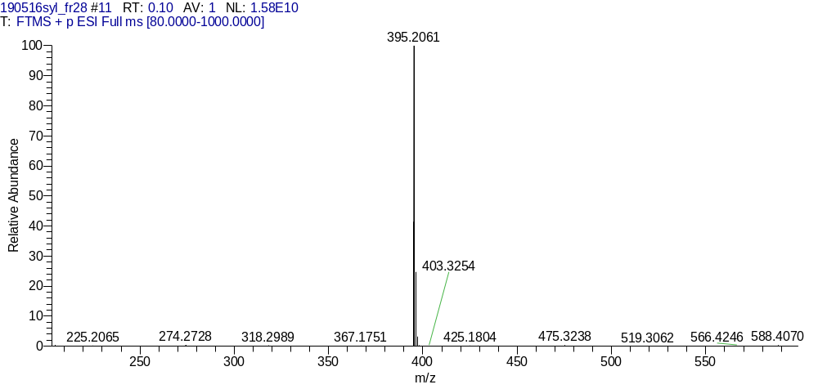
Figure S78. The HR-MS spectrum of compound 12e
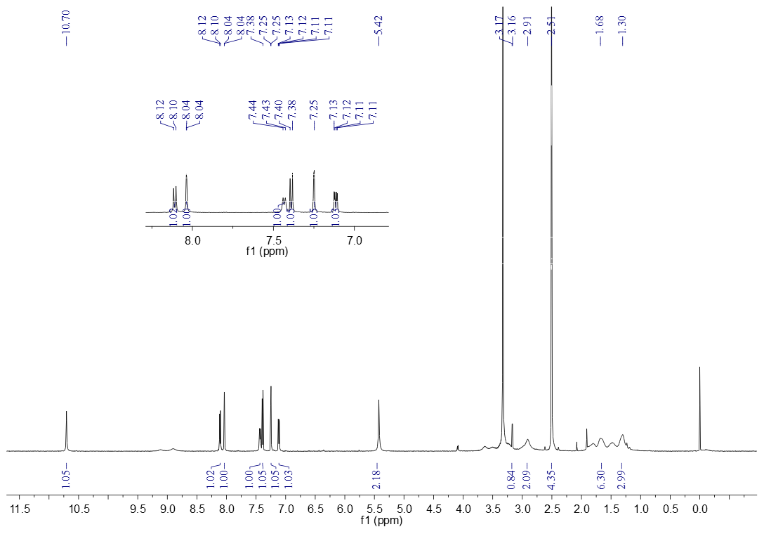 Figure S79. The ¹HNMR spectrum of compound 12f (DMSO-d₆)

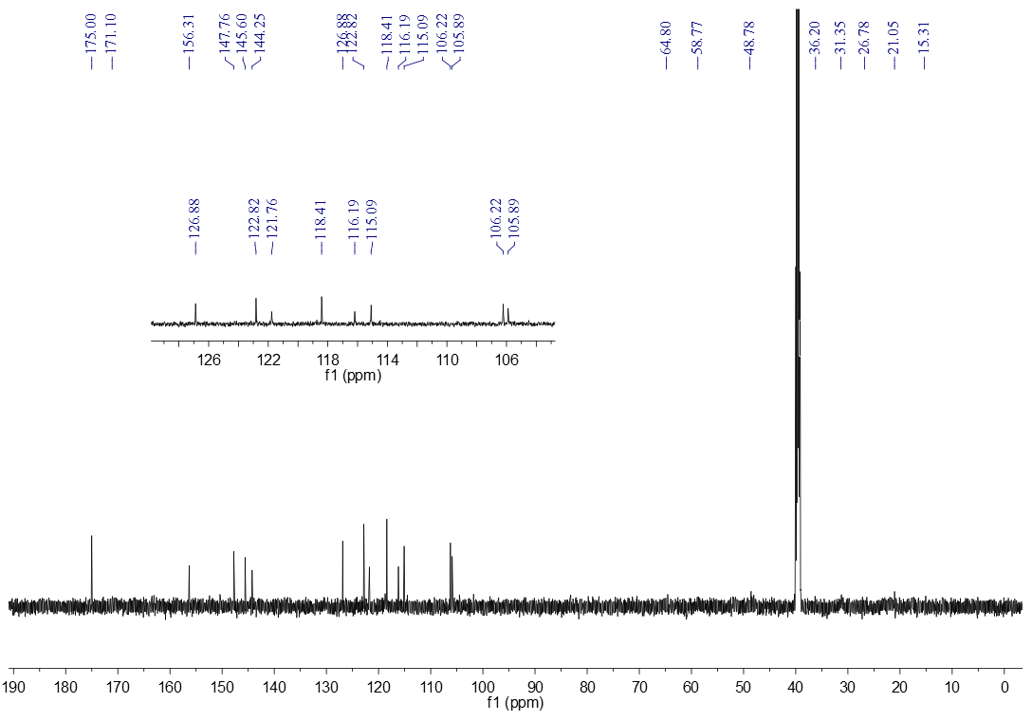 Figure S80. The ¹³CNMR spectrum of compound 12f (DMSO-d₆)
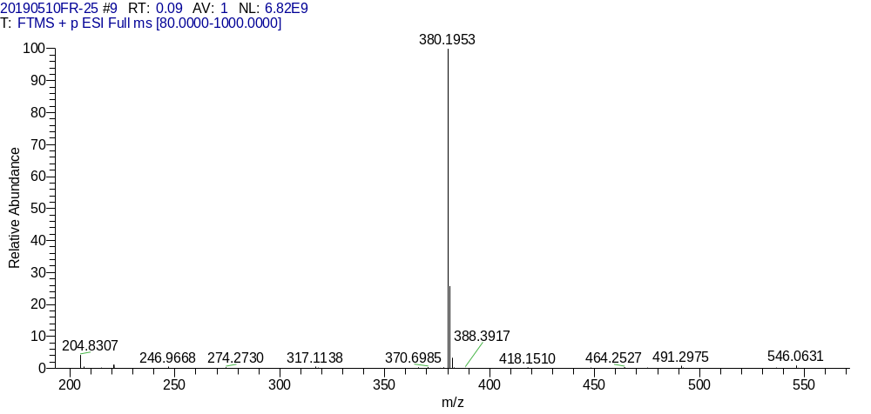
Figure S81. The HR-MS spectrum of compound 12f

Correspond author. e-mail address: xiaoqiao@hbu.edu.cn(Xiaoqiang Qiao); yalisong@hbu.edu.cn (Yali Song)

