Comparative genomics and functional characterization of 11 newly isolated non-equol-producing Adlercreutzia strains with anti-inflammatory properties
Chamignon et al

Supplementary figures

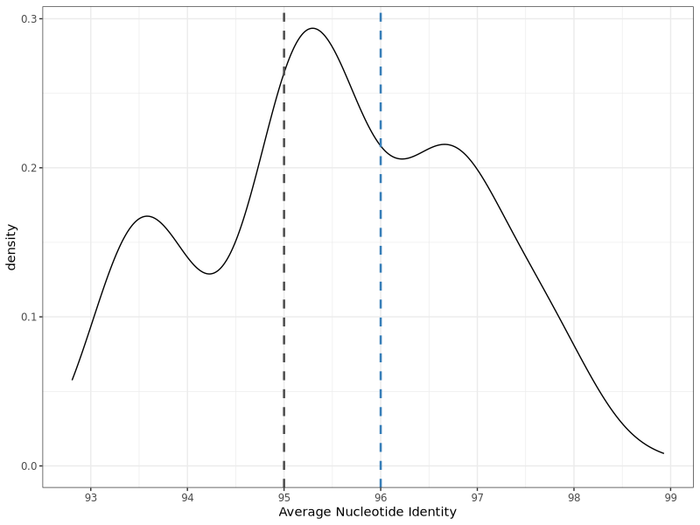
Figure S1: Distribution of pairwise Average Nucleotide Identity (ANI) among the 24 analysed genomes. The density plot highlights that the conventional 95% species boundary (black dashed line) falls within a high-density peak rather than a distinct gap. The blue dashed line indicates the 96% ANI cutoff, which aligns with a local minimum in the distribution and was used to more accurately delineate genome clusters.
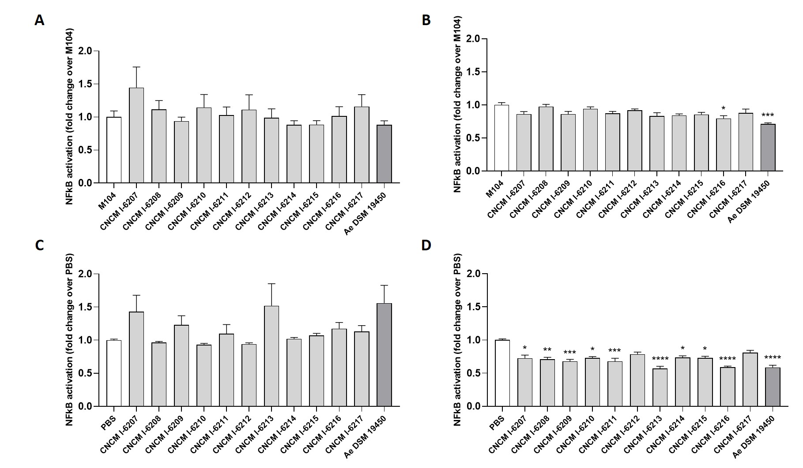
Figure S2: Effect of supernatant (_SN) (A and B) and pellet (_P) (C and D) of the newly isolated strains and A. equolifaciens DSM 19450 on NF-κB activity of HT-29 NF-κB cell line.
Activities were measured in non-inflammatory (A and C) or inflammatory (_TNF) (B and D) conditions repeated three times independently with triplicate determinations. Values are expressed as fold increase over group controls (M104 or PBS). Statistical significance was assessed with a Kruskal–Wallis test followed by Dunn’s multiple-comparison post-hoc test. * p < 0.05, ** p < 0.01, *** p < 0.001, **** p < 0.0001.

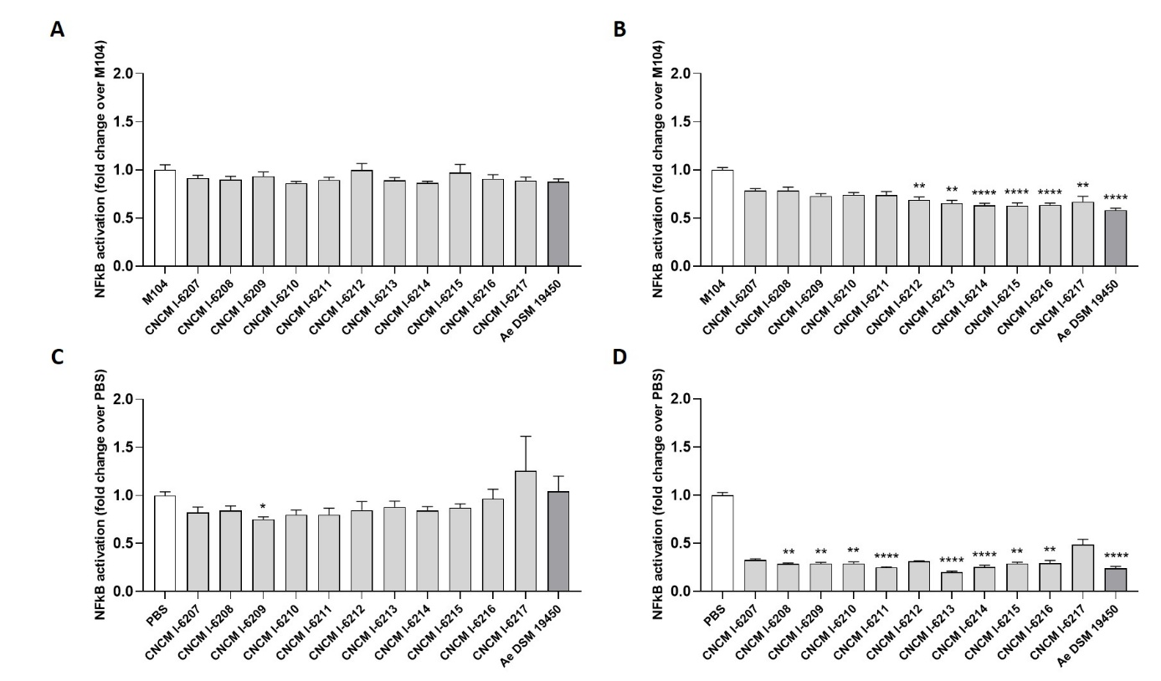
Figure S3: Effect of supernatant (_SN) (A and B) and pellet (_P) (C and D) of the newly isolated strains and A. equolifaciens DSM 19450 on NF-κB activity of HepG2 NF-κB cell line.
Activities were measured in non-inflammatory (A and C) or inflammatory (_TNF) (B and D) conditions repeated three times independently with triplicate determinations. Values are expressed as fold increase over group controls (M104 or PBS). Statistical significance was assessed with a Kruskal–Wallis test followed by Dunn’s multiple-comparison post-hoc test. * p < 0.05, ** p < 0.01, **** p < 0.0001.

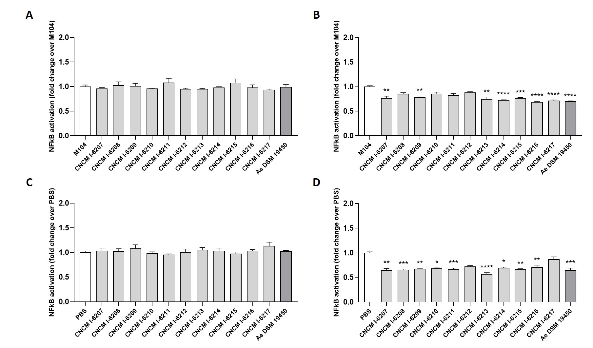
Figure S4: Effect of supernatant (_SN) (A and B) and pellet (_P) (C and D) of the newly isolated strains and A. equolifaciens DSM 19450 on NF-κB activity of HEK Null1 cell line.
Activities were measured in non-inflammatory (A and C) or inflammatory (_TNF) (B and D) conditions repeated three times independently with triplicate determinations. Values are expressed as fold increase over group controls (M104 or PBS). Statistical analysis consisted of Kruskall-Wallis followed by Dunn’s multiple comparison test. * p < 0.05, ** p < 0.01, *** p < 0.001, **** p < 0.0001.

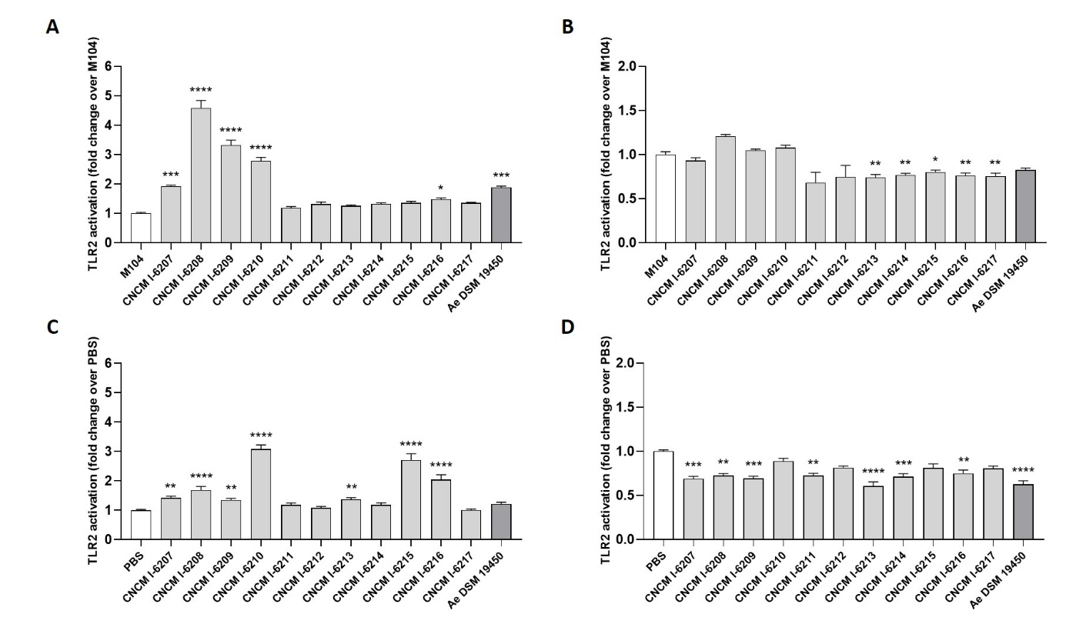
Figure S5: Effect of supernatant (_SN) (A and B) and pellet (_P) (C and D) of the newly isolated strains and A. equolifaciens DSM 19450 on NF-κB activity of HEK TLR2 cell line.
Activities were measured in non-inflammatory (A and C) or inflammatory (_TNF) (B and D) conditions repeated three times independently with triplicate determinations. Values are expressed as fold increase over group controls (M104 or PBS). Statistical analysis consisted of Kruskall-Wallis followed by Dunn’s multiple comparison test. * p < 0.05, ** p < 0.01, *** p < 0.001, **** p < 0.0001.

Supplementary information
Supplementary Table 1: Genome assembly quality and metadata of newly isolated Adlercreutzia strains and publicly available GenBank genomes.

