An LLM-Agentic Workflow for Data-Driven Modeling: From Toy Image Reconstruction to Thermodynamic Modeling

Supporting information:
Figure S1 illustrates the standard workflow of the NSGA-II algorithm. In contrast to Auto-DDM, each iteration proceeds by directly using the parent pool to generate offspring without any revision or intervention from the LLM agent. Aside from this key difference, the rest of the workflow remains consistent with Auto-DDM.
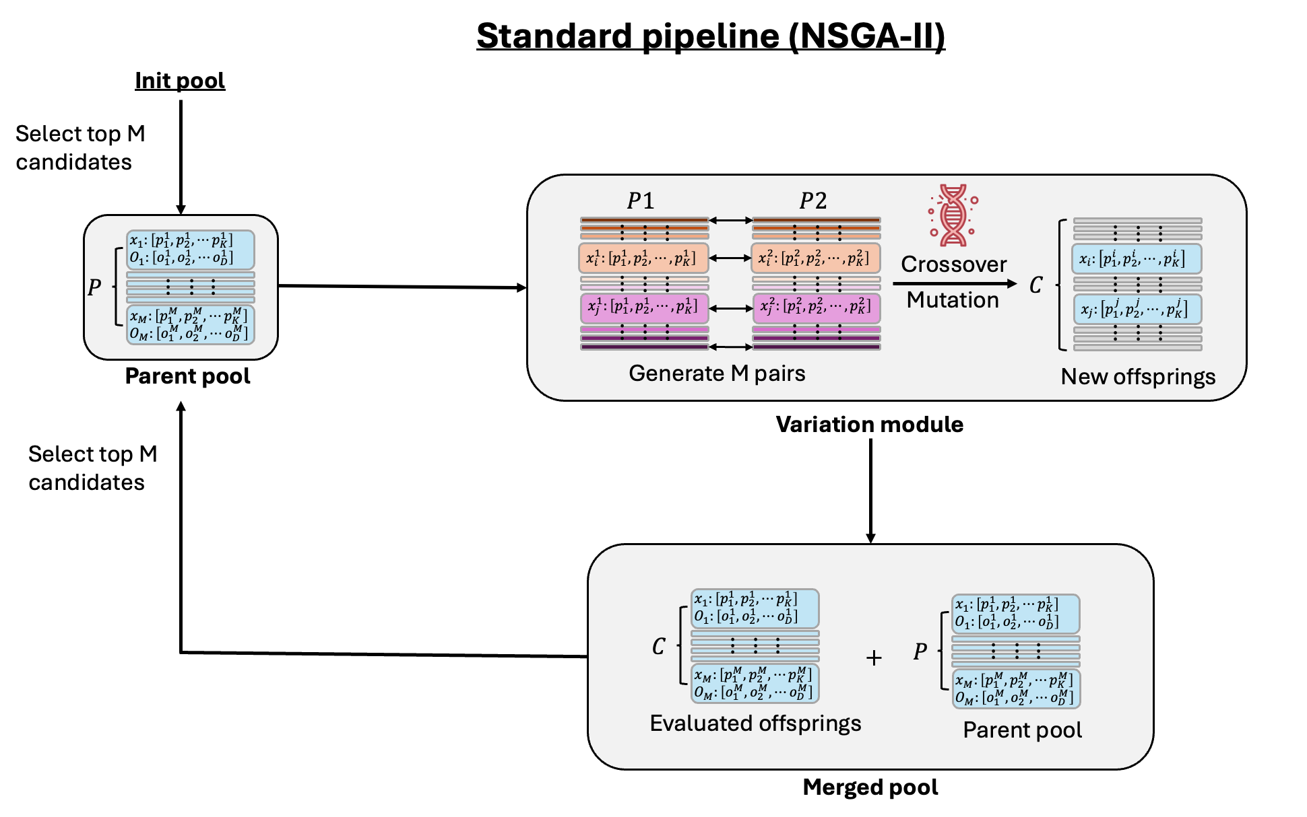
Figure S1. The modular workflow for standard NSGA-II method
Figure S2 presents the evaluation of the ESPEI surrogate model, trained on a randomly sampled dataset of 50,000 traces with a 20% test split. Predicted values are plotted against ground truth for all 22 thermodynamic properties. The model achieved an average $R^{2}$ score of 0.99, indicating excellent predictive accuracy across the board.
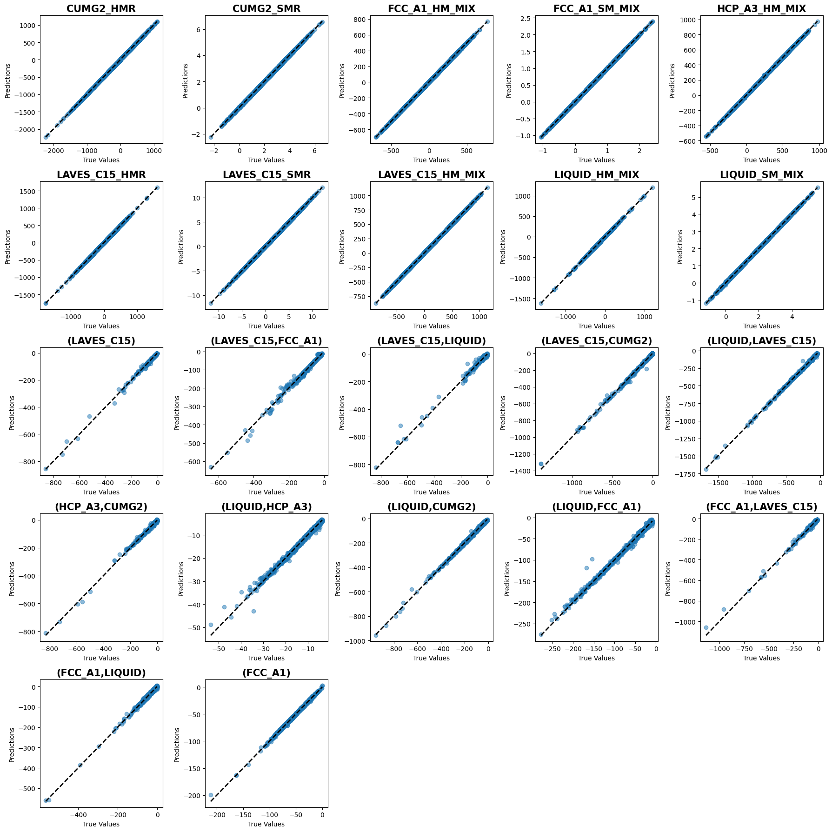
Figure S2. Predicted vs. true values for 22 thermodynamic properties using the ESPEI surrogate model.
Figure S3 compares the predicted thermochemical property curves (solid lines) with experimental data points across different properties and temperatures. The left panel presents predictions from the CALPHAD model constructed using the Auto-DDM framework, while the right panel shows predictions from a CALPHAD model developed with expert-guided dataset weighting, as reported in ESPEI’s demonstration study.
Auto-DDM’s model demonstrates good agreement with most thermochemical property datasets, with the notable exception of FCC entropy of mixing and liquid entropy of mixing. These discrepancies reflect an intentional tradeoff by Auto-DDM, prioritizing the reduction of phase boundary errors over strict adherence to high-variance entropy measurements. Entropy data, being inherently uncertain and indirectly derived, are commonly treated as qualitative checks rather than stringent fitting targets in CALPHAD domain.
Interestingly, a similar mismatch in entropy-related properties is observed in the expert-constructed model, suggesting this limitation is intrinsic to the data quality rather than modeling strategy. However, Auto-DDM exhibits a less pronounced deviation and achieves broader overall alignment with experimental data, underscoring its potential for balanced and interpretable model construction in complex, multi-objective settings.
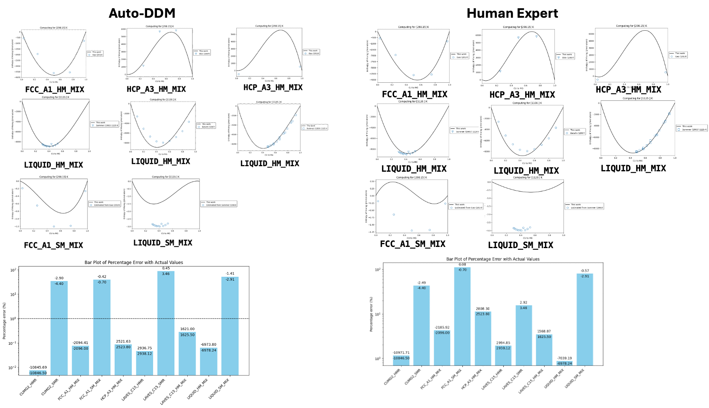
Figure S3. Predicted thermochemical properties from CALPHAD models built with Auto-DDM (left) and expert guidance (right). Lines denote model outputs; points are experimental data. Auto-DDM shows strong overall agreement and less severe entropy mismatches, reflecting effective tradeoff handling in multi-objective fitting.
Figure S4 presents the evolution trajectories of the ensemble Monte Carlo sampler used to perform Bayesian inference for quantifying parameter uncertainties in the CALPHAD model. Specifically, we visualize the progression of 88 walkers along the 7th parameter dimension over increasing iteration limits (800, 1600, 3200, and 6400). The right column shows the corresponding parameter-wise Gelman–Rubin R-hat values for all 22 parameters, serving as convergence qualitative diagnostics.
At 800 iterations, we begin to observe percolation across the ensemble chains for the 7th parameter, indicating early-stage convergence. This trend stabilizes at 1600 iterations and remains consistent through 3200 and 6400 iterations, confirming sustained convergence. This behavior is also corroborated by the decreasing R-hat values across parameters, suggesting improved mixing and convergence of the chains.
Based on these results, we adopt 800 iterations as the default setting when performing CALPHAD model assessment with Auto-DDM’s optimization pipeline to ensure rapid exploration during dataset weighting. For the final uncertainty quantification in CALPHAD model parameters, we extend the sampling to 3200 iterations to ensure robust convergence of the ensemble sampler.
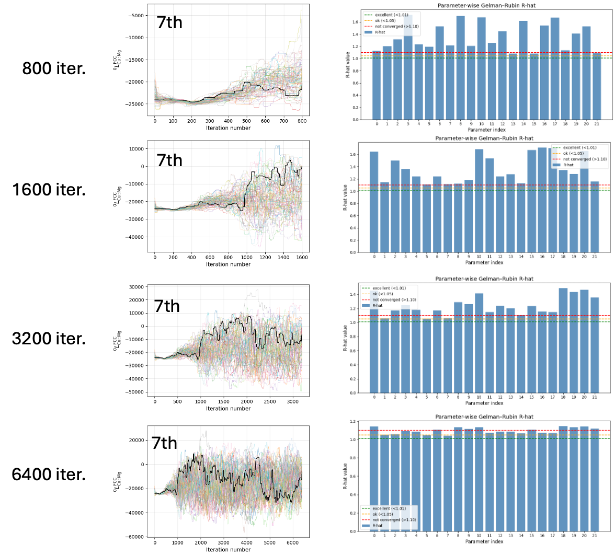
Figure S4. Convergence analysis of the ensemble Monte Carlo sampler along the 7th parameter dimension with increasing iteration limits (800 to 6400). Left: evolution of 88 walkers; Right: parameter-wise Gelman–Rubin R-hat values indicating improved convergence with longer sampling.

