Supplementary Materials
for

Structural Basis of Transcriptional Coactivator PC4 Binding to a Platinum Crosslinked Double-Stranded Oligonucleotide
Yuanyuan Wang,^{1,3,5,9} Min Zang,^{2,9} Zhifeng Du,^{1,5,7,9} Yinzhu Hou,^{1,5} Wei Zheng,¹ Juan Qiao,¹ Kui Wu,⁸ Qun Luo,^{1,5} Li Qi,^{1,5} Yao Zhao,^{1,5,10} Hao Dong^{2,10} and Fuyi Wang^{1,4,5,6,10}
¹ Beijing National Laboratory for Molecular Science; CAS Key Laboratory of Analytical Chemistry for Living Biosystems, Institute of Chemistry, Chinese Academy of Sciences, Beijing 100190, P.R. China.
² State Key Laboratory of Analytical Chemistry for Life Science, Kuang Yaming Honors School, Chemistry and Biomedicine Innovation Center (ChemBIC), & Institute for Brain Sciences, Nanjing University, Nanjing, 210023, China.
³ College of Pharmacy, Hebei University of Chinese Medicine, Shijiazhuang 050200, China.
⁴ National Centre for Mass Spectrometry in Beijing; Beijing 100049, P.R. China
⁵ University of Chinese Academy of Sciences, Beijing 100049, P.R. China.
⁶ Basic Medical College, Shandong University of Chinese Traditional Medicine, Jinan 250355, P.R. of China.
⁷ School of Pharmacy, Huazhong University of Science and Technology, Wuhan, Hubei, 430030, P.R. China.
⁸ Key Laboratory of Hubei Province for Coal Conversion and New Carbon Materials; School of Chemistry and Chemical Engineering, Wuhan University of Science and Technology, Wuhan, 430081, P.R. China.
⁹ These authors contributed equally: Yuanyuan Wang, Min Zang, Zhifeng Du.
¹⁰ E-mail: fuyi.wang@iccas.ac.cn; donghao@nju.edu.cn; yaozhao@iccas.ac.cn.

Table of Contents

Figure S1 – S23.
Table S1 – S2.

References
Figure S1. Characterization of 1,3-trans-PtTz crosslinked oligodeoxynucleotide (ODN) I by HPLC (a) and ESI-MS (b). (a) Chromatogram of reaction mixture of strand I with trans-PtTz at 310 K for 24 h. Fraction A is free strand I and fraction B mono-platinated ODN I by trans-PtTz; (b) Mass spectrum of fraction B in (a) and the insert shows the isotopic model of doubly-charged ion of platinated strand I, [1,3-trans-PtTz- I]⁴⁻.
Figure S2. Mass spectra of (A) non-deuterated PC4, (B) deuterated PC4, (C) deuterated PC4 after incubated with unmodified dsODN III, and (D) deuterated PC4 after incubation with the 1,3-GTG trans-PtTz intrastrand crosslinked dsODN (1,3-trans-PtTz-III) .

Figure S3. Sequence coverage map of peptic peptides of PC4 identified by LC-ESI-MS. The secondary structural elements of β-sheets and α-helix determined by X-ray crystallography (M63 – L127) ¹ (PDB code: 2C62) are also shown above the sequence. Black double-arrow lines represent identified peptides (Pep1 – Pep20) and arrows refer to N-terminal and C-terminal of each peptide.
Figure S4. (a, b) Kinetic curves of HDX of peptic peptides Pep1 and Pep2 arising from apo-PC4 (square) and holo-PC4 (ligated with 1,3-trans-PtTz-III) (circle). (c, d) Mass spectra of (i) non-deuterated and (ii and iii) deuterated peptides Pep1 and Pep2 derived from the apo-PC4 (ii) and the holo-PC4 (iii) incubated in D₂O buffer for 1 min and 120 min, respectively. The vertical green lines correspond to the centroid m/z of each deuterated peptide.
Figure S5. (a, b) Kinetic curves of HDX of peptic peptides Pep3 and Pep4 arising from apo-PC4 (square) and holo-PC4 (circle). (c, d) Mass spectra of (i) non-deuterated and (ii and iii) deuterated peptides Pep3 and Pep4 derived from apo-PC4 (ii) and holo-PC4 (iii) incubated in D₂O buffer for 1 min and 120 min, respectively. The vertical green lines correspond to the centroid m/z of each deuterated peptide.
Figure S6. (a, b) Kinetic curves of HDX of peptic peptides Pep5 and Pep7 arising from apo-PC4 (square) and holo-PC4 (circle). (c, d) Mass spectra of (i) non-deuterated and (ii and iii) deuterated peptides Pep5 and Pep7 derived from the apo-PC4 (ii) and the holo-PC4 (iii) incubated in D₂O buffer for 1 min and 120 min, respectively. The vertical green lines correspond to the centroid m/z of each deuterated peptide.
Figure S7. (a, b) Kinetic curves of HDX of peptic peptides Pep8 and Pep9 arising from apo-PC4 (square) and holo-PC4 (circle). (c, d) Mass spectra of (i) non-deuterated and (ii and iii) deuterated peptides Pep8 and Pep9 derived from apo-PC4 (ii) and holo-PC4 (iii) incubated in D₂O buffer for 1 min and 120 min, respectively. The vertical green lines correspond to the centroid m/z of each deuterated peptide.
Figure S8. (a, b) Kinetic curves of HDX of peptic peptides Pep10 and Pep11 arising from apo-PC4 (square) and holo-PC4 (circle). (c, d) Mass spectra of (i) non-deuterated and (ii and iii) deuterated peptides Pep10 and Pep11 derived from apo-PC4 (ii) and holo-PC4 (iii) incubated in D₂O buffer for 1 min and 120 min, respectively. The vertical green lines correspond to the centroid m/z of each deuterated peptide.
Figure S9. (a, b) Kinetic curves of HDX of peptic peptides Pep12 and Pep14 arising from apo-PC4 (square) and holo-PC4 (circle). (c, d) Mass spectra of (i) non-deuterated and (ii and iii) deuterated peptides Pep12 and Pep14 derived from apo-PC4 (ii) and holo-PC4 (iii) incubated in D₂O buffer for 1 min and 120 min, respectively. The vertical green lines correspond to the centroid m/z of each deuterated peptide.
Figure S10. (a, b) Kinetic curves of HDX of peptic peptides Pep15 and Pep17 arising from apo-PC4 (square) and holo-PC4 (circle). (c, d) Mass spectra of (i) non-deuterated and (ii and iii) deuterated peptides Pep15 and Pep17 derived from apo-PC4 (ii) and holo-PC4 (iii) incubated in D₂O buffer for 1 min and 120 min, respectively. The vertical green lines correspond to the centroid m/z of each deuterated peptide.
Figure S11. (a, b) Kinetic curves of HDX of peptic peptides Pep18 and Pep19 arising from apo-PC4 (square) and holo-PC4 (circle). (c, d) Mass spectra of (i) non-deuterated and (ii and iii) deuterated peptides Pep18 and Pep19 derived from apo-PC4 (ii) and holo-PC4 (iii) incubated in D₂O buffer for 1 min and 120 min, respectively. The vertical green lines correspond to the centroid m/z of each deuterated peptide.
Figure S12. (a) Kinetic curves of HDX of peptic peptides Pep20 arising from apo-PC4 (square) and holo-PC4 (circle). (b) Mass spectra of (i) non-deuterated and (ii and iii) deuterated peptides Pep20 derived from apo-PC4 (ii) and holo-PC4 (iii) incubated in D₂O buffer for 1 min and 120 min, respectively. The vertical green lines correspond to the centroid m/z of each deuterated peptide.
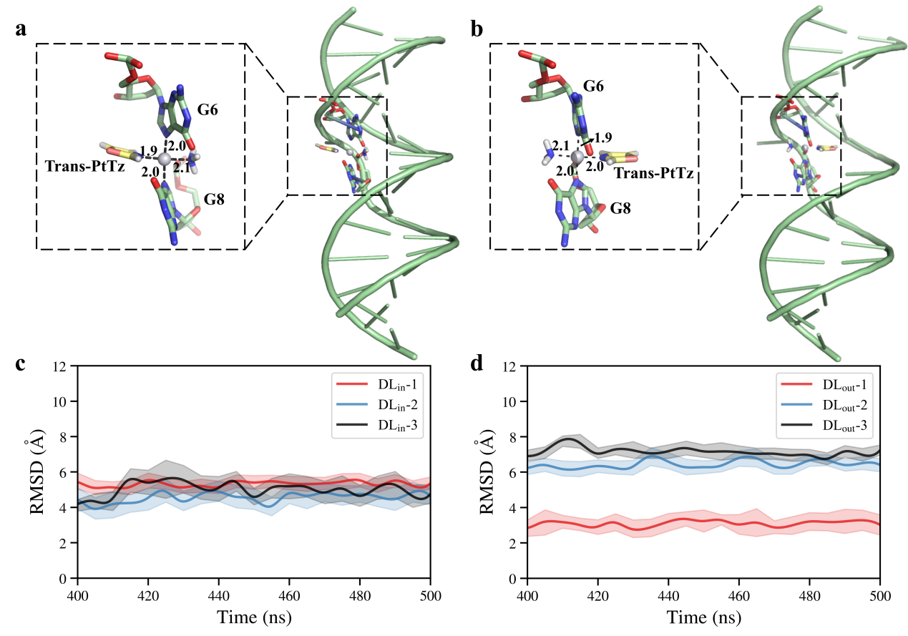
Figure S13. The initial structures and conformation changes of 1,3-trans-PtTz-III. (a) The DL_{in} (a) and the DL_{out} (b) configurations of the 1,3-trans-PtTz-III complex. Pt-related coordination bonds are indicated by dashed lines (in Å). The root mean squared deviations (RMSD) of the protein backbone in three parallel simulations for the DL_{in} (c) and the DL_{out} (d) configurations.

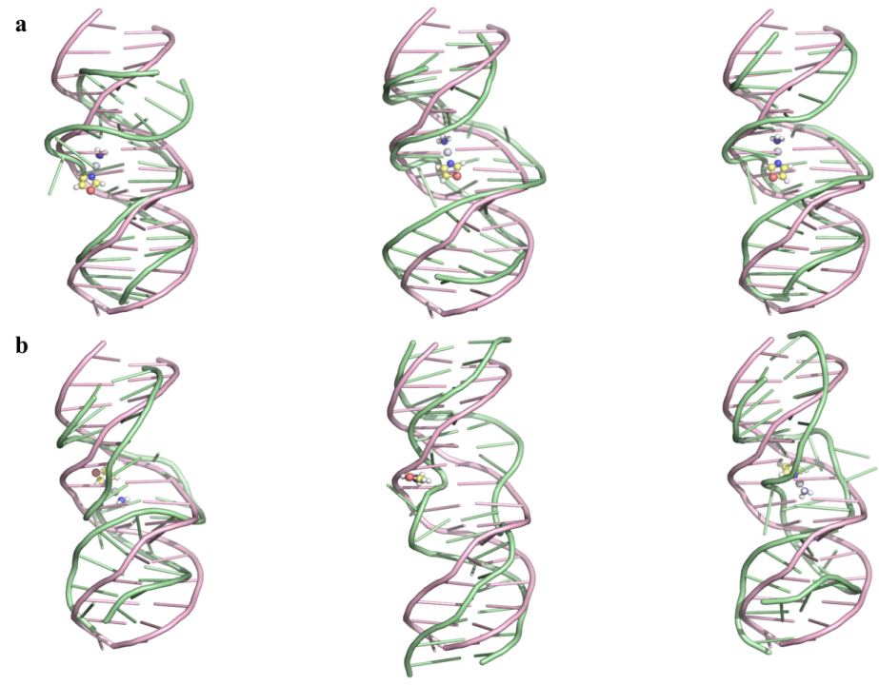
Figure S14. The comparison between the B-form ODN III model (light pink) and three parallel (a) DL_{in} or (b) DL_{out} models (pale green)..

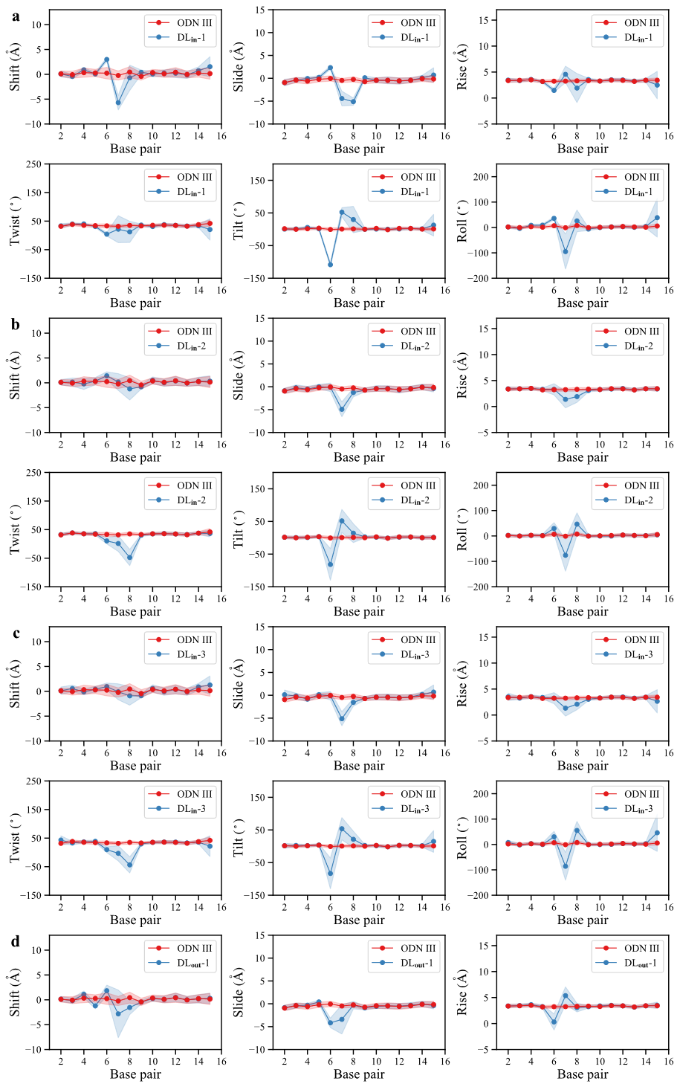
(continued on next page)
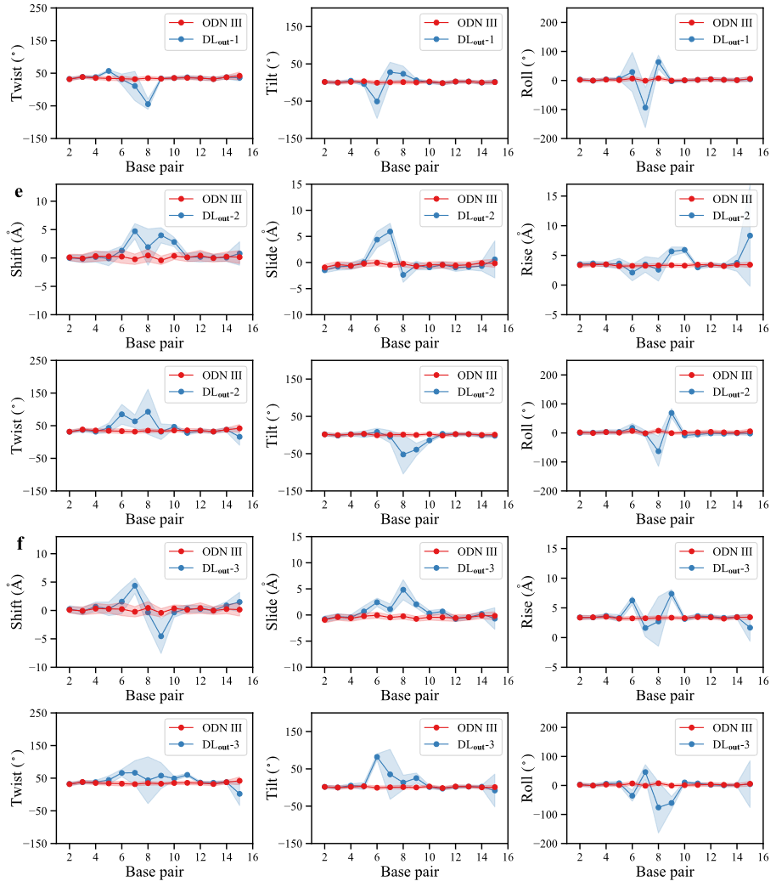
Figure S15. Inter-base pair parameters versus base pair number for ODN III (red) and six DL complexes (blue). (a), (b), (c) showing comparisons between ODN III and DL_{in-1}, DL_{in-2}, and DL_{in-3}, respectively; (d), (e), (f) showing comparisons between ODN III and DL_{out-1}, DL_{out-2}, and DL_{out-3}, respectively.

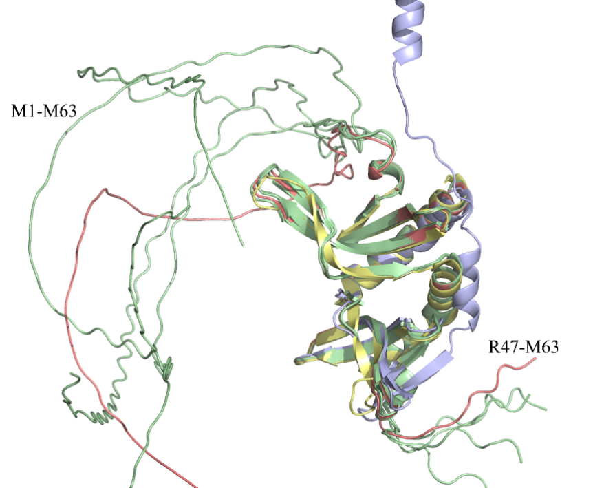
Figure S16. Structural prediction using AlphaFold2 and tFold. Both methods show consistent predictions for the M63-L127 segment, which are very close to the experimentally determined structure (PDB entry 2C62.pdb). However, tFold predicted the N-terminal disordered structure as a helix (in light blue); five predictions from AlphaFold2 (pale green, red and deepsalmon) show that the N-terminal segment (M1-M63) is disordered.

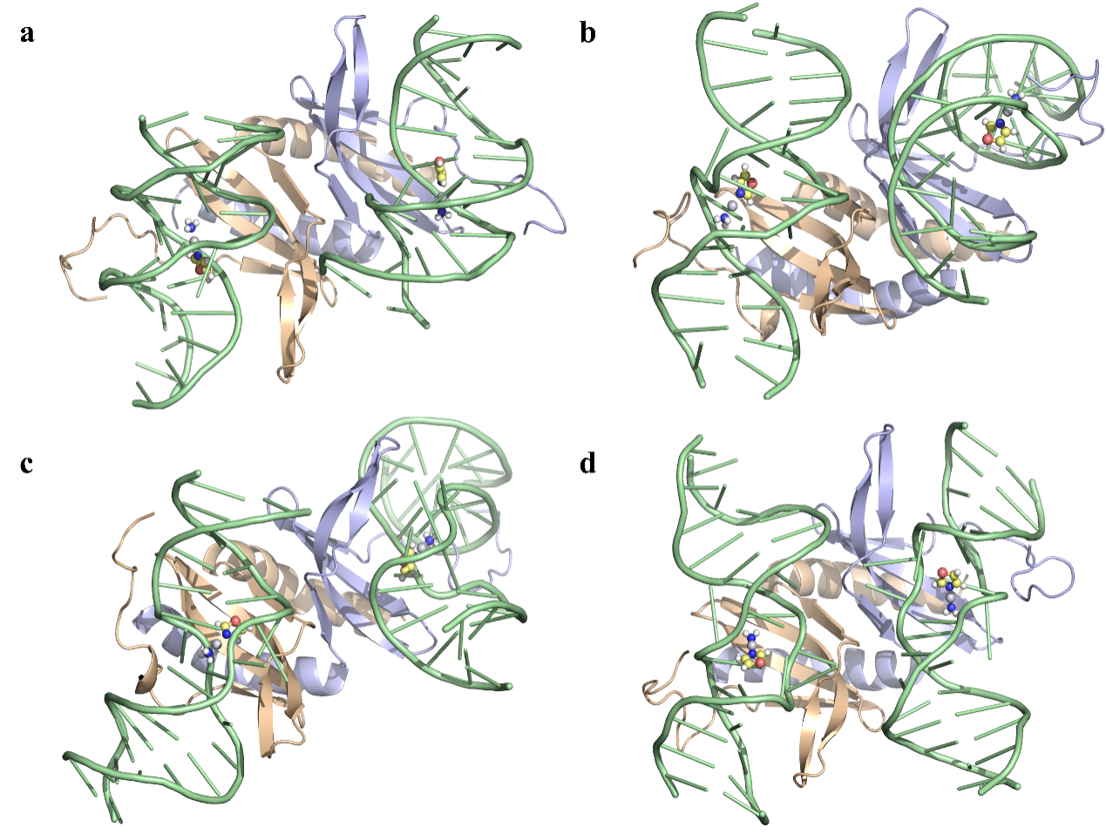
Figure S17. The representative structures of four holo-PC4 (1,3-trans-PtTz-III-PC4) complexes. The PC4 protein monomer 1, the PC4 protein monomer 2 and the two bound trans-PtTz-III for (a) holo-PC4-1 and (b) holo-PC4-2 and (c) holo-PC4-3 and (d) holo-PC4-4 are shown in wheat, light blue and pale green cartoon, respectively. Trans-PtTz is shown in ball-stick-model.

Based on the differences in binding modes, holo-PC4-1 to holo-PC4-4 are briefly described below. Holo-PC4-1: PC4 binds to the major groove of DL_{out} and the DNA strand binding trans-PtTz is close to the PC4 dimer interface; holo-PC4-2, PC4 bound to the minor groove of DL_{out} and the DNA strand binding trans-PtTz is away from the PC4 dimer interface; holo-PC4-3, PC4 bound to the major groove of DL_{in} and DNA strand binding trans-PtTz is away from the PC4 dimer interface; holo-PC4-4, PC4 bound to the minor groove of DL_{in} and DNA strand binding trans-PtTz is away from the PC4 dimer interface.

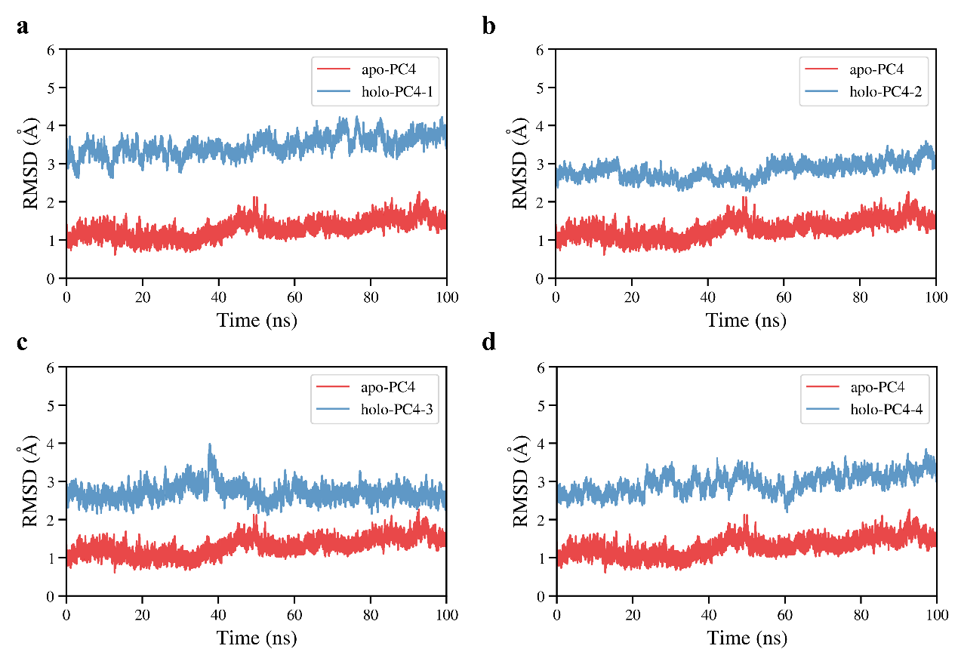
Figure S18. The backbone RMSD (root mean square deviation) of apo-PC4 (in red) protein and holo-PC4-1 (a), holo-PC4-2 (b), holo-PC4-3 (c), and holo-PC4-4 (d) complexes (in blue) in 100 ns MD simulations.

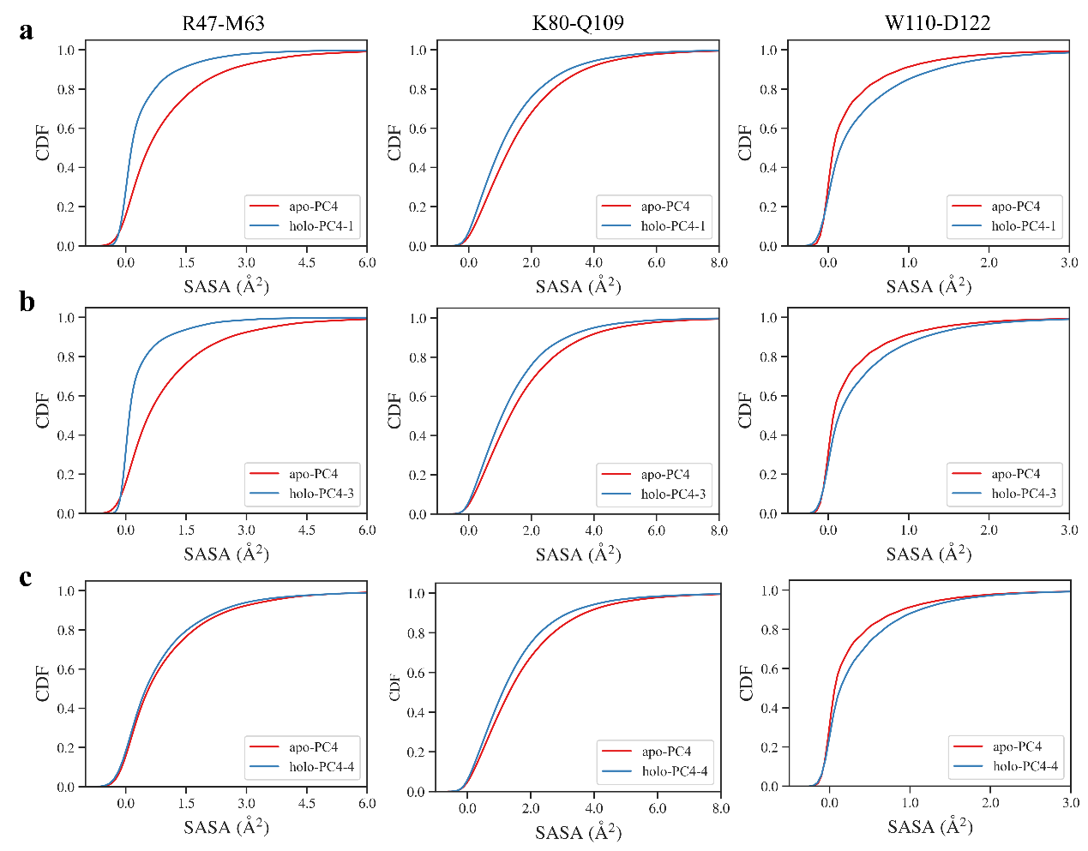
Figure S19. The cumulative distribution functions of SASA (solvent accessible surface area) of apo-PC4 (red) and the R47-M63 (N-terminal disordered binding region, left panel), K80-Q109 (β-sheet binding region, middle panel) and W110-D122 (right panel) in the (a) holo-PC4-1, (b) holo-PC4-3, and (c) holo-PC4-4 complexes.

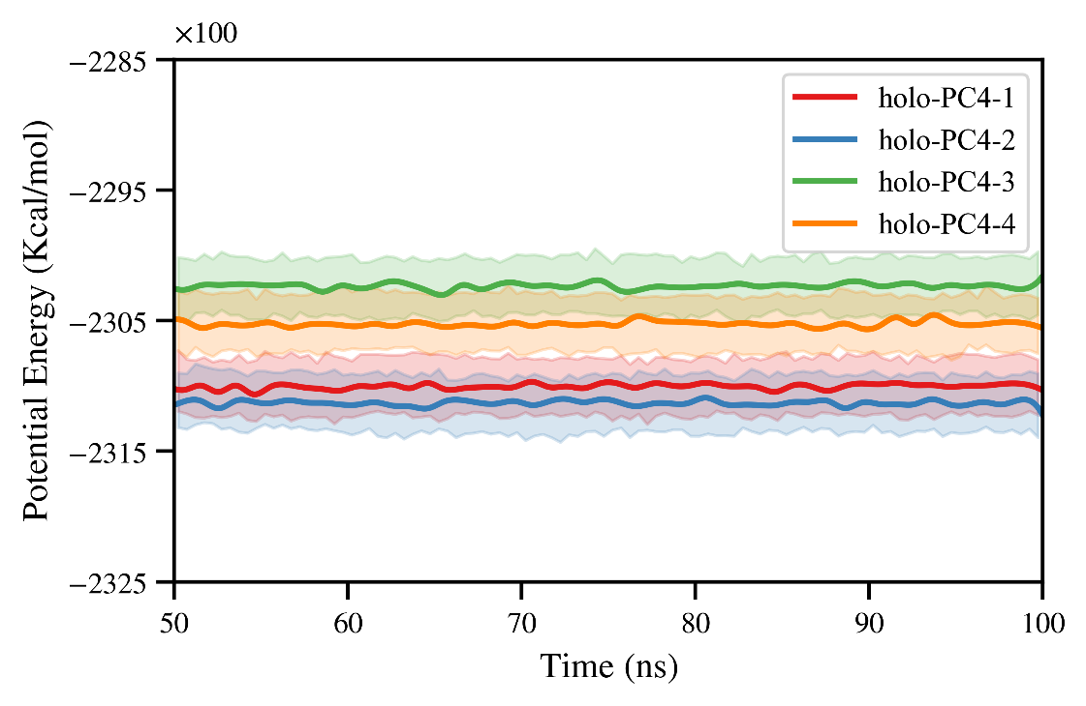
Figure S20. The potential energies of four holo-PC4 complexes, holo-PC4-1, holo-PC4-2, holo-PC4-3, holo-PC4-4 colored in red, blue, green, and orange, respectively.

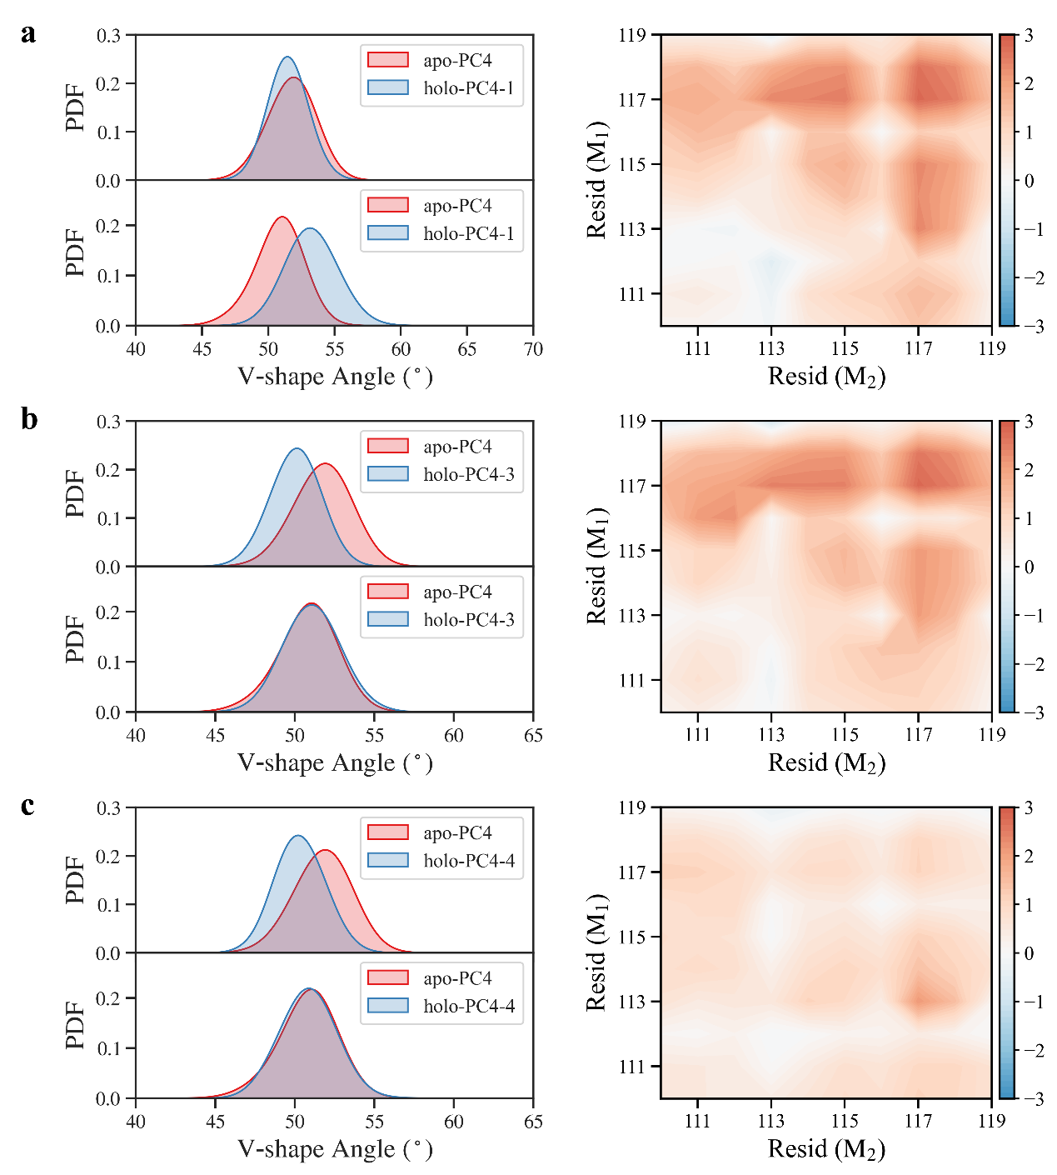
Figure S21. The probability density distribution of V-shaped angle of apo-PC4 and (a) holo-PC4-1, (b) holo-PC4-3, (c) holo-PC4-4 (left panel). The corresponding matrix of closest distance differences between subunits are shown in the right panel.

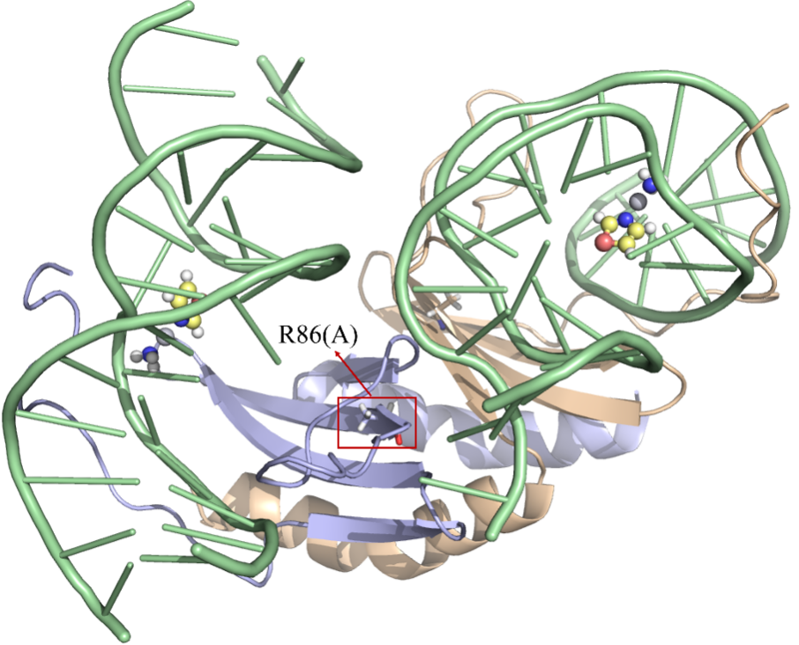
Figure S22. The representative structure of mutant PC4R86A in holo-PC4-2 complex. The two subunits of PC4 and the two bound trans-PtTz-III are shown in wheat, light blue, and pale green cartoon, respectively. Trans-PtTz is shown in the ball-stick-model.

Figure S23. MS/MS spectra for the tryptic peptides containing amino residue 86 of (a) PC4wt and (b) PC4R86G.

Table S1. All energies are in kcal/mol. The squared deviations for each data is shown.
 | ∆G_{ele} | ∆G_{vdw} | ∆G_{SA} | ∆G_{PB} | ∆G_{binding}
holo-PC4-1 | -6384.18±183.43 | -244.64±10.48 | 6573.00±176.42 | -32.86±0.98 | -88.68±24.86
holo-PC4-2 | -7052.27±200.42 | -257.00±12.53 | 7205.91±192.22 | -36.39±1.05 | -139.64±24.49
holo-PC4-3 | -4954.47±148.27 | -296.15±14.20 | 5225.72±143.28 | -36.49±1.20 | -61.38±24.81
holo-PC4-4 | -6624.05±203.29 | -230.16±13.22 | 6808.30±195.09 | -32.67±1.19 | -78.57±22.94
mut-holoPC4-1 | -4636.78±314.61 | -220.86±11.93 | 4838.85±308.72 | -29.92±0.91 | -48.72±22.83
mut-holoPC4-2 | -5080.99±199.93 | -241.72±12.94 | 5233.27±197.24 | -32.63±1.53 | -122.06±20.41
mut-holoPC4-3 | -3342.33±141.00 | -328.69±12.05 | 3678.52±130.39 | -39.35±0.89 | -31.85±29.55
mut-holoPC4-4 | -4438.13±220.31 | -214.15±12.24 | 4682.56±209.28 | -29.66±1.45 | 0.63±27.47

Table S2. Hydrogen bond formation, and occupancy of the holo-PC4-1, holo-PC4-2, holo-PC4-3, and holo-PC4-4 models. The first left column in each part is bond location in the format of “acceptor atom@ODN base-donor atom@amino acid”. O_{w/o}, O_{direct}, and O_{indirect} represent occupancy of no hydrogen bond, direct hydrogen bond and indirect hydrogen bond, respectively.
Monomer 1 | O_{w/o}  (%) | O_{direct}  (%) | O_{indirect}  (%) | Monomer 2 | O_{w/o}  (%) | O_{direct}  (%) | O_{indirect}  (%)
holo-PC4-1
OP@21-NH@Arg75 | 18.1 | 25.8 | 56.1 | OP@A21-NH@Arg75 | 42.1 | 5.7 | 52.1
OP@T4-NZ@Lys78 | 42.8 | 27.6 | 29.6 | OP@A22-NH@Arg75 | 4.3 | 44.0 | 51.7
OP@T5-NH@Arg86 | 44.9 | 0.0 | 55.1 | OP@G23-NZ@Lys78 | 32.7 | 23.3 | 43.9
OP@G6-NH@Arg86 | 36.0 | 0.0 | 64.0 | OP@T5-NH@Arg86 | 0.12 | 71.6 | 28.2
OP@G6-NH@Arg100 | 11.7 | 22.7 | 65.6 | OP@G6-NH@Arg100 | 13.3 | 53.7 | 33.0
OP@T7-NH@Arg100 | 1.7 | 50.2 | 48.1 | OP@T5(chain1)-NZ@Lys101 | 2.5 | 53.2 | 44.3
OP@G30(chain2)-NH@Arg100 | 6.2 | 61.7 | 32.0
OP@T4(chain2)-NZ@Lys101 | 9.1 | 71.6 | 19.3
holo-PC4-2
OP@G6-NZ@Lys78 | 26.1 | 73.0 | 0.9 | OP@A19-NZ@Lys78 | 29.3 | 19.8 | 50.9
OP@G20-NZ@Lys80 | 42.9 | 12.7 | 44.4 | OP@G20-NZ@Lys80 | 46.3 | 17.7 | 36.0
OP@A22-NH@Arg86 | 0.7 | 63.7 | 35.7 | OP@A22-NH@Arg86 | 0.6 | 66.0 | 33.4
OP@C23-NH@Arg100 | 2.1 | 51.9 | 46.0 | OP@C23-NH@Arg100 | 10.8 | 31.7 | 57.5
OP@T13(chain2)-NH@Arg100 | 2.9 | 56.1 | 41.1 | OP@T12(chain1)-NH@Arg100 | 20.4 | 14.7 | 64.9
OP@A22(chain2)-NH@Arg100 | 28.7 | 7.2 | 64.1 | OP@T13(chain1)-NH@Arg100 | 16.1 | 32.3 | 51.5
OP@A21(chain2)-NZ@Lys101 | 13.5 | 52.9 | 33.6 | OP@A21(chain1)-NZ@Lys101 | 17.8 | 60.6 | 21.6

holo-PC4-3
OP@G8-NH@Arg75 | 15.6 | 55.3 | 29.0 | OP@G8-NH@Arg75 | 11.4 | 63.3 | 25.4
O2@T4-NZ@Lys78 | 31.4 | 1.3 | 67.3 | OP@T7-NZ@Lys78 | 41.0 | 21.9 | 37.1
O2@T5-NZ@Lys78 | 21.6 | 72.6 | 5.8 | OP@G28-NZ@Lys80 | 23.3 | 29.9 | 46.8
OP@G28-NZ@Lys80 | 46.3 | 18.1 | 35.3 | OP@A26-NH@Arg86 | 7.1 | 0.4 | 93.5
OP@A29-NZ@Lys80 | 8.2 | 31.6 | 60.2 | OP@A26(chain2)-NH@Arg100 | 43.0 | 16.0 | 40.9
OP@A27-NH@Arg86 | 4.2 | 73.1 | 22.7 | OP@A26(chain2)-NH@Lys101 | 33.7 | 22.9 | 43.4
OP@A26(chain2)-NH@Arg100 | 1.3 | 89.6 | 9.1
OP@A27(chain2)-NZ@Lys101 | 2.9 | 79.9 | 17.2
holo-PC4-4
OP@G20-NZ@Lys78 | 2.4 | 69.0 | 28.6 | OP@G20-NZ@Lys78 | 3.3 | 30.6 | 66.1
OP@G14-NZ@Lys80 | 43.9 | 4.0 | 52.1 | OP@A21-NZ@Lys78 | 19.7 | 31.2 | 49.1
OP@A21-NZ@Lys80 | 9.5 | 50.3 | 40.2 | OP@A21-NZ@Lys80 | 44.0 | 18.2 | 37.9
OP@A22-NH@Arg86 | 2.3 | 0.0 | 97.7 | OP@A24-NH@Arg86 | 1.2 | 30.1 | 68.7
OP@C23-NH@Arg86 | 11.6 | 0.0 | 88.4 | O2@T10(chain1)-NH@Arg100 | 18.1 | 51.4 | 30.5
OP@C23(chain2)-NH@Arg100 | 1.2 | 89.2 | 9.5 | O4@T9(chain1)-NZ@Lys101 | 19.0 | 0.0 | 81.0
O4@T9(chain2)-NZ@Lys101 | 13.6 | 0.0 | 86.4 | OP@A22(chain1)-NZ@Lys101 | 4.1 | 62.9 | 33.0
OP@A22(chain2)-NZ@Lys101 | 5.4 | 77.2 | 17.4

References.

(1) Werten, S.; Moras, D., A global transcription cofactor bound to juxtaposed strands of unwound DNA, Nat. Struct. Mol. Biol. 2006, 13 (2), 181-182.

