Risk stratification by minimal residual disease detection and ctDNA dynamics from personalised assays in stage II-III colorectal cancer in a UK multi-centre prospective study (TRACC Part B)
Supplementary Materials
Tables

Supplementary Table 1: Patients with recurrence (n=30)
Patient number | Stage | Primary tumour location | Cancer therapy type | ACT after surgery | Duration of ACT (weeks) | Time to relapse from surgery (months) | Time to relapse from end of ACT (months) | Site of relapse | CEA at relapse (ug/L)
7 | II | Colon | Surgery alone | None | NA | 13 | NA | Lung | 5
13 | II | Rectum | Surgery + ACT | Raltitrexed | 22 | 38 | 31 | Liver | 5
17 | II | Colon | Surgery + ACT | FOLFOX | 22 | 24 | 17 | Local | 10
18 | II | Colon | Surgery + ACT | Capecitabine | 23 | 19 | 10 | Anastomotic site | 3
30 | II | Colon | Surgery + ACT | Capecitabine | 15 | 24 | 19 | Peritoneum | 26
45 | II | Colon | Surgery alone | None | NA | 15 | NA | Liver | 16
50 | II | Rectum | Surgery + ACT | CAPOX | 6 | 19 | 15 | Liver | Not available
51 | II | Colon | Surgery alone | None | NA | 3 | NA | Liver | Not available
55 | III | Colon | Surgery alone | None | NA | 34 | NA | Lung and distant nodes | Not available
56 | III | Colon | Surgery alone | None | NA | 2 | NA | Distant lymph nodes | 3
62 | III | Rectum | RT+ Surgery+ ACT | CAPOX | 9 | 26 | 22 | Rectum | 6
70 | III | Rectum | CRT + Surgery+ ACT | CAPOX | 9 | 15 | 10 | Lung | 1
72 | III | Rectum | CRT + Surgery+ ACT | Capecitabine | 23 | 37 | 29 | Lung | 6
73 | III | Colon | Surgery + ACT | Capecitabine | 22 | 24 | 18 | Liver, peritoneum | 1
80 | III | Colon | Surgery + ACT | Capecitabine | 23 | 12 | 6 | Peritoneum, distant lymph nodes | 11
81 | III | Rectum | CRT + surgery + ACT | CAPOX | 9 | 34 | 30 | Lung | 7
83 | III | Colon | Surgery alone | None | NA | 23 | NA | Liver | 2
89 | III | Rectum | CRT + Surgery | None | NA | 2 | NA | Liver, lung | 62
95 | III | Colon | Surgery + ACT | FOLFOX | 6 | 7 | 2 | Liver | 3.3
99 | III | Colon | Surgery alone | None | NA | 1 | NA | Peritoneum, mesenteric lymph nodes | 2
100 | III | Rectum | CRT + Surgery+ ACT | FOLFOX | 10 | 14 | 9 | Liver | 2
101 | III | Rectum | CRT + surgery | Yes, NA | NA | 4 | NA | Lung | 0
102 | III | Rectum | CRT + Surgery | None | NA | 2 | NA | Liver | 75
104 | III | Rectum | CRT + Surgery+ ACT | Capecitabine | 13 | 14 | 7 | Lung, pelvis | 8
105 | III | Colon | Surgery + ACT | Capecitabine | 9 | 7 | 3 | Liver | 40
106 | III | Rectum | CRT + Surgery | None | NA | 11 | NA | Lung | 1
108 | III | Rectum | Surgery + ACT | Capecitabine | 12 | 25 | 20 | Lung | 2
112 | III | Colon | Surgery + ACT | FOLFOX | 1 | 9 | 6 | Lung | 28.4
115 | III | Rectum | Surgery alone | None | NA | 2 | NA | Liver | 45.5
114 | III | Colon | Surgery + ACT | Oxaliplatin + modified deGramont | 23 | 8 | 1 | Liver, peritoneum, omentum, paracolic gutter, ovaries | 10
ACT, adjuvant chemotherapy; CAPOX, capecitabine plus oxaliplatin; CEA, carcinoembryonic antigen (CEA reference range: <4ug/L [non-smokers] <6ug/L [smokers]); CRT, chemoradiotherapy; FOLFOX, 5-fluorouracil plus oxaliplatin; MRD, minimal residual disease; RT, radiotherapy.

Figures
Supplementary Figure 1: Consort diagram

Patients with stage II or III CRC who underwent surgery (+/- neo-adjuvant CRT), n=122
Evaluable plasma samples
Baseline, n=116
Post-surgery, n=116
Month 3, n=30
Month 6, n=21
Month 9, n=24
Month 12, n=18
Month 18, n=19
Month 24, n=15
Month 30, n=30
Month 36, n=6
Month 48, n=2
Relapse, n=5
Primary tumour samples collected, n=122
Chemotherapy Details
Neo-adjuvant CRT, n=23
ACT, n=63
Single agent capecitabine, n=21
Doublet chemotherapy with oxaliplatin, n=35
Other, n=7

WES QC Pass, n=116

ACT, adjuvant chemotherapy; CRC, colorectal cancer; CRT, chemoradiotherapy; QC, quality control; WES, whole exome sequencing
Supplementary Figure 2: cfDNA concentration at different timepoints
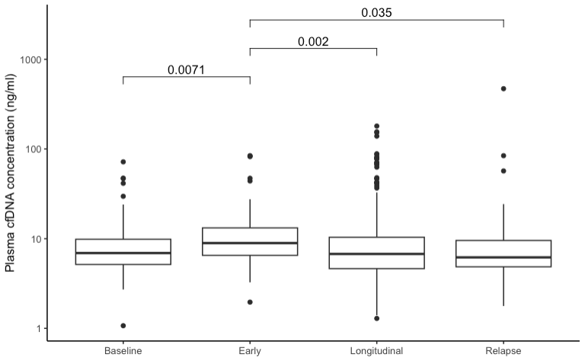
*Early samples were those taken <28 days after surgery
Supplementary Figure 3a: Multivariate regression model for RFS (stage II) (n=52)
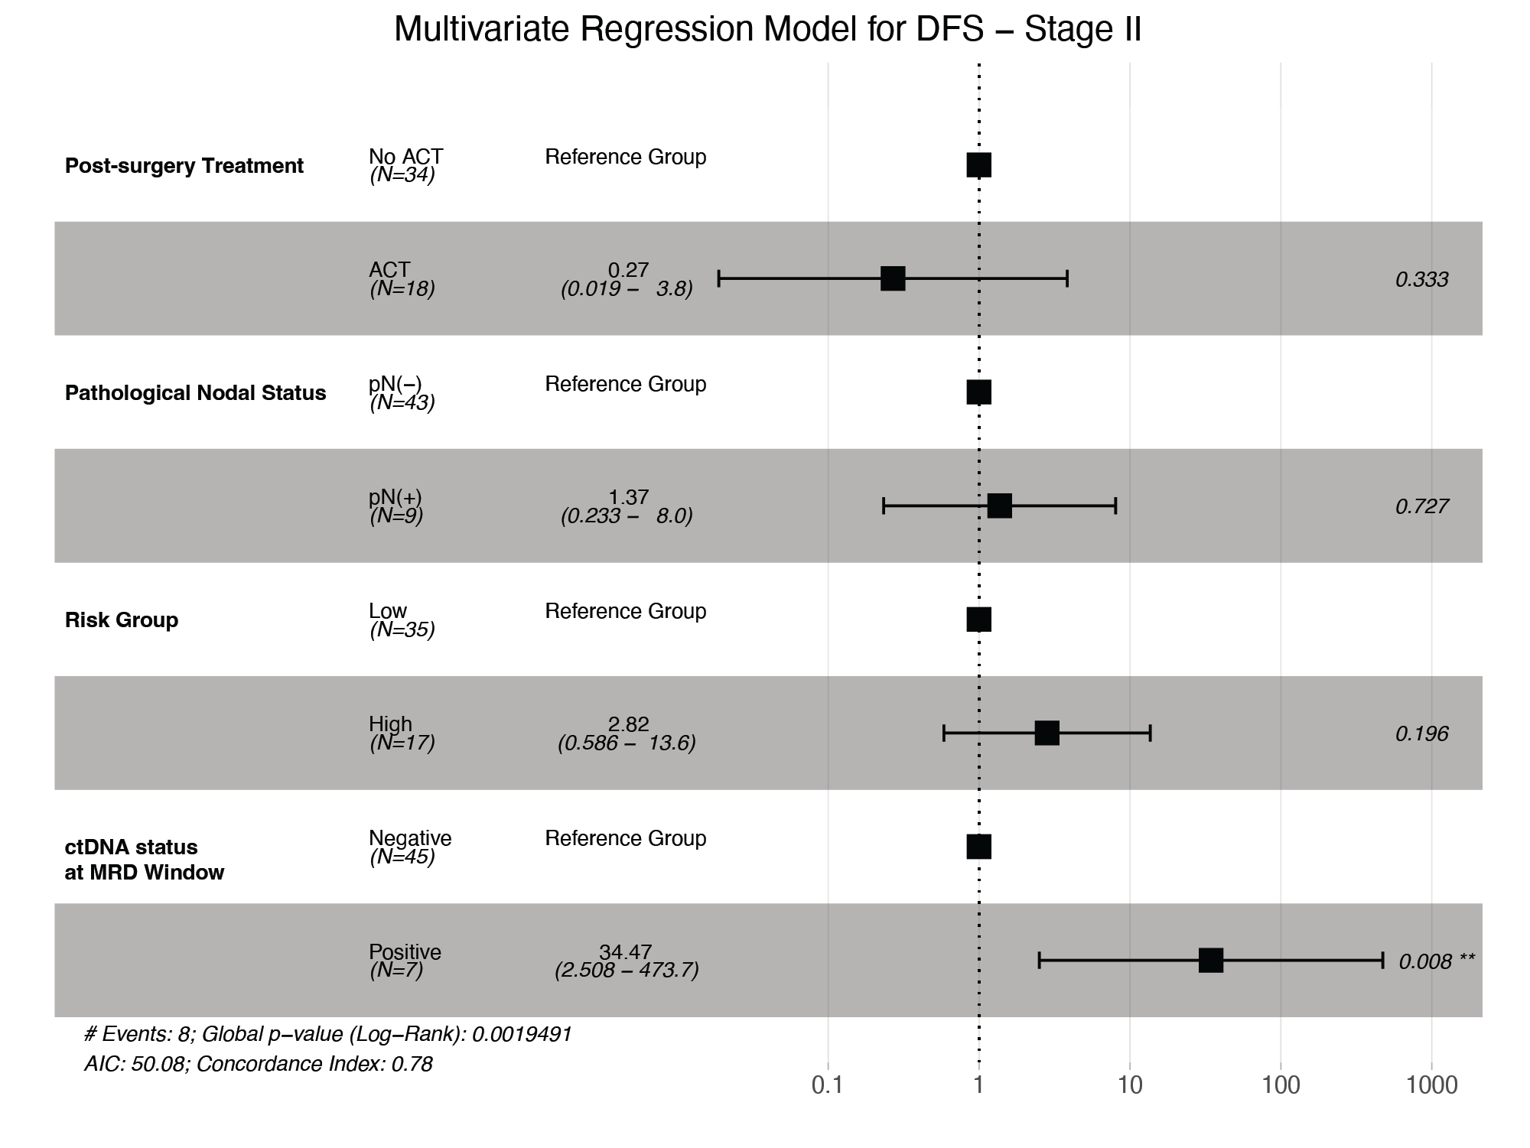
MRD, minimal residual disease

Supplementary Figure 3b: Multivariate regression model for RFS (stage III) (n=64)
MRD, minimal residual disease

Supplementary Figure 4a: RFS in high risk MRDpos patients according to ACT administration
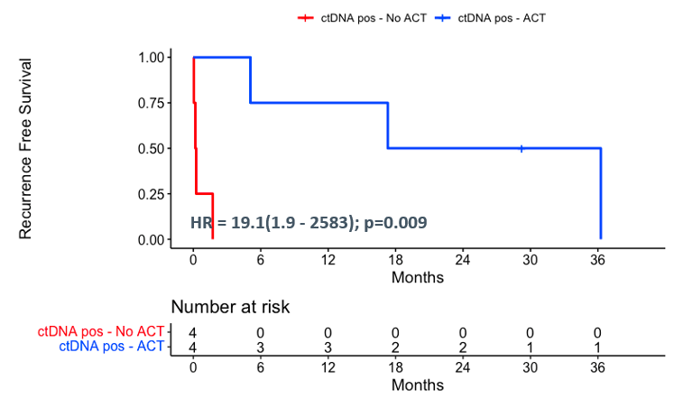
ACT, adjuvant chemotherapy; HR, hazard ratio; MRDpos, minimal residual disease positive; neg, negative; pos, positive

Supplementary Figure 4b: RFS in high risk MRDneg patients according to ACT administration
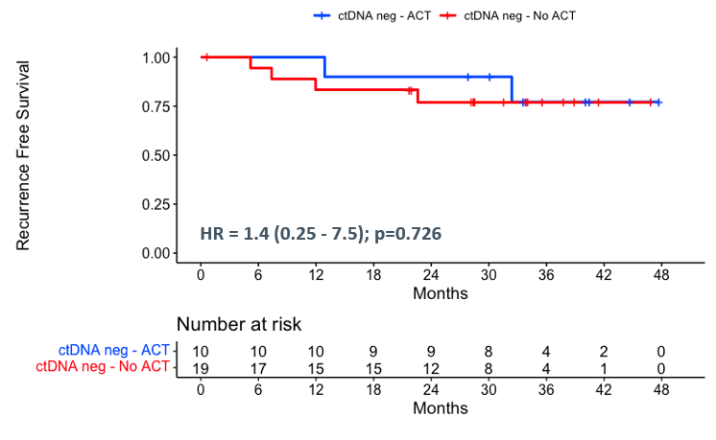
ACT, adjuvant chemotherapy; HR, hazard ratio; MRDneg, minimal residual disease negative; neg, negative; pos, positive

Supplementary Figure 5: ctDNA concentration at baseline stratified by (a) T-stage, (b) N-stage, (c) extramural invasion and (d) perineural invasion
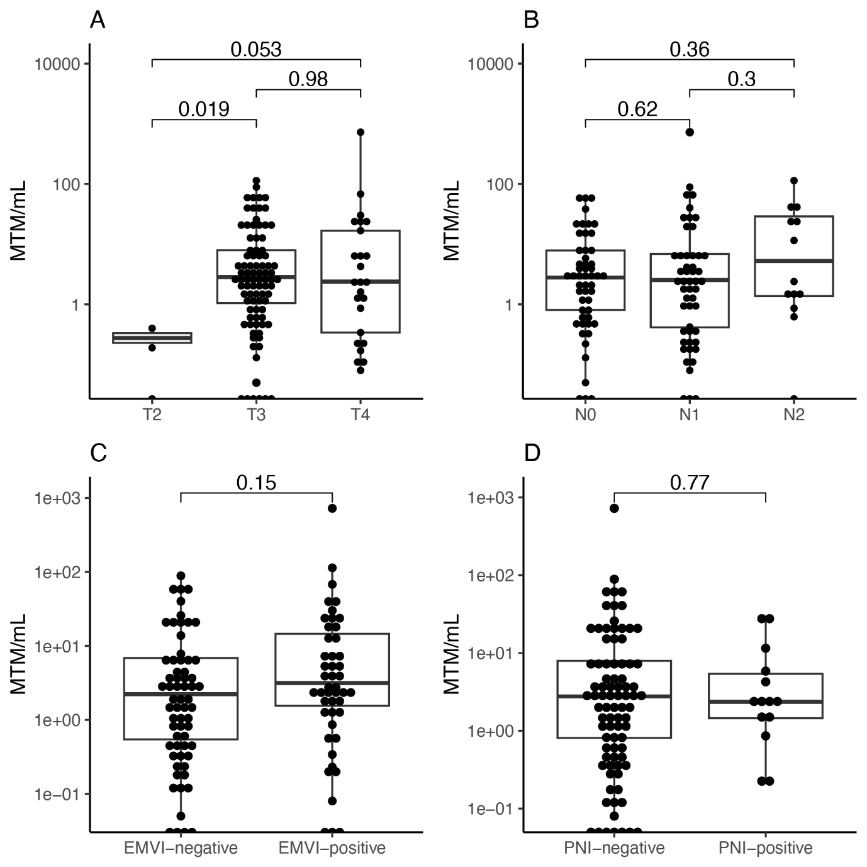

EMVI, extramural venous invasion; MTM/ml, mean tumour molecules per millilitre; N, nodal; PNI, perineural invasion; T, tumour

Supplementary Figure 6: Mean ctDNA concentration at baseline, MRD timepoint, and relapse
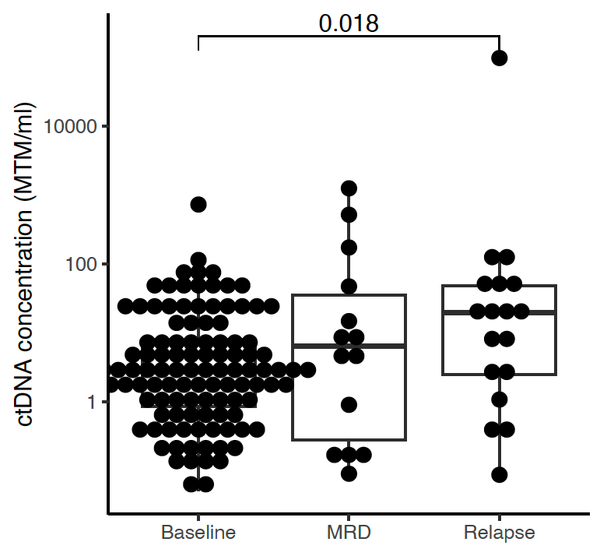
MRD, minimal residual disease; MTM/ml, mean tumour molecules per millilitre

Supplementary Figure 7a: Recurrence sites by MRD in patients with rectal primary tumours (n=14)
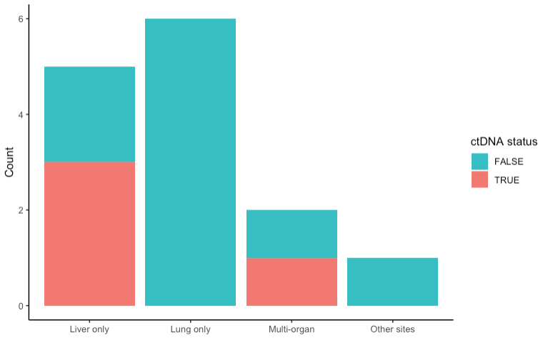
MRD, minimal residual disease; MRDneg, minimal residual disease negative; MRDpos, minimal residual disease positive

Supplementary Figure 7b: Recurrence sites by MRD in patients with colon primary tumours (n=16)
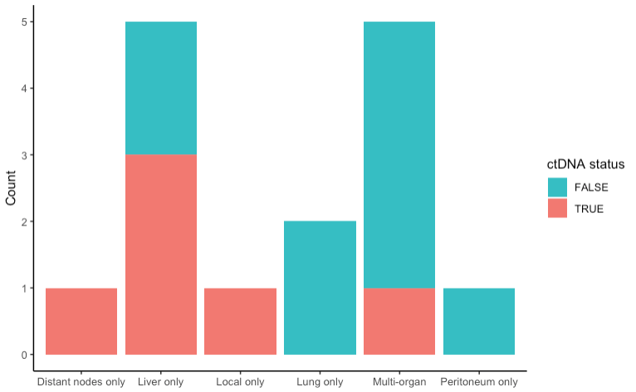
MRD, minimal residual disease; MRDneg, minimal residual disease negative; MRDpos, minimal residual disease positive

Supplementary Figure 8: Time from first detected ctDNA level to recurrence by average fold change in ctDNA concentration per day (n=11)
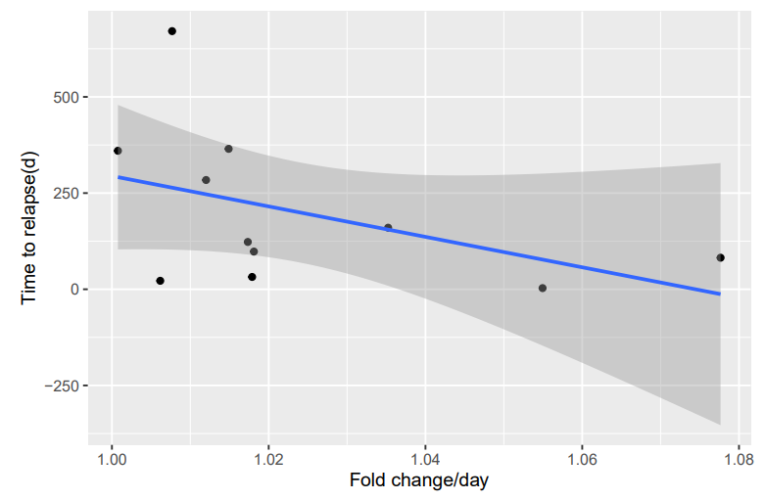
D, day

Supplementary Figure 9a: Case vignette patient 83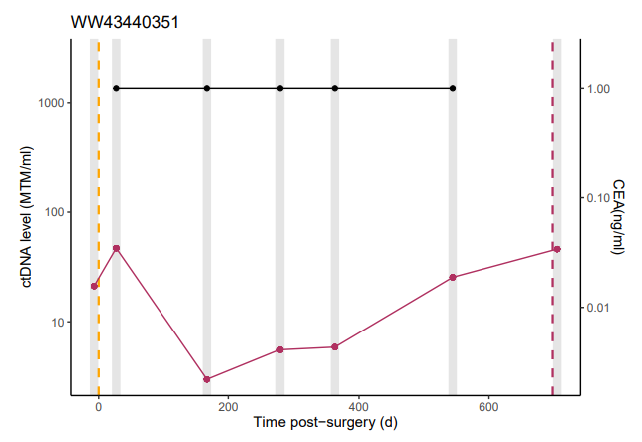

Patient 83 had a colon primary tumour, treated with surgery alone, and recurred in the liver only.
CEA, carcinoembryonic antigen (CEA reference range: <4ug/L [non-smokers] <6ug/L [smokers]); D, day; MTM, mean tumour molecules
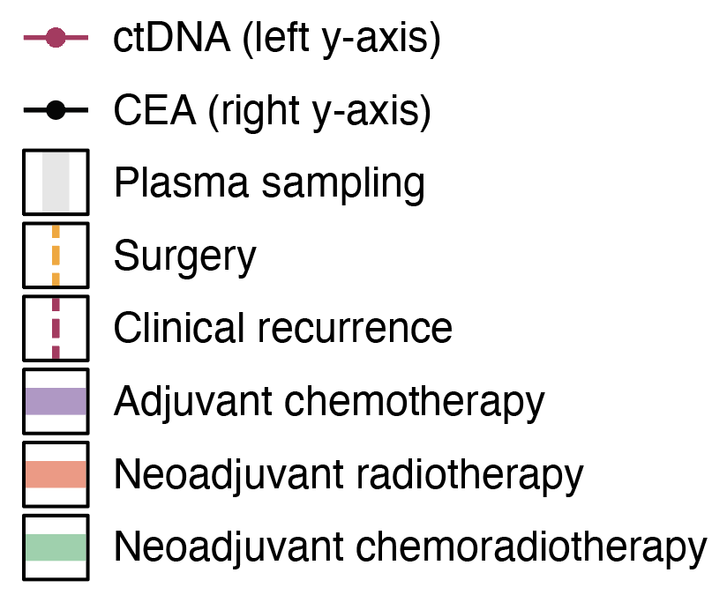
Supplementary Figure 9b: Case vignette patient 13
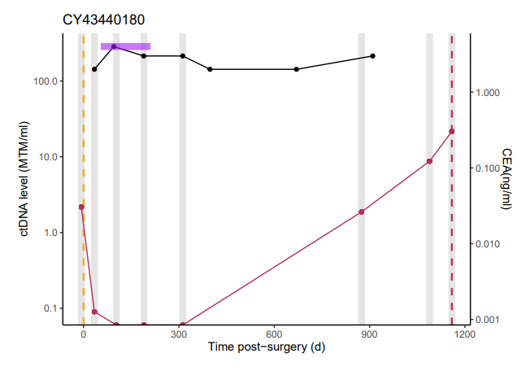

Patient 13 had a rectal primary tumour, treated with surgery and adjuvant raltitrexed, and recurred in the liver only.
CEA, carcinoembryonic antigen (CEA reference range: <4ug/L [non-smokers] <6ug/L [smokers]); D, day; MTM, mean tumour molecules

Supplementary Figure 9c: Case vignette patient 70
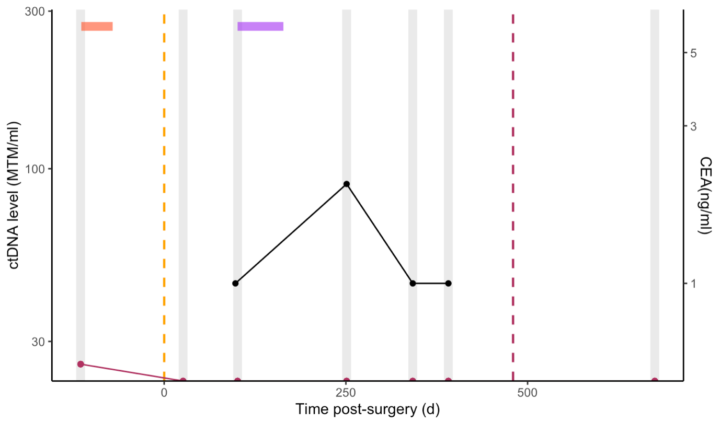
Patient 70 had a rectal primary tumour, treated with neo-adjuvant CRT followed by surgery plus adjuvant CAPOX and recurred in the lung only.
CAPOX, capecitabine plus oxaliplatin; CEA, carcinoembryonic antigen (CEA reference range: <4ug/L [non-smokers] <6ug/L [smokers]); CRT, chemoradiotherapy; D, day; MTM, mean tumour molecules

Supplementary Figure 9d: Case vignette patient 72
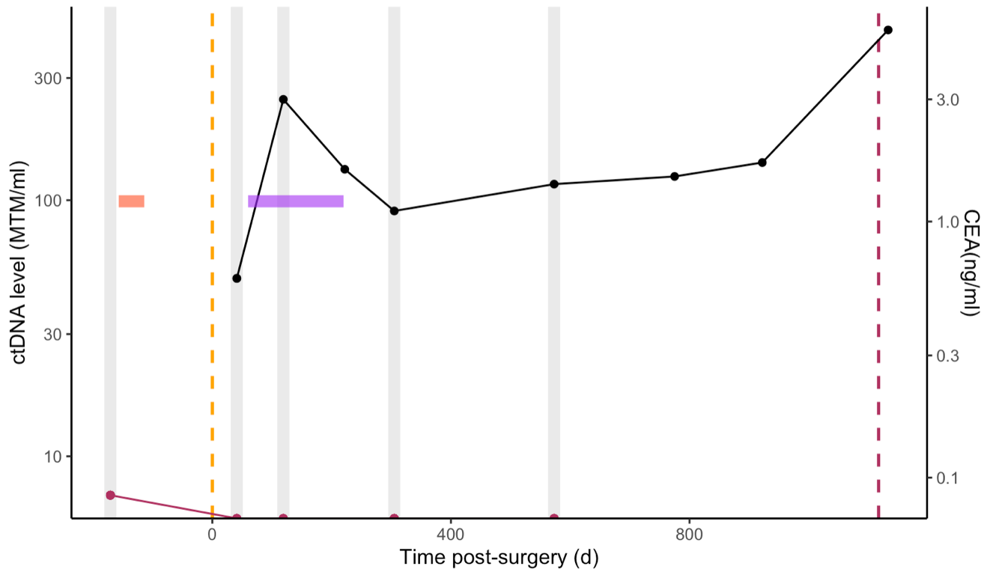

Patient 72 had a rectal primary tumour, treated with neo-adjuvant CRT followed by surgery plus adjuvant capecitabine and recurred in the lung only.
CEA, carcinoembryonic antigen (CEA reference range: <4ug/L [non-smokers] <6ug/L [smokers]); CRT, chemoradiotherapy; D, day; MTM, mean tumour molecules

Supplementary Figure 9e: Case vignette patient 62
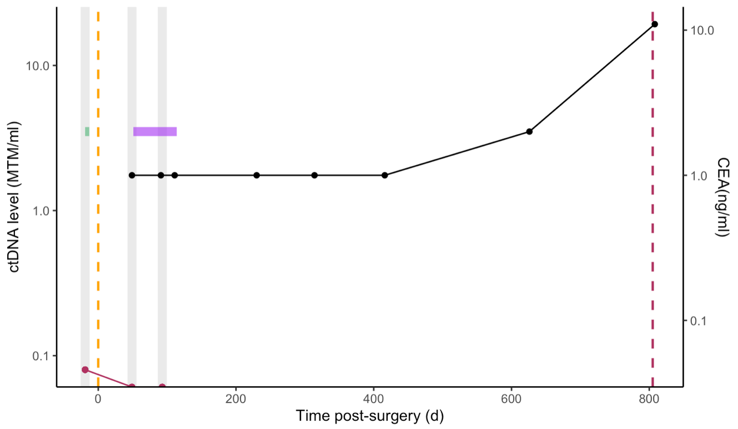

Patient 62 had a rectal primary tumour, treated with neo-adjuvant RT followed by surgery plus adjuvant CAPOX and recurred in the rectum.
CAPOX, capecitabine plus oxaliplatin; CEA, carcinoembryonic antigen (CEA reference range: <4ug/L [non-smokers] <6ug/L [smokers]); D, day; MTM, mean tumour molecules; RT, radiotherapy

Supplementary Figure 10: Cumulative incidence of positive ctDNA or CEA sample, stratified by eventual relapse.
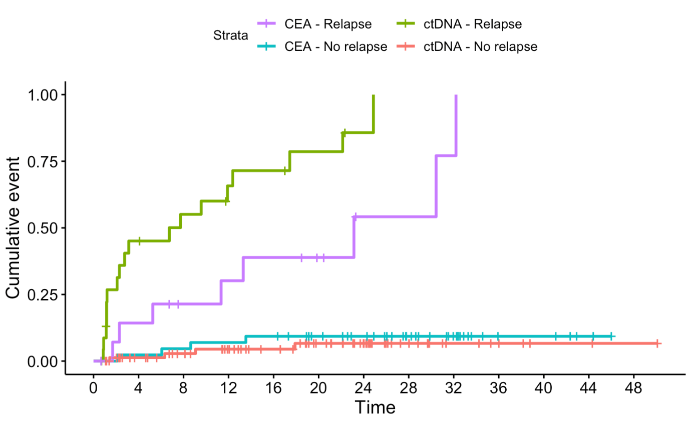
CEA, carcinoembryonic antigen (CEA reference range: <4ug/L [non-smokers] <6ug/L [smokers])

Appendix 1: Principal Investigator of TRACC Part B Trial
Professor David Cunningham
Dr Nicol George
Dr Graham Branagen
Dr Sarah Duff
Dr Gihan Ratnayake
Dr Joseph Huang
Dr Sorena Afshar
Dr Bryony Eccels
Dr Martin Scott-Brown
Dr Deborah Williamson
Dr Rajarshi Roy
Dr Shreerang Bhide
Mr Francesco Di Fabio
Dr Claire Hall
Dr Lucinda Melcher
Dr Mark Hill
Dr Sarah Slater
Dr Amelie Harle
Dr Sing Yu Moorcraft
Mr Nadeem Ashraf
Dr Stephen Falk
Mr Paris Tekkis
Dr Venkatesh Gajapathy
Dr Shazza Rehman
Dr Paul Ross
Dr Stergios Boussios
Dr Georgina Walker
Mr Nicholas West
Mr Muti Abulafi
Dr Sheela Rao
Dr Vanessa Potter
Dr Francisca Marti
Dr Ashraf Azzabi
Mr Jack Broadhurst
Dr Roshan Agarwal

