Multiple factors mediate insecticide selectivity to a key predator for cotton insect pest management

Denner Manthay Potin¹, Anderson Vinnicius Arruda Machado¹, Paulo Roberto Ramos Barbosa², Jorge Braz Torres^{1,*}

¹Departamento de Agronomia-Entomologia, Universidade Federal Rural de Pernambuco, Rua Dom Manoel de Medeiros, Recife, PE, 52171-900, Brazil
²Universidade Federal dos Vales do Jequitinhonha e Mucurí - Campus Unaí. Instituto de Ciências Agrárias. Av. Universitária, no. 1000, 38610000 - Unaí, MG, Brazil

Table 1S Insecticides, chemical groups, modes of action (MOA), field rates and target pest species in the cotton ecosystem, and classifications in insecticide selective (S) and non-selective (NS) according to previous studies.
Insecticides | Chemical group | MoA IRAC¹ | Field rate  (mL/ha) | Target pest species²
Chlorantraniliprole 200 SC^{S} | Diamides | 28 | 150 | Aa, Cv, Ha, Hz, Sf
Cyantraniliprole 100 SC^{S} | Diamides | 28 | 750 | Bt, Ag, Se
Chlorpyrifos 480 EC^{NS} | Organophosphate | 1B | 700 | Aa, Cv, Pg, Há
Chlorfenapyr 240 SC^{NS} | Pyrroles | 13 | 1500 | Cv, Ha, Pl, Tu, Sf
Dimethoate 400 EC^{NS} | Organophosphate | 1B | 1250 | Ag, Fr, Tu, Bt, Hn
Spinetoram 120 SC^{S} | Spinosyns | 5 | 150 | Ha, Fr, Sf
Indoxacarb 150 EC^{NS} | Oxadiazines | 22A | 800 | Aa, Ds, Ha, Cv, Pg, Sf
Lambda-cyhalothrin 50 CS^{NS} | Pyrethroid | 3A | 400 | Aa, Agg, Cv, Pg, Hn
Malathion 1000 EC^{NS} | Organophosphate | 1B | 2000 | Aa, Ag, Agg
Pymetrozine 500 WG^{S} | Pyridine azomethine | 9B | 400 | Bt, Ag
Pyriproxifen 100 EC^{S} | Pyriproxifen | 7C | 500 | Bt, Ag
Thiamethoxam 250 WG^{NS} | Neonicotinoid | 4A | 200 | Bt, Ag, Agg, Fr
¹Insecticide Resistance Action Committee.
²Source: AGROFIT 2020 (Sistema de Agrotóxicos Fitossanitários); Aa, Alabama argillacea (Hübner); Ag, Aphis gossypii Glover; Agg, Anthonomus grandis grandis Boheman; Bt, Bemisia tabaci (Gennadius); Cv, Chloridea virescens (Fabricius); Ds, Dysdercus spp.; Fr, Frankliniella sp.; Ha, Helicoverpa amigera (Hübner); Hn, Horcias nobillelus (Berg); Hz, Helicoverpa zea (Boddie); Pg, Pectinophora gossypiella (Saunders); Pl, Polyphagotarsonemus latus Banks; Sf, Spodoptera frugiperda (J.E. Smith); Se, Spodoptera eridania (Cramer); Tu, Tetranychus urticae Koch.

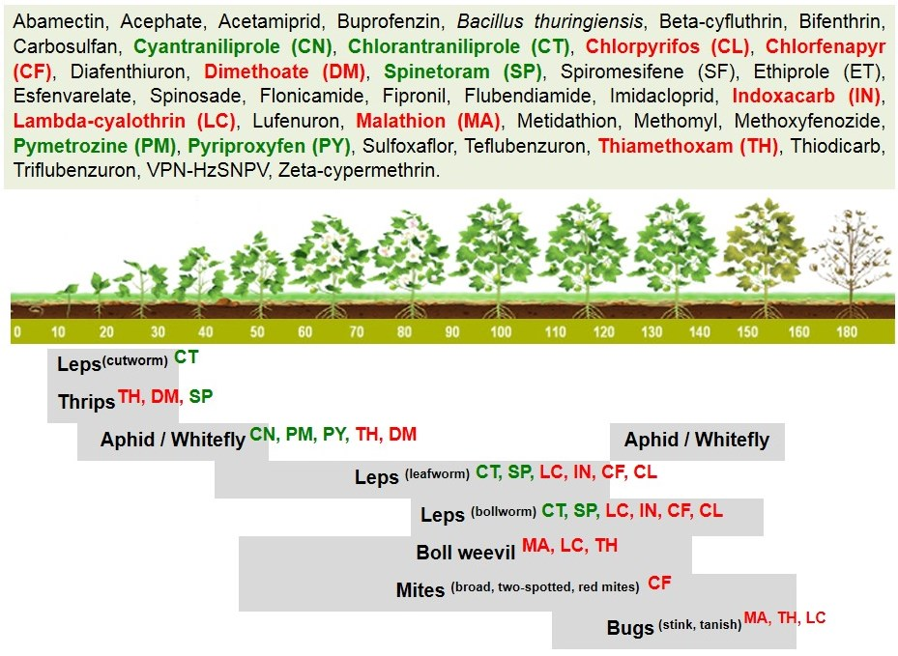
Fig. 1S. Insecticides registered and target pest species that they are used against through the cotton growing season. Insecticides highlighted were tested against the ring-legged earwig, Euborellia annulipes, and they were considered, based on previous studies, as selective (green), or non-selective (red).

References
AGROFIT (Sistema de Agrotóxicos Fitossanitários) 2021. Available in: <http://agrofit.agricultura.gov.br/agrofit_cons/!ap_ingrediente_ativo_rep_cons>. Accessed in: 12/03/2021.
IRAC. 2021. Available in: <https://www.irac-br.org/modo-de-acao>. Accessed in: 02 de Fev. 2021.

