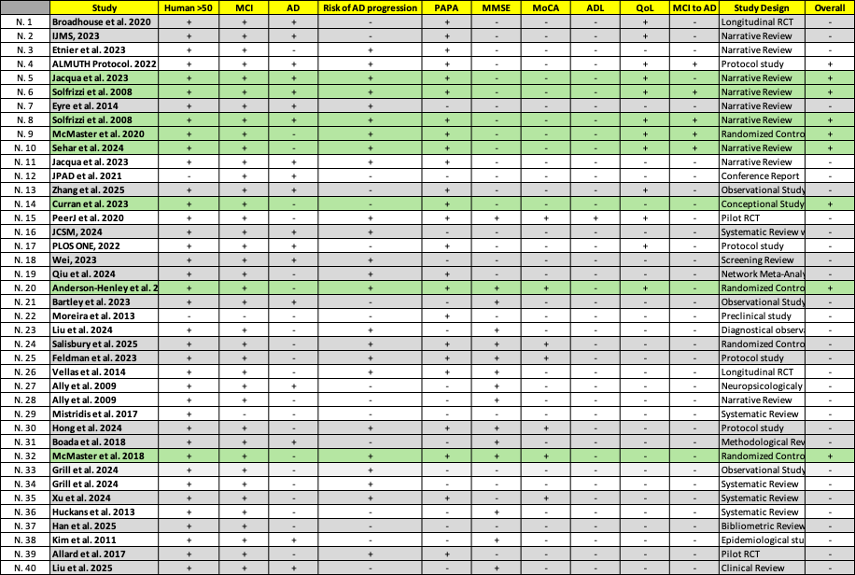
Table 1 – RoB2 excel tool on inclusion criteria

