Supplementary Information
Epigenetic Locking of Vascular and Inflammatory Effectors
Siddalingaiah H S, MD

Supplementary Methods

1. Data Acquisition and Quality Control
Raw fastq files were downloaded from GEO and processed using Cell Ranger ARC v2.0 (10x Genomics). Reference genome: GRCh38. Alignment parameters: default. Quality metrics tracked: Total UMI count, gene count, ATAC fragment count, TSS enrichment, nucleosome signal. Cells failing any of the following were excluded: genes < 200, genes > 5000, %MT > 15%, ATAC fragments < 1000, TSS enrichment < 4.

2. Doublet Removal
DoubletFinder v2.0.3 was used with pK optimization. Expected doublet rate: 4% for 10x datasets. Homotypic doublet proportion estimated per cluster. Doublets removed prior to integration.

3. Integration and Batch Correction
Integration used Harmony (v1.0) with theta=2 and max.iter=20. UMAP: 30 neighbors, min.dist=0.3, metric=cosine. Clustering: Louvain algorithm, resolution=0.8.

4. Peak Calling and Gene Activity
ATAC peaks called using MACS2 via Signac. Peak-gene links established using LinkPeaks with +/- 500kb window. Gene activity scores calculated by summing ATAC fragments in promoter regions (+/- 2kb TSS).

Supplementary Tables

Supplementary Table 1. Dataset Characteristics
Table S1. Summary of Single-Cell Datasets
Dataset | GEO ID | Cells (QC-pass) | Tissue | Conditions
TB (BAL) | GSE167232 | 5,412 | BAL | Active TB vs. Control
TB (PBMC) | GSE287288 | 4,945 | PBMC | Active TB vs. Control
Sepsis | GSE151263 | 24,796 | PBMC | Sepsis vs. Healthy
Dengue | GSE154386 | 20,000 | PBMC | Acute vs. Baseline

Supplementary Table 2. Complete Core Signature (Top 50)
Table S2. Top 50 Core Primed Genes (Full List in GitHub)
Rank | Gene Symbol
1 | TYMP
2 | HLA-DRB5
3 | MYL12A
4 | AIF1
5 | S100A9
6 | ARPC3
7 | PRDX1
8 | UBB
9 | CD52
10 | S100A10
11 | RPS26
12 | LGALS3
13 | CD63
14 | S100A11
15 | VIM
16 | TSPO
17 | TMSB4X
18 | CYBA
19 | HLA-C
20 | CALM2
21 | B2M
22 | S100A4
23 | NDUFB8
24 | UBL5
25 | BLOC1S1
26 | ALDH2
27 | RPS27
28 | RETN
29 | GAPDH
30 | NDUFV2
31 | HLA-A
32 | TYROBP
33 | CTSD
34 | NDUFC2
35 | RPL13
36 | HLA-DRA
37 | RAC2
38 | ANXA1
39 | RPL26
40 | PSMB3
41 | PSMA5
42 | H3F3A
43 | UQCR10
44 | PFN1
45 | PYCARD
46 | ARPC2
47 | LGALS1
48 | NDUFA12
49 | RPS15A
50 | ANXA5

Supplementary Figures
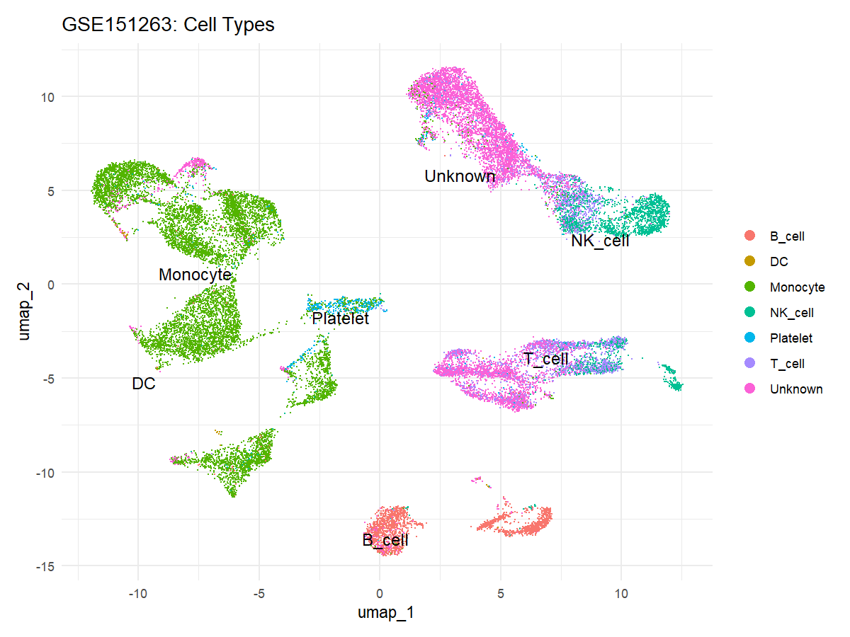
Figure S1. UMAP of Sepsis dataset colored by cell type annotation.
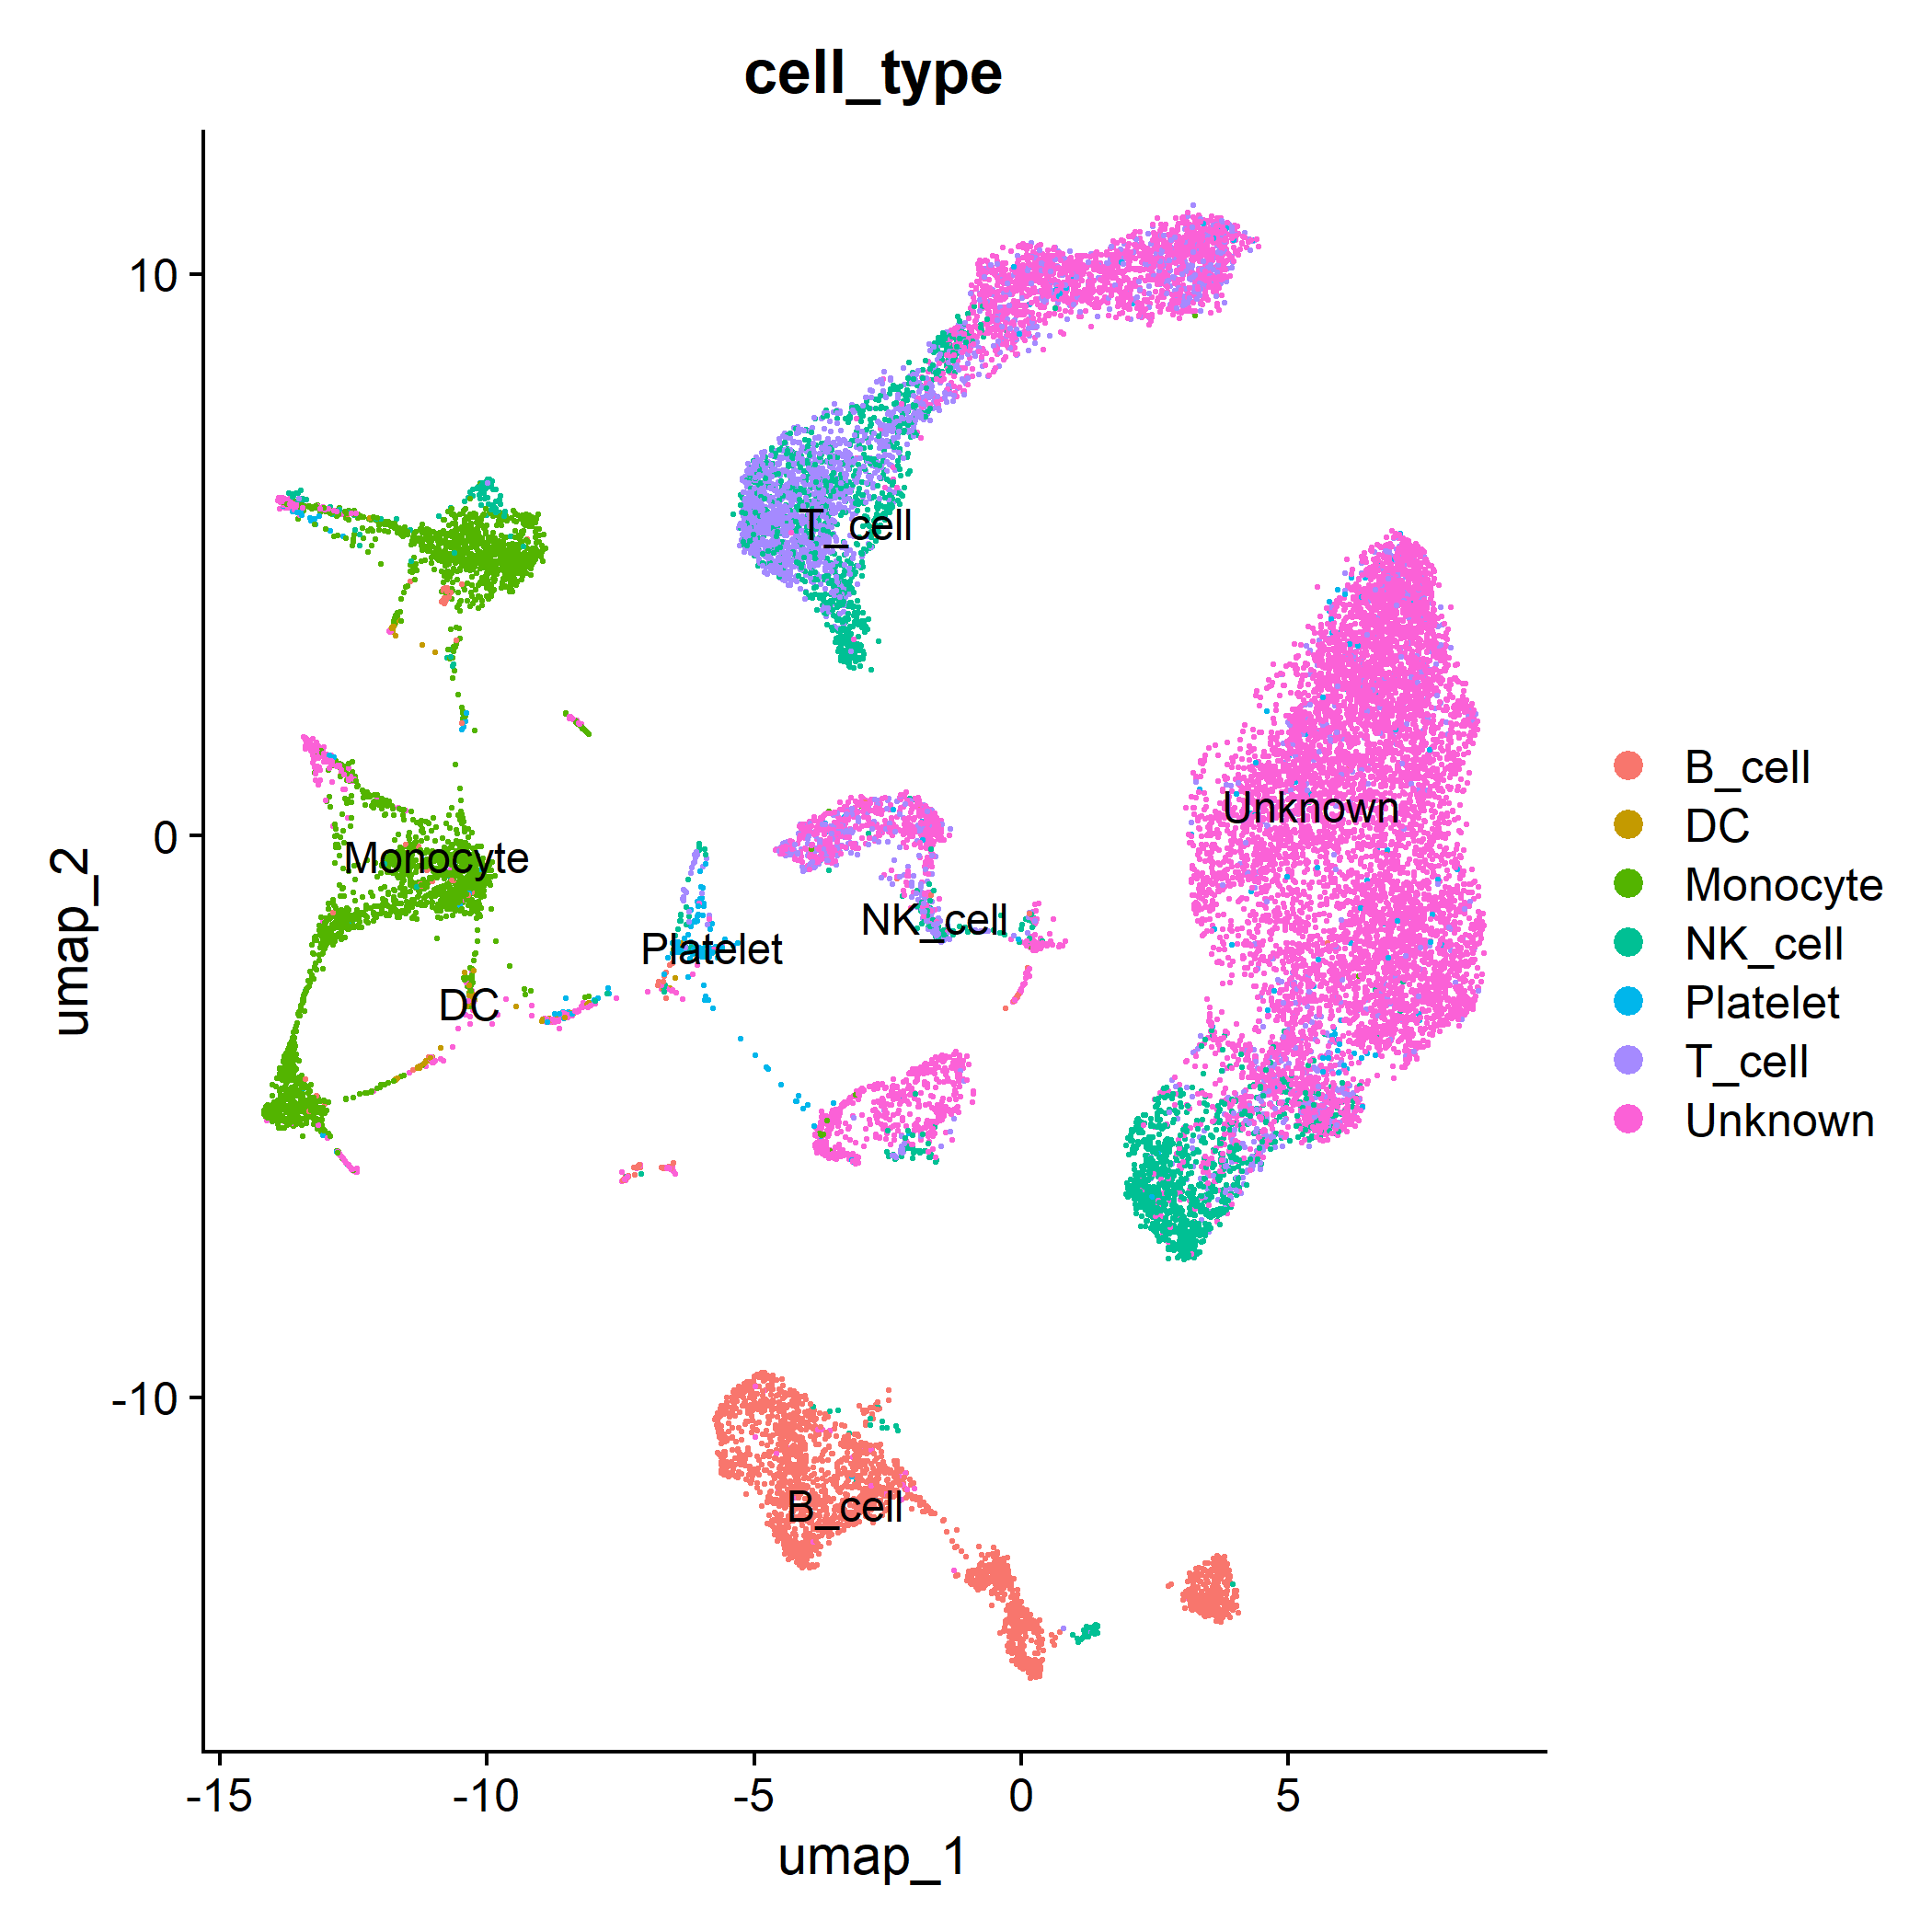
Figure S2. UMAP of Dengue dataset colored by cell type annotation.
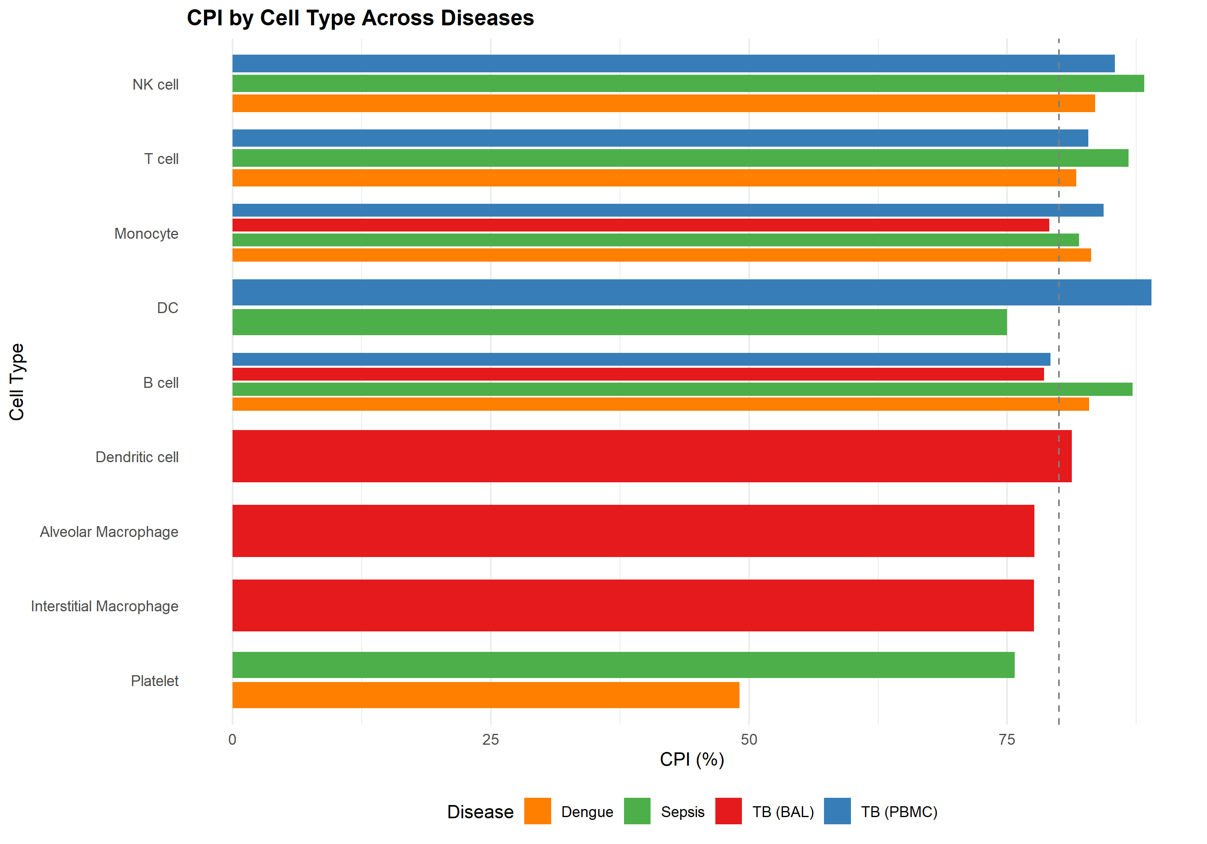
Figure S3. CPI by Cell Type and Disease. Bar chart showing CPI stratified by immune subset.

