Multi-omics analysis reveals glycerophospholipid metabolism mediated the improvement of meat quality by Se-enriched yeast in finishing pigs

Xiangqi Qiu¹, Panpan Lu³, Minfei Xiao¹, Sumei Zeng ¹, Xiangqi Qiu ¹, HaitaoYu ², Ai hua Deng², Min Zhu ¹, E Xu ¹*, Xiangfang Zeng ² *
1.Key Laboratory of Animal Genetics, Breeding and Reproduction in the Plateau Mountainous Region, Ministry of Education /Institute of Animal Nutrition and Feed Science, College of Animal Science, Guizhou University, Guiyang 550025, China
2. State Key Laboratory of Animal Nutrition and Feeding, College of Animal Science and Technology, China Agricultural University, Beijing 100193, China
3. College of Animal Science, South China Agricultural University/Guangdong Provincial Key Laboratory of Animal Nutrition Control/Guangdong Laboratory for Lingnan Modern Agriculture/State Key Laboratory of Swine and Poultry Breeding Industry, Guangzhou 510642, China

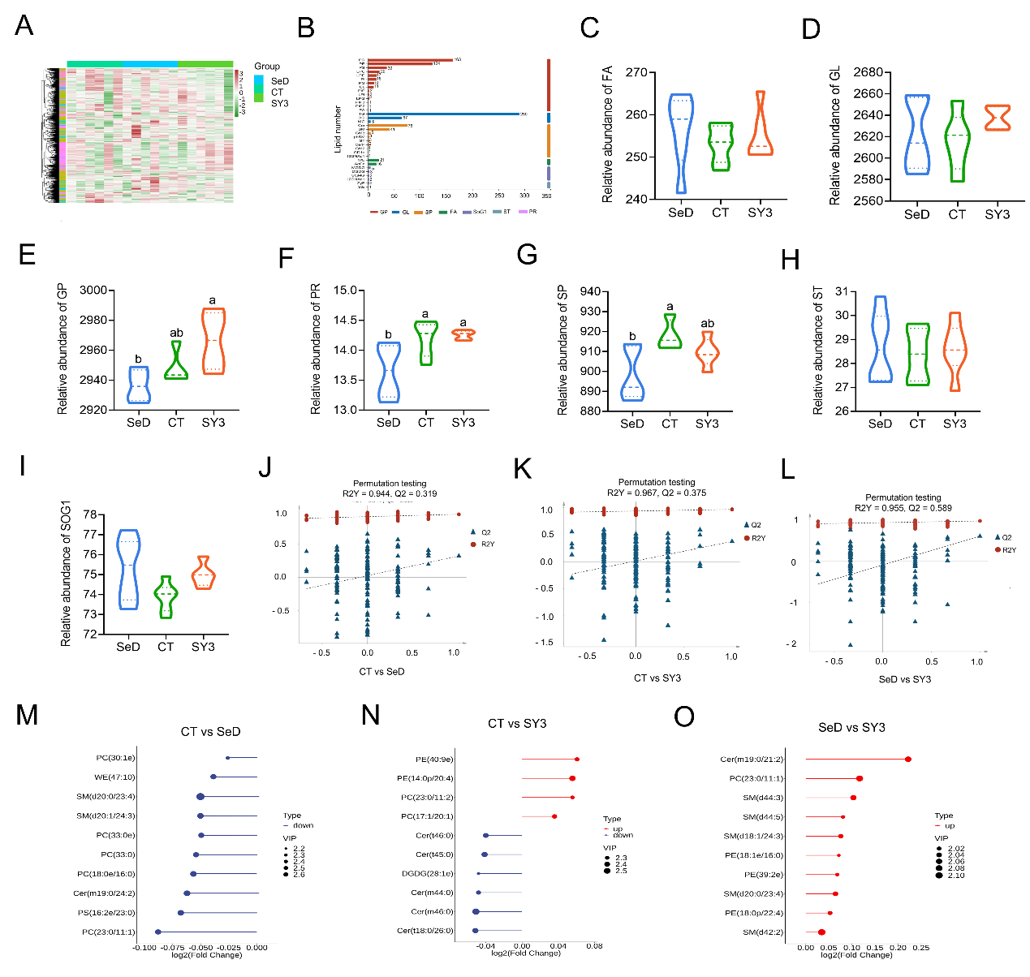
Fig. 1. Characteristics of lipids profile of LD muscle in CT, SeD and SY3 groups.
(A)Heat map of l lipids profile. (B) Lipid subclass composition of lipids. (C-I) The relative abundance of 7 categories of lipids in LD msucle in 3 paired-comparisons, n = 6. (J-L) OPLS-DA models validated by permutation tests in 3 paired-comparisons. (M-O) Lollipop plot of top 10 DLMs in 3 paired-comparisons. SeD = Se deficiency group（basal diet group）; CT = basal diet group+0.3mg Se-enriched yeast;SY3 = basal diet+3 mg Se-enriched yeast.Values were presented by mean + SE. Mean with different superscripts in same row differ (P < 0.05).

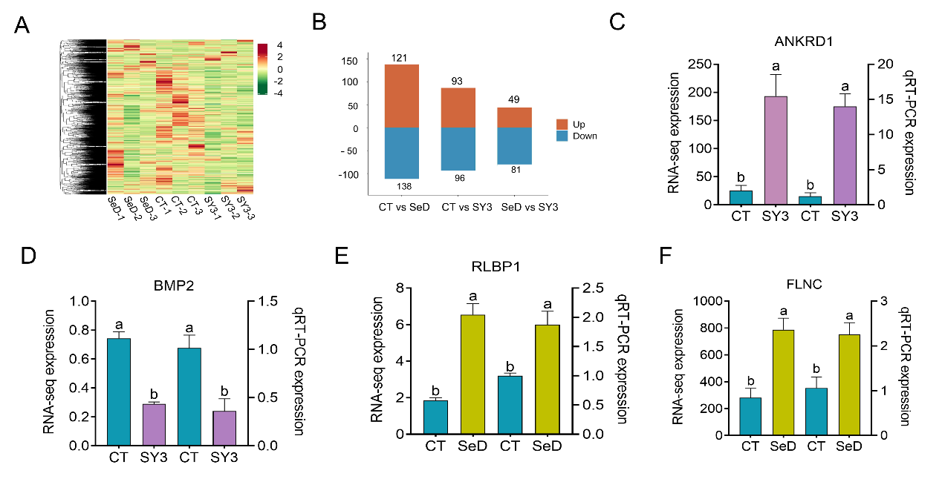
Fig. 2. Transcriptomic analysis of LD muscle of SeD, CT and SY3 groups.
(A)Heatmap of genes profile. (B) Bar chart of DEGs in 3 paired-comparisons.
(C) Verification of DEGs by RT-qPCR, n = 6. SeD = Se deficiency group（basal diet group）; CT = basal diet group+0.3mg Se-enriched yeast;SY1 = basal diet + 1 mg Se-enriched yeast; SY3 = basal diet + 3 mg Se-enriched yeast.Values were presented by mean + SE. Mean with different superscripts in same row differ (P < 0.05).

