APPENDIX

Appendix I

 | N | % Valid | % Valid Cum. | % Total | % Total Cum.
Self-Focused | 4175 | 18.81 | 18.81 | 18.81 | 18.81
Nationalist Aid Giver | 7188 | 32.38 | 51.19 | 32.38 | 51.19
EU Aid giver | 1531 | 6.90 | 58.08 | 6.90 | 58.08
National Europeanist | 2655 | 11.96 | 70.04 | 11.96 | 70.04
General Humanitarian | 3923 | 17.67 | 87.72 | 17.67 | 87.72
Other | 2727 | 12.28 | 100.00 | 12.28 | 100.00
Total | 22199 | 100.00 | 100.00 | 100.00 | 100.00
Table A1. Distribution of ‘Solidarity Profiles’ (All Countries Combined)
Notes. Solidarity profiles are constructed from three items asking how much help (0–10) should be given in a major crisis to: (1) a region within one’s own country, (2) another EU country, and (3) a non-EU country. Responses are rescaled to 0–1, with ‘don’t know’ coded to the midpoint (0.5), and country-specific medians are calculated for each of the three items. For each respondent, we compute a personal mean solidarity score across the three levels and define a tolerance of 0.1 on the 0–1 scale to identify ‘generalists’ whose three scores are all close to their own mean. ‘General Humanitarians’ are generalists whose three scores are all at or above their country’s medians; ‘Self-Focused’ are generalists whose three scores are all at or below the medians. ‘EU Aid Givers’ are those whose solidarity with other EU countries is higher than both their national and non-EU solidarity; ‘National Europeanists’ have very similar solidarity toward their own country and the EU (difference ≤ 0.1), and both scores exceed their non-EU solidarity. ‘Nationalist Aid Givers’ are those whose solidarity is highest toward their own country (above both EU and non-EU). Respondents who do not meet any of these criteria are assigned to the residual ‘Other’ category.

Table A2. Distribution of ‘Solidarity Profiles’ (All Countries Combined), ‘Don’t Know’ Midpoints Excluded)
 | N | % Valid | % Valid Cum. | % Total | % Total Cum.
Self-Focused | 3376 | 16.60 | 16.60 | 16.60 | 16.60
Nationalist Aid Giver | 6853 | 33.70 | 50.31 | 33.70 | 50.31
EU Aid giver | 1418 | 6.97 | 57.28 | 6.97 | 57.28
National Europeanist | 2559 | 12.59 | 69.87 | 12.59 | 69.87
General Humanitarian | 3480 | 17.12 | 86.98 | 17.12 | 86.98
Other | 2647 | 13.02 | 100.00 | 13.02 | 100.00
Total | 20333 | 100.00 | 100.00 | 100.00 | 100.00

Figure A1. Distribution of Solidarity Profiles within each country 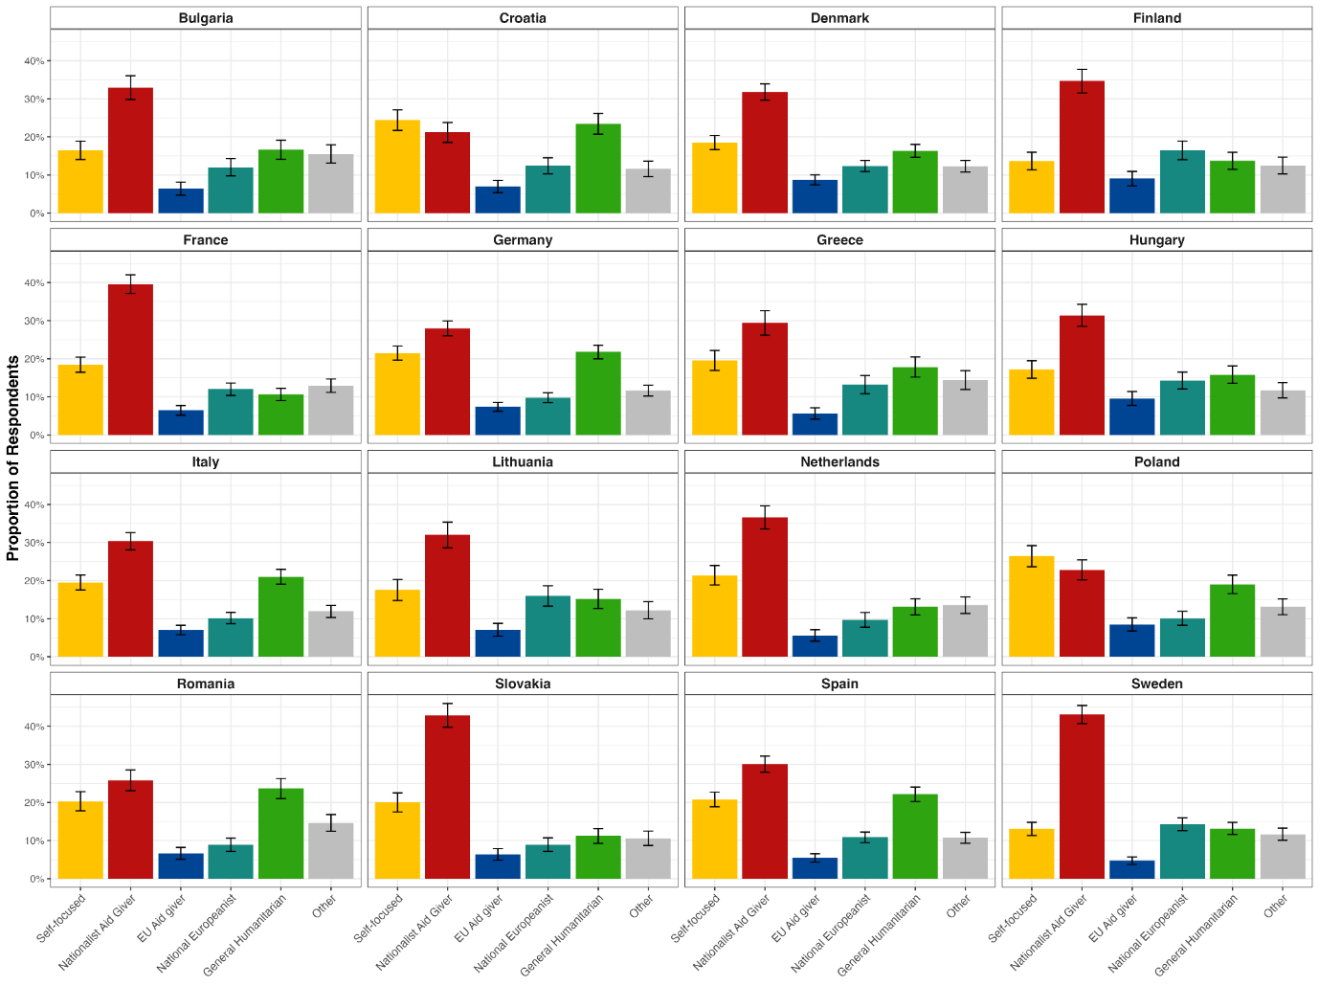

Figure A2. Distribution of the three Types of Solidarity across all Profiles and within the entire Sample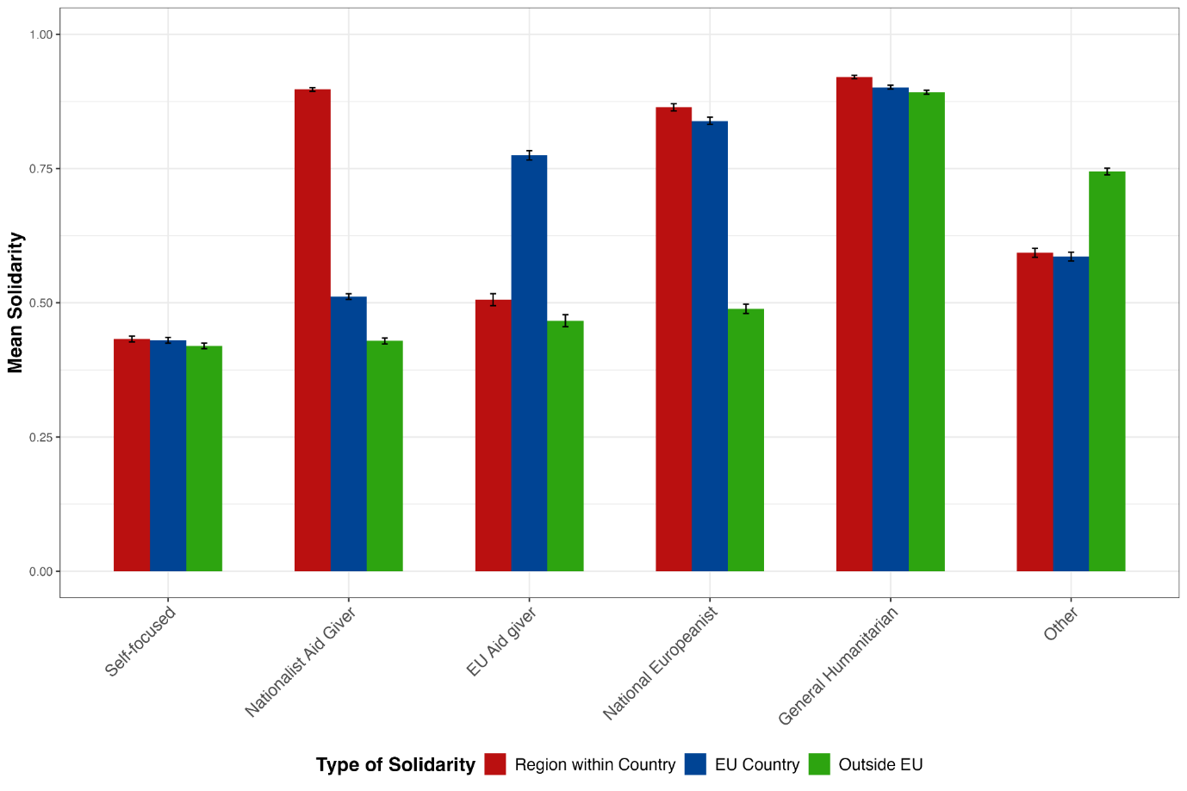

Figure A3. Distribution of each Type of Solidarity for the Other Profile (Violin Plot) 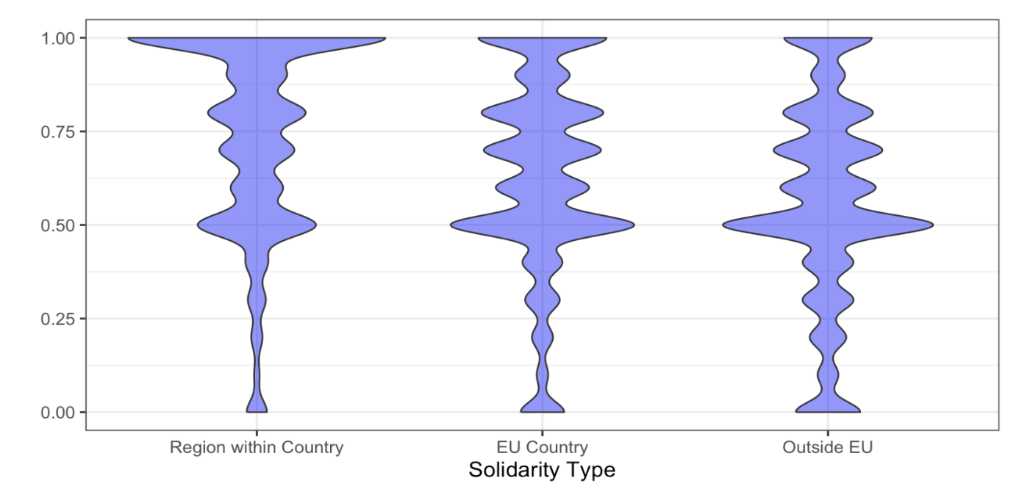

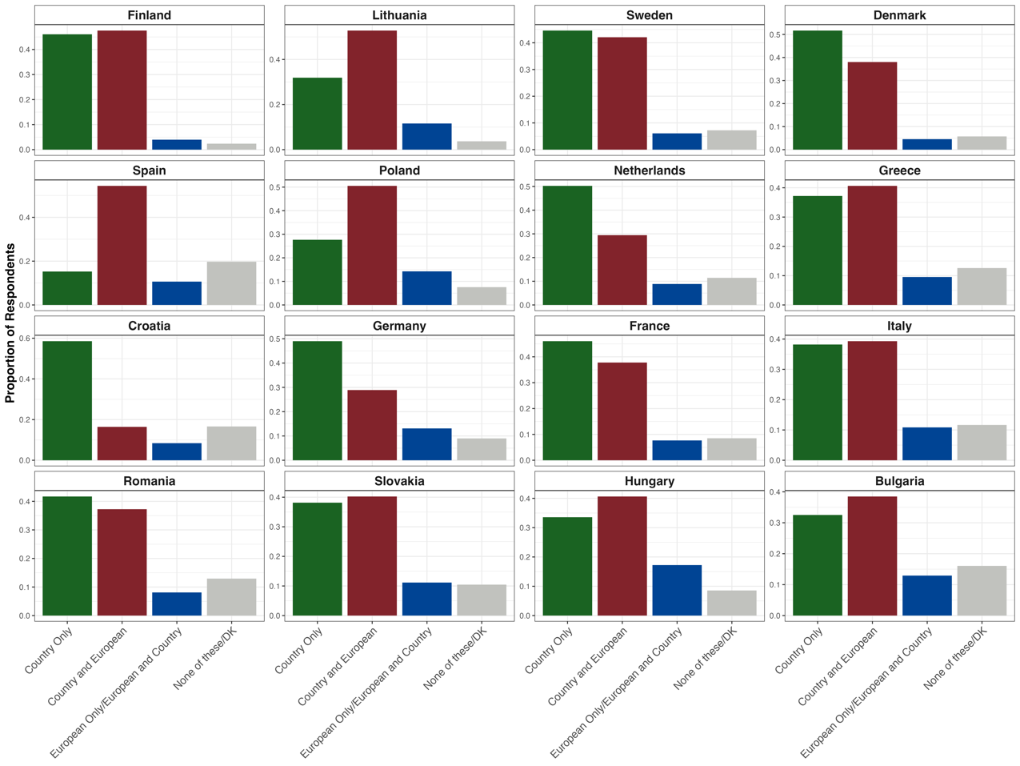
Figure A4. Distribution of European Identity Categories within Countries

Figure A5. Expectation of Help across All Countries: Own Country, EU Country, Outside EU Country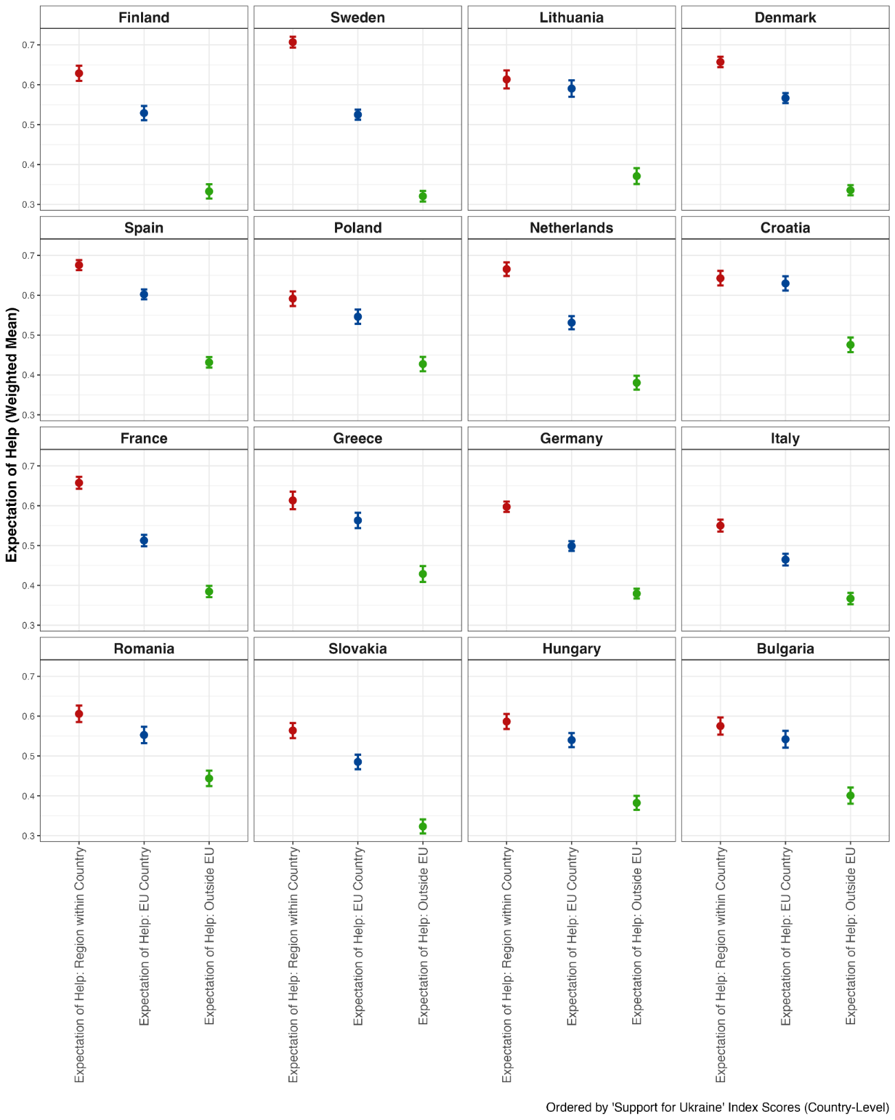

Table A3. Descriptive Statistics of All Main Models IVs
Variable | Mean | Median | SD | Min | Max
Age | 0.67 | 0.75 | 0.34 | 0.00 | 1.00
Female | 0.53 | 1.00 | 0.50 | 0.00 | 1.00
Perceived Low Income | 0.33 | 0.00 | 0.47 | 0.00 | 1.00
College Educated | 0.33 | 0.00 | 0.47 | 0.00 | 1.00
Ideology: Extreme Left | 0.14 | 0.00 | 0.35 | 0.00 | 1.00
Ideology: Left | 0.14 | 0.00 | 0.35 | 0.00 | 1.00
Ideology: center | 0.20 | 0.00 | 0.40 | 0.00 | 1.00
Ideology: right | 0.13 | 0.00 | 0.34 | 0.00 | 1.00
Ideology: Extreme Right | 0.15 | 0.00 | 0.35 | 0.00 | 1.00
Ideology: No Ideology | 0.24 | 0.00 | 0.43 | 0.00 | 1.00
European Identity: Country Only | 0.40 | 0.00 | 0.49 | 0.00 | 1.00
European Identity: Country and European | 0.40 | 0.00 | 0.49 | 0.00 | 1.00
European Identity: European Only / European and country | 0.10 | 0.00 | 0.30 | 0.00 | 1.00
European Identity: DK/None of These | 0.10 | 0.00 | 0.30 | 0.00 | 1.00
Profile: Self-Focused | 0.12 | 0.00 | 0.33 | 0.00 | 1.00
Profile: EU Aid Giver | 0.19 | 0.00 | 0.39 | 0.00 | 1.00
Profile: Nationalist Aid Giver | 0.32 | 0.00 | 0.47 | 0.00 | 1.00
Profile: National Europeanist Aid Giver | 0.07 | 0.00 | 0.25 | 0.00 | 1.00
Profile: General Humanitarian | 0.12 | 0.00 | 0.32 | 0.00 | 1.00
Profile: Other | 0.18 | 0.00 | 0.38 | 0.00 | 1.00
Expectation of Help: Region Within Own Country | 0.63 | 0.70 | 0.30 | 0.00 | 1.00
Expectation of Help: EU Country | 0.54 | 0.50 | 0.29 | 0.00 | 1.00
Expectation of Help: Non-EU Country | 0.38 | 0.40 | 0.29 | 0.00 | 1.00

Table A4. Model Specifications
Model 1:  European Solidarity | Model 2:  Solidarity Profiles | Model 3:  Expectations of Help | Model 4:  Solidarity Profiles and Expectations of Help
Age | Age | Age | Age
Female | Female | Female | Female
Low Income | Low Income | Low Income | Low Income
College Educated | College Educated | College Educated | College Educated
Ideology | Ideology | Ideology | Ideology
European Identity |  |  | European Identity
 | Solidarity Profiles |  | Solidarity Profile
 |  | Expectation of Help: Region Within Own Country | Expectation of Help: Region Within Own Country
 |  | Expectation of Help: EU Country | Expectation of Help: EU Country
 |  | Expectation of Help: Non-EU Country | Expectation of Help: Non-EU Country

Table A4.1. Model Specifications
Some and Strong Knowledge of EU initiatives Model | Cohesion Fund Assessment (‘Strong Knowledge’ Respondents only) Model | Beneficiary or Contributor to the EU Model
Age | Age | Age
Female | Female | Female
Low Income | Low Income | Low Income
College Educated | College Educated | College Educated
Some Knowledge of SURE/Recovery Plan
 | Cohesion Fund Assessment (‘Strong Knowledge’ Respondents only)
 |  | EU Contributor (0) or Beneficiary (1)
 |  | Expectation of Help: Region Within Own Country
 |  | Expectation of Help: EU Country
 |  | Expectation of Help: Non-EU Country

Table A5. VIF Table for All Model
Variable | Model 1 | Model 2 | Model 3 | Model 4 | Reference Category
Age | 1.04 | 1.04 | 1.03 | 1.07 | -
Female | 1.03 | 1.02 | 1.02 | 1.03 | Male
Low Income | 1.03 | 1.03 | 1.03 | 1.04 | Middle/High income
College Educated | 1.04 | 1.02 | 1.03 | 1.04 | Non-college educated
Ideology: Extreme Right | 1.51 | 1.50 | 1.50 | 1.52 | Center
Ideology: Extreme Left | 1.45 | 1.45 | 1.45 | 1.46 | Center
Ideology: No Ideology | 1.49 | 1.49 | 1.48 | 1.49 | Center
Ideology: Right | 1.46 | 1.46 | 1.48 | 1.48 | Center
Ideology: Left | 1.46 | 1.46 | 1.47 | 1.47 | Center
Territorial Identity: Country Only | 1.19 |  |  | 1.22 | Country Only
Territorial Identity: European Only or European and Country | 1.25 |  |  | 1.30 | Country Only
Territorial Identity: Country and European | 1.13 |  |  | 1.14 | Country Only
Profile: Other |  | 1.62 |  | 1.66 | Self-focused
Profile: Nationalist Aid Giver |  | 2.15 |  | 2.36 | Self-focused
Profile: EU Aid Giver |  | 1.37 |  | 1.40 | Self-focused
Profile: National Europeanist |  | 1.64 |  | 1.79 | Self-focused
Profile: General Humanitarian |  | 1.79 |  | 2.02 | Self-focused
Expectation of Help: EU Country |  |  | 1.72 | 1.82 | -
Expectation of Help: Non-EU Country |  |  | 1.39 | 1.46 | -
Expectation of Help: Region Within Own Country |  |  | 1.35 | 1.46 | -

Table A6. Multiple Regression: Determinants of Support for Ukraine in the EU
 | Model 1: European Solidarity | Model 2: Solidarity Profiles | Model 3: Expectations of Help
Age | 0.035* | 0.028+ | 0.029
 | (0.015) | (0.015) | (0.018)
Female (Ref: Male) | -0.017*** | -0.021*** | -0.025***
 | (0.004) | (0.004) | (0.004)
Low Income (Ref: Middle/High income) | -0.026*** | -0.024*** | -0.024***
 | (0.004) | (0.004) | (0.005)
College Educated (Ref: Non-college educated) | 0.016** | 0.022*** | 0.021***
 | (0.004) | (0.003) | (0.004)
Ideology: Extreme Left (Ref: Center) | 0.023* | 0.015+ | 0.028*
 | (0.010) | (0.008) | (0.010)
Ideology: Left (Ref: Center) | 0.026** | 0.028** | 0.029**
 | (0.009) | (0.007) | (0.007)
Ideology: Right (Ref: Center) | 0.022+ | 0.023+ | 0.024+
 | (0.012) | (0.012) | (0.011)
Ideology: Extreme Right (Ref: Center) | -0.015 | -0.023 | -0.018
 | (0.021) | (0.021) | (0.021)
Ideology: No Ideology (Ref: Center) | -0.034*** | -0.035*** | -0.038***
 | (0.006) | (0.005) | (0.005)
Territorial Identity: None of these/DK  (Ref: Country Only) | 0.021
 | (0.012)
Territorial Identity: European Only/European and Country  (Ref: Country Only) | 0.089**
 | (0.025)
Territorial Identity: Country and European  (Ref: Country Only) | 0.117***
 | (0.010)
Profile: Nationalist Aid Giver (Ref: Self-focused) |  | 0.010
 |  | (0.009)
Profile: EU Aid giver (Ref: Self-focused) |  | 0.069***
 |  | (0.010)
Profile: National Europeanist (Ref: Self-focused) |  | 0.120***
 |  | (0.009)
Profile: General Humanitarian (Ref: Self-focused) |  | 0.193***
 |  | (0.010)
Profile: Other (Ref: Self-focused) |  | 0.072***
 |  | (0.005)
Expectation of Help: Region Within Own Country |  |  | 0.028+
 |  |  | (0.015)
Expectation of Help: EU Country |  |  | 0.224***
 |  |  | (0.013)
Expectation of Help: Non-EU Country |  |  | 0.018
 |  |  | (0.011)
Num.Obs. | 22199 | 22199 | 22199
R2 Adj. | 0.195 | 0.226 | 0.229
R2 Within Adj. | 0.089 | 0.123 | 0.126
RMSE | 0.23 | 0.23 | 0.23
FE: Country | X | X | X
p < 0.1, * p < 0.05, ** p < 0.01, *** p < 0.001

Note: The model integrating all blocks of our explanatory variables (model 4 in Table A4) is already reported in Table 1.

Table A7. Multiple Regression: Determinants of Support for Ukraine in the EU (without ‘Don’t Knows’)
 | Model 1: European Solidarity | Model 2: Solidarity Profiles | Model 3: Expectations of Help | Model 4:  Solidarity Profiles and Expectations of Help
Age | 0.045* | 0.037+ | 0.038+ | 0.029+
 | (0.018) | (0.019) | (0.019) | (0.016)
Female (Ref: Male) | -0.016** | -0.019** | -0.022*** | -0.015**
 | (0.005) | (0.005) | (0.005) | (0.004)
Low Income (Ref: Middle/High income) | -0.039*** | -0.040*** | -0.032*** | -0.026***
 | (0.005) | (0.006) | (0.005) | (0.004)
College Educated (Ref: Non-college educated) | 0.014** | 0.022*** | 0.020*** | 0.009*
 | (0.005) | (0.003) | (0.004) | (0.003)
Ideology: Extreme Left (Ref: Center) | 0.026* | 0.016 | 0.029* | 0.016
 | (0.011) | (0.009) | (0.011) | (0.009)
Ideology: Left (Ref: Center) | 0.026* | 0.029** | 0.030** | 0.017*
 | (0.010) | (0.008) | (0.008) | (0.008)
Ideology: Right (Ref: Center) | 0.020 | 0.023 | 0.021 | 0.021+
 | (0.014) | (0.014) | (0.014) | (0.011)
Ideology: Extreme Right (Ref: Center) | -0.018 | -0.027 | -0.023 | -0.013
 | (0.023) | (0.023) | (0.023) | (0.019)
Ideology: No Ideology (Ref: Center) | -0.056*** | -0.061*** | -0.054*** | -0.043***
 | (0.006) | (0.005) | (0.005) | (0.006)
Territorial Identity: None of these/DK (Ref: Country Only) | 0.001 |  |  | 0.002
 | (0.016) |  |  | (0.014)
Territorial Identity: European Only/European and Country  (Ref: Country Only) | 0.101** |  |  | 0.074**
 | (0.029) |  |  | (0.023)
Territorial Identity: Country and European (Ref: Country Only) | 0.134*** |  |  | 0.093***
 | (0.012) |  |  | (0.008)
Nationalist Aid Giver (Ref: Self-focused) |  | 0.027* |  | 0.004
 |  | (0.010) |  | (0.008)
EU Aid giver (Ref: Self-focused) |  | 0.097*** |  | 0.062***
 |  | (0.011) |  | (0.012)
National Europeanist (Ref: Self-focused) |  | 0.151*** |  | 0.085***
 |  | (0.010) |  | (0.010)
General Humanitarian (Ref: Self-focused) |  | 0.241*** |  | 0.161***
 |  | (0.013) |  | (0.010)
Other (Ref: Self-focused) |  | 0.101*** |  | 0.064***
 |  | (0.009) |  | (0.008)
Expectation of Help: Region Within Own Country |  |  | 0.032+ | 0.027+
 |  |  | (0.018) | (0.015)
Expectation of Help: EU Country |  |  | 0.252*** | 0.179***
 |  |  | (0.015) | (0.010)
Expectation of Help: Non-EU Country |  |  | 0.020 | -0.004
 |  |  | (0.014) | (0.009)
Num.Obs. | 15856 | 15856 | 15030 | 15030
R2 Adj. | 0.212 | 0.253 | 0.252 | 0.322
R2 Within Adj. | 0.097 | 0.144 | 0.144 | 0.224
RMSE | 0.24 | 0.24 | 0.23 | 0.22
FE: Country | X | X | X | X
p < 0.1, * p < 0.05, ** p < 0.01, *** p < 0.001

Appendix II: Additional bivariate statistical tests to assess the robustness of our profiles: ANOVA

To further explore the validity and distinctions across our created solidarity profiles, we conducted additional bivariate statistical tests, specifically an Analysis of Variance (ANOVA). This test compares the means of the Ukraine support index (i.e., our dependent variable) across our six solidarity profiles. We aim to determine if the mean support significantly differs between these profiles.

Before performing the ANOVA, we first ensure that certain assumptions are met:

1. Homogeneity of Variances: We perform a Levene's Test for homogeneity of variances. A resulting p-value greater than 0.05 indicates that we failed to reject the null hypothesis of equal variances across groups. With a p-value of 0.24, the assumption of homogeneity of variances is met.

2. Normality of Residuals: Here, we check whether the residuals are normally distributed within each group. We conducted the Shapiro-Wilk test for normality. With all p-values above 0.05, we can conclude that the assumption of normality is met for each profile. Here are the p-values for each group:

- General Humanitarian: p-value = 0.90
- Self-focused: p-value = 0.72
- EU Aid Giver: p-value = 0.16
- National Europeanists: p-value = 0.64
- Nationalist Aid Giver: p-value = 0.53
- Other: p-value = 0.56

Upon ensuring that the assumptions are satisfied, we proceed with the ANOVA test. With a p-value < 0.0001, the resulting analysis showed that our solidarity profile variable is statistically significant (p < .05), indicating that there are indeed significant differences in levels of support for Ukraine aid across the different solidarity profiles.
E

