Supplementary Table S1 | DAPT hyperparameter configuration.
Parameter | Stage 1 | Stage 2
Corpus | World-DAPT multi-site (NOAA SanctSound, USWTR, NRS, ONMS, icListen / ONC, NPS Glacier Bay) | 2021 PALAOA subset
Duration (hours) | 5,673 | 287
Epochs | 1 | 1
Steps | 126,365 | 6,385
Batch size | 16 | 16
Learning rate | 1×10⁻⁴ peak (5% warmup + cosine decay to 0) | 1×10⁻⁵ peak (5% warmup + cosine decay to 0)
Optimiser | AdamW | AdamW
Precision | bfloat16 mixed precision | bfloat16 mixed precision
MAM mask ratio | 75% (random per-patch) | 75% (random per-patch)
Tokeniser | k-means with k = 1024 over BEATs AS-2M patch features | (same as Stage 1)
Validation split | 1% (drop_last = True) | 1% (drop_last = True)

Supplementary Table S2 | Label taxonomy and dataset composition (totals) for the 56-class underwater sound event dataset used for SED training.
The label taxonomy and the underlying 56-class audio dataset are those used in Noda et al. (2024)¹¹ (categories: Biophony, Geophony, Anthrophony). For biological classes, the scientific name is provided separately from the common name and any dataset-internal call-type annotations (e.g., type A/B/C/D). Totals are reported at the 10 s-clip level: total hours were computed as the number of labelled 10 s clips multiplied by the fixed clip length (10 s) and converted to hours. Classes 50–52 correspond to sounds recorded from green sea turtles (Chelonia mydas); two of these classes (50 and 52) contain fewer than 40 labelled clips because they were originally annotated at the 2 s-event level for an earlier short-window CNN training protocol, and when re-aggregated to the 10 s-clip level used in the present study, multiple events within a single clip collapse into a single count.
idx | Level 1 | Level 2 | Scientific name | Common name / note | total clips | total hours
0 | Biophony | Fish | Myripristis berndti | Blotcheye soldierfish | 208 | 0.578
1 | Biophony | Fish | Pseudanthias dispar | Peach fairy basslet | 41 | 0.114
2 | Geophony | Noise |  | background noise | 253 | 0.703
3 | Biophony | Fish | Lutjanus decussatus | Checkered snapper | 49 | 0.136
4 | Biophony | Fish | Chromis viridis | blue-green chromis; type A | 233 | 0.647
5 | Biophony | Fish | Chromis viridis | blue-green chromis; type B | 321 | 0.892
6 | Anthrophony | Human |  | diver breathing | 140 | 0.389
7 | Anthrophony | Vessel |  | diver support boat | 87 | 0.242
8 | Biophony | Fish | Gymnothorax javanicus | giant moray | 229 | 0.636
9 | Anthrophony | Vessel |  | small workboat / drone-like vessel | 110 | 0.306
10 | Biophony | Mammal | Dugong dugon | dugong; type A | 140 | 0.389
11 | Biophony | Mammal | Dugong dugon | dugong; type B | 40 | 0.111
12 | Biophony | Fish | Pseudanthias evansi | Yellowback anthias | 118 | 0.328
13 | Anthrophony | Vessel |  | ferry | 107 | 0.297
14 | Biophony | Fish | Dascyllus aruanus | Whitetail dascyllus; type A | 54 | 0.15
15 | Biophony | Fish | Plotosus spp. | striped eel catfish | 441 | 1.225
16 | Biophony | Fish | Amphiprion frenatus | tomato clownfish | 49 | 0.136
17 | Anthrophony | Construction |  | underwater hammer | 106 | 0.294
18 | Biophony | Fish | Chaetodon unimaculatus | teardrop butterflyfish | 128 | 0.356
19 | Anthrophony | Vessel |  | patrol boat | 140 | 0.389
20 | Anthrophony | Vessel |  | cargo ship | 50 | 0.139
21 | Biophony | Fish | Zoramia leptacanthus | Threadfin cardinalfish | 138 | 0.383
22 | Biophony | Mammal | Globicephala macrorhynchus | short-finned pilot whale; type A | 134 | 0.372
23 | Anthrophony | Vessel |  | pleasure / small coastal boat | 101 | 0.281
24 | Biophony | Fish | Myripristis kuntee | Shoulderbar soldierfish; type A | 54 | 0.15
25 | Biophony | Fish | Myripristis kuntee | Shoulderbar soldierfish; type B | 66 | 0.183
26 | Biophony | Fish | Stegastes nigricans | Dusky farmerfish; type A | 58 | 0.161
27 | Biophony | Fish | Stegastes nigricans | Dusky farmerfish; type B | 138 | 0.383
28 | Biophony | Mammal | Globicephala macrorhynchus | short-finned pilot whale; type B | 45 | 0.125
29 | Biophony | Fish | Neoniphon sammara | Sammara squirrelfish; type A | 85 | 0.236
30 | Biophony | Mammal | Tursiops aduncus | Indo-Pacific bottlenose dolphin | 56 | 0.156
31 | Biophony | Fish | Dascyllus aruanus | Whitetail dascyllus; type B | 94 | 0.261
32 | Biophony | Fish | Dascyllus aruanus | Whitetail dascyllus; type C | 162 | 0.45
33 | Biophony | Fish | Dascyllus aruanus | Whitetail dascyllus; type D | 75 | 0.208
34 | Biophony | Fish | Centropyge vrolikii | Pearlscale angelfish | 133 | 0.369
35 | Biophony | Fish | Acanthurus dussumieri | Eyestripe surgeonfish | 54 | 0.15
36 | Biophony | Fish | Pomacentrus amboinensis | Ambon damsel; type A | 62 | 0.172
37 | Biophony | Fish | Pomacentrus amboinensis | Ambon damsel; type B | 131 | 0.364
38 | Geophony | Rain |  | rain | 172 | 0.478
39 | Biophony | Fish | Abudefduf sexfasciatus | Scissortail sergeant; type A | 103 | 0.286
40 | Biophony | Fish | Abudefduf sexfasciatus | Scissortail sergeant; type B | 98 | 0.272
41 | Biophony | Fish | Chrysiptera cyanea | Sapphire devil; type A | 225 | 0.625
42 | Biophony | Fish | Chrysiptera cyanea | Sapphire devil; type B | 1762 | 4.894
43 | Biophony | Mammal | Tursiops truncatus | common bottlenose dolphin | 103 | 0.286
44 | Biophony | Mammal | Globicephala macrorhynchus | short-finned pilot whale; type C | 105 | 0.292
45 | Anthrophony | Vessel |  | tanker | 100 | 0.278
46 | Biophony | Mammal | Pseudorca crassidens | false killer whale | 102 | 0.283
47 | Anthrophony | Vessel |  | regular service vessel | 124 | 0.344
48 | Anthrophony | Vessel |  | tugboat | 101 | 0.281
49 | Biophony | Fish | Neoniphon sammara | Sammara squirrelfish; type B | 67 | 0.186
50 | Biophony | Reptile | Chelonia mydas | green sea turtle; breath | 24 | 0.067
51 | Biophony | Reptile | Chelonia mydas | green sea turtle; flipper stroke | 53 | 0.147
52 | Biophony | Reptile | Chelonia mydas | green sea turtle; collision/impact | 8 | 0.022
53 | Geophony | Wave |  | wave | 148 | 0.411
54 | Biophony | Mammal | Megaptera novaeangliae | humpback whale; type A | 127 | 0.353
55 | Biophony | Mammal | Megaptera novaeangliae | humpback whale; type B | 60 | 0.167
 |  |  |  | TOTAL | 8112 | 22.533

Supplementary Table S3 | Sensitivity to tolerance (±15 s vs ±20 s) in the HICEAS multi-species diagnostic evaluation using unknownness scores
Macro- and micro-averaged Precision (P), Recall (R), F1, and false positives per hour (FP/h) when the per-window detection score is −kNN_z, −Mahalanobis_z, or −CCED2 in the HICEAS multi-species evaluation (annotation-restricted scoring; a quantile threshold q = 0.99 selects the top 1% most-extreme windows per recording, after which a per-recording per-hour cap retains at most K = 2 windows per hour ranked by score (i.e., the two highest-scoring candidates within each one-hour bucket; Methods §4.4.4); selections are taken from the lower tail because higher unknownness corresponds to lower (more negative) values for these negated-distance scores). Row labels combine the aggregation rule and the temporal-match tolerance: macro@15 = per-species P, R, F1, and FP/h averaged across the 7 species with a ±15 s temporal-match tolerance; micro@20 = P, R, F1, and FP/h computed once over events from all species pooled together with ±20 s; analogously for the other combinations. This table is an unknownness-only diagnostic evaluation; the main HICEAS analysis (recording-level Promoter, 5-fold stratified cross-validation) is reported in Table 4.
Score | Split | P | R | F1 | FP/h
BEATs+DAPT embeddings (this work)
-kNN_z | macro@15 | 0.355 | 0.244 | 0.257 | 38.72
-kNN_z | micro@15 | 0.462 | 0.142 | 0.218 | 32.30
-kNN_z | macro@20 | 0.415 | 0.301 | 0.313 | 35.10
-kNN_z | micro@20 | 0.519 | 0.160 | 0.245 | 28.86
-Mahalanobis_z | macro@15 | 0.357 | 0.249 | 0.261 | 38.58
-Mahalanobis_z | micro@15 | 0.459 | 0.142 | 0.216 | 32.45
-Mahalanobis_z | macro@20 | 0.416 | 0.304 | 0.316 | 35.03
-Mahalanobis_z | micro@20 | 0.515 | 0.159 | 0.243 | 29.12
-CCED2 | macro@15 | 0.361 | 0.252 | 0.264 | 38.32
-CCED2 | micro@15 | 0.466 | 0.144 | 0.220 | 32.02
-CCED2 | macro@20 | 0.417 | 0.303 | 0.316 | 34.99
-CCED2 | micro@20 | 0.521 | 0.161 | 0.246 | 28.72
Perch 2.0 embeddings (win10; no underwater DAPT; baseline)
-kNN_z | macro@15 | 0.301 | 0.192 | 0.204 | 41.94
-kNN_z | micro@15 | 0.651 | 0.118 | 0.200 | 20.95
-kNN_z | macro@20 | 0.346 | 0.232 | 0.17000.245 | 39.24
-kNN_z | micro@20 | 0.697 | 0.127 | 0.214 | 18.18
-Mahalanobis_z | macro@15 | 0.251 | 0.143 | 0.155 | 44.94
-Mahalanobis_z | micro@15 | 0.643 | 0.117 | 0.198 | 21.41
-Mahalanobis_z | macro@20 | 0.302 | 0.189 | 0.202 | 41.84
-Mahalanobis_z | micro@20 | 0.696 | 0.126 | 0.214 | 18.26
-CCED2 | macro@15 | 0.260 | 0.152 | 0.164 | 44.39
-CCED2 | micro@15 | 0.646 | 0.118 | 0.199 | 21.21
-CCED2 | macro@20 | 0.299 | 0.186 | 0.198 | 42.04
-CCED2 | micro@20 | 0.693 | 0.126 | 0.213 | 18.40
* Perch “win10” uses 10-s window embeddings extracted with start_sec = center_sec - 5 and duration_sec = 10.
† Why the three scores yield nearly identical macro/micro values (BEATs+DAPT, n = 54,419 HICEAS Operations windows). Pairwise top-1% overlaps under the same selection rule as the table (q = 0.99, per-recording per-hour cap K = 2, lower tail) are tabulated in Supplementary Table S4: Mahalanobis vs CCED2 = 97.1% (529/545 shared), kNN vs CCED2 = 84.6% (461/545 shared), kNN vs Mahalanobis = 81.8% (446/545 shared). The dominant reason CCED2 reproduces the Mahalanobis-only metrics almost exactly is the 97.1% Mahalanobis-CCED2 overlap (only 16 swapped windows; see also Discussion §3.2). For the secondary kNN-CCED2 comparison: 168 windows are picked by one score but not the other (Pearson r = 0.767 between per-window scores), but they differ qualitatively: the 84 unique to −kNN_z are locally isolated points (mean d_knn_z = 3.02, mean d_maha_z = 13.4) inside the in-distribution covariance ellipsoid; the 84 unique to −CCED2 lie off the principal covariance axes (mean d_knn_z = 2.74, mean d_maha_z = 15.7); the 461 shared windows are extreme on both axes (mean d_knn_z = 3.50, mean d_maha_z = 18.9). Supplementary Figures S2 (Venn) and S3 visualise the kNN-CCED2 split. Because the swapped windows still rank in the upper tail of both scores, the per-row P/R/F1/FP/h differences in the table are small but nonzero.
‡ Annotation-restricted scoring (Methods §4.5.3). Per-species scoring is restricted at the recording level: only recordings in which experts annotated the species at least once are used. This prevents recordings of unknown species composition from being counted as false-positive sources. Within an included recording, all time spans are scored — including time spans not covered by an expert annotation, where any AI detection is counted as a false positive.
§ Uppercase K vs lowercase k. The K in this table is the per-hour cap defined in the legend (= 2 events per recording per hour). It is distinct from the lowercase k = 2 used in the FRDR pipeline (Table 3 and Supplementary Table S5), which denotes the minimum number of suprathreshold contiguous windows required to form an event group (an event-grouping parameter, not a cap).
Supplementary Table S4 | Top-1% selection overlap statistics for −kNN_z, −Mahalanobis_z and −CCED2 under different encoders.
Pairwise overlap of top-1% selections (n_select = 545 of n = 54,419 HICEAS Operations windows) under each unknownness score, computed independently for the BEATs+DAPT (this work) and Perch 2.0 encoders on the same HICEAS OP segments. |A ∩ B| denotes the number of windows in both top-1% selections; |A ∪ B| the union; Jaccard = |A ∩ B| / |A ∪ B|; overlap % = |A ∩ B| / 545. The 3-way intersection is the number of windows in the top 1% under all three scores. Pearson r is computed over the entire 54,419-window distribution, not the top 1% only; d_knn and d_maha denote the per-window kNN and Mahalanobis distances respectively, and cced2 denotes the per-window CCED2 score = z(d_knn) + z(d_maha), where z is z-score standardisation on the in-distribution background set (Methods §4.3).
Encoder | Pair | |A ∩ B| | |A ∪ B| | Jaccard | Overlap %
BEATs+DAPT | kNN vs Mahalanobis | 446 | 644 | 0.693 | 81.8%
BEATs+DAPT | kNN vs CCED2 | 461 | 629 | 0.733 | 84.6%
BEATs+DAPT | Mahalanobis vs CCED2 | 529 | 561 | 0.943 | 97.1%
Perch 2.0 | kNN vs Mahalanobis | 327 | 763 | 0.429 | 60.0%
Perch 2.0 | kNN vs CCED2 | 406 | 684 | 0.594 | 74.5%
Perch 2.0 | Mahalanobis vs CCED2 | 460 | 630 | 0.730 | 84.4%
3-way intersection: BEATs+DAPT 446, Perch 2.0 327. Pearson r over all 54,419 windows: BEATs+DAPT r(d_knn, d_maha) = 0.698, r(d_maha, cced2) = 0.995, r(d_knn, cced2) = 0.767; Perch 2.0 r(d_knn, d_maha) = 0.942, r(d_maha, cced2) = 0.991, r(d_knn, cced2) = 0.979. The Mahalanobis vs CCED2 overlap dropping from 97.1% (BEATs+DAPT) to 84.4% (Perch) on the same dataset, and the kNN vs Mahalanobis overlap dropping from 81.8% to 60.0%, demonstrate that the relative balance between the two CCED2 components is encoder-dependent. Visualisation of the Perch 3-way overlap is provided in Supplementary Figure S4.

Supplementary Table S5 | Summary of evaluation protocols (which methods are applied to which datasets under which operating constraints, and where the corresponding results appear).
Dataset | Task | Methods | Operating constraint / Score reported
56-class held-out (Section 2.1) | Sound event detection | BEATs + DAPT encoder with 56-class SED head | Event F1, clip F1, segment F1
FRDR (Section 2.2) | Continuous right-whale upcall detection | Quiet (SED head), Promoter (logistic regression on embeddings), Union (Detect–Group–Promote–Union), Fusion (simple linear score fusion of CCED2 and Quiet) | Recall at FP/h = 10
FRDR (Section 2.2, Table 3) | Unknownness-score ablation | kNN_z, Mahalanobis_z, and CCED2 under a CCED2-only thresholding regime (per-file median/MAD normalisation, 3-point smoothing, k = 2, min_sep = 3 s, tol = ±10 s) | Recall at FP/h = 10
HICEAS InD/OOD (Section 2.3) | InD/OOD evaluation (HICEAS as out-of-distribution corpus) | CCED2, kNN_z and Mahalanobis_z | AUROC, AUPR(in/out)
HICEAS species-wise (Section 2.3, Table 4) | Multi-species recording-level discrimination | Promoter (logistic regression on 768-dim BEATs+DAPT recording-mean embeddings) under 5-fold stratified CV | Promoter AUC (5-fold CV mean ± SD), F1
HICEAS OP (Section 2.3, Supplementary Table S3) | Per-species unknownness-only diagnostic | Unknownness score thresholding (annotation-restricted scoring) per species detection thresholds, min_sep, hour_cap, and shift_sec | Macro/micro-averaged P, R, F1, FP/h at tol ±15 s and ±20 s
* k (= 2 in this study; Table 3 and the FRDR row in this Supplementary Table): minimum number of suprathreshold windows required to form an event in the FRDR detection pipeline (Methods §4.4.4). Distinct from the uppercase K (top-K cap under annotation-restricted scoring; Supplementary Table S3).
† min_sep, hour_cap, shift_sec: detection post-processing parameters (Methods §4.4.4): min_sep is the minimum event separation in seconds, hour_cap is the maximum events per hour cap, and shift_sec is the detection time shift in seconds applied before matching.

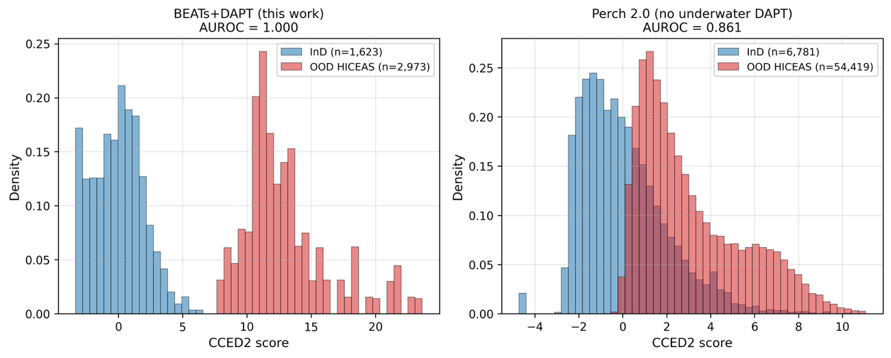
Supplementary Figure S1 | HICEAS InD vs OOD CCED2 score distributions.
Histograms of CCED2 scores for in-distribution (InD; left of each panel) and out-of-distribution (OOD; right of each panel) segments computed with BEATs+DAPT (left panel) and Perch 2.0 (right panel) embeddings. For BEATs+DAPT, the InD reference is the held-out 56-class SED validation split (n = 1,623) and the OOD set is the bandwidth-matched HICEAS OOD subset (n = 2,973). For Perch 2.0, the InD reference is the combined 56-class SED training split and the HICEAS PR (Promoter) dev set (n = 6,781) and the OOD set is the HICEAS OP segment set (n = 54,419), as specified in Methods §4.3. OOD samples are HICEAS multi-species towed-array segments. AUROC values: BEATs+DAPT = 1.000 (clean separation); Perch 2.0 = 0.861 (substantial overlap). The BEATs–Perch gap reflects the BEATs encoder architecture and general-audio pretraining; underwater-specific domain-adaptive pretraining contributes minimally at this AUROC ceiling, since BEATs PRETRAIN (without underwater DAPT) achieves a comparable AUROC ≈ 1.000 (Methods §4.3 and Discussion).

Supplementary Figure S2 | Overlap of top-1% selections under −kNN_z and −CCED2.
Venn diagram of the 545 windows selected by each score under the same selection rule as Supplementary Table S3 (top 1% of n = 54,419 HICEAS Operations windows; quantile threshold q = 0.99, per-recording per-hour cap K = 2 ranked by score, lower tail). 461 windows are common to both scores (overlap = 461 / 545 ≈ 85% of either selection; Jaccard similarity = 461 / 629 = 0.733, where Jaccard = |A ∩ B| / |A ∪ B| with A and B the two sets of selected windows); 84 windows are unique to −kNN_z and 84 are unique to −CCED2 (symmetric difference = 168). This visualises the diagnostic statistics reported in footnote † of Supplementary Table S3. Pairwise top-1% overlap statistics for BEATs+DAPT (see Supplementary Table S4 for full statistics): kNN vs Mahalanobis = 446 shared (Jaccard 0.69, 81.8%); kNN vs CCED2 = 461 shared (Jaccard 0.73, 84.6%); Mahalanobis vs CCED2 = 529 shared (Jaccard 0.94, 97.1%); 3-way intersection = 446. The high Mahalanobis vs CCED2 overlap reflects the dominant contribution of the Mahalanobis component to CCED2 in this dataset; this is why the figure focuses on the kNN vs CCED2 comparison, which most informatively shows how the kNN component shifts the selection. Encoder-comparison statistics (BEATs+DAPT vs Perch) are reported in Supplementary Table S4; the Perch 3-way Venn diagram is shown in Supplementary Figure S4.
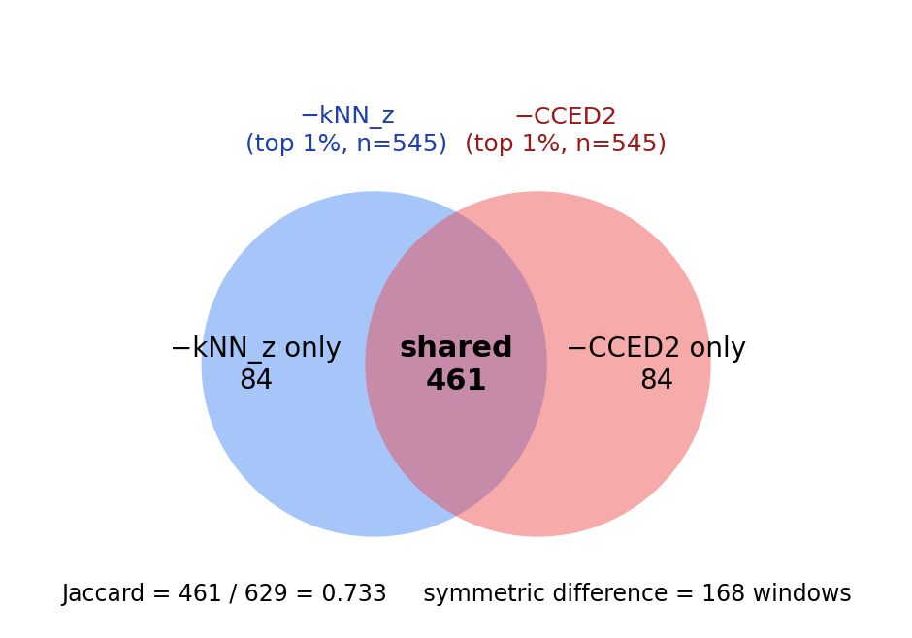

Supplementary Figure S3 | Top-1% selections in feature-space coordinates.
2-D scatter of all n = 54,419 HICEAS Operations windows in the (d_knn_z, d_maha_z) plane (BEATs+DAPT embeddings; z-scoring is anchored on the in-distribution background set). Grey: all 54,419 windows (background distribution; the coloured subsets are overlaid on top). The bulk of grey points clusters in the lower-left (low d_knn_z, low d_maha_z), corresponding to typical in-distribution windows; the coloured top-1% selections lie in the upper region. Purple: windows in the top 1% under both −kNN_z and −CCED2 (n = 461). Blue: windows in the top 1% only under −kNN_z (n = 84) — these have high kNN distance but only moderately elevated Mahalanobis distance, i.e., they are locally isolated points that still lie within the principal covariance axes of the in-distribution set. Red: windows in the top 1% only under −CCED2 (n = 84) — these have moderate kNN distance but high Mahalanobis distance, i.e., they lie off the principal covariance axes. The complementary placement of the blue and red clusters explains why combining the two distances in CCED2 surfaces a different mix of anomalies than either alone. While the three scores yield closely comparable standalone macro/micro F1 in this diagnostic (Supplementary Table S3 and main text §2), this complementary coverage is one of the reasons CCED2 was adopted as the candidate-surfacing score for Promoter training in the main DGPU pipeline, where it contributes to the ~5.8-fold recall improvement reported in Table 2.
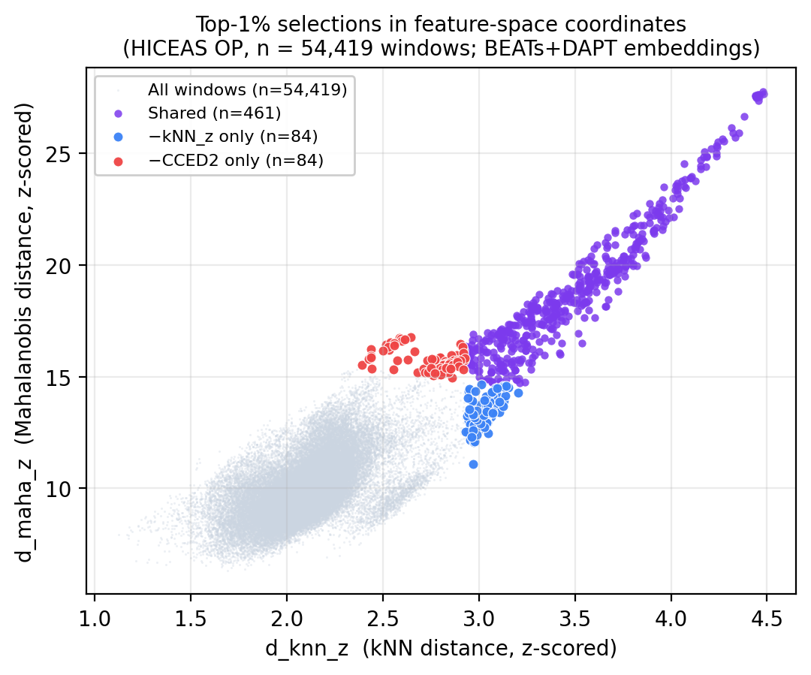

Supplementary Figure S4 | Perch 2.0 top-1% selection 3-way Venn diagram (kNN, Mahalanobis, CCED2) on HICEAS Operations windows.
Three-way Venn diagram of the top-1% windows (n_select = 545 per score; n_total = 54,419) selected by −kNN_z, −Mahalanobis_z and −CCED2 using Perch 2.0 embeddings on the same HICEAS Operations subset as Supplementary Figure S2. Numbers in each region are window counts. The 3-way intersection is 327 windows (vs 446 for BEATs+DAPT under the same protocol; cf. Supplementary Table S4); pairwise overlaps are kNN vs Mahalanobis = 60.0%, kNN vs CCED2 = 74.5%, Mahalanobis vs CCED2 = 84.4% — markedly lower than the corresponding BEATs+DAPT overlaps (81.8%, 84.6%, 97.1% respectively). The smaller Mahalanobis vs CCED2 overlap under Perch indicates that the kNN component substantially shifts the selection under Perch, where the local-density and covariance-structure rankings of the top-1% windows diverge more than under BEATs+DAPT, supporting the design rationale for retaining CCED2 (= z(kNN) + z(Mahalanobis)) as an ensemble unknownness score (Discussion §3.2).
